# **Image result for softwarica college of it and ecommerceIOT Individual Project**

# **IOT Based Vehicle Pollution Detection System**

[image]

Submitted by: Basanta Tajpuirya

Batch: 25B, College ID: 160467

Module leader: Shrawan Thakur

## **ABSTRACT:**

A vehicle pollution detection system is mainly used to detect and evaluate pollution index of vehicle in polluted urban areas where old vehicle produces mass pollution by their gas/smoke. It helps people to be aware of their unhealthy surrounding and government to monitor over vehicles that produces a lot of smoke. Smoke/Gas emitted by the vehicles is considered as primary source of environment pollution. Urban areas with high inflow of transport medium causing huge amount of air/environment pollution as well as decreasing quality of breathable air which leads to living being to suffer many health diseases. This paper uses Internet of Things(IOT) to obtain the main goal of introducing vehicle pollution detection system that is capable enough for efficiently detecting pollution index for cars and other vehicles polluting the city roads with harmful gases. The proposed system also provides android application interface for monitoring pollution index with the android phone. The measured data can also be distributed to transport departments and related agencies of national health and environment as well as the vehicle owner. The system is cheaper in terms of cost without compromising the reliable result in detecting the pollution index of vehicle.

## **INTRODUCTION**

Air pollution is the presence of harmful unwanted biological molecules, particulates, or other extra harmful things into the atmosphere. It is a one of the major cause of allergies, infections and eventually reason of death to some people.

Also talking about air pollution, it also affects other existing creatures like animals as well as food crops, or the ecological or built environments. They are also considered responsible for various kinds of respiratory infections (such as asthma), causes of many types of cancer in individuals, if they are not protected to these kinds of toxins or chemicals for long period of time. For example, carbon monoxide (CO) is insanely poisonous to humans as it may happen headaches, serious asphyxiation cause of composition of carboxyhemoglobin and thus a reason of death if protection is ignored for a long time. The World Health Organization (WHO) in 2014 estimated that 7 million people died worldwide because of air pollution.

In order to monitor emission of smoke for all vehicles, I have developed an IOT based system called Vehicle Pollution Detection System through which we can be able to detect pollution level of vehicle and monitor all the vehicles easily. The IOT takes vital role in this project paper, in order to detects the level of smoke the sensor should be placed at the exhaust of vehicle, with help of IOT the value is updated to the Nodejs server cloud. Which makes easier for the vehicle owner as well as transport office to monitor level of pollution emitted by the vehicle.

## **AIMS**

* Aim of this project is to reduce the air pollution by monitoring the smoke emission level of vehicles.

## **OBJECTIVES**

* Measure the smoke emission level of vehicles using sensor.
* Transfer the value of sensor to the Nodejs server.
* Retrieve data from Nodejs server to android application.
* Distribute data to vehicle owner and transport office.

## **PROPOSED METHODOLOGY**

In this system mq2 smoke sensor is placed at the vehicle exhaust, monitor the smoke for nitrogen oxide and carbon monoxide value emitted from the exhaust. I have used NODE MCU ESP8266MOD micro controller. The analogue value provided by the sensor is received and processed as programmed by the microcontroller. The microcontroller is programmed to continuously send the value obtained from the sensor to the Nodejs server. IOT plays role for the system to sync the calculated value to the Nodejs server. The NODE MCU helps to obtain the reading from sensor and update it to the cloud server using the Wi-Fi and internet. Both the vehicle owner and the transport department can be able to use real time data of pollution index which is continuously updated by the controller.

Figure : Block Diagram

## **NODE MCU-ESP8266**

Node MCU is a micro controller that comes with the inbuilt WiFi module. Wi-fi module is considered as open source IOT platform that helps micro controller to establish connection to a Wi-Fi network through which micro controller can be able to make simple TCP/IP requests. Lua is used as a scripting language inside this firmware. XTOS is the OS for the micro controller and ESP8266 is used for the processor. The power is supplied to the micro controller through an USB port. It has a limited primary memory(RAM) of 128KB and secondary memory (storage) of 4MB.

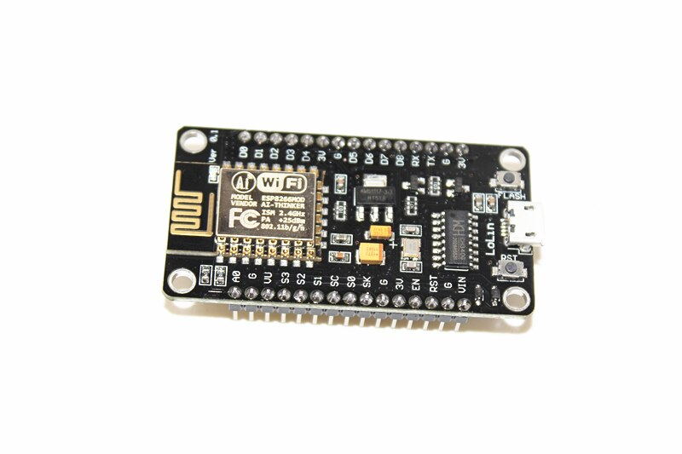

Figure : Node MCU esp8266MOD

## **MQ2 Gas/Smoke Sensor**

MQ-2 sensor is used to detect level of Hydrocarbon gases from 3000ppm to 10000ppm. Potentiometer can be used to adjust low and high sensitivity of the sensor. The sensor has four pins i.e., digital, and analog pins for output and power, ground. The output of depends upon the density of Carbon Monoxide (CO) gas that means output will be high if the density of the gas is high and low if the density of the gas is low. The output of the sensor can be obtained in analogue output.

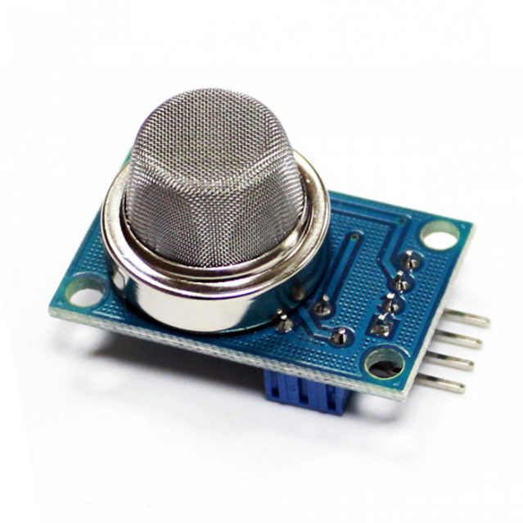

Figure : MQ2 sensor

## **BREADBOARD**

The purpose of the breadboard in this project is to make quick and easy electrical connections between micro controller and sensor so that the circuit can be tested before permanently soldering the connections. Breadboards have many small sockets organized on them, and some groups of sockets are organized in a way so that they can have same electrical connection.

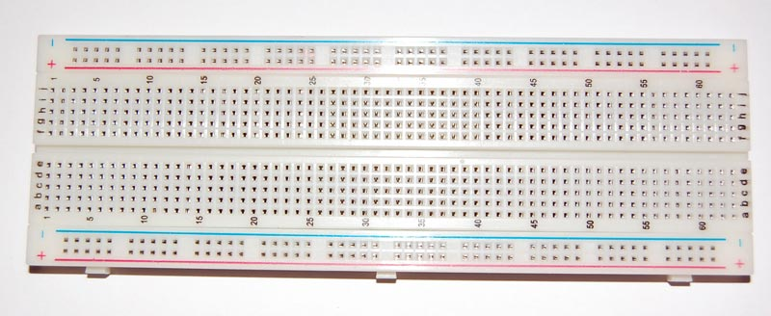

Figure : Breadboard

## **INTERNET OF THINGS**

Internet of things(IoT) is the network of physical devices embeds with sensors, electronics, actuator , software, and internet, connected together to share data. IoT helps sense data of any object and control it remotely.

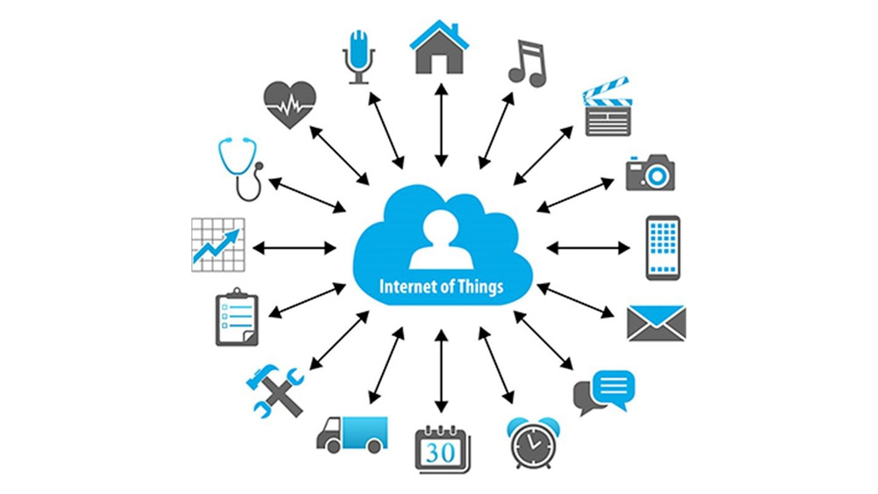

Figure : Internet of things

## **FUTURE SCOPE**

Components of the proposed system are easily available on marketplaces which makes it cost efficient and maintainable. In upcoming future days GPS module should be used with the devices which will provide geo location and help to update vehicle and pollution information to the regional transport office and to calculate and monitor the amount of gases emitted from vehicles in particular region. Furthermore, immediate fine can be applied to the vehicle owner if the vehicle emits more than the threshold set by the government.

## **CONCLUSION**

The environment/air pollution caused because of the emission of harmful unwanted gases like hydrocarbon, Carbon Monoxide (CO) and nitrogen oxide exhausted from vehicle, need to be monitored and decreased to save our precious environment and human lives. This system can be the one of the best solutions to vehicle gas emission monitoring system to reduce environment pollution as well as extend the life span of the vehicles.

## **References:**

GitHub: <https://github.com/basantashubhu/vehicle-pollution-detection.git>

YouTube: <https://www.youtube.com/watch?v=QPxqb46eqFc>