Thesis for the Degree of Master of Science in Electrical Engineering in Power System.

“Reactive Power Compensation by Optimal Sizing & Placement of D-STATCOM of 11kV Begnas Feeder Using PSO Based Optimization Algorithm”



**Ganga Prasad Sah (2021-01-91-003)**

**School of Engineering Faculty of Science and Technology**

**Pokhara University, Nepal**

Thesis for the Degree of Master of Science in Electrical Engineering in Power System

“Reactive Power Compensation by Optimal Sizing & Placement of D-STATCOM of 11kV Begnas Feeder Using PSO Based Optimization Algorithm”

**Supervised by Associate Prof Dr. Shailendra Kumar Jha Kathmandu University**

A thesis submitted in fulfillment of the requirements for the degree of Master of Science in Electrical Engineering in Power System

# GANGA PRASAD SAH (2021-01-91-003)

**School of Engineering Faculty of Science and Technology**

**Pokhara University, Nepal**

# DEDICATION

I would like to dedicate this thesis to my Family Specially My Wife and Son Divyansh Raj Shah.

# DECLARATION

I hereby declare that this study entitled “**REACTIVE POWER COMPENSATION BY OPTIMAL SIZING & PLACEMENT OF D-STATCOM OF 11 KV BEGNAS FEEDER USING PSO BASED OPTIMIZATION ALGORITHM”** is based on my

original research work. Related works on the topic by other researchers have been duly acknowledged. I owe all the liabilities relating to the accuracy and authenticity of the data and any other information included hereunder*.*

Ganga Prasad Sah 2021-01-91-003

06 January, 2024

# RECOMMENDATION

This is to certify that this thesis “**REACTIVE POWER COMPENSATION BY OPTIMAL SIZING & PLACEMENT OF D-STATCOM OF 11KV BEGNAS FEEDER USING PSO BASED OPTIMIZATION ALGORITHM**” prepared and

submitted by **Ganga Prasad Sah** in partial fulfillment of the requirements of the degree of Master of Science (M.Sc.) in Electrical Engineering in Power System awarded by Pokhara University, has been completed under my/our supervision. I/we recommend the same for acceptance by Pokhara University.

Dr. Shailendra Kumar Jha School Of Engineering Kathmandu University

06 January 2024

# CERTIFICATE

# ACKNOWLEDGEMENTS

I would like to convey my heartfelt thanks to my thesis supervisor, Dr. Shailendra Kumar Jha for his exceptional supervision, priceless assistance, and consistent support, which enabled me to successfully finish my thesis work. My heartfelt gratitude to him for showing such keen interest in both my academic and personal affairs. I'd want to thank him again for his kind support and inspiration.

Special thanks to Assoc. Prof. Er. Lalit Bickram Rana, Coordinator, MSc. in Electrical Engineering in Power System, School of Engineering, Pokhara University, for their assistance in completing the thesis.

I would like to express my gratitude to Er. Teknath Tiwari, Er. Rajkumar Raman, Er. Binod Sharma, Er. Abnish Tiwari, Er. Sandeep Dhami, Er. Pramod Raj Pangeni and Er. Amrit Babu Adhikari for your invaluable assistance during this thesis study.

Sincere gratitude to my seniors, family members, and colleagues from SOE, Pokhara University, and NEA for their valuable assistance in finishing the task.

I'd also want to thank the NEA Pokhara Grid Division (132/11kV Kundhar Substation, Pokhara), Kaski and NEA Lekhnath Distribution Centre Nepal for providing accurate data.

Finally, I want to thank everyone who has helped me, both directly and indirectly, with the thesis work.

Ganga Prasad Sah 2021-01-91-003

06/01/2024

# ABSTRACT

Distribution system is a part of an electric power system, which links the high voltage transmission networks with the end consumers. This work offers the way of improving the performance of the distribution network by improving voltage profile and reduction of power loss via injecting reactive power through the network. Generally radial distribution networks or system with lengthy line length and high loading have power quality issues like low voltage and higher loss. This study has been conducted on Begnas Feeder of Lekhnath Distribution Centre. In this work, the first condition has aimed to find the best optimal D-STATCOM sizing and placement by using Particle Swarm Optimization (PSO). Results obtained have been compared For each load level (Light, Medium & Heavy) load reported in literature. As stated, the PSO method performs better in terms of reducing both real and reactive power losses and improvement of voltage profile. The model has been formulated to minimize the total Power loss and Improve Voltage Profile at Light, Medium and Heavy load of 11 KV 72 buses Begnas Feeder by Optimal Size and Placement of D-STATCOM using PSO. Generally, the simulation results show that the proposed technique is effective to maintain all bus voltage magnitudes within the IEEE acceptable limit and thereby reducing power losses significantly. In This Research Basic Methods that have been used in this Study are Load flow analysis, Voltage Stability Index, PSO Optimization Algorithm, Backward and forward load flow analysis is Selected to compute all the required parameters in the existing Distribution System D-STATCOM is used to improve bus voltage profile. Voltage stability index is used to identify place for placing D-STATCOM. An effectively particle swarm optimization is used to search the best location and is employed to deduce the size and location of D-STATCOM for the weak buses. The results obtained are compared without and with D-STATCOM. By the optimal placement and sizing of D-STATCOM the voltage profile improved and the power loss reductions are obtained in the 11 KV Begnas Feeder of Lekhnath DC.

**Keywords**: D-STATCOM, Forward-Backward load flow, Particle Swarm based Optimization, Voltage Stability index, Power Loss Reduction &Voltage Profile

# TABLE OF CONTENT

## Page

DEDICATION i

DECLARATION ii

RECOMMENDATION iii

CERTIFICATE iv

ACKNOWLEDGEMENTS v

ABSTRACT vi

TABLE OF CONTENT vii

LIST OF TABLES x

LIST OF FIGURES xi

LIST OF APPENDIX xii

LIST OF ABBREVIATION/ACRONYMS xiii

CHAPTER 1

INTRODUCTION 1

* 1. Background 1
  2. Statement of the Problem: 3
  3. Thesis objectives 4
     1. General Objective 4
     2. Specific Objectives: 5
  4. Scope and Limitations 5
  5. Outline of the Thesis: 6

CHAPTER 2

LITERATURE REVIEW 7

* 1. Overview of Distribution Network: 8
     1. Distribution Static Compensator (D-STATCOM ): 9
     2. MODELING OF D_STATCOM 10
     3. D-STATCOM ALLOCATION TECHNIQUE FOR LOSS REDUCTION: 10
     4. Power Loss in Distribution System: 11
        1. Types of power loss 11
        2. Non-Technical Losses: 12
        3. Measures for reducing technical losses: 12
        4. Power flow/Load Flow: 13
  2. Backward Forward Sweep Method: 13
  3. Optimization Technique (PSO): 14

CHAPTER 3

METHODOLOGY 15

* 1. Case Study 15
  2. Collection of Data: 16
     1. Load Modeling: 16
  3. Design Details: 16
  4. Load Details of Begnas Feeder 17
  5. Proposed Methodology: 18
  6. Optimal Location of D-STATCOM Based on Voltage Stability

Index (VSI) 18

* 1. Particle Swarm Optimization (PSO) Fitness Function: 19
  2. Problem Formulation 20
  3. Overall Block Diagram Process 21

CHAPTER 4

RESULTS AND DISCUSSION 24

* 1. Introduction 24
  2. IEEE 69 Bus Results 24
     1. Voltage Profile & Active Power Loss

for IEEE 69 Bus Systems with Light Load Model 24

* + 1. Reactive Power loss & Performance of PSO for

IEEE 69 Bus Systems with Light Model 25

4 2.3 Voltage Profile & Active Power Loss for IEEE 69

Bus Systems with Medium Load Model 26

* + 1. Reactive Power loss & Performance of PSO for IEEE

69 Bus Systems with Medium Load Model 26

4 2.5 Voltage Profile & Active Power Loss for IEEE 69

Bus Systems with Heavy Load Model: 27

* + 1. Reactive Power loss & Performance of PSO for

IEEE 69 Bus System with Heavy Load Model: 28

* + 1. Performance & Evaluation of before and after

Compensation at all Load Levels for IEEE 69 Bus Systems: 29

* 1. Begnas Feeder Results: 30
  2. Voltage Profile & Active Power Loss for 11 kV Begnas 72

Bus System with Light Load Model: 30

* + 1. Reactive Power loss and Performance of PSO for 11 kV

Begnas 72 Bus System with Light Load Model: 31

* + 1. Voltage Profile & Active Power Loss for 11 kV Begnas

72 Bus System with Medium Load Model: 32

* + 1. Reactive Power loss and Performance of PSO for 11 kV

Begnas 72 Bus System with Medium Load Model 33

* + 1. Voltage Profile & Active Power Loss for 11 kV Begnas

72 Bus System with Heavy Load Model: 34

* 1. Performance & Evaluation of Before and after Compensation

at all Load Levels For 11 Kv Begnas 72 Bus System 36

* 1. Financial Analysis Before & After Compensation for 72 Bus Systems 37

CHAPTER

CONCLUSION AND RECOMMENDATIONS 39

* 1. Conclusion 39
  2. Recommendation 40

REFERENCE 41

APPENDICES 43

# LIST OF TABLES

## Title Page

Table 1 IEEE 69 Bus Systems Result with Light Model 25

Table 2 IEEE 69 Bus Systems Result with Medium Load Model 27

Table 3 IEEE 69 Bus System Result with Heavy Load Model 28

Table 4 Performance & Evaluation of before and after Compensation

at all Load Levels for IEEE 69 Bus Systems 29

Table 5 11 kV Begnas 72 Bus System with Light Load Model 31

Table 6 11 kV Begnas 72 Bus System with Medium Load Model 33

Table 7 11 kV Begnas 72 Bus System with Heavy Load Model 35

Table 8 Performance & Evaluation of Before and after Compensation at all

Load Levels For 11 Kv Begnas 72 Bus System 36

Table 9 Financial Analysis Before & After Compensation for 72 Bus Systems 37

# LIST OF FIGURES

**Title Page**

|  |  |  |
| --- | --- | --- |
| Fig.1.1 | Voltage profile of Begnas Feeder at average and maximum loading | 4 |
| Fig.1.2 | GIS Mapping of Begnas feeder | 4 |
| Fig. 2.1 | Radial Distribution Network | 9 |
| Fig. 2.2 | Voltage with respect to distance without voltage control on high load. | 9 |
| Fig. 2.3 | Block Diagram of D-STATCOM | 10 |
| Fig. 2.3.1 | Moderling of D_Statcom | 10 |
| Fig. 3.1 | SLD of 11kV Begnas Line of Lekhnath Substation | 15 |
| Fig. 3.2 | Demand Curve of Begnas feeder | 17 |
| Fig. 3.3 | Overall block diagram of process: | 21 |
| Fig. 4.1 | Voltage Profile for Light Load Model | 21 |
| Fig. 4.2 | active Power Loss for Light Load Model | 24 |
| Fig. 4.3 | Reactive Power Losses with Light Load Model | 24 |
| Fig. 4.4 | PSO Performances with Light Load Model | 25 |
| Fig. 4.5 | Voltage Profile for IEEE 69 Bus Systems for medium Load Model | 26 |
| Fig. 4.6  Fig. 4.7  Fig. 4.8 | Active for IEEE 69 Bus Systems for medium Load Model Reactive Power Losses With Medium  Performance of PSO with Medium | 26  26 |
| Fig. 4.9 | Voltage Profile for Heavy Load | 27 |
| Fig. 4.10 | Active Power Loss for Heavy Load Model | 27 |
| Fig. 4.11 | Reactive Power Loss with Heavy Load Model | 28 |
| Fig. 4.12 | PSO Performances with Heavy Load Model | 28 |
| Fig. 4.13 | Voltage profile of 11 kV begnas 72 buses for Light load Mode | 30 |
| Fig. 4.14 | Active Power loss of 11 kV begnas 72 buses for Light load | 31 |
| Fig. 4.15 | Reactive Power loss for Light Load | 31 |
| Fig. 4.16 | Performances of PSO for Light Load | 31 |
| Fig. 4.17 | Voltage profile of 11 kV begnas 72 buses for Medium load Model | 32 |
| Fig. 4.18 | Active Power Loss e of 11kV begnas 72 buses for Medium Load | 32 |
| Fig. 4.19 | Reactive Power loss for Medium Load | 33 |
| Fig. 4.20 | Performance of PSO for Medium Load | 33 |
| Fig. 4.21 | Voltage Profile of 11 kV begnas 72 buses for Heavy Load | 34 |
| Fig. 4.22 | Active Power Loss of 11 kV begnas 72 buses for Heavy Load | 34 |
| Fig. 4.23 | Reactive Power Loss for Heavy Load Model | 35 |
| Fig. 4.24 | Performances of PSO for Heavy Load Model | 35 |

# LIST OF APPENDIX

|  |  |  |
| --- | --- | --- |
| **Title** |  | **Page** |
| Appendix 1 | Line and load data for IEEE 69 bus system considered | 43 |
| Appendix 2 | Line and load data for Begnas Feeder considered | 46 |
| Appendix 3 | Load data for Begnas Feeder considered | 49 |
| Appendix 4 | Voltage profile of Begnas feeder for base case | 51 |
| Appendix 5 | Feeder Length Details | 52 |
| Appendix 6 | Calculation Sheet & Financial Analysis of Annual Saving & |  |
|  | Pay-Back Period | 53 |

# LIST OF ABBREVIATION/ACRONYMS

|  |  |
| --- | --- |
| RDS | Radial Distribution System |
| D-STATCOM | Distribution Compensator |
| DLF | Decoupled Load Flow |
| NEA | Nepal Electricity Authority |
| PSO | Particle Swarm optimization |
| KW | Kilo Watt |
| kVAR | KVA Reactive |
| I | Current flowing through branch |
| IEEE | Institute of Electrical and Electronics  Engineering |
| DN | Distribution Network |
| BIBC | Bus Injected Current to Branch Current |
| KV | Kilo Volt |
| KVA | Kilo Volt Ampere |
| BCBV | Branch Current to Bus Voltage |
| VSI | Voltage Stability Index |
| MATLAB | Matrix Laboratory |
| GSA | Gravitational Search Algorithm |
| MW | Real power in Mega Watts |
| DG | Distributed Generation |
| P.U | Per Unit |
| DTR | Distribution Transformer |

**CHAPTER 1: INTRODUCTION**

## Background

The modern society is such a lot dependent upon the utilization of electricity that it became part of our life. Generation, transmission as well as distribution are essential for electric power system As a result modern electric power systems are complex networks with multiple generating stations and load centers are interconnected with long power transmission and distribution networks. Unlike transmission systems, distribution systems have high R/X ratio, which result in high power loss and which leads to voltage instability The electricity loss through transmission and distribution in case of Nepal is around 12.05% till mid December 2022 .which is almost equal to international average loss of 12-13% . However, a loss of 1% in a distribution network increases the cost of the numerous benefits as it generates and Absorb Reactive Power. Some of these are loss curtailment economical; voltage reinforcement environmental friendly load parity and reliability of network are part of the benefit.

The performance of distribution system becomes inefficient due to the reduction in voltage magnitude and increase in distribution losses. In this thesis work, IEEE 69 Bus system and 11 kV Begnas Feeder of Lekhnath DC has been chosen to analyze the power losses and low voltage problem.

In this Thesis the way of improving voltage profile and reduction of power loss via injecting/Absorbing reactive power through the Network.

Different researchers have proposed different ways for solving the problem of optimization and the methods of improving voltage profile in distribution systems. In the recent past, much effort has been contributed to solving the optimal D-STATCOM placement problem, utilizing different algorithms and considering different objectives. Indeed in the nature inspired metaheuristic method, the Gravitational Search Algorithm (GSA) was proposed to assessment of distribution network (DN) to reduce the losses and improve power quality, obtaining precise allocation of distributed generation (DG) and distribution static synchronous compensator (D-STATCOM). Babaketal. Proposed a combination of Discrete Imperialistic Competition and Nelder-Mead algorithms to solve D-STATCOMs placement optimization problem. It was assumed that optimal number, locations and sizes of DSTATCOM are determined in radial distribution

network while Distributed Generations are installed in the system. Manjappa et al. [12] proposed to optimally size and place the D-STATCOM in distribution system using Power Loss Index (PLI) and bio inspired algorithm known as Flower Pollination Algorithm (FPA). The main objective is to minimize the overall cost. Raja et al. [13] introduced with planning and optimization using simple and fast load flow solution for optimal placements and optimal sizes of the Distribution Static Synchronous Compensator (D-STATCOM) with different optimization methods. In [14], the optimal sizes of the DG units and capacitor banks were obtained on application of a Cuckoo Search Optimization Algorithm while computations for Voltage stability was performed using the Voltage Stability Index (VSI). According to [15], the significant expense for construction and development of power network share mitigation alleviation of existing issues that are excessive power losses, voltage profile problems, voltage instabilities and reliability issues. As per a novel modified optimization method was used to find the optimal location and size for placing distribution static compensator in the radial distribution test feeder in order to improve its performance by minimizing the total power losses of the test feeder, enhancing the voltage profile.

In this work distribution network optimization (power loss) minimization, enhancement of voltage profile and impact optimization of distribution network using D-STATCOM with proper sizing and locating by incorporating into Begnas 11 kV feeder distribution system Using PSO Algorithm Optimization Technique to solve the above stated problems. Unlike previous contributions, this research work attempts to apply one of the emerging optimization algorithms to deal with the optimal sizing and placement of the D-STATCOM for 11kV Begnas 72 bus System on Light, Medium and Heavy Load under consideration. Moreover, no assessment or no any research work has been carried out to address the existing issues on the begnas 11 kV feeder distribution substation so far. So, this research work, in addition to enriching the literature dealing with national grid problems, will contribute its fair share in rectifying the particular local issues of the Feeder under study.

In radial distribution feeder, there is a significant power loss and the voltage profile along the length will sometimes be in unacceptable range.

Power loss and voltage drop is inherent feature of the electrical system and it is in avoidable. But there are certain methods to minimize them.

In this thesis, Reactive Power Compensation for Minimization of power losses and voltage profile improvements with Optimal Sizing & Placement of D-STATCOM Using PSO Algorithm is proposed to solve this problem.

## Statement of the Problem:

The electrical energy to consumer is delivered through transmission and distribution network that operates on maximum permissible limits. Extra growth in load arouses the reduction of voltage profile and escalates the power losses [10]. Electric power distributors have a obligation to assure supplying the required voltage level to their customers. Because of the low voltage, electrical equipment of small to medium industries, enterprises, households and motors of drinking water supplies and Irrigation cannot even run or may get burnt on some cases due to excessive current drawn. The level of voltage along with reliability of power supply at the extreme end of the feeders at the case study area of this research Lekhnath distribution system significantly low. The researcher has confirmed that there are many areas serving at a voltage level of below the standard voltage deviation (i.e. 0.95-1.05). Moreover, this weak voltage profile leads the system to high power loss. As a result, a voltage that is not at its limit causes voltage instability and blackout. At certain loading, the voltage drop is not maintained, and it caused weak voltage profile. So, to ascertain standard voltage profile, along with the minimization of power loss, a scientific solution is highly required. Thus, the researcher has decided to install D-STATCOM to the feeder line. Comprising D- STATCOM at proper site has

## Technical losses include:

Primary line losses (Generally 11kV) Transformer losses

Distribution line (400/230V)

This feeder contains 72 numbers of buses. Most of the domestic loads, small Industries, Commercial load of Pokhara Lekhnath are connected to this feeder. It covers most of the area of Pokhara Mahanagar (Wada No: 27, 30, 31& 32) & Almost 90 % of Rupa Gaunpalika and 50% Area of Madi Gaunpalika.

The trunk length of feeder is around 50 Km long and total length including laterals is

155.50 km long with weasel/rabbit/dog conductor and has 216/125 Amp

maximum/average load. There is a problem of low voltage and hence, there is need of some methods for improvement of voltage in this distribution feeder.

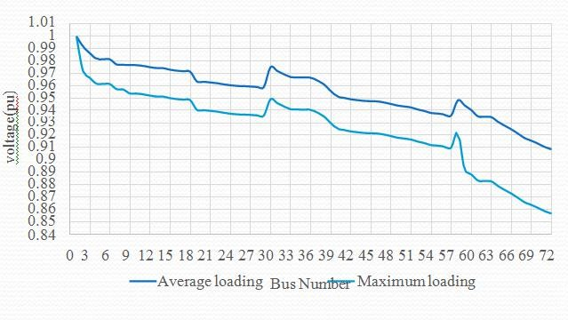

Fig. 1.1. Voltage profile of Begnas Feeder at average and maximum loading

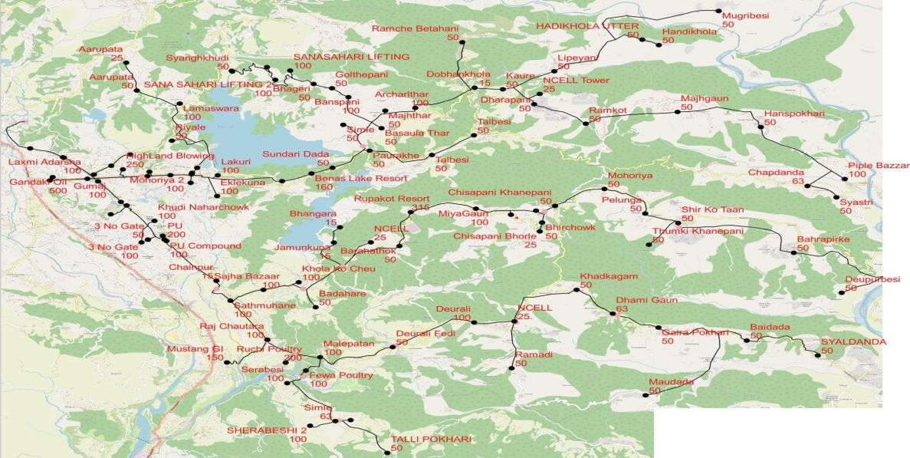

Fig.1.2. GIS Mapping of Begnas feeder [Source: NEA Lekhnath DC]

## Thesis objectives

## General Objective

The prime goal of this thesis is to decrease the Power loss and to improve the voltage. Profile of the 11 kV Begnas feeder and analyze the optimal Size and Location of D- STATCOM for reactive Power Compensation.

## Specific Objectives:

* + - 1. To analyze the voltage profile and power loss of the system.
      2. To identify the candidate nodes for the Placement of D-STATCOM based on Power loss and Voltage profile problem.
      3. To Compare the Power loss and voltage profile results after and Before the Placement of D-STATCOM at Different Load level (Light, medium, Heavy).

## Scope and Limitations

The PSO Algorithm is programmed with MATLAB to seek the optimal Size & locations of STATCOMs at Different Load Level and their nominal values. This power system issues such as losses, reactive power, and its load ability are investigated provides the possibility of simulating and analyzing a variety of cases.

The thesis is restricted on investigation about D-STATCOM impacts on losses ,voltage profile and Financial Analysis only. Issues related with protection of power systems are not considered in this thesis.

The scope and limitation of the study are as follow:

## Scopes:

* Analyzing of the real power loss and voltage profile in primary Distribution lines.
* Analyze Optimum Size & Location of Distribution Static Compensator (D- STATCOM) for Reactive Power Control and its Impact on Distribution Network on Different Load Level (Base, Normal and Peak Load)
* The allocation and size of the D-STACOMs are considering only the power loss and voltage profiles
* Maintain minimum voltage along the feeder near to 1 P.U.
* Reduce loading of branches in feeder.

## Following are the limitations:

* Doesn’t takes into account of the DTR losses and secondary line losses.
* Issues related with harmonics, fault current, protection of power systems have not considered.

## Outline of the Thesis:

For achievement of earlier stated objectives the thesis is arranged within five

**In Chapter 1,** introduction along with problems perceived on distribution feeders are stated in a clear manner. In addition to this the comprehensive objectives, scopes and the methods used for attaining the main objective are summarized.

**Chapter 2** gives a summary of extensive literature reviews. The general theoretical backgrounds are discussed. It discusses about distribution system losses, power flow, distributed generations, and optimization algorithms.

**In Chapter 3,** methodology for the research is proposed which includes system modeling, power flow study and optimization techniques on distribution system performance improvements on power leakage and voltage profiles are considered.

**In Chapter 4,** results and discussions obtained are discussed.

**Lastly, Chapter 5** concludes the work performed and results achieved

# CHAPTER 2: LITERATURE REVIEW

Feeder rearrangements, transformer reallocation, and interconnection of independent power sources at optimal sizing and allocations along radial distribution feeders have been formerly accomplished with shunt power capacitors. Different methods are established and applied using different representing and optimization techniques. The optimization functions specially directed to minimization of power losses raising of installed capacity, control of power factor and improvement of voltage profile. In order to address the issue of voltage improvement and loss minimization in distribution systems, numerous researchers have proposed various solutions. Recent research has shifted away from the traditional usage of capacitors and all of the mentioned techniques in favor of the integration of D-STATCOM into the systems. The optimal DG location and sizing problem has recently received a lot of activity, with numerous algorithms and goals are taken into account.

According to recent study, installing Distribution Compensator (D-STATCOM) in the power network offers several benefits, including an increase in voltage profile and a decrease in power loss on the power network. The size and placement of the D- STATCOM determine how much they enhance the voltage profile together with minimize power system loss. A network's reactive power can be impacted by D- STATCOM in a variety of ways, which allows it to support voltage. However, in order to optimize the voltage profile of the network, this support needs on the strategic positioning and scale of D-STATCOM Finding the ideal D-STATCOM size and placement in the network is therefore essential to maximizing these benefits, as placing D-STATCOM units in the wrong places could compromise system functionality. To address this issue, several algorithms have been created. Here are some evaluations of earlier works to decrease real power losses and enhance the voltage profile.

* Devabalaji kaliaperumal rukamni,[1] proposes an analytical approach for findingoptimal sizing and location of D-STATCOM in RDS using Bio-Inspired Cuckoo search Algorithm.
* Azmerawu Argawu Elende, Mulugeta GebreHiwot GebreMichael [2] used Distribution Network Optimization by Optimal Size and Placement of D- STATCOM using TLBO Optimization Algorithm.
* Temsgen Taye [3] used Different Optimization Technique for Improvement of

Feeder Loss and Voltage Profile.

* Amal Amin, Salah kamel ,Ali Selim and Loai Nasrat [4] had proposed Optimal Placement of D-STATCOM in Radial Distribution Network Using Hybrid Analytical– Coyote Optimization Technique.

In order to maximize D-STATCOM size and location, actual and reactive power losses were taken into account using PSO. To determine the candidate buses for D-STATCOM allocation, real and reactive powers as well as Voltage Stability Index parameters were taken into consideration. Although, the-objective function can be improved by taking into account additional power system components, such as system updating issues.

Each of the research projects mentioned above has benefits and drawbacks of its own. However, this thesis study employs a method that is appropriate for Optimal Size & Placement of D-STATCOMs units to minimize power losses and thus enhance voltage profile.

This design for this Thesis is based on optimal placement and sizing of Distribution Static Compensator (D-STATCOM) incorporated by optimization algorithm. To demonstrate the effectiveness, Matlab software is used and tested on IEEE 69 and 71 bus radial distribution systems (RDS) to derive the locations and sizing of D- STATCOM. The results obtained by the optimization algorithm with the base case infer that the power losses are reduced and improved voltage profiles for the tested distribution systems.

## Overview of Distribution Network:

Distribution systems do duty as the connection between the distribution substation and the customers. Throughout the service area, this system delivers the safe and dependable conveyance of electric energy to a variety of clients. A typical distribution system starts as a medium-voltage three-phase circuit, usually between 30 and 60 KV, and ends at the customer's premises, usually at the meter, at a lower secondary three- or single-phase voltage, usually below 11 kV.

A simple model of radial distribution feeder is as shown in Figure 2.1. Powerlosses occur due to the resistance of distribution lines and other factors.

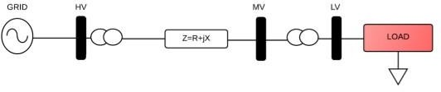

Fig. 2.1. Radial Distribution Network

[Source: IEEE Southeren power Conference 2021]

Voltage drop is increased upon increment of both length and the Load of the feeder. The voltage along a feeder will drop gradually from the substation towardsthe end of the feeder as shown in Figure 2.2.

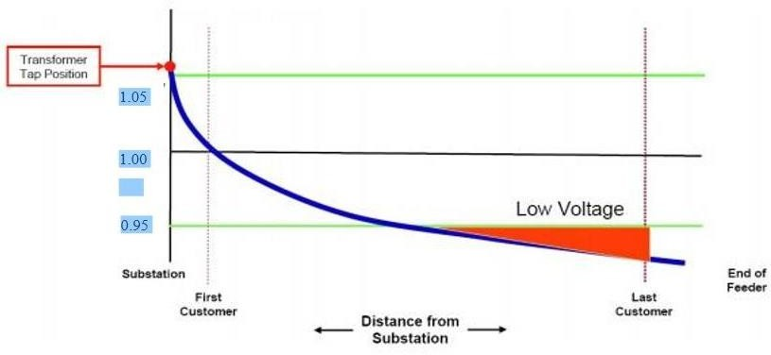

Fig 2.2. Voltage with respect to distance without voltage control on high load. (Source IEEE SPEC 2021 Conference Paper)

## Distribution Static Compensator (D-STATCOM ):

D-STATCOM is a custom power device used mainly for load compensation. It is a fast response solid-state power electronic based shunt controlled voltage source converter (VSC) which inject the current to the utility feeder or nodes in distribution system for the smooth reactive power compensation to improve the power quality in distribution system such as enhancement of the voltage profile and minimization of thepower loss of the distribution system.

* D-STATCOM consists of three phase bus, shunt transformer, VSC and DC Capacitor .
* The output voltage of the D-STATCOM can be controlled according to the requirement of the reactive power since it is a voltage sourced converter.
* Usually, this device is sustained by a DC Energy storage capacitor. It generates the inductive and capacitive reactive power according to the load demand to meet the specifications of utility.

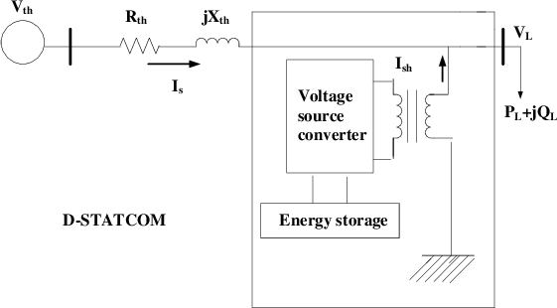

Fig 2.3 Block Diagram of D-STATCOM [Source: IEEE SPEC 2021 Conference paper]

## MODELING OF D_STATCOM

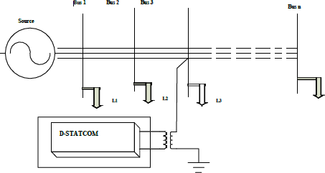

Fig: 2.3.1. Moderling of D_Statcom

[Source: IEEE SPEC 2021 Conference paper]

## D-STATCOM ALLOCATION TECHNIQUE FOR LOSS REDUCTION:

* Devabalaji kaliaperumal rukamni [1] propose an analytical approach for findingoptimal sizing and location of D-STATCOM in RDS using Bio-Inspired Cuckoo search Algorithm.
* Azmerawu Argawu Elende, Mulugeta GebreHiwot GebreMichael [2] used Distribution Network Optimization by Optimal Size and Placement of D- STATCOM using TLBO Optimization Algorithm.
* Temsgen Taye [3] used Different Optimization Technique for Improvement of Feeder Loss and Voltage Profile.
* Amal Amin, Salah kamel ,Ali Selim and Loai Nasrat [4] had proposed Optimal Placement of D-STATCOM in Radial Distribution Network Using Hybrid Analytical– Coyote Optimization Technique.

## Power Loss in Distribution System:

We are aware that some losses have considerable impact on the economy of the electricity system. It is common knowledge that not all of the energy sent to a utility for distribution really reaches the final user. Technical and non-technical losses cause the distribution system to lose a significant quantity of energy. In the power sector, the distribution system is responsible for the majority of technical and non-technical losses.

## Types of power loss

**Technical Losses:**

The physical characteristics of the power system's components are to blame for technical losses in the power system. The power lost in transmission lines and transformers as a result of internal electrical resistance is the most striking example. Technical losses are losses that happen naturally (as a result of internal power system activity) and are mostly caused by power loss in electrical system components such transmission lines, power transformers, measuring systems & etc. Technical losses can be calculated and controlled as long as the relevant power system uses loads in predictable quantities. Technical losses, which include substation, transformer, and line- related losses, happen during transmission and distribution. These include resistive losses in the primary feeders, losses in the core and windings of distribution transformers, losses in the secondary network, losses in service drops, and losses in kWh meters. Electricity distribution entails losses that cannot be minimized.

The nine forms of losses listed below are caused by technical losses, which result from current moving through the electrical network:

**Copper losses:** They result from I2R losses, which are present in all inductors due to the conductors' finite resistance losses that are inherent in all inductors because of the finite resistance of conductors.

**Dielectric losses:** These losses are a result of the conductors' heating effect on the dielectric materials.

**Induction and radiation losses:** The electromagnetic fields surrounding the conductors have caused these losses. Technical losses can be calculated and controlled as long as the relevant power system uses loads in predictable quantities.

The reasons for technical losses are as follows:

* Harmonics distortion
* Inadequate earthing at consumer end.
* Extensive single phase lines.
* Unbalanced loading.
* Overloading and low voltage losses.
* Losses resulting from low standard of equipment.

## Non-Technical Losses:

Non-technical losses on the contrary are those that are brought on by events outside the power system or by loads and circumstances that the technical losses calculation did not account for. Non-technical losses are more challenging to quantify since system operators frequently fail to account for them, leaving no records of them. On the other side, non-technical losses (NTL) stem from theft, inaccurate metering, and unmetered electricity.

## Measures for reducing technical losses:

Identification of the weakest areas in the distribution system and improving them reduced the length of LT lines by the installation of more distribution transformers or the relocation of distribution substations (DTs).Installing smaller capacity distribution transformers at each consumer location rather than forming clusters and replacing DTs with those that have reduced no load losses, like amorphous core transformers.

* + - * + Shunt capacitors installation in order to improve power factor.
        + Integration of D-STATCOM with the purpose of reducing power loss.

## Power flow/Load Flow:

There are numerous methods for solving load flow calculations. However, a load flow technique that is considered acceptable must adhere to certain standards, including fast speed, minimal storage needs, high reliability, and generally accepted adaptability and simplicity .power transfer from generators to consumers via the grid system. The load flow problem is typically solved iteratively using the Gauss-Seidel method. A key prerequisite for power system research is load flow analysis.

For radial feeder Backward –forward Sweep Method is used for load flow.

## Calculation of load current

The load current at any bus is given as:

ILn= ( Pn-jQn)/ Vn Where n=1,2 ….N …. (1) where,

IL= Load Current

N= total. No. of buses Pn= Active power Qn= Reactive power Vn= Bus Voltage

## Backward Forward Sweep Method:

The relation between load current and branch current can be found by using KCL equation. The matrix can Written as:

[IB]= [BIBC] [IL] … (2)

Where,

IB= Branch Current

BIBC= Bus injection to Branch Current Matrix

Forward sweep algorithm is used to calculate the voltage at each bus starting from branches from first layer to last layer. Backward Sweep algorithm is used to calculate the branch current starting from the last layer towards the branches connected to root node.

Vn (K)= Vm(K)-IB(K)*Zm(K) …(3)

Where,

K=1, 2,…..Nb

Nb= total no. of. Branches= N-1

Vn (K) = receiving end Voltage Vm (K) = sending end Voltage.

The power flow is calculated using backward and forward propagation using iterations. The forward sweep will provide the voltage magnitudes whereas the backward propagation provides the power of each branch. The iterative method has fast convergence as compared to conventional methods. The results for IEEE 69 bus test system are calculated for this Thesis. It is concluded that the following load flow method is an efficient method for fast convergence tendency in radial distribution networks.

## Optimization Technique (PSO):

Particle swarm optimization is a computational method that optimizes a problem by iteratively trying to improve a candidate solution with regard a given measure of quality.

Update velocity:

Vik+1=c*[wvik+c1r1*(Pbest- Sik)+c2r2*(Gbest- Sik)] Update position:

Sik+1=Sik+ Vik+1

Where,

w= weighting coefficient

c1, c2=acceleration coefficient

r1, r2= random numbers between 0 and 1 which can change the speed and accuracy of algorithm.

Pbest= best position that has been found by ith iteration to kth iteration Gbest=best position of all particles

The main advantages of the PSO algorithm are summarized as: simple concept, easy implementation, robustness to control parameters, and computational efficiency when compared with mathematical algorithm and other heuristic optimization techniques.

# CHAPTER 3: METHODOLOGY

This section discusses the methods and case studies used in this thesis to evaluate the system performance. The power flow along with the optimization technique applied throughout the thesis are programmed and simulated in Matlab software.

## Case Study:

The thesis has been done in Begnas feeder line. This feeder line is located in Lekhnath distribution systems. This feeder is modeled as 72 nodes and 71 segments. It has 68 loads total capacity of 2.611 MW capacities. Total demand of the feeder is supplied from the substation located at Pokhara-26 Kharanephant. The loads associated to one section are placed at the end of each segment. The Lekhnath substation which receives power from Bharatpur substation and Lekhnath Kaligandaki Substation has a 132/11KV transformer from which four 11KV primary distribution line are originated. These feeder are Begnas, Kalika, Khaireni and Budibazar. Among these feeder Begnas feeder experiences high power loss and voltage deviation problem due to its long length.

The distribution network feeder line has drawn in Figure 3.1 this has been done for the ease of analysis. Low voltage profile buses and locations influenced by loss can be plainly pictured in the course of evaluation.

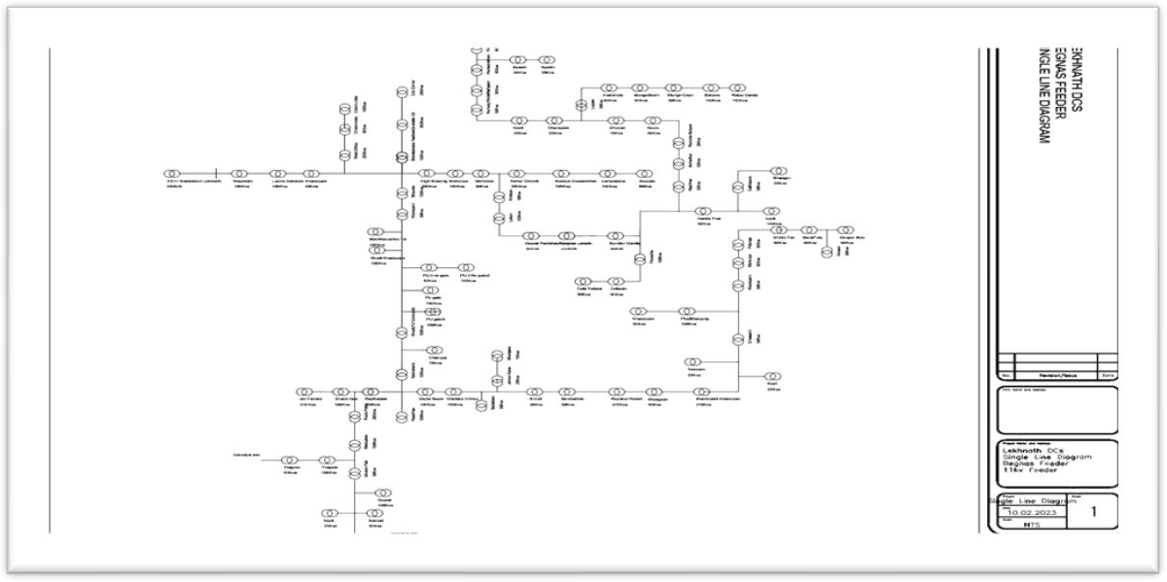

Fig. 3.1: SLD of 11kV Begnas Line of Lekhnath Substation

Radiating through the nodes are the loads supplied by the transformers. The power line is radiated through the substation (node number 1). Power flow of the feeder originates at the substation point (node 1) to the branches of the radially distributed network.

The existing power distribution in Lekhnath Area is of radial distribution system nature. Consumer receives power beginning with the source substation in a straightforward fashion. In that area no loops and interconnection or mesh type network topology exists. However radial distribution network is economical with regard to configuration along with protection, but is exposed to perturbation thus being little reliable. From all the outgoing feeders, Begnas feeder has recorded low voltage profile at its different buses.

## Collection of Data:

* Selection of available IEEE bus test system which is suitable to portray a low voltage distribution feeder and its problem literature review to solve the problem. IEEE 69 bus test system has been chosen for this work.
* Collection of data (voltage level, resistance, reactance, loading and its line configuration) of selected IEEE 69 bus test system and finding the low voltage point and their values at Light, Normal and Peak Load.
* Collection of real feeder data (Substation feeder data, voltage level, resistance and reactance of line, daily monthly and annual loading condition, load and its line configuration) of 11 kV Begnas feeder and finding the low voltage point, nodes and their values at different location from DTR installed, HT metering unit, TOD meter installed in substation and industries

## Load Modeling:

The load in the system is modeled as constant real (P) and reactive (Q) power load.

## Design Details:

This design is based on optimal placement and sizing of Distribution Static Compensator (D- STATCOM) incorporated by optimization algorithm. To demonstrate the effectiveness, Matlabsoftware is used and tested on IEEE 69 and 71 bus radial distribution systems (RDS) to derivethe locations and sizing of D-STATCOM. The result obtained by the optimization algorithm with the base case infers that the power losses are reduced and improved voltage profiles for the tested distribution systems.

i

The objective function of reduce the power loss, F (k) = min ∑br

i=1

Ri ∗ I2

## Load Details of Begnas Feeder

* The daily load curve at the peaking day has been drawn with the help of dailylog sheet taken from the Pokhara Grid Lekhnath Substation.
* The average demand load curve for a whole year has been drawn with the help of daily load curve at peaking day of separate 12 months.
* The average peak load of the Begnas feeder in Year Mangsir 2079 is 4155.77 KVA at 7:00 PM and average annual demand is 2611.43 KVA.

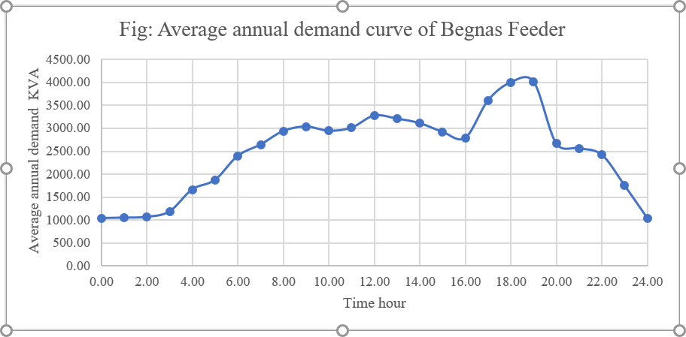

Fig. 3.2: Demand Curve of Begnas feeder

* + The peak load of this feeder at the date of Mangsir 01 079 B.S is 4461.58 kVA at 7:00 PM.
  + The load during morning and early night are almost same and minimum. The demand is being increased during the evening time from 5:PM to 8:PM. Because domestic loads occurs in these period.
  + This feeder contains 71 number of transformer with total installed capacity 7225 kVA.
  + Average load of Year 2079 on the basis of 12 peaking day of 12 months is taken as reference for load flow analysis in this thesis.
  + From the load profile it is found that average maximum percentage loading in the feeder is 50 % of the total capacity of distribution transformer. So every distribution transformer is loaded to 50 % of its capacity and here afterit is the 100% loading on the feeder and is considered as the base load for study in this thesis.
  + The combined power factor of the feeder is found to be around 0.856 Total active and reactive power load is 2611.20 kW and 1794.58 kVAR respectively for load flow analysis.

i

The objective function to reduce the power loss, F (k) = min ∑br

i=1

Ri ∗ I2

## Proposed Methodology:

This Thesis makes an effort to follow optimization algorithm for optimal sizing and placement of D-STATCOM for reactive power control of Distribution system (11 kV Begnas feeder) and IEEE 69 Bus System for Different Load level (Light, Medium, And Peak Load).

The first condition has aimed to find the best optimal D-STATCOM sizing and placement by using PSO with IEEE 69 Bus System And new best system at Light, Medium and Peak Load.

Moreover, the algorithms have been used to manage the randomly generated switching condition in the D-STATCOM sizing.

## Optimal Location of D-STATCOM Based on Voltage Stability Index (VSI)

In order to restrict solution space to a few buses, voltage sensitive nodes are first identified by penetrating DSTATCOM with the total feeder loading capacity at each node at a Different Load Level and then, calculating the voltage stability index.

(VSI) using When D-STATCOM is connected at bus (t), VSI for bus (t) is defined as in fig & Eqn. Below.

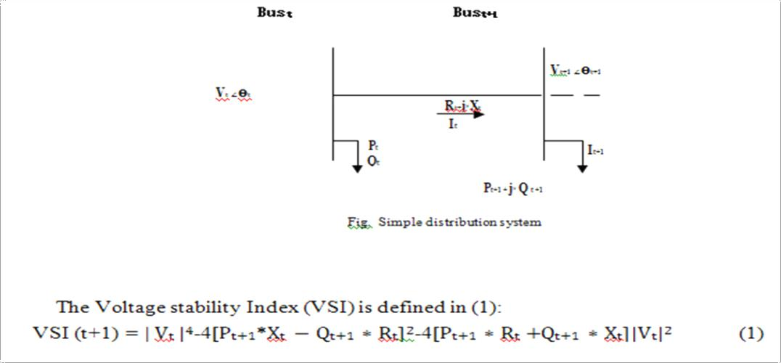

[Source IEEE SPEC Conference 2021 ]

* The D-STATCOM is placed at the node with least VSI

## To determine the optimal size of D-STATCOM, the following steps are taken.

* *First, the D-STATCOM is placed at the node with least VSI.*
* Keeping the power factor of D-STATCOM constant, its size is varied from a minimum value to a value equal to feeder loading capacity inconstant steps until the minimum system loss is found.
* The D-STATCOM size which results in minimum loss is taken as optimal.

## Particle Swarm Optimization (PSO) Fitness Function:

Particle swarm optimization (PSO) is a computational method that optimizes a problemby iteratively trying to improve a candidat[e](https://en.wikipedia.org/wiki/Candidate_solution) solution with regard to a given measure of quality. It solves a problem by having a population of candidate solutions, here dubbed particles, and moving these particles around in the [search](https://en.wikipedia.org/wiki/Optimization_(mathematics))-[space](https://en.wikipedia.org/wiki/Optimization_(mathematics)) according to simple [mathematical](https://en.wikipedia.org/wiki/Formula) formula over the particle's position and velocity. Each particle's movement is influenced by its local best known position, but is also guided toward the best known positions in the search-space, which are updated as better positions are found by other particles. This is expected to move the swarm toward the best solutions.

In this Thesis, the objective function has been represented as power loss in the distribution.

* The number of objective functions has been used for the performance calculation of a Radial distribution system (RDS) by using D-STATCOM sizes and location planning. Themain goal of this work is to deal with the technical issues and achieve improvement accordingly.
* A Particle Swarm Optimization algorithm for finding the optimal location and sizing ofD-STATCOM with the aim of reducing the total power loss along with voltage profile improvement of Radial Distribution System is proposed in this Thesis.

The PSO approach for solving optimal sizing of DSTATCOM to minimize the power loss and to improve the voltage profile takes the following steps:

* **Step1**: Get the inputs which are the line impedance and the bus data.
* **Step2:** Initially [nop x n] number of particles are generated where nop is the number of population and n is the number of DSTATCOOM devices.
* **Step3:** Generate initial [nop x n] number of velocities randomly between the limits. Iteration count is 1.
* **Step4:** load flow analysis is performed by placing all the n DSTSATCOM devices at the particular candidate locations and power losses P DSTATCOM are calculated. Same procedure is repeated for nop (number of particles) to find the total real power loses.
* **Step5:** for maximum loss reduction fitness function can be calculated by the following formula:

Fitness FA= PL- P DSTATCOM

* + **Step6:** the current iteration count is incremented, if the iteration count not reaches maximum then go to step5.

**Step7:** gbest fitness and the gbest particle give maximum loss reduction and optimal sizes of DSTATCOM respectively.

## Problem Formulation

The objective of the optimal placement and sizing of D- STATCOM is to minimize the total power loss in the distribution network with voltage profile improvement.

Min f = min (PT Loss) CONSTRAINTS:

The reactive power injected by D-STATCOM to the system is limited by upper and lower bounds given

Qmin≤ QD-STATCOM≤ Qmax

The system voltage in all buses should be an acceptable range Vmin ≤ Vi ≤Vmax Vi is the voltage of ith bus and i bus varies from 1 to number of buses.

## : Overall Block Diagram Process



11kV

Begnas feeder with significan t power losses and low voltage problem

Run load flow and get result

Compu te VSI factor at each node to find most sensiti ve bus

Get the optimized size of DSTATC

OM with iterative computati on for various cases

Simulate distribution feeder with optimized size and location in Matlab

Get the result with reduced power losses and improved voltage for Various cases

Fig. 3.3 Overall block diagram of process:

Input line and bus data of feeder, and set bus voltage limits. Backward and forward load flow analysis is selected to compute all the required parameters in the existing distribution system. Run load flow analysis to get voltage stability index analysis for each node and determine optimal position & most sensitive bus. Using PSO Optimization Algorithm, Get the optimized size of D-STATCOM with iterative computation for various cases till minimum power loss is achieved for each case.

## Flowchart:

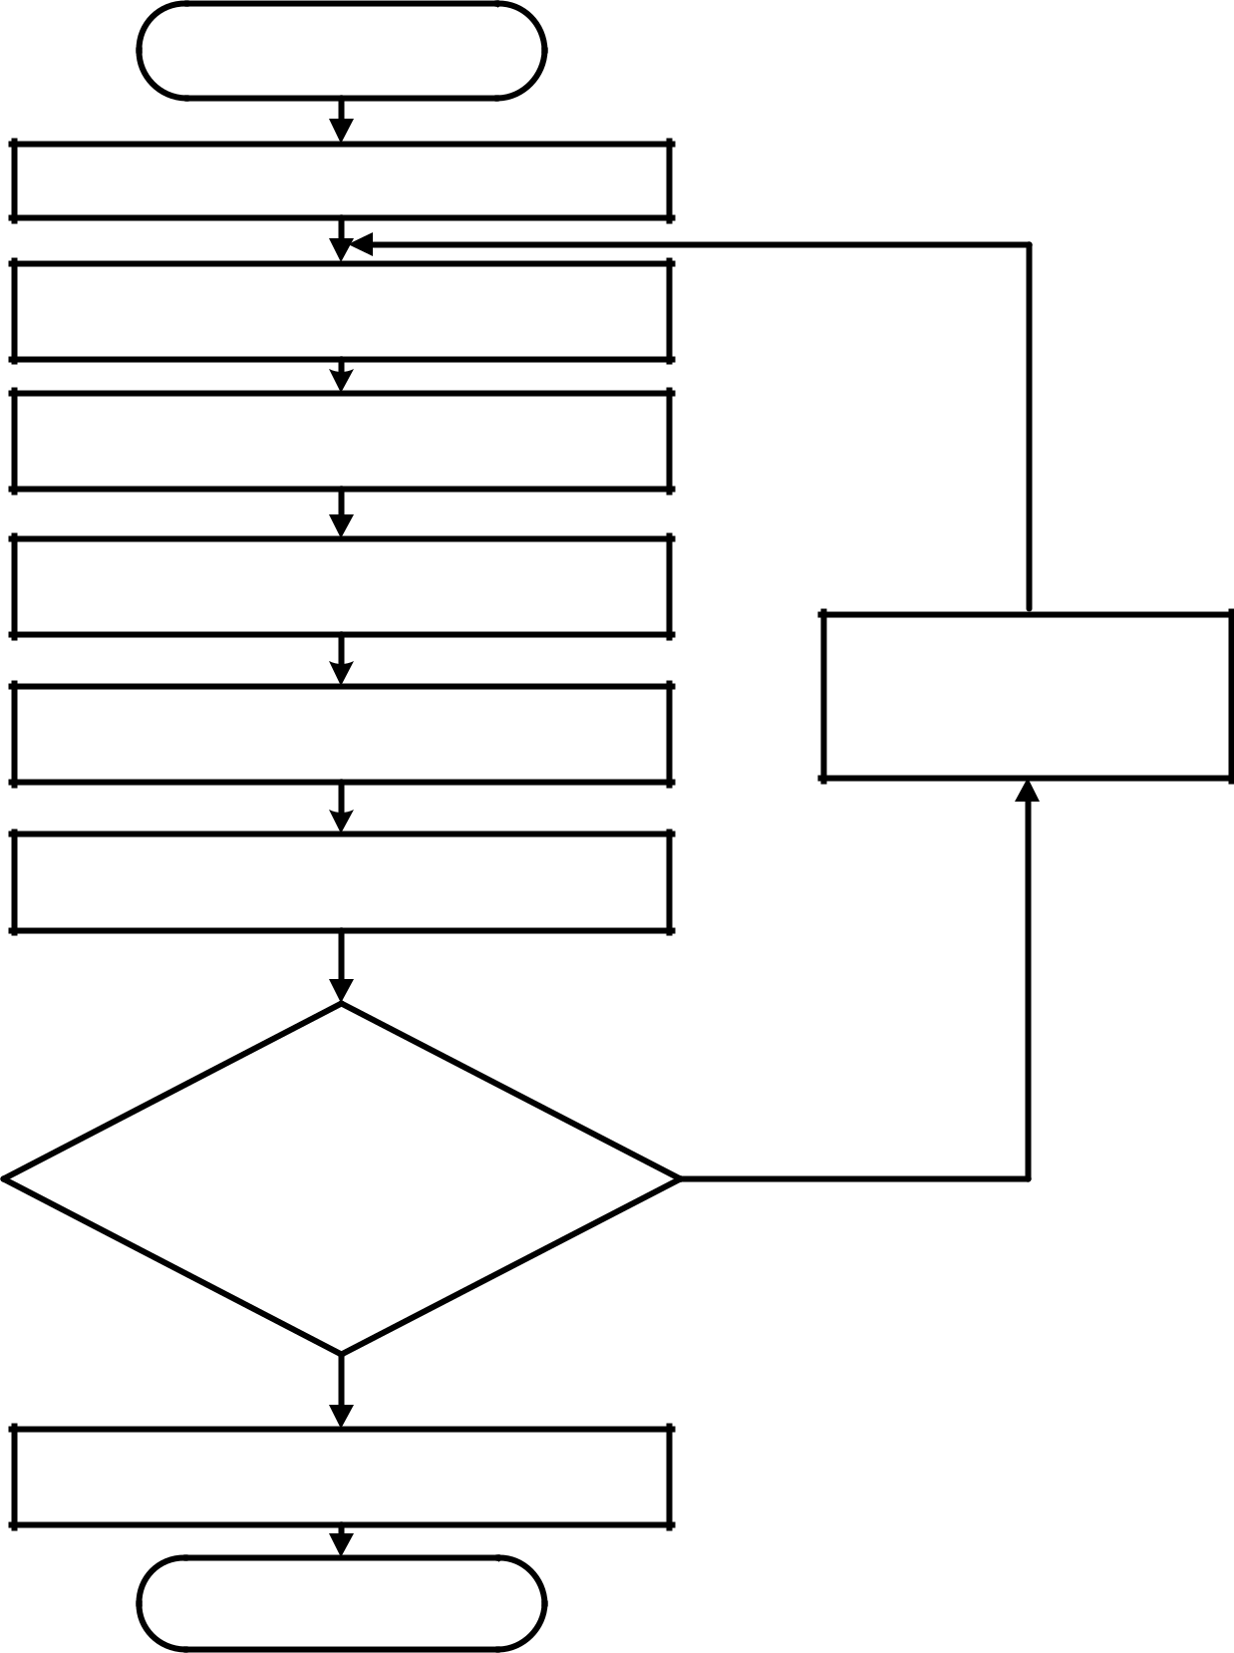

**Start**

**Run base case load flow and determine losses and**

**Find VSI and identify optimal position**

**Select the No. of D-STATCOM and its power factor**

**Place at respective location**

**Calculate the size of the first single D-Statcom using PSO method & Backward forward Load flow**

**Update the network by allocating the first D-STATCOM at its appropriate place**

**Calculate losses and Voltage profiles**

**No**

**Optimum solution?**

**Yes**

**Stop & Print Results**

**End**

Fig: 3.4 Flowchart to find optimal size and location of D-STATCOM

## Algorithm for optimal size and placement of D-STATCOM for radial distribution system is given below:

**Step 1:** Input line and bus data, and set bus voltage limits.

**Step 2:** Calculate the power loss using backward-forward sweep in distribution system. **Step 3:** Randomly produces an initial population of particles with random positions and velocities on volume in the solution space.

**Step 4:** For each and every particle if the bus voltage is within the limits in each particle, calculate transmission loss or, that particle is infeasible.

**Step 5:** For each particles, analyze its objective value with the individual best. If the objective value is lower than P best, set this value as the current P best, and note the corresponding particle position.

**Step 6:** Update the velocity and position of particle respectively.

**Step 7:** If the iteration number attains the maximum limit, go to Step8 Or set iteration i = i+ 1, and go back to Step 4.

**Step 8:** Print the optimal solution to the target problem. The best position includes the optimal locations and size of D-STATCOM, and the corresponding fitness value representing the minimum power loss

# CHAPTER 4: RESULTS AND DISCUSSION

## Introduction

In this chapter, the outcomes obtained using load flow and VSI methods are presented. At last the improvements from the optimization are also presented. The consequences are represented in plot and table form. The algorithm sketched within the preceding chapter is carried out and programmed in Matlab software. The major codes programmed following the execution procedures of the put forwarded algorithm are presented. The results are analyzed for many situations based (Light, Medium & Heavy Load) on the test bus system being examined, the type of DSTATCOM being appropriately allocated, and ratings. Various analogies are performed to express the network losses reduction together with upgrading voltage profile with reference to several Cases for D-STATCOM Location and Sizes. At last Financial Analysis before Compensation and after Compensation of D-STATCOM is done and analysis of annual saving and Payback Period is also done.

## IEEE 69 Bus Results

* + 1. **Voltage Profile & Active Power Loss for IEEE 69 Bus Systems with Light Load Model:**

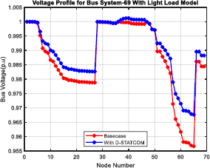

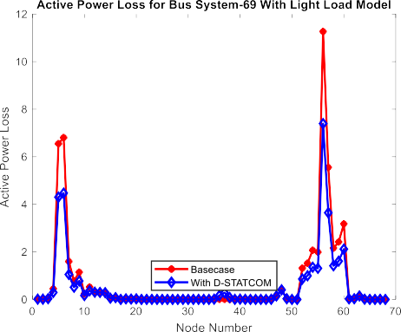

Fig: 4.1 Voltage Profile for Light Load Model Fig: 4.2 active Power Loss for Light Load Model

## Reactive Power loss & Performance of PSO for IEEE 69 Bus Systems with Light Model

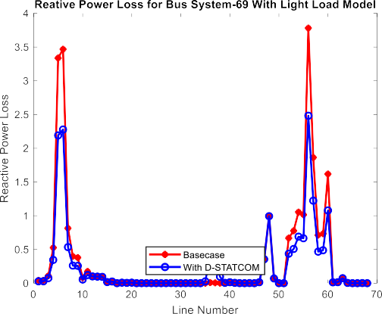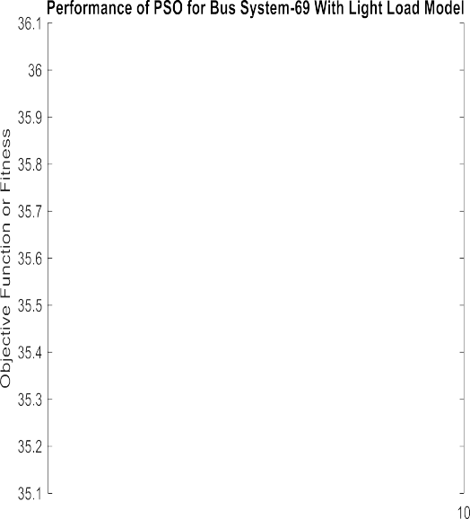

Fig: 4.3 Reactive Power Losses with Light Load Model Fig: 4.4 PSO Performances with Light Load Model

Table 1: IEEE 69 Bus Systems Result with Light Model

|  |  |  |
| --- | --- | --- |
| Parameters | Light Load-0.5 | |
| Base case | PSO |
| Active Power loss(kw) | 13.5732 | 12.4559 |
| Reactive Power Loss(kvar) | 4.44 | 4.42 |
| Minimum Voltage(p.u) | 0.98123 | 0.98134 |
| Maximum Voltage(p.u) | 0.99844 | 0.99845 |
| DSTATCOM Location Bus No: | - | 39 -20- 2 |
| DSTATCOM Size (kVAR) | - | 427-402- 885 |
| Active Power Loss(%) | - | 8.23166 |
| Reactive Power Loss(%) | - | 5.20931 |

## Voltage Profile & Active Power Loss for IEEE 69 Bus Systems with Medium Load Model:

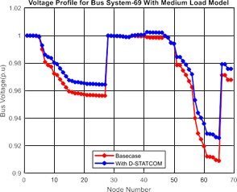

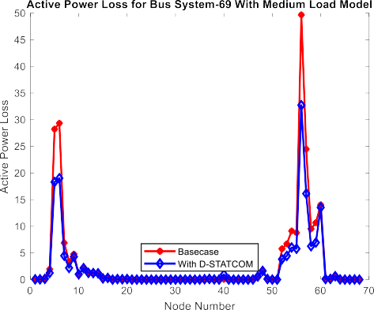Fig: 4.5 Voltage Profile for IEEE 69 Bus Systems for medium Load Model

|  |  |  |  |  |  |  |  |  |
| --- | --- | --- | --- | --- | --- | --- | --- | --- |
|  |  |  | |  |  | |  |  |
|  |  |  | |  |  | |  |  |
|  |  |  | |  |  | |  |  |
|  |  |  | |  |  | |  |  |
|  |  |  | |  |  | |  |  |
|  |  |  | |  |  | |  |  |
|  |  |  | |  |  | |  |  |
|  |  |  | |  |  | |  |  |
|  |  |  |  |  |  |  |  |  |
|  | | |
|  |  |  |  |  |  |

Fig: 4.6 Active for IEEE 69 Bus Systems for medium Load Model

## Reactive Power loss & Performance of PSO for IEEE 69 Bus Systems with Medium Load Model

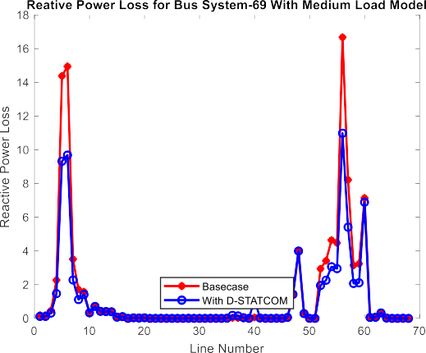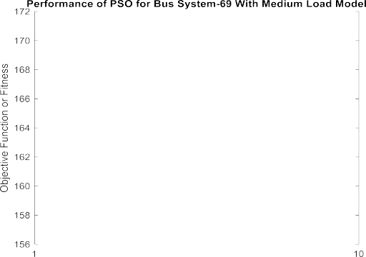

Fig: 4.7 Reactive Power Losses With Medium Fig: 4.8 Performance of PSO with Medium Load Model Load Model

Table 2: IEEE 69 Bus Systems Result with Medium Load Model

|  |  |  |
| --- | --- | --- |
| Parameters | Medium Load-1 | |
| Base case | PSO |
| Active Power loss(kw) | 55.8503 | 45.3923 |
| Reactive Power Loss(kVAR) | 18.29 | 14.5 |
| Minimum Voltage(p.u) | 0.96164 | 0.96197 |
| Maximum Voltage(p.u) | 0.99683 | 0.99685 |
| DSTATCOM Location Bus No: | - | 72 -43- 70 |
| DSTATCOM Size (kVAR) | - | 850-445- 345 |
| Active Power Loss(%) | - | 18.7251 |
| Reactive Power Loss(%) | - | 20.7583 |

## : Voltage Profile & Active Power Loss for IEEE 69 Bus Systems with Heavy Load Model:

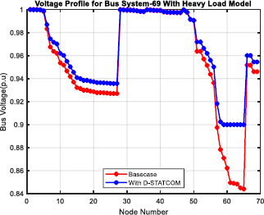

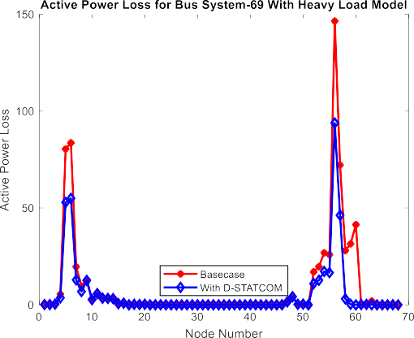Fig. 4.9 Voltage Profile for Heavy Load

|  |  |  |  |  |  |  |
| --- | --- | --- | --- | --- | --- | --- |
|  |  |  |  |  |  |  |
|  |  |  |  |  |  |  |
|  |  |  |  |  |  |  |
|  | | |

Fig: 4.10 Active Power Loss for Heavy Load Model

## Reactive Power loss & Performance of PSO for IEEE 69 Bus System with Heavy Load Model:

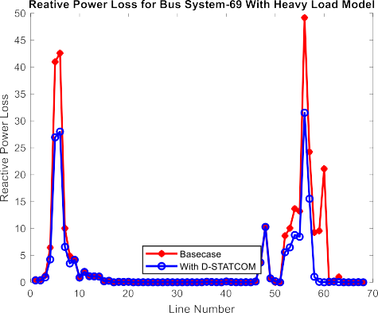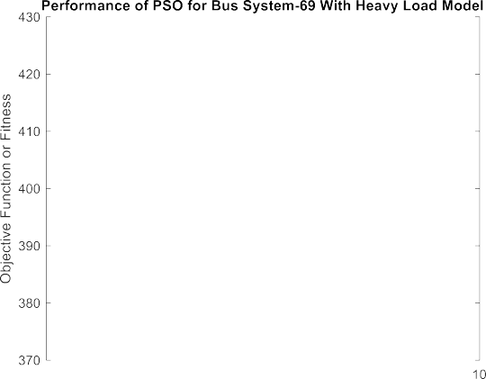

Fig: 4.11 Reactive Power Loss with Heavy Fig: 4.12 PSO Performances with Heavy Load Model Load Model

Table 3: IEEE 69 Bus System Result with Heavy Load Model

|  |  |  |
| --- | --- | --- |
| Parameters | Heavy Load-1.6 | |
| Base case | PSO |
| Active Power loss(kw) | 148.2175 | 112.6237 |
| Reactive Power Loss(kVAR) | 48.55 | 36.59 |
| Minimum Voltage(p.u) | 0.93692 | 0.93798 |
| Maximum Voltage(p.u) | 0.99481 | 0.99489 |
| DSTATCOM Location Bus No: | - | 23- 58 - 62 |
| DSTATCOM Size (kVAR) | - | 406 -593- 235 |
| Active Power Loss(%) | - | 24.0146 |
| Reactive Power Loss(%) | - | 24.6335 |

## Performance & Evaluation of before and after Compensation at all Load Levels for IEEE 69 Bus Systems:

Table 4: Performance & Evaluation of before and after Compensation at all Load Levels for IEEE 69 Bus Systems

|  |  |  |  |  |  |  |
| --- | --- | --- | --- | --- | --- | --- |
| Parameters | Light Load-0.5 | | Medium Load-1 | | Heavy Load-1.6 | |
|  | Base case | PSO | Base case | PSO | Base case | PSO |
| Active Power loss(kW) | 13.5732 | 12.4559 | 55.8503 | 45.3923 | 148.2175 | 112.6237 |
| Reactive Power  Loss(kVAR) | 4.44 | 4.42 | 18.29 | 14.50 | 48.55 | 36.59 |
| Minimum Voltage(p.u) | 0.98123 | 0.98134 | 0.96164 | 0.96197 | 0.93692 | 0.93798 |
| Maximum Voltage(p.u) | 0.99844 | 0.99845 | 0.99683 | 0.99685 | 0.99481 | 0.99489 |
| DSTATCOM  Location Bus Number | - | 39 -20-2 | - | 72-43-70 | - | 23- 58-62 |
| DSTATCOM  Size(kVAR) | - | 427- 402-885 | - | 850-445-345 | - | 406-593-235 |
| Active Power Loss (%) | - | 8.23166 | - | 18.7251 | - | 24.0146 |
| Reactive Power Loss (%) | - | 5.20931 | - | 20.7583 | - | 24.6335 |

Upon summarizing the results for **IEEE 69** bus systems For Light Load Case the Active Power loss is Found to be **13.5732** KW for Base Case While Using PSO Active Power loss Reduced to **12.4559** KW , Similarly Reactive Power Loss is Reduced to **4.44** kVAR to **4.42** kVAR From Base Case to PSO. Minimum Voltage is increased from **0.98123** to **0.98134** P.U From Base Case to PSO, While Maximum Voltage is Increased from **0.99844** to **0.99845** P.U from Base Case to PSO. The Optimal Location of Bus Number for D-STATCOM is Found to be **39, 20 & 2th** Bus .The Size of D-STATCOM is found to be **427** kVAR for **39th** Bus, **402** kVAR for **20th** and **885** kVAR for **2nd** Bus with Having total Size of 3 no’s D-STATCOM **1714** kVAR. The Percentage of reduction in Active Power Loss is Found to be **8.23%** while in Reactive Power Loss is found to be **5.20%**

Similarly For **IEEE 69** bus systems for Medium Load Case the Active Power loss is Found to be **55.8503** KW for Base Case While Using PSO Active Power loss Reduced to **145.3923** KW, Similarly Reactive Power Loss is Reduced to **18.29** kVAR to **14.50** kVAR From Base Case to PSO, Minimum Voltage is Increased from **0.96164** to

**0.961974** P.U From Base Case to PSO, While Maximum Voltage is Increased from **0.99683** to **0.99685** P.U From Base Case to PSO. The Optimal Location of Bus Number is Found to be **72, 43 & 70th** Bus .The Size of D-STATCOM is found to be **850** kVAR for **72th** Bus, **445** kVAR for **43th** and **345** kVAR for **70th** Bus with Having total Size of 3 no’s D-STATCOM **1640** kVAR . The Percentage of reduction Active Power Loss is found to be **18.72%** while in Reactive Power Loss is found to be **20.75**%.

Similarly for **IEEE 69** bus system Heavy Load Case the Active Power loss is Found to be **142.21** KW for Base Case While Using PSO Active Power loss Reduced to **112.6237** KW , Similarly Reactive Power Loss is Reduced to **48.55** kVAR to **36.59** kVAR From Base Case to PSO ,Minimum Voltage is Increased from **0.93692** to **0.93798** P.U From Base Case to PSO, While Maximum Voltage is Increased from **0.99481** to **0.996489** P.U From Base Case to PSO . The Optimal Location of Bus Number is Found to be **23, 58 & 62th** Bus .The Size of D-STATCOM is found to be **406** kVAR for **23th** Bus, **593** kVAR for **58th** and **235** kVAR for **62th** Bus with Having total Size of 3 no’s D-STATCOM **1234** kVAR. The Percentage of reduction Active Power Loss is found to be **24.01%** while Percentage of reduction in Reactive Power Loss is found to be **24.63%.**

## Begnas Feeder Results:

* + 1. **Voltage Profile & Active Power Loss for 11 kV Begnas 72 Bus System With Light Load Model:**

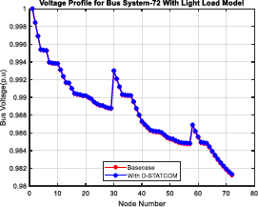

Fig 4.13 Voltage profile of 11 kV begnas 72 buses for Light load Mode

|  |  |  |  |  |  |  |  |
| --- | --- | --- | --- | --- | --- | --- | --- |
|  |  |  |  |  |  |  |  |
|  |  |  |  |  |  |  |  |
|  |  |  |  |  |  |  |  |
|  |  |  |  |  |  |  |  |
|  |  |  |  |  |  |  |  |
|  |  |  |  |  |  |  |  |
|  |  |  |  |  |  |  |  |
|  |  |  |  |  |  |  |  |
|  |  |  |  |  |  |  |  |

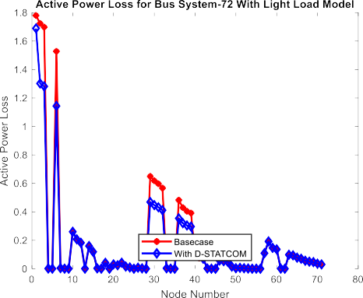Fig 4.14 active Power loss of 11 kV begnas 72 buses for Light load

## Reactive Power loss and Performance of PSO for 11 kV Begnas 72 Bus System with Light Load Model:

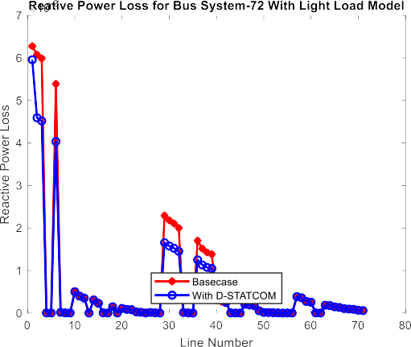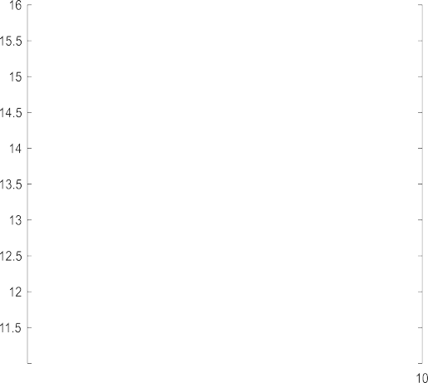

Fig 4.15 Reactive Power loss for Fig 4.16 Performances of PSO for Light load Light load

Table 5: 11 kV Begnas 72 Bus System with Light Load Model

|  |  |  |
| --- | --- | --- |
| Parameters | Light Load-0.5 | |
| Base case | PSO |
| Active Power loss(kw) | 51.5971 | 35.1676 |
| Reactive Power Loss(kvar) | 23.5472 | 17.0222 |
| Minimum Voltage(p.u) | 0.95664 | 0.96763 |
| Maximum Voltage(p.u) | 0.99998 | 1.0012 |
| DSTATCOM Location Bus Number | - | 40 -61- 12 |
| DSTATCOM size (kVAR) | - | 702 691 236 |
| Active Power Loss(%) | - | 31.8419 |

|  |  |  |
| --- | --- | --- |
| Reactive Power Loss(%) | - | 27.7102 |

## Voltage Profile & Active Power Loss for 11 kV Begnas 72 Bus System with Medium Load Model:

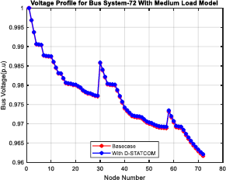

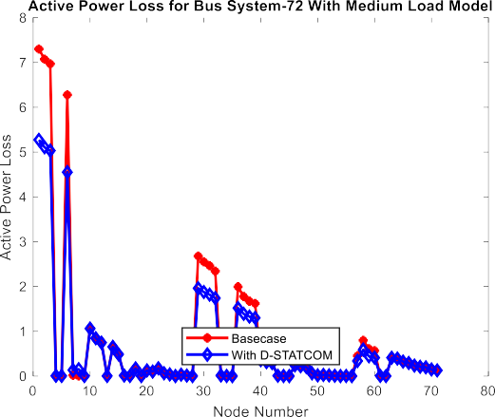Fig 4.17 Voltage profile of 11 kV begnas 72 buses for Medium load Model

|  |  |  |  |  |  |  |  |
| --- | --- | --- | --- | --- | --- | --- | --- |
|  |  |  |  |  |  |  |  |
|  |  |  |  |  |  |  |  |
|  |  |  |  |  |  |  |  |
|  |  |  |  |  |  |  |  |
|  |  |  |  |  |  |  |  |
|  |  |  |  |  |  |  |  |
|  |  |  |  |  |  |  |  |
|  |  |  |  |  |  |  |  |

Fig 4.18 Active Power Loss e of 11 kV begnas 72 buses for Medium load Model

## Reactive Power loss and Performance of PSO for 11 kV Begnas 72 Bus System with Medium Load Model

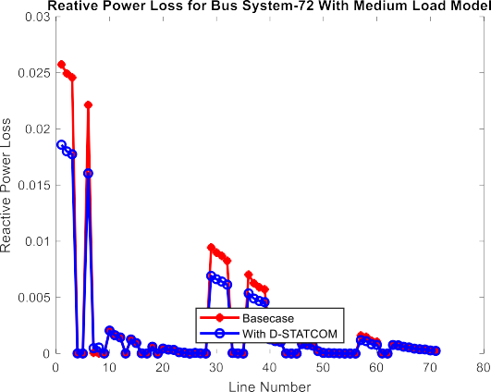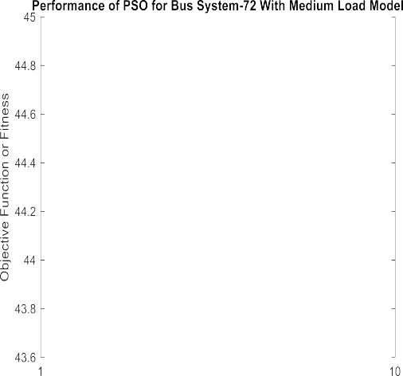

Fig 4.19 Reactive Power loss for Fig 4.20 Performance of PSO for Medium Load Medium Load

Table 6: 11 kV Begnas 72 Bus System with Medium Load Model

|  |  |  |
| --- | --- | --- |
| Parameters | Medium Load-1 | |
| Base case | PSO |
| Active Power loss(kw) | 224.9606 | 157.6823 |
| Reactive Power Loss(kVAR) | 102.147 | 73.8842 |
| Minimum Voltage(p.u) | 0.90901 | 0.92568 |
| Maximum Voltage(p.u) | 0.99997 | 1.0026 |
| DSTATCOM Location Bus Number |  | 60- 41- 10 |
| DSTATCOM size (kVAR) | - | 908 -512 - 983 |
| Active Power Loss(%) | - | 29.9067 |
| Reactive Power Loss(%) | - | 27.6688 |

## Voltage Profile & Active Power Loss for 11 kV Begnas 72 Bus System with Heavy Load Model:

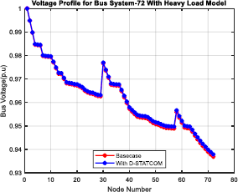

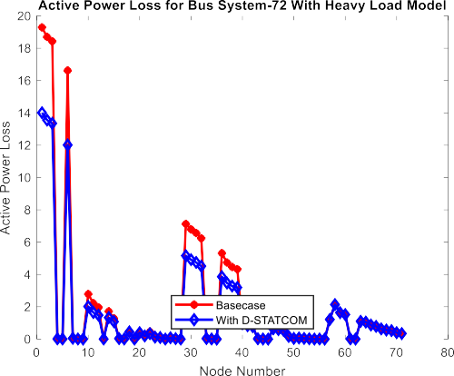Fig 4.21 Voltage Profile of 11 kV begnas 72 buses for Heavy Load

|  |  |  |  |  |  |  |  |
| --- | --- | --- | --- | --- | --- | --- | --- |
|  |  |  |  |  |  |  |  |
|  |  |  |  |  |  |  |  |
|  |  |  |  |  |  |  |  |
|  |  |  |  |  |  |  |  |
|  |  |  |  |  |  |  |  |
|  |  |  |  |  |  |  |  |
|  |  |  |  |  |  |  |  |
|  |  |  |  |  |  |  |  |
|  |  |  |  |  |  |  |  |
|  |  |  |  |  |  |  |  |

Fig 4.22 Active Power Loss of 11 kV begnas 72 buses for Heavy Load

## Reactive Power loss and Performance of PSO for 11 kV Begnas 72 Bus System with Heavy Load Model

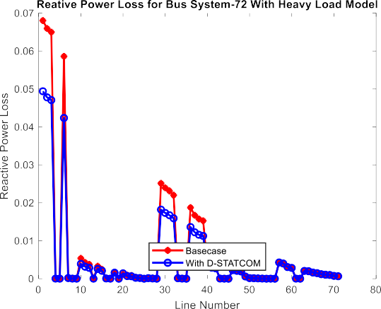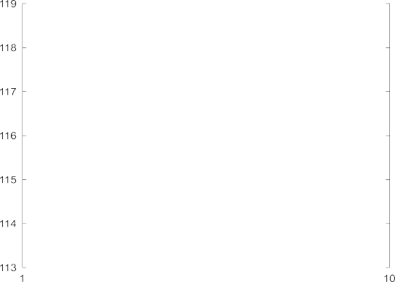

Fig 4.23 Reactive Power Loss for Heavy Fig 4.24 Performances of PSO for load Model Heavy load

Table 7: 11 kV Begnas 72 Bus System with Heavy Load Model

|  |  |  |
| --- | --- | --- |
| Parameters | Heavy Load- 1.6 | |
| Base case | PSO |
| Active Power loss(kw) | 652.41 | 373.7844 |
| Reactive Power Loss(kVAR) | 294.206 | 175.1404 |
| Minimum Voltage(p.u) | 0.84398 | 0.95 |
| Maximum Voltage(p.u) | 0.99994 | 0.99996 |
| DSTATCOM Location Bus Number | - | 63 -51- 60 |
| DSTATCOM size (kVAR) | - | 591 -836- 837 |
| Active Power Loss(%) | - | 42.7071 |
| Reactive Power Loss(%) | - | 40.4702 |

## Performance & Evaluation of Before and after Compensation at all Load Levels For 11 Kv Begnas 72 Bus System

Table 8: Performance & Evaluation of Before and after Compensation at all Load Levels For 11 Kv Begnas 72 Bus System

|  |  |  |  |  |  |  |
| --- | --- | --- | --- | --- | --- | --- |
|  | Light Load-0.5 | | Medium Load-1 | | Heavy Load-1.6 | |
| Parameters | |  |  |  |  |  |
|  | Base case | PSO | Base case | PSO | Base case | PSO |
| Active Power loss(kw) | 51.5971 | 35.1676 | 224.9606 | 157.6823 | 652.41 | 373.7844 |
| Reactive Power Loss(kVAR) | 23.5472 | 17.0222 | 102.147 | 73.8842 | 294.206 | 175.1404 |
| Minimum Voltage(p.u) | 0.95664 | 0.96763 | 0.90901 | 0.92568 | 0.84398 | 0.95 |
| Maximum Voltage(p.u) | 0.99998 | 1.0012 | 0.99997 | 1.0026 | 0.99994 | 0.99996 |
| DSTATCOM  Location Bus Number | - | 40-61-12 | - | 60- 41-10 | - | 63-51-60 |
| DSTATCOM  Size(kvar) | - | 702- 691-236 | - | 908-512-983 | - | 591-836-837 |
| Active Power Loss (%) | - | 31.8419 | - | 29.9067 | - | 42.7071 |
| Reactive Power Loss (%) | - | 27.7102 | - | 27.6688 | - | 40.4702 |

Upon summarizing the results for **11 kV Begnas Feeder 72** bus systems For Light Load Case the Active Power loss is Found to be **51.5971** KW for Base Case While Using PSO Active Power loss Reduced to **35.1676** KW , Similarly Reactive Power Loss is Reduced to **23.5472** kVAR to **17.022** kVAR From Base Case to PSO. Minimum Voltage is increased from **0.95664** to **0.96763** P.U From Base Case to PSO, While Maximum Voltage is Increased from **0.99998** to **1.0012** P.U from Base Case to PSO. The Optimal Location of Bus Number for D-STATCOMs is Found to be **40, 61 & 12th** Bus .The Size of D-STATCOM is found to be **702** kVAR for **40th** Bus, **691** kVAR for **61th** and **236** kVAR for **12th** Bus with Having total Size of 3 no’s D-STATCOM **1629** kVAR. The Percentage of reduction in Active Power Loss is Found to be **31.84%** while Percentage of reduction in Reactive Power Loss is found to be **27.7102%**

Similarly For **11 kV Begnas Feeder 72** bus systems for Medium Load Case the Active Power loss is Found to be **224.9606** KW for Base Case While Using PSO Active Power loss Reduced to **157.6823** KW, Similarly Reactive Power Loss is Reduced to **102.147** kVAR to **73.8842** kVAR From Base Case to PSO, Minimum Voltage is Increased from **0.90901** to **0.92568** P.U From Base Case to PSO, While Maximum Voltage is Increased from **0.99997** to **1.0026** P.U From Base Case to PSO. The Optimal Location of Bus

Number is Found to be **60, 41 & 10th** Bus .The Size of D-STATCOMs is found to be **908** kVAR for **60th** Bus, **512** kVAR for **41th** and **983** kVAR for **10th** Bus with Having total Size of 3 no’s D-STATCOM **2403** kVAR . The Percentage of reduction Active Power Loss is found to be **29.9067%** while in Reactive Power Loss is found to be **27.6688**%.

Similarly **11 kV Begnas Feeder 72** bus system Heavy Load Case the Active Power loss is Found to be **652.41** KW for Base Case While Using PSO Active Power loss Reduced to **373.7844** KW , Similarly Reactive Power Loss is Reduced to **294.206** kVAR to **175.1404** kVAR From Base Case to PSO, Minimum Voltage is Increased from **0.84398** to **0.95** P.U From Base Case to PSO, While Maximum Voltage is Increased from **0.99994** to **0.99996** P.U From Base Case to PSO . The Optimal Location of Bus Number is Found to be **63, 51 & 60th** Bus .The Size of D-STATCOM is found to be **591** kVAR for **63th** Bus, **836** kVAR for **51th** and **837** kVAR for **60th** Bus with Having total Size of 3 no’s D-STATCOM **2264** kVAR. The Percentage of reduction Active Power Loss is found to be **42.70%** while Percentage of reduction in Reactive Power Loss is found to be **40.47%.**

## Financial Analysis Before & After Compensation for 72 Bus Systems:

Table 9: Financial Analysis Before & After Compensation for 72 Bus Systems:

|  |  |  |  |  |  |
| --- | --- | --- | --- | --- | --- |
| **Active Power loss(KW)** | | | | | |
|  | **Light Load** | **Medium Load** | **Heavy Load** | **Average Active**  **Power Loss** | |
| **Before Compensation** | 51.59 | 224.96 | 652.41 | Average | 309.65 |
| **After Compensation** | 35.1676 | 157.68 | 373.78 |  | 188.88 |
| **Reduction in active Power loss using PSO** | | |  |  | **120.777** |

|  |  |  |  |
| --- | --- | --- | --- |
| Per/k VAR cost of D-STATCOM | Nrs.10000 | Reference paper 2021 IEEE SOUTHEREN POWER ELECTRONOICS CONFERENCE  & Indian market | |
| Parameters | Light Load | Medium Load | Heavy Load |
| Size of D-STATCOM (kVAR) | 1629 | 2403 | 2264 |
| Average Size of D-STATCOM |  | 2403 | Maximum  is Consider |
| Cost of D-STATCOM (Nrs) |  | 10000 |  |
| Investment Cost of D-STATCOM (Rs/kVAR) |  | 24030000 |  |
| Installation cost (10%) |  | 2403000 |  |
| Total Cost (Nrs.) |  | 26433000 |  |
| Annual Maintenances Cost (3%) |  | 7929900 |  |

|  |  |  |  |  |
| --- | --- | --- | --- | --- |
| Power Loss deduction (kW) = | | Power loss before D-STATCOM-Power loss after D-STATCOM | | |
|  |  | 309.65-188.88= | 120.77 | kWH |
|  | For One Year = | 1057945.2 | kWH |  |
| Unit of kWH of Lekhnath DC as per 2079-080 (Rs.) | | 10.5 | per unit | Source Nea Lekhnath DC |
| Total Save in cash due to power loss reduction (Rs.) | | 11,108,424.60 | | |

# CHAPTER 5: CONCLUSION AND RECOMMENDATIONS

## Conclusion

This Thesis includes distribution network optimization and enhancement of the voltage profile, of the begnas Feeder distribution system. Basic methods that have been used in this study are load flow analysis, voltage stability index analysis, and PSO Optimization Algorithm, Backward and forward load flow analysis is selected to compute all the required parameters in the existing distribution system. Radial distribution network power flow model was developed based on Bus Injected to Branch Current matrix (BIBC) technique. The effectiveness and applicability of the approach has been demonstrated on the 72-bus 11 kV begnas Feeder in Lekhnath DC.

* + - PSO is used to select design variables depending on both the optimal placement and optimal sizing of D-STATCOM.
    - The algorithm is efficient in terms of reducing both real and reactive power losses. The total overall power loss, voltage profile improvement using the PSO optimization approaches D-STATCOM inject & generate reactive power into the network along with active power while performing network reconfiguration improved the efficiency and performance of the distribution system by reducing the power loss and improving the voltage profile.
    - The simulation results proved the efficient capability of the suggested method for controlling D- STATCOM in order to improve voltage profile & power loss on distribution systems.
    - The proposed work explains about a method which is used to improve the voltage performance of feeders in a 132/11 kV Begnas feeder and hence reduce the power loss. Sweep algorithm is used to determine the bus voltage and power loss in IEEE69 distribution systems and feeders namely 11 kV Begnas feeder of Lekhanth DC.
    - Optimal Size & Placement of D-STATCOM give Annual Saving of and Nrs,

**11108424.60** and have Pay Back Period of 2.38 year.

This work presents an efficient approach for the placement of D-STATCOM in radial distribution system. Voltage stability index values for all the buses are determined to find the optimal bus which is selected as candidate bus for placement of DSTATCOM.

The D-STATCOM is modeled by calculating injected reactive power for different reference voltages. Particle swarm optimization algorithm is used to find sizing of D- STATCOM.

## Recommendation

* + - Additional research could concentrate on Impact of Optimum sizing and placement of reactive power Compensator (D-STATCOM) Along Distribution Network using others optimization algorithm Considering Economical analysis of D-STATCOM and Feeder cost.
    - Further Additional research could concentrate on Optimal Placement of Distribution Static Compensator in Radial Distribution System. Considering ANN (Artificial Neural network ) & AI (Artificial Intelligence).
    - The consequence of increasing the grid fault current by installing generation often leads to negative impact on other aspects of system performance (e.g. protection coordination). So additional research could also focus on the protection system of the Distribution systems.

# REFERENCE

[1].Subbarami Reddy1, V Usha Reddy2, "Optimal Placement of D-STATCOM in Radial Distribution System using Fuzzy and Penguins Search Optimization Algorithm," *Innovative research in electrical, electronics, instrumentation and control engineering*, Vols. Vol. 3,, no. Issue 11, pp. 102-106, November 2015.

[2.] Y. T. Gebreyes, "Studies on voltage control of distribution substations using static var compensators," *Addis Ababa institute of technology*, Addis Ababa, 2019.

[3.]T.Taye,"Improvement of Distribution Feeder Loss and Voltage Profile (Case Study:Bella Substation Distribution Feeder)," *Addis Ababa university*, Addis Ababa, Ethiopia, October, 2019“

[4.]S M Suhail Hussain, "An Analytical Approach for Optimal Location of D- STATCOM in Radial Distribution System," *in msubbaramiah, Mahboobnagar*, India.

, 22 December 2018..

[5].Shiva Pujan Jaiswal Department of Electrical Engineering UEC, RTU, Kota, India, "Allocation of UPFC in Distribution System to Minimize the Losses," *in International Conference on Innovative Applications of Computational Intelligence* on Power, Energy and Controls with their Impact on Humanity (CIPECH1, UEC, RTU, Kota, India , November2014.

[6.]K. S. a. T. Kulworawanichpong, "Cost estimation for reactive power compensation in distribution power system by using D- STATCOM," *in biomechanical, robotics and energy research, Seoul Korea, August 25-28.*

[7].N. G. K. R. N. A. S. A. R. B. neeraj kanwar, "application of tlbo for distribution network planning via coordination of distributed generation and network reconfiguration," *international federation of automatic control, elsevier ltd,* 2015.

[8].A. M. I. A. V. H. T. A. Oloulade, "Optimization of the number, size and placement of D-STATCOM in radial distribution network using Ant Colony Algorithm*," American Journal of Engineering Research and Reviews*, pp. 1-13, 2018.

[9]A. K. S. C. Aadesh Kumar Arya, "Assessment of Deployment of DGs and D- STATCOMs in Distribution Network using Gravitational Search Algorithm,"

*International Journal of Recent Technology and Engineering (IJRTE), vol. 8 , no. 5,*

*pp*. 119-127, January 2020.

[10].B. S. C. A. Ashouri, "Optimal Placement of D-STATCOMs into the Radial Distribution Networks in the Presence of Distributed Generations," American Journal of Electrical and Electronic Engineering,, vol. 4, no. 2, pp. 40-48, 2016.

[11] V. B. Manjappa.N, "Optimal Sizing &Placement of D- STATCOM in Radial Distribution System using Power Loss Index and Bio Inspired Algorithm," *International Journal of Advanced Research in Electrical, Electronics and Instrumentation Engineering*, vol. 7, no. 8, pp. 3344-3348, August 201.1

[12]. Y. S. P. P. G. P. K. T. R. R. D. Raja Reddy. Devour, "Optimal placement of D- STATCOM in Electrical Distribution System*," International journal of advanced science and technology, vol. 29, no. 04, p. 7055 – 7061, 2020.*

[13].M. Uchendu, "Placement of Distributed Generation and Shunt Capacitor in Distribution Network using Cuckoo Search Algorithm," *Nigerian journal of technological development, vol. 17, no. 2, pp. 79-87, JUNE 2020.*

[14]. Y.Purushottam Jaipuria, "Optimal Allocation Of D-STATCOM In The Distribution Network Using Optimization Algorithm," *European Journal of Molecular & Clinical Medicine, vol. 07, no. 03, pp. 1247-1257, 2020.*

[15].R. H. A. M. G. S. F. Mekhamer, "Enhancing radial distribution system performance by optimal placement of DSTATCOM," *International journal of Electrical and computer Engineering (IJECE), vol. 10, no. 3, pp. 2850-2860, 2020.*

**APPENDIX 1**

**LINE AND LOAD DATA FOR IEEE 69 BUS SYSTEM CONSIDERED**

|  |  |  |  |  |  |  |
| --- | --- | --- | --- | --- | --- | --- |
| **Branch No.** | **Sending Bus** | **Receivieng Bus** | **Resistance (Ohm)** | **Reactance (Ohm)** | **Nominal Load at Receiving Bus** | |
| **P (kW)** | **Q (kVAR)** |
| 1 | 1 | 2 | 0.0005 | 0.0012 | 0 | 0 |
| 2 | 2 | 3 | 0.0005 | 0.0012 | 0 | 0 |
| 3 | 3 | 4 | 0.0015 | 0.0036 | 0 | 0 |
| 4 | 4 | 5 | 0.0251 | 0.0294 | 0 | 0 |
| 5 | 5 | 6 | 0.366 | 0.1864 | 2.6 | 2.2 |
| 6 | 6 | 7 | 0.3811 | 0.1941 | 40.4 | 30 |
| 7 | 7 | 8 | 0.0922 | 0.047 | 75 | 54 |
| 8 | 8 | 9 | 0.0493 | 0.0251 | 30 | 22 |
| 9 | 9 | 10 | 0.819 | 0.2707 | 28 | 19 |
| 10 | 10 | 11 | 0.1872 | 0.0619 | 145 | 104 |
| 11 | 11 | 12 | 0.7114 | 0.2351 | 145 | 104 |
| 12 | 12 | 13 | 1.03 | 0.34 | 8 | 5 |
| 13 | 13 | 14 | 1.044 | 0.345 | 8 | 5.5 |
| 14 | 14 | 15 | 1.058 | 0.3496 | 0 | 0 |
| 15 | 15 | 16 | 0.1966 | 0.065 | 45.5 | 30 |
| 16 | 16 | 17 | 0.3744 | 0.1238 | 60 | 35 |
| 17 | 17 | 18 | 0.0047 | 0.0016 | 60 | 35 |
| 18 | 18 | 19 | 0.3276 | 0.1083 | 0 | 0 |
| 19 | 19 | 20 | 0.2106 | 0.069 | 1 | 0.6 |
| 20 | 20 | 21 | 0.3416 | 0.1129 | 114 | 81 |
| 21 | 21 | 22 | 0.014 | 0.0046 | 5 | 3.5 |
| 22 | 22 | 23 | 0.1591 | 0.0526 | 0 | 0 |
| 23 | 23 | 24 | 0.3463 | 0.1145 | 28 | 20 |
| 24 | 24 | 25 | 0.7488 | 0.2475 | 0 | 0 |

|  |  |  |  |  |  |  |
| --- | --- | --- | --- | --- | --- | --- |
| 25 | 25 | 26 | 0.3089 | 0.1021 | 14 | 10 |
| 26 | 26 | 27 | 0.1732 | 0.0572 | 14 | 10 |
| 27 | 3 | 28 | 0.0044 | 0.0108 | 26 | 18.6 |
| 28 | 28 | 29 | 0.064 | 0.1565 | 26 | 18.6 |
| 29 | 29 | 30 | 0.3978 | 0.1315 | 0 | 0 |
| 30 | 30 | 31 | 0.0702 | 0.0232 | 0 | 0 |
| 31 | 31 | 32 | 0.351 | 0.116 | 0 | 0 |
| 32 | 32 | 33 | 0.839 | 0.2816 | 14 | 10 |
| 33 | 33 | 34 | 1.708 | 0.5646 | 9.5 | 14 |
| 34 | 34 | 35 | 1.474 | 0.4873 | 6 | 4 |
| 35 | 3 | 36 | 0.0044 | 0.0108 | 26 | 18.55 |
| 36 | 36 | 37 | 0.064 | 0.1565 | 26 | 18.55 |
| 37 | 37 | 38 | 0.1053 | 0.123 | 0 | 0 |
| 38 | 38 | 39 | 0.0304 | 0.0355 | 24 | 17 |
| 39 | 39 | 40 | 0.0018 | 0.0021 | 24 | 17 |
| 40 | 40 | 41 | 0.7283 | 0.8509 | 1.2 | 1 |
| 41 | 41 | 42 | 0.31 | 0.3623 | 0 | 0 |
| 42 | 42 | 43 | 0.041 | 0.0478 | 6 | 4.3 |
| 43 | 43 | 44 | 0.0092 | 0.0116 | 0 | 0 |
| 44 | 44 | 45 | 0.1089 | 0.1373 | 39.22 | 26.3 |
| 45 | 45 | 46 | 0.0009 | 0.0012 | 39.22 | 26.3 |
| 46 | 4 | 47 | 0.0034 | 0.0084 | 0 | 0 |
| 47 | 47 | 48 | 0.0851 | 0.2083 | 79 | 56.4 |
| 48 | 48 | 49 | 0.2898 | 0.7091 | 384.7 | 274.5 |
| 49 | 49 | 50 | 0.0822 | 0.2011 | 384.7 | 274.5 |
| 50 | 8 | 51 | 0.0928 | 0.0473 | 40.5 | 28.3 |
| 51 | 51 | 52 | 0.3319 | 0.1114 | 3.6 | 2.7 |
| 52 | 52 | 53 | 0.174 | 0.0886 | 4.35 | 3.5 |
| 53 | 53 | 54 | 0.203 | 0.1034 | 26.4 | 19 |
| 54 | 54 | 55 | 0.2842 | 0.1447 | 24 | 17.2 |
| 55 | 55 | 56 | 0.2813 | 0.1433 | 0 | 0 |

|  |  |  |  |  |  |  |
| --- | --- | --- | --- | --- | --- | --- |
| 56 | 56 | 57 | 1.59 | 0.5337 | 0 | 0 |
| 57 | 57 | 58 | 0.7837 | 0.263 | 0 | 0 |
| 58 | 58 | 59 | 0.3042 | 0.1006 | 100 | 72 |
| 59 | 59 | 60 | 0.3861 | 0.1172 | 0 | 0 |
| 60 | 60 | 61 | 0.5075 | 0.2585 | 1244 | 888 |
| 61 | 61 | 62 | 0.0974 | 0.0496 | 32 | 23 |
| 62 | 62 | 63 | 0.145 | 0.0738 | 0 | 0 |
| 63 | 63 | 64 | 0.7105 | 0.3619 | 227 | 162 |
| 64 | 64 | 65 | 1.041 | 0.5302 | 59 | 42 |
| 65 | 11 | 66 | 0.2012 | 0.0611 | 18 | 13 |
| 66 | 66 | 67 | 0.0047 | 0.0014 | 18 | 13 |
| 67 | 12 | 68 | 0.7394 | 0.2444 | 28 | 20 |
| 68 | 68 | 69 | 0.0047 | 0.0016 | 28 | 20 |
| 69* | 11 | 43 | 0.5 | 0.5 | - | - |
| 70* | 13 | 21 | 0.5 | 0.5 | - | - |
| 71* | 15 | 46 | 1 | 1 | - | - |
| 72* | 50 | 59 | 2 | 2 | - | - |
| 73* | 27 | 65 | 1 | 1 | - | - |

**APPENDIX: 2**

**LINE AND LOAD DATA FOR BEGNAS FEEDER CONSIDERED**

|  |  |  |  |  |  |  |  |
| --- | --- | --- | --- | --- | --- | --- | --- |
| **Branch No.** | **Sending Bus** | **Receiving Bus** | **Length (m)** | **Conductor type** | **Resistance (Ohm/Km)** | **Inductance (H/Km)** | **Transformer Capacity (KVA) at**  **Receiving**  **Bus** |
| 1 | 1 | 2 | 324 | Dog | 0.30063 | 0.00106 | 100 |
| 2 | 2 | 3 | 450 | Dog | 0.30063 | 0.00106 | 50 |
| 3 | 3 | 4 | 210 | Dog | 0.30063 | 0.00106 | 200 |
| 4 | 4 | 5 | 529 | Rabbit | 0.5968 | 0.001115 | 50 |
| 5 | 5 | 6 | 610 | Rabbit | 0.5968 | 0.001115 | 100 |
| 6 | 4 | 7 | 390 | Dog | 0.30063 | 0.00106 | 0 |
| 7 | 7 | 8 | 320 | Dog | 0.30063 | 0.00106 | 200 |
| 8 | 8 | 9 | 97 | Dog | 0.30063 | 0.00106 | 200 |
| 9 | 9 | 10 | 350 | Dog | 0.30063 | 0.00106 | 100 |
| 10 | 7 | 11 | 430 | Rabbit | 0.5968 | 0.00115 | 200 |
| 11 | 11 | 12 | 345 | Rabbit | 0.5968 | 0.00115 | 100 |
| 12 | 12 | 13 | 240 | Rabbit | 0.5968 | 0.00115 | 0 |
| 13 | 13 | 14 | 116 | Rabbit | 0.5968 | 0.00115 | 100 |
| 14 | 13 | 15 | 410 | Rabbit | 0.5968 | 0.00115 | 200 |
| 15 | 15 | 16 | 190 | Rabbit | 0.5968 | 0.00115 | 0 |
| 16 | 16 | 17 | 1120 | Rabbit | 0.5968 | 0.00115 | 100 |
| 17 | 17 | 18 | 1550 | Rabbit | 0.5968 | 0.00115 | 100 |
| 18 | 16 | 19 | 450 | Dog | 0.30063 | 0.00106 | 100 |
| 19 | 19 | 20 | 1040 | Rabbit | 0.5968 | 0.00115 | 50 |
| 20 | 19 | 21 | 600 | Dog | 0.30063 | 0.00106 | 100 |
| 21 | 21 | 22 | 420 | Dog | 0.30063 | 0.00106 | 50 |
| 22 | 22 | 23 | 250 | Rabbit | 0.5968 | 0.001115 | 300 |
| 23 | 23 | 24 | 650 | Rabbit | 0.5968 | 0.001115 | 100 |
| 24 | 24 | 25 | 580 | Rabbit | 0.5968 | 0.001115 | 50 |
| 25 | 25 | 26 | 830 | Weasel | 0.99847 | 0.00179 | 50 |
| 26 | 25 | 27 | 580 | Weasel | 0.99847 | 0.00179 | 50 |
| 27 | 27 | 28 | 310 | Weasel | 0.99847 | 0.00179 | 100 |
| 28 | 28 | 29 | 850 | Weasel | 0.99847 | 0.00179 | 50 |
| 29 | 7 | 30 | 290 | Dog | 0.30063 | 0.00106 | 100 |
| 30 | 30 | 31 | 448 | Dog | 0.30063 | 0.00106 | 100 |
| 31 | 31 | 32 | 381 | Dog | 0.30063 | 0.00106 | 100 |

|  |  |  |  |  |  |  |  |
| --- | --- | --- | --- | --- | --- | --- | --- |
| **Branch No.** | **Sending Bus** | **Receiving Bus** | **Length (m)** | **Conductor type** | **Resistance (Ohm/Km)** | **Inductance (H/Km)** | **Transformer Capacity (KVA) at**  **Receiving Bus** |
| 32 | 32 | 33 | 350 | Dog | 0.30063 | 0.00106 | 0 |
| 33 | 33 | 34 | 450 | Dog | 0.30063 | 0.00106 | 150 |
| 34 | 34 | 35 | 548 | Dog | 0.30063 | 0.00106 | 100 |
| 35 | 35 | 36 | 710 | Dog | 0.30063 | 0.00106 | 50 |
| 36 | 33 | 37 | 402 | Dog | 0.30063 | 0.00106 | 200 |
| 37 | 37 | 38 | 550 | Dog | 0.30063 | 0.00106 | 100 |
| 38 | 38 | 39 | 900 | Dog | 0.30063 | 0.00106 | 50 |
| 39 | 39 | 40 | 790 | Dog | 0.30063 | 0.00106 | 0 |
| 40 | 40 | 41 | 482 | Dog | 0.30063 | 0.00106 | 100 |
| 41 | 41 | 42 | 263 | Dog | 0.30063 | 0.00106 | 50 |
| 42 | 42 | 43 | 358 | Dog | 0.30063 | 0.00106 | 0 |
| 43 | 43 | 44 | 1090 | Weasel | 0.99847 | 0.00179 | 50 |
| 44 | 44 | 45 | 950 | Weasel | 0.99847 | 0.00179 | 50 |
| 45 | 45 | 46 | 845 | Weasel | 0.99847 | 0.00179 | 25 |
| 46 | 43 | 47 | 740 | Dog | 0.30063 | 0.00106 | 50 |
| 47 | 47 | 48 | 650 | Dog | 0.30063 | 0.00106 | 50 |
| 48 | 48 | 49 | 810 | Dog | 0.30063 | 0.00106 | 500 |
| 49 | 49 | 50 | 890 | Dog | 0.30063 | 0.00106 | 300 |
| 50 | 50 | 51 | 936 | Dog | 0.30063 | 0.00106 | 100 |
| 51 | 51 | 52 | 830 | Weasel | 0.99847 | 0.00179 | 50 |
| 52 | 52 | 53 | 990 | Weasel | 0.99847 | 0.00179 | 50 |
| 53 | 53 | 54 | 1300 | Weasel | 0.99847 | 0.00179 | 0 |
| 54 | 54 | 55 | 1150 | Weasel | 0.99847 | 0.00179 | 50 |
| 55 | 54 | 56 | 1250 | Weasel | 0.99847 | 0.00179 | 50 |
| 56 | 56 | 57 | 1080 | Weasel | 0.99847 | 0.00179 | 25 |
| 57 | 40 | 58 | 710 | Dog | 0.30063 | 0.00106 | 100 |
| 58 | 58 | 59 | 650 | Rabbit | 0.5968 | 0.001115 | 200 |
| 59 | 59 | 60 | 900 | Rabbit | 0.5968 | 0.001115 | 50 |
| 60 | 60 | 61 | 1200 | Rabbit | 0.5968 | 0.001115 | 100 |
| 61 | 61 | 62 | 820 | Weasel | 0.99847 | 0.00179 | 50 |
| 62 | 62 | 63 | 1140 | Weasel | 0.99847 | 0.00179 | 50 |
| 63 | 61 | 64 | 1090 | Rabbit | 0.5968 | 0.001115 | 25 |
| 64 | 64 | 65 | 890 | Rabbit | 0.5968 | 0.001115 | 100 |
| 65 | 65 | 66 | 540 | Rabbit | 0.5968 | 0.001115 | 50 |
| 66 | 66 | 67 | 1100 | Rabbit | 0.5968 | 0.001115 | 100 |
| 67 | 67 | 68 | 910 | Rabbit | 0.5968 | 0.001115 | 50 |

|  |  |  |  |  |  |  |  |
| --- | --- | --- | --- | --- | --- | --- | --- |
| 68 | 68 | 69 | 750 | Rabbit | 0.5968 | 0.001115 | 25 |
| **Branch No.** | **Sending Bus** | **Receiving Bus** | **Length (m)** | **Conductor type** | **Resistance (Ohm/Km)** | **Inductance (H/Km)** | **Transformer Capacity (KVA) at**  **Receiving Bus** |
| 69 | 69 | 70 | 1040 | Rabbit | 0.5968 | 0.001115 | 100 |
| 70 | 70 | 71 | 920 | Rabbit | 0.5968 | 0.001115 | 50 |
| 71 | 71 | 72 | 1260 | Rabbit | 0.5968 | 0.001115 | 630 |
| 72* | 18 | 24 | 760 | Dog | 0.30063 | 0.00106 | - |
| 73* | 24 | 43 | 1050 | Dog | 0.30063 | 0.00106 | - |

**APPENDIX: 3**

**LOAD DATA FOR BEGNAS FEEDER CONSIDERED**

|  |  |  |  |  |  |  |  |  |  |  |  |  |  |  |  |
| --- | --- | --- | --- | --- | --- | --- | --- | --- | --- | --- | --- | --- | --- | --- | --- |
| **Bus No.** | **Tfr Capacity KVA** | **0Hour** | | **4Hour** | | **8Hour** | | **12Hour** | | **16Hour** | | **18Hour** | | **20Hour** | |
| **P**  **kva** | **Q kVAR** | **P**  **kva** | **Q kVAR** | **P**  **Kva** | **Q kVAR** | **P**  **Kva** | **Q kVAR** | **P**  **kva** | **Q kVAR** | **P**  **kva** | **Q kVAR** | **P**  **kva** | **Q kVAR** |
| 2 | 100 | 27 | 15 | 36 | 18 | 55 | 26 | 58 | 27 | 52 | 23 | 68 | 33 | 59 | 28 |
| 3 | 50 | 12 | 7.5 | 18 | 9 | 27.5 | 13 | 29 | 13.5 | 26 | 11.5 | 34 | 16.5 | 29.5 | 14 |
| 4 | 200 | 47 | 30 | 72 | 36 | 110 | 52 | 116 | 54 | 104 | 46 | 136 | 66 | 118 | 56 |
| 5 | 50 | 12 | 7.5 | 18 | 9 | 27.5 | 13 | 29 | 13.5 | 26 | 11.5 | 34 | 16.5 | 29.5 | 14 |
| 6 | 100 | 23 | 15 | 36 | 18 | 55 | 26 | 58 | 27 | 52 | 23 | 68 | 33 | 59 | 28 |
| 7 | 0 | 0 | 0 | 0 | 0 | 0 | 0 | 0 | 0 | 0 | 0 | 0 | 0 | 0 | 0 |
| 8 | 200 | 48 | 30 | 72 | 36 | 110 | 52 | 116 | 54 | 104 | 46 | 136 | 66 | 118 | 56 |
| 9 | 50 | 12 | 7.5 | 18 | 9 | 27.5 | 13 | 29 | 13.5 | 26 | 11.5 | 34 | 16.5 | 29.5 | 14 |
| 10 | 100 | 24 | 15 | 36 | 18 | 55 | 26 | 58 | 27 | 52 | 23 | 68 | 33 | 59 | 28 |
| 11 | 200 | 48 | 30 | 72 | 36 | 110 | 52 | 116 | 54 | 104 | 46 | 136 | 66 | 118 | 56 |
| 12 | 100 | 24 | 15 | 36 | 18 | 55 | 26 | 58 | 27 | 52 | 23 | 68 | 33 | 59 | 28 |
| 13 | 0 | 0 | 0 | 0 | 0 | 0 | 0 | 0 | 0 | 0 | 0 | 0 | 0 | 0 | 0 |
| 14 | 100 | 24 | 15 | 36 | 18 | 55 | 26 | 58 | 27 | 52 | 23 | 68 | 33 | 59 | 28 |
| 15 | 200 | 48 | 30 | 72 | 36 | 110 | 52 | 116 | 54 | 104 | 46 | 136 | 66 | 118 | 56 |
| 16 | 0 | 0 | 0 | 0 | 0 | 0 | 0 | 0 | 0 | 0 | 0 | 0 | 0 | 0 | 0 |
| 17 | 100 | 24 | 15 | 36 | 18 | 55 | 26 | 58 | 27 | 52 | 23 | 68 | 33 | 59 | 28 |
| 18 | 100 | 24 | 15 | 36 | 18 | 55 | 26 | 58 | 27 | 52 | 23 | 68 | 33 | 59 | 28 |
| 19 | 100 | 24 | 15 | 36 | 18 | 55 | 26 | 58 | 27 | 52 | 23 | 68 | 33 | 59 | 28 |
| 20 | 50 | 12 | 7.5 | 18 | 9 | 27.5 | 13 | 29 | 13.5 | 26 | 11.5 | 34 | 16.5 | 29.5 | 14 |
| 21 | 100 | 24 | 15 | 36 | 18 | 55 | 26 | 58 | 27 | 52 | 23 | 68 | 33 | 59 | 28 |
| 22 | 50 | 12 | 7.5 | 18 | 9 | 27.5 | 13 | 29 | 13.5 | 26 | 11.5 | 34 | 16.5 | 29.5 | 14 |
| 23 | 300 | 72 | 45 | 108 | 54 | 165 | 78 | 174 | 81 | 156 | 69 | 204 | 99 | 177 | 84 |
| 24 | 100 | 24 | 15 | 36 | 18 | 55 | 26 | 58 | 27 | 52 | 23 | 68 | 33 | 59 | 28 |
| 25 | 50 | 12 | 7.5 | 18 | 9 | 27.5 | 13 | 29 | 13.5 | 26 | 11.5 | 34 | 16.5 | 29.5 | 14 |
| 26 | 50 | 12 | 7.5 | 18 | 9 | 27.5 | 13 | 29 | 13.5 | 26 | 11.5 | 34 | 16.5 | 29.5 | 14 |
| 27 | 100 | 24 | 15 | 36 | 18 | 55 | 26 | 58 | 27 | 52 | 23 | 68 | 33 | 59 | 28 |
| 28 | 100 | 24 | 15 | 36 | 18 | 55 | 26 | 58 | 27 | 52 | 23 | 68 | 33 | 59 | 28 |
| 29 | 50 | 12 | 7.5 | 18 | 9 | 27.5 | 13 | 29 | 13.5 | 26 | 11.5 | 34 | 16.5 | 29.5 | 14 |
| 30 | 100 | 24 | 15 | 36 | 18 | 55 | 26 | 58 | 27 | 52 | 23 | 68 | 33 | 59 | 28 |
| 31 | 100 | 17 | 10 | 30 | 14 | 50 | 26 | 51 | 27 | 52 | 23 | 68 | 33 | 59 | 28 |
| 32 | 100 | 24 | 15 | 36 | 18 | 55 | 26 | 58 | 27 | 52 | 23 | 68 | 33 | 59 | 28 |
| 33 | 0 | 0 | 0 | 0 | 0 | 0 | 0 | 0 | 0 | 0 | 0 | 0 | 0 | 0 | 0 |
| 34 | 150 | 36 | 22.5 | 54 | 27 | 82.5 | 39 | 87 | 40.5 | 78 | 34.5 | 92 | 49.5 | 88.5 | 42 |
| 35 | 100 | 24 | 15 | 36 | 18 | 55 | 26 | 58 | 27 | 52 | 23 | 68 | 33 | 59 | 28 |
| 36 | 50 | 12 | 7.5 | 18 | 9 | 27.5 | 13 | 29 | 13.5 | 26 | 11.5 | 34 | 16.5 | 29.5 | 14 |

|  |  |  |  |  |  |  |  |  |  |  |  |  |  |  |  |
| --- | --- | --- | --- | --- | --- | --- | --- | --- | --- | --- | --- | --- | --- | --- | --- |
| **Bus No.** | **Tfr Capacity KVA** | **0Hour** | | **4Hour** | | **8Hour** | | **12Hour** | | **16Hour** | | **18Hour** | | **20Hour** | |
| **P**  **kva** | **Q kVAR** | **P**  **kva** | **Q kVAR** | **P**  **Kva** | **Q kVAR** | **P**  **Kva** | **Q kVAR** | **P**  **kva** | **Q kVAR** | **P**  **kva** | **Q kVAR** | **P**  **kva** | **Q kVAR** |
| 37 | 200 | 48 | 30 | 72 | 36 | 110 | 52 | 116 | 54 | 104 | 46 | 136 | 66 | 118 | 56 |
| 38 | 100 | 24 | 15 | 36 | 18 | 55 | 26 | 58 | 27 | 52 | 23 | 68 | 33 | 59 | 28 |
| 39 | 50 | 12 | 7.5 | 18 | 9 | 27.5 | 13 | 29 | 13.5 | 26 | 11.5 | 34 | 16.5 | 29.5 | 14 |
| 40 | 0 | 0 | 0 | 0 | 0 | 0 | 0 | 0 | 0 | 0 | 0 | 0 | 0 | 0 | 0 |
| 41 | 100 | 24 | 15 | 36 | 18 | 55 | 26 | 58 | 27 | 52 | 23 | 68 | 33 | 59 | 28 |
| 42 | 50 | 12 | 7.5 | 18 | 9 | 27.5 | 13 | 29 | 13.5 | 26 | 11.5 | 34 | 16.5 | 29.5 | 14 |
| 43 | 0 | 0 | 0 | 0 | 0 | 0 | 0 | 0 | 0 | 0 | 0 | 0 | 0 | 0 | 0 |
| 44 | 50 | 12 | 7.5 | 18 | 9 | 27.5 | 13 | 29 | 13.5 | 26 | 11.5 | 34 | 16.5 | 29.5 | 14 |
| 45 | 50 | 12 | 7.5 | 18 | 9 | 27.5 | 13 | 29 | 13.5 | 26 | 11.5 | 34 | 16.5 | 29.5 | 14 |
| 46 | 25 | 6 | 3.75 | 9 | 4.5 | 13.8 | 6.5 | 14.5 | 6.75 | 13 | 5.75 | 17 | 8.25 | 14.75 | 7 |
| 47 | 50 | 12 | 7.5 | 18 | 9 | 27.5 | 13 | 29 | 13.5 | 26 | 11.5 | 34 | 16.5 | 29.5 | 14 |
| 48 | 50 | 12 | 7.5 | 18 | 9 | 27.5 | 13 | 29 | 13.5 | 26 | 11.5 | 34 | 16.5 | 29.5 | 14 |
| 49 | 500 | 120 | 75 | 180 | 90 | 275 | 130 | 290 | 135 | 260 | 115 | 340 | 165 | 295 | 140 |
| 50 | 300 | 72 | 45 | 108 | 54 | 165 | 78 | 174 | 81 | 156 | 69 | 204 | 99 | 177 | 84 |
| 51 | 100 | 24 | 15 | 36 | 18 | 55 | 26 | 58 | 27 | 52 | 23 | 68 | 33 | 59 | 28 |
| 52 | 50 | 12 | 7.5 | 18 | 9 | 27.5 | 13 | 29 | 13.5 | 26 | 11.5 | 34 | 16.5 | 29.5 | 14 |
| 53 | 50 | 12 | 7.5 | 18 | 9 | 27.5 | 13 | 29 | 13.5 | 26 | 11.5 | 34 | 16.5 | 29.5 | 14 |
| 54 | 0 | 0 | 0 | 0 | 0 | 0 | 0 | 0 | 0 | 0 | 0 | 0 | 0 | 0 | 0 |
| 55 | 50 | 12 | 7.5 | 18 | 9 | 27.5 | 13 | 29 | 13.5 | 26 | 11.5 | 34 | 16.5 | 29.5 | 14 |
| 56 | 50 | 12 | 7.5 | 18 | 9 | 27.5 | 13 | 29 | 13.5 | 26 | 11.5 | 34 | 16.5 | 29.5 | 14 |
| 57 | 25 | 6 | 3.75 | 9 | 4.5 | 13.8 | 6.5 | 14.5 | 6.75 | 13 | 5.75 | 17 | 8.25 | 14.75 | 7 |
| 58 | 100 | 24 | 15 | 36 | 18 | 55 | 26 | 58 | 27 | 52 | 23 | 68 | 33 | 59 | 28 |
| 59 | 200 | 48 | 30 | 72 | 36 | 110 | 52 | 116 | 54 | 104 | 46 | 136 | 66 | 118 | 56 |
| 60 | 50 | 12 | 7.5 | 18 | 9 | 27.5 | 13 | 29 | 13.5 | 26 | 11.5 | 34 | 16.5 | 29.5 | 14 |
| 61 | 100 | 24 | 15 | 36 | 18 | 55 | 26 | 58 | 27 | 52 | 23 | 68 | 33 | 59 | 28 |
| 62 | 50 | 12 | 7.5 | 18 | 9 | 27.5 | 13 | 29 | 13.5 | 26 | 11.5 | 34 | 16.5 | 29.5 | 14 |
| 63 | 50 | 12 | 7.5 | 18 | 9 | 27.5 | 13 | 29 | 13.5 | 26 | 11.5 | 34 | 16.5 | 29.5 | 14 |
| 64 | 25 | 6 | 3.75 | 9 | 4.5 | 13.8 | 6.5 | 14.5 | 6.75 | 13 | 5.75 | 17 | 8.25 | 14.75 | 7 |
| 65 | 100 | 24 | 15 | 36 | 18 | 55 | 26 | 58 | 27 | 52 | 23 | 68 | 33 | 59 | 28 |
| 66 | 50 | 12 | 7.5 | 18 | 9 | 27.5 | 13 | 29 | 13.5 | 26 | 11.5 | 34 | 16.5 | 29.5 | 14 |
| 67 | 100 | 24 | 15 | 36 | 18 | 55 | 26 | 58 | 27 | 52 | 23 | 68 | 33 | 59 | 28 |
| 68 | 50 | 12 | 7.5 | 18 | 9 | 27.5 | 13 | 29 | 13.5 | 26 | 11.5 | 34 | 16.5 | 29.5 | 14 |
| 69 | 25 | 6 | 3.75 | 9 | 4.5 | 13.8 | 6.5 | 14.5 | 6.75 | 13 | 5.75 | 17 | 8.25 | 14.75 | 7 |
| 70 | 100 | 24 | 15 | 36 | 18 | 55 | 26 | 58 | 27 | 52 | 23 | 68 | 33 | 59 | 28 |
| 71 | 50 | 12 | 7.5 | 18 | 9 | 27.5 | 13 | 29 | 13.5 | 26 | 11.5 | 34 | 16.5 | 29.5 | 14 |
| 72 | 630 | 151 | 94.5 | 226.  8 | 113.4 | 347 | 163.8 | 365.  4 | 170.1 | 327  .6 | 144.9 | 428  .4 | 207.9 | 371.7 | 176.4 |

# APPENDIX 4

**VOLTAGE PROFILE OF BEGNAS FEEDER FOR BASE CASE**

|  |  |  |  |  |  |
| --- | --- | --- | --- | --- | --- |
| Bus No | Voltage | Bus No | Voltage | Bus No | Voltage |
| 1 | 1 | 29 | 0.966791 | 57 | 0.935836 |
| 2 | 0.991609 | 30 | 0.975073 | 58 | 0.948291 |
| 3 | 0.9863 | 31 | 0.971955 | 59 | 0.944136 |
| 4 | 0.981618 | 32 | 0.969264 | 60 | 0.940255 |
| 5 | 0.981409 | 33 | 0.966964 | 61 | 0.935245 |
| 6 | 0.981318 | 34 | 0.966745 | 62 | 0.9349 |
| 7 | 0.9772 | 35 | 0.966618 | 63 | 0.934582 |
| 8 | 0.976909 | 36 | 0.966555 | 64 | 0.930827 |
| 9 | 0.976682 | 37 | 0.964218 | 65 | 0.927627 |
| 10 | 0.976627 | 38 | 0.961082 | 66 | 0.924691 |
| 11 | 0.976 | 39 | 0.955736 | 67 | 0.921182 |
| 12 | 0.974955 | 40 | 0.951245 | 68 | 0.917627 |
| 13 | 0.974218 | 41 | 0.950145 | 69 | 0.915509 |
| 14 | 0.974136 | 42 | 0.949027 | 70 | 0.913055 |
| 15 | 0.972909 | 43 | 0.948336 | 71 | 0.910427 |
| 16 | 0.972145 | 44 | 0.947727 | 72 | 0.908545 |
| 17 | 0.971673 | 45 | 0.947473 |  | |
| 18 | 0.971327 | 46 | 0.947336 |
| 19 | 0.971418 | 47 | 0.946418 |
| 20 | 0.971182 | 48 | 0.945236 |
| 21 | 0.970618 | 49 | 0.943936 |
| 22 | 0.970036 | 50 | 0.943227 |
| 23 | 0.9691 | 51 | 0.942409 |
| 24 | 0.968355 | 52 | 0.9408 |
| 25 | 0.967827 | 53 | 0.939545 |
| 26 | 0.967655 | 54 | 0.937945 |
| 27 | 0.967364 | 55 | 0.937491 |
| 28 | 0.966973 | 56 | 0.936782 |

**APPENDIX 5 FEEDER LENGTH DETAILS**

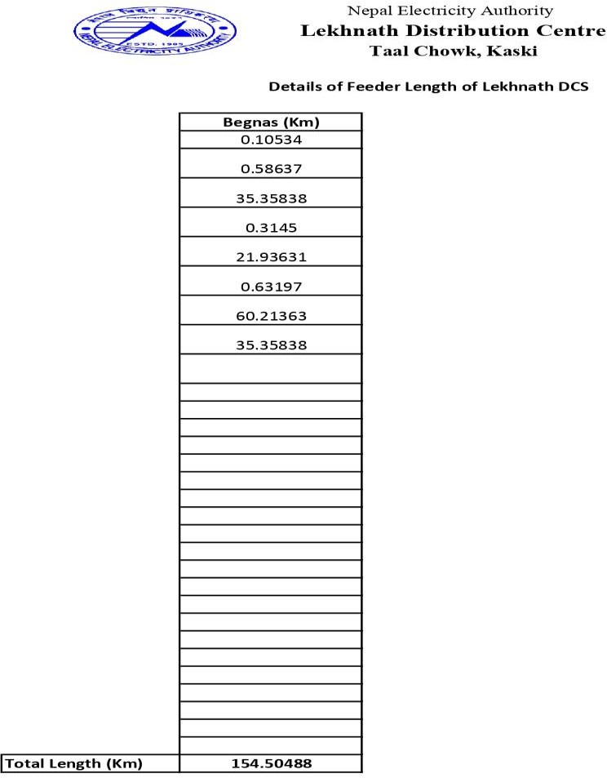

**APPENDIX 6**

**CALCULATION SHEET & FINANCIAL ANALYSIS OF ANNUAL SAVING & PAY-BACK PERIOD**

|  |  |  |  |  |  |  |  |  |  |  |  |  |
| --- | --- | --- | --- | --- | --- | --- | --- | --- | --- | --- | --- | --- |
| Power Loss deduction(kW) = | | | Power loss before D-Statcom - Power loss after D-Statcom | | | | | | | | | |
|  | | | 309.65-188.88= | | 120.77 | | kWH | | |  |  |  |
| For One Year = | | | 1057945.2 | | kWH | |  | | |  |  |  |
| Unit of kWH of Lekhnath DC as per | | | 10.5 | | per Unit | | Source Nea Lekhnath Dc | | |  |  |  |
| Total Save in cash due to power loss | | | 11,108,424.60 | |  | |  | | |  |  |  |
| Year | Cash Flow | Operation and Maintenance Cost | Net Cash Flow | Discount Factor (10%) | | PV Cash | | Discounted cash flow | Remarks | | | |
| 0 | (26,433,000.00) |  | (26,433,000.00) | 100% | | (26,433,000.00) | | (26,433,000.00) |  | | | |
| 1 | 11,108,424.60 | (792,990.00) | 10,315,434.60 | 0.9091 | | 9,377,667.82 | | (17,055,332.18) |  | | | |
| 2 | 11,108,424.60 | (792,990.00) | 10,315,434.60 | 0.8264 | | 8,525,152.56 | | (8,530,179.62) |  | | | |
| 3 | 11,108,424.60 | (792,990.00) | 10,315,434.60 | 0.7513 | | 7,750,138.69 | | (780,040.93) |  | | | |
| 4 | 11,108,424.60 | (792,990.00) | 10,315,434.60 | 0.6830 | | 7,045,580.63 | | 6,265,539.70 |  | | | |
| 5 | 11,108,424.60 | (792,990.00) | 10,315,434.60 | 0.6209 | | 6,405,073.30 | | 12,670,613.00 |  | | | |
| 6 | 11,108,424.60 | (792,990.00) | 10,315,434.60 | 0.5645 | | 5,822,793.91 | | 18,493,406.91 |  | | | |
| 7 | 11,108,424.60 | (792,990.00) | 10,315,434.60 | 0.5132 | | 5,293,449.01 | | 23,786,855.92 |  | | | |
| 8 | 11,108,424.60 | (792,990.00) | 10,315,434.60 | 0.4665 | | 4,812,226.37 | | 28,599,082.29 |  | | | |
| 9 | 11,108,424.60 | (792,990.00) | 10,315,434.60 | 0.4241 | | 4,374,751.25 | | 32,973,833.54 |  | | | |

|  |  |
| --- | --- |
| Annual Saving (Nrs) | 11,108,424.60 |

|  |  |  |  |  |
| --- | --- | --- | --- | --- |
| Pay Back Period | Cost of Project | 26433000 | 2.38 | Yrs |
|  | Annual Saving (Nrs) | 11,108,424.60 |  |  |

|  |  |  |  |  |
| --- | --- | --- | --- | --- |
| **Per/KVAr cost of D-STATCOM** | **Nrs.10000** | **Reference paper 2021 IEEE SOUTHEREN POWER ELECTRONOICS CONFERENCE & indian**  **market** | | |
|  |  |  |  |  |
| **Parameters** | **Light Load** | **Medium**  **Load** | **Heavy Load** |  |
| **Size of D-STATCOM (kVAR)** | **1629** | **2403** | **2264** |  |
| **Avg Size of D-STATCOM** | **2403** | | | **Maxm is**  **Consider** |
| **Cost of D-STATCOM (Nrs)** | **10000** | | |  |
| **Investment Cost of D-Statcom(Rs/kVAR)** | **24030000** | | |  |
| **Installation cost (10%)** | **2403000** | | |  |
| **Total Cost (Nrs)** | **26433000** | | |  |
|  |  |  |  |  |
| **Annual Mainteance Cost (3%)** | **7929900** | | |  |