HK2  
ScrollTop (Scroll To Top)

short line

Basant Mandal (HK2 - HashTagKitto)  
15th July, 2023

# Introduction

Scroll Top adds an intuitive icon at the bottom-right corner of each page so that with one click you will be at the top of the page. No more dragging of the scroll bar. It will be just fun and ergonomic to use. Scroll Top is an uncomplicated free Open Source Magento Module allowing site visitors to immediately and seamlessly get back to the top of your web page after scrolling a lengthy page.

**Please Note**:- This Module Adds Scroll to Top Button in Magento Store Frontend. Scroll to Top Button Automatically gets activated when you scroll down.

# Features

1. Simple, Open Source & Free.
2. No more dragging scroll bar.
3. Available on all pages of Magento Store Frontend.

# Installation Guide

From your magento root directory run these below commands:-

1. Setup :- **Extract the zip folder in app/code**
2. Run :- **php bin/magento module:enable HK2_ScrollTop**
3. Run :- **php bin/magento setup:upgrade**
4. Run :- **php bin/magento setup:static-content:deploy**

# 

# 

# 

# 

# How to Configure & Check ?

1. Enable from **Backend** - **Store** - **Configuration** - **HK2** - **Scroll** **Top**

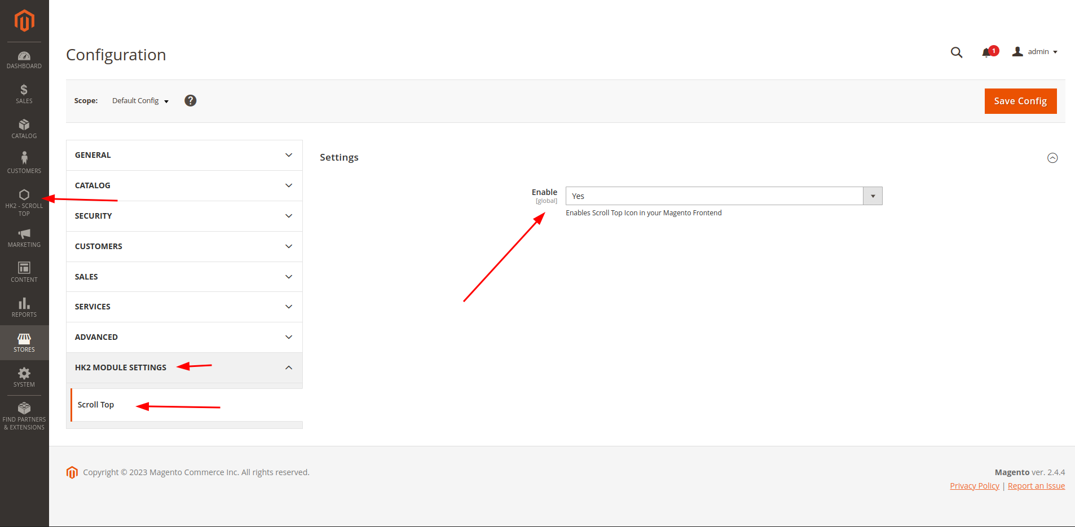

Once the Module has been activated by changing **Enable** = **Yes & saving it.**  
**Clear the Cache** & then you can check the **Magento Store Frontend** & on the Bottom Right Side you can see the Scroll To Top Icon.

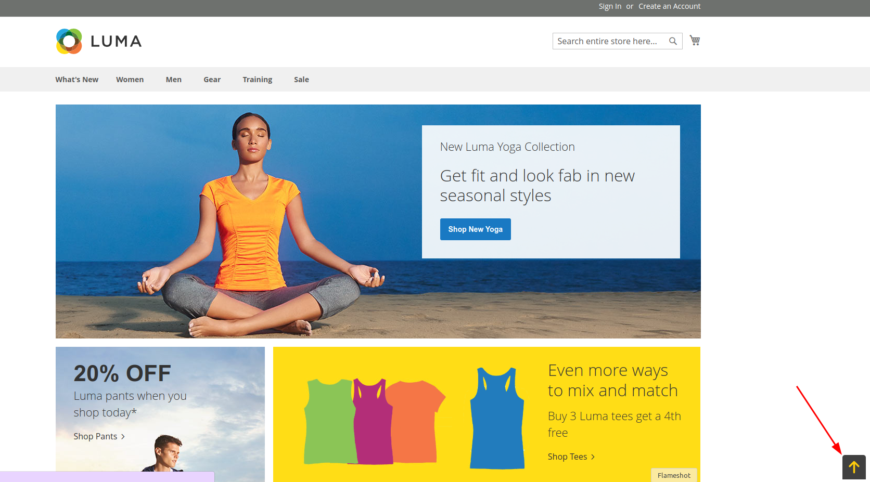

# Disclaimer

1. **Basant Mandal (HK2 - Hash Tag Kitto)** does not make any warranties about the completeness, reliability and accuracy of this image or its related products. Any action you take upon the information you find here is strictly at your own risk.
2. **Basant Mandal (HK2 - Hash Tag Kitto)** will not be liable for any losses and/or damages in connection with the use of our website.

short line

# Support - Bug Reporting

For Bug reporting, Please open an issue at https://github.com/basantmandal/HK2-ScrollTop/issues on GitHub. When filing a bug remember that the better written the bug is, the more likely it is to be fixed.

In case of any feedback or any feature additions feel free to contact at [support@hashtagkitto.co.in](mailto:support@hashtagkitto.co.in)