Municipal Digital Services — Business Case & Integration Blueprint
A self-initiated systems analysis by Basant Tamang, synthesising three earlier case studies (Birth Register Migration, Ward Appointment System, Sifaris Digital Letters) into one integration proposal.

Executive Summary
Three separate case studies in this portfolio each solved one municipal ward-office problem on its own: cleaning and migrating birth records (Project 2), booking ward appointments (Project 1), and issuing recommendation letters, or sifaris (Project 3). Each works, but each also keeps its own copy of who a citizen is. This document makes the business case for connecting them through one shared Citizen Registry, so a citizen's verified details are entered once and reused everywhere, instead of being re-typed, re-verified, and occasionally mismatched across three systems.
The proposed integration costs an estimated NPR 2,400,000 to build (48 person-weeks) and NPR 600,000/year to run, against an estimated NPR 3,375,000/year in citizen time saved by avoiding unnecessary return trips — a simple payback period of about 11 months. Beyond the money, it closes a real risk already visible in the existing projects: duplicate or mismatched citizen records are harder to catch when three systems never compare notes.
The recommended path is not to build everything at once. It is sequenced in three phases — a low-cost pilot, a one-system connection, and full three-way integration — so the ward office gets a working improvement within weeks rather than waiting a year for a single big release.

1. Context
This portfolio contains three independent case studies, each addressing one part of a citizen's journey through the ward office:
Project | What it does | What it already knows about a citizen
Project 2 — Birth Register Migration | Cleans and migrates decades of paper-era birth records into one de-duplicated database | Name, date of birth, parents' names, registration number
Project 1 — Ward Appointment System | Lets citizens book a time slot for a ward-office service instead of queueing | Name, phone number, service requested
Project 3 — Sifaris Digital Letters | Issues and QR-verifies recommendation letters for banks and other receiving organisations | Name, citizenship/registration number, letter purpose
Each project was scoped, designed, and delivered as its own unit — correctly, since trying to solve all three at once would have delayed every one of them. Now that all three exist, the next question a System Analyst should ask is: do they need to talk to each other, and is it worth the cost of making them?

2. The Problem
None of the three systems currently shares a citizen record with the others. In practice, that means:
- The same citizen is re-entered three times. A citizen whose birth record was just cleaned in Project 2 still has to give their name and details again when booking an appointment (Project 1) and again when requesting a sifaris letter (Project 3).
- Small mismatches are invisible across systems. A name spelled slightly differently in one system than another is not flagged, because nothing compares the three records to each other.
- A citizen's visit to one service gives no advance notice to the next. If a citizen books an appointment in Project 1 specifically to collect a sifaris letter, Project 3 has no way of knowing that in advance.
- Fraud and duplicate-identity checks are weaker than they could be. Project 2's birth-register work already solved "is this the same person as that other record?" once, at real effort — but that solved problem is not reused by the other two systems.
None of this is a defect in any single project. It is the natural limit of building three systems independently, and it is exactly the kind of gap a System Analyst is expected to notice and size up — not just design one system well, but see how systems should work together.

3. Objective
Propose, cost, and sequence an integration that lets Projects 1, 2 and 3 share one verified citizen record, so that:
- A citizen's details are entered and corrected once, not up to three times
- Each system can detect a likely duplicate or mismatch by checking the shared registry, rather than only within its own data
- A future service can be added to the municipality's digital offerings without re-solving "who is this citizen" from scratch

4. Proposed Integrated Architecture
The proposal is a single Citizen Registry sitting at the centre, seeded by the clean data from the Birth Register Migration (Project 2), and looked up — not duplicated — by the two front-line services.
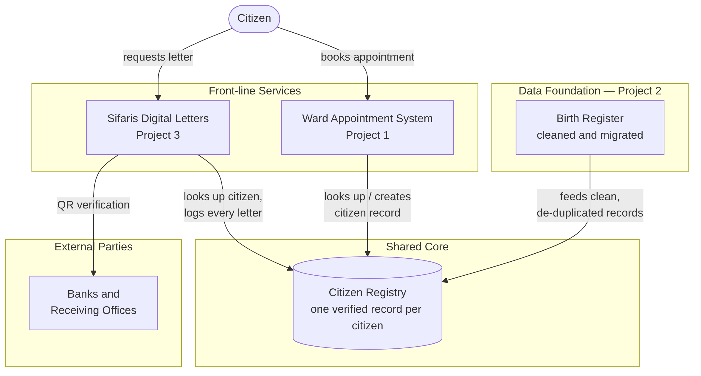
How it works, in short:
- Birth Register (Project 2) feeds the first batch of clean, de-duplicated citizen records into the registry. This reuses work already done rather than starting over.
- Ward Appointment System (Project 1) looks up a citizen's record when booking starts, and creates one if it's genuinely new — rather than keeping its own separate list of names and phone numbers.
- Sifaris Digital Letters (Project 3) looks up the same registry to verify who it's issuing a letter for, and logs that every letter was linked to a real, checked citizen record.
- Banks and receiving organisations verify a letter's QR code, which checks against the same shared registry — so a forged or duplicate letter is easier to catch.
Full diagram source is in diagrams/integration-architecture.md (and its editable Mermaid source, for anyone who wants to adjust the diagram).

5. Cost-Benefit Analysis
Worked figures are in analysis/cost-benefit-model.csv. Summary:
Item | Value
Annual ward-office visits across the three services | 150,000
Visits currently requiring an avoidable return trip (system down / wrong room / officer absent / re-entering details) | ~20% (30,000 visits/year)
Time saved per avoided return trip | 45 minutes
Value of citizen time (conservative local estimate) | NPR 150/hour
Annual citizen benefit | NPR 3,375,000/year
One-time integration build cost (48 person-weeks × NPR 50,000/week) | NPR 2,400,000
Annual operating cost (hosting, maintenance, support) | NPR 600,000/year
Simple payback period | ~11 months
From Year 2 onward, the net annual benefit to citizens (time saved, less ongoing running cost) is approximately NPR 2,775,000/year. This is a citizen-time saving, not a direct cash saving to the municipality — the business case for it rests on service-quality and trust improvements as much as on the arithmetic, and the figures above should be treated as planning estimates, not audited numbers.

5.1 What this estimate does not include
To stay conservative and honest, this estimate leaves out some real but harder-to-quantify benefits: fewer duplicate-identity fraud cases, faster staff processing time, and the value of citizens trusting the ward office more. Including those would likely shorten the payback period further, not lengthen it.

6. Sequencing and Stakeholder Recommendation
Building all three integrations simultaneously would be the highest-risk, slowest-to-prove option. The recommended path is phased:
Phase | What happens | Why this order
Phase 1 — Quick win (2–3 weeks) | Stand up the shared Citizen Registry seeded from the already-cleaned Project 2 birth-register data. No other system changes yet. | Lowest risk: it reuses data that is already clean, and nothing citizen-facing changes yet, so it can be verified quietly before anything depends on it.
Phase 2 — Pilot (4–6 weeks) | Connect Project 1 (Ward Appointment System) to the registry: bookings look up and create citizen records there instead of a separate list. | Project 1 is the citizen's first touchpoint and has the smallest, best-understood data model of the two front-line systems — a safer first integration than the letter-issuing system.
Phase 3 — Full integration (remaining ~6–8 weeks) | Connect Project 3 (Sifaris Digital Letters) to the same registry, including the bank/receiving-organisation QR verification path. | Sifaris letters carry more legal and financial weight (they are relied on by banks), so this step comes last, once the registry has already proven itself in Phase 2.
This sequencing means the ward office sees a working improvement after Phase 1–2 (roughly 6–9 weeks), rather than waiting for one large release at the end of 48 person-weeks.

7. RACI Matrix
Activity | Ward Office Management | System Analyst (this project) | Developer(s) | IT/Hosting | Banks / Receiving Orgs
Approve integration business case | A | R | C | I | I
Design shared Citizen Registry schema | C | A/R | C | I | —
Migrate Project 2 data into registry (Phase 1) | I | A/R | C | C | —
Integrate Project 1 booking flow (Phase 2) | C | A | R | C | —
Integrate Project 3 letter flow (Phase 3) | C | A | R | C | I
Sign off on QR verification change for receiving organisations | A | R | C | I | C
Operate and maintain shared registry post-launch | I | C | C | A/R | —
R = Responsible, A = Accountable, C = Consulted, I = Informed.

8. Integration-Specific Risks
Risk | Likelihood | Impact | Mitigation
Merging three systems' data surfaces previously-hidden duplicate or mismatched citizen records | High | Medium | Expected, not a defect — run a manual review queue (already built for Project 2) rather than auto-merging; treat conflicts as a data-quality finding
A single shared registry becomes a single point of failure for all three services | Medium | High | Each front-line system keeps a local cache and the same printable-fallback pattern already built for Project 1 downtime
Phase 3's bank-facing QR change requires external sign-off outside the ward office's control | Medium | Medium | Sequenced last (Section 6) and flagged to receiving organisations early, not as a surprise at go-live
Estimated effort (48 person-weeks) assumes familiarity with all three existing codebases | Low | Medium | All three systems were built with the same documentation standard, reducing ramp-up time for whoever implements this

9. Recommendation and Next Steps
- Approve Phase 1 (shared Citizen Registry seeded from Project 2 data) as a low-risk, low-cost first step — no citizen-facing system changes required.
- Use Phase 1 as the checkpoint to confirm the cost-benefit estimates in Section 5 before committing to Phases 2–3.
- Proceed to Phase 2 (Ward Appointment System integration) only after Phase 1 is verified in production.
- Brief banks and other receiving organisations early about the Phase 3 QR-verification change, well ahead of implementation.

Sources
This business case is built entirely from data and designs already produced in the portfolio's three underlying case studies:
- Project 1 — Ward Appointment System: interview findings (pain points P8–P10), requirements, and architecture
- Project 2 — Birth Register Migration: de-duplication approach and migration results
- Project 3 — Sifaris Feasibility Study: options analysis, legal/policy review, and rollout plan
All cost and benefit figures in Section 5 are planning-level estimates created for this business case and should be validated against actual data before being used for budget approval.

