**QUEUE ILLUSTRATION**

**Add to empty doubly circular queue:**

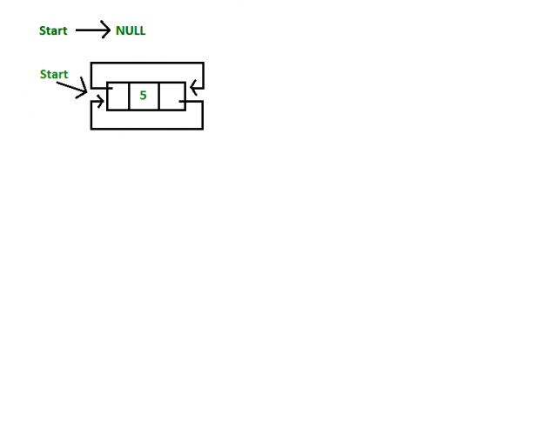

**Add to not empty doubly circular queue:**

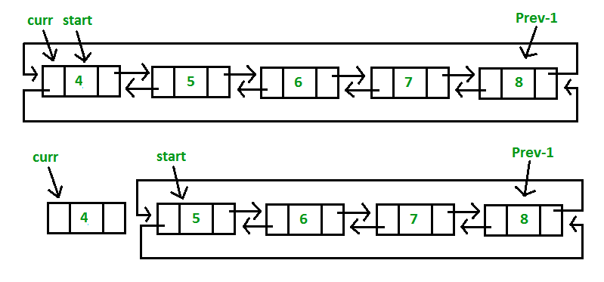

**Remove from queue:**

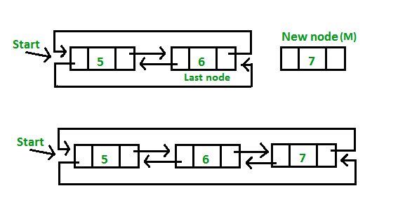

**STACK ILLUSTRATION**

**General stack:**

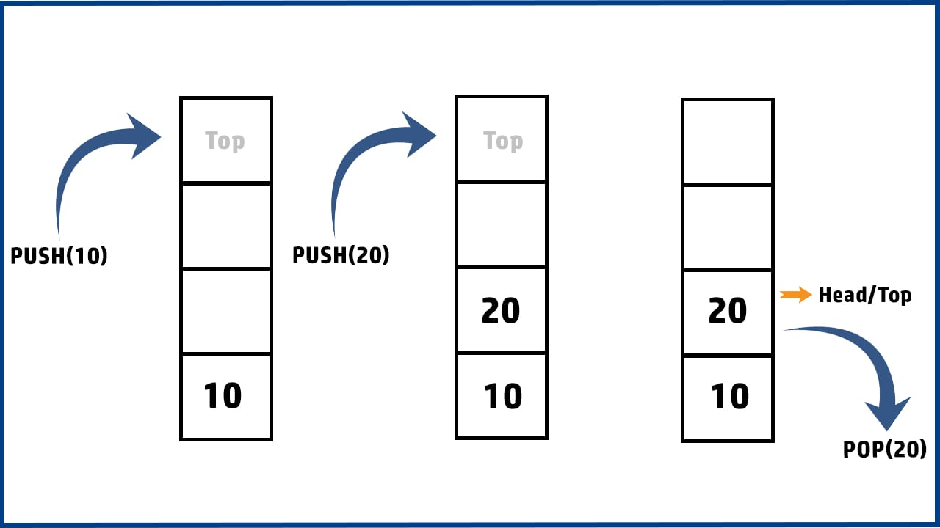

**Add to stack:**

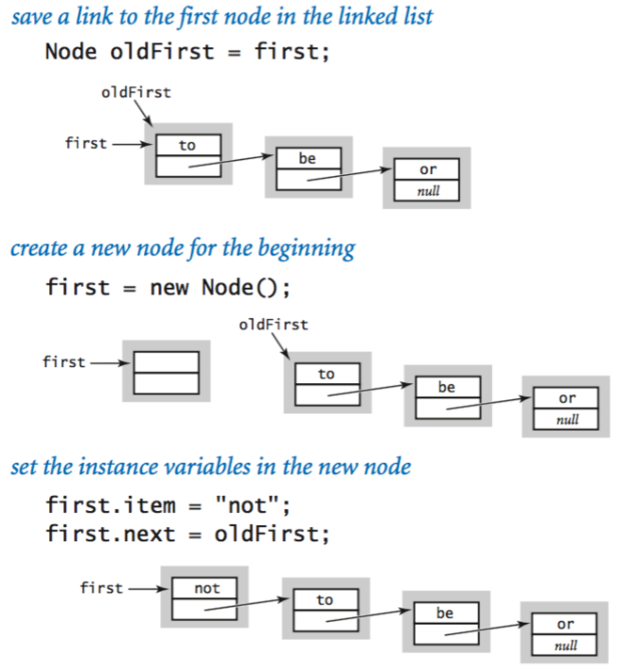

**Remove from stack:**

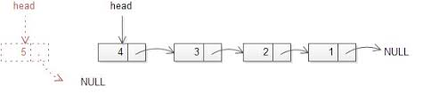

**BINARY SEARCH TREE ILLUSTRATION**

**Add to BST:**

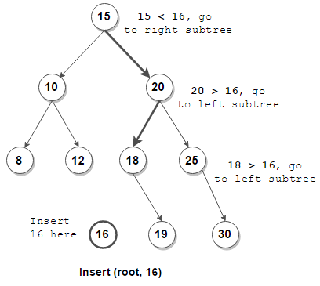

**Remove from BST:**

