Stock Analysis

# AMZN

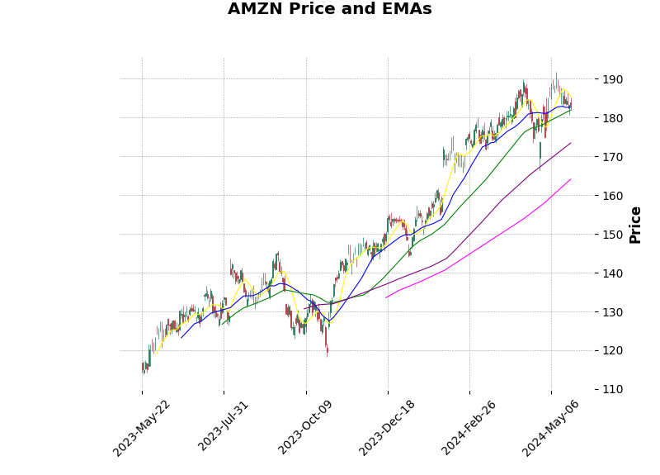

# MSFT

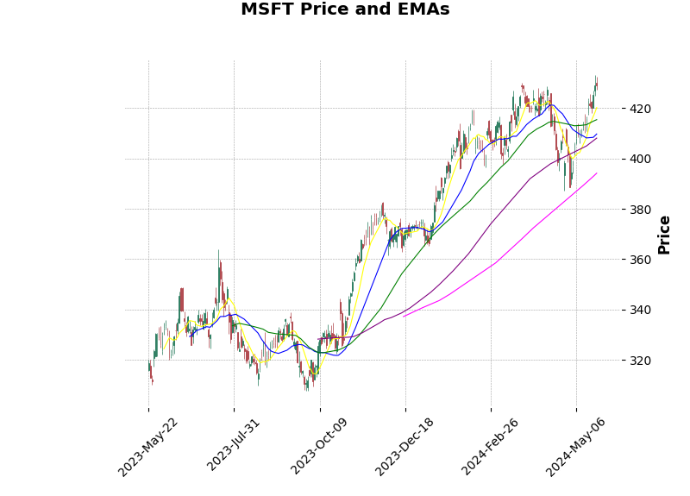

# SPOT

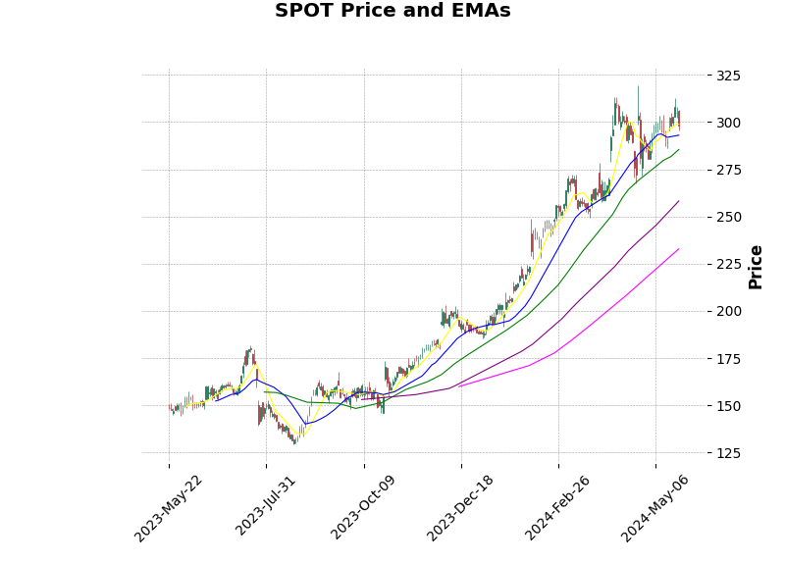

# META

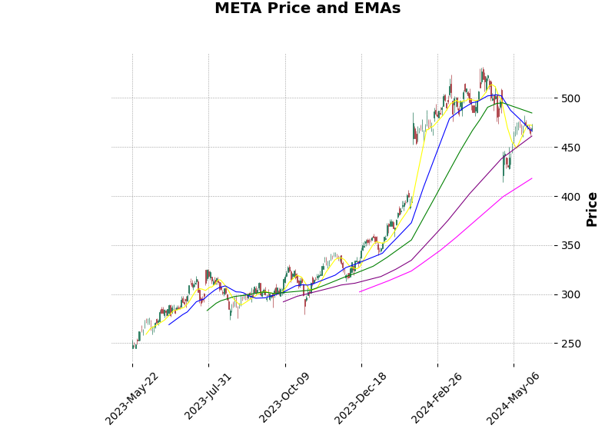

# NFLX

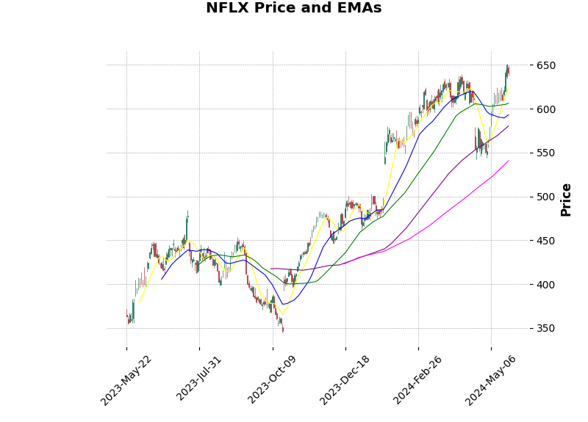

# ORCL

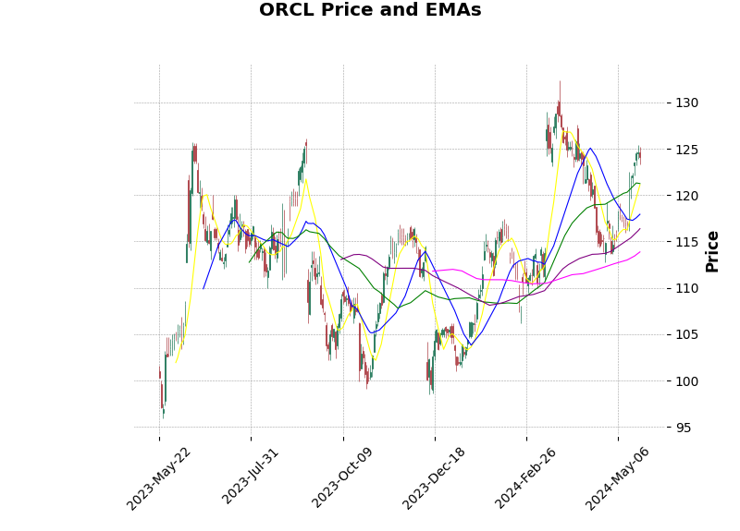

# ADBE

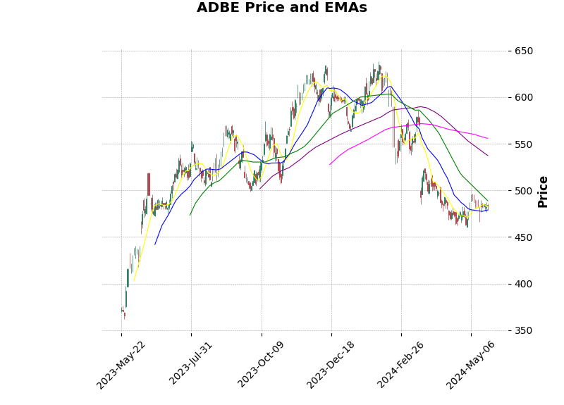

# GOOG

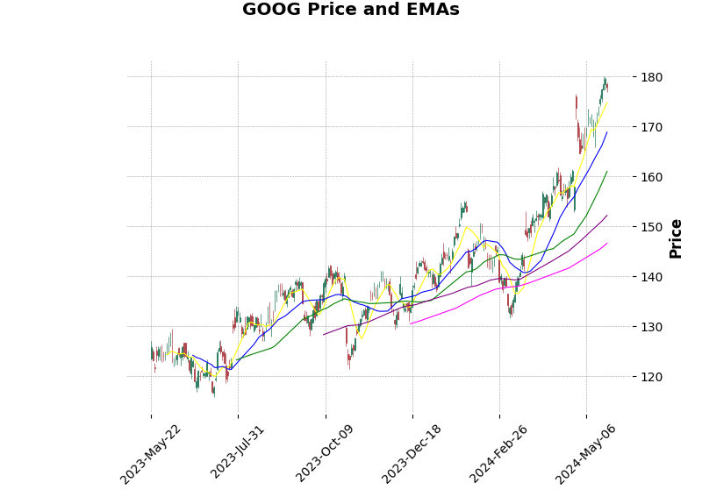

# GOOGL

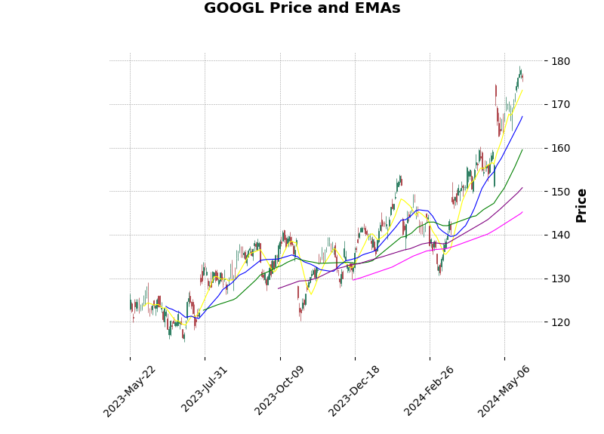

# MA

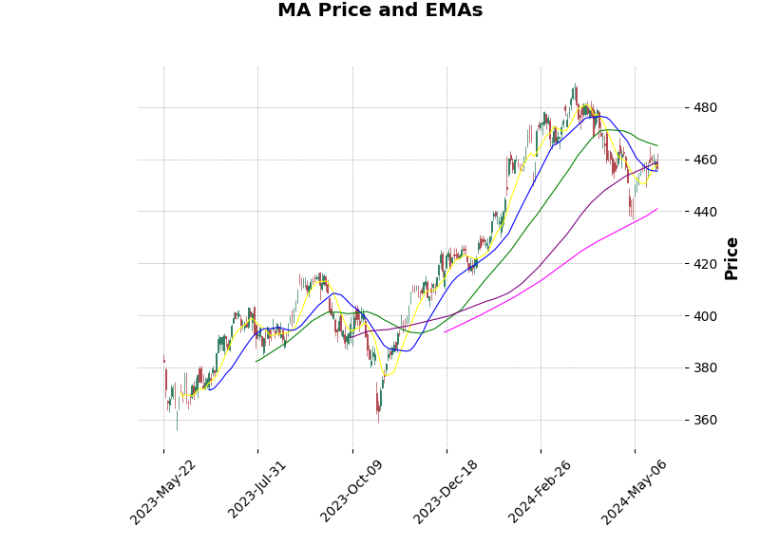

# PYPL

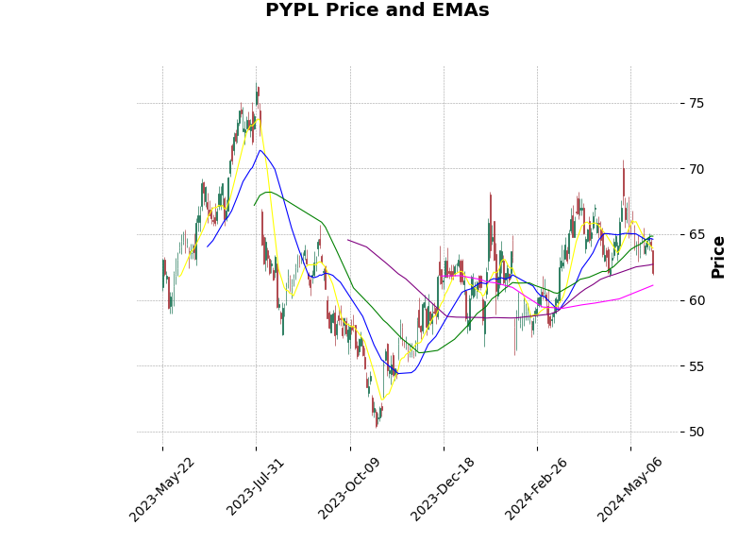

# NVDA

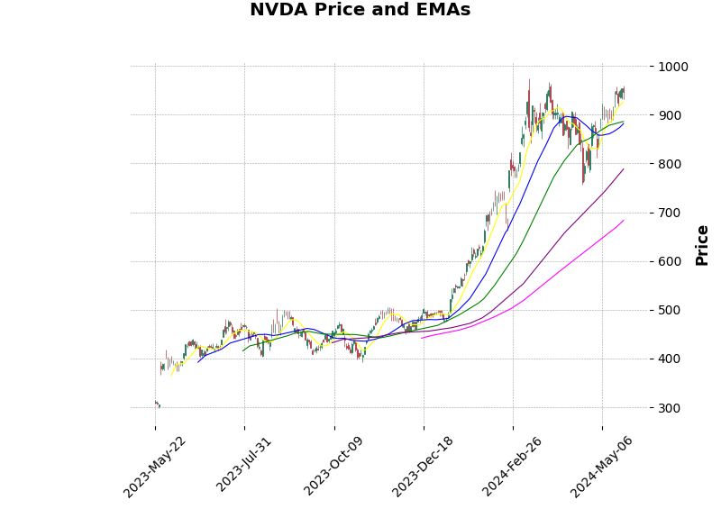

# AMD

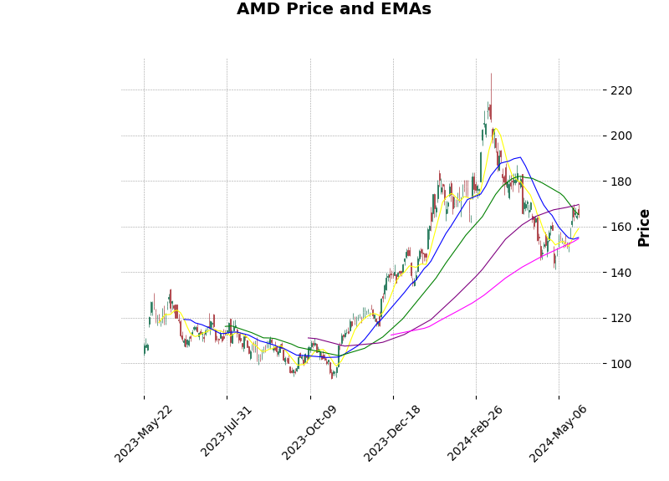

# INTC

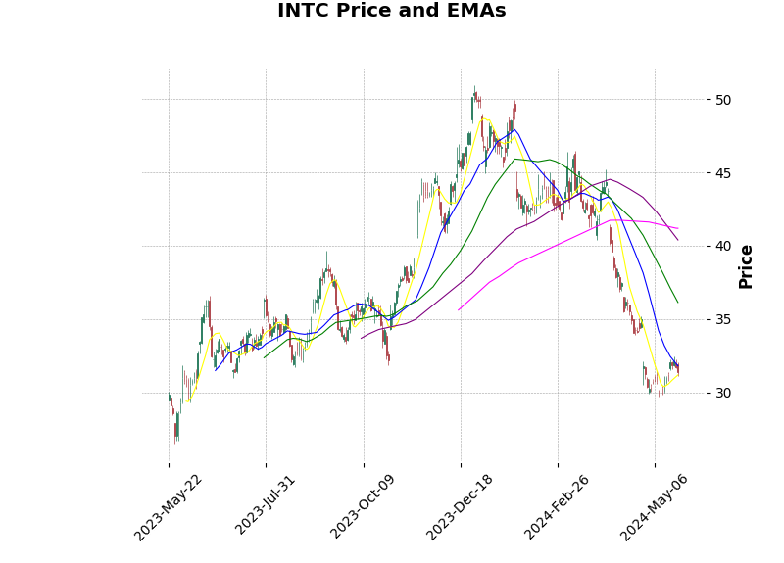

# WMT

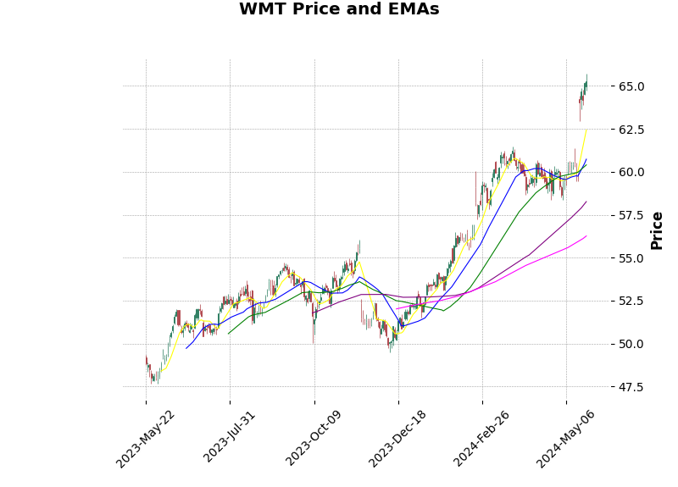

# Summary

AMZN: BUY

MSFT: BUY

SPOT: BUY

NFLX: BUY

ORCL: BUY

GOOG: BUY

GOOGL: BUY

NVDA: BUY

WMT: BUY

ADBE: SELL

INTC: SELL

META: HOLD

MA: HOLD

PYPL: HOLD

AMD: HOLD