

**SPM Polytechnic Kumthe, Solapur**

Report

On

**“Barcode Generator Website”**

Submitted in the partial fulfilment of award of the Diploma.

In

Computer Engineering

Submitted By

1. **Mr. Basavaraj Dundappa Fulari Roll No.133**
2. **Mr. Vishal Shashikant Koli Roll No.134**

* PHP BARCODE GENERATOR

1. **Introduction:**

Gone are the days when you used to go to a store, pick items from a shelf and reach the point of sale; cashier used to cast a look upon the items, check the items’ prices from the list and add it to the total bill. This was time consuming, irritating for the customers and often times the price and product information entered manually was faulty. Advancements in technology has affected virtually all walks of everyday life; Likewise, computerized point of sale systems were introduced and if there was anything left in completely automating POS, barcodes were introduced. This book has been written for the business owners who want to get basic insight about the barcodes. Those, who want to know what barcodes actually are, and what their different types are. After reading this book, business owners will be able to decide that which barcode suits their business needs. This book is also intended towards the software developer and professionals who are working on a project which integrates barcode for example, point of sale system, medical image system or any departmental store application. After reading this book, IT professionals will be able to make a decision about the barcodes to use based on the requirements of the project.

What are barcodes?

Barcode is nothing but a piece of paper pasted on items. You would have seen patterns of black and white vertical lines on items in stores, books, hardware items etc. These lines may seem oblivious to you but they contain large amount of information regarding the product on which they are pasted. But with little research you can have an idea what are several types of barcodes, what their functionalities are and what are their advantages and disadvantages. Diverse algorithms are used to

**Why use barcodes?**

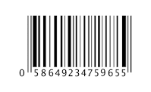

An important question exists that needs to be answered before dwelling into the details of the barcodes. Following are some of the reasons:

• Barcode encoding and decoding is extremely fast and can save lots of time that is spent in manually encoding and decoding information.

• Barcodes are secure way of encoding information and chance of faulty information and human error is minimal.

• Barcodes nowadays are extremely cost effective; the encoding hardware and scanning devices have become cheaper and reliable.

• Barcodes helps in decision making process by providing processed data using specialized programming algorithms.

• Process automation is the biggest advantage that comes with barcode implementation in point of sale systems.

**What are applications of barcodes?**

Almost every industry is employing barcodes for automating their product information storage and retrieval purposes. Following are some of the general application areas of barcodes.

• Whole sale dealers and retail shop owners make use of barcodes for product identification.

• Medical and surgical industry places barcodes on medicine, surgical equipment and diagnosis machinery.

• Shipping and marine industry make use of barcodes for secure shipment and product information.

• Electronic and computer industry employ barcodes on electronic devices and hardware components.

• Postal industries use barcodes for efficient parcel routing and mail delivery across the board.

Apart from the above mentioned applications, there are hundreds of other areas where barcodes are being widely and successfully used.

In the next chapter we are going to explain what are the two major categories of barcodes and how they differ from each other, pros and cons of both and finally the usage of both barcodes.

Categories of barcodes:

Barcodes have now become an essential part of almost every Brick and Mortar Company. You will rarely find a product without a barcode Tag. Different types of barcodes are used for different purposes in business sectors. There are several advantages of using barcodes as compared to manual data entry. Typical usage of barcodes include

• Tracking sale and purchase of large number of items in an inventory.

• Barcodes are pasted on sports tickets which allow one to enter a sports arena.

• Barcodes are often placed on gift tokens that when decoded tells which gift that token corresponds. Types of barcodes There are two major types of barcodes 1- One Dimensional or Linear Barcodes 2- Two Dimensional Barcodes

One Dimensional Barcodes :

One dimensional or linear barcodes are commonly referred as first generation barcodes. These barcodes consist of vertical lines at specific gaps resulting in a particular pattern. Hardware scanners are used to scan these patterns and decode the information stored in those particular patterns. These barcodes are also commonly called discrete, one dimensional or UPC barcodes. Advantages of Linear Barcodes

• In linear barcodes, vertical lines are used to store data; hence data is generated in one direction which is easier to generate as compared to generating data in multi-dimensions.

• Linear barcodes are easier to scan. Just like barcode generation, barcode decoding is also done in one direction which is easier to perform.

• No special hardware or software is required to scan these barcodes and a simple and inexpensive scanner can be used to generate and scan linear barcodes. Disadvantages of Linear Barcodes:

• Linear barcodes can only store small amount of data. In order to store large amount of data in linear barcodes, it has to be stretched horizontally with additional vertical lines and spaces, resulting in large barcodes.

• Barcode, once distorted cannot be scanned correctly. Small damage, line at the start or end of the barcode can modify or destroy the data stored in the barcode.

Two Dimensional Barcodes :

2-D barcodes are more complex and store data in the form of a matrix or stack. Stacked 2-D barcodes contain data in the form stacks of linear barcodes whereas matrix 2-D barcodes store data in the form of hexagonal, square or circular cells. They can store data in both vertical and horizontal direction. Advantages of 2-D barcodes

• These barcodes can store much larger amount of data ranging up to thousands of alphanumeric characters.

• Error correction formula can be embedded into barcode which helps in the retrieval of data in case barcode is damaged up to 15 to 20%.

• Variety of data can be embedded into these barcodes such as numeric, binary, text and Unicode data.

Disadvantages of 2-D barcodes :

• Specialized hardware and software scanners are required to generate and decode these barcodes which can be expensive. Copyright (c) 2014, www.bytescout.com. Do not copy without a permission. 3 • Complex algorithm needs to be designed for 2-D barcodes which make things much complex as compared linear barcodes.

* **IMPLEMENTATION**

**Programming Languages :**

This project is based on the concept of Web Technology, so we used following languages :

* HTML
* CSS
* PHP

**Database:**

* MySQL

**Software requirements**

* Visual Studio Code Editor /
* XAMPP Server – For PHP / My SQL database
* Browser – Any latest Updated Browser – Google Chrome

**Hardware requirements:**

* Keyboard, Mouse, Desktop Screen
* Ram – 8GB
* SSD – 1TB
* Processor – I5

**HTML:**

The Hyper Text Markup Language or HTML is the standard markup language for documents designed to be displayed in a web browser. It can be assisted by technologies such as cascading style sheet (CSS) and Scripting languages such as JavaScript. HTML elements are the building blocks of HTML pages.

**CSS :**

CSS is the language for describing the presentation of web pages, including colors, layout, and fonts. It allows one to adapt the presentation to different types of devices, such as large screens, small screens, or printers. CSS is independent of HTML and can be used with any XML based markup language.

**PHP :**

PHP (Hypertext Preprocessor) is known as a general-purpose scripting language that can be used to develop dynamic and interactive websites. It was among the first server-side languages that could be embedded into HTML, making it easier to add Functionality to web pages without needing to call external files for data.

**Bootstrap :**

Bootstrap is a free and open-source CSS framework directed at responsive, mobile-first front-end web development. It contains HTML, CSS and JavaScript-based design templates for typography, forms, buttons, navigation, and other interface components.

**MySQL Database :**

MySQL is an open-source relational database management system. Its name is a combination of "My", the name of co-founder Michael Widenius's daughter My, and "SQL", the acronym for Structured Query Language.

A database is a structured collection of data. It may be anything from a simple shopping list to a picture gallery or a place to hold the vast amounts of information in a corporate network. In particular, a relational database is a digital store collecting data and organizing it according to the relational model. In this model, tables consist of rows and columns, and relationships between data elements all follow a strict logical structure. An RDBMS is simply the set of software tools used to actually implement, manage, and query such a database.

* CODING

1st Page Coding(welcome+introduction)

<html>

<head>

<style>

.back

{

height: 1620px;

font-size: 30px;

color: white;

}

.modify

{

margin-left: 700px;

}

</style>

<link rel="stylesheet" href="css/bootstrap.css">

<link rel="stylesheet" href="css/bootstrap-grid.css">

<link rel="stylesheet" href="css/bootstrap-reboot.css">

<link rel="stylesheet" href="css/bootstrap-utilites.css”>

<script src="js/bootstrap.js" async defer></script>

<script src="js/bootstrap.bundle.js" async defer></script>

</head>

<body style="background-image: url(images/i2.jpg);background-size: cover;">

<div class="back">

<br><br>

<center style="margin-left: -580px;">"In Above Bar Code Generator Website<br>

We Can Create A No Of Bar Code." <br><br>

According To Customer Requirement<br>

Also Provide a Facility of Print<br>

With Your Budget<br><br><br>

<i style="color:black;">For More Information And Get Enjoy<br>

Please Click On Login Button<br>

And Also Contact....

<br>

<br><br>

<a href="home.html">

<img src="https://www.pngmart.com/files/3/Next-Button-PNG-HD.png" width="200px">

</a>

</i>

<br><br><br><br>

<cente style="margin-left: 480px;">Application Of Barcode Generator</cente>

<br><br>

<div class="modify">

<div class="container text-center">

<div class="row">

<div class="col">

<div class="card" style="width: 18rem;">

<img src="https://images.unsplash.com/photo-1486406146926-c627a92ad1ab?ixlib=rb-4.0.3&ixid=M3wxMjA3fDB8MHxzZWFyY2h8Mzh8fGJ1c2luZXNzfGVufDB8fDB8fHww&auto=format&fit=crop&w=500&q=60" class="card-img-top" alt="...">

<div class="card-body">

<p class="card-text"><i style="color: blue;">In Business Sector</i><br>

<h4>

In Business sector High amount Of Barcode Are Use.For ex:-D-Mart

</h4>

</p>

</div>

</div>

</div>

<div class="col">

<div class="card" style="width: 18rem;">

<img src="https://images.unsplash.com/photo-1455165814004-1126a7199f9b?ixlib=rb-4.0.3&ixid=M3wxMjA3fDB8MHxzZWFyY2h8MTh8fGluZHVzdHJpYWx8ZW58MHx8MHx8fDA%3D&auto=format&fit=crop&w=500&q=60" class="card-img-top" alt="...">

<div class="card-body">

<p class="card-text"><i style="color: blue;">In Industrial Sector</i><br>

<h4>

In Industrial sector High amount Of Barcode Are Use.For ex:- Tea Factory

</h4> </div>

</div>

</div>

<div class="col">

<div class="card" style="width: 18rem;">

<img src="https://images.unsplash.com/photo-1584982751601-97dcc096659c?ixlib=rb-4.0.3&ixid=M3wxMjA3fDB8MHxzZWFyY2h8MTB8fGhlYWx0aGNhcmV8ZW58MHx8MHx8fDA%3D&auto=format&fit=crop&w=500&q=60" class="card-img-top" alt="...">

<div class="card-body">

<p class="card-text"><i style="color: blue;">In Medical Sector</i><br>

<h4>

In Medical sector High amount Of Barcode Are Use.For ex:-Medicine

</h4> </div>

</div> </div>

</div>

</div>

</div>

<br><br>

<h3 style="color: blue;">For More Information Please Click On Below Link</h3><br>

<a href="https://youtu.be/HYH4Ma5SolI" style="color: white;">Youtube Video:https/basavaraj/vishaluilkjgy/secure<h3></h3></a>

</center>

<br><br><br>

<div class="container text-center">

<div class="row">

<div class="col">

<img src="https://d3jmn01ri1fzgl.cloudfront.net/photoadking/webp_thumbnail/62f385f9ce890_json_image_1660126713.webp

" width="500px">

</div>

<div class="col">

<img src="https://cdn.dribbble.com/users/5297140/screenshots/13995496/media/14926154614bfc790f749c95649a7919.gif

" width="500px">

</div>

</div>

</div>

<br><br><br>

<center>

<a href="https://photoadking.com/templates/ad-maker/electronic-advertisement/">

<img src="https://media3.giphy.com/media/v1.Y2lkPTc5MGI3NjExcnJjOXAyYnR4NjQ4eGlvNmpxZDFia2F2Nzc2cWMyZDFxbGgxOW5yYiZlcD12MV9naWZzX3NlYXJjaCZjdD1n/f7BCWwgz5KaiY0tgpz/giphy.gif" height="100px">

</a>

</center>

</div>

<img src="https://www.codereadr.com/wp-content/uploads/2020/12/Rapid-barcode-scanning_reduced.gif" style="float: right; margin-top: -1500px; margin-right: 100px;">

</body>

</html>

**Output:-**

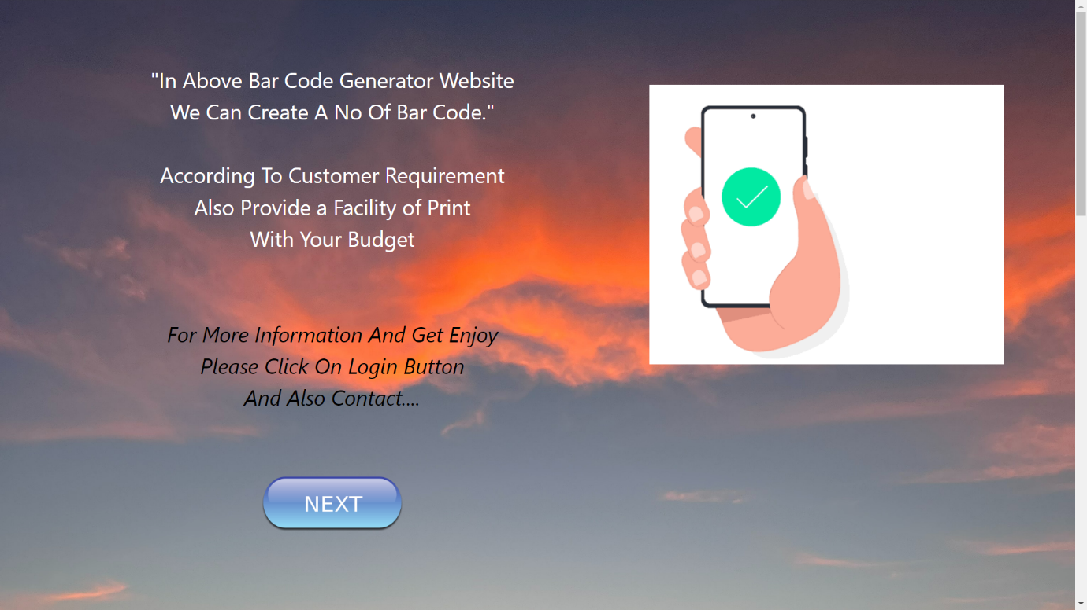

2nd Page Coding(login+cnt)

<html>

<head>

<style>

.ab

{

margin-bottom: 400px;

}

</style>

</head>

<body style="background-image: url(images/myimage.jpg); background-size: cover; background-repeat: no-repeat;">

<br><br><br><br><br><br><br><br><br><br><br>

<center><h1 style="color:pink; font-size: 50px;">Welcome To Bar-Code Generator</h1></center>

<br><br><br><br><br><br>

<img src="images/login.png" style="margin-left: 300px;">

<a href="http://localhost/php_project/login_form.php">

<h3 style="border: 1px solid white; width:200px;color: white; margin-left: 280px;" ><center>Login</center></h3>

</a>

<img src="images/contact.jfif" style="margin-left: 610px;margin-top: -225px; height: 170px; ">

<a href="contact-us1.html">

<h3 style="border: 1px solid white; width:200px;color: white; margin-left: 640px; margin-top: -38px;" ><center>Contact-Us</center></h3>

</a>

</body>

</html>

**Output**:-

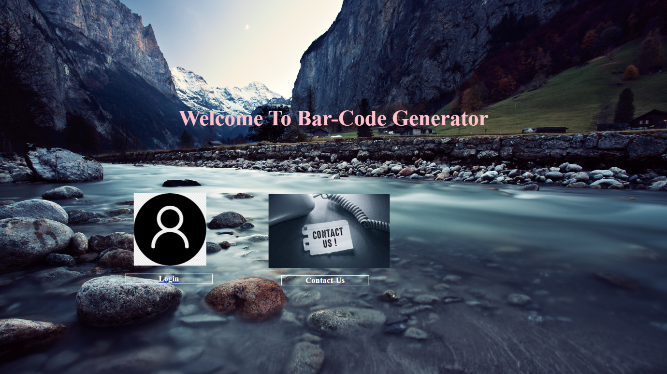

3rd Page Coding(login_page)

<?php

if(isset($_POST['submit']))

{

$var1= $_POST['Username'];

$var2= $_POST['Password'];

$var3= $_POST['system_captcha'];

$var4= $_POST['user_captcha'];

$conn1=new mysqli("localhost","root","","mydata1");

if($conn1->connect_error)

{

die('conneciton is failed' .$conn1->connect_error);

}

else

{

if($var3==$var4)

{

$stmt=$conn1->prepare("insert into today3(Username,Password,system_captcha)values(?,?,?)");

$stmt->bind_param("sss",$var1,$var2,$var3);

$stmt->execute();

echo "successfully";

$stmt->close();

$conn1->close();

}

else

{

echo "Password is Wrong ...........";

}

}

}

?>

<html>

<head>

<style>

.login1

{

border: 7px solid black;

width: 350px;

background-color:gray;

border-left-color: red;

border-top-color: red;

border-right-color: blue;

border-bottom-color: blue;

}

</style>

</head>

<body style="background-image: url(https://media.istockphoto.com/id/1424122417/photo/rectangle-neon-line-loop-purple-neon-frame-motion-rectangle-yellow-bright-pink-animation.webp?b=1&s=170667a&w=0&k=20&c=K4b0nTP7aKpiII2uMmF5aVh1HvJnMnpaKOtLW-QDU0U=); background-size: cover;">

<br><br>

<a href="home.html">

<img src="https://encrypted-tbn0.gstatic.com/images?q=tbn:ANd9GcQR-eLu68RrlEK4LLuRga2vhbLZbNzme5ozoPij8k-PMnaRZJb6SgE8NmZgM6frM0-e9uw&usqp=CAU" height=70px>

</a>

<br><br>

<h1><center style="color: violet;"><i>Login Form</i></center></h1><br>

<center style="font-size: 20px;">

<div class="login1">

<br><br><br><br>

<Form action="login_form.php" method="post">

<label style="font-size:25px">Enter Username</label><br><br>

<input type="email" name="Username" placeholder="Username" required >

<br><br><br>

<label style="font-size:25px">Enter Password</label><br><br>

<input id="password" type="password" name="Password" required pattern="^[a-z0-9]{7,15}$" title="Password may only contain letters and numbers And More Than 7 Digits " placeholder="Password">

<br><br><br>

<?php

$random_value=rand(100,100000);

?>

<input type="text" name="system_captcha" value="<?php echo $random_value ?>"><br>

<input type="text" name="user_captcha" placeholder="Enter captcha"><br><br>

<input type="submit" name="submit" style="height:40px; font-size:20px;background-color:red;cursor: pointer;">

<br><br>

</Form>

</div>

<br><br>

<br><br>

<a href="">

<label style="border:2px solid black; padding:20px; background-color: cornflowerblue;cursor: pointer; ">Next👉</label>­

</a>

</center>

</body>

</html>

Output:-

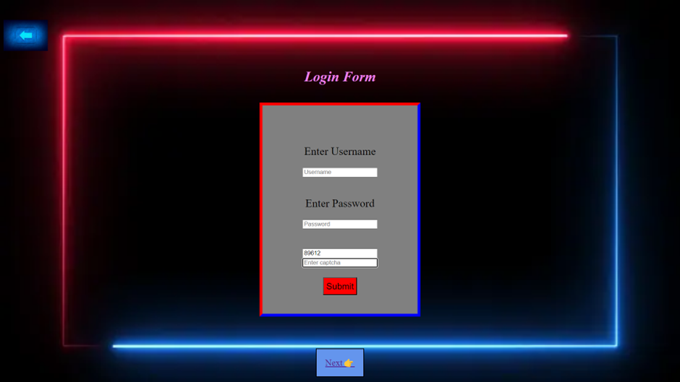

4th Page Coding(Contact-us)

<html>

<head>

<link rel="stylesheet" href="css/bootstrap.css">

<link rel="stylesheet" href="css/bootstrap-grid.css">

<link rel="stylesheet" href="css/bootstrap-reboot.css">

<link rel="stylesheet" href="css/bootstrap-utilites.css">

<script src="js/bootstrap.js" async defer></script>

<script src="js/bootstrap.bundle.js" async defer></script>

<style>

.back

{

background-color: white ;

height: 300px;

}

</style>

</head>

<body style="background-color: grey;">

<a href="home.html">

<img src="https://encrypted-tbn0.gstatic.com/images?q=tbn:ANd9GcQR-eLu68RrlEK4LLuRga2vhbLZbNzme5ozoPij8k-PMnaRZJb6SgE8NmZgM6frM0-e9uw&usqp=CAU" height=70px>

</a>

<h1>

<center style="color:white; font-size: 50px;"> Contact Us

</center>

</h1>

<br><br><br><br><br>

<center style="color: blue; font-size: 30px;">

<i>If You Need Multiple Bar Code

<br>

then Contact Immediatrly

<br>

According To The

<br>

Arrangement Below

</i>

</center>

<br><br><br><br><br><br><br>

<div class="back">

<div class="container text-center">

<div class="row">

<div class="col">

<br><br><br>

<img src="images/what.jfif">

<br>Contact on whatsapp

<br>

<a href="https://web.whatsapp.com/">

<label><u>CLICK</u></label>

</a>

</div>

<div class="col">

<br><br><br>

<img src="images/gmail.jfif">

<br>Contact on G-mail

<br>

<a href="https://accounts.google.com/ServiceLogin?service=mail&passive=true&rm=false&continue=https://mail.google.com/mail/?tab%3Dwm&scc=1&ltmpl=default&ltmplcache=2&emr=1">

<label><u>CLICK</u></label>

</a>

</div>

<div class="col">

<br><br><br>

<img src="images/tool.jfif">

<br>Contact on Tool Number

<br>

<b>9353138494</b>

</div>

</div>

</div>

</div>

</body>

</html>

Output:-

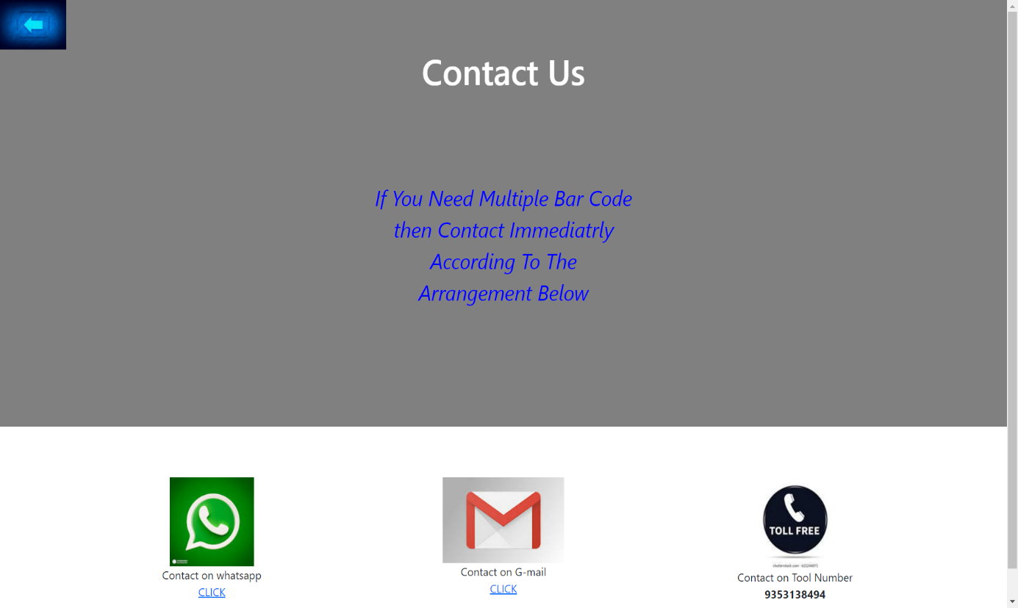

***TESTING REPORT***

|  |  |  |  |  |  |
| --- | --- | --- | --- | --- | --- |
| **Test Case Id** | **Description** | **Input** | **Expected O/P** | **Output** | **Status** |
| 1 | **Login Page**  We Enter A Username And Password. | We Can give Input As A Username And Password. | IF Username And Password is Correct then The Data will Save In DataBase. | Data Will Save In database. | GOOD |
| 2 | **Bar Code Generate Page** | We Can give input : rpduct_name,  Product_id,  Quantity. | Required Number Of Bar Code Can Be Generate. | Barcode Can Generate With Proper Working. | Excellent |

* **Benefits of Barcodes**
* Barcodes eliminate the possibility of human error. ...
* Using a barcode system reduces employee training time. ...
* Barcodes are inexpensive to design and print. ...
* Barcodes are extremely versatile. ...
* Inventory control improves. ...
* Barcodes provide better data.