Screenshot :-
6. Submission and evaluation

Submit one GitHub repository link (your fork or branch of the class repo). Your trainer will announce the deadline.

Submission checklist
- dags/nammamart_etl_<your_name>.py and dags/nammamart_elt_<your_name>.py, both parsing with no import errors
- Helper code in include/ (quality checks, masking functions) and SQL files in include/sql/
- SUBMISSION.md containing: Data Issues Log (Part 0), answers to Part C, governance answers (Part E), observability results table (Part F), recommendation (Part G)
- Screenshots: both DAGs in Graph view (green run), the schedule showing 9:00 AM IST, one quarantine file, query results from dq_results, pipeline_runs and the payment reconciliation table

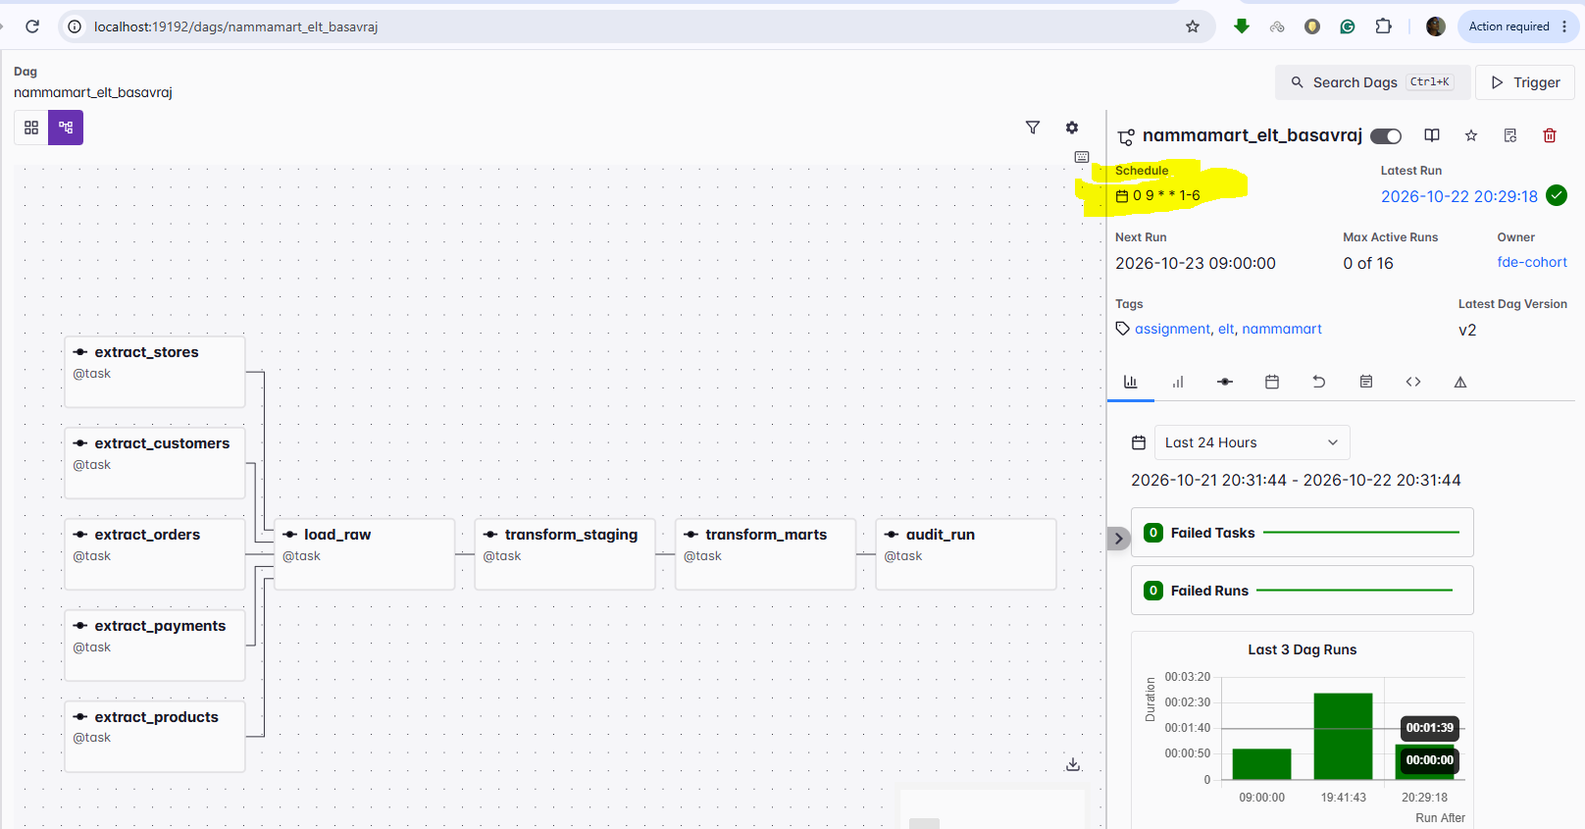
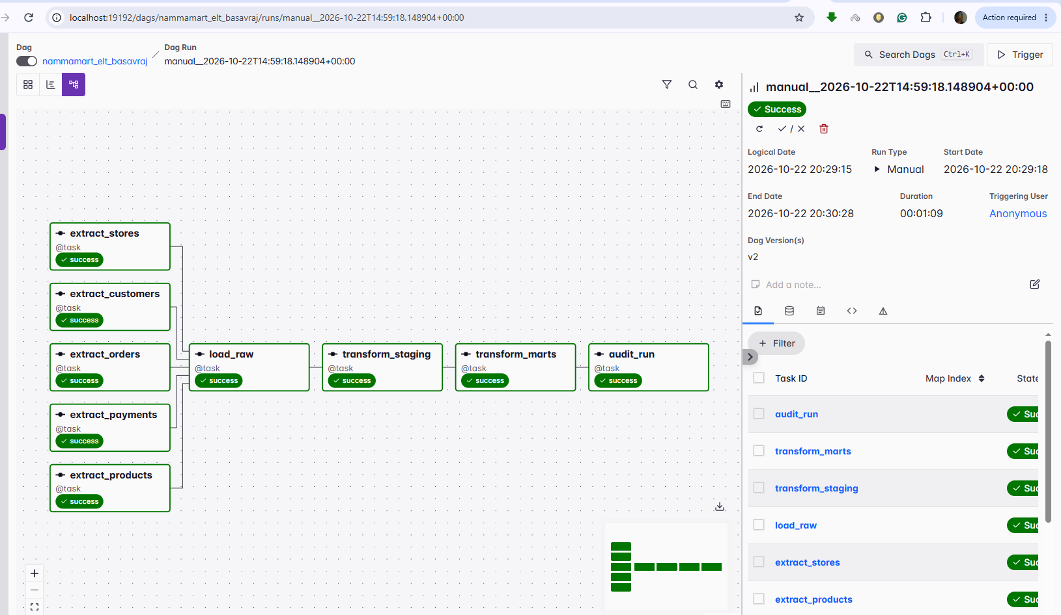

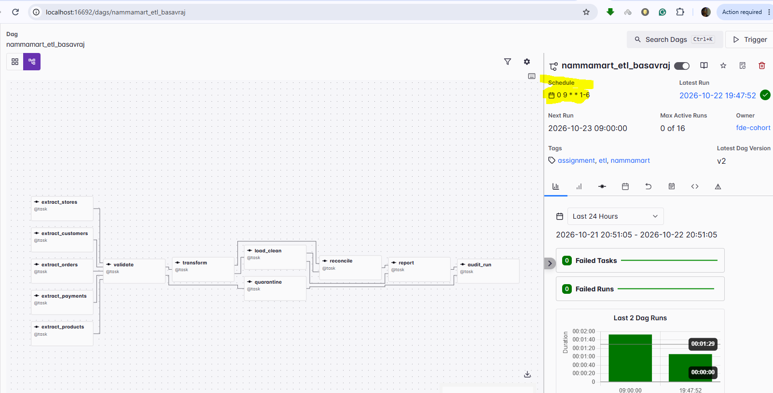
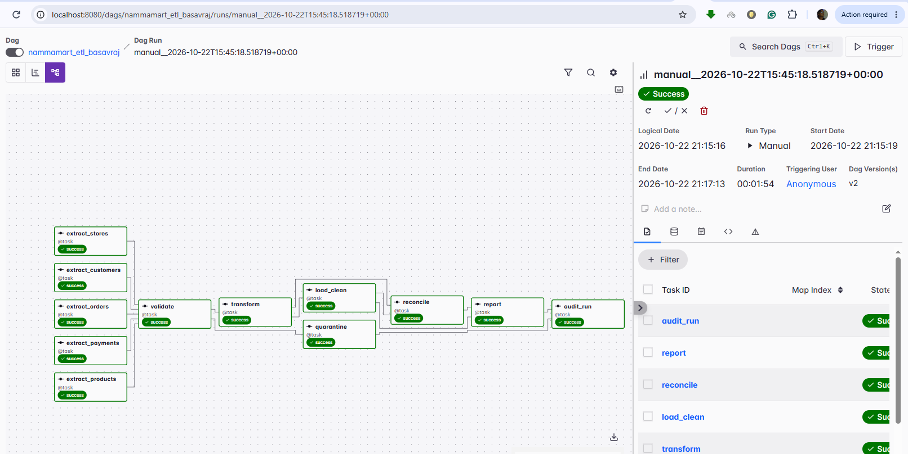

- Answers to all six business questions, as SQL plus result, from both pipelines
Added in SUBMISSION.md
- No API keys, passwords, webhook URLs or unmasked customer data in the repo outside include/data/

