|  |  |
| --- | --- |
| A picture of a winding road and trees  Support Engineer Report | Submitted by,  Basavraj Jaliminhe (8800149) |

**Improvement -1** :- KPI Labels on dashboard are not formatted, example: “Total Models” or “Vehicle Replacement Filter” – not a proper user-friendly label.

**Before Fix**:

**After Fix**:

**Justifcation** :- After fixing the KPI labels look more user friendly. This fix can be made easily by double clicking on KPI label and changing the name.

**Improvement -2 :** Filters are very large on the screen. Not user appealing.

**Before fix:**

**After fix :**

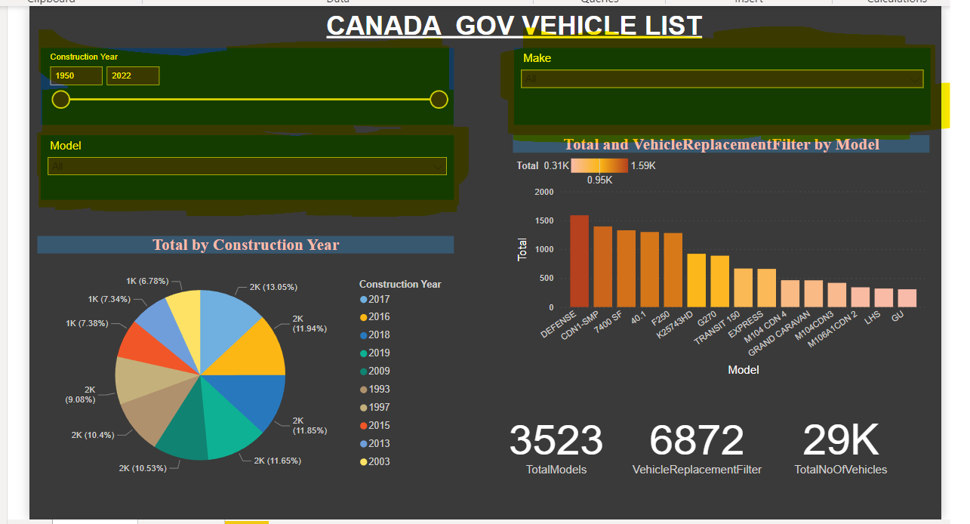

Pro of testing someone’s dashboard:-

Undoubtedly, when looking at other people's work, we will pick up some fresh notions and ideas. It will enhance the Power Bi tool's functionality and comprehension.

Con of testing someone’s dashboard:-

The fundamental issue with testing is that the requirements are not understood. No matter how well the tester tests the dashboard, he/she will never detect the issue if the requirements are misinterpreted.