**Assignment-1**

**Name: Basavraj Jaliminche**

**Student ID:8800149**

**Email:** [**Bjaliminche0149@conestoga.on.ca**](mailto:Bjaliminche0149@conestoga.on.ca)

**Date of Submission: 6/1/2022**

**Setup:**  
For setting up a database, please download the sample schema found here. We are going to be using  
only the “HR: Human Resources” database for this assignment.

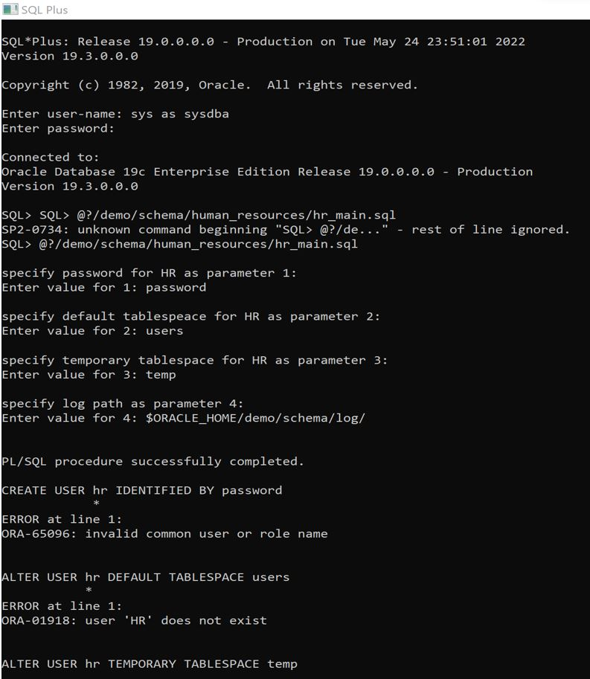

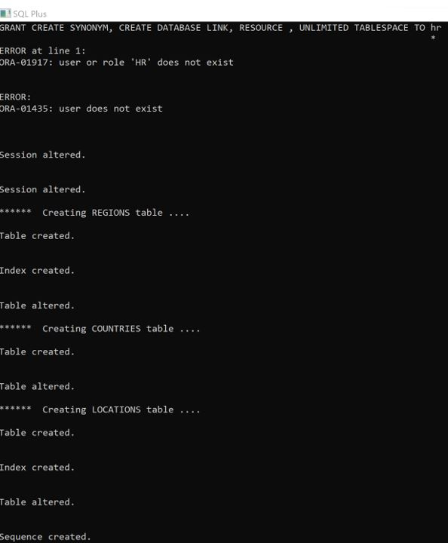

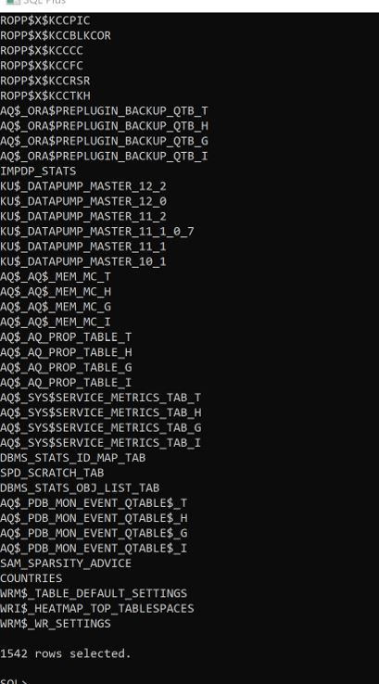

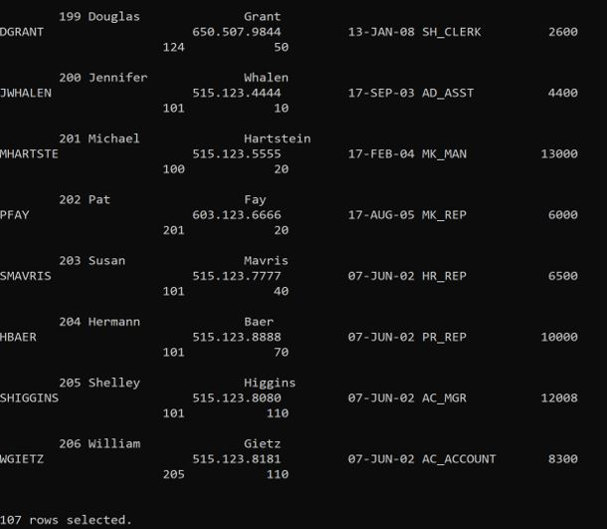

**Tasks:**

After setting up your database schema, perform the following actions on your Oracle instance and take  
screenshots of the command(s) issued as well as the result of the command. Paste each screenshot in a single  
MS Word document:

1. **Create five users on your Oracle instance – ensure that one of these users have your exact first and last  
   name.**

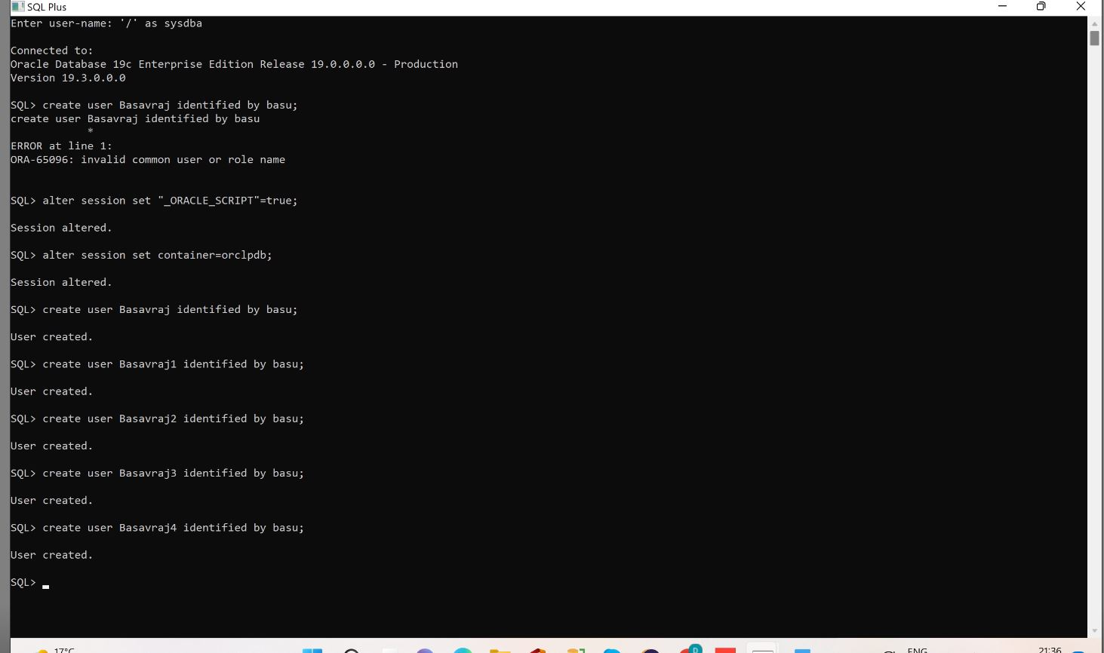

1. **Execute the proper command that shows these five users ordered by the CREATED date.**

Query: - Select * from all_users

Order by created;

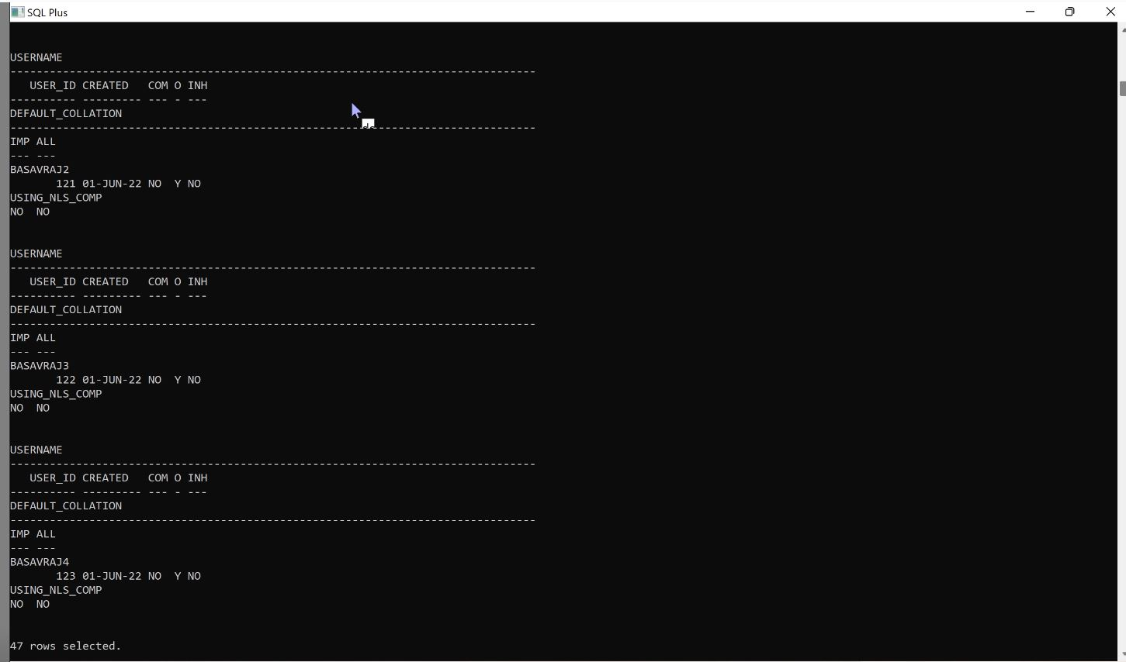

1. **Grant the user with your first and last name with SESSION access as well as the ability to create a table.:-**

**Querty:**

Grant unlimited tablespace to Basavraj;

Grant table,create session,unlimited tablespace to Basavraj

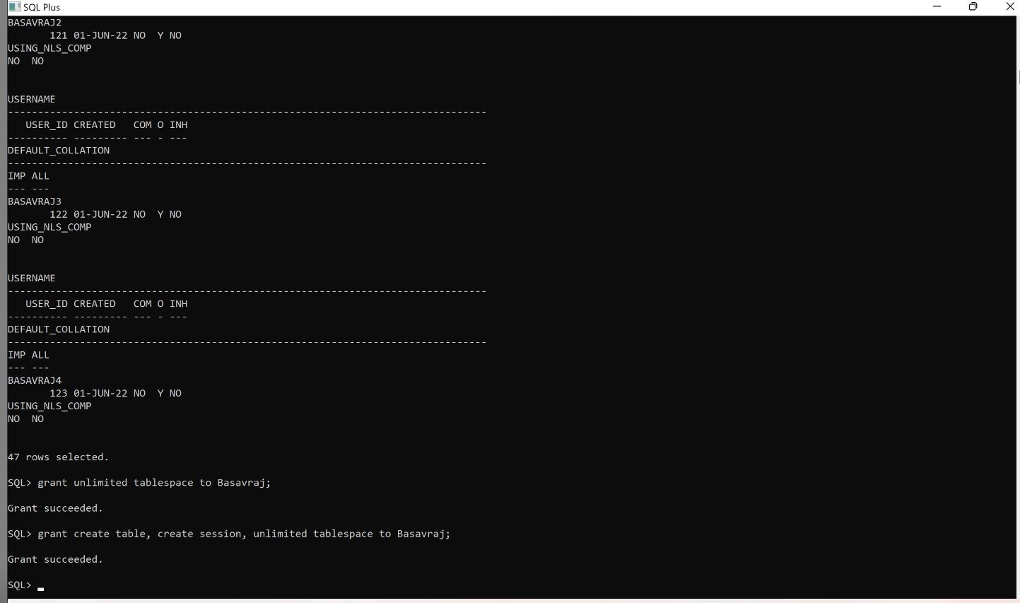

1. **Grant this user with the SELECT, INSERT, UPDATE and DELETE object privileges on a table within this  
   database.**

**Query:** grant select on hr.employees to Basavraj;

grant update on hr.employees to Basavraj;

grant delete on hr.employees to Basavraj;

grant alter on hr.employees to Basavraj;

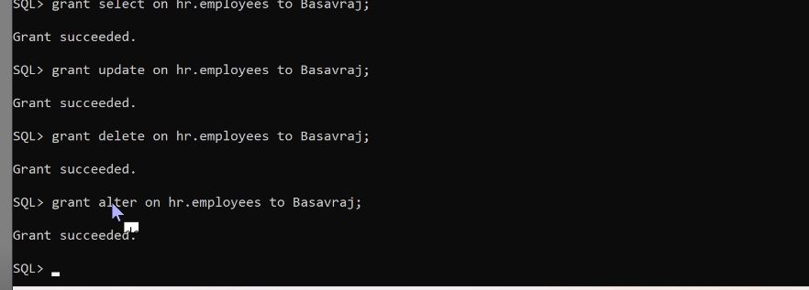

1. **Login as this user and ensure that the user can run a simple select query on the HR table.**

**Query:** connect Basavraj/basu@localhost:1521/orclpbd;

Select * from hr.employees;

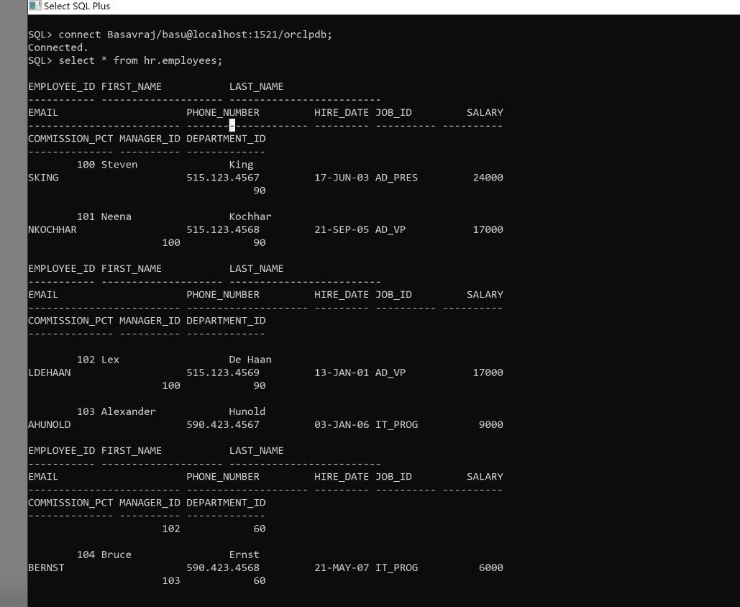

1. **Now, revoke all of the object privileges from that user and repeat the select query.**

Query: revoke select on hr.employees from Basavraj

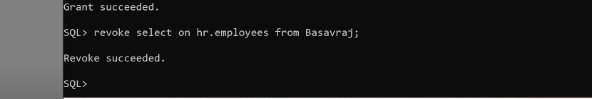

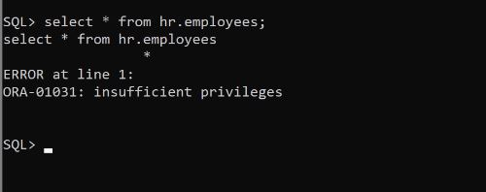

1. **Revoke the system privilege for this user to create a table.**

Revoke create table from Basavraj;

Revoke create session from Basavraj;

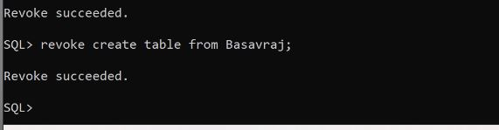

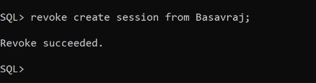

1. **Attempt to create a table from this user’s account.**

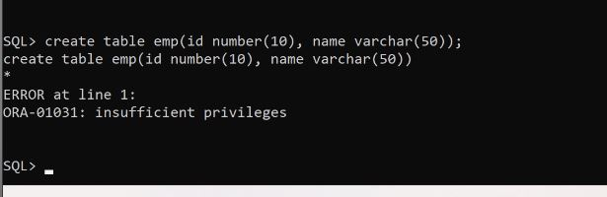

1. **Finally, revoke the ability for that user to login and then attempt to login using that user.**

