**Assignment-2**

**Name: Basavraj Jaliminche**

**Student ID:8800149**

**Email:** [**Bjaliminche0149@conestoga.on.ca**](mailto:Bjaliminche0149@conestoga.on.ca)

**Date of Submission: 10/6/2022**

**Setup:**  
For setting up a database, please download the sample schema found here. We are going to be using  
only the “HR: Human Resources” database for this assignment.

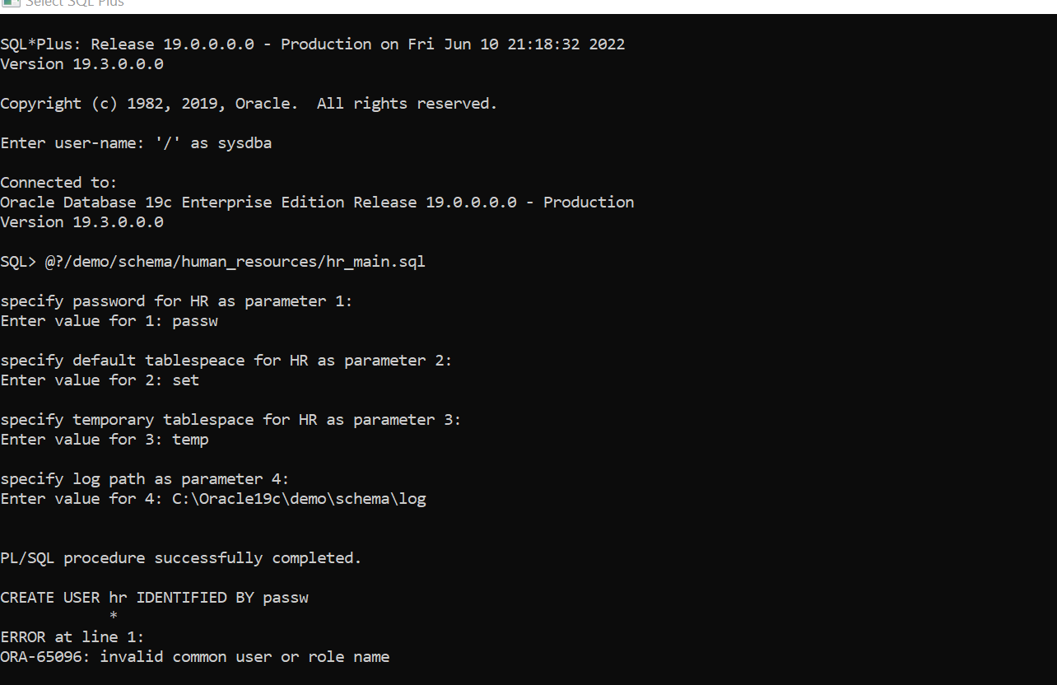

**Tasks:**

After setting up your database schema, perform the following actions on your Oracle instance and take  
screenshots of the command(s) issued as well as the result of the command. Paste each screenshot in a single  
MS Word document:

1. Create five users on your Oracle instance – ensure that these users have your exact first and last name  
   along with a counter as follows: {first_name}_{last_name}_01, {first_name}_{last_name}_02,  
   {first_name}_{last_name}_03, etc..

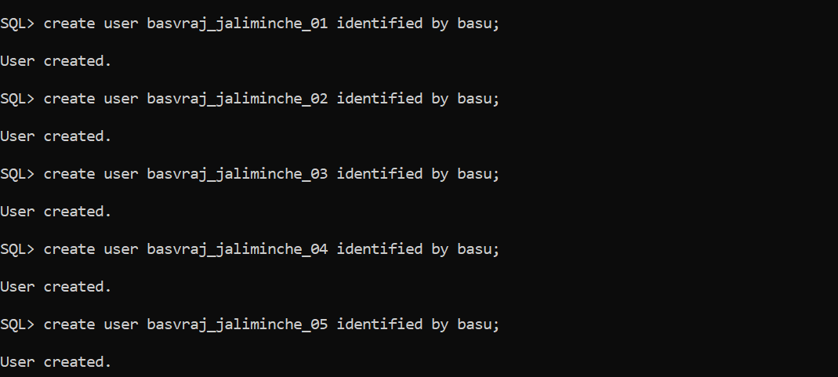

1. Create a role: {your_student_id}_admin – where {your_student_id} is your seven digit CC student id.

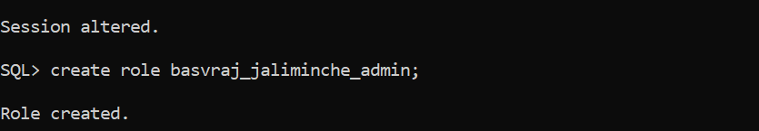

1. For this role, ensure to provide the SELECT, INSERT, UPDATE and DELETE capabilities to a table in your database.



1. Assign two of your users to this role – the _01 and _02 users in particular.

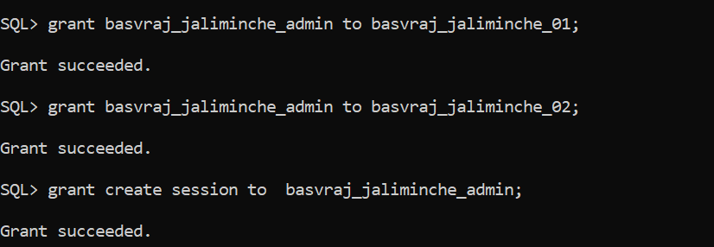

1. Perform the actions of SELECT, INSERT, UPDATE and DELETE to confirm that the role is functional

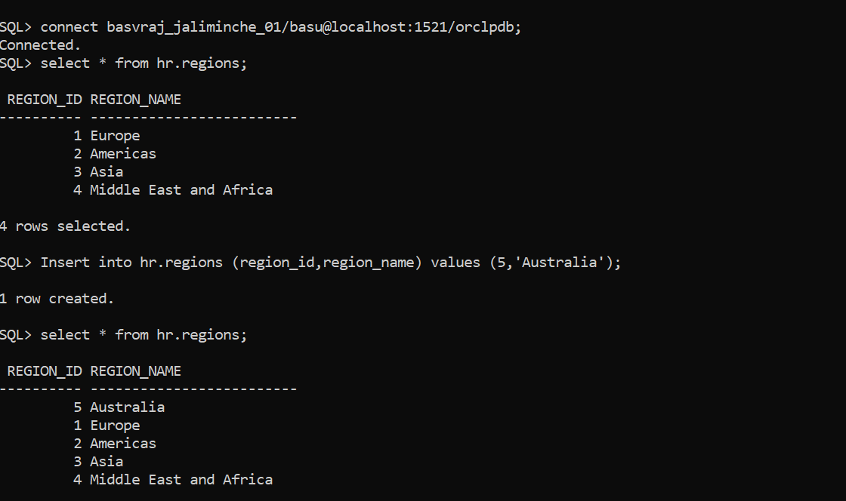

1. Using a user (_03) that is not provided such capabilities, attempt to perform the SELECT, INSERT, UPDATE and DELETE actions. What do you notice?

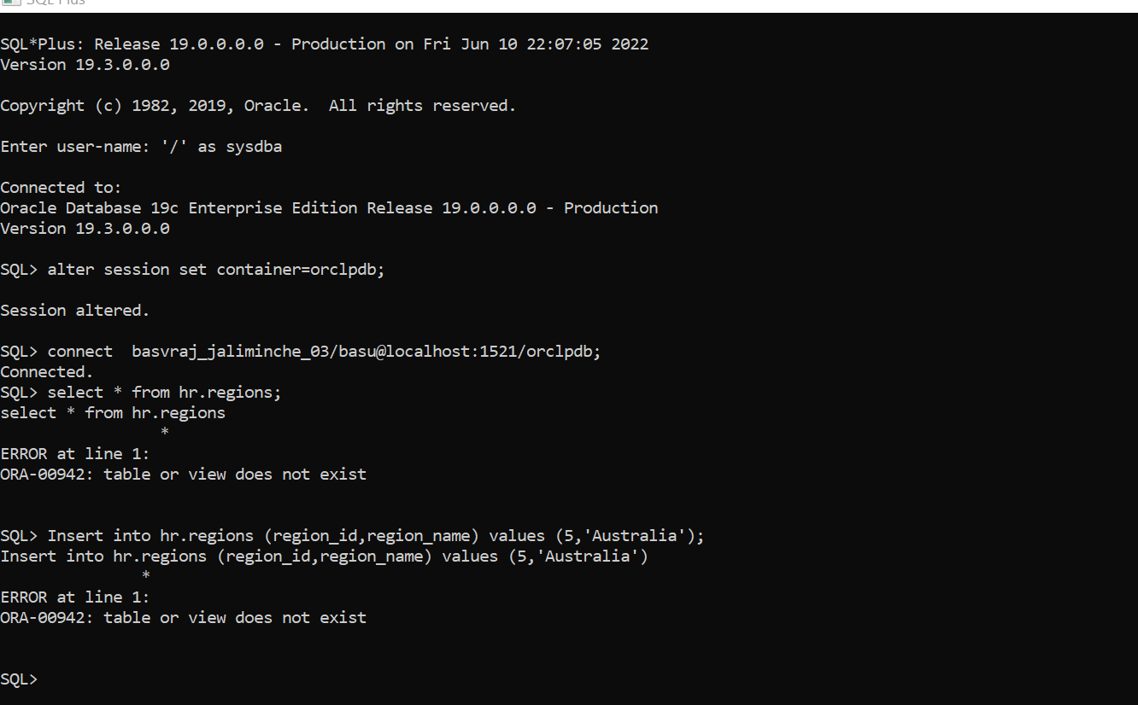

1. Add user (_04) to have the capabilities and redo the last step. What do you notice?

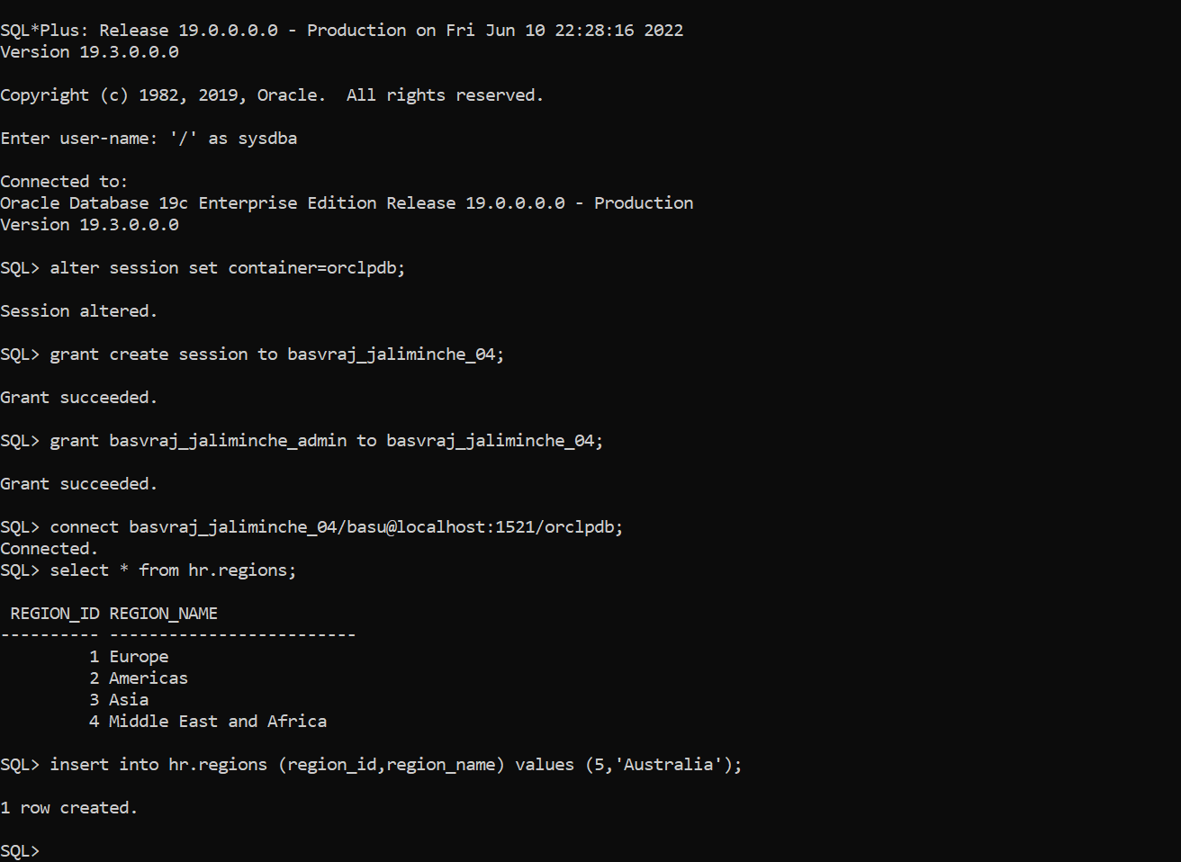

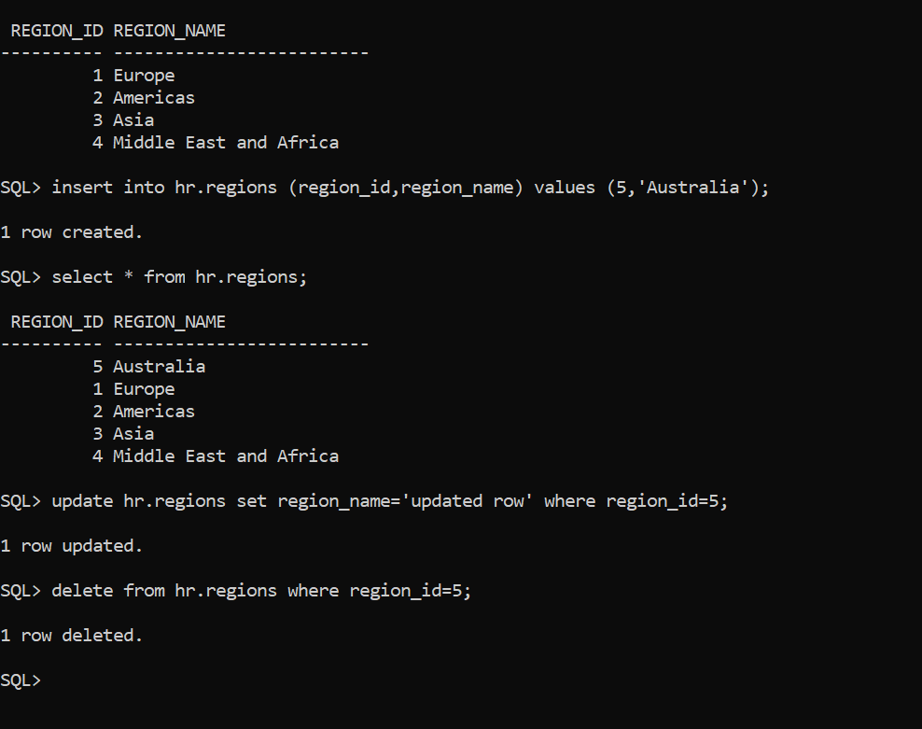

1. Alter the role and remove the DELETE capability.

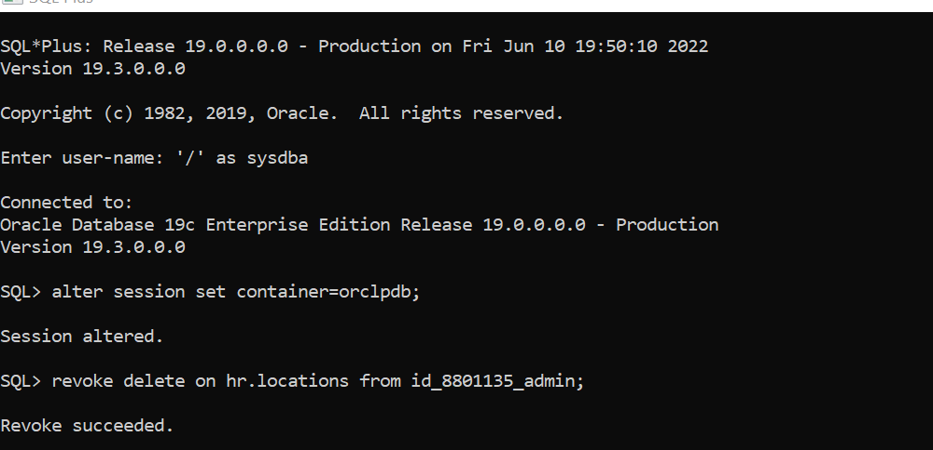

1. Now, with user _02, attempt to delete a table using their account. What happens now?

