**TITLE OF THE PAPER**

Name of the first author1 and Name of the second author2

*1Affiliation of the first author (name of the institution and address)*

*2Affiliation of the second author (if different from first author)*

|  |  |
| --- | --- |
| **Please check one of the following topics:** | |
| Condensed Matter Physics |  |
| Theoretical and Computational Physics |  |
| Applied Physics and Interdisciplinarity |  |
| Educational Physics |  |
|  |  |
| **Type of your contribution:** |  |
| Oral presentation |  |
| Poster presentation |  |

The abstract of the paper, one A4 page at most, including figures, tables and references, using for the references the following notation [1]. Use 12pt Times New Roman font and justified alignment with line spacing set to single.

Equations should be inserted using either the Equation Editor, Math Type or as images. Equations should be centered or in-line with the text. Equations that are centered should be numbered with the number appearing at the right of the paragraph as (x). Reference equations using Eq. (x).

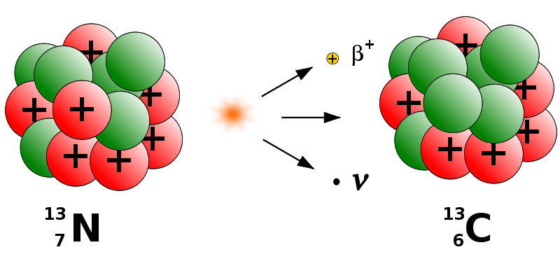

*Figure 1:**Figures should be numbered and figure captions in italics using font size 10.*

The figures and tables must be clear and inserted in the text, with corresponding figure and table captions.

**Keywords**: keyword one, keyword two, keyword three.

**References:**

[1] Initials, Name, *Name of the Journal* **volume**, pages (year).

[2] A. N. Author, A. N. Other-author, *J. Phys.* X **4**, 1-6 (1984).