Andrew Ma and Philip Ross

CSSE373 Final Project

Milestone 1

1. It is possible to transmit all of the data in the sender’s buffer to the receiver’s buffer.

State 0

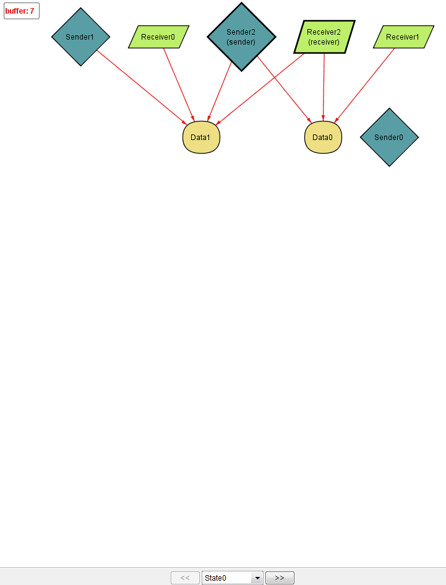

in this starting state, sender 2 is the initial sender which has data1 and data 0 in its buffer and Receiver2 is the first receiver which holds data1 and data 0 in its buffer.

State1

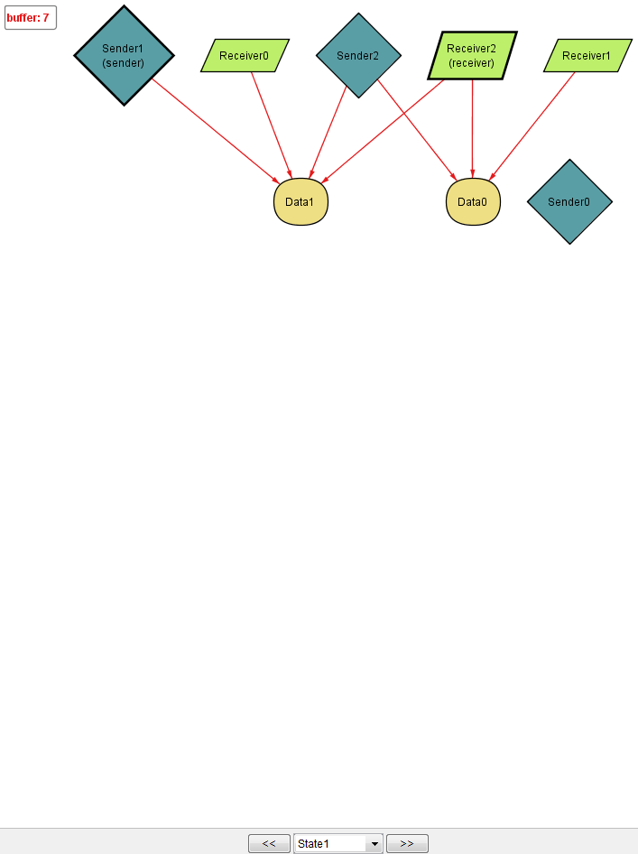

IN this state, we can see that the sender sent data 0 to the receiver. the sender only has data 1 now.

State 2

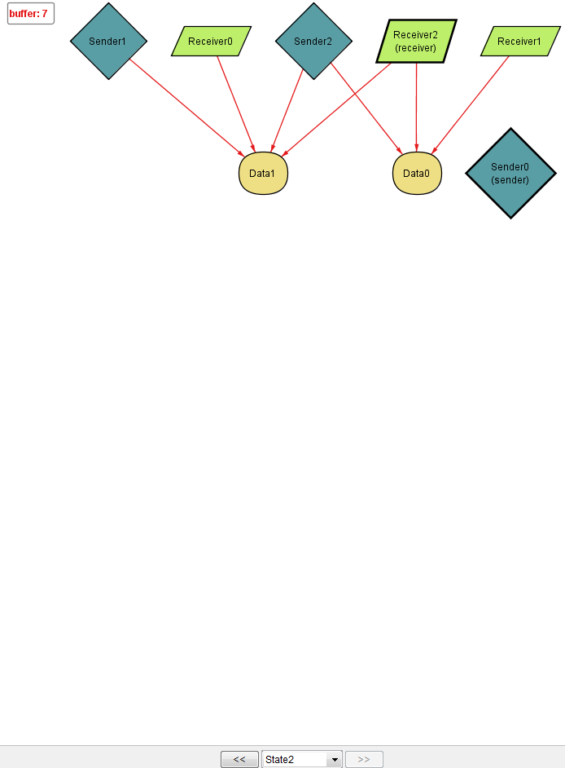

In the final state, we can see that the sender finally sent data1 to the receiver and the sender now has no data.

2. No counterexample was found. It is always possible to transmit all of the data in the sender’s buffer to the receiver’s buffer.

