1: it is possible to send all the data to the receiver.

State0:

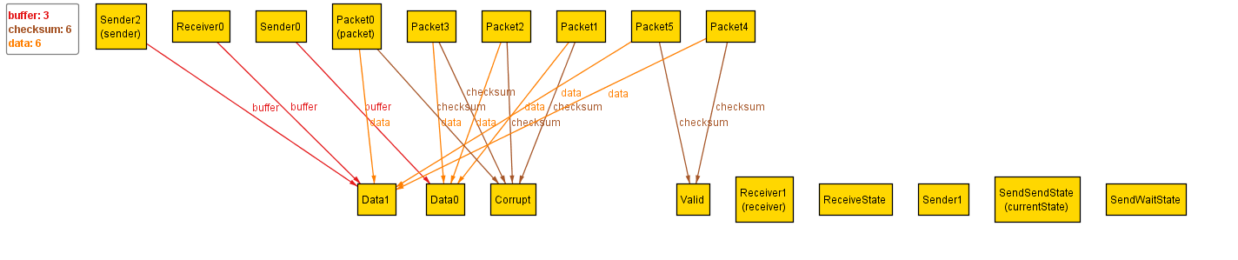State1: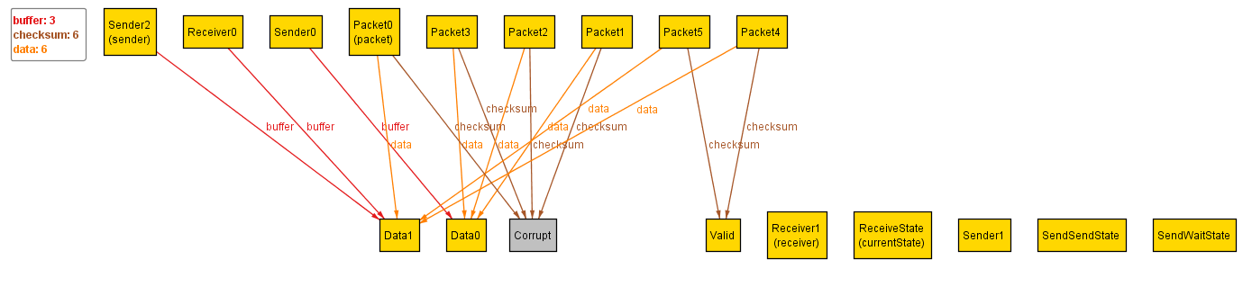State2: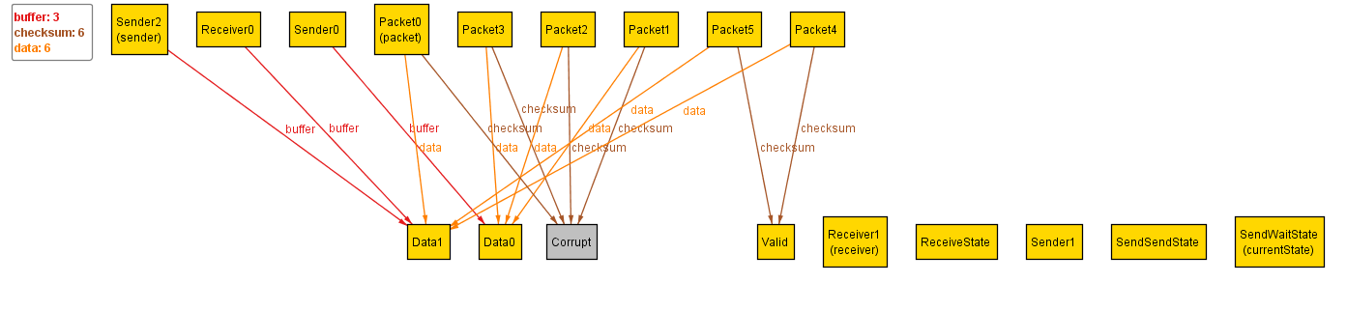State3: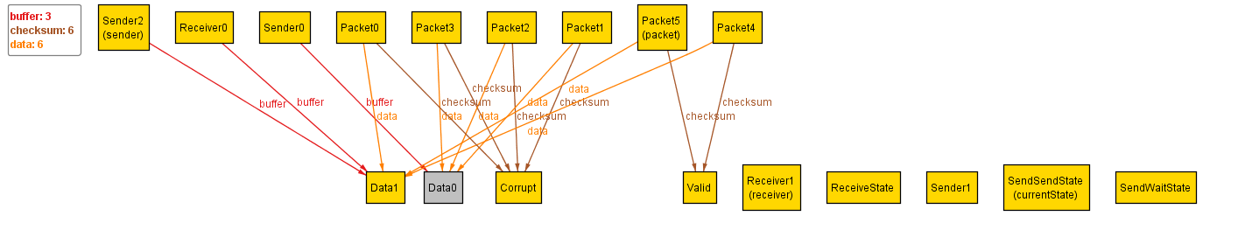State4: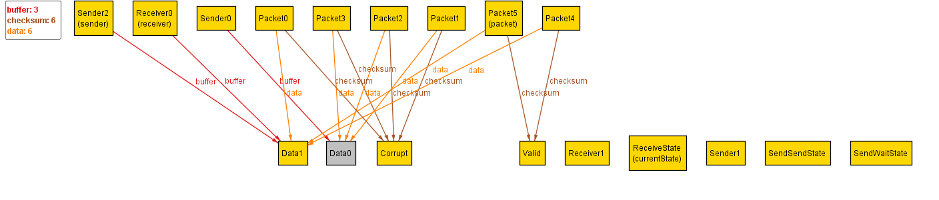State5: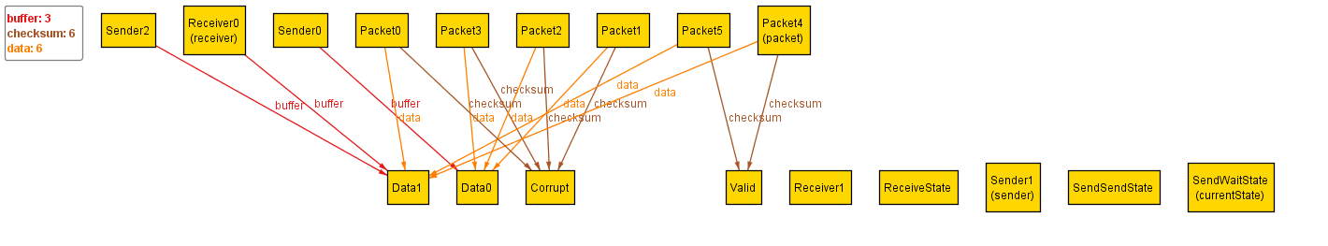

It is not possible to always send all the data to the receiver

State0:

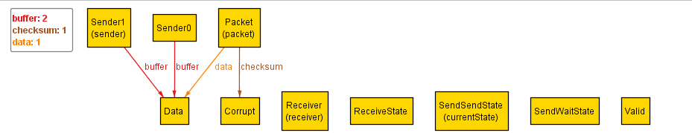State1: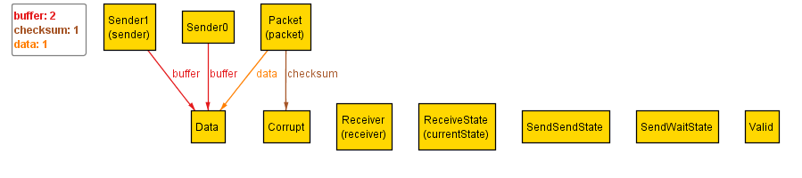State2: