Philip Ross and Andrew Ma

M3 CSSE 373

It is possible to send all the data from the sender to the receiver:

run WinningTrace for 6 State, 1 Data, 7 Stream, 4 Packet

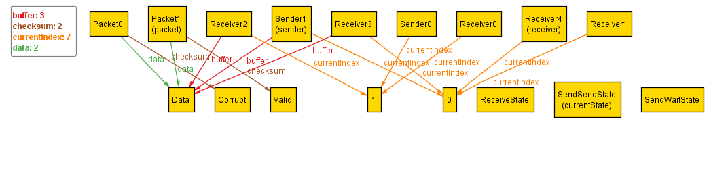

State0. Sender has Data. Packet1 has data and is valid. Sender’s index is 0.

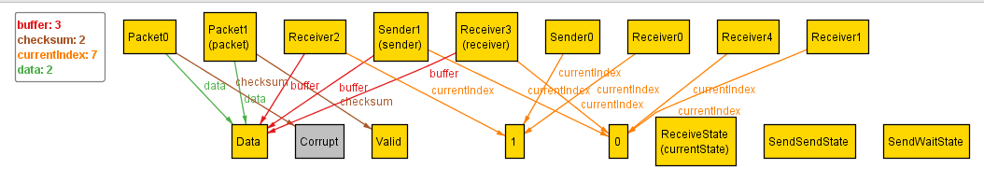

State1. Sender and packet 1 are unchanged. Receiver got the data successfully.

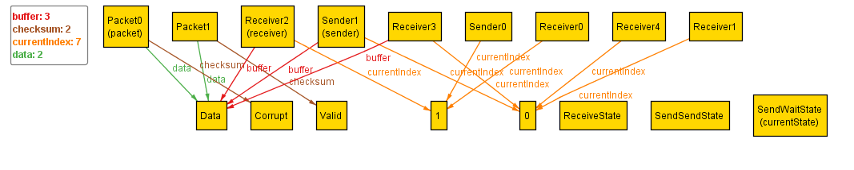

State2. Sender has seen that the send wasn’t successfully because the packet now says it is invalid. Sender stays at index 0 and will try to resend the data next state. Receiver successfully received the data and has updated its index to 1.

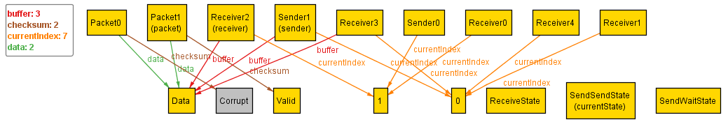

State3. Sender is re-packeting data and is sending it to receiver.

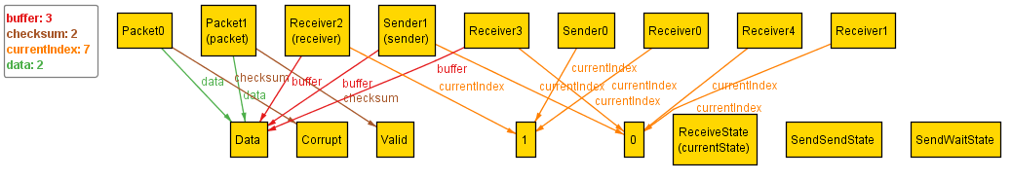

State4. Receiver knows that it has received this data and won’t add it to its list of received data.

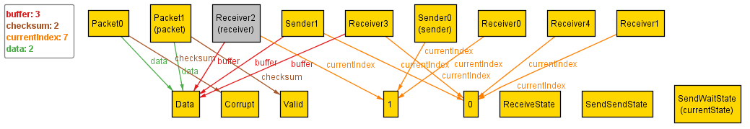

State5. Receiver stays at index 1 because it knows it already received the data. This time, since the packet hasn’t been corrupted, the sender now updates to index 1. Sender and receiver are in sync again.

It is not always possible to transmit all of the data in the sender’s buffer to the receiver’s buffer.

check transferAllData for 3 State, 2 Data, 10 Stream, 2 Packet

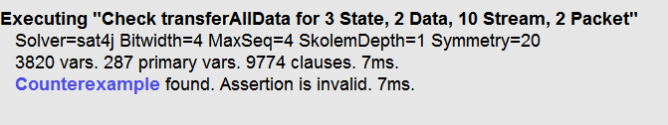

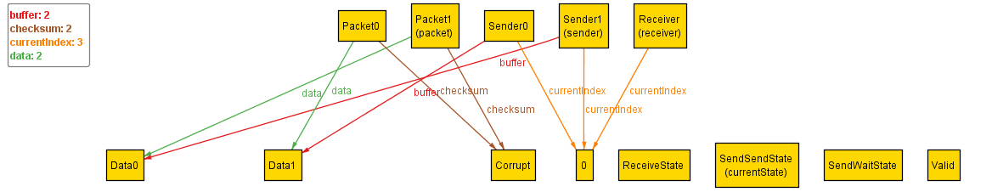

State0. Sender has Data0 and Data0. It is in a corrupt packet.

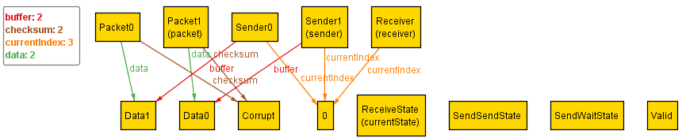

State1. Sender is unchanged, tried to send packet0, but receiver didn’t receive because it was corrupted.

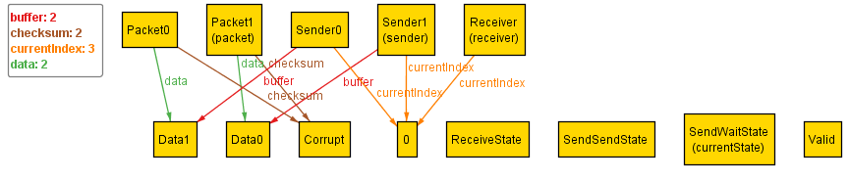

State2. Sender is trying to resend the data. Sender and receiver unchanged.