**Adjust Inventory** occurs when inventory is purchased and later Adjusted to the inventory.

**Adding Adjusts**

To add a new **Adjust**, follow these steps:

1. Click **Add New**

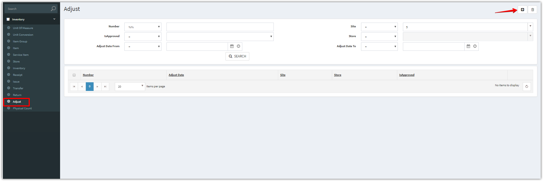

1. Complete the applicable data fields. * denote for required fields. Then click **Save.**

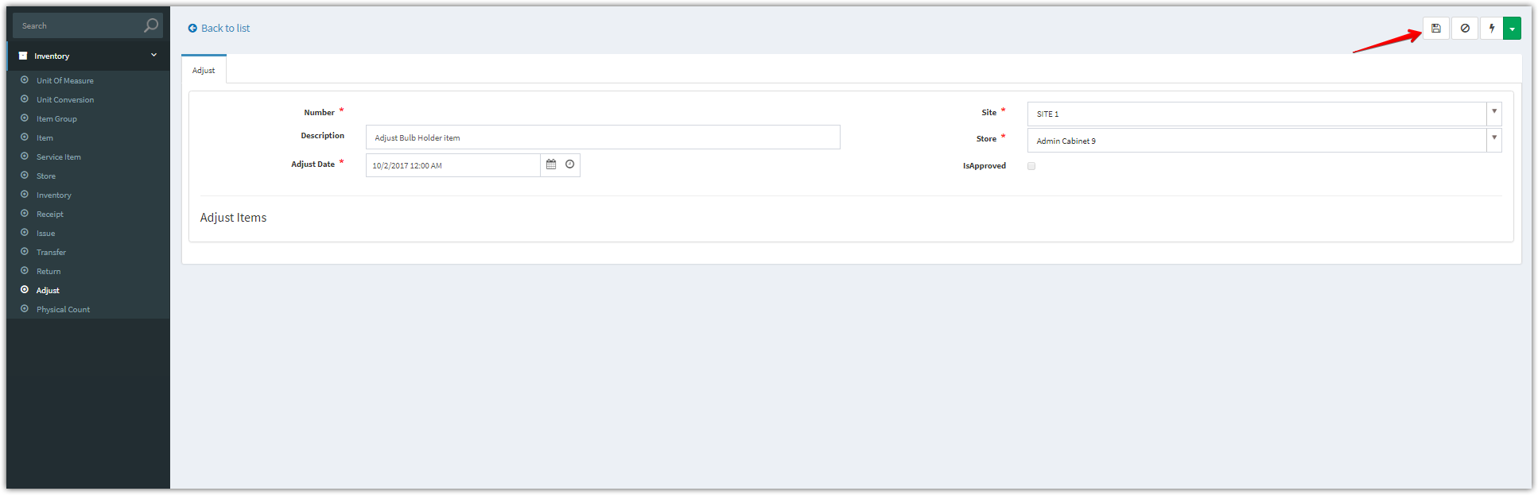

1. After clicking “**Save**” button. Add new items

Click **Add New** to add one item, **Add Multiple** to add multiple items

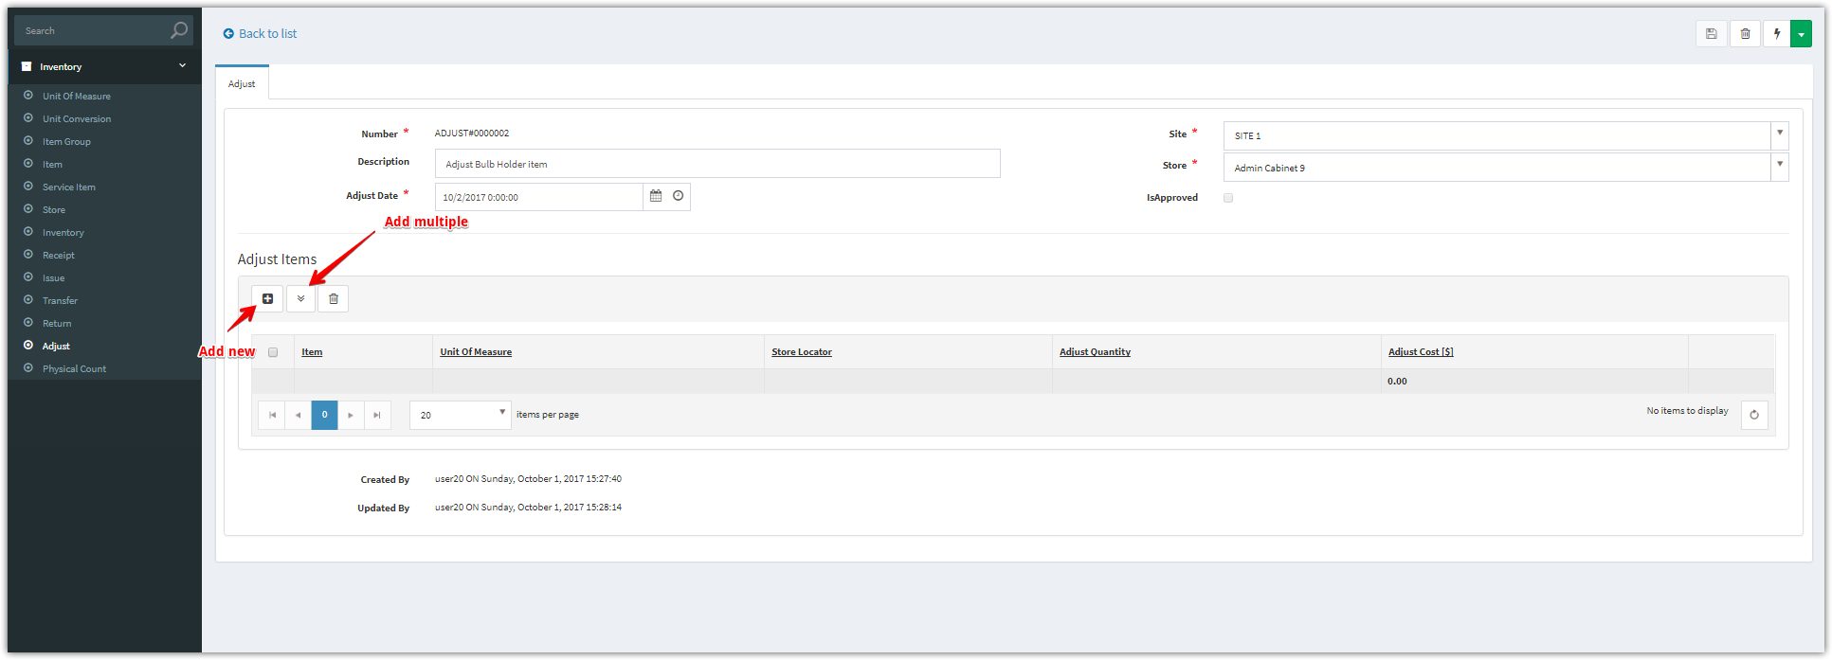

**Add New**

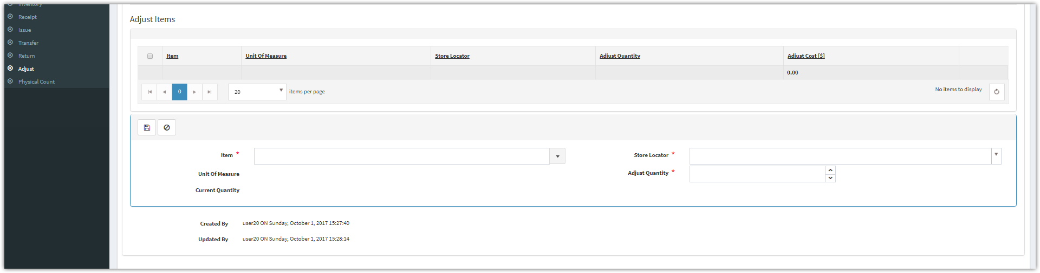

**Add Multiple**

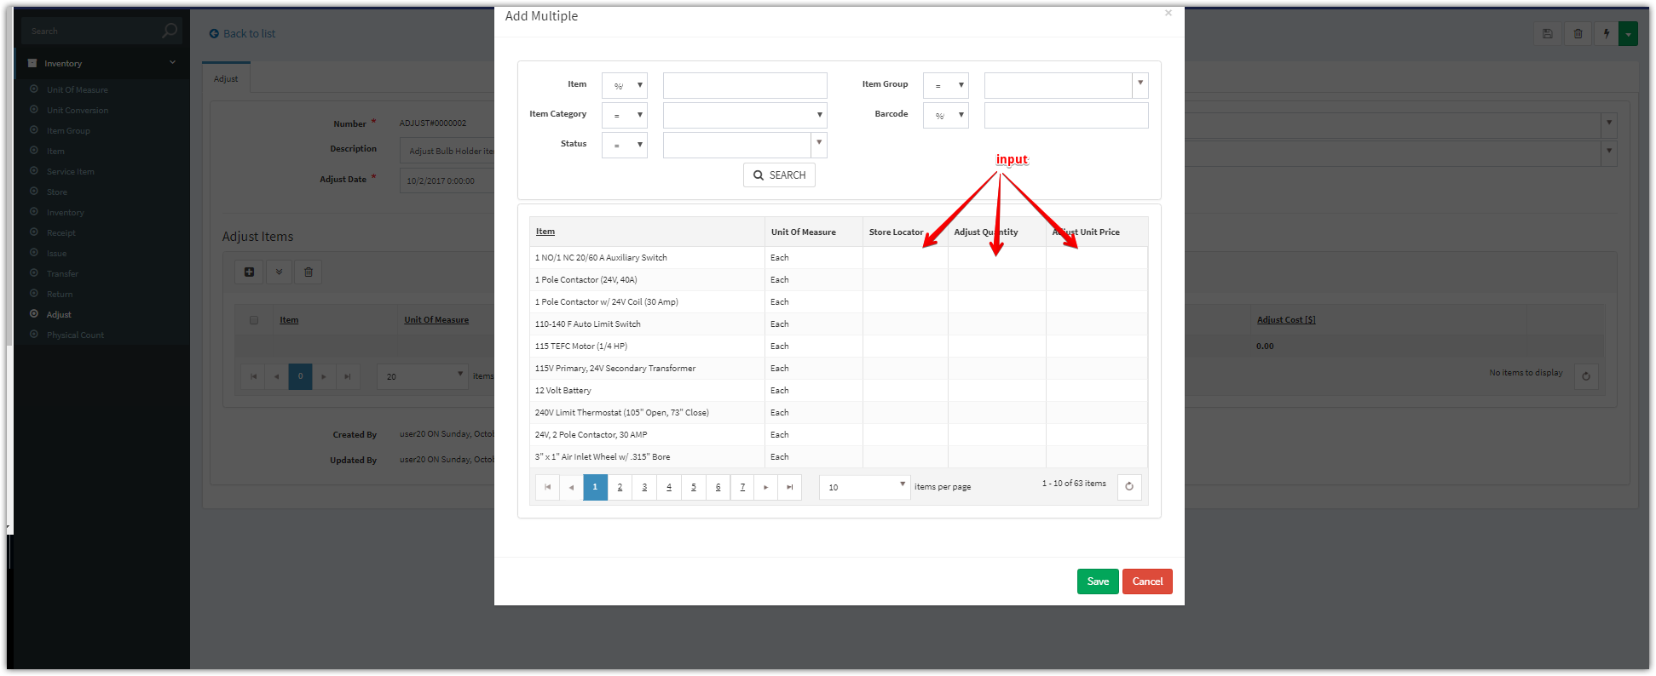

**Note:** we have 2 ways to adjust:

**+ Adjust Up** occurs when the adjust quantity always > 0

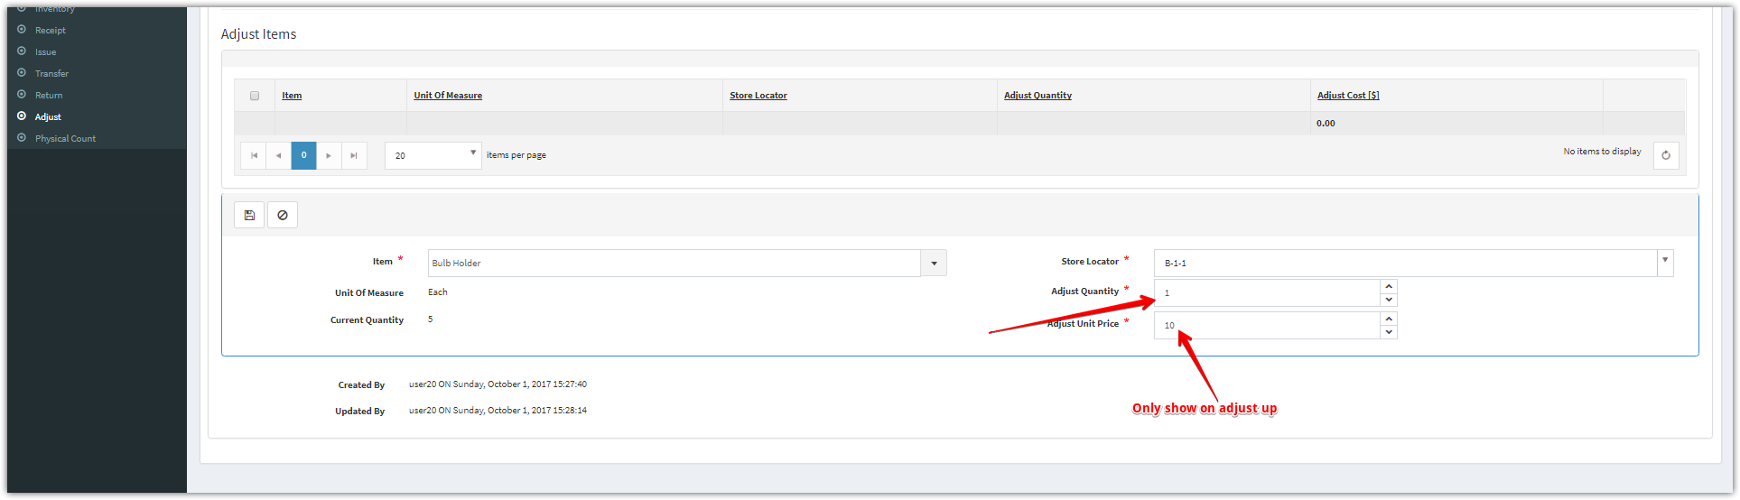

**+ Adjust Down** occurs when theadjust quantity always < 0

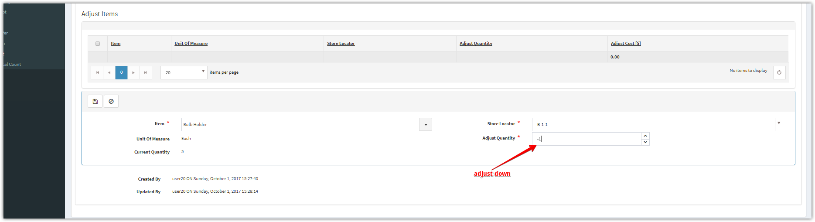

1. Click “**Approve**” button to approve for this Adjust

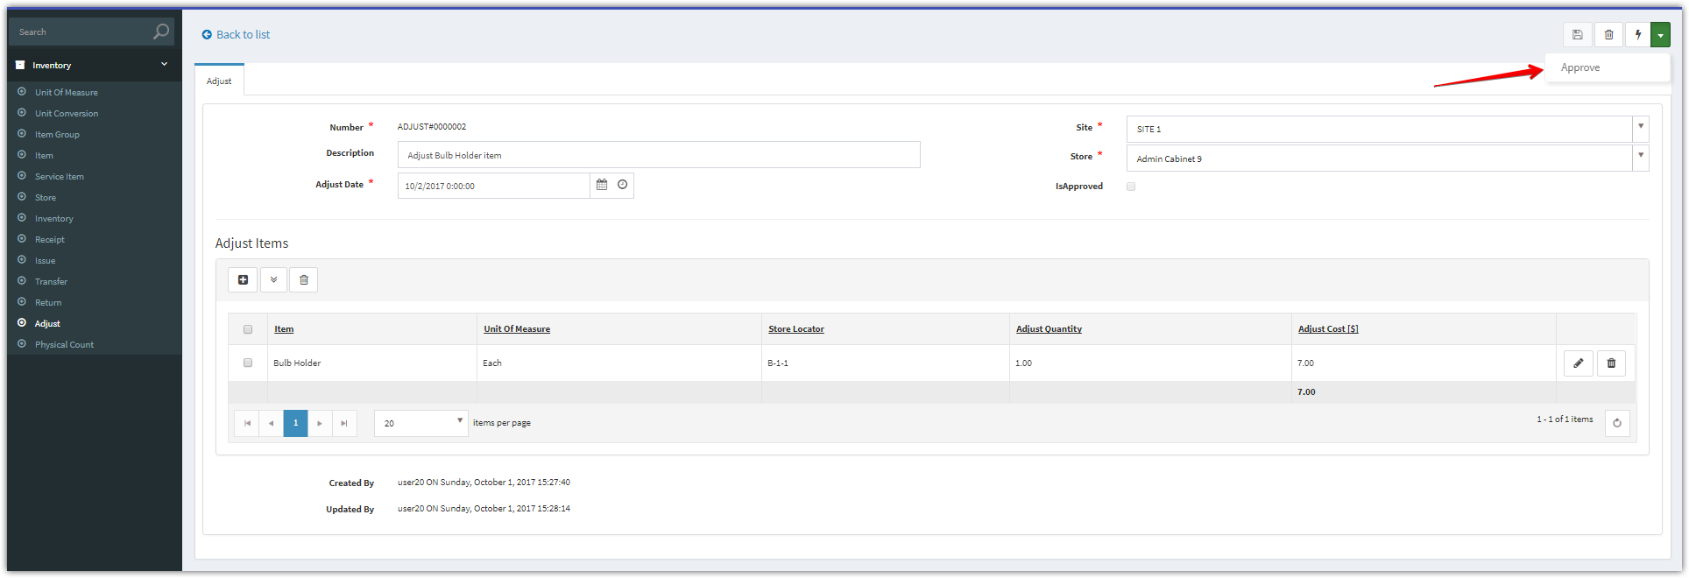

1. After approved, we checked and saw that the “**IsApproved’** checkbox was checked.

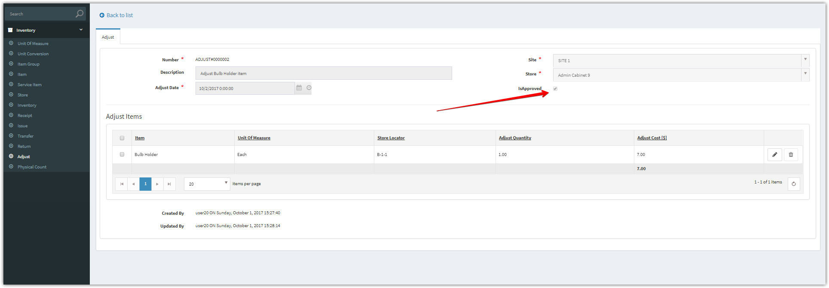

1. This adjust has been added into the inventory, please check this transaction into the inventory.

