**Issue** is a transaction for removing items out of the inventory, such as for a Work Order. An **Issue** will decrease item’s quantity on hand.

**Adding Issues**

To add a new **Issue**, follow these steps:

1. Click **Add New**

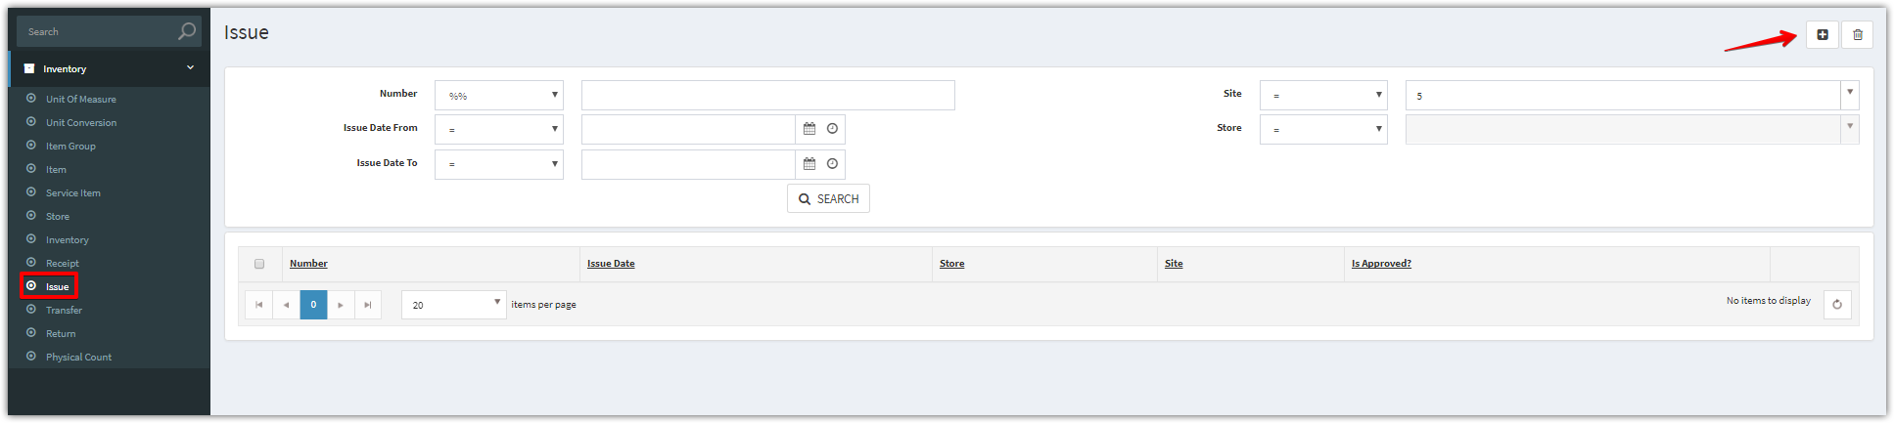

1. Complete the applicable data fields. * denote for required fields. Then click **Save.**

You can create an Issue for a **User** or a **Work Order**

**For a User**

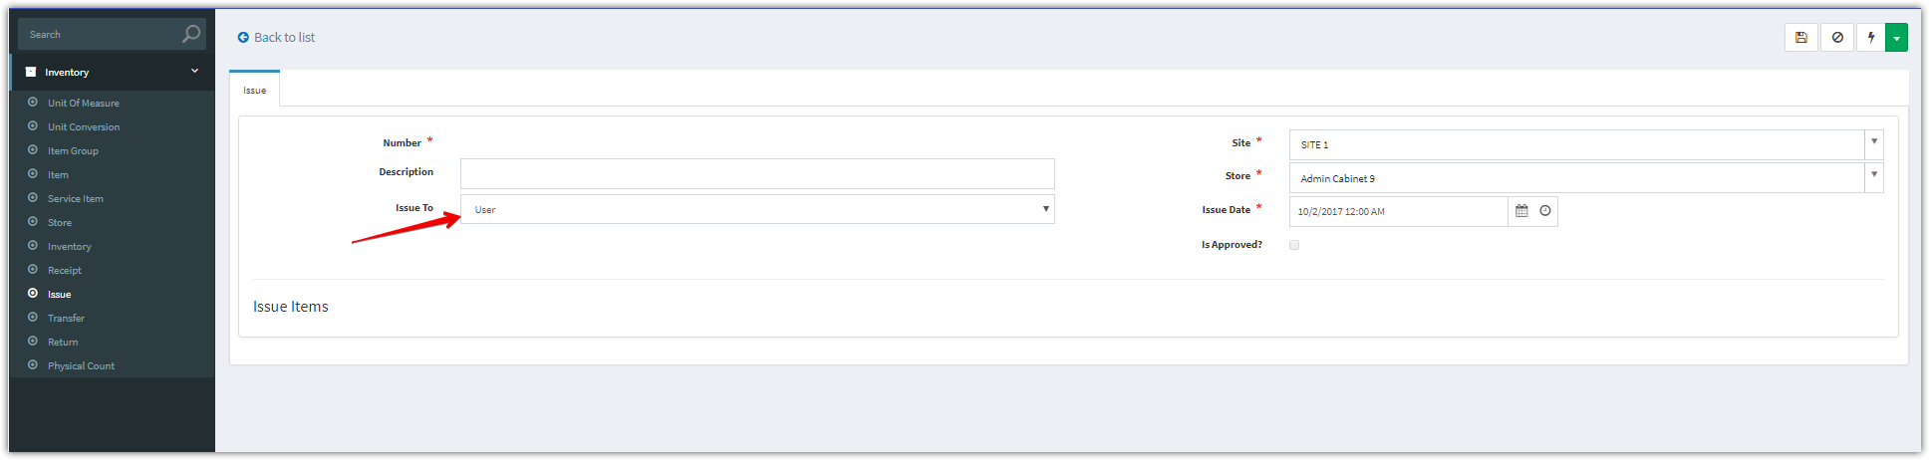

**For a Work Order**, you can select a Work Order to issue.

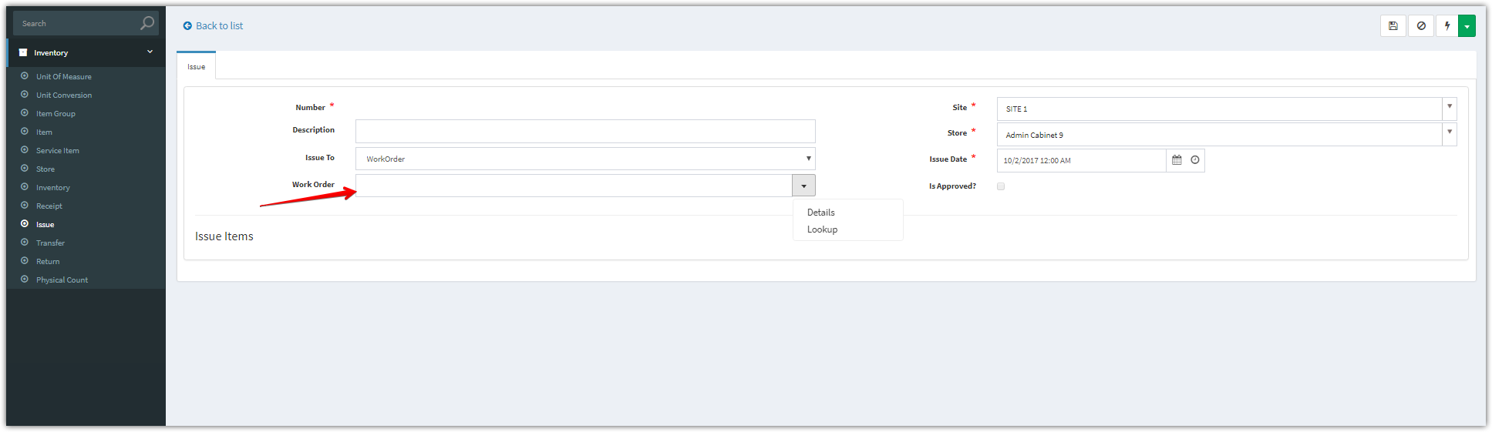

Complete the applicable data fields

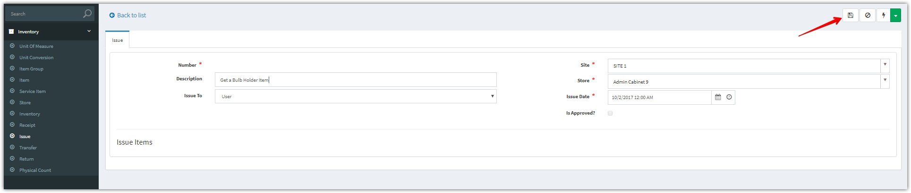

1. After clicking “**Save**” button. Add new items

Click **Add New** to add one item, **Add Multiple** to add multiple items

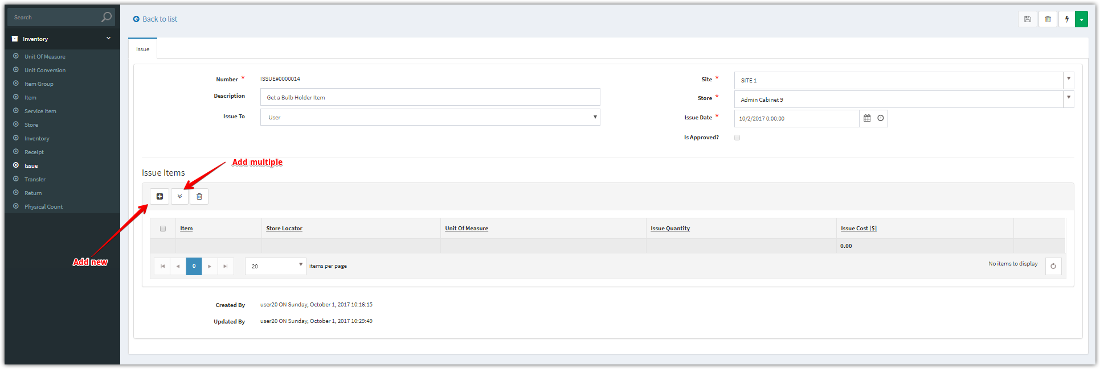

**Add New**

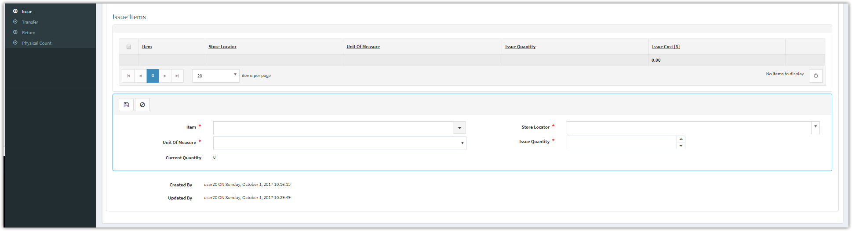

**Add Multiple**

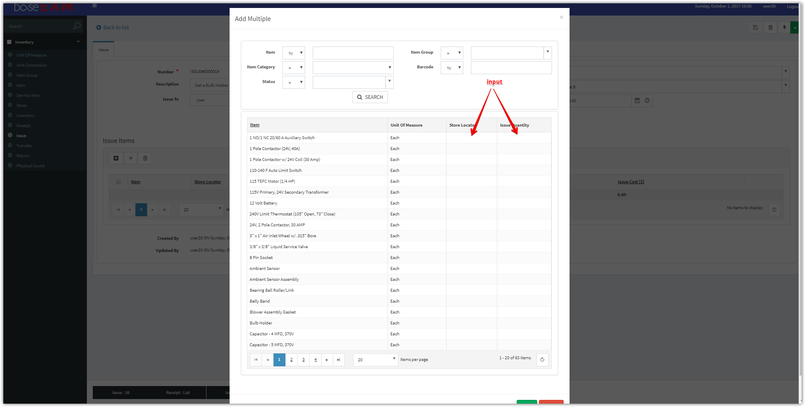

1. Click “**Approve**” to approve this issue

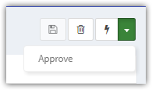

1. After approved, the “**Is Approved’** checkbox will be checked.

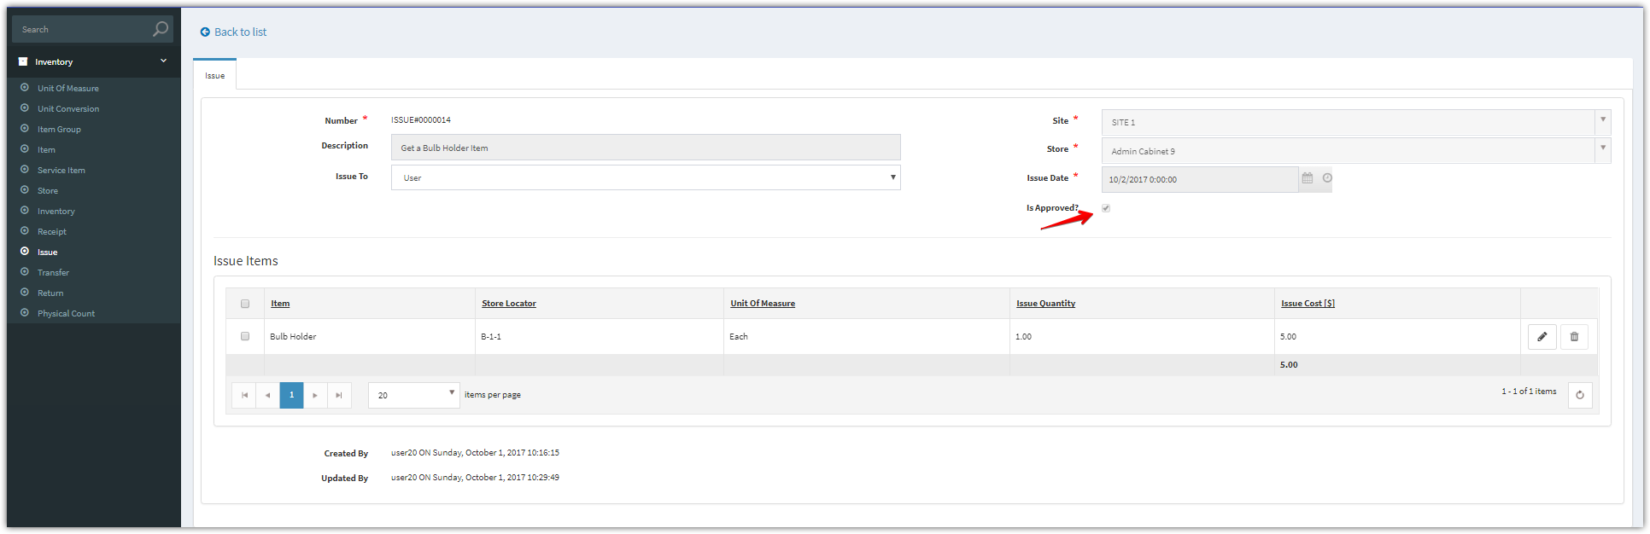

1. You can view the updated quantity and transaction history.

