**Receipt** is a transaction for the acceptance of items into inventory. A **Receipt** increases item’s quantity on hand.

**Adding Receipts**

To add a new **Receipt**, follow these steps:

1. Click **Add New**

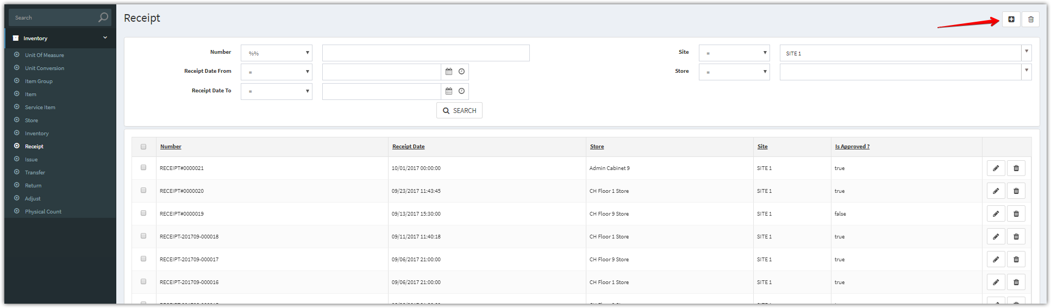

1. Complete the applicable data fields. * denote for required fields. Then click **Save.**

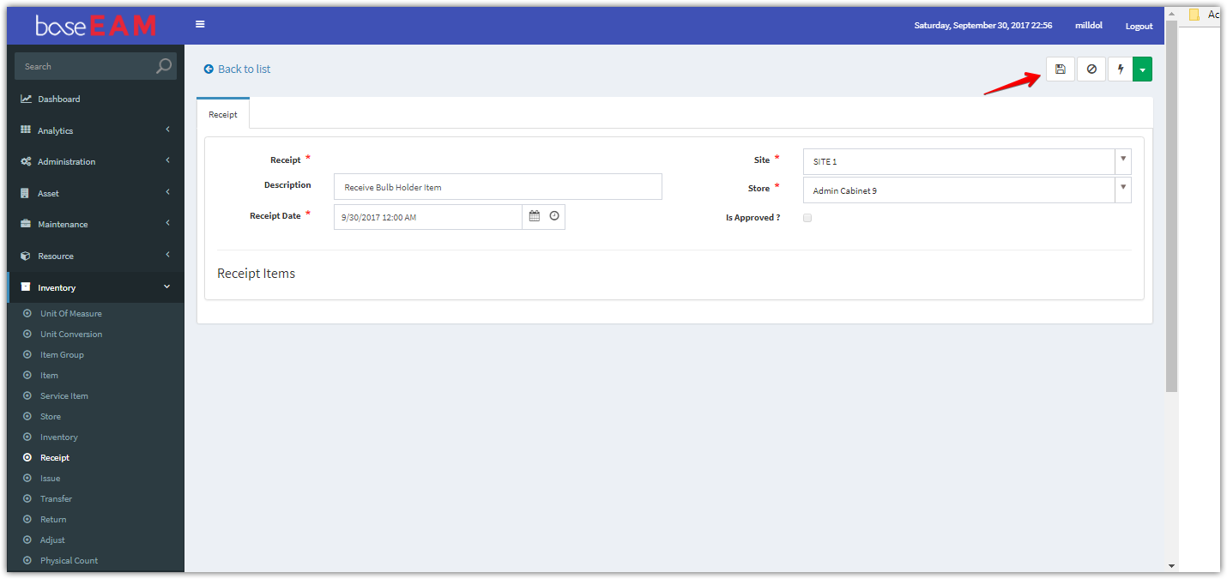

1. After clicking “**Save**” button. Add new items

Click **Add New** to add one item, **Add Multiple** to add multiple items

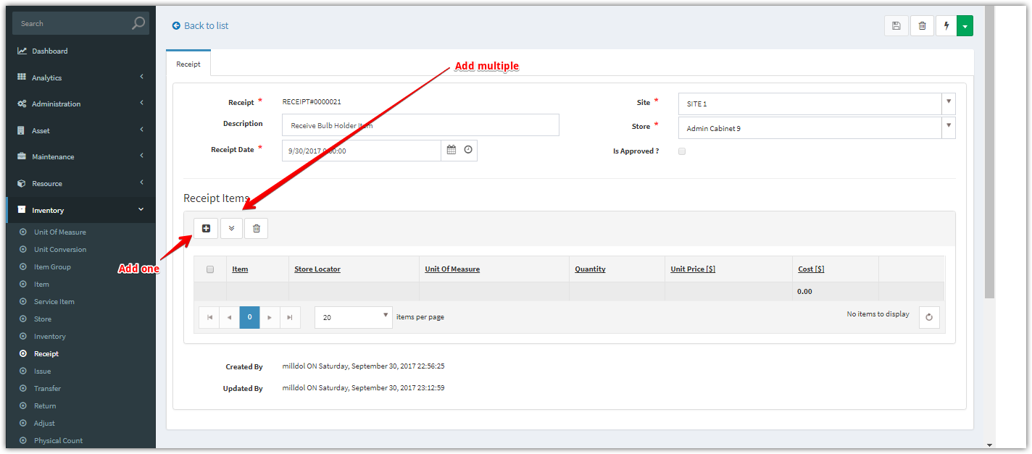

**Add New**

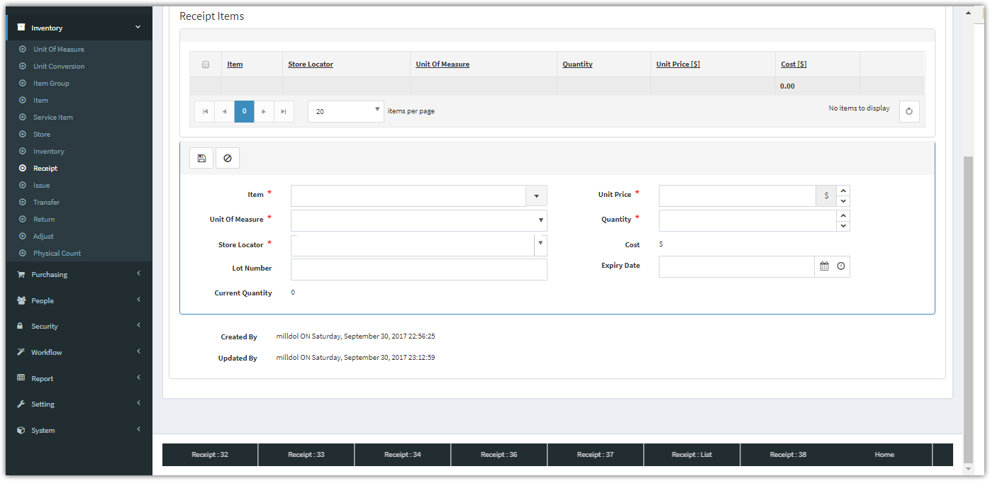

**Add Multiple**

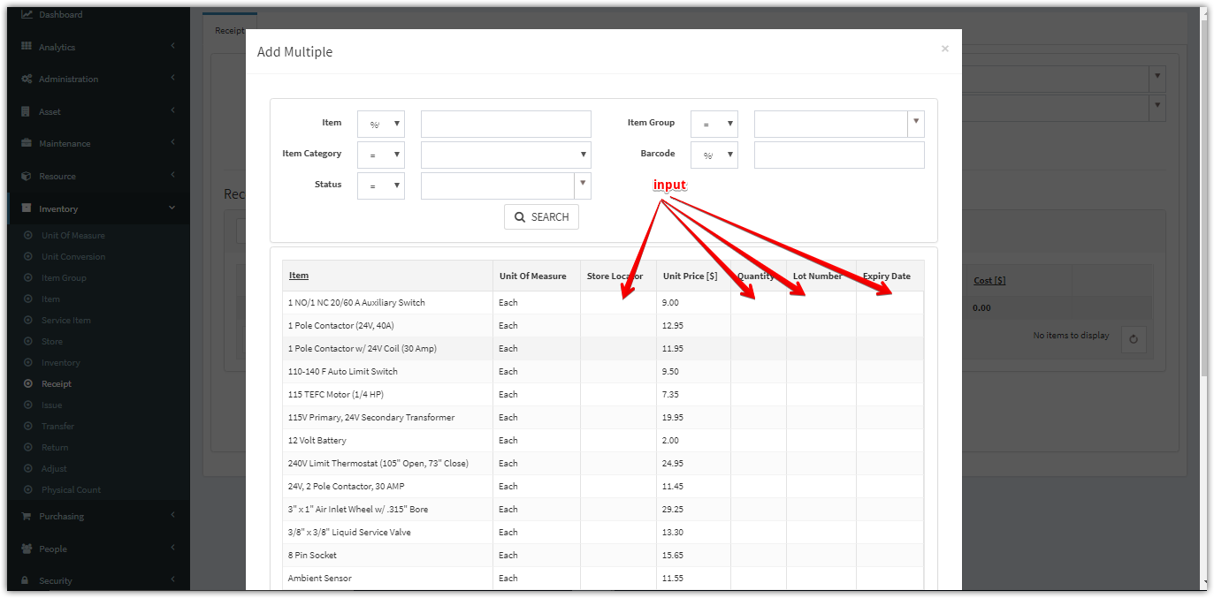

1. Click “**Approve**” to approve this **Receipt**

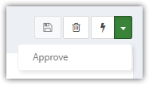

1. After approved, the “Is Approved’ checkbox will be checked.

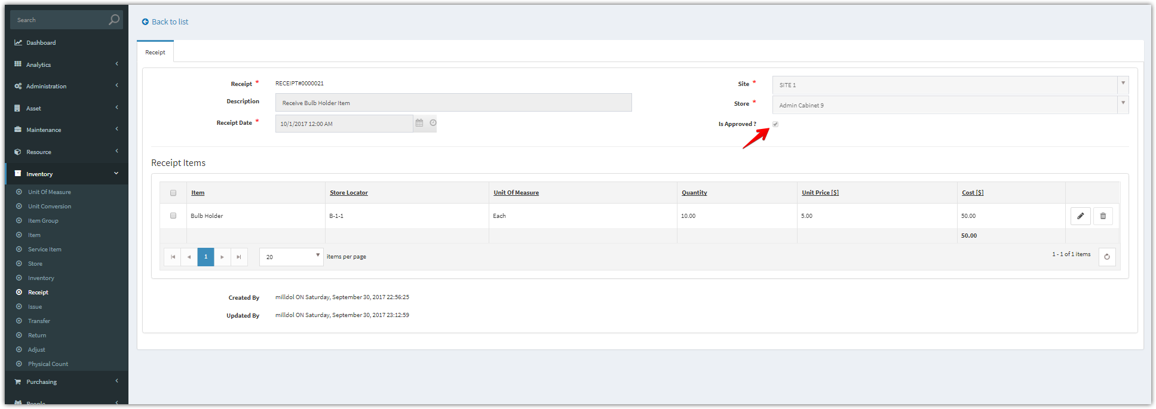

1. You can view the updated quantity and transaction history.

