**Return inventory** occurs when inventory is purchased and later returned to the inventory.

**Adding Returns**

To add a new **Return**, follow these steps:

1. Click **Add New**

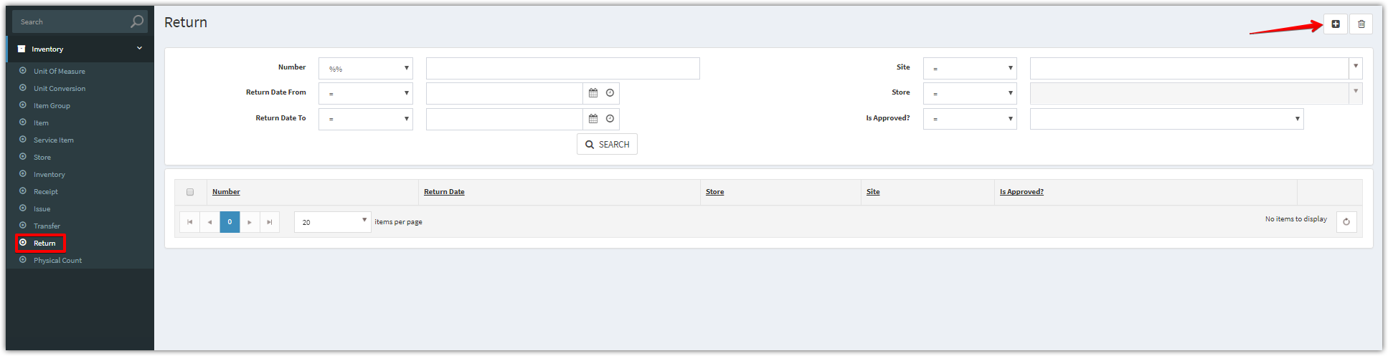

1. Complete the applicable data fields. * denote for required fields. Then click **Save.**

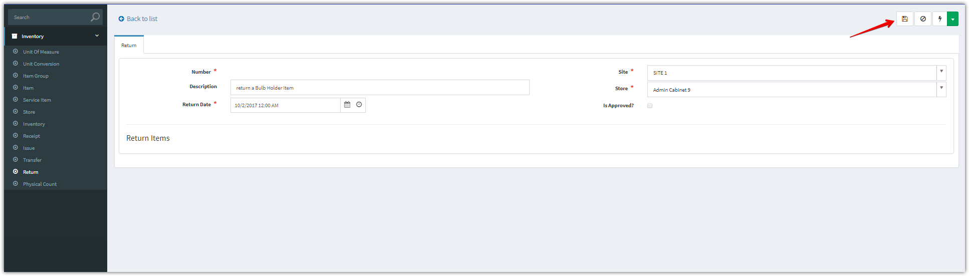

1. After clicking “**Save**” button. Add new items

Click **Add Multiple** to add multiple items

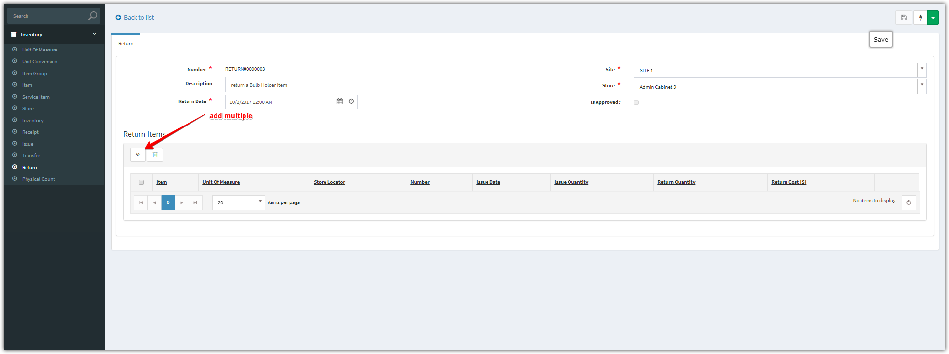

**Add Multiple**

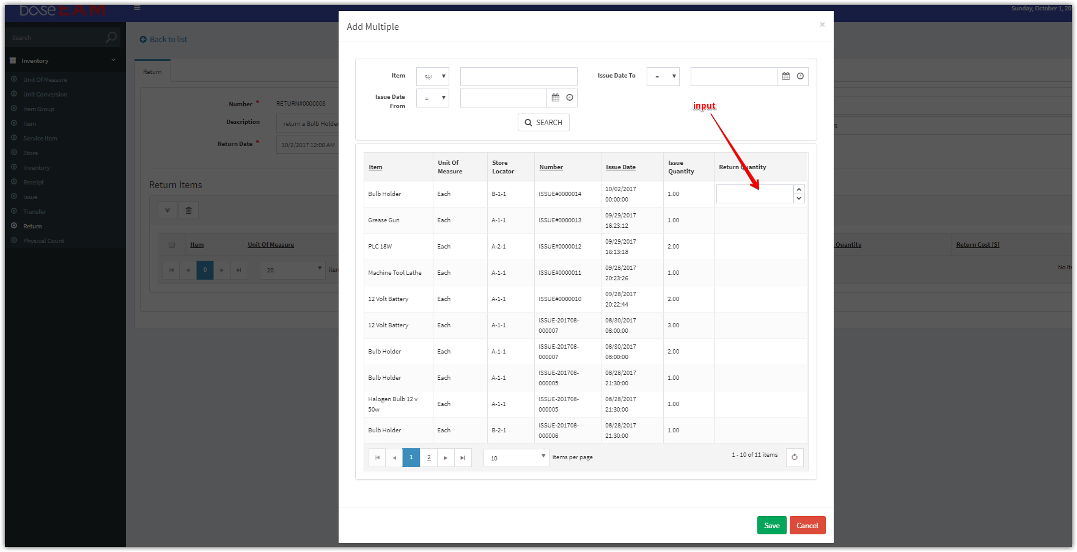

1. Click “**Approve**” button to approve for this return

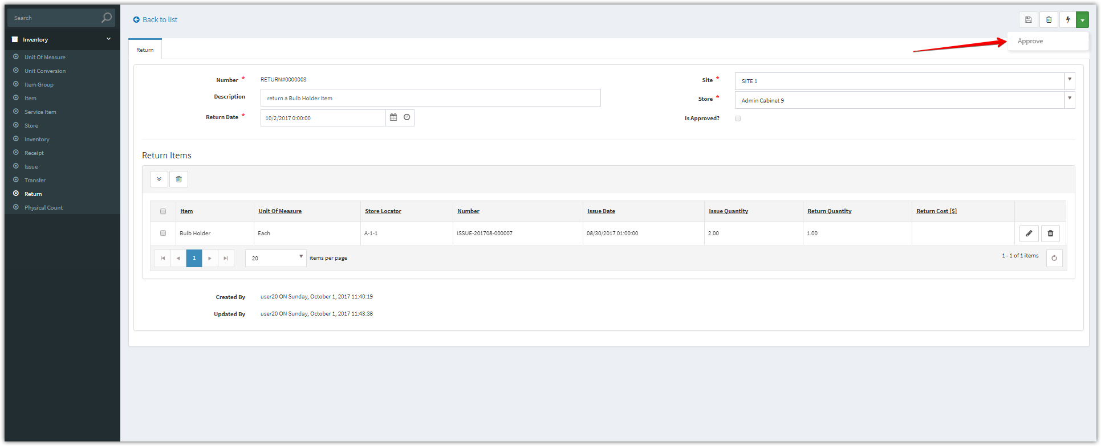

1. After approved, we checked and saw that the “approved’ checkbox was checked.

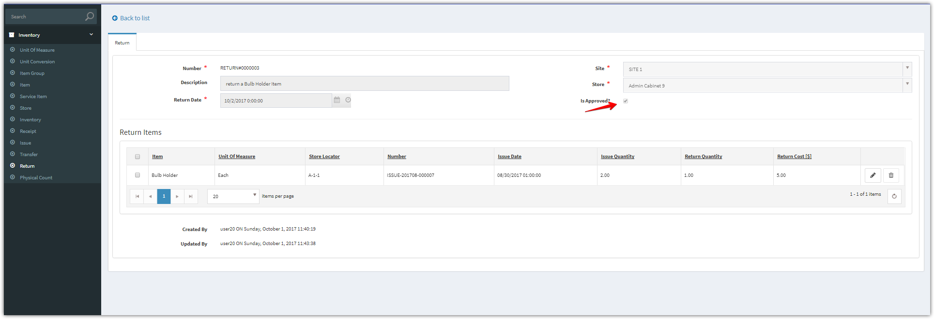

1. This transfer has been added into the inventory, please check this transaction into the inventory.

