**Transfer** is a transaction for transfer/move items from one store’s location to another store’s location.

**Adding Transfers**

To add a new **Transfer**, follow these steps:

1. Click **Add New**

(fix this)

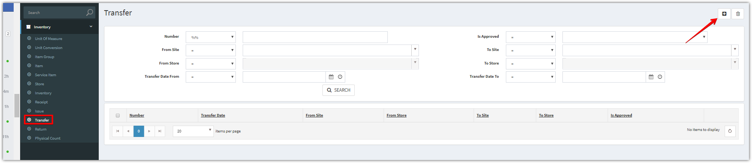

1. Complete the applicable data fields. * denote for required fields. Then click **Save.**

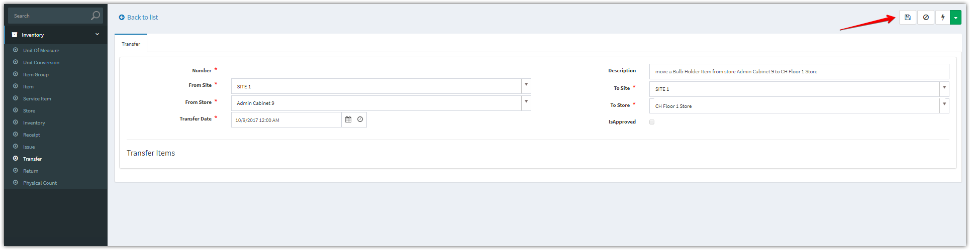

1. After clicking “**Save**” button. Add new items

Click **Add New** to add one item, **Add Multiple** to add multiple items

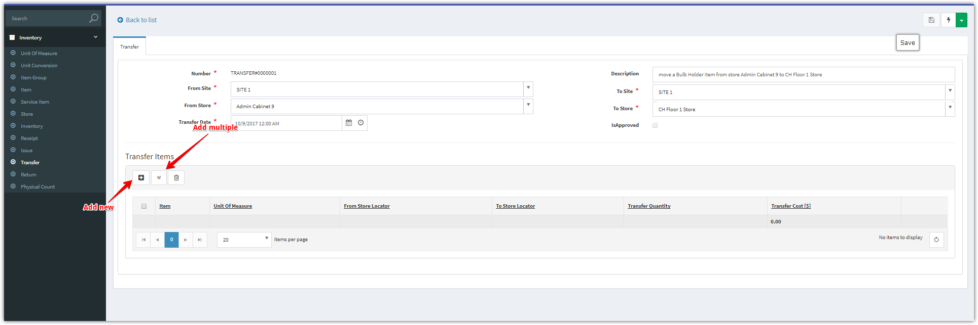

**Add New  
(fix this)**

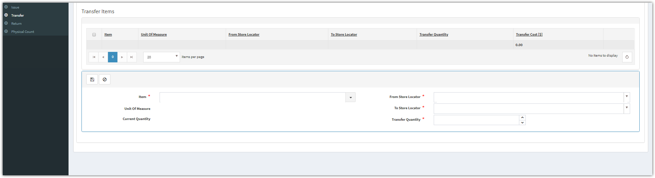

**Add Multiple**

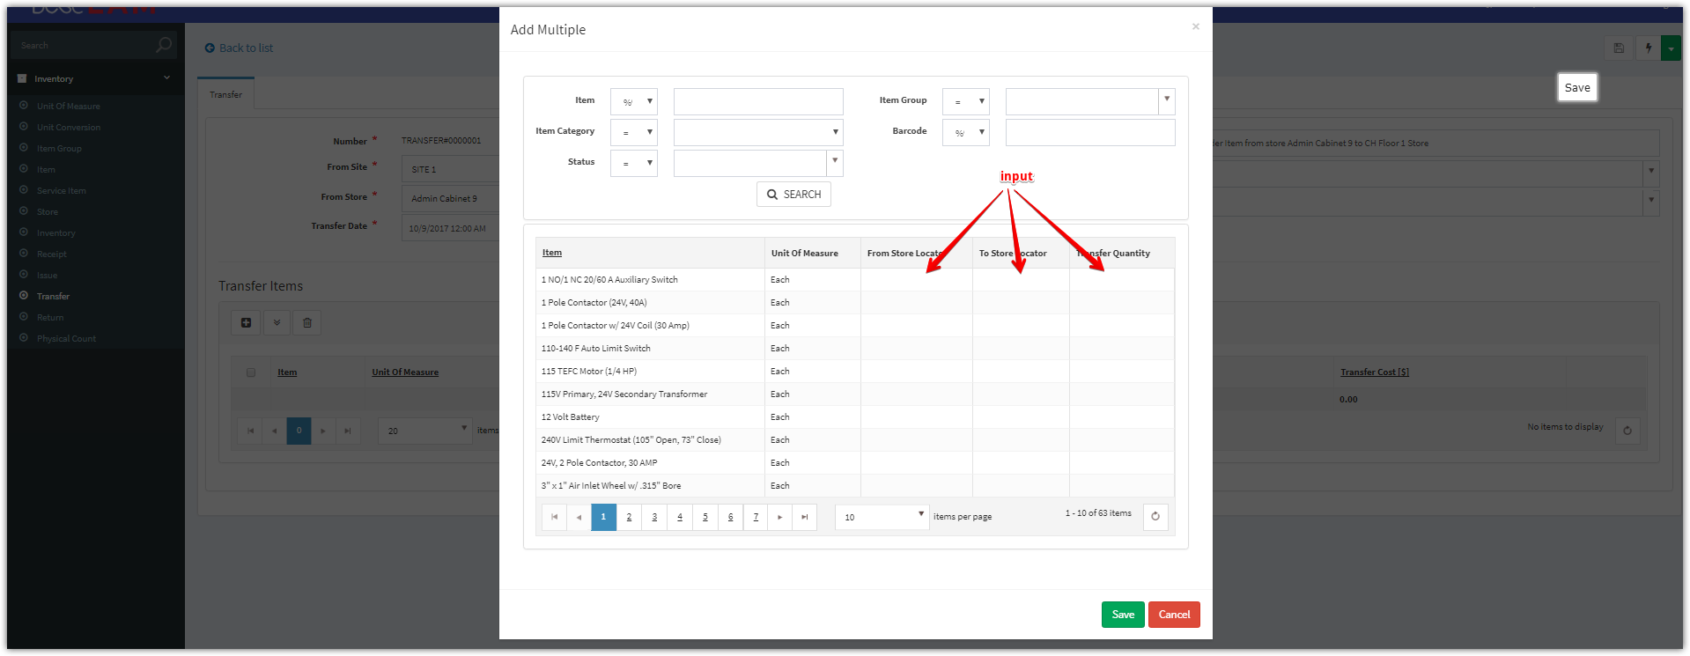

1. Click “**Approve**” button to approve this transfer

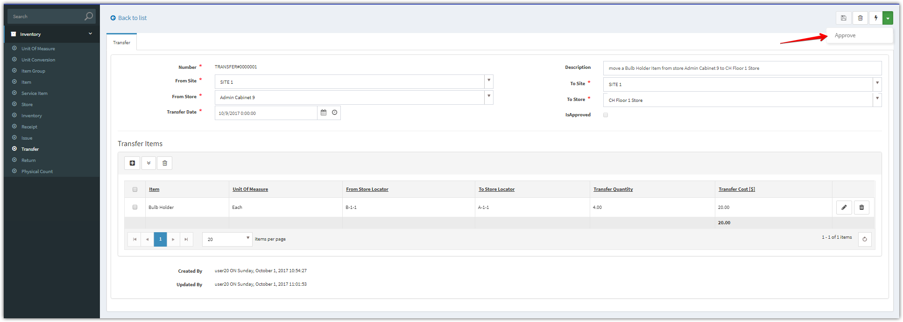

1. After approved, the “Is Approved’ checkbox will be checked.

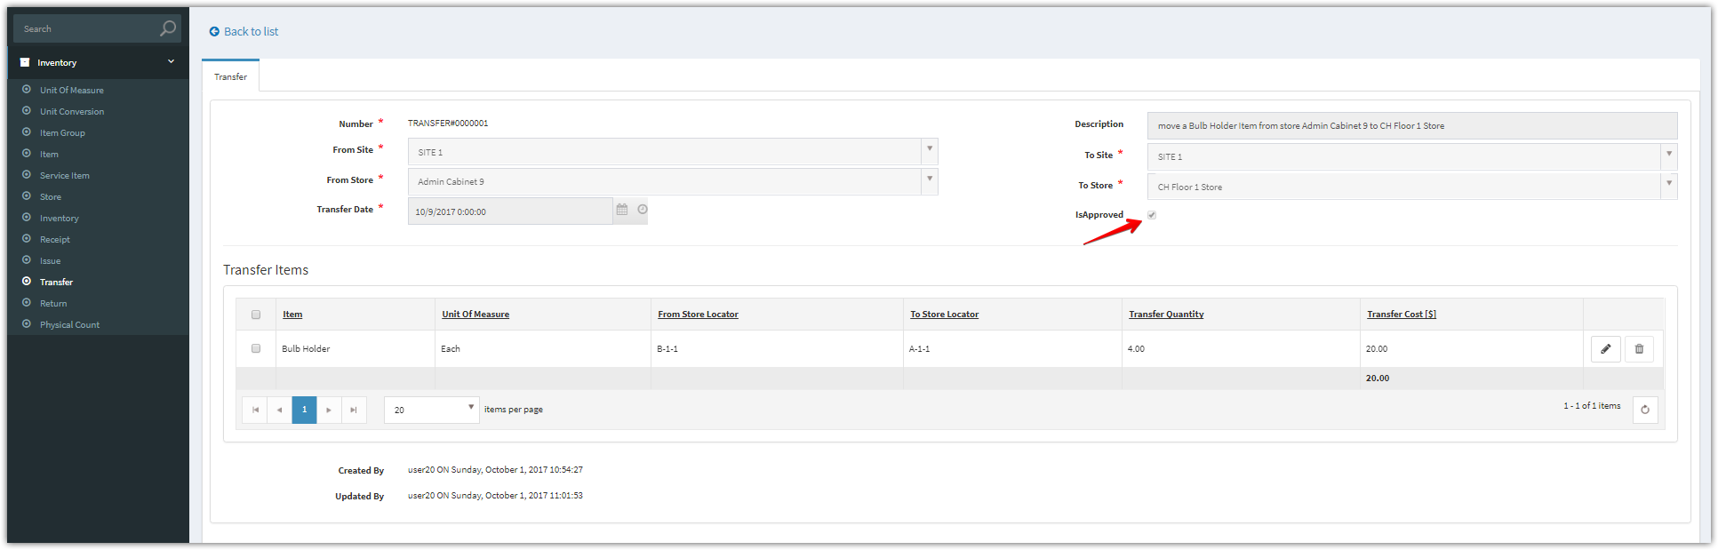

1. You can view the updated quantity and transaction history

For From Site and From Store

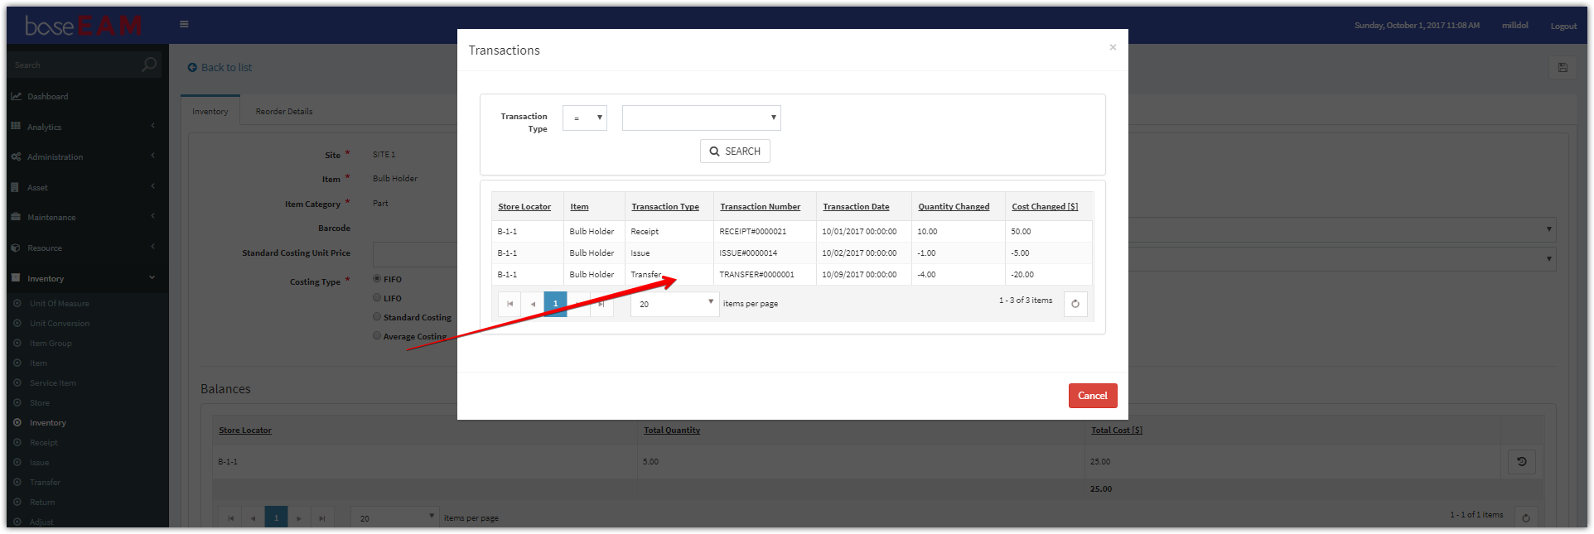

For To Site and To Store

