**Description**

This is a sample setup for an event-based preventive maintenance (PM)

**Steps**

1. Setup events for Asset or Location   
     
   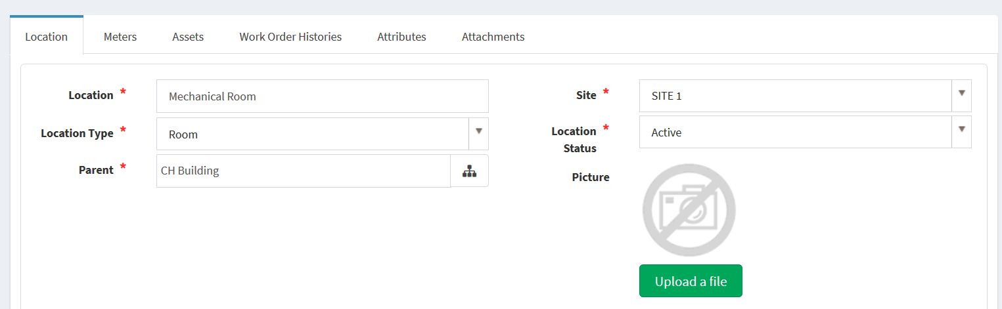  
     
   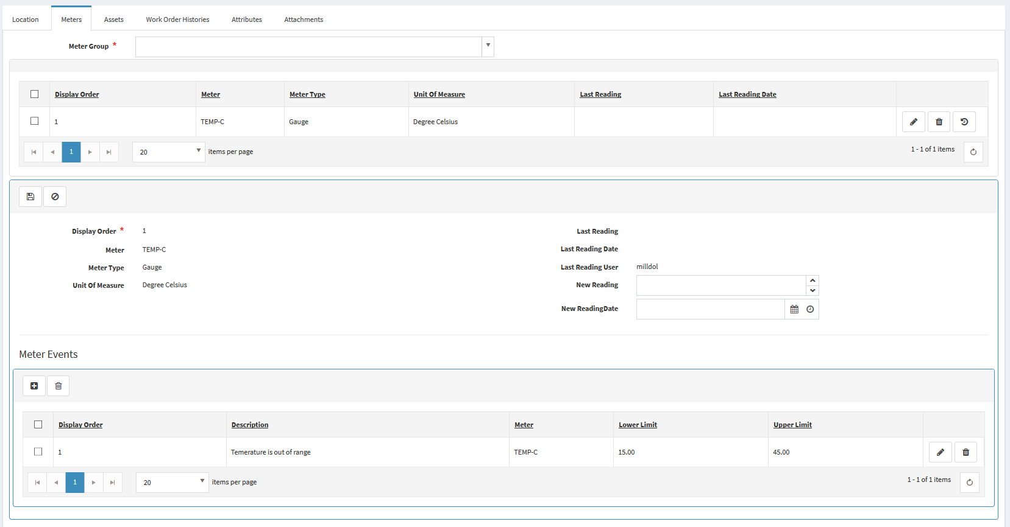
2. As a WorkManager, user5 login to BaseEAM and start defining an Event-Based PM  
   Click Add New  
     
   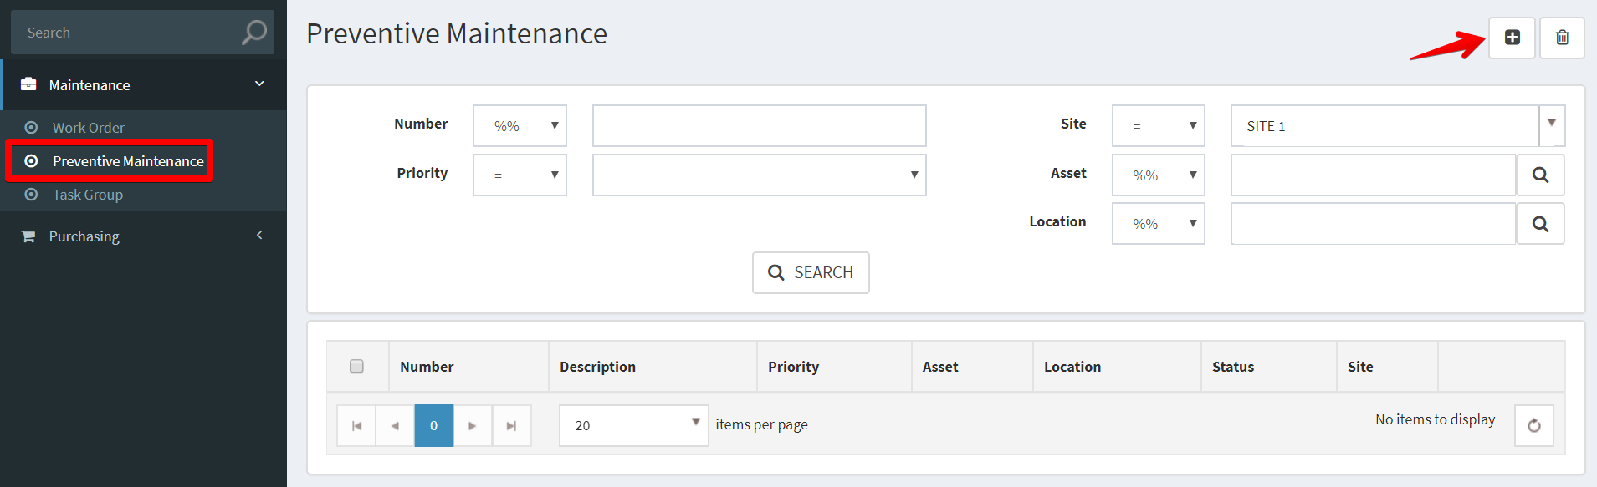
3. Fill out the applicable fields, * denote for required fields. Then click Save.  
     
   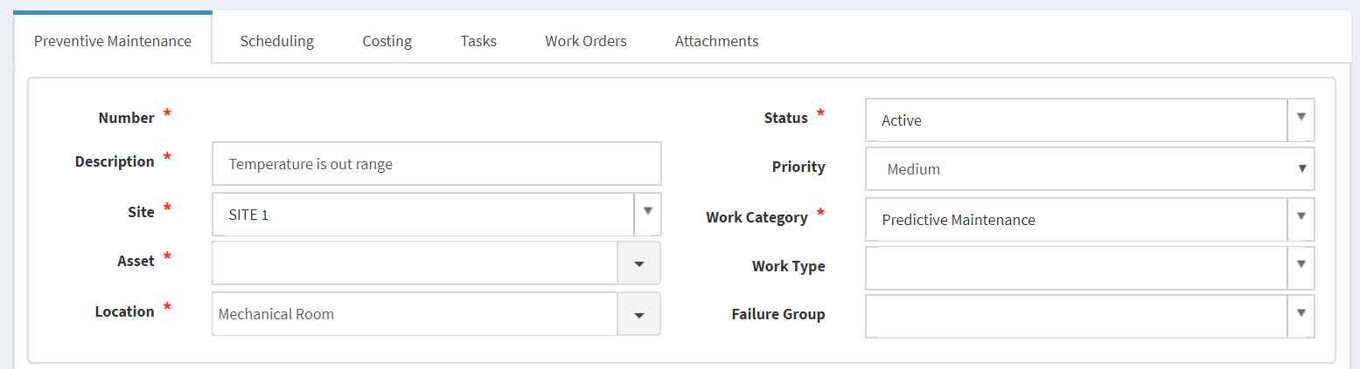
4. Add scheduling information  
     
   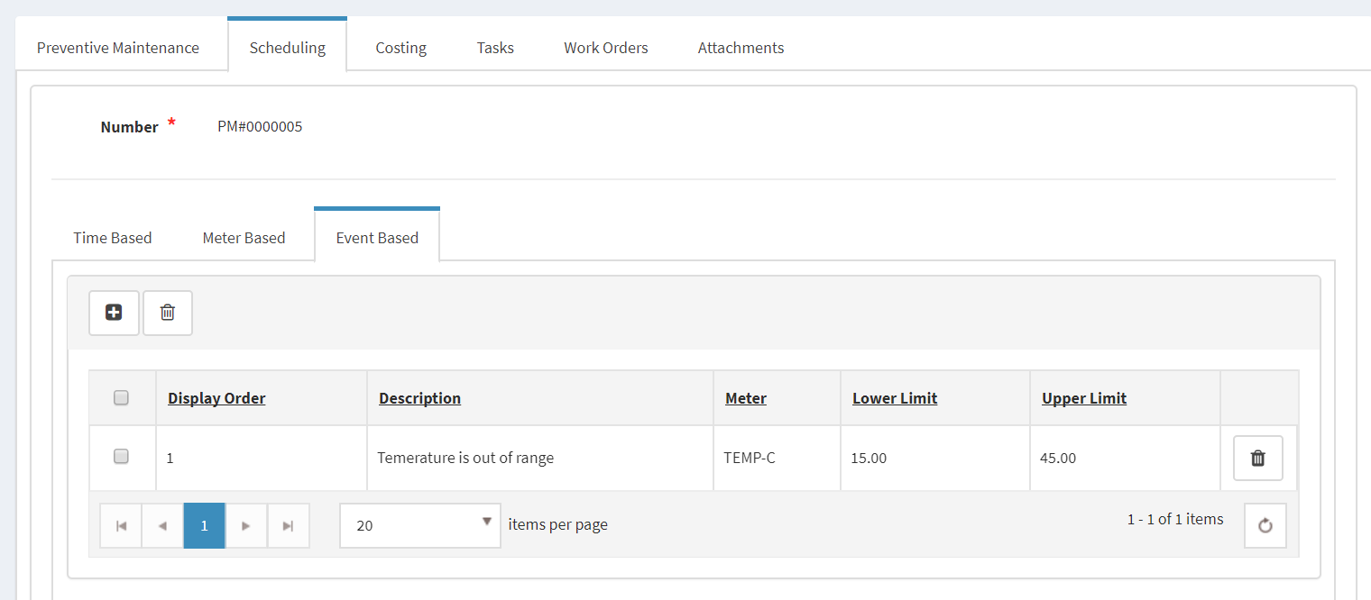
5. Add Costing  
     
   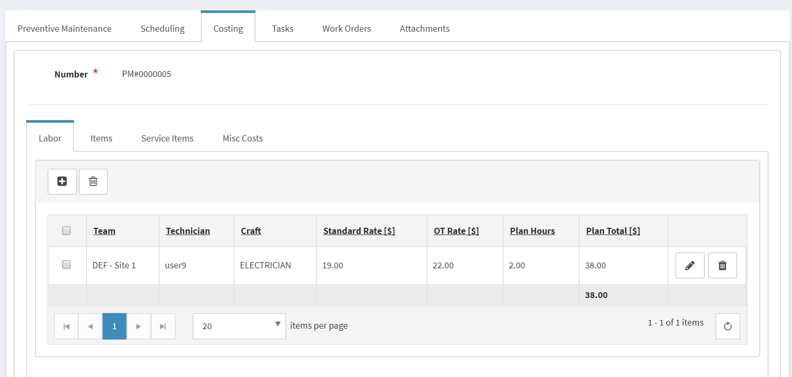
6. Add Tasks  
     
   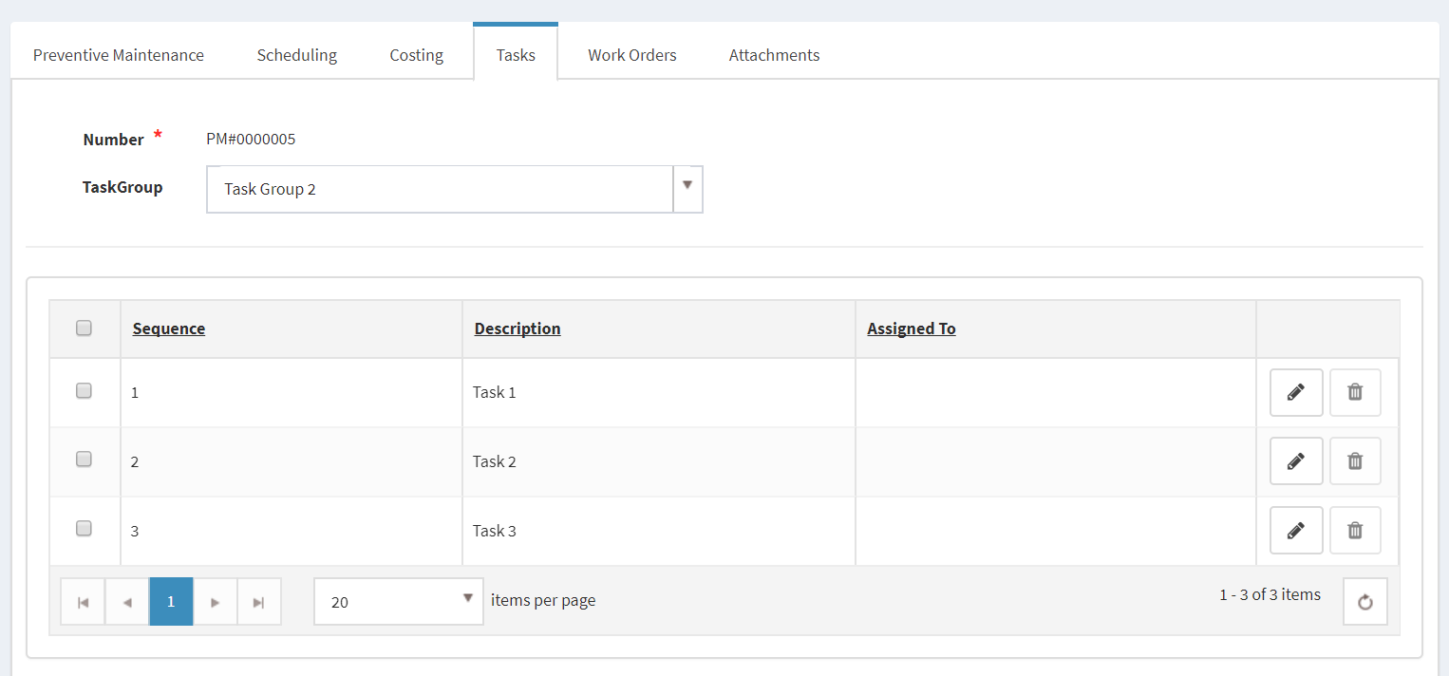
7. Go to Asset/Location details to enter Reading  
     
   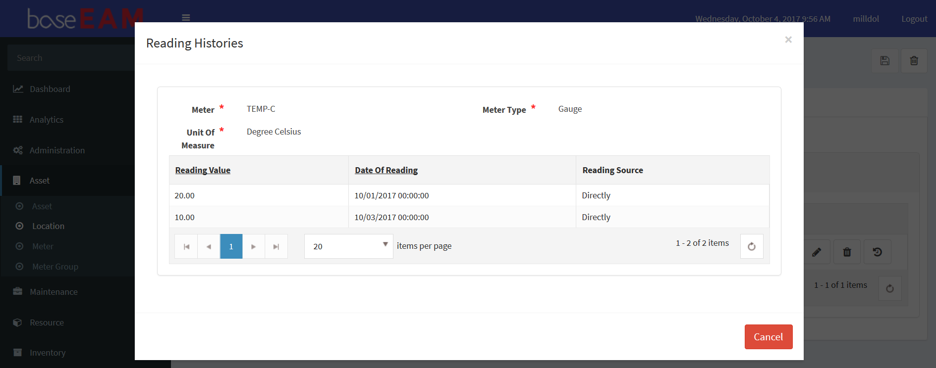
8. When PMJob run, it will generate a new WO for this PM.  
     
   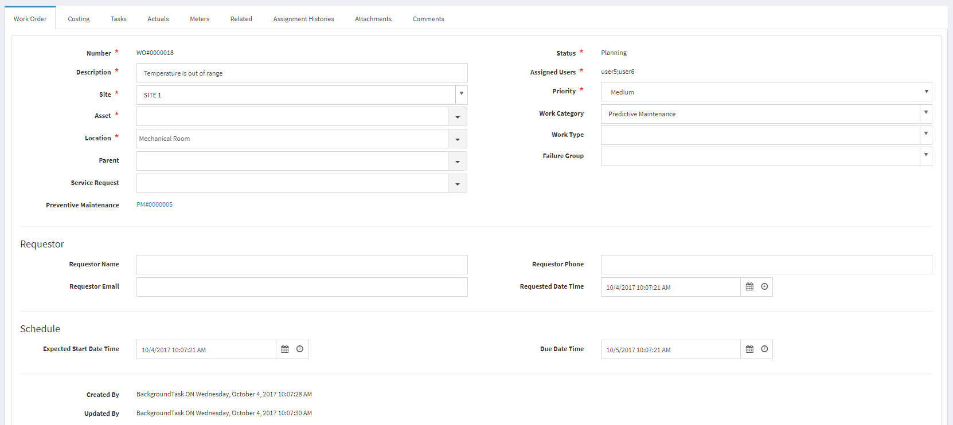  
     
   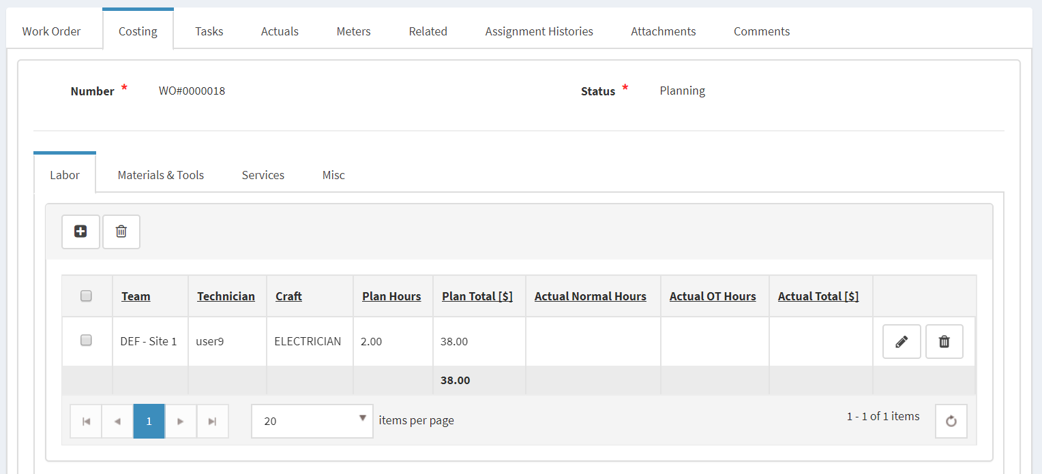  
     
   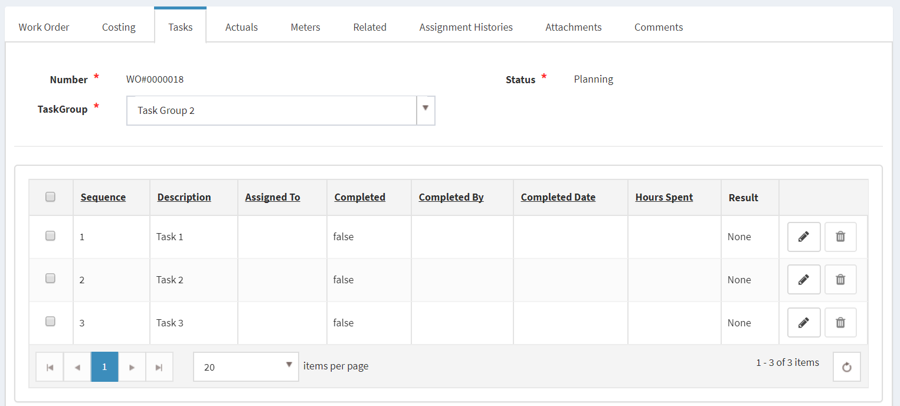  
     
   On PM  
     
   