**Description**

This is a sample setup for a meter-based preventive maintenance (PM)

**Steps**

1. As a WorkManager, user5 login to BaseEAM and start defining a Meter-Based PM  
   Click Add New  
     
   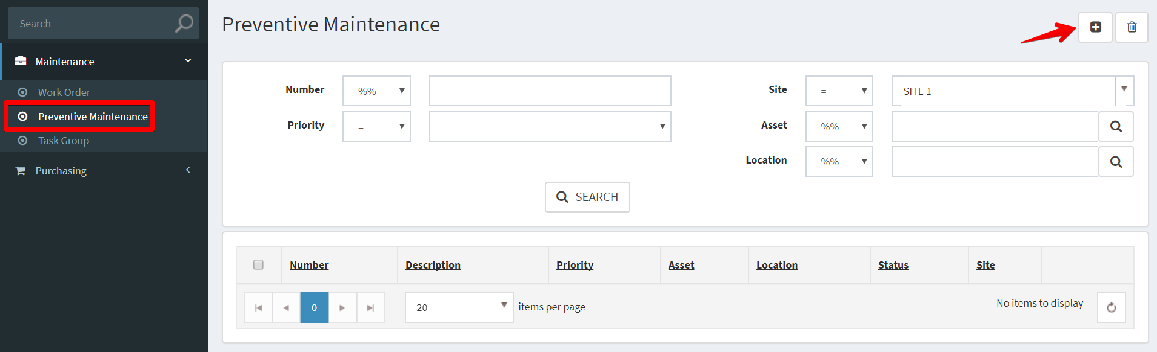
2. Fill out the applicable fields, * denote for required fields. Then click Save.  
     
   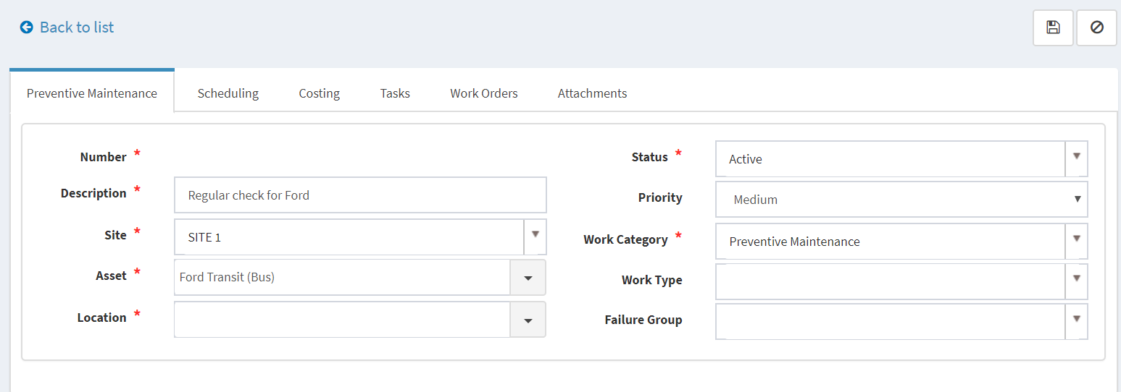
3. Add scheduling information  
     
   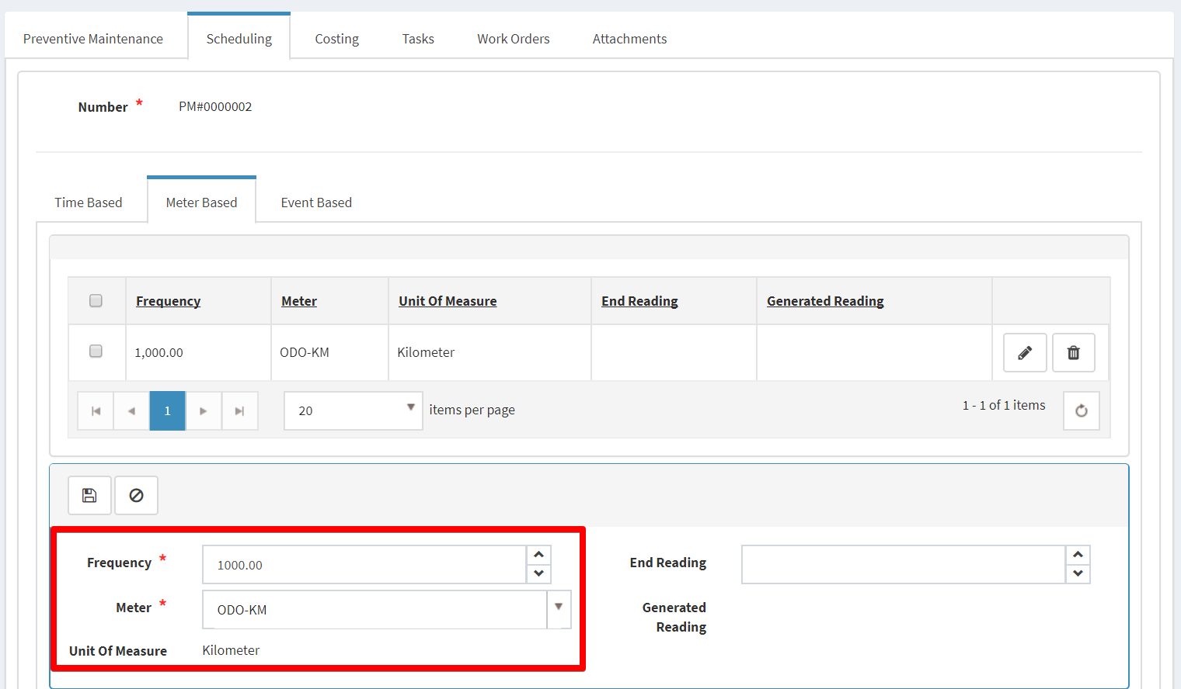
4. Add Costing  
     
   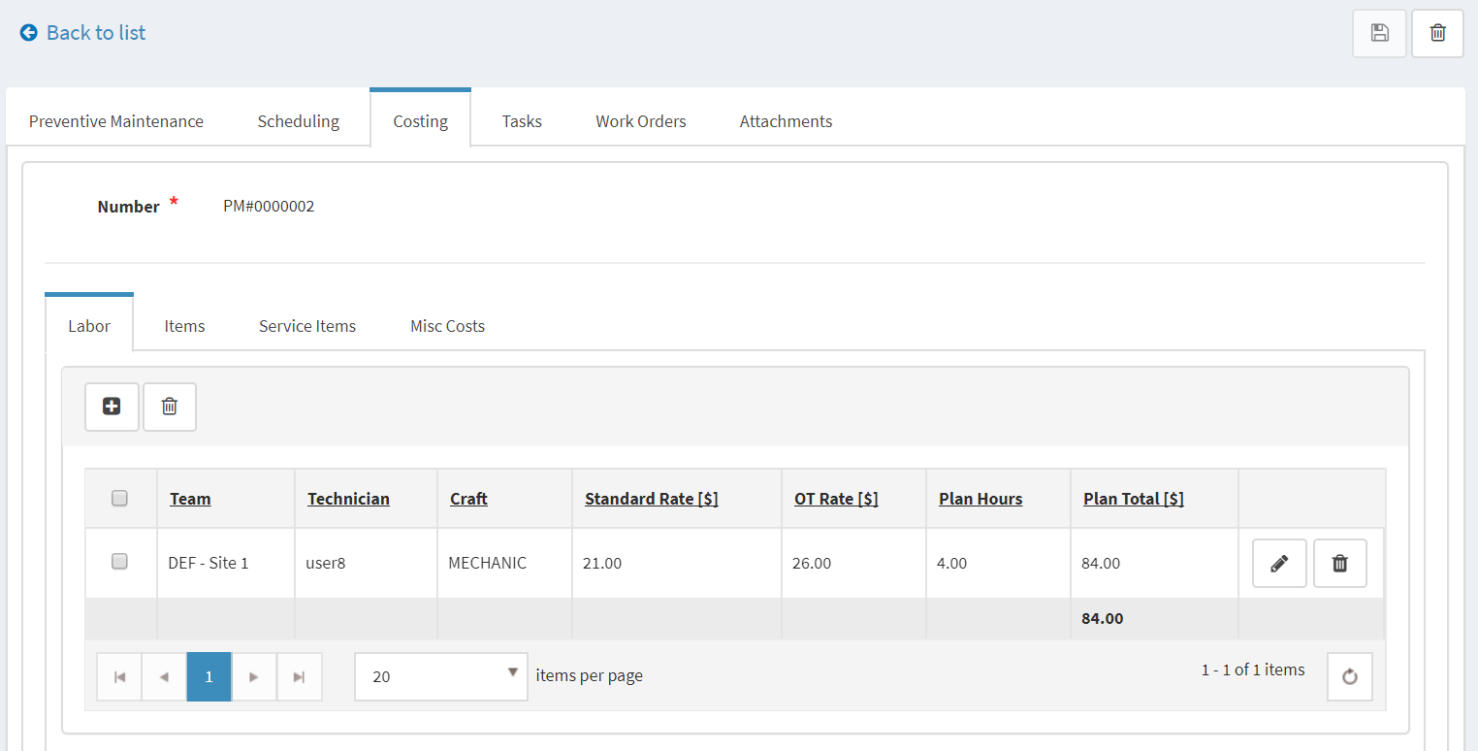
5. Add Tasks  
     
   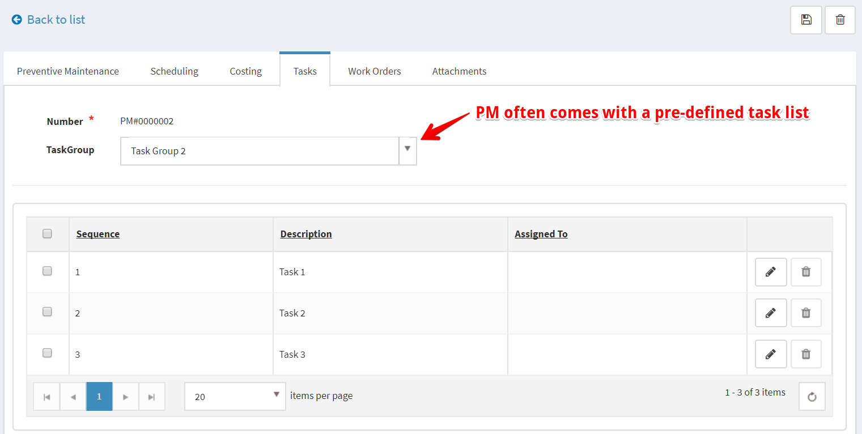
6. Open Asset = Ford Transit (Bus) details, then Meters tab to enter Reading  
     
   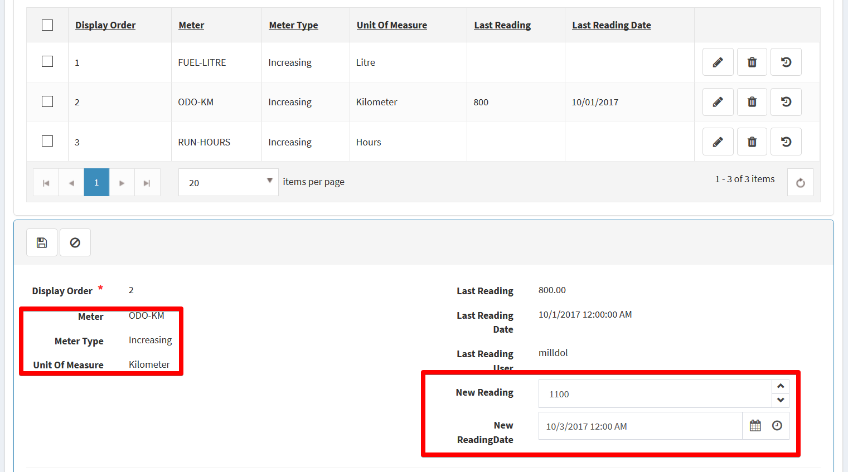
7. If the New Reading satisfied the Meter Frequency then, when PMJob run it will generate a new WO for this PM.  
     
   