**Description**

This is a sample setup for a time-based preventive maintenance (PM)

**Steps**

1. As a WorkManager, user5 login to BaseEAM and start defining a time-based PM  
   Click Add New  
     
   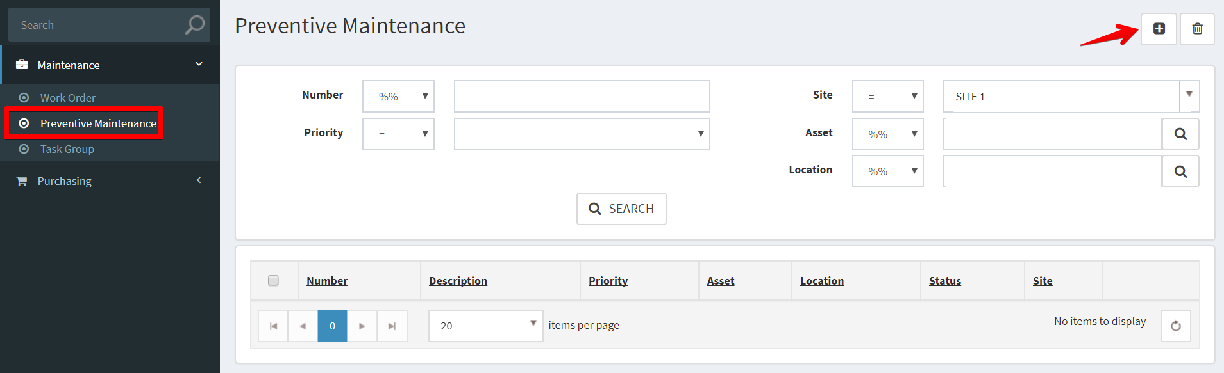
2. Fill out the applicable data fields, * denote for required fields. Then click Save  
     
   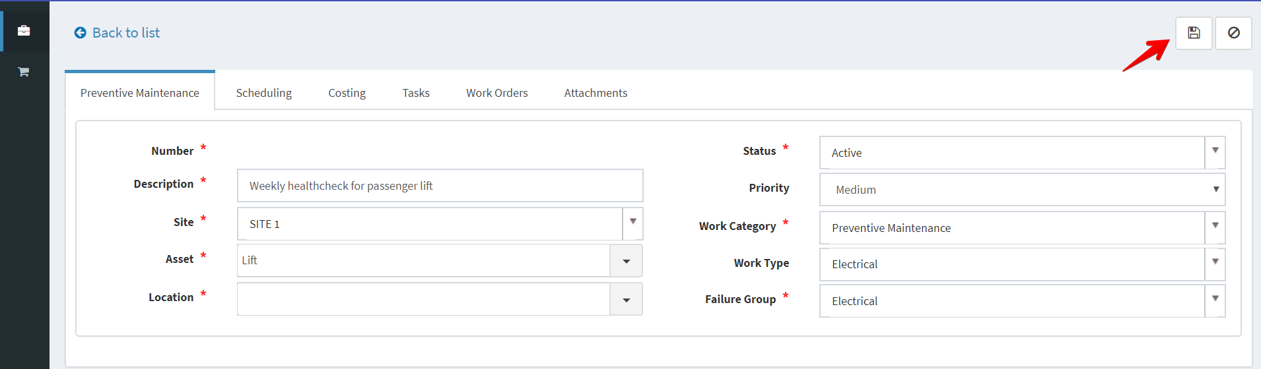
3. Add Scheduling information  
     
   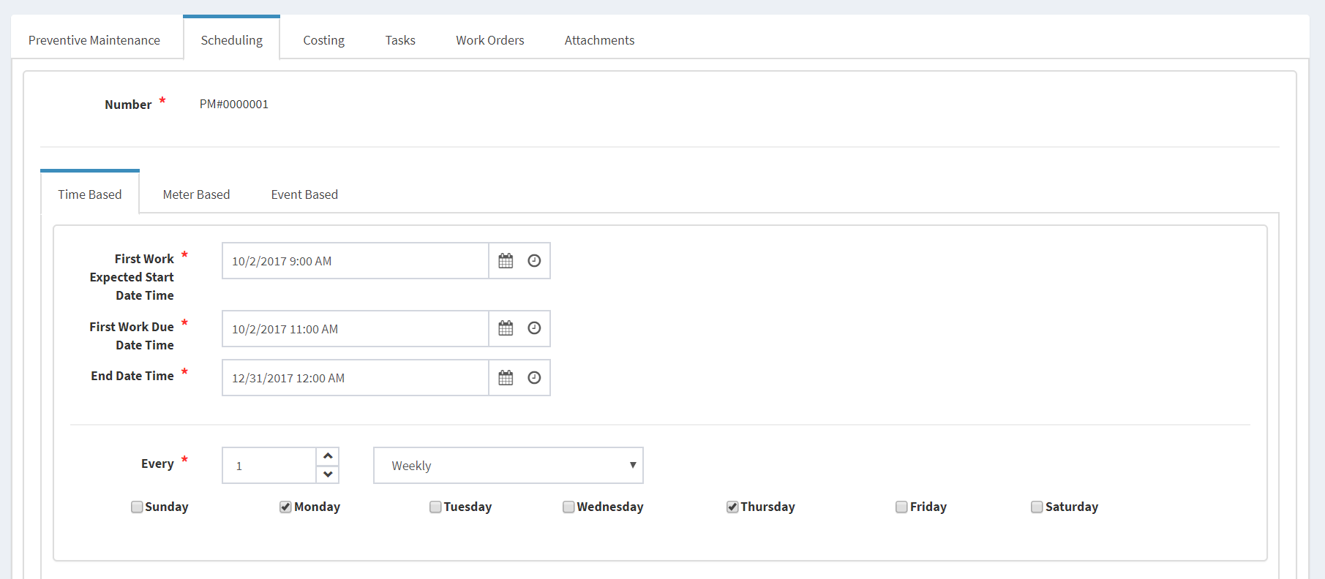
4. Add Costing  
     
   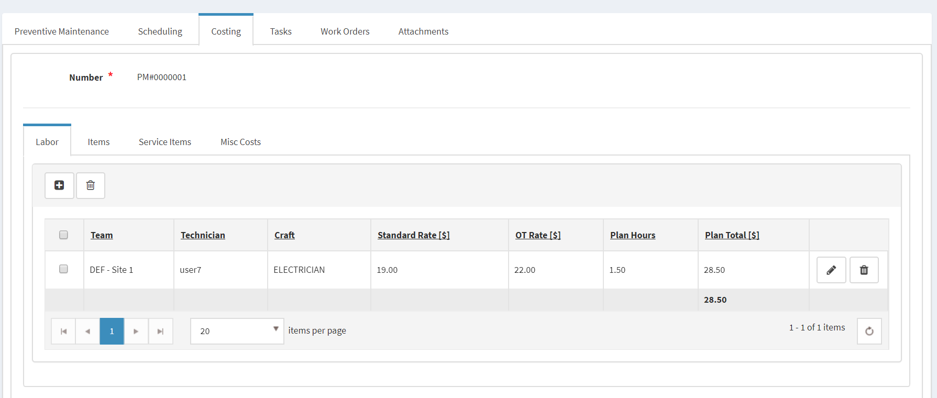
5. Add Tasks  
   In this case, because we setup Task Group 1 for Asset Type = Passenger Lift  
     
   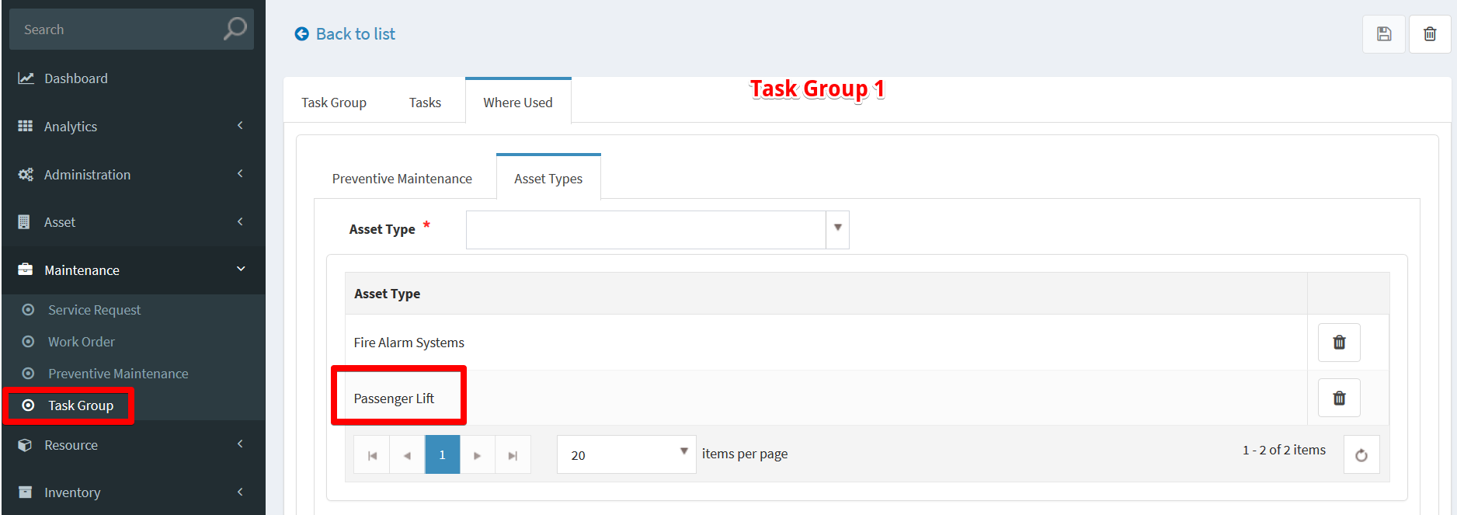  
     
   So the Tasks of this PM will be auto populated.  
     
   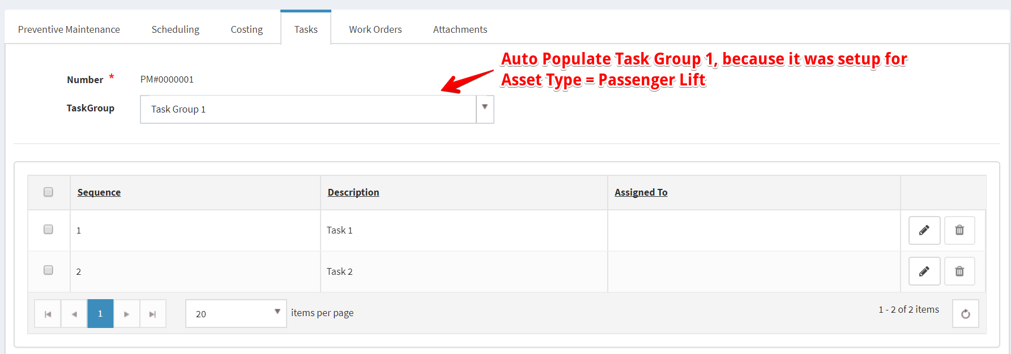
6. When the PM Job run, it will generate a new WO based on PM’s details  
   New WO  
     
   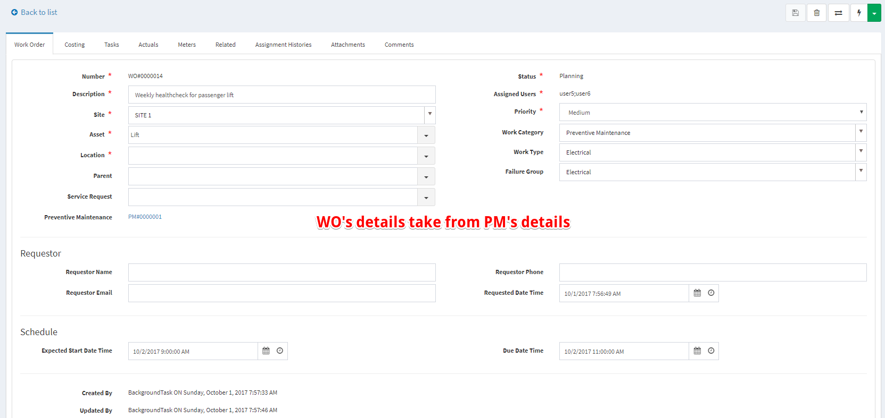  
     
   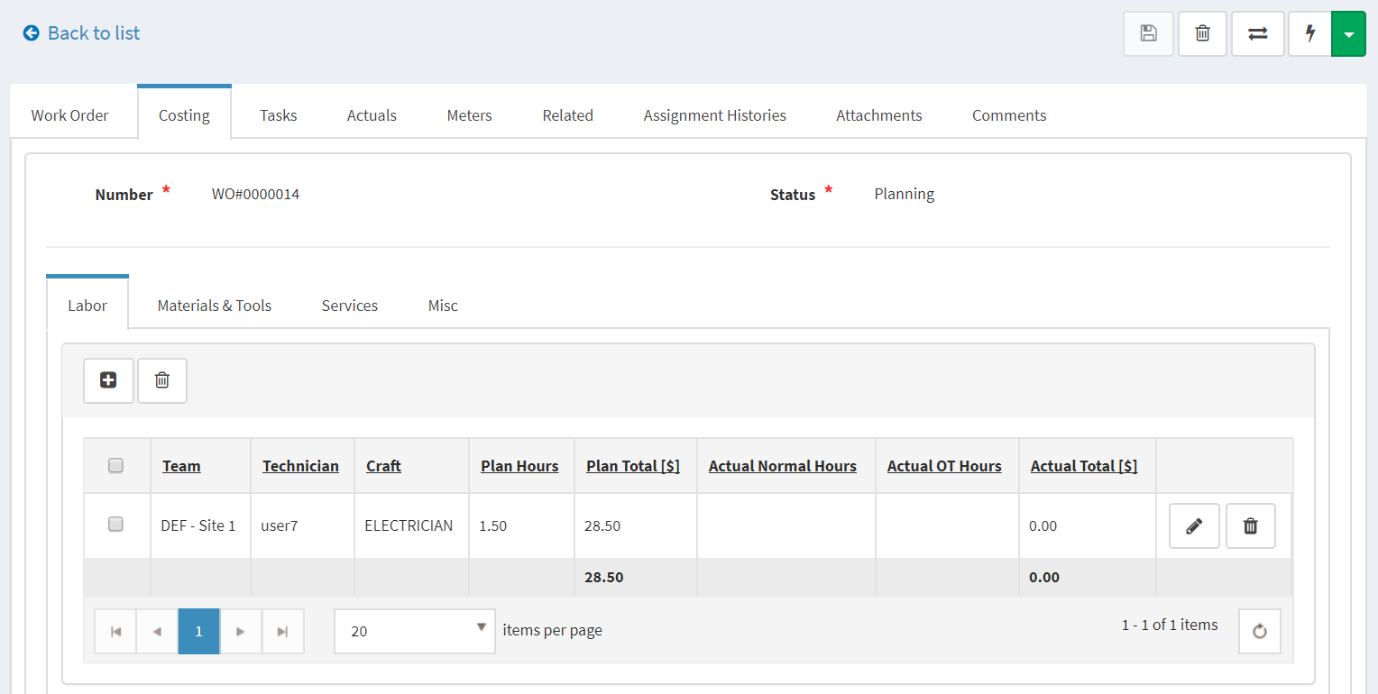  
     
   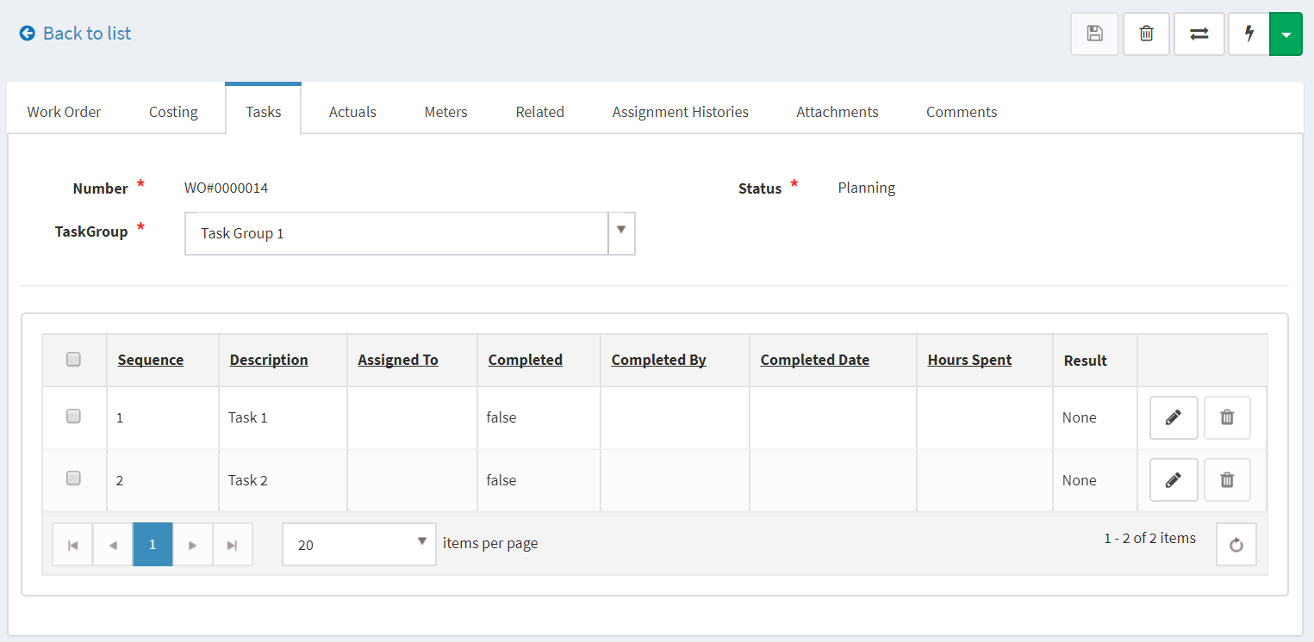  
     
   On Work Orders tab of PM  
     
   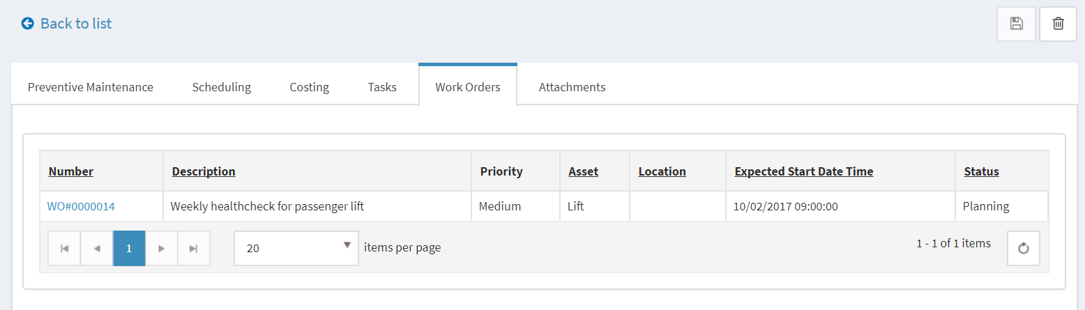
7. You need to complete this WO (WO’s status = Closed or Cancelled), so the PMJob can generate the next WO for this PM.  
   Cancel this WO  
     
   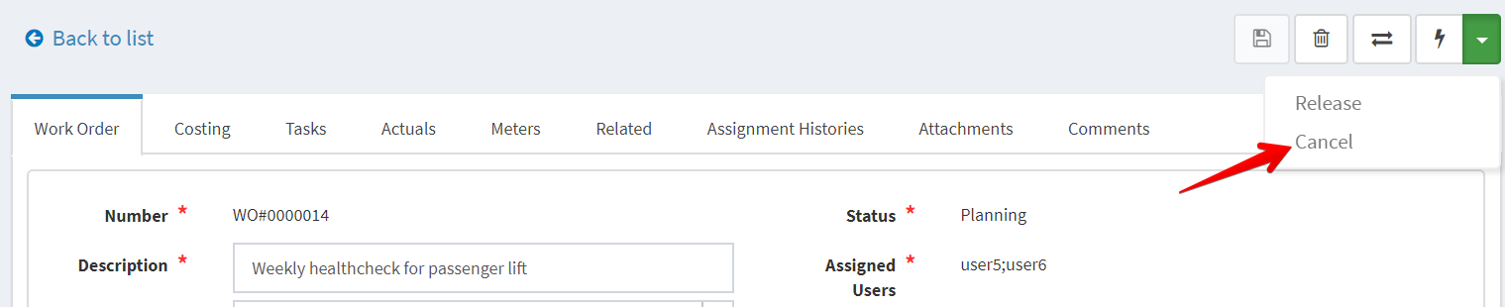
8. The PMJob will generate the next WO  
     
   