**Description**

This scenario is a normal workflow of a work order (WO). The WO will go through **Open, Planning, Execution, Review, Closed**.

A WO can be created from the following Security Groups: **Asset Manager**, **Operation Manager**, **Operation Staff**, **Technician** and **Work Manager**.

**Steps**:

1. As an **Operation Manager**, user12 login to BaseEAM and add a new WO  
     
   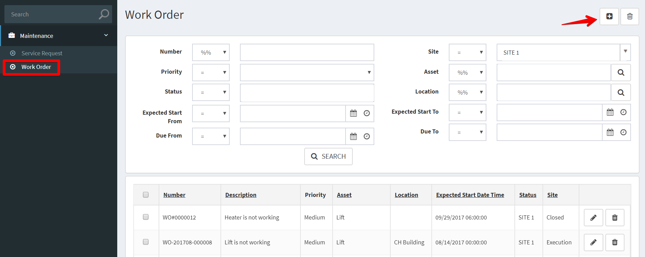  
     
   BaseEAM will auto fill out some data fields based on the current user information.  
     
   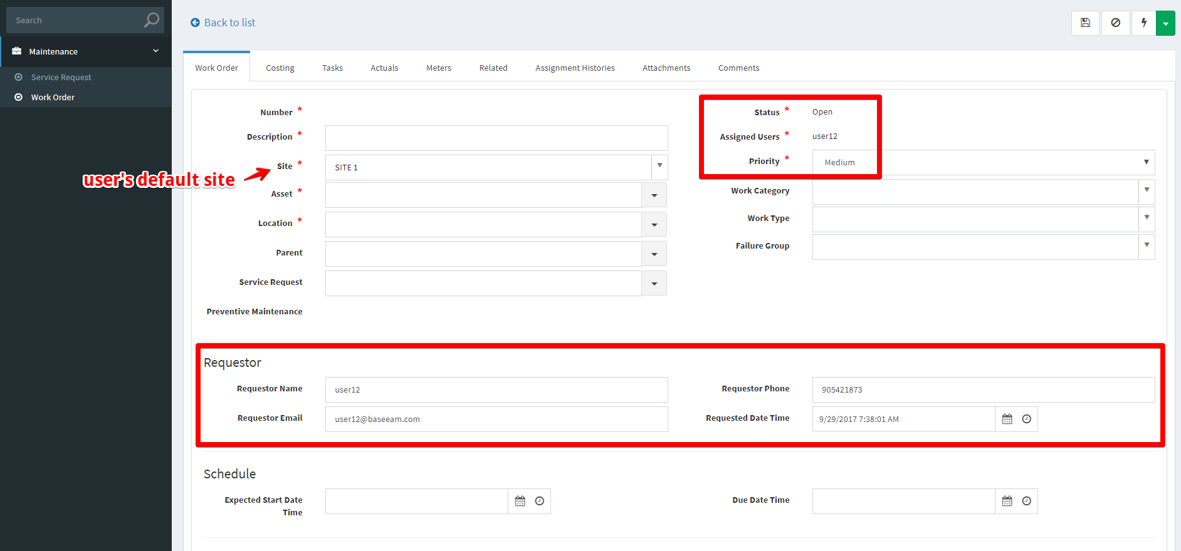
2. Fill out the applicable data fields, * denote for required fields.  
     
   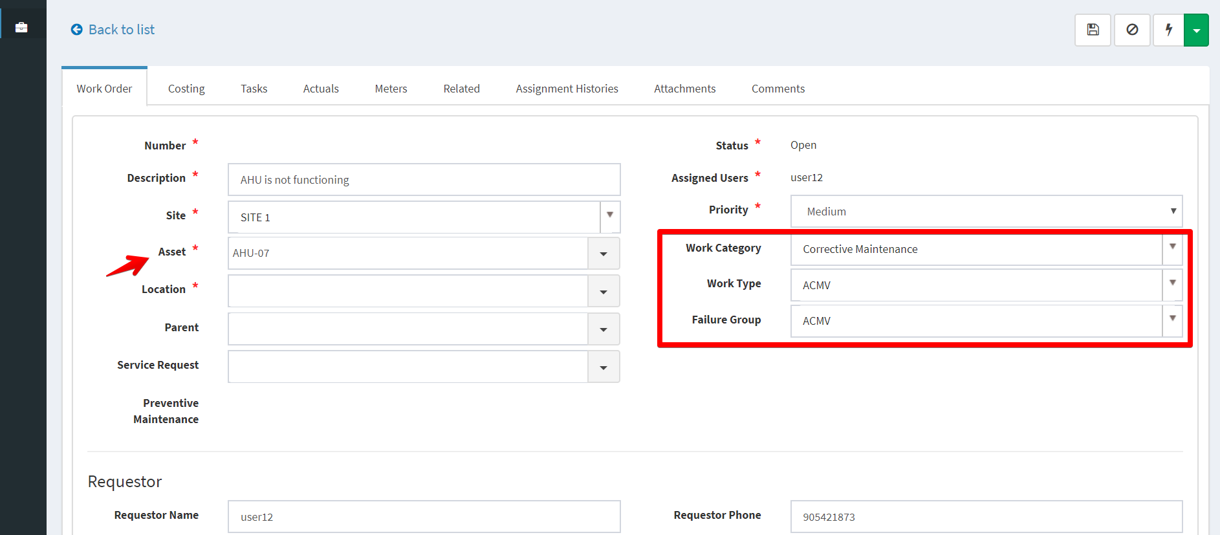
3. Click Submit, add comments, then BaseEAM will route this WO assignment to WorkMangers for planning.  
     
   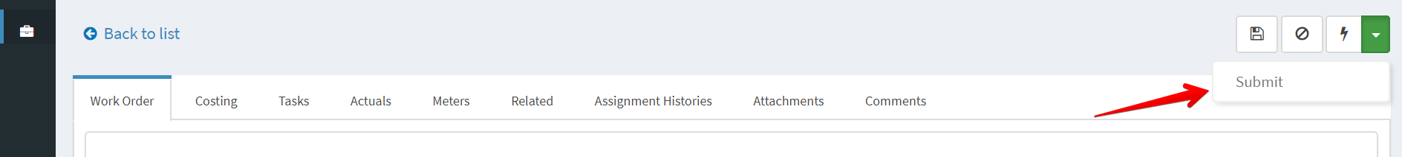  
     
   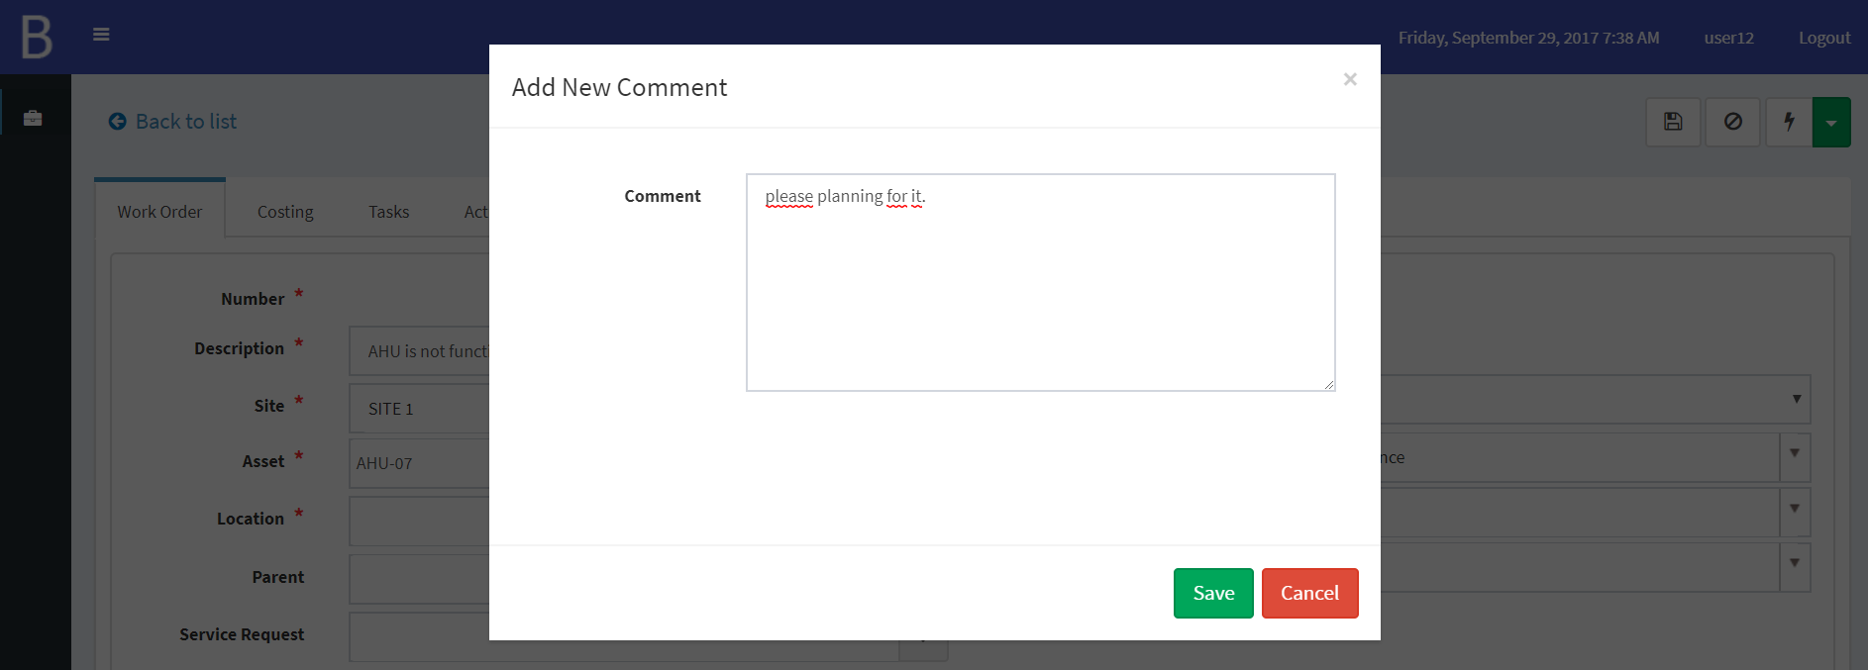

The WO’s status changed to **Planning** and assigned to WorkManagers: user5, user6.  
  
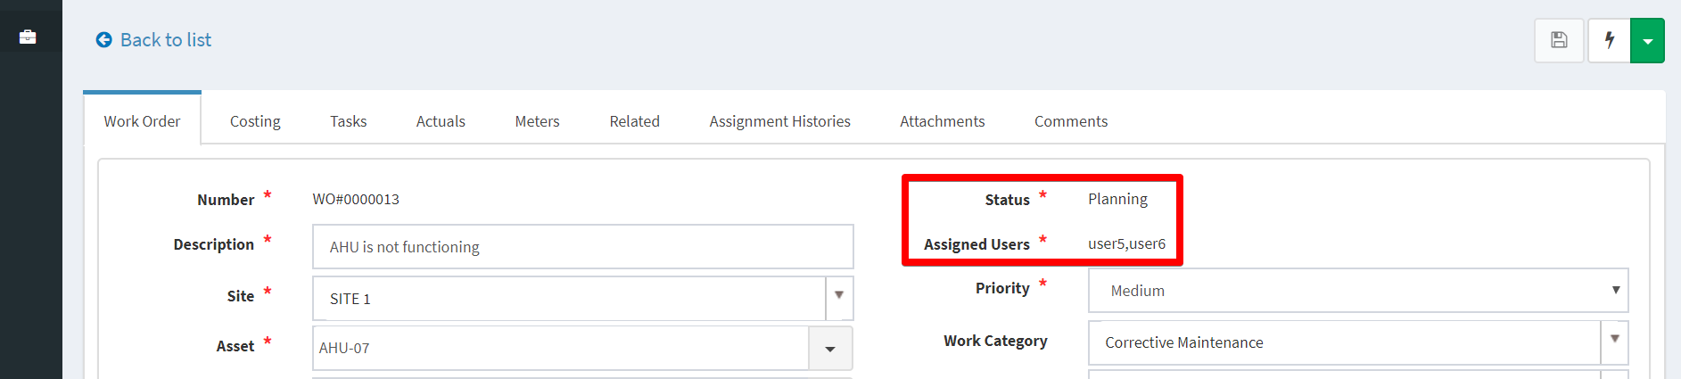  
  
They will receive notifications via Email, SMS, or Push Notification (mobile app) if the information was setup properly in BaseEAM.  
  
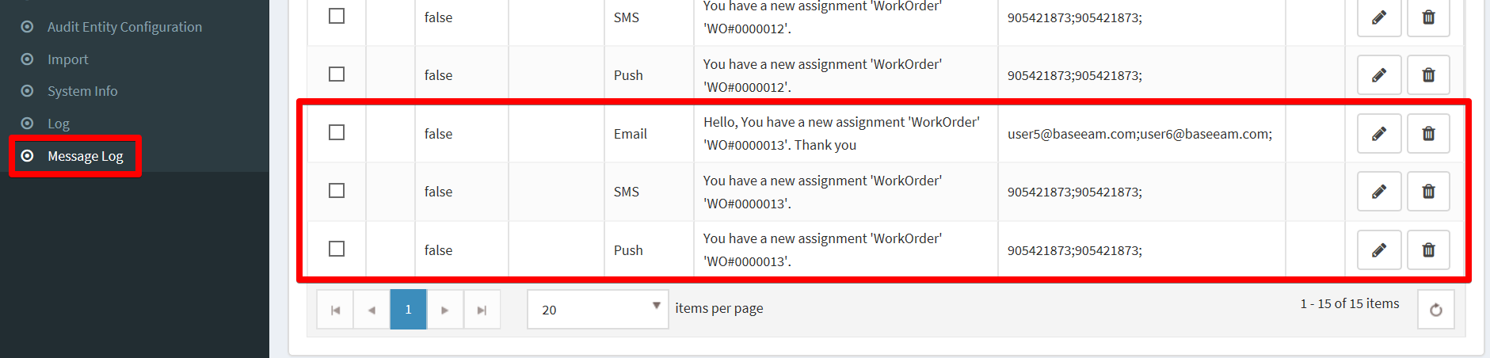

1. As a Work Manager, user5 login to BaseEAM and see there’s a new WO assignment on Dashboard/My Assignments.  
     
   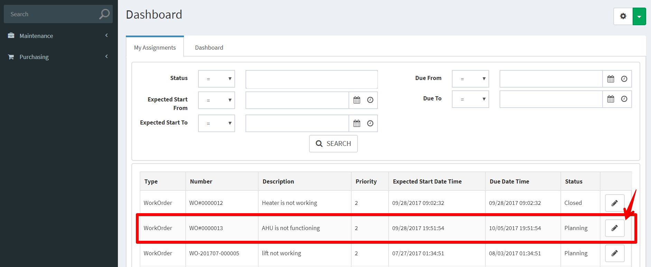  
     
   Then click Details button to start planning for this WO.

Add **Expected Start Date Time** and **Due Date Time** for this WO.  
  
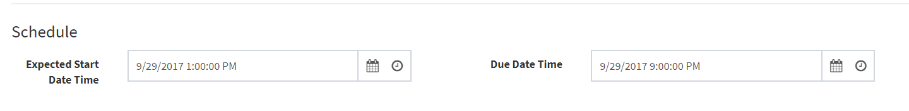

1. Add Plan Labor  
   On Costing tab / Labor tab, click Add new  
     
   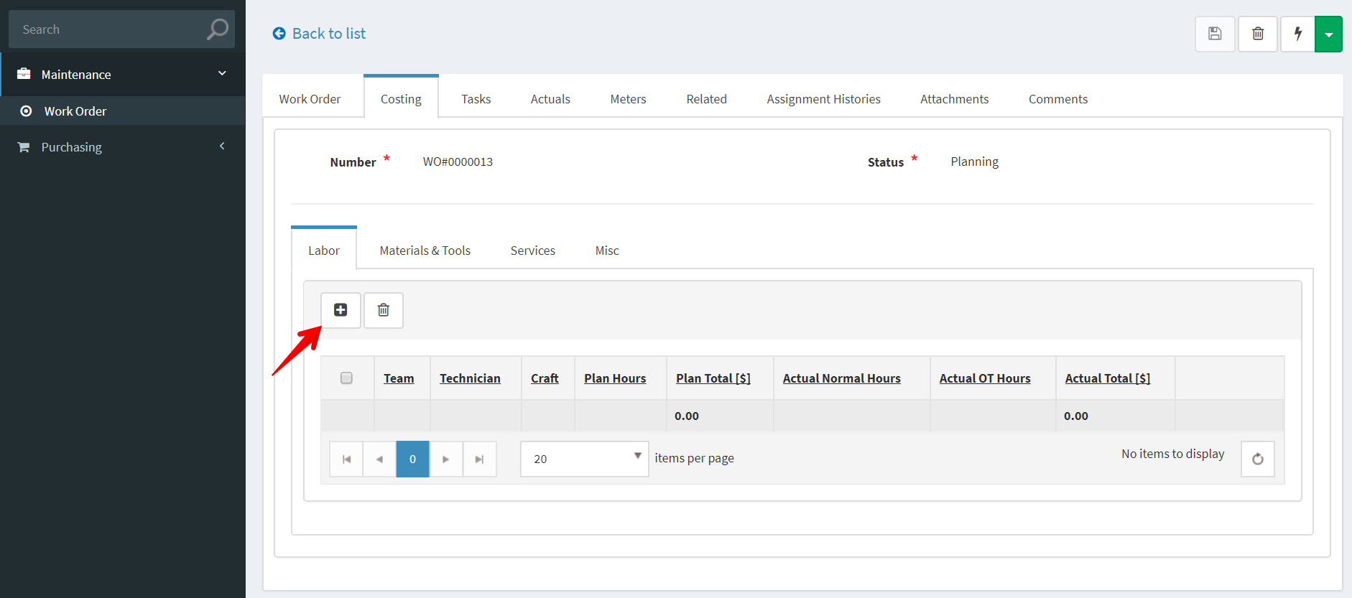  
     
   Fill out the applicable data fields (leave out the Actual section, this is for Technician to fill)  
     
   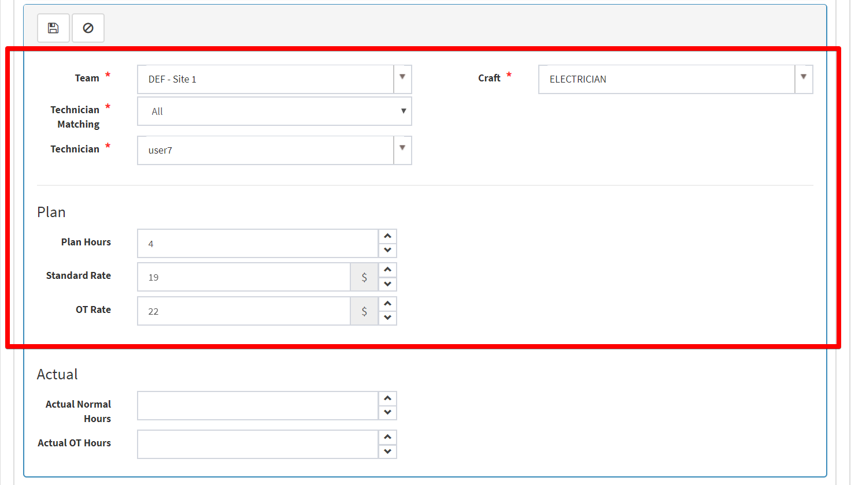  
     
   You can select **Technician Matching** = **Shift** to load technicians that work on shifts relevant to this WO’s **Expected Start Date Time**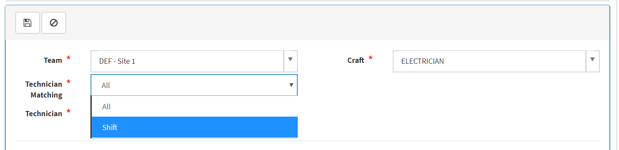Then click Save to commit changes.  
     
   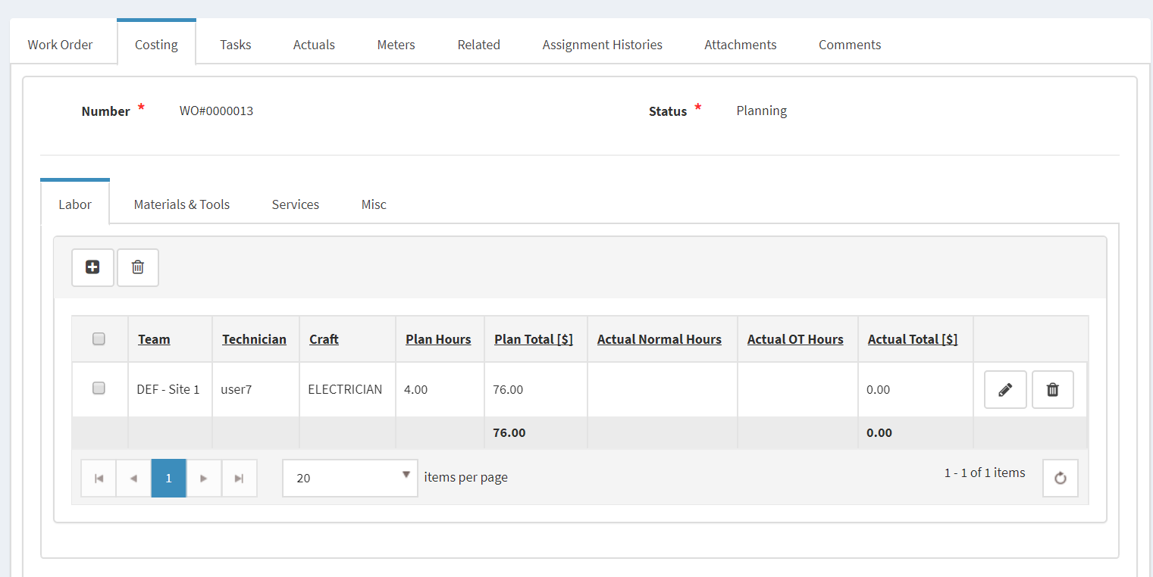
2. Add Plan Materials & Tools  
   Add Materials  
   On Costing tab / Materials & Tools tab, click Add New  
     
   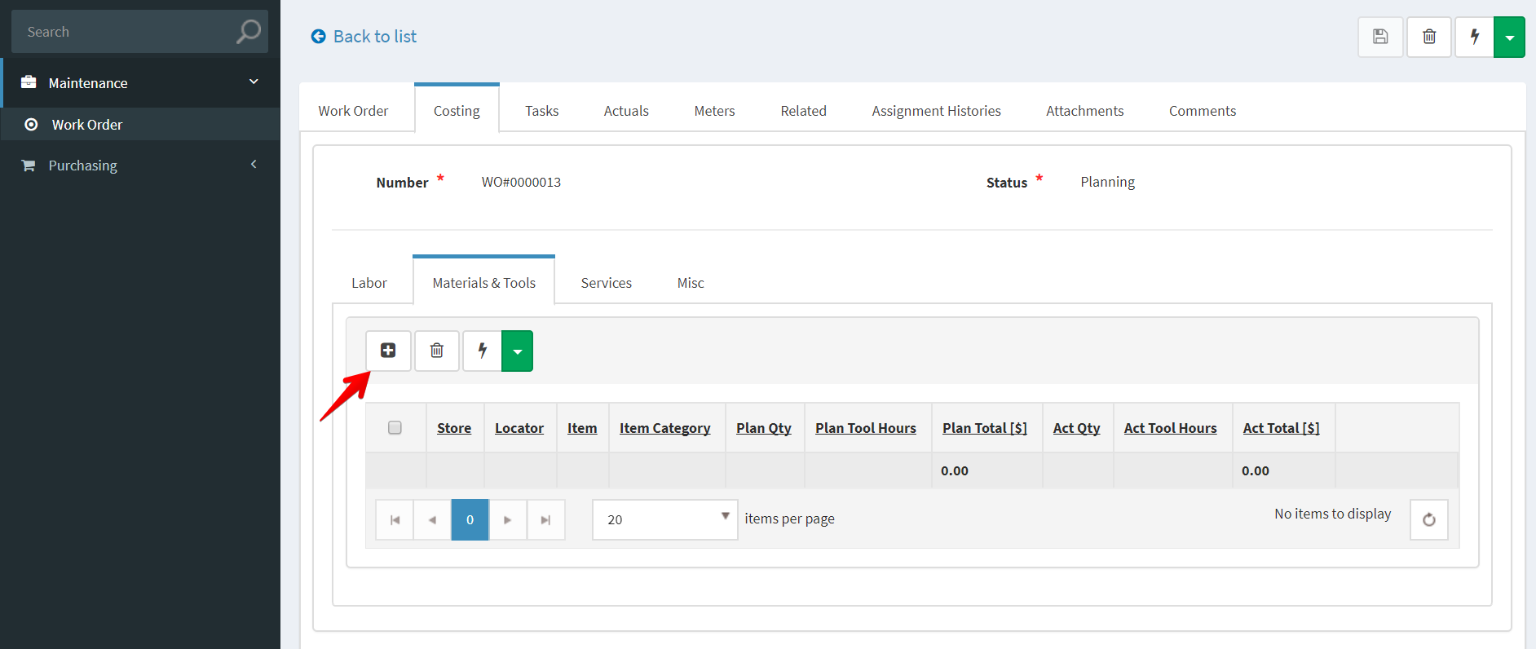  
     
   Fill out the applicable data fields (leave out the Actual section, this is for Technician to fill)  
     
   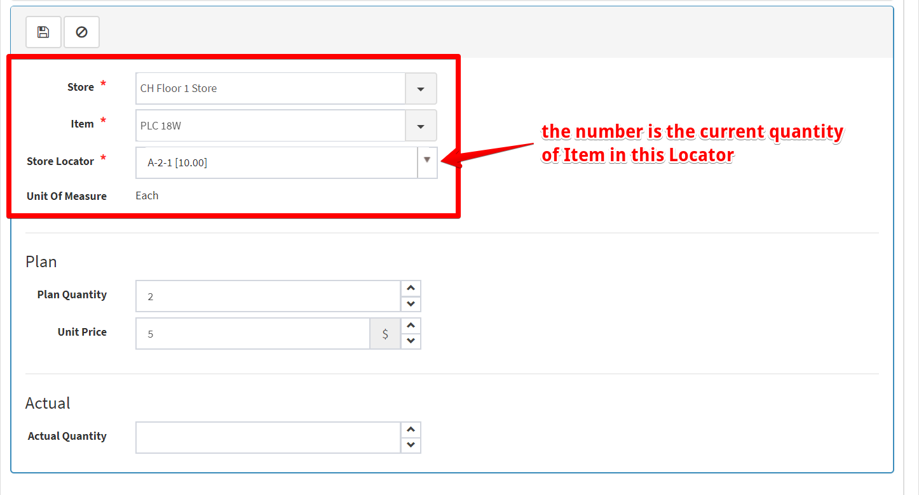  
     
   Then click Save to commit changes  
     
   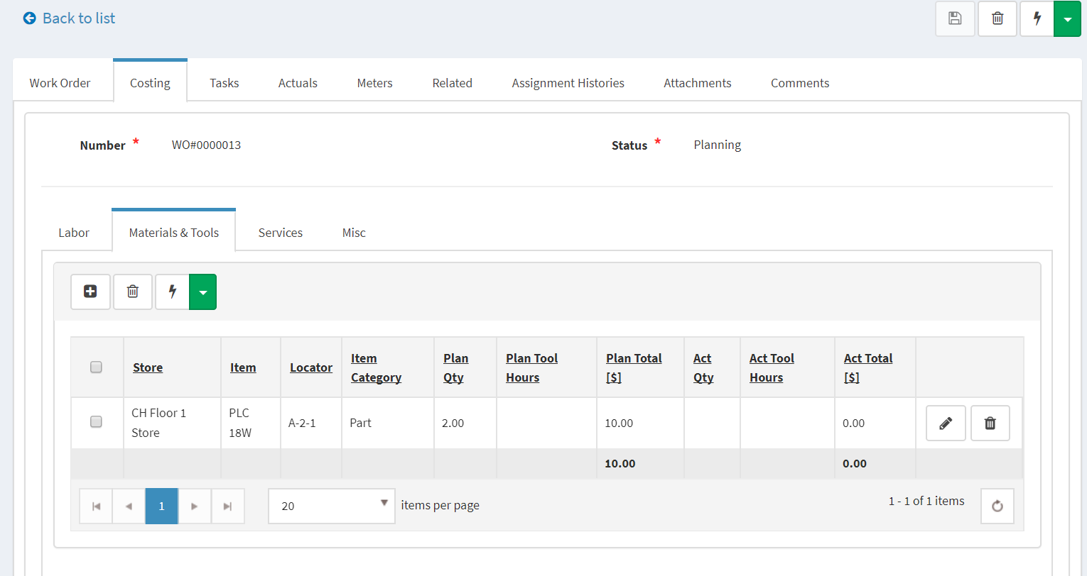  
     
   Add Tools  
   Do the same above steps to add a tool and plan tool hours  
     
   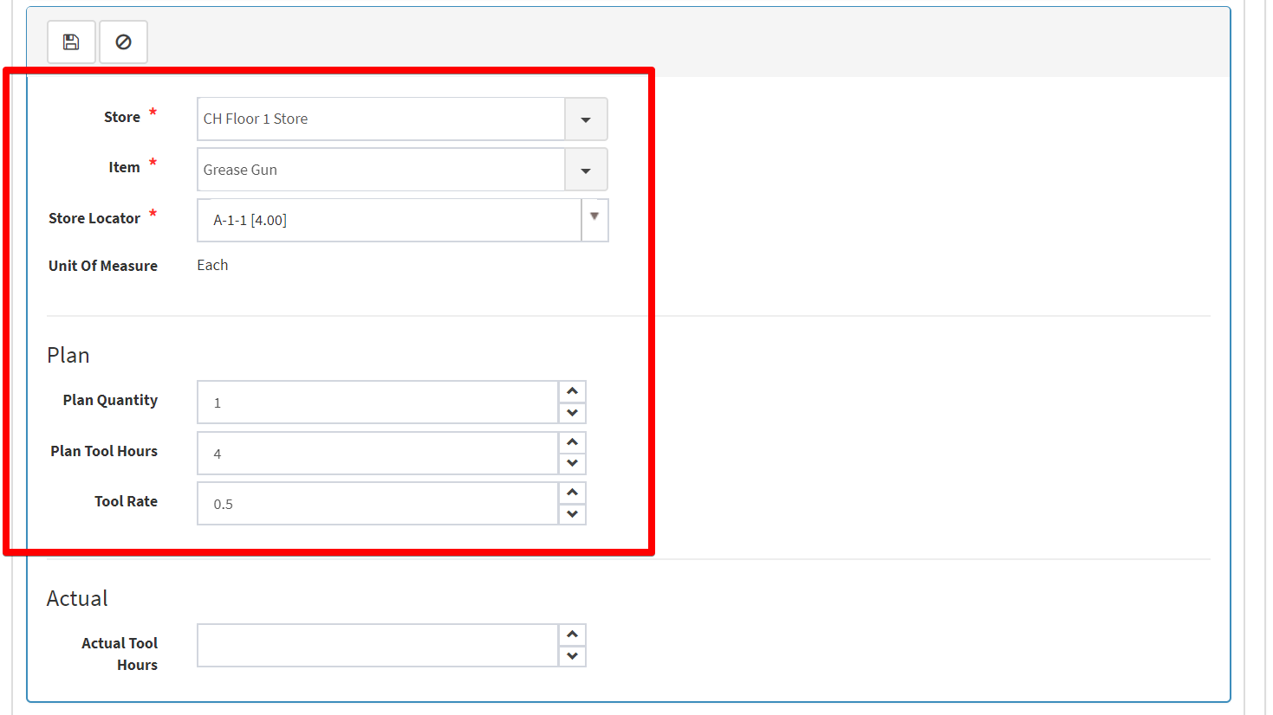  
     
   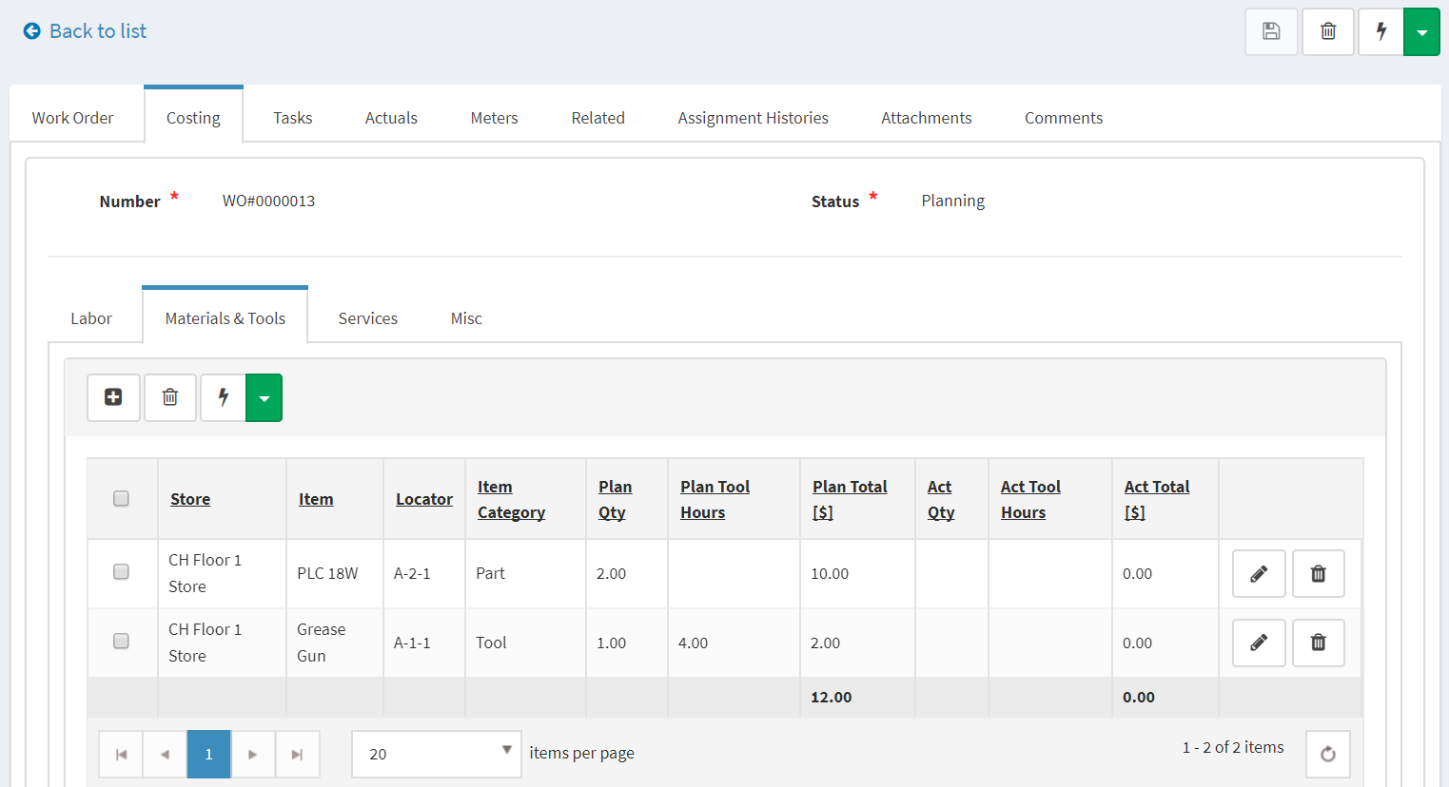
3. You can add Service Items if this WO need services from external vendor  
     
   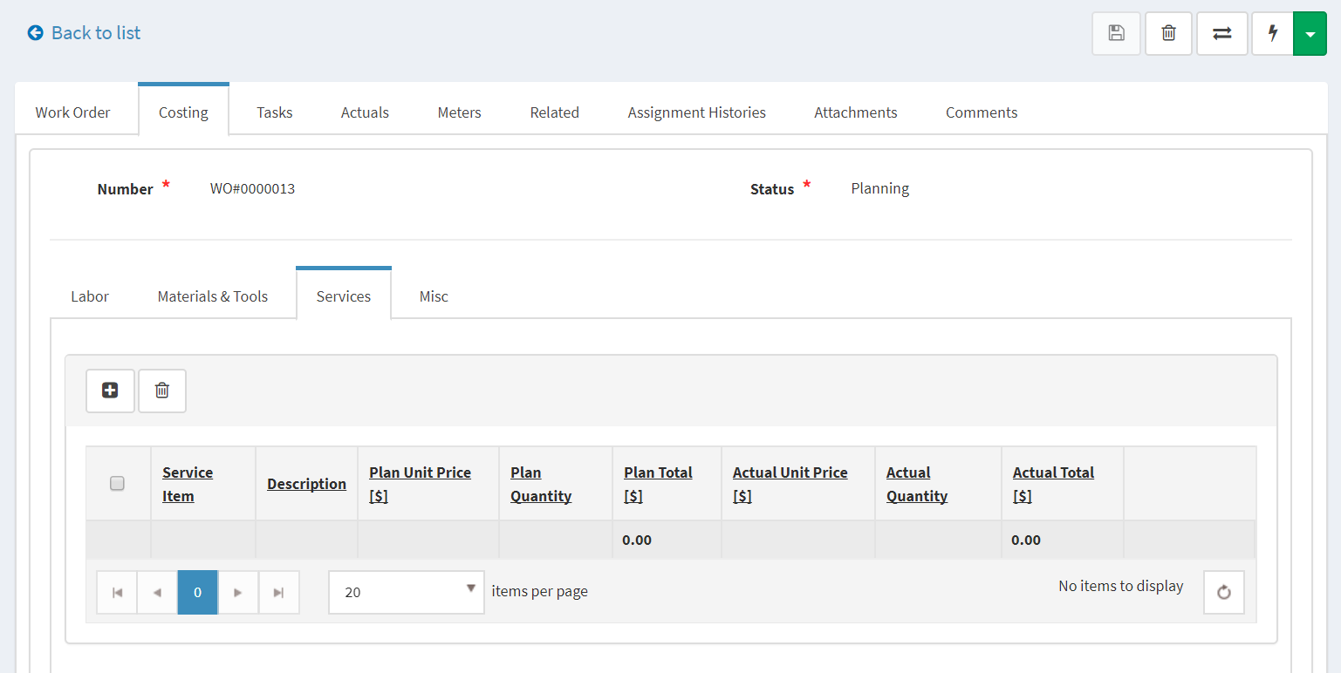
4. You can add other costs if have  
     
   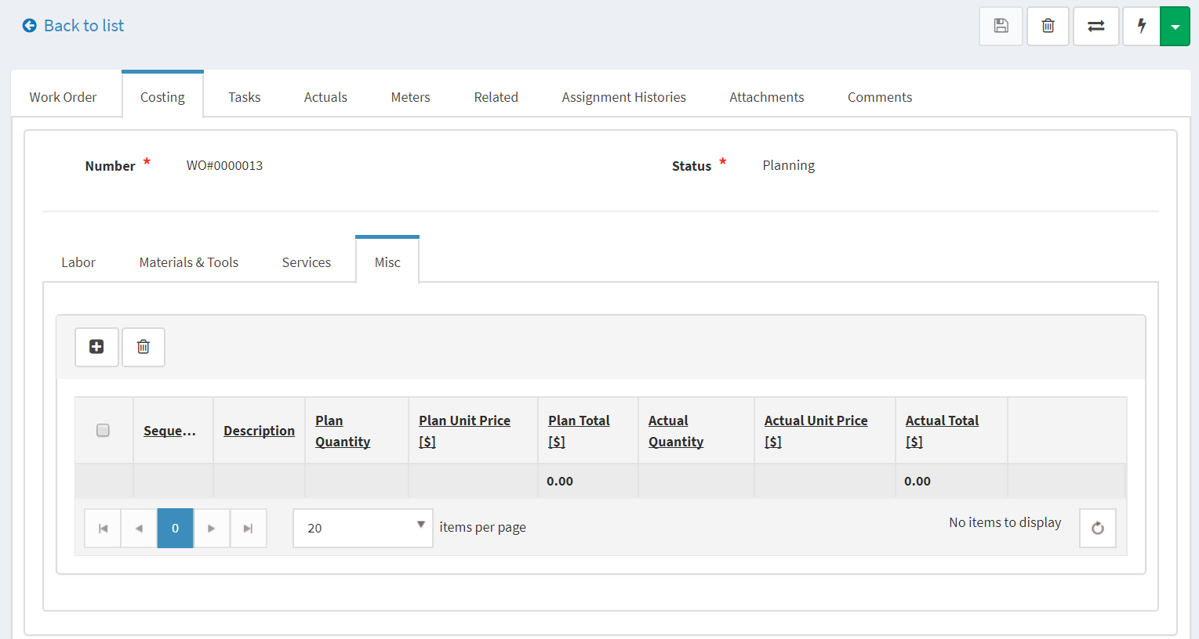
5. Add Tasks  
   Each task represent a step in executing this WO.  
   Click Add New to add a Task  
     
   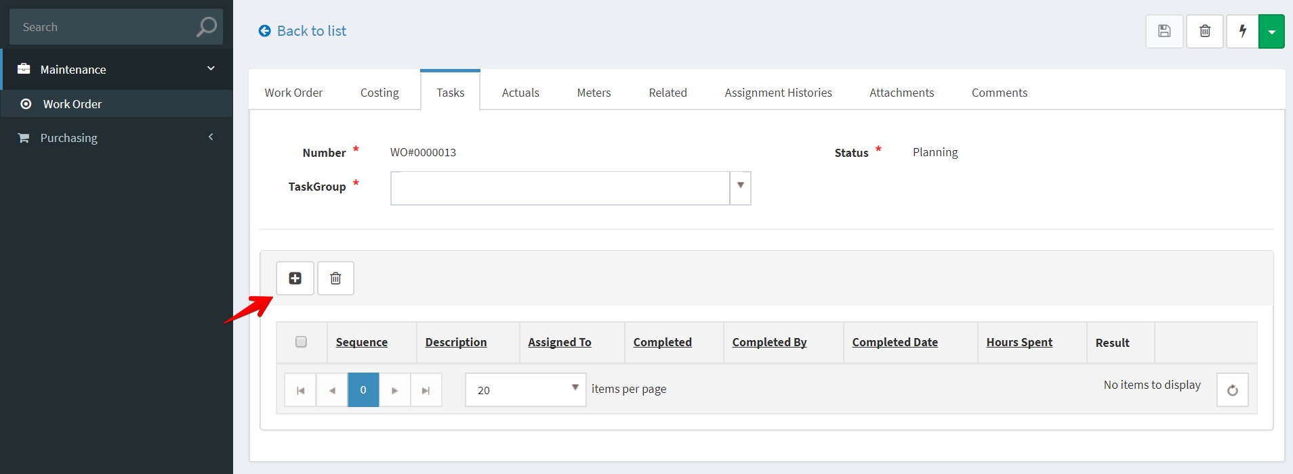  
     
   Fill out the applicable data fields (leave out the Task Completion section, this is for Technician to fill)  
     
   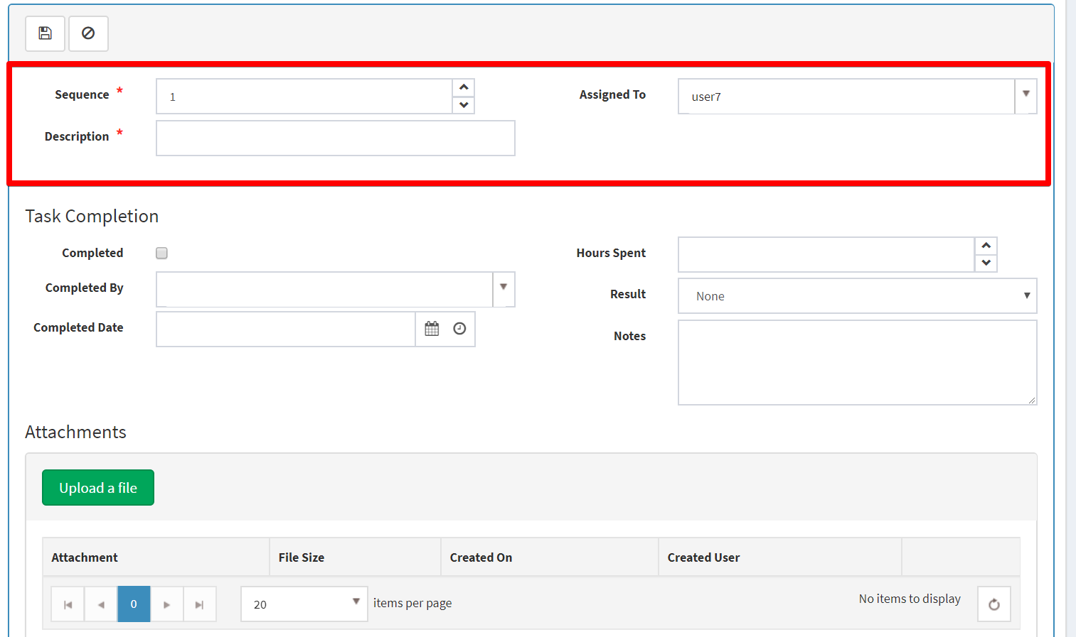

You can add attachments as a guidance documents for this task.  
Then click Save to commit changes. (we added one more Task in this case)

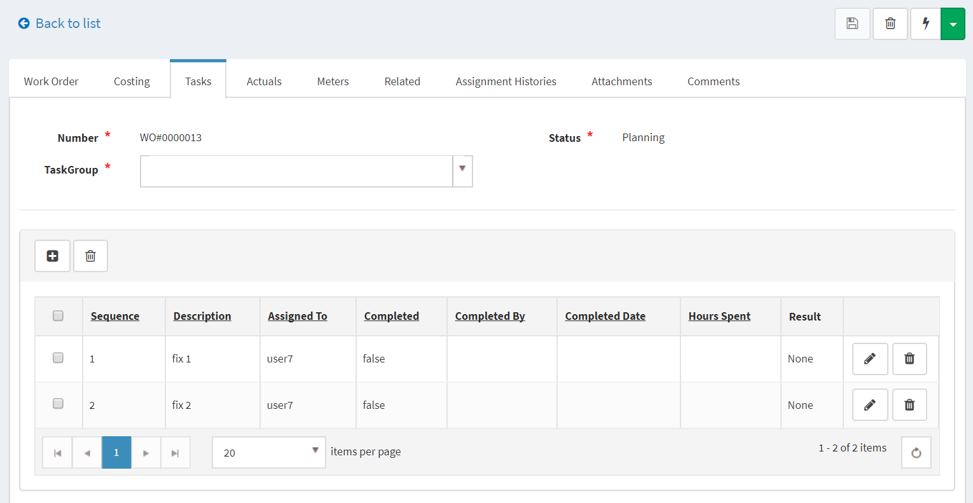

1. At this point, Work Manager (user5) has finished Planning phase, she can release this WO to execution  
   Click Release, then Add Comments  
     
   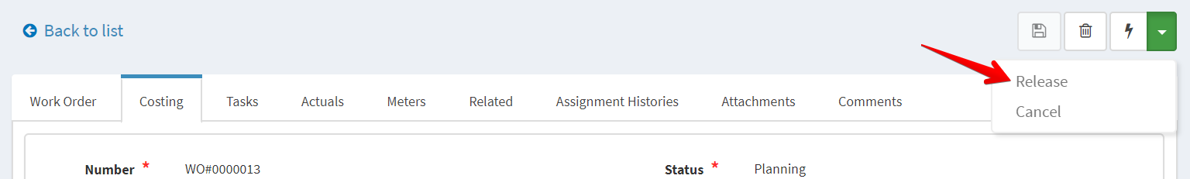  
     
   This WO assignment will be assigned to technicians to execute. In this case, user7 (that is specified in Labor tab) will receive notifications about this WO assignment.  
     
   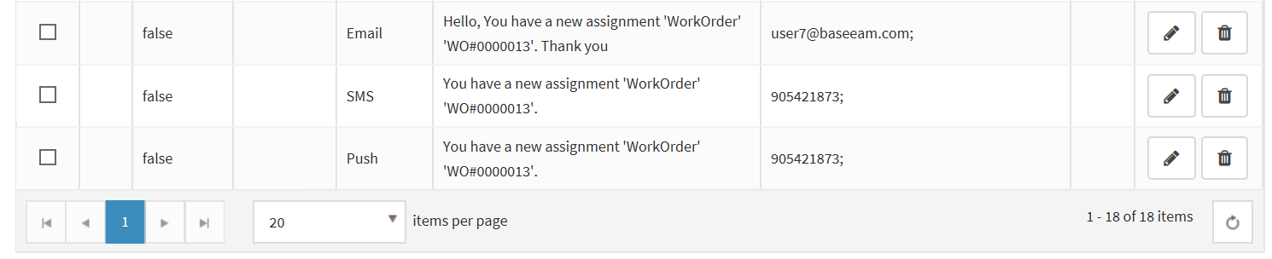
2. As a Technician, user7 login to BaseEAM and see there’s new WO assignment on Dashboard/My Assignments tab  
     
   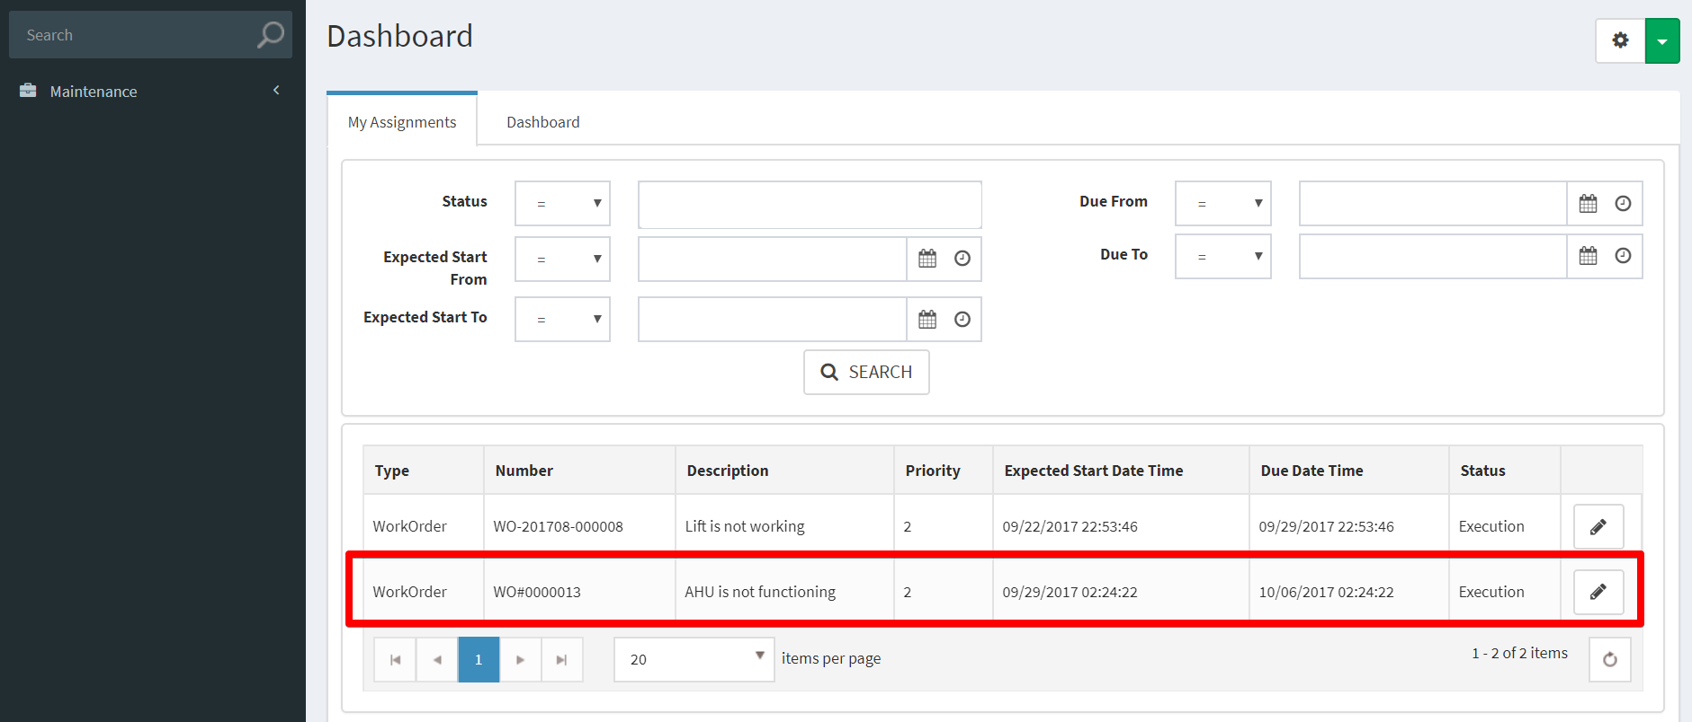  
     
   Click Details to view WO’s details and start executing.

Then user7 need to log her works on this WO.

1. Enter meter reading  
   Enter new reading value and date, then click Save Changes.  
     
   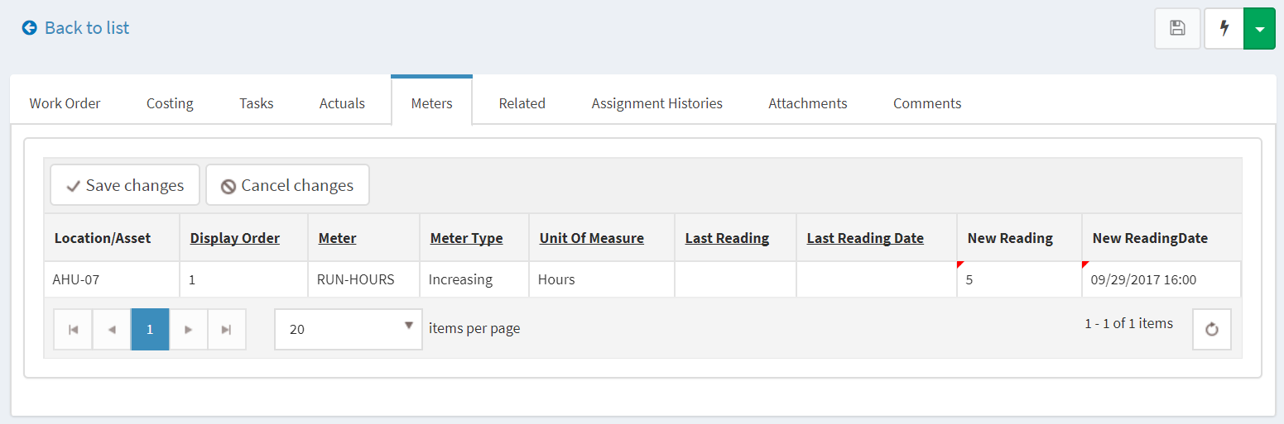
2. Issue Materials & Tools  
   On Materials & Tools tab, click Issue Materials  
     
   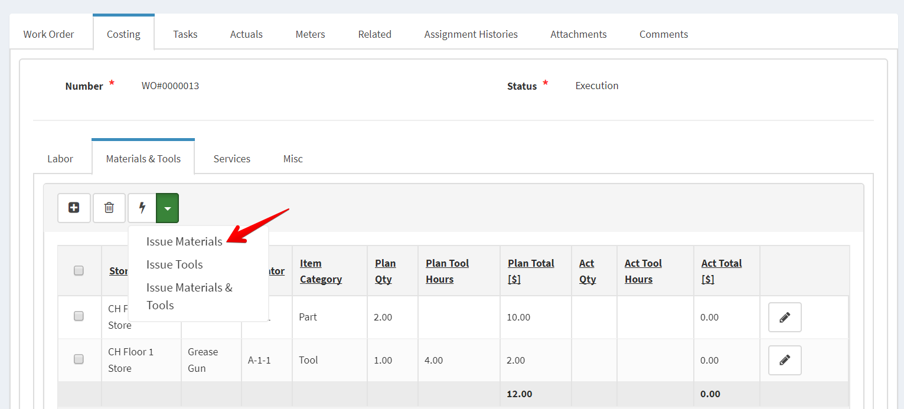  
     
   As **Inventory Manager**, user2 can login and see the new issue. Then she can approve for it.  
     
   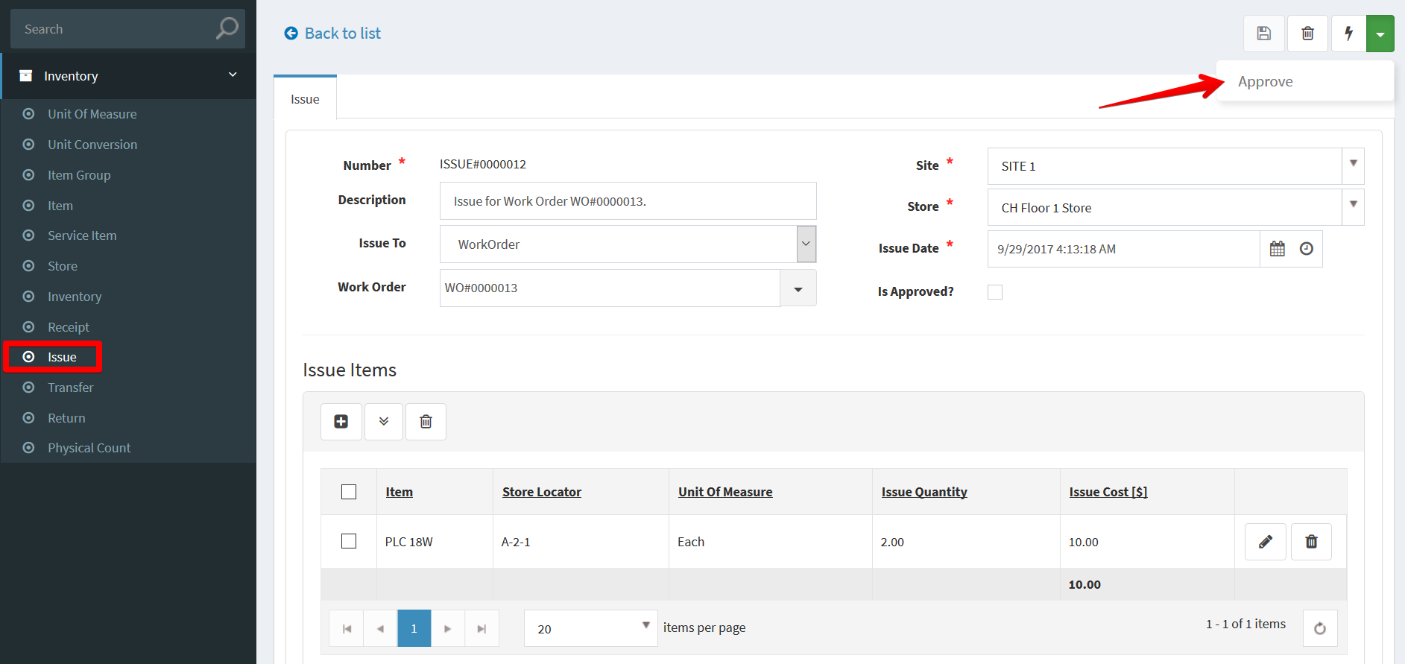  
     
   Do the same to Issue Tools.
3. Complete Tasks  
   Fill out the applicable data fields in Task Completion section.  
     
   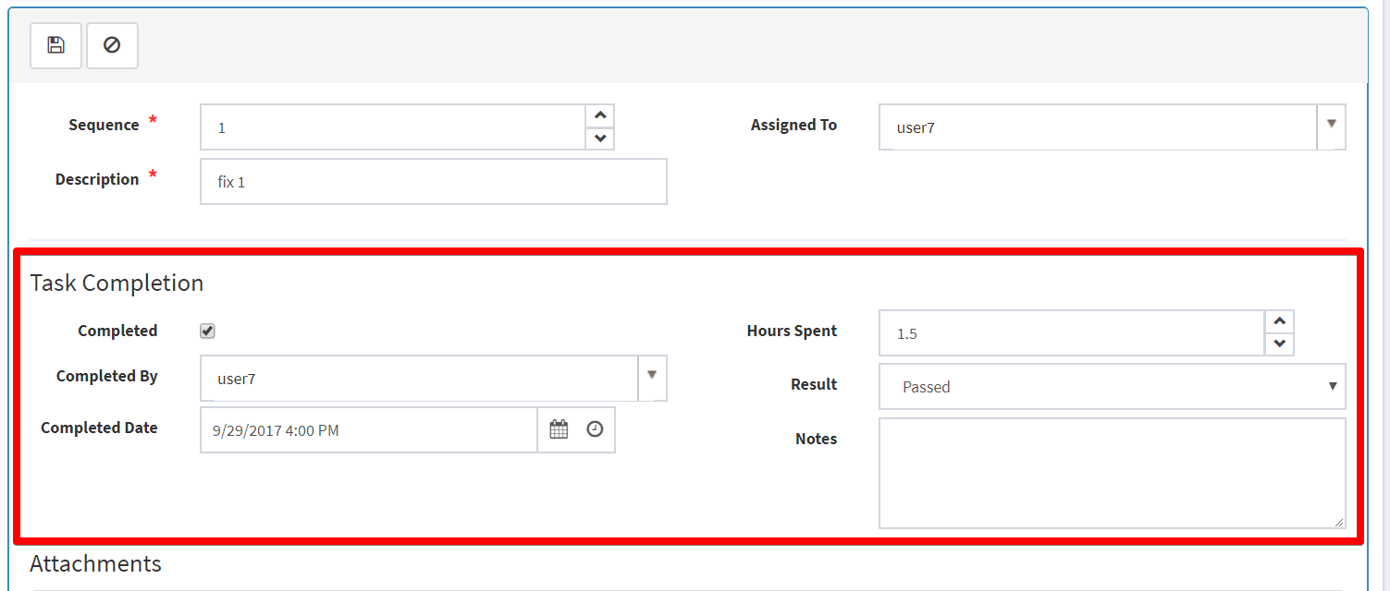  
     
   Then click Save to commit changes  
     
   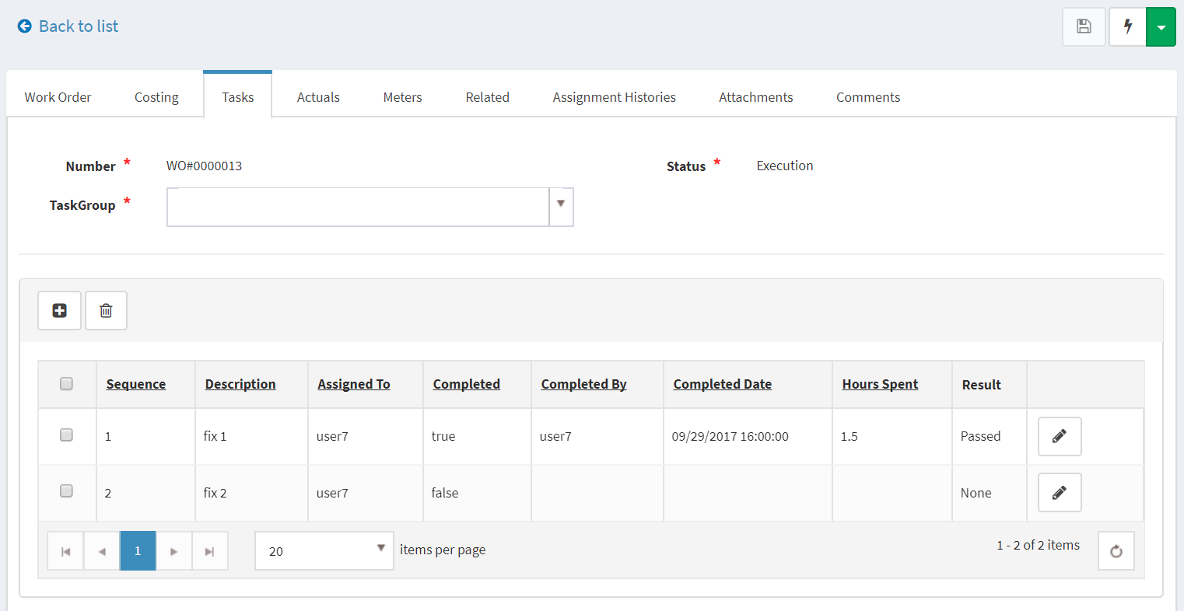
4. Enter Actual Cost for Materials & Tools  
   For Materials, enter Actual Quantity  
     
   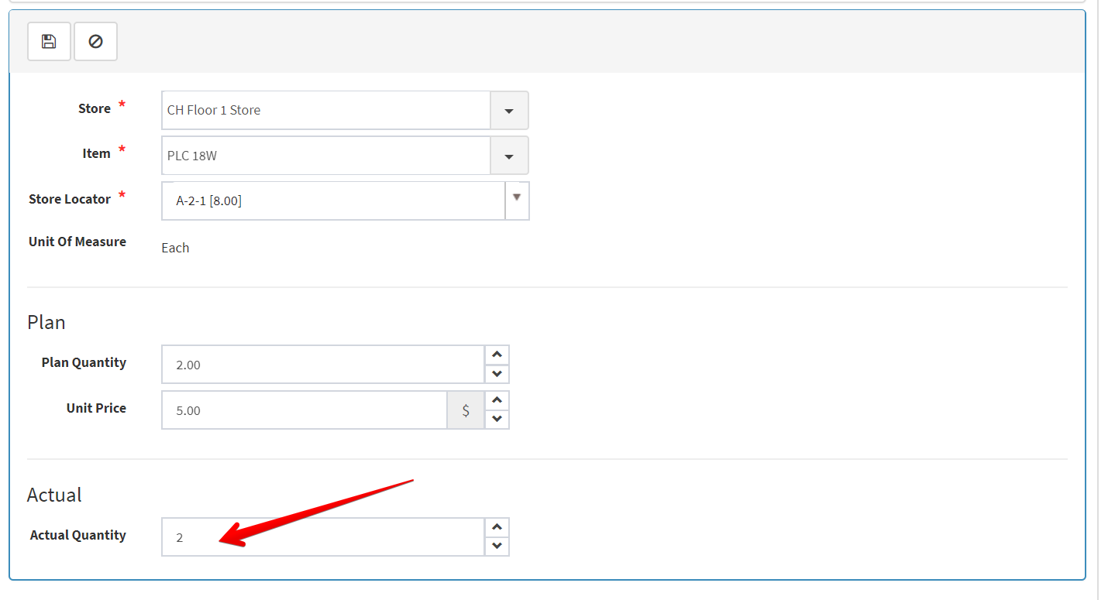  
   For Tools, enter Actual Tool Hours  
     
   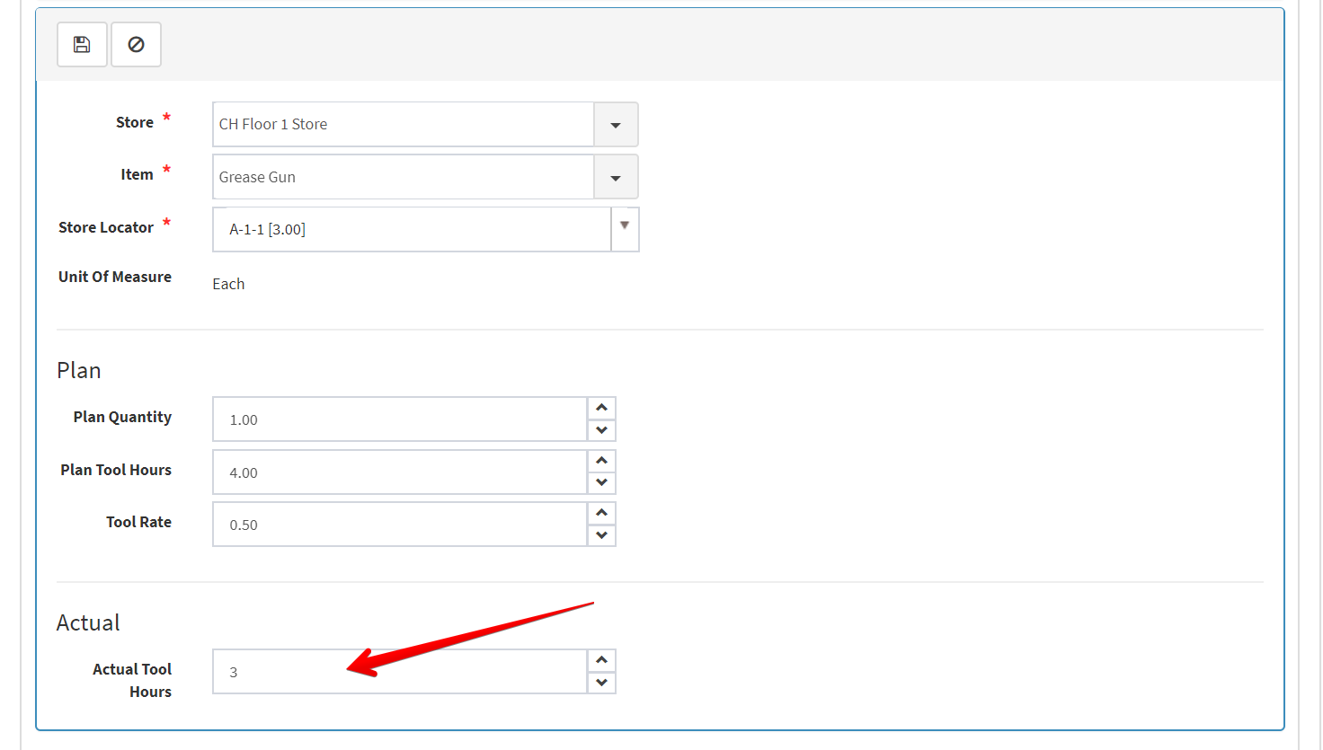
5. Enter Actual Cost for Labor  
     
   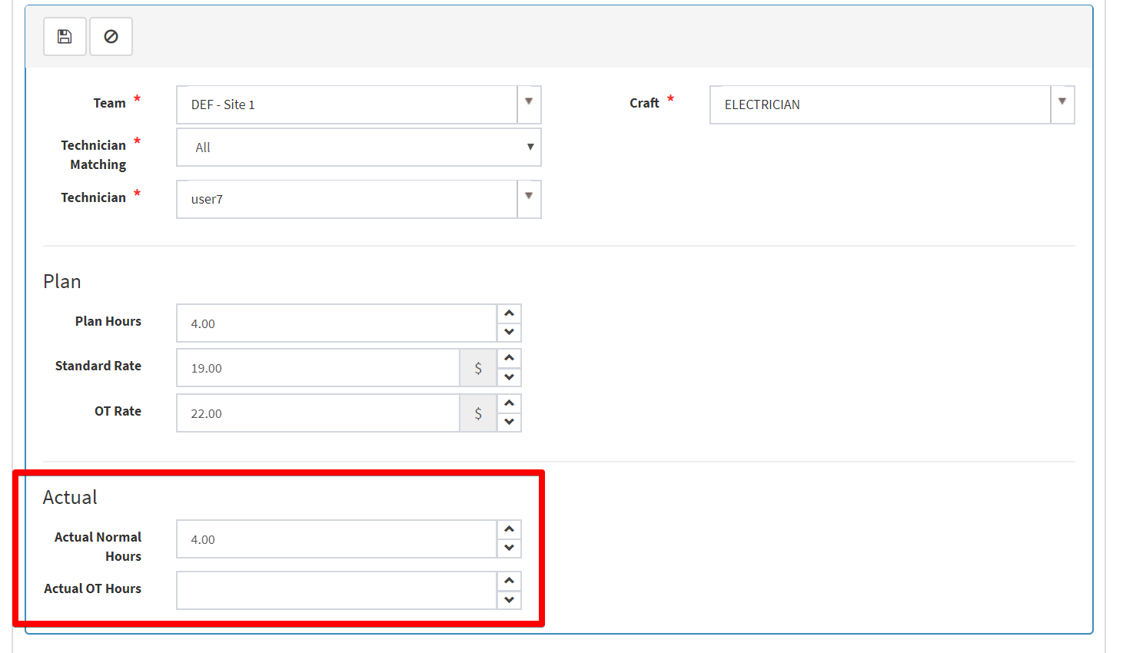
6. Enter Actuals information  
     
   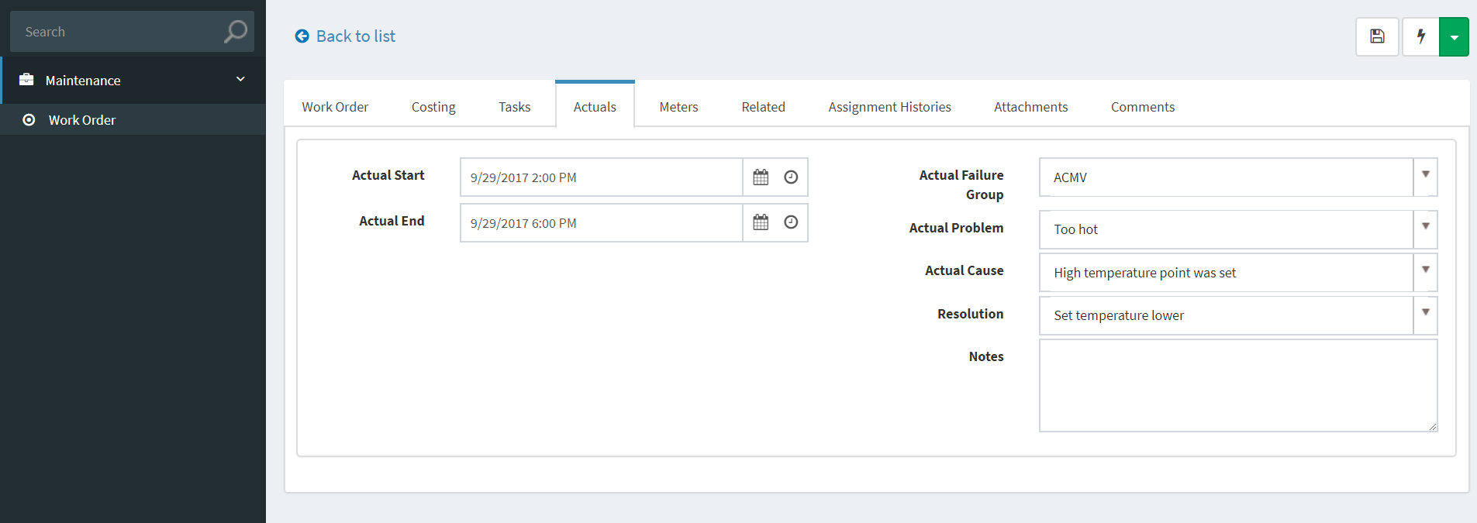

Then click Save

1. If you want to create a follow-up WO you can add it in the Related tab  
     
   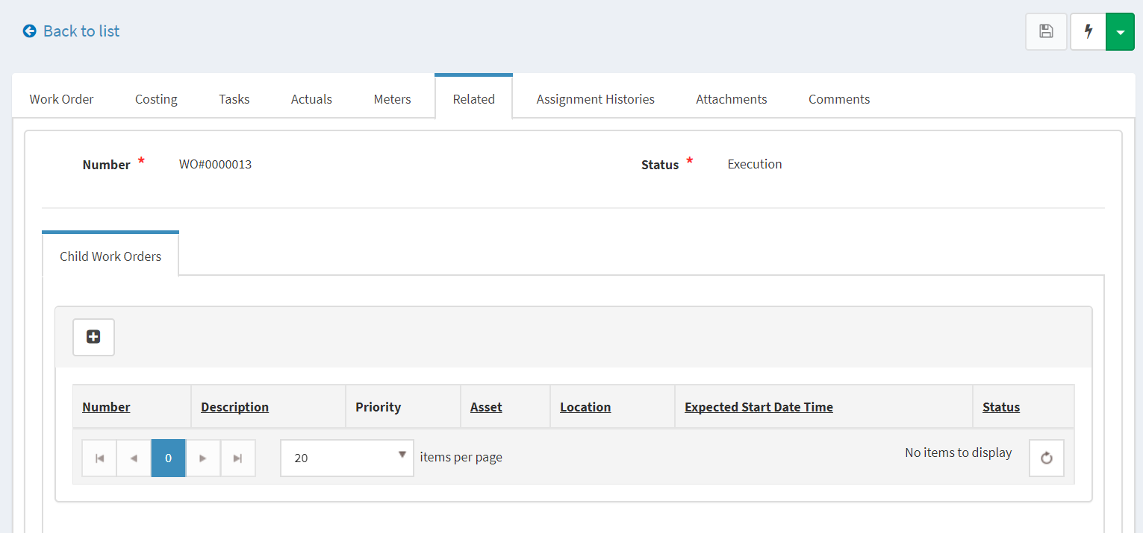
2. At this point, user7 has completed the WO.  
   Click Complete, the Add Comments if have.  
     
   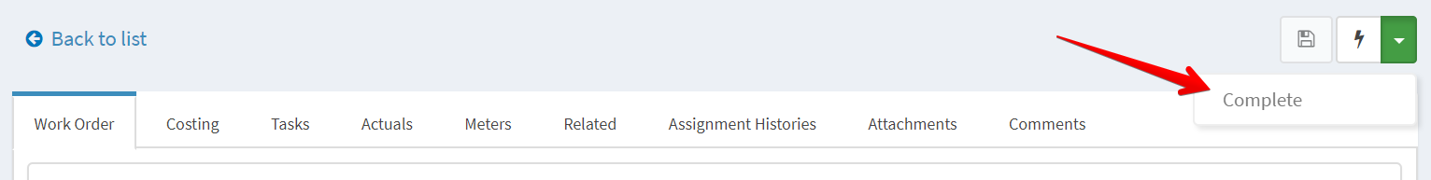   
     
   This WO assignment will be routed to **WorkManagers** to review. In this case user5, user6 will receive notifications about this assignment
3. As a WorkManager, user5 login to BaseEAM and see there’s a new WO assignment need to be review on Dashboard/My Assignments tab.  
     
   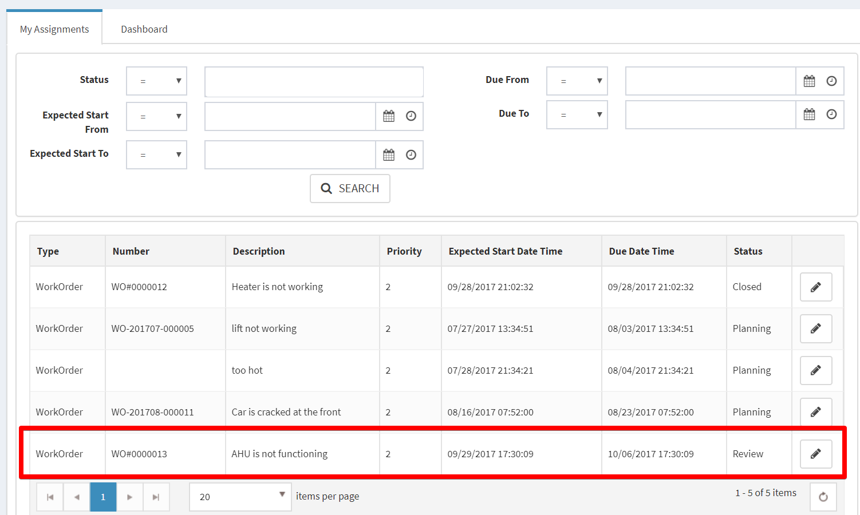

Click Details to view WO’s details.

1. Click Accept to close this WO  
     
   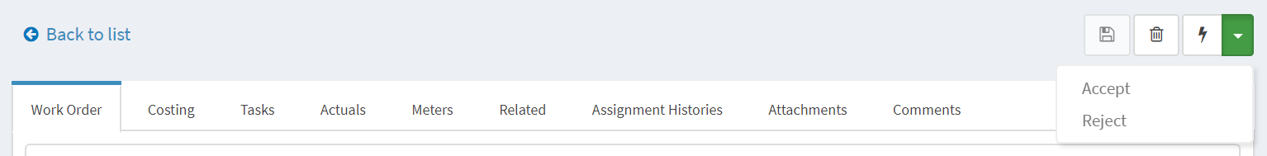  
     
   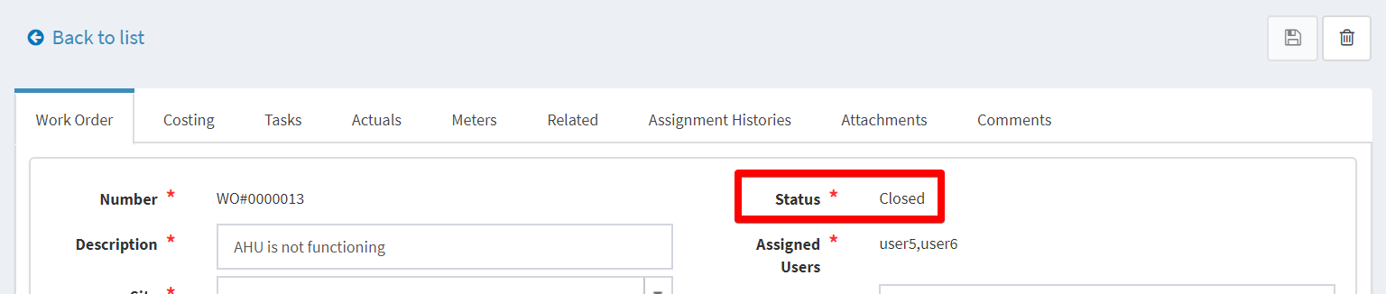
2. For tools, the technician (user7) needs to return it back to the store. And the InventoryManager can handle this.  
   As an InventoryManager, user2 can create a Return document for this tool and the Approve for it.  
     
   