Azure Login and Set Env:

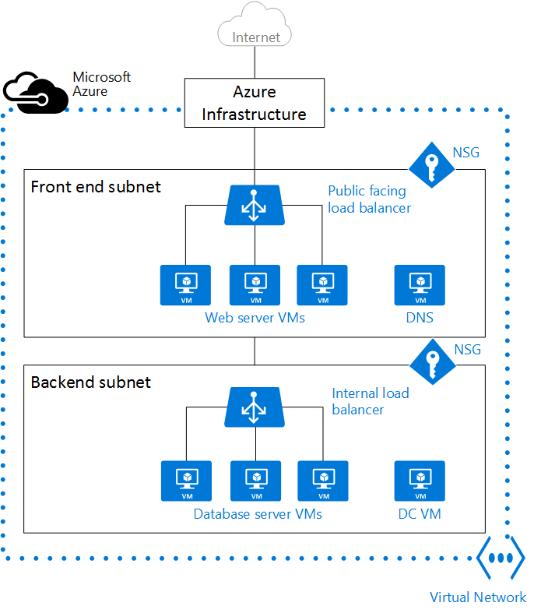

Azure CLI Instructions:

azure login

Username: <your org login>

Pass : <your org pass>

azure account list

azure account set "Your Account Name"

Create a Resource Group

azure group create <Your Resource Group Name> <Your Locaion> westus

azure group deployment create --template-uri https://raw.githubusercontent.com/srakesh28/demo-working/master/1-vnet-nsg-10-working.json <Your Resource Group Name> <optional deployment name>

azure group deployment create --template-uri https://raw.githubusercontent.com/srakesh28/demo-working/master/2-vms-vnet-nsg-linux-working.json <Your Resource Group Name> <optional deployment name>

azure group deployment create --template-uri https://raw.githubusercontent.com/srakesh28/demo-working/master/3-lb-public-ip.json <Your Resource Group Name> <optional deployment name>