Arithmetic
Logic Unit

Date: 29/11/2025

Processor Architecture
(EECG241-17)

Our Team
Code | Section | Name | ID
91240733 | 4 | مريم احمد محمد علي رضا | 1
91240202 | 1 | باسل شريف حميد مصطفى | 2

Instructor:
Eng. Ahmed Atef

Codes are Uploaded in our Github Repositary

Table of contents:
1- Introduction
2- ALU Architecture overview
1. Arithmetic Unit
2. Logic Unit
3. Shift Unit
3- Verilog Code
1. Arithmetic Unit
2. Logic Unit
3. Shift Unit
4. ALU Unit
5. ALU_TB Unit
4- Testbench
5- Do File

1. Introduction
In this project, we designed a 16-bit combinational ALU that implements the required 20 functions across three major blocks:
- Arithmetic Unit
- Logic Unit
- Shift/Rotate Unit

Our Project ALU Codes are uploaded to the Github Repositary

The main objective was to implement all operations and generate the 6 status flags (C, Z, N, V, P, A) as required in the assignment brief (page 1–3 of the PDF)
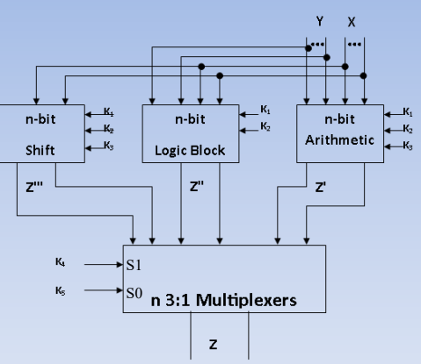
The main Design of the ALU was from Dr. Ibrahim Qamar Slides in Course Processor Architecture.

2. ALU Architecture Overview
The ALU uses the upper bits of F[4:3] to select a block:
00 → Arithmetic
01 → Logic
10 → Shift/Rotate

2.1 Arithmetic Unit
Implements: INC, DEC, ADD, ADD+CIN, SUB, SUB−CIN.
Generates flags: C, Z, N, V, P, Af.

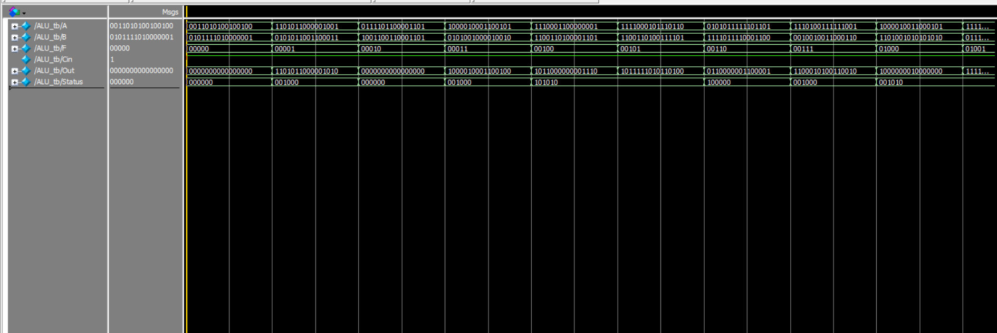

2.2 Logic Unit
Implements: AND, OR, XOR, NOT.
Generates Z, N, P.

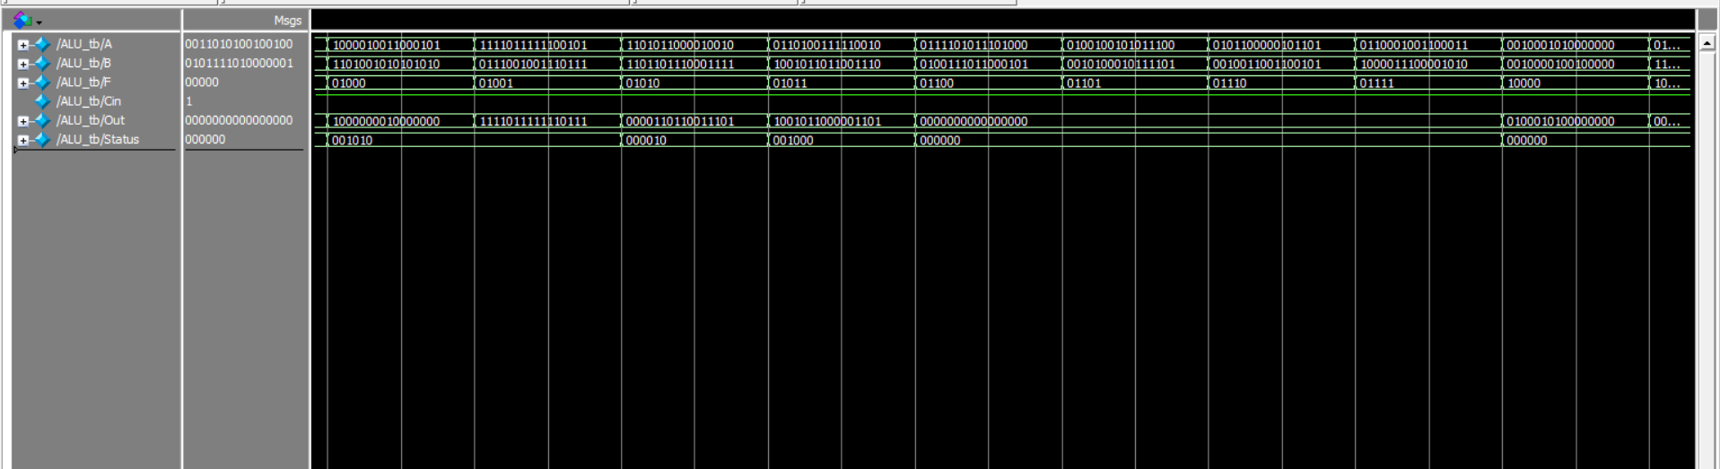

2.3 Shift Unit
Implements: SHL, SHR, SAL, SAR, ROL, ROR, RCL, RCR.
Carry = shifted/rotated-out bit.

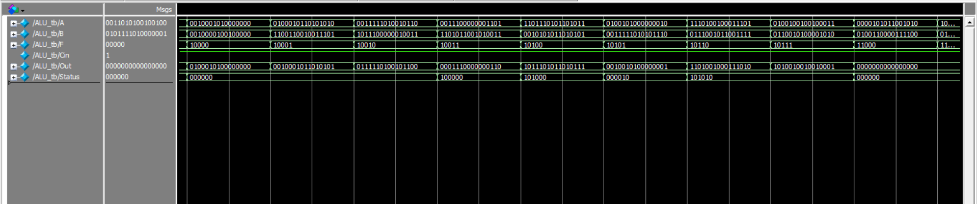

3. Verilog Code
3.1 Arithmetic Unit
tmodule Arithmetic
#(parameter Width=16)
(
input [Width-1:0] A,B,
input Cin,
input [2:0] F,
output reg [Width-1:0] Out,
output reg Cout,
output reg [5:0] Status,
output reg C,Z,N,V,P,Af
);

reg [Width:0] temp;
reg overflow;

always @(*)
begin

case(F)
3'b001: //INC
begin
temp=A+1;
Out=temp[Width-1:0];
Cout=temp[Width];
if(A[Width-1]^Out[Width-1])
overflow=1'b1;
else
overflow=1'b0;
end
////////////////////////////////////////////////////////////
3'b011: //DEC
begin
temp=A-1;
Out=temp[Width-1:0];
Cout=temp[Width];
if(A[Width-1]^Out[Width-1])
overflow=1'b1;
else
overflow=1'b0;
end
////////////////////////////////////////////////////////////
3'b100: //ADD
begin
temp=A+B;
Out=temp[Width-1:0];
Cout=temp[Width];
if( (A[Width-1] & B[Width-1]& ~Out[Width-1]) | ( ~A[Width-1] & ~B[Width-1]& Out[Width-1]) )
overflow=1'b1;
else
overflow=1'b0;
end
////////////////////////////////////////////////////////////
3'b101: //ADD_CARRY
begin
temp=A+B+Cin;
Out=temp[Width-1:0];
Cout=temp[Width];
if( (A[Width-1] & B[Width-1]& ~Out[Width-1]) | ( ~A[Width-1] & ~B[Width-1]& Out[Width-1]) )
overflow=1'b1;
else
overflow=1'b0;
end
////////////////////////////////////////////////////////////
3'b110: //SUB
begin
temp=A-B;
Out=temp[Width-1:0];
Cout=temp[Width];
if( (A[Width-1] & ~B[Width-1]& ~Out[Width-1]) | ( ~A[Width-1] & B[Width-1]& Out[Width-1]) )
overflow=1'b1;
else
overflow=1'b0;
end
////////////////////////////////////////////////////////////
3'b111: //SUB_BORROW
begin
temp=A-B-Cin;
Out=temp[Width-1:0];
Cout=temp[Width];
if( (A[Width-1] & ~B[Width-1]& ~Out[Width-1]) | ( ~A[Width-1] & B[Width-1]& Out[Width-1]) )
overflow=1'b1;
else
overflow=1'b0;
end
////////////////////////////////////////////////////////////
default:
begin
Out=0;
Cout=0;
overflow=0;
end
////////////////////////////////////////////////////////////
endcase

////////////////////////////////////////////////////////////
C = (F[2] | F[0]) ? Cout : 1'b0; // Carry Flag
Z = (F[2] | F[0]) ? (Out=={Width{1'b0}}) : 1'b0; // Zero Flag
N = (F[2] | F[0]) ? Out[Width-1] : 1'b0; // Negative Flag
V = (F[2] | F[0]) ? overflow : 1'b0; // Overflow Flag
P = (F[2] | F[0]) ? ~^Out : 1'b0; // Parity Flag
Af = (F[2] | F[0]) ? ((A[3:0]+B[3:0]+Cin)>4'hF) : 1'b0; // Auxiliary Flag

// The if condition here is just to make the Flags = 0 when the two not used OP Codes in the Project Details

Status={C,Z,N,V,P,Af}; // Concatenate

end
endmodule

3.2 Logic Unit
module Logic
#(parameter Width = 16)
(
input [Width-1:0] A,B,
input [2:0] F,
output reg Z,N,P,
output reg [Width-1:0] Out
);

always@(*) begin
case(F)
3'b000: //AND
begin
Out = A & B;
Z = ~|Out; //Zero Flag
N = Out[Width-1]; //Negative Flag
P = ~^Out; //Parity Flag
end
////////////////////////////////////////////////////////////
3'b001: //OR
begin
Out = A | B;
Z = ~|Out; //Zero Flag
N = Out[Width-1]; //Negative Flag
P = ~^Out; //Parity Flag
end
////////////////////////////////////////////////////////////
3'b010: //XOR
begin
Out = A ^ B;
Z = ~|Out; //Zero Flag
N = Out[Width-1]; //Negative Flag
P = ~^Out; //Parity Flag
end
////////////////////////////////////////////////////////////
3'b011: //NOT
begin
Out = ~A;
Z = ~|Out; //Zero Flag
N = Out[Width-1]; //Negative Flag
P = ~^Out; //Parity Flag
end
////////////////////////////////////////////////////////////
default:
begin
Out = 1'b0;
Z = 1'b0; //Zero Flag
N = 1'b0; //Negative Flag
P = 1'b0; //Parity Flag
end
////////////////////////////////////////////////////////////
endcase

end
endmodule

3.3 Shift Unit
module Shift
#(parameter Width=16)
(
input [Width-1:0] A,
input [2:0] F,
output reg C,Z,N,P,
output reg [Width-1:0] Out
);

reg Cshift;

always @(*)
begin
case (F)
3'b000: //SHL
{C,Out} = {A,1'b0};
////////////////////////////////////////////////////////////
3'b001: //SHR
{Out,C} = {1'b0,A};
////////////////////////////////////////////////////////////
3'b010: //SAL
{C,Out} = {A,1'b0};
////////////////////////////////////////////////////////////
3'b011: //SAR
{Out,C} = {A[Width-1],A};
////////////////////////////////////////////////////////////
3'b100: //ROL
{C,Out} = {A,A[Width-1]};
////////////////////////////////////////////////////////////
3'b101: //ROR
{Out,C} = {A[0],A};
////////////////////////////////////////////////////////////
3'b110: //RCL
begin
Cshift = C;
{C,Out} = {A,Cshift};
end
////////////////////////////////////////////////////////////
3'b111: //RCR
begin
Cshift = C;
{Out,C} = {Cshift,A};
end
////////////////////////////////////////////////////////////
default:
begin
Out = {Width{1'b0}};
C = 1'b0;
Z = 1'b0;
N = 1'b0;
P = 1'b0;
end
////////////////////////////////////////////////////////////
endcase

Z = ~|Out; //Zero Flag
N = Out[Width-1]; //Negative Flag
P = ~^Out; //Parity Flag

end

endmodule

3.4 ALU Unit
module ALU
#(parameter Width=16)
(
input [Width-1:0] A,B,
input Cin,
input [4:0] F, // F[4:3] -> block select, lower bits -> sub-op
output reg [Width-1:0] Out,
output reg [5:0] Status
);

// Registers for the Flags Used
reg C,Z,N,V,P,Af,Cout;

// Arithmetic Wires
wire [Width-1:0] arith_out;
wire arith_C,arith_Z,arith_N,arith_V,arith_P,arith_Af;

// Logic Wires
wire [Width-1:0] logic_out;
wire logic_Z,logic_N,logic_P;

// Shift Wires
wire [Width-1:0] shift_out;
wire shift_C,shift_Z,shift_N,shift_P;

// ================== Instantiations ==================

// Arithmetic block (F[2:0] from ALU F)
Arithmetic#(.Width(Width)) U_ARITH (
.A(A),
.B(B),
.Cin(Cin),
.F(F[2:0]),
.Out(arith_out),
.Cout(), // not used
.Status(), // not used
.C(arith_C),
.Z(arith_Z),
.N(arith_N),
.V(arith_V),
.P(arith_P),
.Af(arith_Af)
);

// Logic block (F[1:0] from ALU F)
Logic#(.Width(Width)) U_LOGIC (
.A(A),
.B(B),
.F(F[2:0]),
.Z(logic_Z),
.N(logic_N),
.P(logic_P),
.Out(logic_out)
);

// Shift block (F[2:0] from ALU F)
Shift#(.Width(Width)) U_SHIFT (
.A(A),
.F(F[2:0]),
.Out(shift_out),
.C(shift_C),
.Z(shift_Z),
.N(shift_N),
.P(shift_P)
);

// ================== ALU Mux Logic ==================

always@(*) begin
case (F[4:3])
2'b00:
begin
// Arithmetic operations
Out = arith_out;
C = arith_C;
Z = arith_Z;
N = arith_N;
V = arith_V;
P = arith_P;
Af = arith_Af;
end
////////////////////////////////////////////////////////////
2'b01:
begin
// Logic operations
Out = logic_out;
C = 1'b0;
Z = logic_Z;
N = logic_N;
V = 1'b0;
P = logic_P;
Af = 1'b0;
end
////////////////////////////////////////////////////////////
2'b10:
begin
// Shift operations
Out = shift_out;
C = shift_C;
Z = shift_Z;
N = shift_N;
V = 1'b0;
P = shift_P;
Af = 1'b0;
end
////////////////////////////////////////////////////////////
default:
begin
// Unused opcodes ------> everything zero
Out = {Width{1'b0}};
C = 1'b0;
Z = 1'b0;
N = 1'b0;
V = 1'b0;
P = 1'b0;
Af = 1'b0;
end
////////////////////////////////////////////////////////////
endcase

Cout = C;
Status = {C,Z,N,V,P,Af};
end

endmodule

3.5 ALU_TB Unit
`timescale 1ns/1ps

module ALU_tb
#(parameter Width = 16);
reg [Width-1:0] A,B;
reg [4:0] F;
reg Cin;
wire[Width-1:0] Out;
wire[5:0] Status;

// Instanstaite of ALI Block
ALU#(.Width(Width)) U_ALU (
.A(A),
.B(B),
.Cin(Cin),
.F(F),
.Out(Out),
.Status(Status)
);

initial
begin
$display(" time | A | B | Cin | F | Out | Status");
$display("----------------------------------------------------------------------------------------");
F = 5'b00000;
repeat(100)

begin
A = $random;
B = $random;
Cin = 1; //$random;
#1
$display("%5t | %b %b %b %b | %b %b",
$time, A, B, Cin, F, Out, Status);
F = F + 1;
#10;

end

end
endmodule

4. Testbench
# time | A | B | Cin | F | Out | Status
# ------------------------------------------------------------------------------------------------------------------------------------------------
# 10000 | 0011010100100100 13604 0101111010000001 24193 1 00000 | 0000000000000000 0 000000
# 20000 | 1101011000001001 54793 0101011001100011 22115 1 00001 | 1101011000001010 54794 001000
# 30000 | 0111101100001101 31501 1001100110001101 39309 1 00010 | 0000000000000000 0 000000
# 40000 | 1000010001100101 33893 0101001000010010 21010 1 00011 | 1000010001100100 33892 001000
# 50000 | 1110001100000001 58113 1100110100001101 52493 1 00100 | 1011000000001110 45070 101010
# 60000 | 1111000101110110 61814 1100110100111101 52541 1 00101 | 1011111010110100 48820 101010
# 70000 | 0101011111101101 22509 1111011110001100 63372 1 00110 | 0110000001100001 24673 100000
# 80000 | 1110100111111001 59897 0010010011000110 9414 1 00111 | 1100010100110010 50482 001000
# 90000 | 1000010011000101 33989 1101001010101010 53930 1 01000 | 1000000010000000 32896 001010
# 100000 | 1111011111100101 63461 0111001001110111 29303 1 01001 | 1111011111110111 63479 001010
# 110000 | 1101011000010010 54802 1101101110001111 56207 1 01010 | 0000110110011101 3485 000010
# 120000 | 0110100111110010 27122 1001011011001110 38606 1 01011 | 1001011000001101 38413 001000
# 130000 | 0111101011101000 31464 0100111011000101 20165 1 01100 | 0000000000000000 0 000000
# 140000 | 0100100101011100 18780 0010100010111101 10429 1 01101 | 0000000000000000 0 000000
# 150000 | 0101100000101101 22573 0010011001100101 9829 1 01110 | 0000000000000000 0 000000
# 160000 | 0110001001100011 25187 1000011100001010 34570 1 01111 | 0000000000000000 0 000000
# 170000 | 0010001010000000 8832 0010000100100000 8480 1 10000 | 0100010100000000 17664 000000
# 180000 | 0100010110101010 17834 1100110010011101 52381 1 10001 | 0010001011010101 8917 000000
# 190000 | 0011111010010110 16022 1011100000010011 47123 1 10010 | 0111110100101100 32044 000000
# 200000 | 0011100000001101 14349 1101011001010011 54867 1 10011 | 0001110000000110 7174 100000
# 210000 | 1101110101101011 56683 0010101011010101 10965 1 10100 | 1011101011010111 47831 101000
# 220000 | 0100101000000010 18946 0011111010101110 16046 1 10101 | 0010010100000001 9473 000010
# 230000 | 1110100100011101 59677 0111001011001111 29391 1 10110 | 1101001000111010 53818 101010
# 240000 | 0100100100100011 18723 0110010100001010 25866 1 10111 | 1010010010010001 42129 101010
# 250000 | 0000101011001010 2762 0100110000111100 19516 1 11000 | 0000000000000000 0 000000
# 260000 | 1011110111110010 48626 0110000110001010 24970 1 11001 | 0000000000000000 0 000000
# 270000 | 1011001101000001 45889 0011010011011000 13528 1 11010 | 0000000000000000 0 000000
# 280000 | 1111001101111000 62328 0001001010001001 4745 1 11011 | 0000000000000000 0 000000
# 290000 | 0000110111101011 3563 0110010110110110 26038 1 11100 | 0000000000000000 0 000000
# 300000 | 1111100111000110 63942 0001001110101110 5038 1 11101 | 0000000000000000 0 000000
# 310000 | 0000001010111100 700 1101110100101010 56618 1 11110 | 0000000000000000 0 000000
# 320000 | 1001101000001011 39435 1011111001110001 48753 1 11111 | 0000000000000000 0 000000
# 330000 | 0100000110000101 16773 0101010101001111 21839 1 00000 | 0000000000000000 0 000000
# 340000 | 0110000000111011 24635 0011001100111010 13114 1 00001 | 0110000000111100 24636 000010
# 350000 | 0011001001111110 12926 0100101100010101 19221 1 00010 | 0000000000000000 0 000000

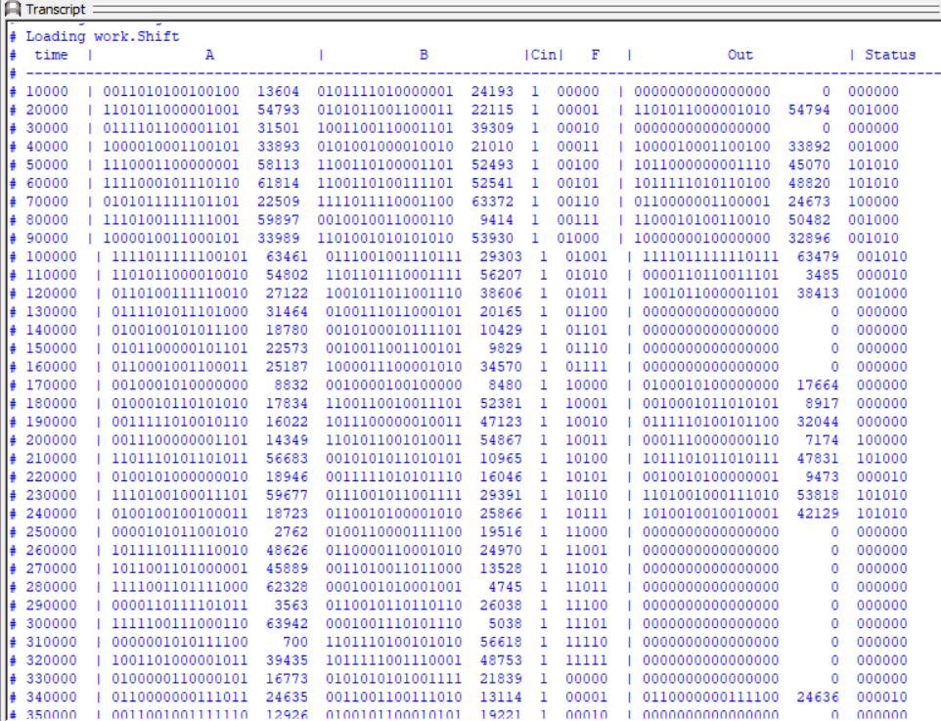
5. Do file
vlib work
vlog ALU.v ALU_TB.v
vsim -voptargs=+acc work.ALU_tb
add wave -r /*
run -all

To run the simulation the Transcript we type :
Do run.txt

