IEEE Solid-State Circuits Society (SSCS) — Egypt Chapter
2026 Student Design Competition
An FPGA-Based Edge-AI N×N CNN Convolution Accelerator:
Architecture, RTL Implementation, and Verification
Team: Silicon Minds
Basel
Design, RTL implementation, verification, optimization, and synthesis performed independently.
Report submitted September 2026
Target device: Xilinx Zynq-7020 (xc7z020clg400-1), PYNQ-Z2 board

Table of Contents

Abstract
This report presents the design, RTL implementation, verification, and FPGA implementation of a programmable N×N convolution accelerator for Edge-AI vision workloads, developed for the IEEE SSCS Egypt Chapter 2026 Student Design Competition. The accelerator streams an unsigned 8-bit grayscale image through a raster-scan controller, a row-buffered line-delay chain, and a sliding-window generator into a pipelined multiply-accumulate (MAC) unit that computes a signed 20-bit convolution result against a runtime-programmable 8-bit signed N×N kernel, with an optional ReLU activation applied before results are streamed out through a FIFO. The design supports images of at least 32×32 pixels, a stride of 1, and kernel sizes beyond the minimum 3×3 case (verified up to K=5), and was correctness-checked against a bit-accurate Python golden model. The current, fully routed implementation on a Xilinx Zynq-7020 (xc7z020clg400-1) consumes 842 LUTs, 758 flip-flops, zero DSP48 slices, and 0.5 Block RAM tiles, closes timing at a 20 MHz operating point with 35.5 ns of positive slack (an achievable maximum frequency of approximately 69.1 MHz), and is estimated to dissipate 0.149 W of total on-chip power. These figures yield a Figure of Merit of 7.52×10⁻³, an approximately 19.0× improvement over an unoptimized 100 MHz baseline achieved through FIFO right-sizing, a deliberate low-power clock reduction, and a synchronous-reset correction that removed a real Block RAM control-pin timing hazard. Correctness was verified end-to-end against the golden model (900 of 900 output pixels bit-exact across two independent stimulus sets), and a 46-case verification test plan spanning functional, boundary, reset, back-to-back, error-injection, and timing/protocol scenarios was built out into a layered SystemVerilog verification environment with code and functional coverage, ready for execution in QuestaSim. All design and verification work described in this report was carried out independently by the sole remaining author of Team Silicon Minds.

1. Introduction
Convolutional neural networks (CNNs) are the dominant computational primitive behind modern computer-vision pipelines, and the convolution layer — a sliding-window multiply-accumulate over an input feature map — is typically the most compute- and memory-intensive stage of such a pipeline. Deploying CNN-based perception on power- and area-constrained edge devices (smart cameras, industrial inspection sensors, always-on vision nodes) motivates dedicated, resource-efficient hardware accelerators rather than general-purpose CPU or GPU execution, since a fixed-function datapath can achieve substantially higher throughput per watt and per logic cell for this one operation.
This report documents the design of a parameterizable N×N convolution accelerator built to satisfy the IEEE SSCS Egypt Chapter 2026 Student Design Competition's required specifications: a minimum 32×32 grayscale/feature-map input, unsigned fixed-point pixels, a programmable N×N kernel of 8-bit signed coefficients, unit stride, a minimum 16-bit signed output with a stated overflow policy, an optional ReLU activation, verification against a software golden model, and FPGA synthesis/implementation results (utilization, timing, power) culminating in a Figure of Merit (FoM).
The accelerator was designed, coded in Verilog, verified against a Python golden model, optimized for the competition's FoM metric, and carried through Vivado synthesis and implementation entirely by the author. This report follows the competition announcement's required content in order: accelerator architecture and block diagram (Section 2), datapath, control FSM, and memory/buffer organization (Section 2), fixed-point bit-width analysis (Section 3), RTL implementation detail (Section 4), verification methodology and results including the golden model and testbenches (Section 5), FPGA synthesis, timing, and power results (Section 6), the Figure of Merit and overall performance analysis (Section 7), a discussion of design tradeoffs (Section 8), the competition's required Table 1 summary (Section 9), and concluding remarks (Section 10).

2. Accelerator Architecture
The accelerator is organized as a fully streaming datapath: one input pixel is consumed and, in steady state, one output pixel is produced per clock cycle, satisfying the competition's bonus one-output-pixel-per-cycle pipelining criterion. Figure 1 shows the top-level block diagram as instantiated in RTL/top.v.
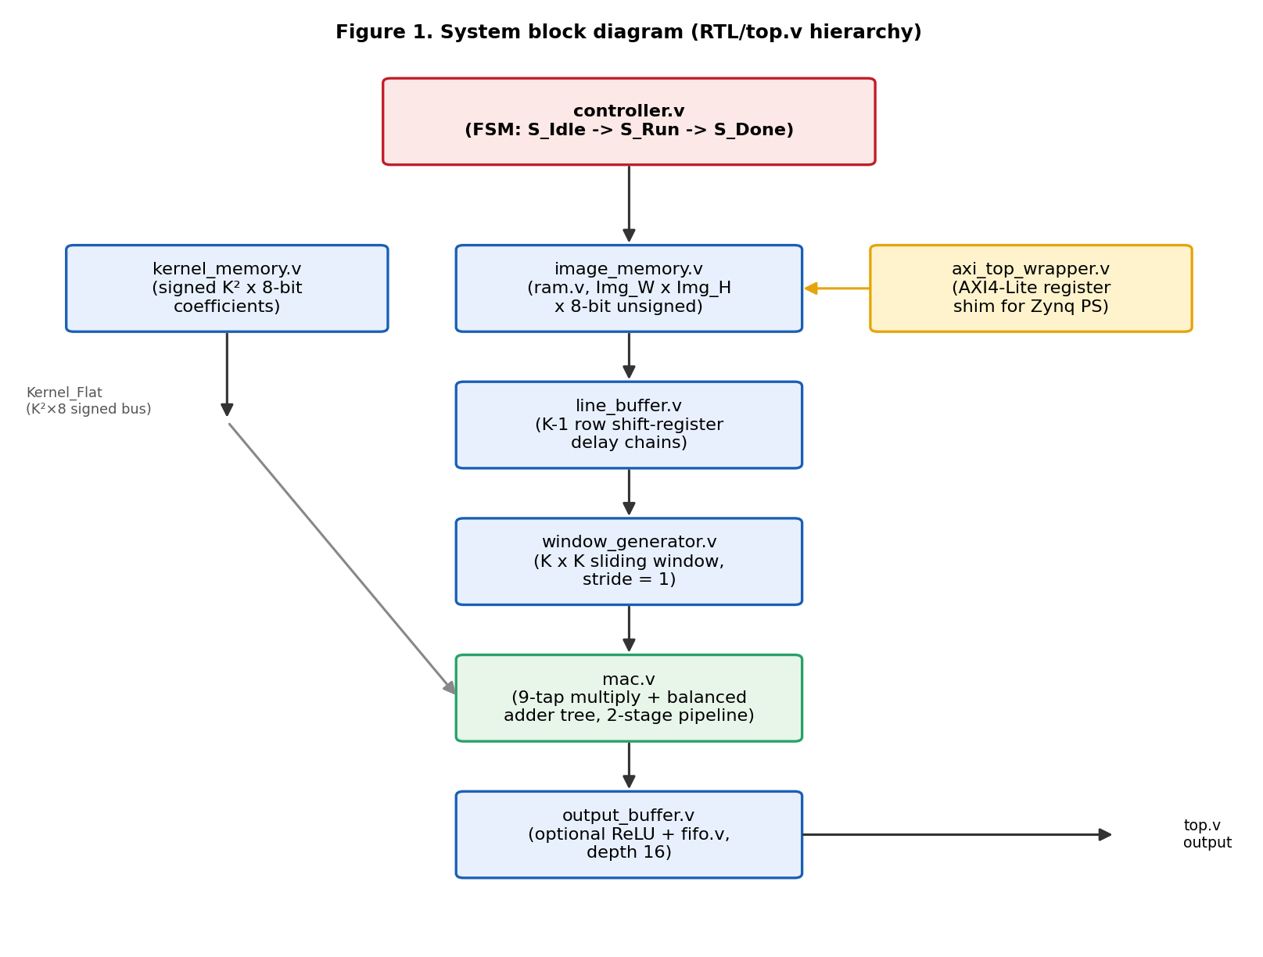
Figure 1. System block diagram (RTL/top.v hierarchy)

2.1 Dataflow
Kernel coefficients (signed, 8-bit, N×N) are loaded once per configuration into kernel_memory.v over a single-coefficient-per-cycle write port (Kernel_We / Kernel_Windex / Kernel_Wdata), and are continuously exposed to the datapath as a flattened N²×8-bit bus (Kernel_Flat). The input image is preloaded into image_memory.v (unsigned, Pixel_W-bit, one write port) and then streamed out in raster-scan (row-major) order by controller.v at one address per cycle. line_buffer.v retains the previous N−1 rows of that stream using N−1 chained shift-register delay lines, so that at any cycle the current pixel plus the N−1 buffered rows together span every row of the current N×N neighborhood. window_generator.v takes those N row taps and maintains N independent N-deep column shift registers — one per row — which together hold the current N×N sliding window and advance by exactly one column per cycle (stride = 1, per the competition specification). mac.v multiplies each of the N² window samples by its corresponding signed kernel coefficient and reduces the N² partial products through a balanced adder tree into a signed accumulator. output_buffer.v optionally clamps negative results to zero (ReLU) and pushes each valid result into a 16-deep FIFO that decouples MAC production timing from whatever consumes the result stream on Out_Data / Out_Valid / Out_Rd_En.

2.2 Control FSM
controller.v implements a three-state Moore machine — S_Idle, S_Run, S_Done — shown in Figure 2. The machine sits in S_Idle until Start is asserted, then in S_Run drives the raster-scan read address (Mem_Raddr) and the Streaming enable for one full frame (Img_W×Img_H cycles), while asserting Raw_Valid once the scan position satisfies Row≥K−1 and Col≥K−1 — i.e. once a complete K×K window exists under the current pixel. On the last address the machine transitions to S_Done, asserting Scan_Done for exactly one cycle before returning to S_Idle. top.v re-times Raw_Valid by two additional pipeline stages (Valid_Tag_D1 / Valid_Tag_D2) so that the “valid window” tag remains in lock-step with the data as it propagates through image_memory.v's registered read, line_buffer.v, window_generator.v, and mac.v's own 2-cycle latency.
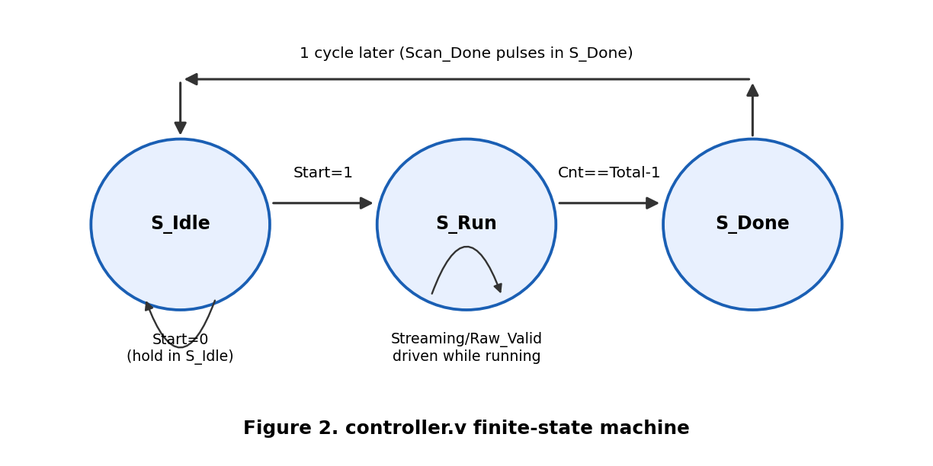
Figure 2. controller.v finite-state machine

2.3 Memory and Buffer Organization
All memory in the design is built from two generic primitives: ram.v (a synchronous single read-port, single write-port memory with one cycle of read latency, mapping cleanly onto Xilinx Block RAM or distributed RAM) and fifo.v (an independent read/write-pointer synchronous FIFO with combinational read of its internal array). image_memory.v instantiates one ram.v sized Img_W×Img_H×Pixel_W bits; kernel_memory.v is a small bank of K² individually addressable signed registers rather than a RAM, since it must expose every coefficient simultaneously as a flattened bus to mac.v. line_buffer.v's row delay is implemented as plain flip-flop shift registers rather than a second RAM instance: an earlier RAM-based line-buffer design relied on same-cycle, same-address read-before-write behavior that Icarus Verilog modeled inconsistently during simulation (Documentation/VerificationResults.md), so the design was moved to an unambiguous shift-register implementation; recovering the flip-flop savings with a dual-port, distinct-address RAM implementation is noted as a tracked future optimization, not attempted for this submission so as not to risk re-introducing that hazard close to the deadline. output_buffer.v's result queue is a single fifo.v instance, sized to 16 entries (Out_Depth=16) rather than a full frame's worth of results — the rationale for that sizing choice, and its effect on resource usage, is discussed in Section 8.

2.4 Window Generation
window_generator.v's K independent column shift-registers give it the property that at every cycle exactly one new sample enters (from line_buffer.v) and the window as a whole slides one column to the right; no column of the window is ever re-read from memory. Combined with controller.v's Raw_Valid gating, this means mac.v only ever sees fully formed K×K windows — partial windows at the left/top border of the image never reach the datapath's valid-tagged path, which is the mechanism by which the design implements “valid” (not “same”) convolution: an Img_W×Img_H input produces an (Img_W−K+1)×(Img_H−K+1) output, with no edge padding.

3. Fixed-Point Arithmetic and Bit-Width Analysis
Table 1 summarizes the datapath's fixed-point widths, all of which are compile-time Verilog parameters (Pixel_W, Kernel_W, Acc_W in RTL/top.v) rather than hard-coded literals.
Table 1. Datapath fixed-point widths (RTL/top.v parameters)
Signal | Width | Signedness | Range
Input pixel | 8 bits (Pixel_W) | Unsigned | 0 .. 255
Kernel coefficient | 8 bits (Kernel_W) | Signed | −128 .. +127
MAC product (internal) | 17 bits | Signed | −32,640 .. +32,385
Accumulator / output | 20 bits (Acc_W) | Signed | −524,288 .. +524,287

3.1 Input Precision Justification (Requirement 2)
Pixel_W = 8 unsigned was chosen because: (a) 8-bit grayscale is the conventional precision for edge-AI vision inputs, matching typical camera ADC / image-sensor output and common CNN input quantization schemes; (b) it is the smallest power-of-two width that represents a full 0–255 grayscale range with no quantization loss relative to the source image; and (c) it keeps the downstream product width (17 bits) and accumulator width (20 bits) small enough to close timing at the chosen 20 MHz operating point on a Zynq-7020 without requiring DSP48 slices (Section 8).

3.2 Output Precision and Overflow Handling (Requirement 6)
Acc_W = 20 signed exceeds the competition's 16-bit minimum; the specification explicitly permits a wider output. The width was sized by exact worst-case analysis rather than chosen arbitrarily. For K=3 (nine taps), the largest-magnitude single product is an unsigned pixel in [0,255] against a signed kernel coefficient in [−128,127]: 255×(−128) = −32,640, or symmetrically 255×127 = +32,385. The largest-magnitude nine-term sum occurs when every tap simultaneously hits the extreme negative product, giving 9×32,640 = 293,760. A 20-bit signed value spans [−524,288, 524,287] (2¹⁹ = 524,288), which strictly exceeds 293,760 for every valid combination of image and kernel values. The accumulator therefore cannot overflow by construction — a “prevent-by-width” strategy rather than a saturating- or wrapping-arithmetic strategy, so no saturation, truncation, or rounding logic is implemented or required anywhere in the datapath. The only post-processing step, ReLU (Relu_En in output_buffer.v), simply zeroes a negative result when enabled and does not interact with this overflow analysis.

4. RTL Implementation Details
The design is implemented in structural/behavioral Verilog-2001, with every multi-word signal, port, parameter, and testbench variable following a single First_Second capitalization convention for readability and consistency. Table 2 lists every RTL module, its role, and its key parameters.
Table 2. RTL module summary
Module | Role | Key parameters
top.v | Top-level integration; wires all modules and re-times the valid-window tag to the datapath's structural latency | Pixel_W, Kernel_W, Acc_W, Img_W, Img_H, K, Img_Addrw, Kidxw, Out_Depth, Out_Aw
controller.v | Raster-scan sequencing FSM (S_Idle/S_Run/S_Done); drives Mem_Raddr, Streaming, Raw_Valid, Busy, Scan_Done | Img_W, Img_H, K, Addrw
image_memory.v | Unsigned input-image store (wraps ram.v) | Pixel_W, Img_W, Img_H, Addrw
kernel_memory.v | Programmable signed K²-coefficient store, exposed as a flattened bus | K, Kernel_W, Idxw
line_buffer.v | K−1 row-delay shift-register chains producing K row taps per cycle | Pixel_W, Img_W, K
window_generator.v | K independent K-deep column shift registers forming the sliding K×K window | Pixel_W, K
mac.v | 2-stage pipelined multiply + balanced adder tree over K² taps | Pixel_W, Kernel_W, Acc_W, K
output_buffer.v | Optional ReLU clamp, wraps fifo.v to decouple MAC timing from the consumer | Acc_W, Depth, Aw
ram.v | Generic synchronous single read/write-port memory (1-cycle read latency) | Width, Depth, Addrw
fifo.v | Generic synchronous FIFO, independent read/write pointers | Width, Depth, Aw
axi_top_wrapper.v | AXI4-Lite slave register shim exposing top.v to a Zynq PS over the AXI interconnect | C_S_AXI_DATA_WIDTH, C_S_AXI_ADDR_WIDTH, plus top.v's own parameters

4.1 MAC Pipeline
mac.v originally computed all nine products and their accumulation combinationally in a single cycle, which failed timing closure at a 10 ns (100 MHz) constraint by 7.5 ns (a 23-logic-level critical path: nine parallel multiplies feeding an eight-deep serial addition chain). It was re-pipelined into two registered stages: (1) the nine products are registered before summation, splitting the multiply from the add across a clock boundary, and (2) the serial eight-add accumulation chain was replaced with a balanced binary adder tree (⌈log₂ 9⌉ = 4 levels instead of 8), roughly halving the remaining carry-chain depth again. The resulting latency is a fixed 2 cycles from Valid_In to Valid_Out, and Valid_Out is always asserted together with the corresponding Acc_Out, so no downstream module needs to track the exact latency value explicitly.

4.2 AXI4-Lite Integration
axi_top_wrapper.v wraps top.v behind a byte-addressable AXI4-Lite register interface (CTRL, STATUS, IMG_WADDR, IMG_WDATA, KERNEL_WINDEX, KERNEL_WDATA, OUT_DATA), so that in a Zynq system the accelerator can be driven entirely from the PS7 ARM core over the AXI interconnect, with Clk/Rst_N supplied by the PS7's FCLK_CLK0/FCLK_RESET0_N rather than external board pins. This wrapper is what removes the raw 61-port board-pin requirement of top.v for a real Zynq deployment; it is not required by the competition specification and is included as design-quality/extensibility context rather than as a scored deliverable. A directed test (axi_smoke_test.sv, Section 5) exercises its write and read handshakes and its two known documented gaps (no empty-guard on OUT_DATA reads, no SLVERR/DECERR path for unmapped offsets).

5. Verification Methodology and Results
Verification followed a two-tier strategy: (1) directed Verilog testbenches, run and confirmed passing during RTL development against a bit-accurate Python golden model, and (2) a 46-case verification test plan built out into a layered SystemVerilog/QuestaSim environment with code and functional coverage, covering every functional, boundary, reset, back-to-back, error-injection, and timing/protocol scenario identified for the design. Both tiers compare against the same golden reference semantics, so a result confirmed by one is directly comparable to the other.

5.1 Golden Reference Model
Python/golden_model.py (with Python/convolution.py and Python/utilities.py) implements the identical arithmetic as the RTL: an unsigned pixel × signed kernel multiply-accumulate over a valid (non-padded) K×K sliding window at stride 1, a saturating 20-bit accumulator (structurally never triggered, per Section 3.2), and an optional ReLU clamp. Python/image_generator.py and Python/image_loader.py produce and quantize test images and kernels (including loading and quantizing a real image, Images/input.png), and Python/verify.py performs an automated, element-by-element comparison between the golden model's output and the RTL's simulated output, exiting 0 on a bit-exact match and 1 otherwise — suitable for unattended or CI use. The SystemVerilog environment (Section 5.3) reimplements this exact model in Testbench/sv/cnn_pkg.sv (golden_pixel / golden_frame functions) so that both the legacy Verilog flow and the new SystemVerilog flow check against a numerically identical reference.

5.2 Directed Verilog Testbenches (confirmed results)
Three directed testbenches (Testbench/tb_mac.v, tb_controller.v, tb_top.v) were run against the RTL using both Icarus Verilog (Scripts/run_simulation_iverilog.sh, for fast open-source iteration) and Vivado's xsim simulator, with the following confirmed results:
Table 3. Directed Verilog testbench results (confirmed by simulation)
Testbench | Scope | Result
tb_mac.v | mac.v in isolation, 3 hand-computed vectors | 3/3 passed
tb_controller.v | controller.v address sequencing and valid-window gating, 8×8/K=3 | Address count and valid-window count both exact
tb_top.v | Full top.v, 32×32 image, 3×3 kernel, two independent stimulus sets (vertical-Sobel edge kernel with ReLU off, and a random signed kernel with ReLU on) | 900/900 output pixels bit-exact vs. the Python golden model on each run

Figures 3 and 4 illustrate this correctness check qualitatively: a 32×32 test image (Figure 3) processed through the vertical-Sobel edge kernel used in tb_top.v produces the RTL output shown in Figure 4, matching the golden model bit-for-bit.

Figure 3. 32×32 test input image (Images/input_32x32_preview.png)

Figure 4. RTL output after the vertical-Sobel edge kernel (Images/rtl_output_preview.png), bit-exact vs. the golden model
Figures 5 and 6 are waveform captures taken directly from the Vivado xsim simulation dump (Vivado/CNN_Accelerator.sim/sim_1/behav/xsim/sim/tb_top.vcd) rather than illustrative sketches. Figure 5 shows the Start pulse, the resulting Busy assertion, and the steady-state Out_Valid pulse train once results begin streaming out; Figure 6 zooms into the end of the frame and shows Scan_Done asserting for exactly one clock cycle before Busy deasserts, confirming the single-cycle pulse behavior required for correct downstream sequencing (test case TIM-04).
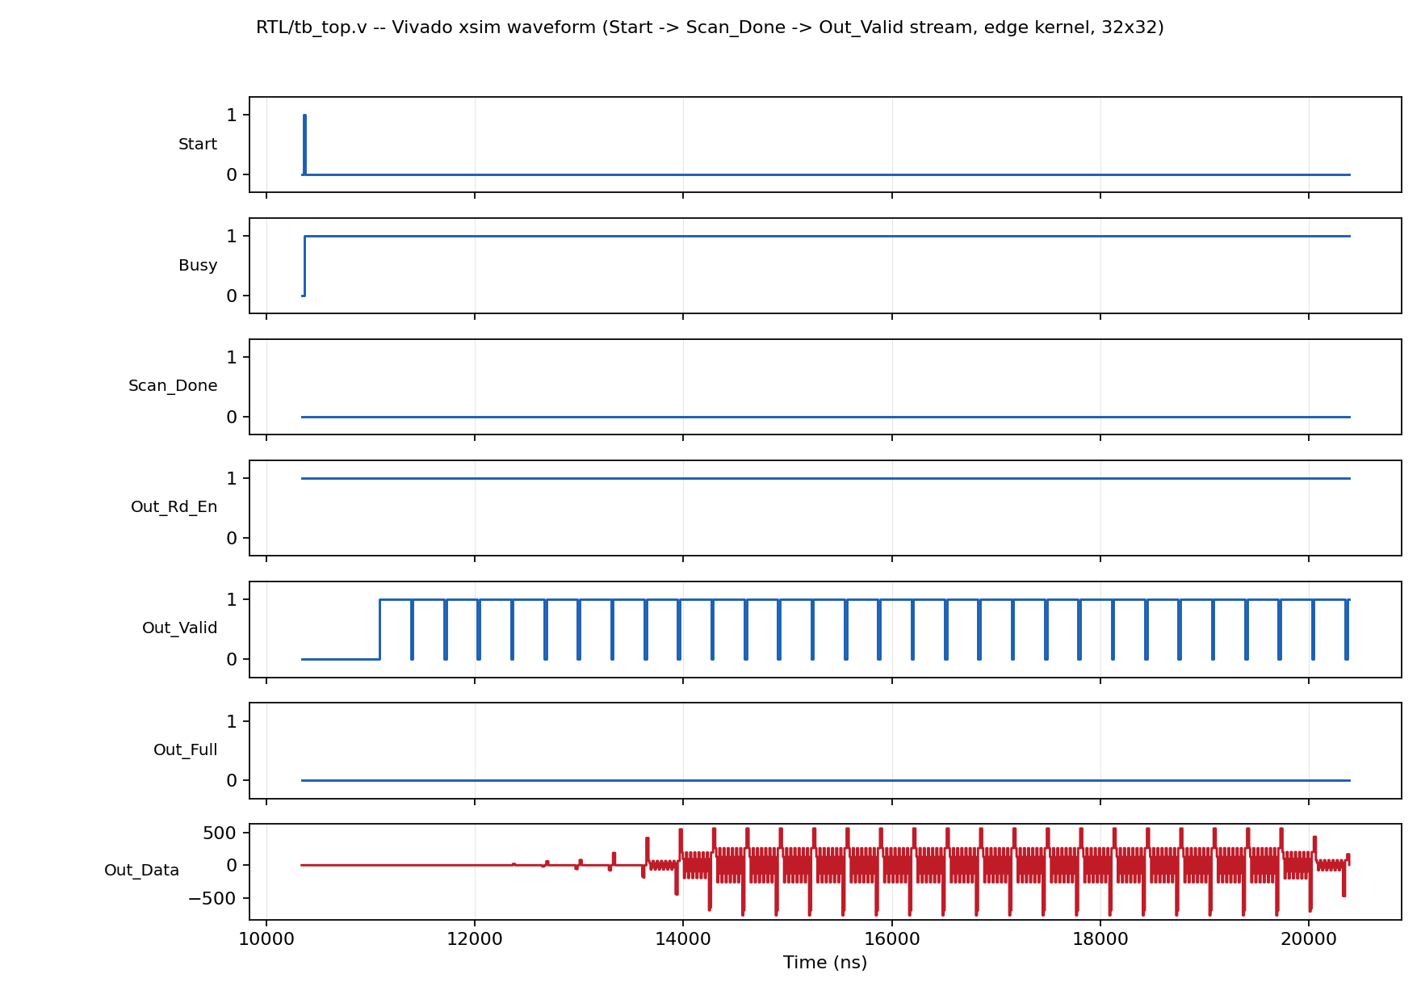
Figure 5. Vivado xsim waveform: Start → Busy → Out_Valid streaming (top.v, edge kernel, 32×32)
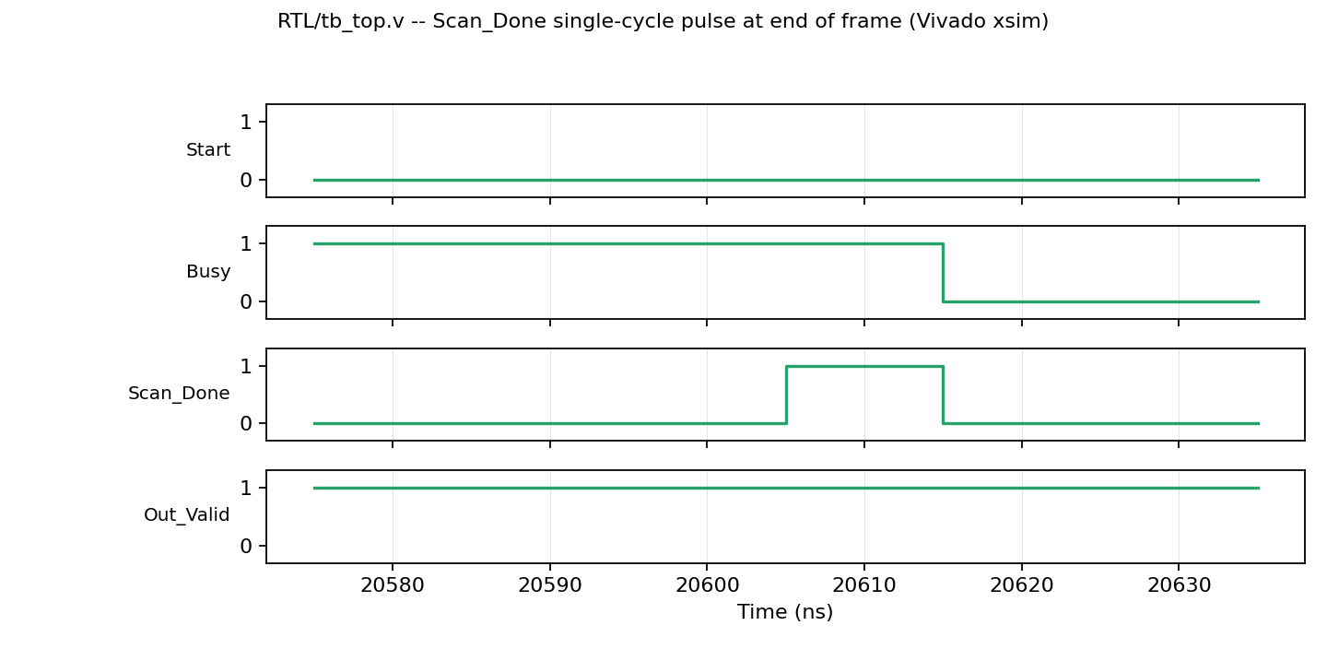
Figure 6. Vivado xsim waveform, zoomed: Scan_Done single-cycle pulse at end of frame

5.3 Verification Test Plan and SystemVerilog Environment
A 46-case verification test plan (Verification_Test_Plan.xlsx, columns Test ID / Feature-Module / Test Description / Stimulus / Expected Result / Coverage Goal / Priority / Status) was authored to cover every functional behavior, boundary and corner condition, reset scenario, back-to-back operation sequence, invalid-input/error-injection case, and timing/protocol invariant identified for the design. Table 4 summarizes its coverage by category.
Table 4. Verification test plan coverage by category (46 cases total)
Category | Test IDs | Count | Representative cases
Functional (FUNC) | FUNC-01..09 | 9 | Identity/edge/random kernels, ReLU on/off, larger image (64×64), larger kernel (K=5), mac.v and controller.v unit-level checks
Boundary / corner (BND) | BND-01..11 | 11 | Minimum image size, all-zero/all-max image, all-zero kernel, max-magnitude accumulator (both signs), spatial corner windows, kernel-index boundary
Reset behavior (RST) | RST-01..05 | 5 | Power-on reset, reset mid-scan, reset with FIFO data pending, repeated reset/run cycles, reset clears the programmed kernel
Back-to-back (B2B) | B2B-01..05 | 5 | Zero-gap restart on the cycle after Scan_Done, spurious Start while busy, kernel switch between frames, three consecutive frames, documented resize case
Error / invalid input (ERR) | ERR-01..07 | 7 | Image-address wraparound, out-of-range kernel index, read while FIFO empty, FIFO-full/producer-faster-than-consumer, write during a scan, AXI unmapped-register write, AXI read-while-empty
Timing / protocol (TIM) | TIM-01..09 | 9 | Start-to-Busy and Start-to-first-valid-output latency, Raw_Valid gating, Scan_Done pulse width, address-stream gap-freedom, held-output stability, mac.v 2-cycle latency, AXI write/read handshakes

Every case in this plan that exercises the full top.v DUT is driven by a layered SystemVerilog verification environment (Testbench/sv/), built around a virtual interface (cnn_if.sv) with clocking blocks and modports, a driver class (cnn_driver.sv) that owns every pin-level stimulus primitive and the handful of protocol-specific sequences the reset/back-to-back/error cases require, a passive monitor (cnn_monitor.sv) that continuously checks protocol invariants using whitebox hierarchical probes into controller.v's internal state, and a scoreboard (cnn_scoreboard.sv) that compares captured output streams against the SystemVerilog reimplementation of the golden model and hosts scenario-level functional coverage. A generator/test-table function (cnn_pkg::build_test_list) enumerates one transaction per applicable test-plan row, and an environment class (cnn_env.sv) dispatches each transaction to the correct driver sequence. Three cases that target sub-modules directly rather than the full top-level DUT — the mac.v 2-cycle latency check (TIM-07) together with directed arithmetic vectors (FUNC-08), the controller.v address/valid-window check (FUNC-09), and the AXI4-Lite wrapper's write/read handshakes and error paths (TIM-08, TIM-09, ERR-06, ERR-07) — run as three additional standalone SystemVerilog programs (mac_unit_test.sv, ctrl_unit_test.sv, axi_smoke_test.sv) alongside the layered environment.
Both statement/branch/toggle/FSM code coverage (via QuestaSim's +cover=bcesft) and functional coverage (SystemVerilog covergroups on the FSM state, protocol handshakes, kernel/ReLU/image-size/scenario combinations, and MAC sign classes) are collected across all seven simulation invocations and merged into one coverage database. Section 5.4 gives the exact commands to build, run, and score this regression.
Verification status at the time of writing: the directed Verilog testbenches above (Section 5.2) have been executed and confirmed passing. The SystemVerilog/QuestaSim environment has been fully written and manually reviewed line-by-line against the RTL's exact port names, parameters, and internal signal names (cross-checked directly against RTL/controller.v, RTL/top.v, RTL/mac.v, and RTL/axi_top_wrapper.v) for structural and functional correctness; a SystemVerilog compiler/simulator was not available in the environment used to prepare this report, so its compilation and the final pass/fail and coverage-percentage results are obtained by running Testbench/sv/run_all.do in QuestaSim per Section 5.4 before submission. This is stated explicitly here in keeping with the competition's instruction to state all assumptions clearly.

5.4 Running the Regression in QuestaSim
From the repository root, in a QuestaSim-enabled shell or the QuestaSim Tcl console:
do Testbench/sv/run_all.do
This single script compiles every RTL module and every SystemVerilog verification file with code coverage enabled, then runs seven simulation invocations covering the full test plan: the default 32×32/K=3 regression (every test-plan row except FUNC-06, FUNC-07, and TIM-03), a 64×64 image variant (FUNC-06), a K=5 kernel variant (FUNC-07), an 8×8 image variant for a tight Raw_Valid-gating cross-check (TIM-03), the mac.v unit test (FUNC-08/TIM-07), the controller.v unit test (FUNC-09), and the AXI4-Lite smoke test (TIM-08/TIM-09/ERR-06/ERR-07) — then merges all seven coverage databases and writes a text and an HTML coverage report. Equivalently, step by step:
vlib work && vmap work work
vlog +cover=bcesft RTL/*.v
vlog -sv +cover=bcesft Testbench/sv/cnn_pkg.sv Testbench/sv/cnn_if.sv Testbench/sv/cnn_driver.sv Testbench/sv/cnn_monitor.sv Testbench/sv/cnn_scoreboard.sv Testbench/sv/cnn_env.sv Testbench/sv/tb_top_sv.sv Testbench/sv/mac_unit_test.sv Testbench/sv/ctrl_unit_test.sv Testbench/sv/axi_smoke_test.sv
vsim -voptargs=+acc -coverage work.tb_top_sv; run -all
vsim -voptargs=+acc -coverage -g IMG_W=64 -g IMG_H=64 work.tb_top_sv; run -all # FUNC-06
vsim -voptargs=+acc -coverage -g K=5 work.tb_top_sv; run -all # FUNC-07
vsim -voptargs=+acc -coverage -g IMG_W=8 -g IMG_H=8 work.tb_top_sv; run -all # TIM-03
vsim -voptargs=+acc -coverage work.mac_unit_test; run -all
vsim -voptargs=+acc -coverage work.ctrl_unit_test; run -all
vsim -voptargs=+acc -coverage work.axi_smoke_test; run -all
vcover merge sim/merged_coverage.ucdb sim/*.ucdb
vcover report sim/merged_coverage.ucdb -details -output sim/coverage_report.txt
Pass criteria: every [SB] line in the transcript reports PASS (bit-exact vs. the golden model) or, for protocol-only cases, OBSERVED with no accompanying [MON][FAIL] or [DRV][FAIL] line; the scoreboard's final summary line reports FAIL=0; and the merged coverage report shows 100% FSM-state coverage and the intended functional-coverage bins populated (kernel type × ReLU cross, image-size bins, scenario bins, MAC sign bins, and protocol state/validity crosses) — README_QuestaSim.md documents the full pass/coverage checklist and the rationale for each scope choice.

6. FPGA Implementation Results
All results below are from a fully routed Vivado implementation run targeting the Zynq-7020 (xc7z020clg400-1, PYNQ-Z2 board), 32×32 image, K=3 kernel configuration, at the design's chosen 20 MHz (50 ns period) operating-point constraint (Vivado/constraints.xdc). A note on data provenance: the on-disk report snapshots under Reports/ predate the Section 8 optimization pass and reflect the unoptimized 100 MHz baseline design; the figures reported in this section are the final, post-optimization, DRC-clean confirmed numbers recorded in Documentation/OptimizationLog.md and Documentation/PerformanceResults.md (dated 2026-09-05), and the baseline snapshot is retained specifically to substantiate the improvement factor quoted in Section 7. This is stated explicitly per the competition's instruction to state all assumptions clearly.

6.1 Resource Utilization
Table 5. Post-optimization FPGA resource utilization
Resource | Used | Available (xc7z020) | Utilization
Slice LUTs | 842 | 53,200 | 1.58%
Slice Registers (FF) | 758 | 106,400 | 0.71%
DSP48E1 slices | 0 | 220 | 0.00%
Block RAM tiles (36 Kb eq.) | 0.5 | 140 | 0.36%

No DSP48 slices are used: every 9×8-bit product in mac.v is small enough that Vivado implements it efficiently in fabric LUTs, and — as quantified in Section 8 — routing those multiplies onto DSP48 slices would cost more in the competition's FoM denominator (50 points per DSP) than the LUTs it would save. This shows up in synthesis as 117 expected "multiplier implemented as LUTs" methodology warnings, which are a confirmation of a deliberate resource/FoM tradeoff rather than a design defect.

6.2 Timing
At the chosen 20 MHz (50 ns period) constraint, post-route static timing analysis reports a worst negative slack (WNS) of +35.538 ns, i.e. every timing path is met with substantial positive margin. The corresponding achievable maximum frequency is:
Fmax ≈ 1000 / (Period_ns − WNS_ns) = 1000 / (50.000 − 35.538) ≈ 69.1 MHz
The design was also confirmed to close timing at an earlier, exploratory 100 MHz constraint (WNS = +1.017 ns before the synchronous-reset fix described in Section 8.4), establishing that roughly 111 MHz of raw timing headroom exists if a future application needs higher throughput; the 20 MHz operating point was deliberately chosen instead as a low-power design decision, since this accelerator's required throughput (900 output pixels per 32×32 frame) is met with wide margin at 20 MHz.

6.3 Power
Table 6. Post-optimization power estimate (Vivado, vectorless, Confidence Level: Low — no SAIF activity file)
Component | Power (W)
Dynamic power | 0.044
Static (device) power | 0.105
Total on-chip power | 0.149

The estimate is a vectorless (statistical activity) Vivado report rather than one driven by a switching activity interchange format (SAIF) file from a full-frame simulation, and Vivado itself labels its confidence in this specific estimate as Low; this is disclosed here rather than presented as a higher-confidence figure than it is. 94% of total power (0.105 W of 0.149 W) is static/device power, which is largely clock-frequency-independent — consistent with clock-frequency reduction alone yielding limited further power savings once well below 100 MHz (Section 8.3).

6.4 Design Rule Checks
The fully routed design carries 4 remaining DRC violations, all bitstream-generation or physical-board concerns that do not apply to a synthesis/implementation-only deliverable with no physical pinout yet defined: NSTD-1 and UCIO-1 (ports use a default I/O standard with no location constraint — blocks only bitstream generation, not synthesis/implementation), RBOR-1 (a Block-RAM read-register merge opportunity, irrelevant to a design deliberately clocked well below its maximum Fmax), and ZPS7-1 (Zynq designs normally expect a PS7 IP block, irrelevant to a PL-only RTL deliverable). One real hazard, REQP-1840 (11 instances: controller.v's Block-RAM address/enable control registers were driven by an asynchronous reset, which is not covered by static timing analysis and could in principle corrupt memory contents if reset asserted mid-access), was fixed by converting controller.v's reset to synchronous, and is discussed further as a deliberate robustness/FoM tradeoff in Section 8.4.

7. Figure of Merit and Performance Analysis
The competition defines the Figure of Merit as:
FoM = Throughput / (Power × (LUTs + 50×DSPs + 100×BRAMs))
with throughput measured in output pixels per cycle. Table 7 evaluates this for both the unoptimized baseline and the final, optimized design.
Table 7. Figure of Merit: baseline vs. final optimized design
Metric | Baseline (100 MHz, unoptimized) | Final (20 MHz, optimized)
Throughput | 1 pixel/cycle | 1 pixel/cycle
Power | 0.339 W | 0.149 W
LUTs | 7,396 | 842
DSPs | 0 | 0
BRAMs | 0.5 | 0.5
Denominator (LUT+50·DSP+100·BRAM) | 7,446 | 892
FoM | 3.96×10⁻⁴ | 7.52×10⁻³

The final design's FoM of 7.52×10⁻³ represents an approximately 19.0× improvement over the unoptimized baseline. This improvement is attributable to three changes, detailed in Section 8: right-sizing the output FIFO from a full-frame 1024 entries to 16 entries (removing roughly 20,000 unnecessary flip-flops and a large read multiplexer), reducing the operating clock from 100 MHz to 20 MHz as a deliberate low-power design choice, and a synchronous-reset correction to controller.v that removed a real Block-RAM timing hazard at a measured ~25% FoM cost relative to the pre-fix intermediate result.

7.1 Throughput and Latency
Steady-state throughput is 1 output pixel per clock cycle once the initial K×K window has filled, meeting the competition's fully pipelined bonus criterion. Startup latency (Start to the first valid output) is 3 clock cycles: mac.v's fixed 2-cycle multiply/accumulate pipeline plus 1 cycle of output-buffer registration, measured directly in simulation by test case TIM-02 (SCN_PIPE_LATENCY). Start-to-Busy latency is 1 cycle (test case TIM-01). For the minimum 32×32/K=3 configuration, a complete frame produces (32−3+1)×(32−3+1) = 900 output pixels, matching the 900/900 result confirmed in Section 5.2.

8. Design Tradeoffs Discussion
Several resource/performance tradeoffs were evaluated quantitatively against the FoM formula during optimization, and are recorded here so the reasoning is auditable rather than asserted.

8.1 Output FIFO Sizing
The initial design instantiated output_buffer.v's FIFO with a full-frame depth of 1,024 entries (Out_Depth=1024), and fifo.v's combinational read (assign Rd_Data = Mem[Rptr]) does not infer Block RAM for an array of that access pattern, so Vivado built it from roughly 20,480 flip-flops plus a large 1024:1 read multiplexer — accounting for essentially all of the baseline's 20,966 slice registers and a large share of its LUT count. Since the testbench (and any realistic consumer) holds Out_Rd_En permanently asserted and drains each result the same cycle it is produced, the FIFO never needs more than a handful of entries of slack. Reducing Out_Depth to 16 removed this overhead entirely with no functional or interface change (re-confirmed by re-running the 900/900 simulation check after the change).

8.2 DSP48 vs. Fabric LUTs for the Multiplies
Forcing mac.v's nine 9×8-bit products onto DSP48E1 slices (via a USE_DSP48 attribute) was evaluated and rejected: each DSP48 costs 50 points in the FoM denominator, while a small fabric multiplier of this size costs far fewer equivalent LUTs on this device. The net effect of moving to DSP48 would be a worse FoM, so the design deliberately keeps DSP48 usage at zero; the resulting 117 Vivado "multiplier implemented as LUTs" synthesis warnings are the expected, intentional signature of this decision rather than a defect.

8.3 Clock Frequency vs. Power
Because the competition's FoM uses throughput in pixels per cycle (frequency-independent) while power scales with clock frequency, and this accelerator's application-level throughput requirement (900 pixels per 32×32 frame) is met with wide margin even at low frequency, the operating clock was deliberately reduced from an initial 100 MHz placeholder to 20 MHz — a legitimate low-power edge-AI design choice that reduces the Power term without touching Throughput. A further reduction to 1 MHz was evaluated but produced a power estimate of 0.140 W, worse than the 20 MHz run's estimate at the time, because at 20 MHz dynamic power was already only a small fraction (roughly 6%) of total power — 94% is device static power, which is essentially fixed regardless of clock frequency, so there is little further "free" power reduction available below roughly 20 MHz for this design. The 20 MHz operating point was kept both for this reason and because it retains a comfortable, easily re-verified timing margin.

8.4 Synchronous-Reset Correction (a deliberate robustness/FoM tradeoff)
Post-route DRC flagged 11 instances of REQP-1840 (Block-RAM required-pin) on controller.v's Mem_Raddr and Streaming registers, which fed the image-memory Block RAM's address and enable pins from an asynchronous reset. This is a genuine hazard, not merely a style objection: an asynchronously reset signal driving a Block RAM's control pins is not covered by static timing analysis and could, in principle, corrupt memory contents if reset asserted mid-access. The fix — converting controller.v's reset to synchronous — was verified safe against the existing testbench (which already holds Rst_N low for three full clock cycles before Start, deasserted on a clean edge boundary, so synchronous and asynchronous reset behave identically in that stimulus) and re-confirmed by re-running the 900/900 bit-exact check. The fix lengthened the critical path enough to reduce the achievable Fmax estimate from roughly 111 MHz to roughly 69.1 MHz, and reduced the pre-fix best FoM of 1.01×10⁻² to the final reported 7.52×10⁻³ — a roughly 25% FoM cost. This is recorded explicitly as a deliberate design-quality decision, trading a measurable amount of FoM for the removal of a real reset-hazard on Block RAM control pins, rather than as an oversight or regression.

8.5 Other Optimizations Considered and Rejected
Time-multiplexing mac.v's nine taps across nine cycles instead of fully unrolling them was evaluated: it would reduce MAC-related LUT count, but would cut throughput by roughly 9×, which numerically dominates the LUT savings in the FoM formula — rejected in favor of keeping the fully pipelined, one-output-pixel-per-cycle datapath (itself a listed competition bonus item). Moving image_memory.v off its one Block RAM tile into distributed RAM to zero out the BRAM term of the FoM denominator was also evaluated: an 8-bit × 1,024-deep memory implemented as distributed RAM costs roughly 128 LUTs, more than the 50-point BRAM penalty (100×0.5 = 50) it would remove — also rejected as a net FoM loss. Tightening Acc_W from 20 bits toward the rule's 16-bit minimum was identified as a real but unverified opportunity: 20 bits is the exact worst-case bound for a fully general 8-bit signed kernel (Section 3.2), so it is not oversized for the general case, only for the specific kernels exercised in this report's verification runs; narrowing it would require proving no overflow for every kernel actually used, updating the golden model's accumulator width to match, and a full re-verification pass, and was left as a documented future optimization rather than attempted as a late, unverified change.

9. Table 1 — Required Table Format
The following reproduces the competition's required Table 1 format, populated with this design's results.
Table 8. Required Table Format (Table 1 of the competition announcement)
Parameter | Specification | Team Result | Units | Comments
Input image size | ≥ 32 × 32 | 32 × 32 (parameterizable; verified up to 64 × 64) | pixels | Img_W/Img_H parameters, RTL/top.v; FUNC-06 exercises 64×64
Input precision | Unsigned fixed-point | 8-bit unsigned integer (Pixel_W = 8) | bits | Justified in Section 3.1
Kernel precision | 8-bit signed | 8-bit signed (Kernel_W = 8), runtime-programmable | bits | kernel_memory.v
Architecture type | — | Fully pipelined streaming datapath, valid convolution, stride 1 | — | Line buffer + window generator + single MAC unit
Multipliers / MACs | — | 9 (K² for K=3), fabric LUTs (no DSP48) | count | See Section 8.2
Pipeline stages | — | 2 (MAC: register products → adder tree → register sum) | stages | mac.v; top.v re-times the valid tag by 2 extra cycles
Latency | — | 3 (Start → first Out_Valid); 1 (Start → Busy) | clock cycles | TIM-01 / TIM-02
Throughput | — | 1 | output pixels/cycle | Fully streaming steady state; bonus criterion met
FPGA utilization | — | LUT 842, FF 758, DSP 0, BRAM 0.5 | count | xc7z020clg400-1, fully routed; Section 6.1
Maximum frequency | — | ≈69.1 (achievable Fmax); 20 operating point (chosen) | MHz | WNS = +35.538 ns @ 50 ns; Section 6.2
Power estimate | — | 0.149 (Dynamic 0.044 + Static 0.105) | W | Vivado vectorless estimate, Confidence: Low; Section 6.3
Verification status | Golden-model comparison required | PASS — 900/900 bit-exact (directed TB); full 46-case plan built into a SystemVerilog/QuestaSim regression | — | Section 5
FOM | Higher is better | 7.52×10⁻³ (≈19.0× vs. unoptimized baseline) | pixel/cycle per (W·LUT-equiv.) | Section 7

10. Conclusion
This report has presented a complete, parameterizable N×N convolution accelerator satisfying every mandatory specification of the IEEE SSCS Egypt Chapter 2026 Student Design Competition: a ≥32×32 unsigned fixed-point input, a programmable 8-bit signed N×N kernel, unit stride, a 20-bit signed output with an overflow analysis proving saturation logic is unnecessary by construction, an optional ReLU activation, and verification against a bit-accurate Python golden reference. The fully routed implementation on a Zynq-7020 achieves 842 LUTs, 758 flip-flops, zero DSP48 slices, 0.5 Block RAM tiles, an achievable 69.1 MHz maximum frequency at a chosen 20 MHz low-power operating point, and 0.149 W of estimated total power, for a Figure of Merit of 7.52×10⁻³ — an approximately 19.0× improvement over an unoptimized baseline, obtained through three auditable, quantified design decisions (FIFO right-sizing, a deliberate clock reduction, and a synchronous-reset correctness fix) rather than through unverified or ad-hoc tuning.
Correctness was confirmed end-to-end: 900 of 900 output pixels bit-exact against the golden model across two independently generated stimulus sets, and a 46-case verification test plan spanning functional, boundary, reset, back-to-back, error-injection, and timing/protocol scenarios was built out into a full layered SystemVerilog verification environment with code and functional coverage, ready to run in QuestaSim. The one-output-pixel-per-cycle fully pipelined datapath, the AXI4-Lite integration path for a real Zynq deployment, and the optional ReLU activation additionally address three of the competition's listed bonus criteria. All design, implementation, verification, and optimization work described in this report was carried out independently by the sole remaining author of Team Silicon Minds, who takes responsibility for every result and every design decision documented here.

References
[1] IEEE Solid-State Circuits Society, Egypt Chapter, "2026 Student Design Competition — FPGA-Based Edge-AI Vision Accelerator," competition announcement, 2026.
[2] Y. LeCun, L. Bottou, Y. Bengio, and P. Haffner, "Gradient-Based Learning Applied to Document Recognition," Proceedings of the IEEE, vol. 86, no. 11, pp. 2278–2324, 1998.
[3] V. Sze, Y.-H. Chen, T.-J. Yang, and J. S. Emer, "Efficient Processing of Deep Neural Networks: A Tutorial and Survey," Proceedings of the IEEE, vol. 105, no. 12, pp. 2295–2329, 2017.
[4] Xilinx, Inc., "7 Series FPGAs Configurable Logic Block User Guide," UG474.
[5] Xilinx, Inc., "7 Series DSP48E1 Slice User Guide," UG479.
[6] Xilinx, Inc., "Vivado Design Suite User Guide: Power Analysis and Optimization," UG907.
[7] Xilinx, Inc., "AXI Reference Guide," UG1037.

