**Creating a VM using Ubuntu 22.04 jammy:**

**Installing ROS 2:**

**Set locale:**

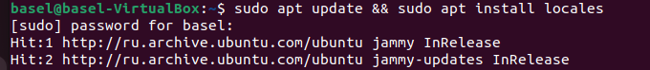

**Setup Sources:**





**Install ROS 2 packages:**

**Environment setup:**

**Try some examples:**

**Talker-listener:**

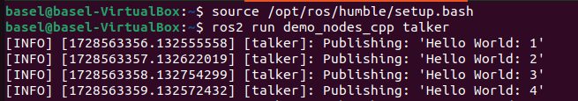

**Pyperplan:**

git clone https://github.com/aibasel/pyperplan

**turtlebot3:**

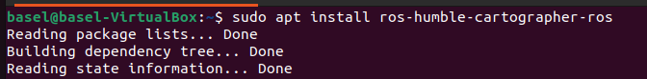

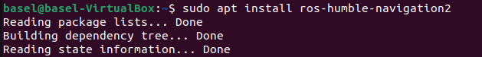

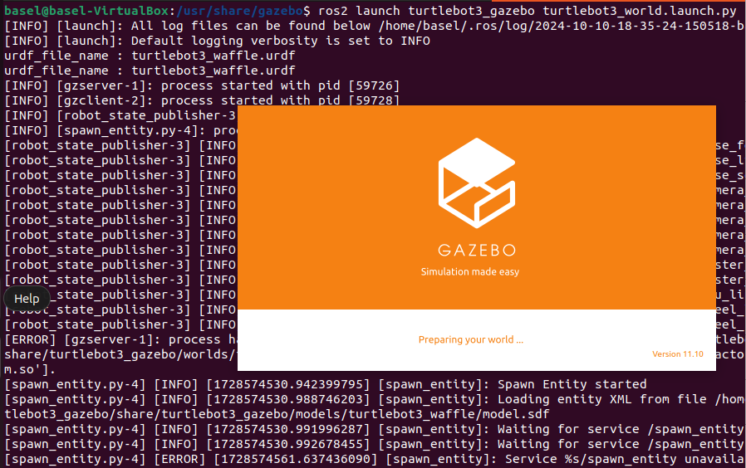

**Turtlebot3 with manipulator:**

