**While working in “EdgeFunction” below points need to remember.**

1. Inside Lambda Function role below changes is required.
2. You can find Execution Role Inside Permission tab.

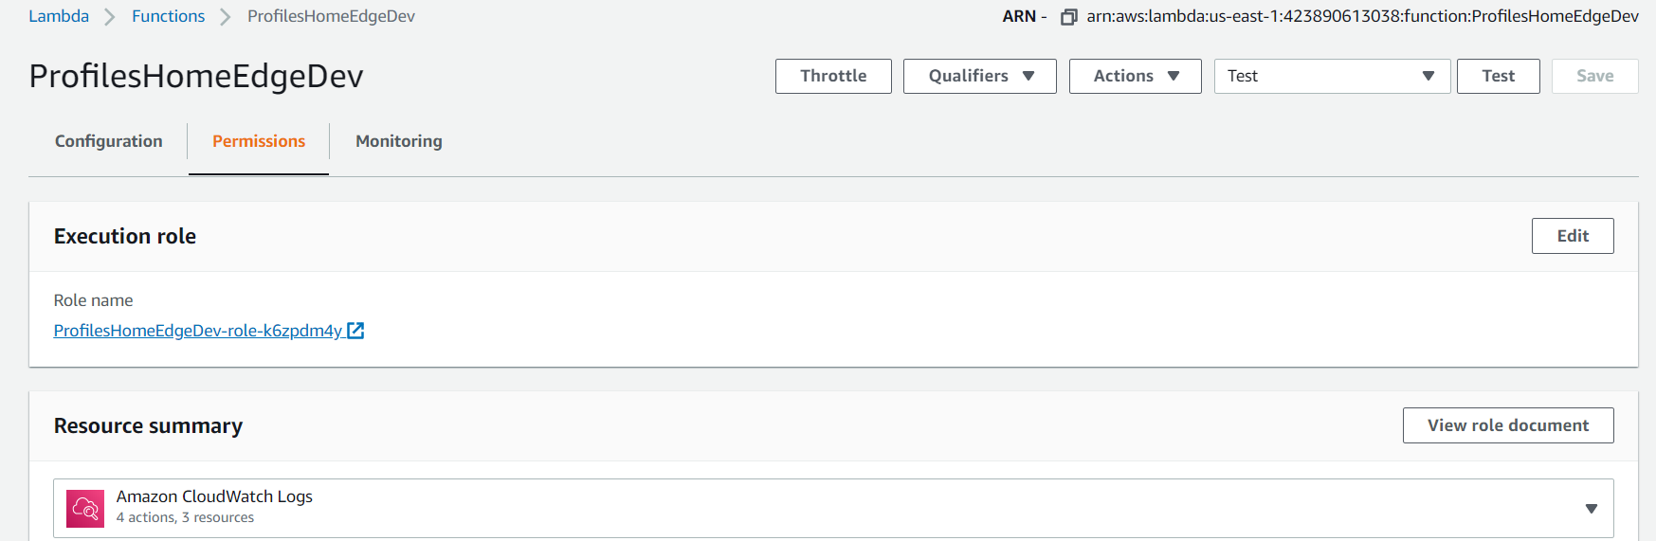

1. Need to add **AWSLambdaExecute** permission.

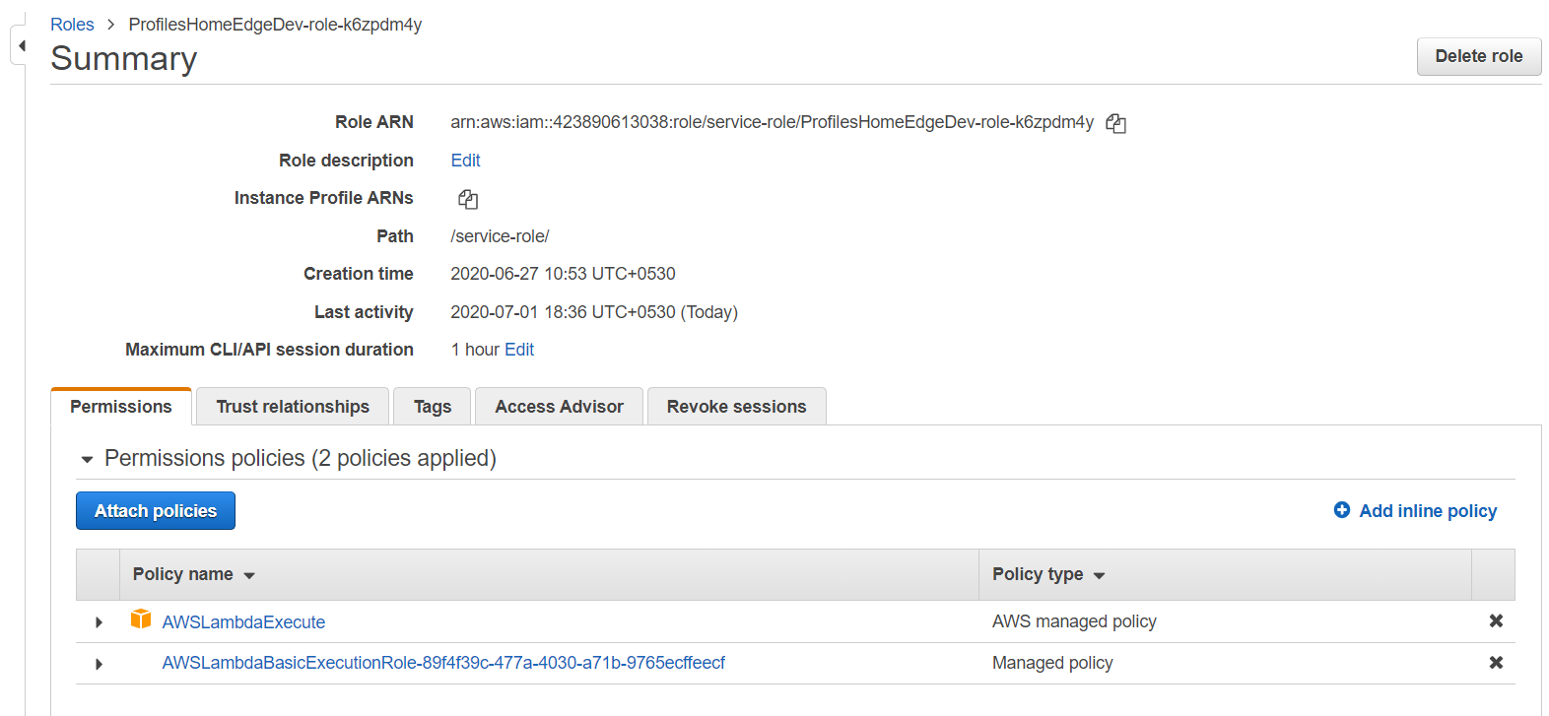

1. Need to add below lines of changes inside Trust Relationship.

"Service": [

"lambda.amazonaws.com",

"edgelambda.amazonaws.com"

]

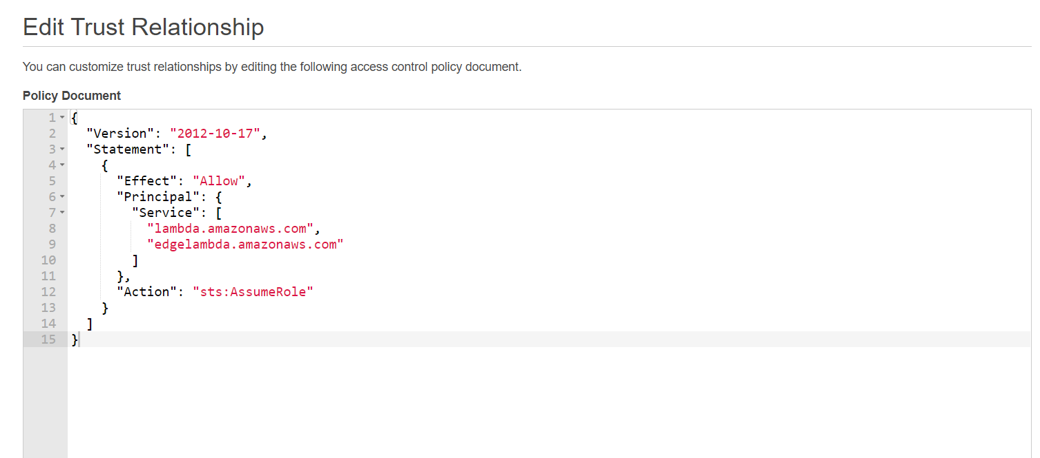

1. Follow Below Steps for adding path pattern inside CloudFront.
2. Create path pattern inside Behaviors tab.

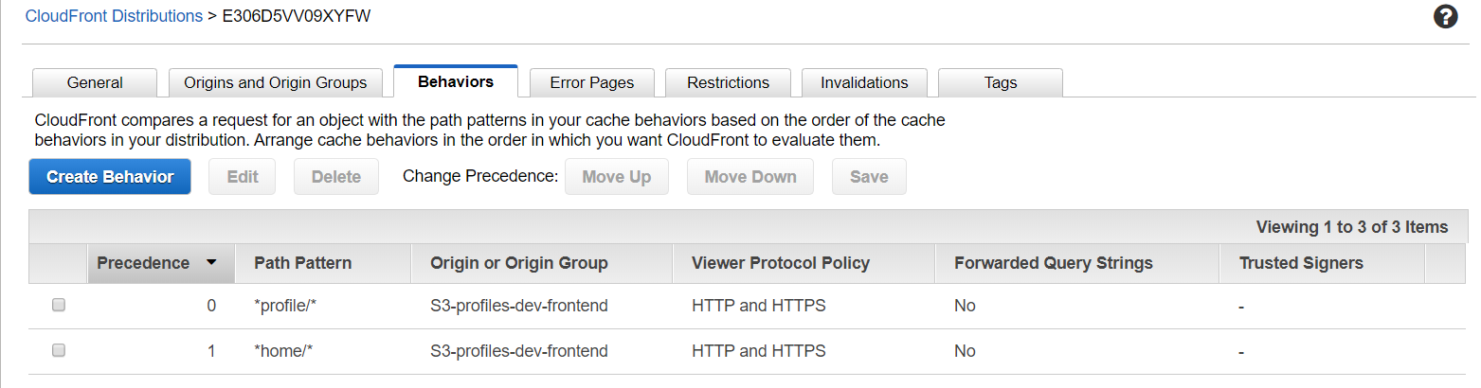

1. Follow below steps for adding CloudFront inside Lambda Function.

Step 1.

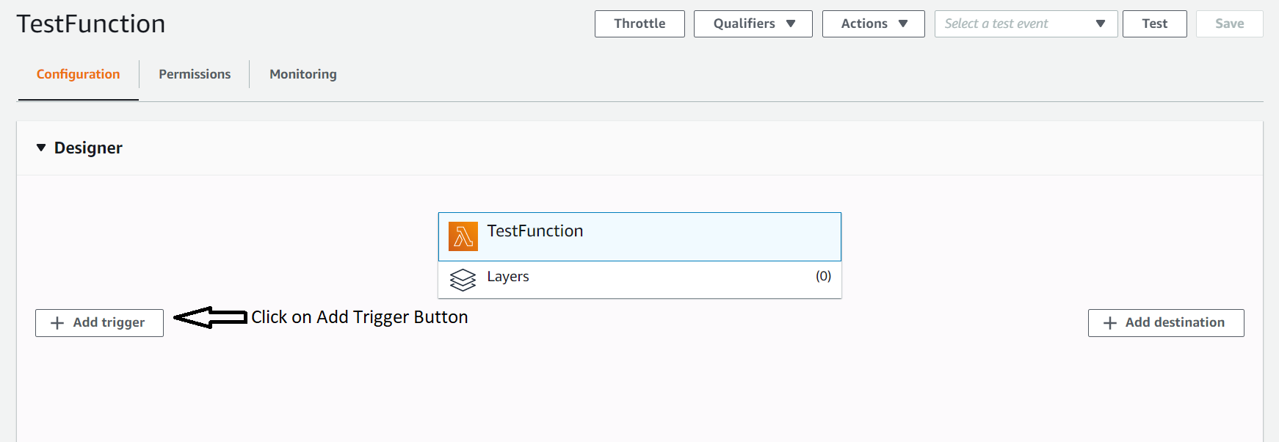

Step 2.

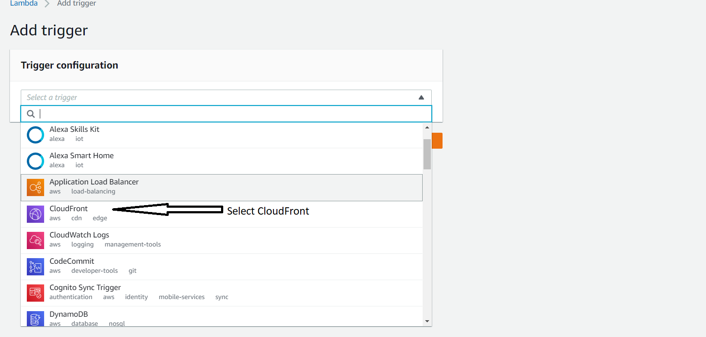

Step 3.

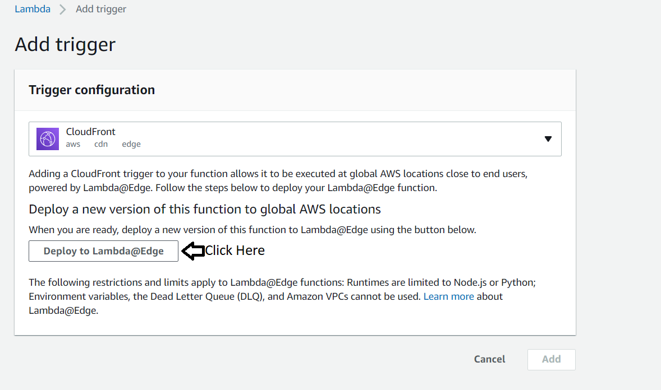

Step 4.

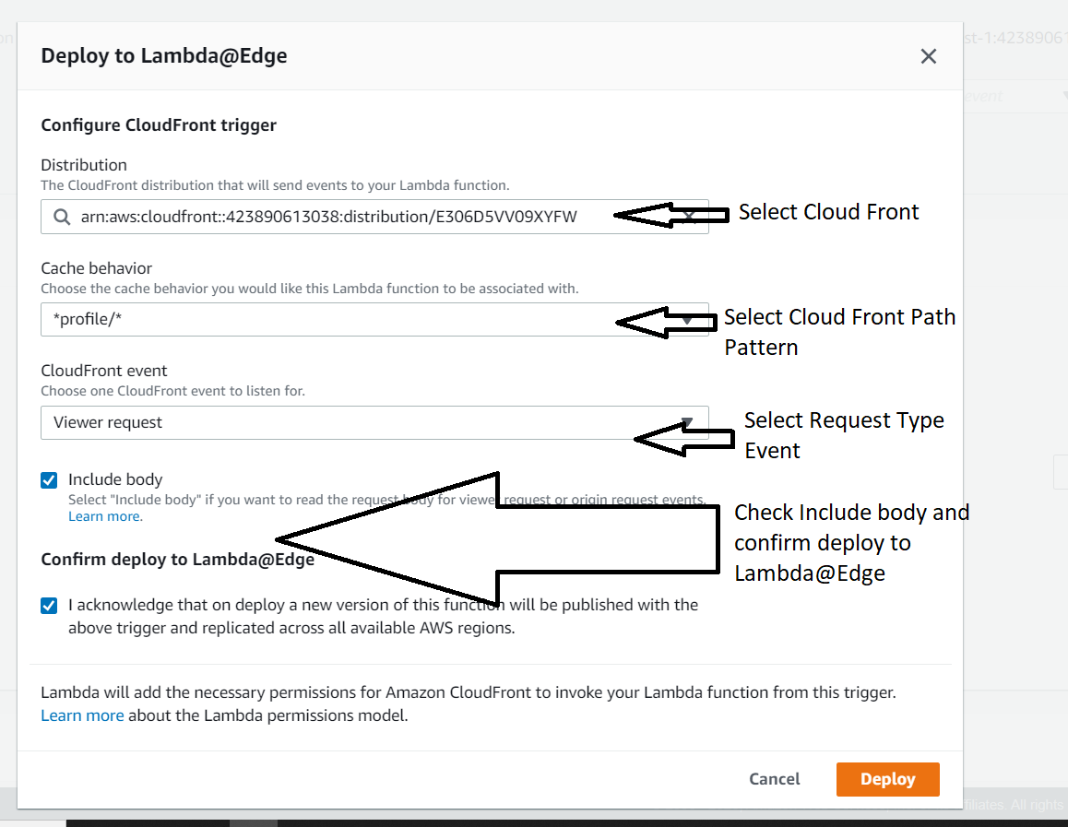

**Note: When you click on Deploy button it will take few minutes. (somethings 10 – 20 minutes to reflect changes in Cloud Front)**

**Note : You can find Lambda function log inside Cloud Watch nearest region.**

Step 5.

