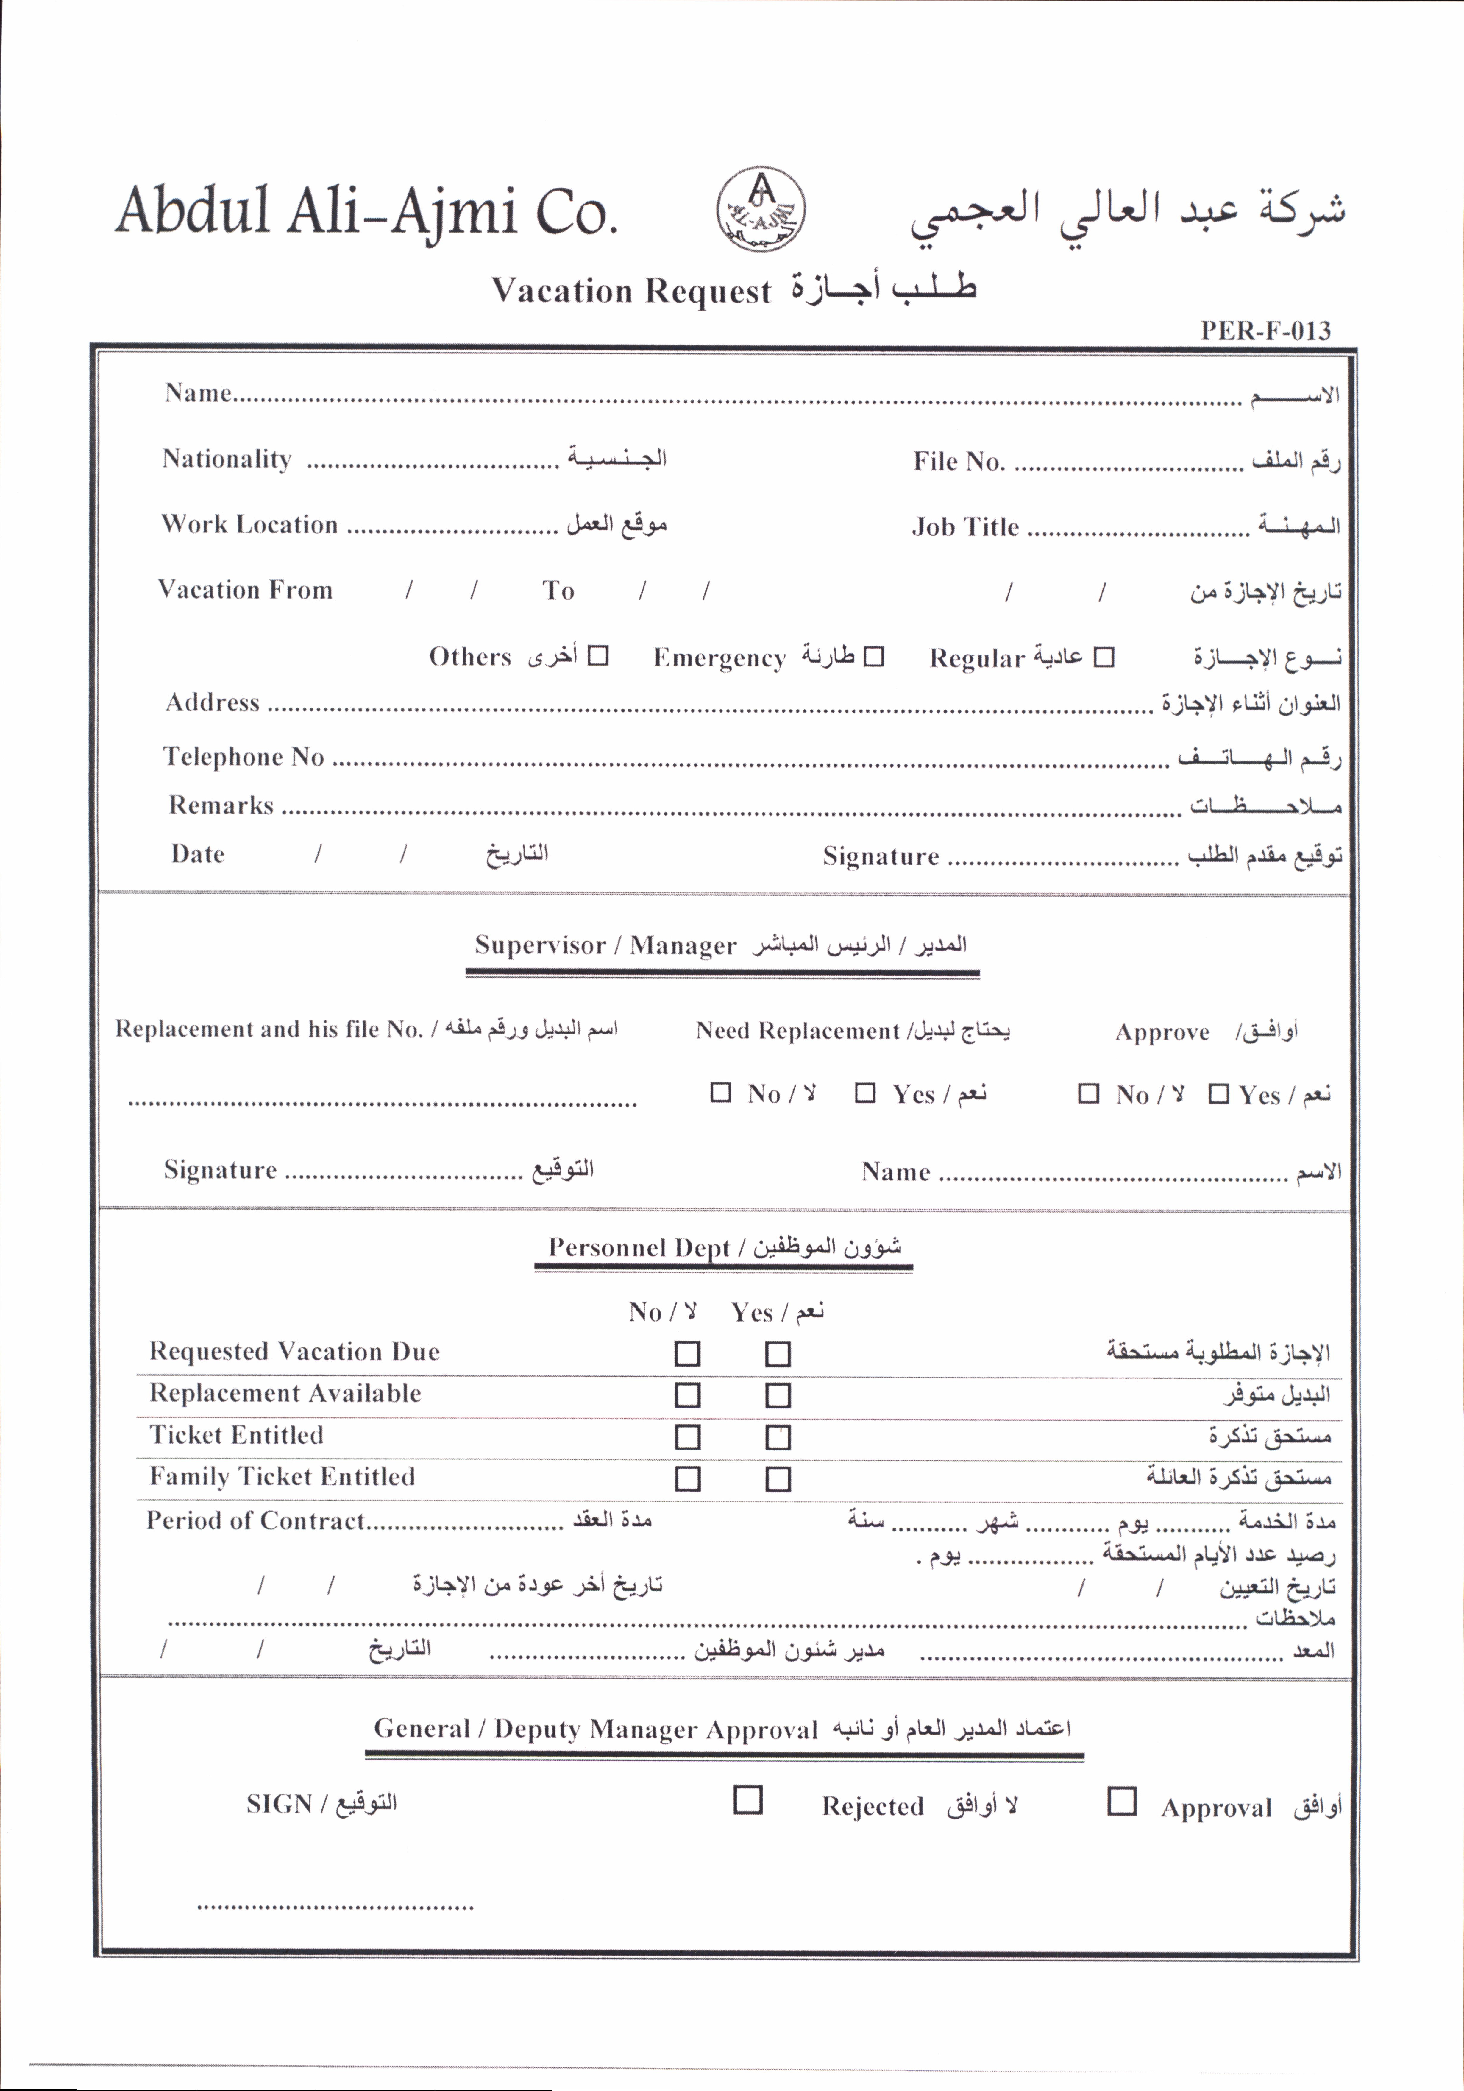

${topMng_name}

${adminMng_name}

${manager_name}

${adminMng_name}

${crM}

${replacement_name _number}

${manager_name}

${cDY}

${crD}

${VEM}

${VDY}

${VFM}

${VFD}

${LY}

${LM}

${LD}

${DM}

${DY}

${DD}

${telephone}

${VEY}

${VED}

${nationality}

${cDY}

${crM}

${crD}

${AmD}

${AmM}

${AmY}

${HY}

${HM}

${HD}

${TR}

${TA}

${adminMng_note}

${Dn}

${Dy}

${m_App}

${repl_App}

${repl_Reject}

${emp_number}

${full_name}

${nationality}

${Em}

${Re}

${Ot}

${m_Reject}

${Contract_per}

${accNo}

${repl_Reject}

${repl_App}

${m_App}

${note}

${emp_name}

${repl_App}

${work_location}

${job_title}