horizontale Linie

**Beuth University of Applied Science**

Advance Software – Game Project

Prof. Dr. Edlich Stefan

Tic Tac Toe – Game Project

**Student : Basem Dabbour ,GitHub : https://github.com/basemdabbour/AS-GAME**

Index

1. ........Introduction
2. .........Sample of Run Program
3. ......... How to Run ?
4. .........Game Design
5. .........Details of the Program
6. .........UML Diagrams
7. .........Metrics (SonarQube, SonarCould,Sonar, Sonarlint)
8. .........Clean Code development
9. ......... Continuous Delivery
10. AOP jointpoints
11. DSL Demo example
12. Logic Solver
13. Scala Code

# Introduction:

Tic Tac Toe is a game against a simple artificial intelligence. An **artificial intelligence** (or **AI**) is a computer program that can intelligently respond to the player’s moves. This game doesn’t introduce any complicated new concepts. The artificial intelligence that plays Tic Tac Toe is really just a few lines of code.*.*

Back when we were a kids , two children’s used to play Tic Tac toy with paper and pencil when one of them is “X“ and the other is “O“ and if one of the players get three of the their marks on the board in row or column or one of the two diagonals , they WIN

And when the board fills up with neither player winning the game break even.

## Simple run for Tic Tac Toe Game:

Figure 1 - Simple run for TTT Game

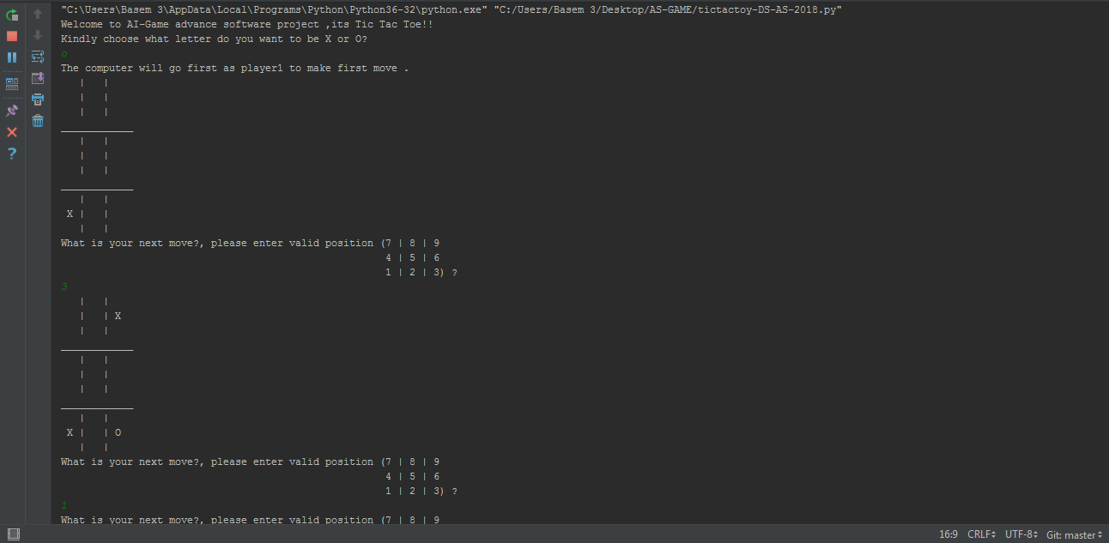

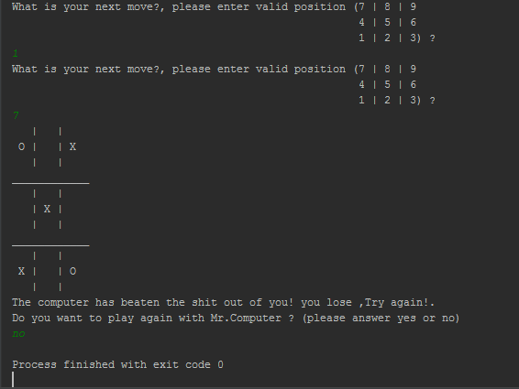

Figure - Simple run of TTT Game 2

## How to Run ?

1. Download Pycharm Professional from [here](https://www.jetbrains.com/pycharm/download/" \l "section=windows)
2. Install it on your local host
3. Open Pycharm after the installation
4. Create new project by clicking on File - > New Project, then in New Project panel choose (Pure Python) and location path of your project in the directory that you want
5. Click on Create and wait couple of minutes to create virtual environment Right click on the project name that contain the path, it will look like this (test C:\Users\...\test, which test is the name of the project
6. Choose New -> Python file
7. Copy the below source code and run it
8. Have Fun!

# Tic Tac Toe  
  
import random  
  
  
def Gameboard(board):  
 # This function prints out the board that it was passed.  
  
 # "board" is a list of 10 strings representing the board (ignore index 0)  
 print(' | |')  
 print(' ' + board[ 7 ] + ' | ' + board[ 8 ] + ' | ' + board[ 9 ])  
 print(' | |')  
 #print('-----------')  
 print('____________')  
 print(' | |')  
 print(' ' + board[ 4 ] + ' | ' + board[ 5 ] + ' | ' + board[ 6 ])  
 print(' | |')  
 # print('-----------')  
 print('____________')  
 print(' | |')  
 print(' ' + board[ 1 ] + ' | ' + board[ 2 ] + ' | ' + board[ 3 ])  
 print(' | |')  
  
  
def inputPlayerletter():  
 # Lts the player type which letter they want to be.  
 # Returns a list with the player’s letter as the first item, and the computer's letter as the second.  
 letter = ''  
 while not (letter == 'X' or letter == 'O'):  
 print('Kindly choose what letter do you want to be X or O?')  
 letter = input().upper()  
  
 # the first element in the list is the player’s letter, the second is the computer's letter.  
 if letter == 'X':  
 return [ 'X', 'O' ]  
 else:  
 return [ 'O', 'X' ]  
  
  
def whoGoesFirst():  
 # Randomly choose the player who goes first.  
 if random.randint(0, 1) == 0:  
 return 'computer'  
 else:  
 return 'player'  
  
  
def playAgain():  
 # This function returns True if the player wants to play again, otherwise it returns False.  
 print('Do you want to play again with Mr.Computer ? (please answer yes or no)')  
 return input().lower().startswith('y')  
  
  
def MakeAMove(board, letter, move):  
 board[ move ] = letter  
  
  
def isWinner(b, L):  
 # Given a board and a player’s letter, this function returns True if that player has won.  
 # We use b instead of board and L instead of letter so we don’t have to type as much.  
 return ((b[ 7 ] == L and b[ 8 ] == L and b[ 9 ] == L) or # across the top  
 (b[ 4 ] == L and b[ 5 ] == L and b[ 6 ] == L) or # across the middle  
 (b[ 1 ] == L and b[ 2 ] == L and b[ 3 ] == L) or # across the bottom  
  
 (b[ 7 ] == L and b[ 4 ] == L and b[ 1 ] == L) or # down the Lft side  
 (b[ 8 ] == L and b[ 5 ] == L and b[ 2 ] == L) or # down the middle  
 (b[ 9 ] == L and b[ 6 ] == L and b[ 3 ] == L) or # down the right side  
  
 (b[ 7 ] == L and b[ 5 ] == L and b[ 3 ] == L) or # diagonal  
 (b[ 9 ] == L and b[ 5 ] == L and b[ 1 ] == L)) # diagonal  
  
  
def getboardCopy(board):  
 # Make a duplicate of the board list and return it the duplicate.  
 dupeboard = [ ]  
  
 for i in board:  
 dupeboard.append(i)  
  
 return dupeboard  
  
  
def FreeSpace(board, move):  
 # Return true if the passed move is free on the passed board.  
 return board[ move ] == ' '  
  
  
def getPlayerMove(board):  
 # Lt the player type in their move.  
 move = ' '  
 while move not in '1 2 3 4 5 6 7 8 9'.split() or not FreeSpace(board, int(move)):  
 print('What is your next move?, please enter valid position (7 | 8 | 9 ',"\n"  
 ' 4 | 5 | 6 ' "\n"  
 ' 1 | 2 | 3) ?')  
 move = input()  
 return int(move)  
  
  
def chooseRandomMoveFromList(board, movesList):  
 # Returns a valid move from the passed list on the passed board.  
 # Returns None if there is no valid move.  
 possibLMoves = [ ]  
 for i in movesList:  
 if FreeSpace(board, i):  
 possibLMoves.append(i)  
  
 if len(possibLMoves) != 0:  
 return random.choice(possibLMoves)  
 else:  
 return None  
  
  
def getComputerMove(board, computerletter):  
 # Given a board and the computer's letter, determine where to move and return that move.  
 if computerletter == 'X':  
 playerletter = 'O'  
 else:  
 playerletter = 'X'  
  
 # Here is our algorithm for our Tic Tac Toe AI:  
 # First, check if we can win in the next move  
 for i in range(1, 10):  
 copy = getboardCopy(board)  
 if FreeSpace(copy, i):  
 MakeAMove(copy, computerletter, i)  
 if isWinner(copy, computerletter):  
 return i  
  
 # Check if the player could win on their next move, and block them.  
 for i in range(1, 10):  
 copy = getboardCopy(board)  
 if FreeSpace(copy, i):  
 MakeAMove(copy, playerletter, i)  
 if isWinner(copy, playerletter):  
 return i  
  
 # Try to take one of the corners, if they are free.  
 move = chooseRandomMoveFromList(board, [ 1, 3, 7, 9 ])  
 if move != None:  
 return move  
  
 # Try to take the center, if it is free.  
 if FreeSpace(board, 5):  
 return 5  
  
 # Move on one of the sides.  
 return chooseRandomMoveFromList(board, [ 2, 4, 6, 8 ])  
  
  
def isboardFull(board):  
 # Return True if every space on the board has been taken. Otherwise return False.  
 for i in range(1, 10):  
 if FreeSpace(board, i):  
 return False  
 return True  
  
  
print('Welcome to AI-Game advance software project ,its Tic Tac Toe!!')  
  
while True:  
 # Reset the board  
 TheBoard = [ ' ' ] * 10  
 playerletter, computerletter = inputPlayerletter()  
 turn = whoGoesFirst()  
 print('The ' + turn + ' will go first as player1 to make first move .')  
 gameIsPlaying = True  
  
 while gameIsPlaying:  
 if turn == 'player':  
 # Player’s turn.  
 Gameboard(TheBoard)  
 move = getPlayerMove(TheBoard)  
 MakeAMove(TheBoard, playerletter, move)  
  
 if isWinner(TheBoard, playerletter):  
 Gameboard(TheBoard)  
 print('very impressive !! You have won the game, Smart Ass!!')  
 gameIsPlaying = False  
 else:  
 if isboardFull(TheBoard):  
 Gameboard(TheBoard)  
 print('The game is a tie!, no one won !')  
 break  
 else:  
 turn = 'computer'  
  
 else:  
 # Computer’s turn.  
 move = getComputerMove(TheBoard, computerletter)  
 MakeAMove(TheBoard, computerletter, move)  
  
 if isWinner(TheBoard, computerletter):  
 Gameboard(TheBoard)  
 print('The computer has beaten the shit out of you! you lose ,Try again!.')  
 gameIsPlaying = False  
 else:  
 if isboardFull(TheBoard):  
 Gameboard(TheBoard)  
 print('The game is a tie!')  
 break  
 else:  
 turn = 'player'  
  
 if not playAgain():  
 break

# Game design:

Here is how the Flowchart for Tic Tac Toe look like, in this game the player (you) will choose between "X" and "O" and who take the first turn will be randomly chosen by using random module in python “ **import random** ”

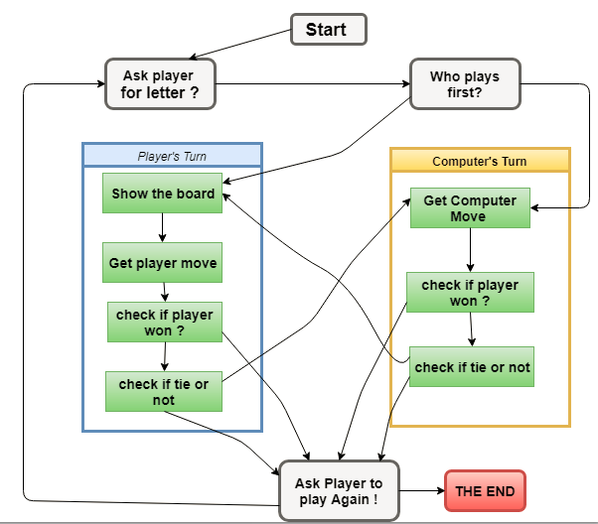

Figure - TTT Flowchart

**Note**: the board is numbered as keyboard number pad as per the following sample:

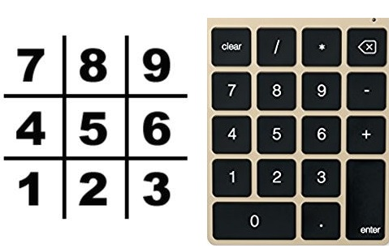

Figure - Board numbering

# Game in details with functions:

In this program, the Tic Tac Toe board is simply represented as a list of strings. Each string will represent one of the nine spaces on the board (either be 'X' for the X player, 'O' for the O player, or a single space ' ' for a blank space.). To make it easier to remember which index in the list is for which space, same as the numbers on a keyboard’s number keypad, as per the Figure 4 we can also agree that list of 10 strings stored in variable board will make board [5] in center, board [1] in bottom left and board [6] in the right side and so on so forth

**Functions**:

* GameBoard(): function to draw the board of strings (1 till 9)
* inputPlayerletter(): function so the player can choose which letter will start with “X” or “O” , and the computer will get the second letter.
* whoGoesFirst() : function to randomly choose the player who will go first in the game , in this case player or computer
* playAgain() : function to repeat the game again by using “random.randint(0, 1) == 0” , if (0) the computer will have the first move , (1) the player will have the first move
* MakeAMove() : function to pass the parameter for the borad[ ] with chosen letter by player or computer
* isWinner(): function with long return line to check if there is three spaces in board filled with same letter horizontally , vertically or diagonally
* getboardCopy(): function to make copy of the board of TTT in the game , making append to the board with new copy of it without changing the original board and moves has been played before.
* FreeSpace(): function to check if the entire board filled with sting or not , make sure to choose the right empty slot to make a move, otherwise a message will pop up to ask for available move
* getPlayerMove(): function to ask the player to enter the number of the space that wants to move on , the (while) loop here makes sure that the player is choosing the empty space each move and check if the space is already taken before or not by calling FreeSpace() , and finally return the move as integer from string
* chooseRandomMoveFromList(): function will first check that the space is valid to make a move on , and returns a valid move from the passed list on the passed board and None in case of no valid/true move made.
* getComputerMove(): function,The algorithm which has been used in TTT game is simple algorithm to compute the results , this algorithm is implemented and used in the getComputerMove() function
* isboardFull(): function that returns True in case all moves(10 strings 1-9, index 0 not used) has already passed through with “X” or “O” , and False in case of any spaces found not filled yet , in other words , isbordFull() invert function of FreeSpace().

# UML Diagrams:

* **Class Diagram:**

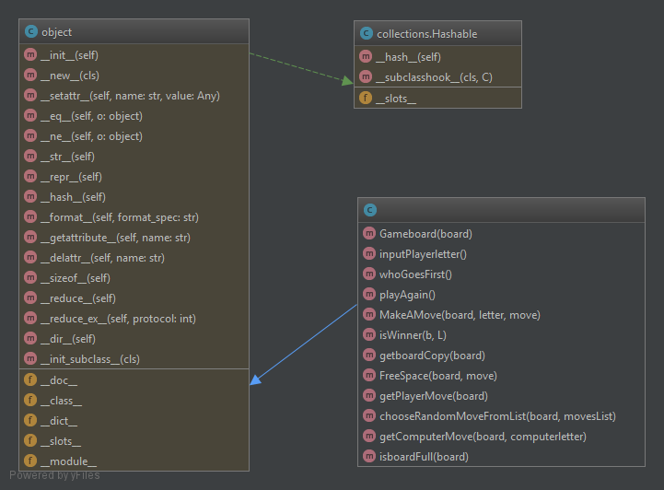

Figure - Class Diagram

* **Use Case Diagram :**

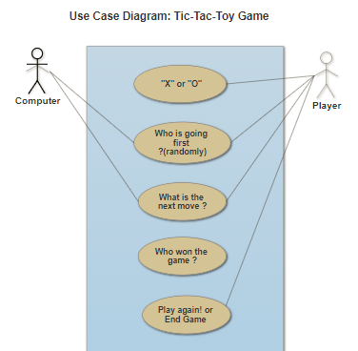

Figure - Use Case Diagram

## SonarQube – Metrics:

With SonarQube we can check how much the code is clean from bugs and vulnrability

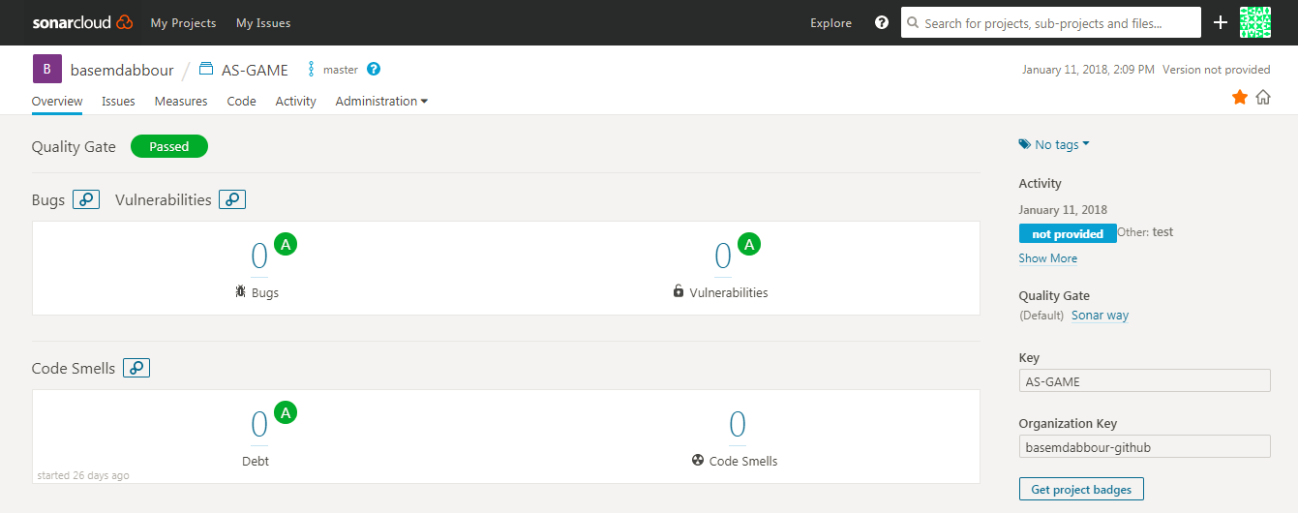By creating new project with token name either existing one or generate new which is linked to new project for testing and analysing by applying one of the metrics (bugs test , line of cods ... e :

Figure 7- SonarQube 1

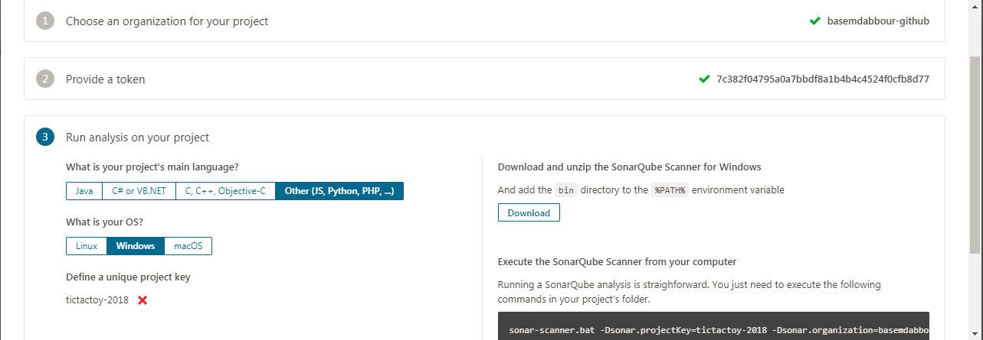

Figure 8-Token with command analysis

The following command will scan the code and do the test:

` sonar-scanner.bat -Dsonar.projectKey=AS-GAME -Dsonar.organization=basemdabbour-github -Dsonar.sources=. -Dsonar.host.url=https://sonarcloud.io -Dsonar.login=ca8628234e17b3cb7011afc999c047e0226ac2d7 `

And the result will be like this:

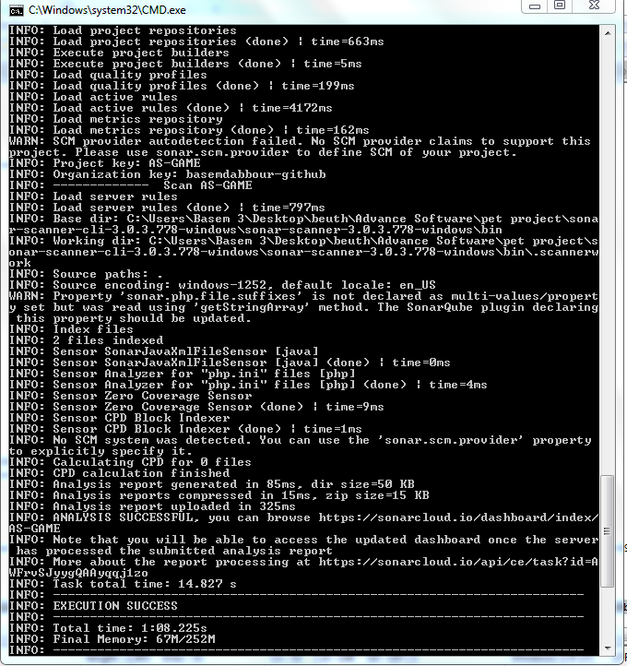

# Clean Code Development:

Writing any software is the most complicated endeavors for human, as Bidan Kernigan the co-author of the AWK PL who summed up the true nature of software development in his book, said

"Controlling complexity is the essence of software development. The harsh reality of real world software development is that software is often created with intentional, or unintentional, complexity and a disregard for maintainability, testability, and quality. The end result of this unfortunate reality is software that can become increasingly difficult and expensive to maintain and that fails sporadically and even spectacularly.".

1. **Always use Class-functions approach**:

Using function is a block of reusable line of codes that is used to perform a specific action and its one of the important steps when writing software code in any programing language.

List of advantages :

* Reducing duplication of code.
* Decomposing complex problems into simpler pieces.
* Improving clarity of the code.
* Reuse of code.
* Information hiding.

You can see all TicTacToy functions previouslly in section 5 - Game In Details.

1. **Use modeul carefully** :

A module can contain executable statements as well as function definitions.

These statements are intended to initialize the module. They are executed only the first time the module name is encountered in an import statement.

Each module has its own private symbol table, which is used as the global symbol table by all functions defined in the module.

*Advantages:*

* No global namespace for objects.
* Python Modules are very easy to import and use.

In Tic Tac Toe game, a "random" module is imported not just to reduce the lines of code, but also contain useful commands:

* random.randint(x,y) : to return random integer from interverl:

if random.randint(0, 1) == 0:  
 return 'computer'  
 else:  
 return 'player'

* random.choice(seq): to return random element from non empty sequance or list ,otherwise return None:

if len(possibLMoves) != 0:  
 return random.choice(possibLMoves)  
 else:  
 return None

1. **Organize your code:**

Don‘t make your code messy especially if you are writing thousands of lines of code, organize your python code by listing all functions first in the body and then the main

1. **Use #Comments**:

Always use #comments in your project to describe what this lines of code do?, not just for your future reference, but also for other people who might end up reading your project and evaluating it.

1. **A clean code hypothetical test:**

Always make hypnosis to check if there is any problem and solution for it: run tests on your code multiple times with different approach to insure and prove that your software can continuously works without breaking down so bad such as the following snippets code :

# Check if the player could win on their next move, and block them.  
 for i in range(1, 10):  
 copy = getboardCopy(board)  
 if FreeSpace(copy, i):  
 MakeAMove(copy, playerletter, i)  
 if isWinner(copy, playerletter):  
 return i  
  
 # Try to take one of the corners, if they are free.  
 move = chooseRandomMoveFromList(board, [ 1, 3, 7, 9 ])  
 if move != None:  
 return move  
  
 # Try to take the center, if it is free.  
 if FreeSpace(board, 5):  
 return 5  
  
 # Move on one of the sides.  
 return chooseRandomMoveFromList(board, [ 2, 4, 6, 8 ])

# Continuous Delivery:

With the help of the [Git plugin](https://wiki.jenkins-ci.org/display/JENKINS/Git+Plugin) Jenkins can easily pull source code from any Git repository that the Jenkins build node can access.

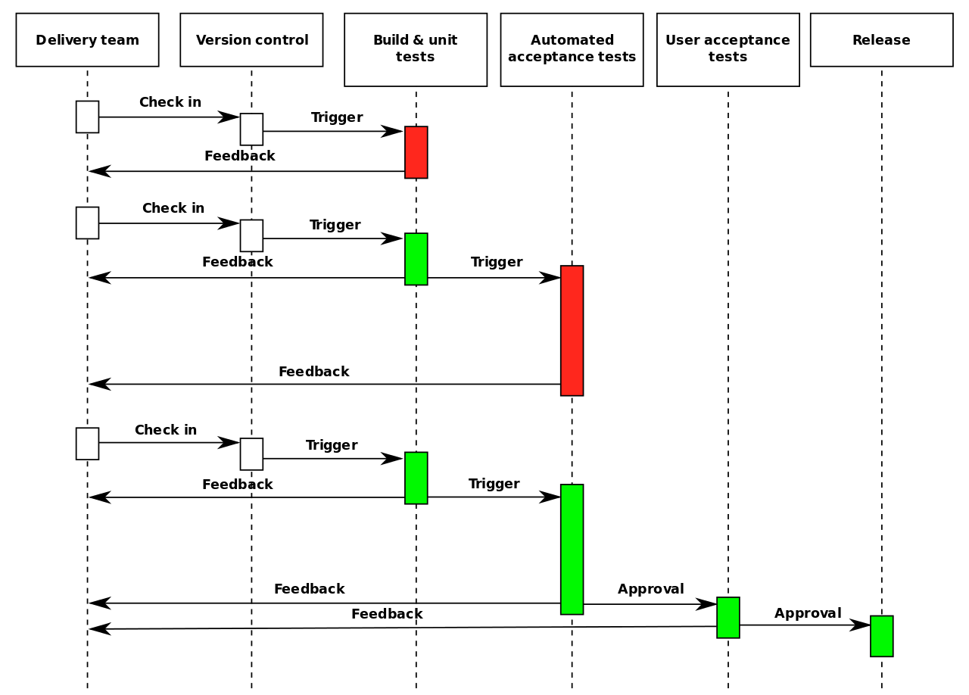

Figure - Continues Delivery Pipeline

# AOP jointpoints:

AOP is very useful to avoid cross-cutting features that affect multiple components of the system.

Some examples are logging, timing, security authorization, etc.

In the case of Tic Tac Toe we can use AOP to add logging to the code, so instead of adding log.print to each function in the program we can define one logging Aspect and define a joint-point of all the main functions that we need to add log to.

The below figure shows separate deferent concerns of implementing the Observer pattern in the context of TicTacToe a board game of Two or more players each modify the board game and need to be notified whenever some of the other players has changed the board, this is one of the powerful illustration of the AOP technique.

The big picture was broken into smaller pieces of concern which improve the programming style.

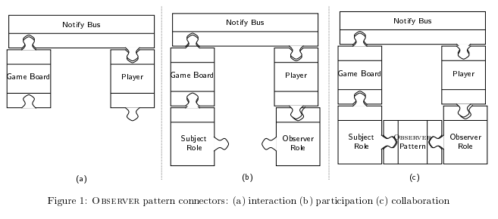

In this figure, we can consider the component based approach for implementing an observer pattern. The board game and players are components, which means that in the board game, each player is an observer who needs to be notified whenever the board game is changed by another player. However it’s connecting the board and the player by a notification bus as shown in (a) which describe the connectors between the components.

The connector represents communication channels between board game and player, whenever a change happened, it will update the player about that change.

## DSL Demo example:

Domain Specific Languages can serve all sort of purposes. They can be used in different contexts and by different kinds of users. Some DSLs are intended to be used by programmers, and therefore are more technical, while others are intended to be used by someone who is not a programmer and therefore they use less geeky concepts and syntax.

There are several examples of public DSL which are used a lot:

* DOT – A DSL to define graphs
* Sed – A DSL to define text transformation
* Gawk – A DSL to print and process text
* Website-spec – A DSL for functional web testing
* SQL – databases
* HTML – web layout
* UML – visual modeling
* PlantUML – A DSL to draw UML diagrams: PlantUML Can be used to define UML diagrams of different kinds. For example we can define a sequence diagram as per the following DSL Demo example snippet:

For example using **[PlantUML](http://plantuml.com/)**, we can define a [Sequence Diagram](http://www.plantuml.com/plantuml/uml/SyfFKj2rKt3CoKnELR1Io4ZDoSa70000) as per the following DSL Demo example snippet:

@startuml

actor Customer1

actor Customer2

actor Partner1

actor Partner2

database Database

Customer1 -> Partner1: Request a refund

Partner1 -> Supplier: Request a credit note

Supplier -> Database: Verify data

Supplier -> Partner1: Issue credit note

Partner1 -> Customer1: Issue credit note

Customer2 -> Partner2: Request a License

Partner2 -> Customer2: Share a quote

Customer2 -> Partner2: Place a Purchase order

Partner2 -> Supplier: Process Purchase order

Supplier -> Database: Verify data

Supplier -> Partner2: issue License with invoice

Partner2-> Customer2: Issue a license with invoice

@enduml

Click [Here](http://www.plantuml.com/plantuml/uml/SyfFKj2rKt3CoKnELR1Io4ZDoSa70000) and copy and past the above code in the PlantUML shell, you will get the following sequence diagram as output

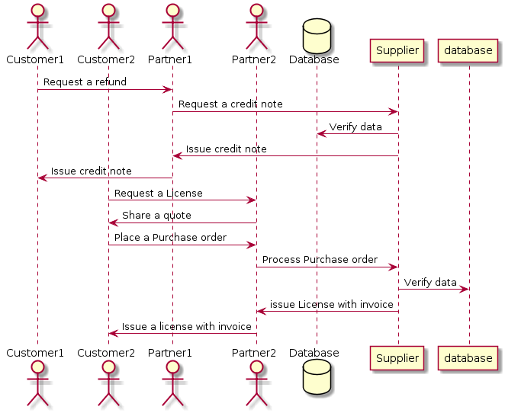

We can define a DSL for Tic Tac Toe game definition and playing, let's say we want to extend Tic Tac Toe to support

user defined game size and number of players:

GAME 5X5

PLAYERS 3

PLAYER_SIGN 1 *

PLAYER_SIGN 2 O

PLAYER_SIGN 2 &

START

PLAYER_CHOICE 1 (2,2)

PLAYER_CHOICE 2 (3,4)

.

.

.

.

EXIT

## Logic Solver:

By using The MiniMax (MM) Algorithm, an unbeatable game can be built

This algorithm designed for perfect information game (chess, checkers ...etc.)

This Algorithm could calculate all the possible moves available for the computer player and use some metric to determine the best possible move.

The following research which has been done In 2013, shows that the Minmax algorithm was the right for the job.

In my code, I am focusing on two player games where Human-Player = +1, and Computer Player = -1

[click here to check the full research article about MM algorithm ](https://www.neverstopbuilding.com/blog/2013/12/13/tic-tac-toe-understanding-the-minimax-algorithm13)

**How it works? **

a) We create a tree of all possible moves for all players to a certain depth.

b) Each position or node of the tree holds a heuristic value which basically it’s the state of the game in single value, so who is wining and who is losing? , so if there is a situation on tree in which player1 wins it would be represented by positive infinity ,and if there is a situation where player2/computer wins it will be represented as negative infinity , and if neither so its either 0 or somewhere in between [-1,+1].

c) Now after the tree has been created, then the algorithm goes to the bottom of the tree and works its way upwards deciding what is the best possible move for each player when it is their turn, which means listing out all the bad moves for that player and then take step upwards and repeat it for the opposite player, so its like removing/filtering all the bad moves for both.

d) From sys import maxsize : since computer cant assign value to infinity , instead we will import maxsize module in python , max size integer which is big number(positive) or small number(negative), and this value will be used to represent infinity or when the player wins or loses.

e) Create Node class , or you can name it anything other than “Node”, and this node will build the tree.

f) In this implementation , Human player is treated as maximizing player and the Computer is minimizing player and evaluating the board stats with minimizing player/computer.

g) In my code, function isWinner() checking if the player got the same letter 3 times in one of row/column/diagonal and returns true if the player won and false if player lost.

With Minmax (MM) algorithm, adding two functions to calculate the _**minimum and maximum score**_ per the following sample and simple code to descripte the algorithm:

def MinScore(board):  
 if isWinner(board, 'x'):  
 return True  
 elif isWinner(board, 'o'):  
 return False  
 elif isboardFull(board):  
 return 0  
 else:  
 bestMoveValue = 100  
 move = 0  
 for i in range(1,10):  
 newBoard = MakeAMove(board, minPlayer, i)  
 if (newBoard==True):  
 predictedMoveValue = maxScore(newBoard)  
 if (predictedMoveValue < bestMoveValue):  
 bestMoveValue = predictedMoveValue  
 move = i  
 return bestMoveValue  
  
  
def MaxScore(board):  
 if isWinner(board, 'x'):  
 return True  
 elif isWinner(board, 'o'):  
 return False  
 elif isboardFull(board):  
 return 0  
 else:  
 bestMoveValue = 100  
 move = 0  
 for i in range(1,10):  
 newBoard = MakeAMove(board, minPlayer, i)  
 if (newBoard==True):  
 predictedMoveValue = maxScore(newBoard)  
 if (predictedMoveValue > bestMoveValue):  
 bestMoveValue = predictedMoveValue  
 move = i  
 return bestMoveValue

# Scala Code:

This following is sample data structure of Tic Tac Toe game:

case class Point(x:Int, y:Int)

case class Choice(p:Player, p:Point)

case class Player(name:String, sign:Char)

case class Board(width:Int, height:Int)

class Game(board:Board, p1: Player, p2:Player, choices: List[Choice]) {

addChoice(c:Choice):Game {

}

hasAWinner():Boolean {

}

}

**Note:** The methods *addChoice* and *hasAWinner* are just templates to explain the idea without implementation.