Patrick DiMisa – CMST386 Project 2

**Client and Topic**

The type of website that I plan to create is one for an imaginary company. The purpose of this company is to sell cosmetic and personal care items.

**Development Process and Engagement**

I am creating this website for a client, which will call for the inclusion of them in the development process. I will conduct background research on design trends in relevant industries, which will give a starting point to how the site is approached and designed. The client will be directly involved in the latter half of this process, where style guides and overall preferences can be taken into account. Required elements and content will also be provided by the client where applicable.

**Testing**

Prior to launch, I will utilize Google’s developer tools, and attempt to approach the site as a consumer to ensure all required and relevant content is accessible and logically placed. For the sake of thorough testing, I will use Google Chrome, Mozilla Firefox, and Microsoft Edge to sweep for errors.

**Description**

The business that I will be creating this site for is Lumina, a cosmetic and personal care company. The goal of Lumina is to provide clean, responsibly produced and affordable products. The target audience of Lumina is younger consumers (millennials and below) that are interested in using products that are environmentally friendly and health-conscious. Ethnicity and education are not deciding factors, however, middle to upper class consumers will be the main target for this brand, as the aforementioned type of products are typically more expensive to produce, and therefore marked up in price from their generic counterparts. The identification of this audience will help shape the aesthetic choices found on the site. In terms of unique content, I will provide original layouts, product designs, and text to add to the visual appeal. I will outsource images and icons used within the site. The site will need to be updated whenever new products are released by Lumina.

**Growth and Maintenance**

Over time, I believe the website will grow by adding new products, as well as rotating through various visual changes related to seasonal offerings. These can include artwork, advertisements, or color theme alterations. To make the site easier to maintain, especially with these changes, the use of custom properties and relevant comments will prove invaluable for quick adjustments. In terms of maintenance, the main tasks will include functionality and compatibility tests, especially as browser support for particular elements expands or otherwise changes. These checks can occur once every 1-2 months.

**Organization**

**Wireframes**

[Homepage](http://framebox.org/AtKZR)

[Contact Page](http://framebox.org/Atlax)

**Flowchart**

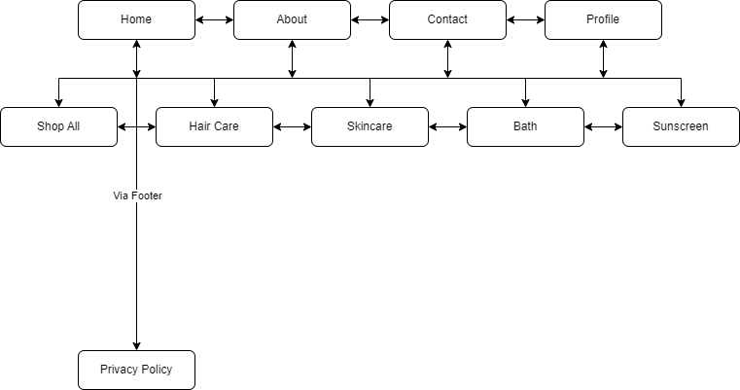

*A 2-layer navigation will separate the product pages from the rest of the site.*

*The privacy policy will be linked in the footer and accessible via any page.*

The layout and navigation that I am considering will emphasize on product lists and grids that will make comparing and shopping for products on the site easy to navigate.

The website and its content will be organized in a way that directs users to make multiple purchases, by making it easier for users to find what they are looking for. The site will include sub-topics that are relevant to the various products sold by Lumina. The site’s pages will be as follows:

* Home
* About
* Contact
* Profile Page (Mock)
* Privacy Policy
* “Shop All” products page
* Hair Care products page
* draw products page
* Sunscreen products page
* Bath products page

**Security**

The website will include e-commerce components such as a shopping basket, and user profiles. These profiles will be necessary in order to process payments and ship orders to the correct customers. The profiles will also need to be password protected for security purposes.

*For the purpose of this site, the cart will have no functionality, and the profile will be a mock, as server-side scripting and a backend database is beyond the scope of CMST386.

**Web Hosting**

The site will need to be HTTPS enabled, and receive SSL/TLS certification in order to conduct e-commerce and related business.

The site will need to support JavaScript in order to conduct necessary practices concerning consumer-site interactions.

The domain name that I have chosen is *luminacosmetics.com.* I chose this domain because it is simple and easy to remember, but also relevant to the purpose and content of the site.

When selecting a web host, multiple factors will need to be considered in order to ensure that the best service for this particular site is chosen. Some things that should be kept in mind when searching are:

Budget

How much is the client prepared to spend on web hosting? Will some content or features of the site need to be altered in order to accommodate a less expensive provider?

Security

Seeing as this is an e-commerce site, which will store sensitive user information such as card numbers names, and addresses, choosing a host with appropriate security features is a necessity for the safety of the site’s users.

**Marketing**

The website will be marketed through social media ad campaigns and traditional online ads. Additionally, partnerships may be made with social media influencers and reviewers in an effort to reach more members of Lumina’s target audience.

In terms of SEO elements, it will be necessary to include relevant keywords, meta tags, and semantically sound HTML. Additionally, the supporting pages will be carefully constructed in conjunction with the pillar page in order to provide uniformity and ease of use.