Horizon Europe - MSCA Doctoral Networks
Computational and Experimental Enzyme Engineering
for New Polymers

Computational tools to select enzymes with high probability to act on polymers

Lead author: Miguel Angel Bayo Valero
Version: Draft
Lead beneficiary: BASF
Deliverable number: D1.3
Deliverable title: Computational tools to select enzymes with high probability to act on polymer
Work Package: 1
Type of deliverable: R – Document, report
Dissemination level: SEN - Sensitive
Due date: 10/26

Table of Contents
Executive Summary 3
Introduction 3
Methodology 5
Results 6
Discussion 10
References 11

Executive Summary
This project is focused on the development of two computational tools, MLP (Molecular Lipophilicity Potential) and MEP (Molecular Electrostatic Potential), designed to characterize the physicochemical properties of biomolecular surfaces and support the study of enzyme-substrate interactions. The tools enable the calculation and visualization of molecular lipophilicity/hydrophilicity and electrostatic surface potential, providing valuable insights into the molecular recognition processes that govern binding, catalysis and substrate specificity. ^{[1 - 3]}

To achieve this objective, two Python-based workflows were developed. MLP is based on the pyMLP Molecular Lipophilic Potential evaluator and implements methodologies derived from the fragmental lipophilicity approaches described by Laguerre et al. and Ghose et al. ^{[1 - 3]} The tool generates three-dimensional molecular lipophilicity potential maps that describe the distribution of hydrophobic and hydrophilic regions on molecular surfaces. These maps allow the identification of surface features that may influence substrate adsorption, molecular recognition and enzyme-substrate interactions.

MEP was developed to generate electrostatic potential maps directly from molecular structures in PQR format. The methodology employs a screened Coulomb (Yukawa/Debye-Hückel) formalism to calculate electrostatic potentials on a three-dimensional grid while accounting for ionic screening effects and dielectric properties. The resulting potential maps can be visualized using standard molecular visualization software such as Pymol or VMD. This approach enables rapid identification of positively and negatively charged surface regions that contribute to intermolecular interactions.

The combined use of MLP ^{[1-3]} and MEP provides a comprehensive framework for the investigation of molecular surface complementarity. By simultaneously evaluating lipophilic and electrostatic properties, the tools enable qualitative analysis of enzyme-enzyme and enzyme-substrate interactions to identify favorable interaction regions and investigate the physicochemical determinants of molecular recognition.

The integration of these tools with existing molecular modelling and visualization workflows facilitates the characterization of complex molecular interfaces and supports future studies involving enzyme engineering, substrate recognition and biomolecular design.

Introduction
Molecular recognition is a fundamental process underlying virtually all biological interactions. The ability of enzymes to selectively recognize, bind and transform their substrates depends not only on the geometric compatibility of the interacting molecules but also on the physicochemical properties distributed across their surfaces. Among these properties, lipophilicity and electrostatic charge play particularly important roles in controlling binding affinity, substrate orientation, molecular association and catalytic efficiency. Understanding how these surface properties influence molecular interactions is therefore essential for investigating biological systems and for guiding rational protein engineering efforts.

Hydrophobic interactions are known to contribute significantly to molecular recognition processes by promoting the association of nonpolar surface regions and minimizing unfavorable interactions with aqueous environments. ^{[4]} The distribution of hydrophobic and hydrophilic areas on an enzyme surface can influence substrate adsorption, binding specificity and the stability of enzyme-substrate complexes. Understanding these properties through MLP ^{[1-3]} provides a valuable way of visualizing and interpreting surface regions that may participate in intermolecular interactions.

Electrostatic interactions also constitute a major driving force governing molecular recognition. Charged and polar residues contribute to the generation of electrostatic fields that influence long-range interaction, substrate guidance, binding orientation and catalytic activity. The analysis of electrostatic surface potentials can reveal favorable interaction sites, identify complementary charge distributions between interacting molecules and provide insights into the molecular binding.

To facilitate the investigation of surface complementarity in biomolecular systems, two computational tools were developed: MLP ^{[1-3]} and MEP. These Python-based applications provide complementary descriptions of molecular surfaces by evaluating lipophilic/hydrophilic and electrostatic properties, respectively.

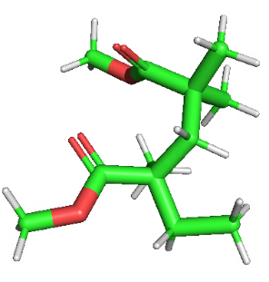
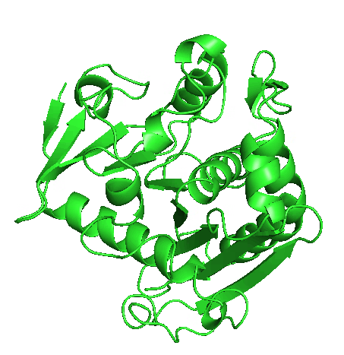
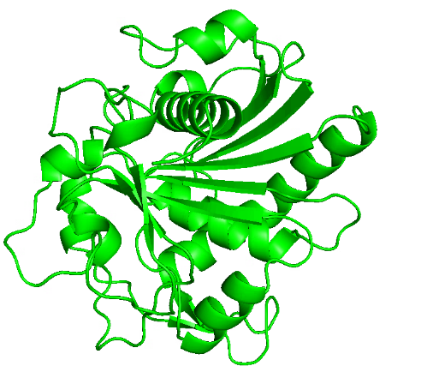
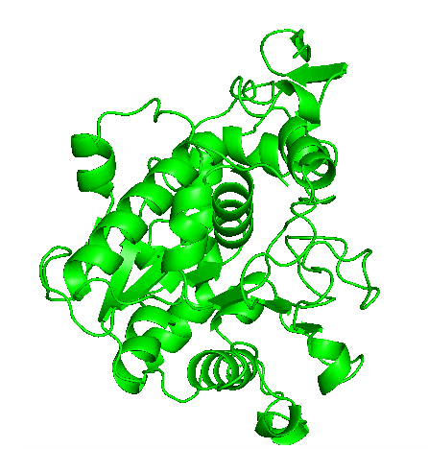
The capabilities of both tools were evaluated using three representative enzyme-ligand systems (see Figure 1) involving industrially relevant lipases and a model polymer substrate. The selected enzymes were Rhizomucor miehei lipase (RM-Lipase, PDB ID: 4TGL, Figure 1A), ^{[5]} Humicola lanuginosa lipase (HL-Lipase, PDB ID: 1TIB, Figure 1B) ^{[6]} and Candida antarctica lipase B (CALB, PDB ID: 1LBS, Figure 1C). ^{[7]} As a model substrate, a poly(methyl methacrylate) (PMMA, Figure 1D) dimer was employed to investigate enzyme-polymer surface complementarity. PMMA was selected because methacrylate-based materials are widely used as support for lipase immobilization. Lipases are known to interact strongly with hydrophobic interfaces through a phenomenon known as interfacial activation, in which exposure to a hydrophobic surface promotes displacement of the lid structure and stabilization of the open, catalytically active conformation.
B
D
C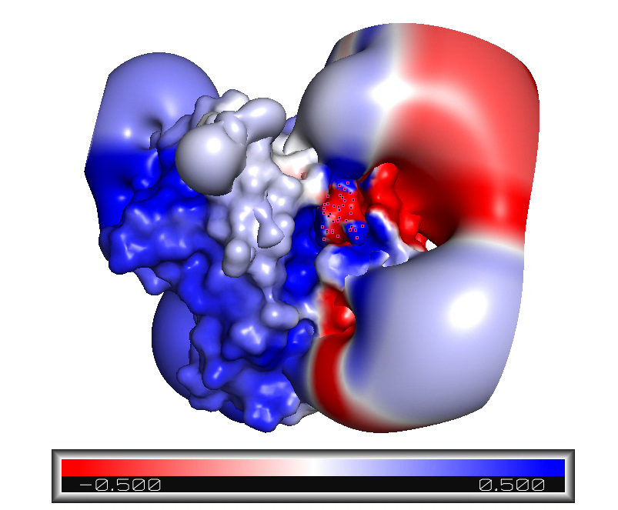
A

Figure 1. Structures of the different enzymes and the polymer dimer. (A) RM-Lipase, (B) HL-Lipase, (C) CALB and (D) PMMA

This behavior has been extensively exploited in biocatalysis, including commercial systems such as Novozym 435®, where CALB is immobilized on a poly(methyl methacrylate)-divinylbenzene resin, CALB immobilized in PMMA nanoparticles and Sepabeads®-based supports containing hydrophobic octadecyl chains that promote lipase adsorption through hydrophobic interactions. These systems highlight the importance of hydrophobic surface complementarity in lipase-support recognition and motivate the use of molecular lipophilicity and electrostatic surface analyses to investigate enzyme-polymer interactions. ^{[8, 9, 14]}

Molecular lipophilicity and electrostatic potential maps were generated for each enzyme and the PMMA dimer, allowing the identification of hydrophobic patches and charged surface regions potentially involved in substrate recognition and binding. These case studies served to demonstrate the applicability of the developed workflows and to assess their usefulness for the qualitative characterization of enzyme-substrate interfaces. ^{[8, 9, 14]}

Together, MLP ^{[1-3]} and MEP provide a computational framework for characterizing molecular surfaces through complementary analyses of lipophilicity and electrostatic potential. By identifying hydrophobic and hydrophilic patches, and charged surface features, these tools facilitate the investigation of molecular recognition processes and support the interpretation of both experimental data and computational models.

The aim of this work is to develop, validate and apply these methodologies to the study of biomolecular systems, offering accessible approaches for assessing surface complementarity and interaction patterns. By enabling the visualization and analysis of lipophilic and electrostatic surface characteristics, the proposed workflow can support future studies in protein engineering, enzyme design, biomolecular modeling and the investigation of complex biological interfaces.

Methodology
This study focuses on the characterization of molecular surface properties relevant to enzyme-substrate recognition and intermolecular complementarity employing MLP ^{[1-3]} and MEP. The workflow was evaluated on three usecase lipase systems, namely RM-Lipase, HL-Lipase and CALB, together with a PMMA dimer as a model polymer substrate. PMMA was selected because these lipases have been widely reported to exhibit good compatibility with PMMA-based materials and are frequently immobilized on PMMA supports for biocatalytic applications. ^{[8, 9]}

Surface maps were initially generated for the enzymes and the PMMA dimer separately to characterize their individual physicochemical properties and identify potential regions of interaction. The PMMA dimer was subsequently analyzed in docked conformations obtained from molecular docking calculations performed with AutoDock v4.2.6. ^{[10]} Protein structures were retrieved from the Protein Data Bank (PDB), cleaned to remove non-essential molecules, and prepared for analysis prior to processing with MLP ^{[1-3]} and MEP.

Interaction analyses focused on residues I85, I89, A90, L92, F94, and V95 in RM-Lipase; I86, I90, L93, and F95 in HL-Lipase; and the catalytic triad residues S105, D187 and H224 in CALB ^{[7-9].} Lipophilicity and electrostatic maps were then visually inspected to assess the degree of physicochemical complementarity at the enzyme-substrate interface and to determine whether the calculated surface features were consistent with the predicted binding modes.

Molecular Lipophilicity Potential
MLP ^{[1-3]} was used to calculate lipophilicity/hydrophilicity maps from the enzyme and PMMA structures. Atomic lipophilicity contributions were assigned according to the Crippen fragmental constants based on atom types and the resulting lipophilicity potential was evaluated on a three-dimensional grid surrounding each molecule using the default Fauchère distance function. The calculated maps were exported in OpenDX format and visualized in PyMOL v2.5.0 ^{[11]} for qualitative analysis of hydrophobic surface features.

Molecular Electrostatic Potential
Electrostatic potential maps were generated with MEP using PQR files containing atomic coordinates, radii and partial charges. Group charges were assigned to heavy atoms by incorporating the charges of bonded hydrogen atoms within 1.3 Å and electrostatic potentials were subsequently calculated on a three-dimensional grid using a screened Coulomb formalism. The resulting maps were exported in OpenDX format and visualized in PyMOL v2.5.0 ^{[11]} by projection onto the molecular surface.

Results
RM-Lipase and PMMA
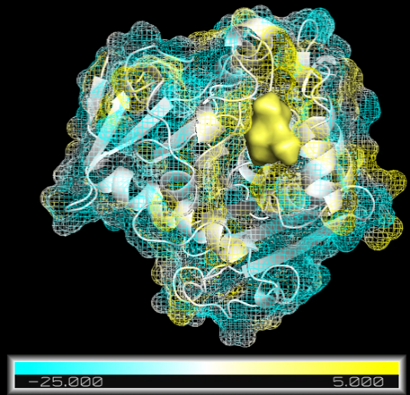
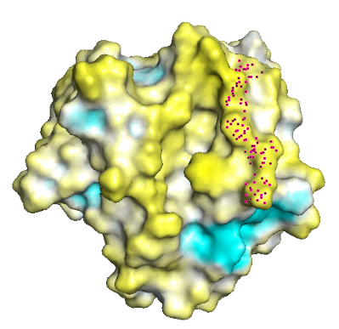
RM-Lipase (PDBID: 4TGL) was obtained from the PDB, while a PMMA monomer structure was retrieved from the NIST database ^{[13]} and used as the basis for constructing a PMMA dimer in Avogadro v1.99 ^{[12]} (see Figure 1D).

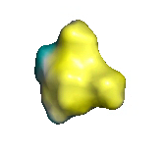

A
B
C
Figure 2. MLP surfaces of the RM-Lipase/PMMA system. (A) MLP surface of the PMMA dimer, with lipophilic and hydrophilic regions shown in yellow and cyan, respectively. (B) MLP surface of RM-Lipase, highlighting lipophilic and hydrophilic surface patches in yellow and cyan, respectively, binding pocket depicted with dots. (C) Docked RM-Lipase/PMMA complex illustrating the qualitative complementarity of the interacting surfaces. Lipophilic regions of the PMMA dimer (isosurface) align with lipophilic patches on the enzyme surface (mesh), while hydrophilic regions correspond to hydrophilic areas. This complementary distribution supports favorable enzyme-substrate interactions. The enzyme surface is displayed as a mesh on a black background to enhance visual contrast.
.

MLP ^{[1-3]} maps were first generated for the unbound system. Visual inspection of the PMMA dimer surface (Figure 2A) revealed a predominantly lipophilic region associated with the polymer backbone (yellow), whereas the ester moieties displayed high hydrophilicity (cyan), consistent with their more polar character. The MLP ^{[1-3]} map of RM-Lipase (Figure 2B) showed several lipophilic and hydrophilic surface patches, notably within the substrate-binding pocket (in dots). The presence of complementary lipophilic and hydrophilic regions on both the enzyme and the polymer suggested that this binding pocket could provide a favorable environment for PMMA recognition.
Analysis of the docked complex (Figure 2C) further supported this hypothesis. The lipophilic regions of the PMMA dimer (yellow) overlap with lipophilic patches within the RM-Lipase binding site (yellow), while hydrophilic regions of the polymer (cyan) align with hydrophilic areas of the enzyme surface (cyan). These observations indicate a clear degree of lipophilic complementarity at the enzyme-substrate interface and provide qualitative evidence supporting the proposed binding mode.

In a similar manner, electrostatic potential maps were generated using MEP. In the PMMA dimer (Figure 3A), the ester functionalities are characterized by regions of negative electrostatic potential (red), arising from the electron-rich carbonyl and ester oxygen atoms. The electrostatic surface of RM-Lipase (Figure 3B) reveals a heterogeneous distribution of positive (blue) and negative (red) surface patches. Notably, the binding pocket region (indicated by dots) contains both positively and negatively charged areas, reflecting the diverse physicochemical nature of the residues lining the active site.

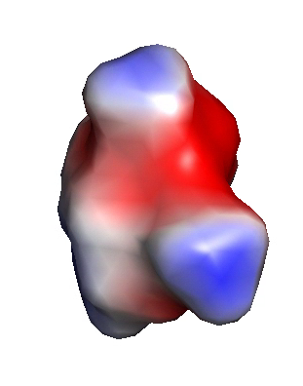
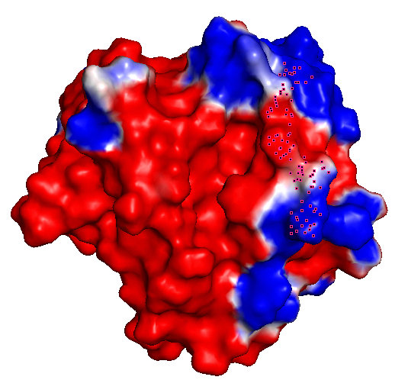
The presence of positively charged regions within the binding pocket suggests the possibility of favorable interactions with the negatively polarized ester groups of PMMA. Analysis of the docked complex (Figure 3C) shows that the PMMA dimer occupies the substrate-binding pocket, where its ester moieties are positioned in proximity to positively charged surface regions, while remaining exposed to neighboring negatively charged areas. This arrangement indicates certain degree of electrostatic complementarity between the polymer substrate and the enzyme surface, supporting the proposed binding mode and suggesting that electrostatic interactions may contribute to substrate recognition and stabilization within the active site.
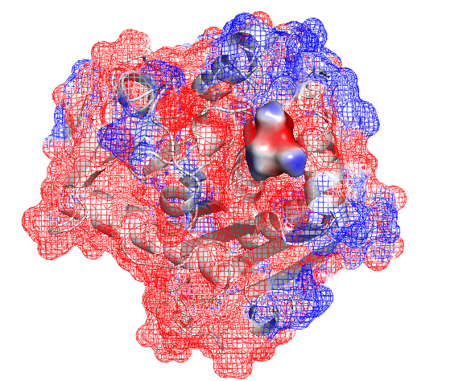



Figure 3. MEP surfaces of the RM-Lipase/PMMA system. (A) Electrostatic surface of the PMMA dimer, where regions of negative electrostatic potential associated with the ester oxygen atoms are shown in red while the polymer backbone exhibits neutral to positive potential and is shown in blue. (B) Electrostatic surface of RM-Lipase, highlighting negatively charged regions in red and positively charged regions in blue around the binding pocket (indicated by dots). (C) Docked RM-Lipase/PMMA complex showing the orientation of the polymer (isosurface) within the enzyme (mesh) binding site and the distribution of complementary electrostatic features at the interaction interface, suggesting favorable enzyme-substrate recognition.

B
C
A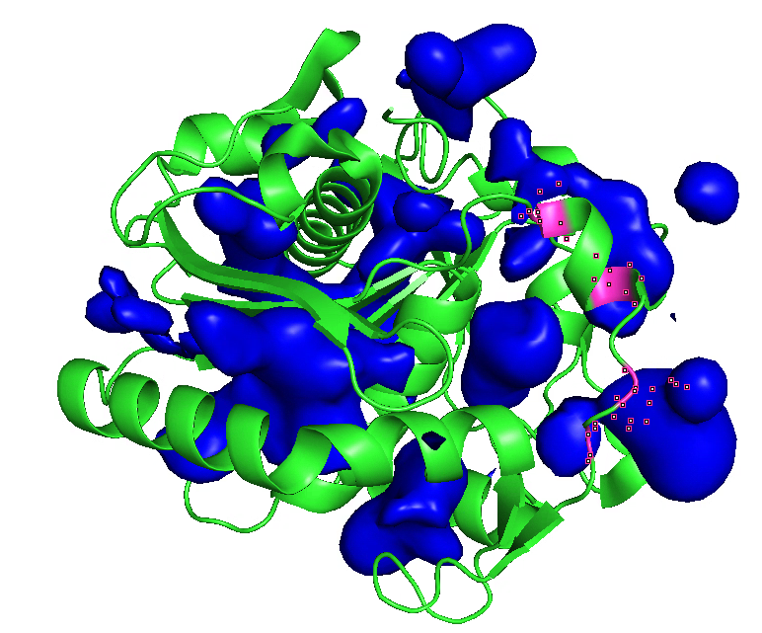

HL-Lipase and PMMA
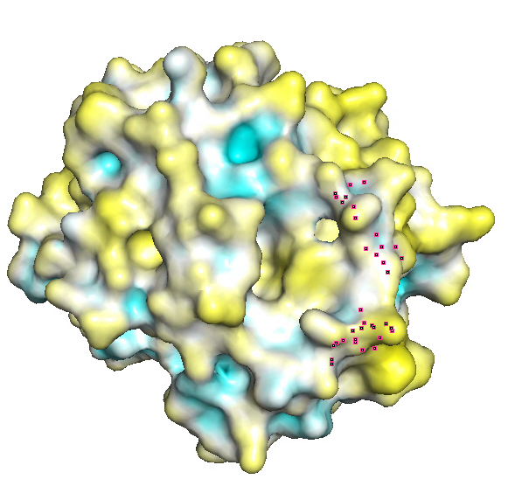
Following the previous case study, the same analysis was performed for the HL-Lipase/PMMA system. The MLP ^{[1-3]} surface of HL-Lipase revealed several hydrophobic patches distributed across the enzyme surface, including regions located around the substrate-binding pocket (Figure 4B). Upon docking, the lipophilic backbone of PMMA (yellow, Figure 4A and 4C) was found to occupy this pocket and interact with the surrounding hydrophobic residues. The observed overlap between the lipophilic surfaces of both molecules indicates a favorable degree of lipophilic complementarity, supporting the proposed binding pose and the potential role of hydrophobic interactions in substrate recognition.
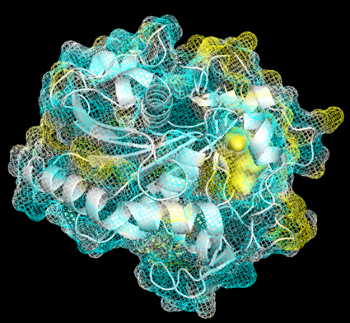
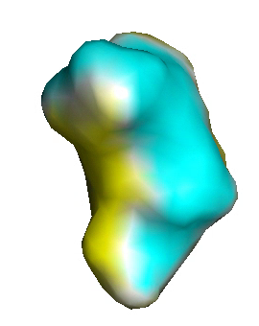

A
B
C
Figure 4. MLP surfaces of the HL-Lipase/PMMA system. (A) MLP surface of the PMMA dimer, with lipophilic and hydrophilic regions shown in yellow and cyan, respectively. (B) MLP surface of HL-Lipase, highlighting lipophilic and hydrophilic surface patches in yellow and cyan, respectively, binding pocket depicted with dots. (C) Docked HL-Lipase/PMMA complex illustrating the qualitative complementarity of the interacting surfaces. Lipophilic regions of the PMMA dimer (isosurface) align with lipophilic patches on the enzyme surface (mesh), while hydrophilic regions correspond to hydrophilic areas. This complementary distribution supports favorable enzyme-substrate interactions. The enzyme surface is displayed as a mesh on a black background to enhance visual contrast.

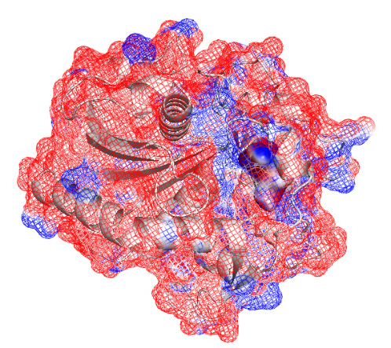
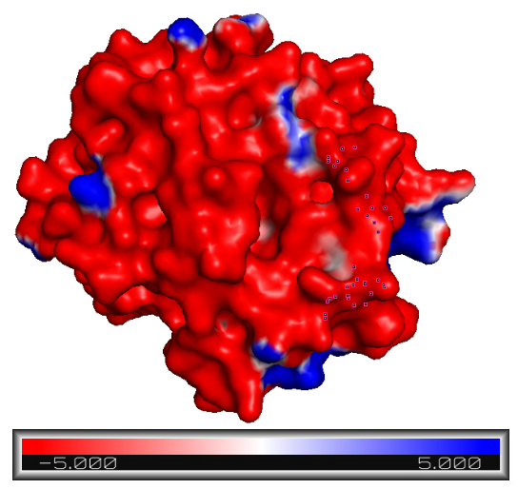
Following the analysis of lipophilicity, electrostatic potential maps were generated for the HL-Lipase/PMMA system using MEP. As observed in the RM-Lipase system, the PMMA dimer (Figure 5A) exhibits regions of negative electrostatic potential (red) associated with the ester functionalities, while less polarized regions are observed along the polymer backbone. The electrostatic surface of HL-Lipase (Figure 5B) is characterized by a heterogeneous distribution of positive (blue) and negative (red) surface patches, with both types of electrostatic environments present around the substrate-binding region (dots).
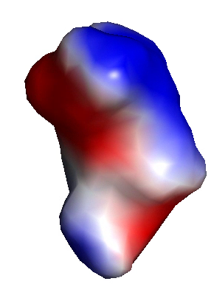

A
B
C
Figure 5. MEP surfaces of the RM-Lipase/PMMA system. (A) Electrostatic surface of the PMMA dimer, where regions of negative electrostatic potential associated with the ester oxygen atoms are shown in red while the polymer backbone exhibits neutral to positive potential and is shown in blue. (B) Electrostatic surface of RM-Lipase, highlighting negatively charged regions in red and positively charged regions in blue around the binding pocket (indicated by dots). (C) Docked RM-Lipase/PMMA complex showing the orientation of the polymer (isosurface) within the enzyme (mesh) binding site and the distribution of complementary electrostatic features at the interaction interface, suggesting favorable enzyme-substrate recognition.

Examination of the docked complex (Figure 5C) revealed that the PMMA dimer is positioned buried within the binding pocket of HL-Lipase, where its negatively polarized ester groups are exposed to neighboring positively charged regions of the enzyme surface. At the same time, surrounding negatively charged patches contribute to a complex electrostatic environment at degree of complementarity between the polymer substrate and the enzyme binding site, supporting the proposed binding mode and indicating that electrostatic interactions, together with lipophilic and hydrophilic interactions identified by MLP ^{[1-3]} analysis, may contribute to substrate recognition and stabilization.

CALB and PMMA

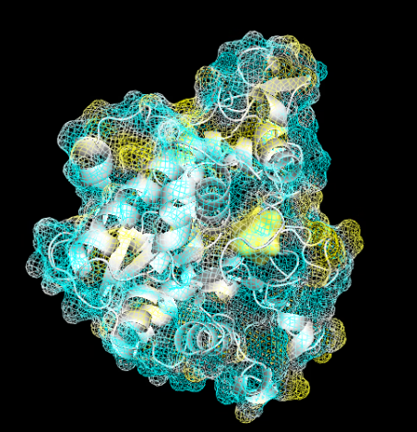
The MLP ^{[1-3]} map of CALB reveals multiple lipophilic regions distributed throughout the enzyme surface (Figure 6B). In agreement with the previous lipase systems, many lipophilic and hydrophilic patches are observed in the vicinity of the active site. Upon docking (Figure 6C), the PMMA dimer is positioned within this lipophilic environment, with its hydrophobic backbone overlapping the enzyme's lipophilic surface. This spatial correspondence suggests a favorable degree of lipophilic complementarity between CALB and PMMA and supports the proposed binding mode.
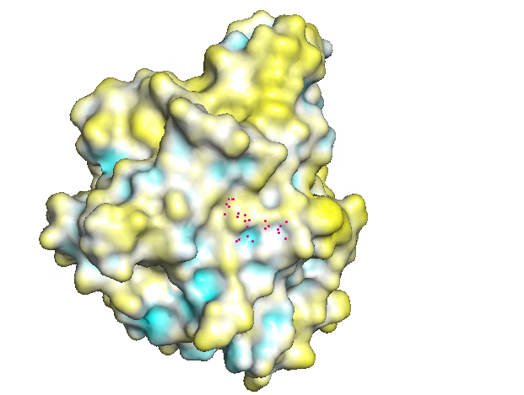
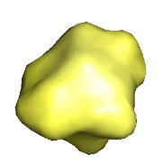

A
B
C
Figure 6. MLP surfaces of the CALB/PMMA system. (A) MLP surface of the PMMA dimer, with lipophilic and hydrophilic regions shown in yellow and cyan, respectively. (B) MLP surface of CALB, highlighting lipophilic and hydrophilic surface patches in yellow and cyan, respectively, binding pocket depicted with dots. (C) Docked CALB/PMMA complex illustrating the qualitative complementarity of the interacting surfaces. Lipophilic regions of the PMMA dimer (isosurface) align with lipophilic patches on the enzyme surface (mesh), while hydrophilic regions correspond to hydrophilic areas. This complementary distribution supports favorable enzyme-substrate interactions. The enzyme surface is displayed as a mesh on a black background to enhance visual contrast.

The electrostatic maps of the CALB/PMMA system reveal a complementary distribution of charged regions at the enzyme-substrate interface. PMMA (Figure 7A) exhibits localized positive and negative electrostatic potentials associated with its ester groups, while CALB (Figure 7B) presents a heterogeneous surface composed of both positively charged (blue) and negatively charged (red) patches. In the docked complex (Figure 7C) the polymer is buried in a region containing both electrostatic environments, placing its negatively polarized ester moieties near positively charged areas of the enzyme. This arrangement suggests favorable electrostatic interactions that may contribute to substrate binding and stabilization within the active-site region.
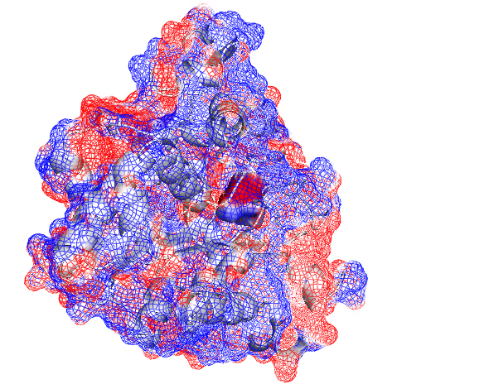
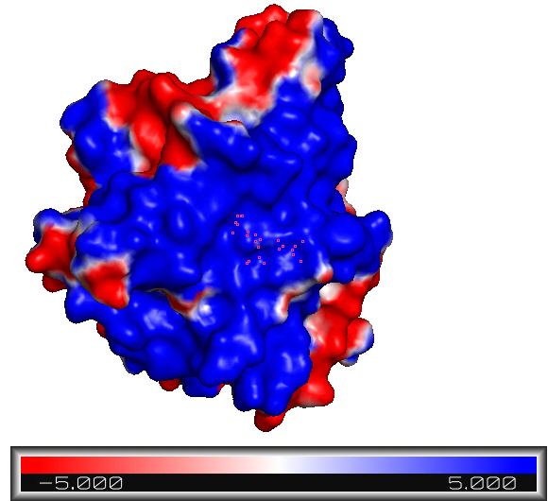
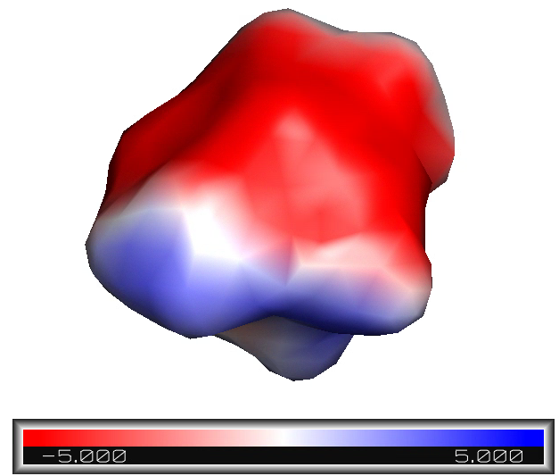

A
B
C
Figure 7. MEP surfaces of the CALB/PMMA system. (A) Electrostatic surface of the PMMA dimer, where regions of negative electrostatic potential associated with the ester oxygen atoms are shown in red while the polymer backbone exhibits neutral to positive potential and is shown in blue. (B) Electrostatic surface of CALB, highlighting negatively charged regions in red and positively charged regions in blue around the binding pocket (indicated by dots). (C) Docked CALB/PMMA complex showing the orientation of the polymer (isosurface) within the enzyme (mesh) binding site and the distribution of complementary electrostatic features at the interaction interface, suggesting favorable enzyme-substrate recognition.
.

Discussion
The results obtained for RM-Lipase, HL-Lipase and CALB demonstrate that MLP ^{[1-3]} and MEP are effective tools for the visualization and qualitative analysis of molecular surface properties. MLP ^{[1-3]} successfully identified lipophilic and hydrophilic regions on both the enzymes and the PMMA dimer, allowing the rapid assessment of hydrophobic complementarity at the enzyme-substrate interface. Likewise, MEP generated clear electrostatic maps that highlighted positively and negatively charged surface regions relevant to molecular recognition.

In all three systems, the combination of lipophilicity and electrostatic analyses revealed complementary surface features consistent with the proposed docking poses. Lipophilic patches on the enzyme surfaces were found in close proximity to the hydrophobic methyl-rich regions of PMMA, while polar and charged residues surrounding the binding region displayed favorable interactions with the ester moieties of the polymer. These observations suggest that both hydrophobic and electrostatic contributions participate in enzyme-polymer recognition.

The observed interaction patterns agree with experimental evidence reported for lipase immobilization on hydrophobic methacrylate-based materials. CALB has been successfully immobilized on PMMA nanoparticles, while commercial biocatalysts such as Novozym 435® exploit the strong affinity of lipases for methacrylate-derived supports. Similar immobilization strategies have also been reported for RM-Lipase and HL-Lipase on hydrophobic carriers such as Sepabeads®, where adsorption is largely driven by interfacial activation and hydrophobic interactions. ^{[8, 9, 14]}

Therefore, the surface complementarity identified by MLP and MEP is consistent with the current understanding of lipase-support interactions. The extensive lipophilic regions highlighted by MLP provide a structural rationale for the favorable association of these enzymes with hydrophobic methacrylate materials, whereas MEP reveals additional electrostatic features that may further contribute to molecular recognition. Together, these results demonstrate that MLP and MEP constitute valuable tools for the qualitative characterization of enzyme-polymer interfaces and for the investigation of molecular interactions relevant to biocatalysis and enzyme immobilization.

References

[1] Laguerre, M., Saux, M., Dubost, J. P., & Carpy, A. (1997). MLPP: a program for the calculation of molecular lipophilicity potential in proteins. Pharmacy and Pharmacology Communications, 3(5‐6), 217-222.
[2] Broto, P., Moreau, G., & Vandycke, C. (1984). Molecular structures: perception, autocorrelation descriptor and sar studies: system of atomic contributions for the calculation of the n-octanol/water partition coefficients. European journal of medicinal chemistry, 19(1), 71-78.
[3] Ghose, A. K., Viswanadhan, V. N., & Wendoloski, J. J. (1998). Prediction of hydrophobic (lipophilic) properties of small organic molecules using fragmental methods: an analysis of ALOGP and CLOGP methods. The Journal of Physical Chemistry A, 102(21), 3762-3772.
[4] Young, T., Abel, R., Kim, B., Berne, B. J., & Friesner, R. A. (2007). Motifs for molecular recognition exploiting hydrophobic enclosure in protein–ligand binding. Proceedings of the National Academy of Sciences, 104(3), 808-813.
[5] Derewenda, U., Brzozowski, A. M., Lawson, D. M., & Derewenda, Z. S. (1992). Catalysis at the interface: the anatomy of a conformational change in a triglyceride lipase. Biochemistry, 31(5), 1532-1541.
[6] Derewenda, U., Swenson, L., Wei, Y. U. N. Y. I., Green, R., Kobos, P. M., Joerger, R., ... & Derewenda, Z. S. (1994). Conformational lability of lipases observed in the absence of an oil-water interface: crystallographic studies of enzymes from the fungi Humicola lanuginosa and Rhizopus delemar. Journal of lipid research, 35(3), 524-534.
[7] Uppenberg, J., Oehrner, N., Norin, M., Hult, K., Kleywegt, G. J., Patkar, S., ... & Jones, T. A. (1995). Crystallographic and molecular-modeling studies of lipase B from Candida antarctica reveal a stereospecificity pocket for secondary alcohols. Biochemistry, 34(51), 16838-16851.
[8] Petkar, M., Lali, A., Caimi, P., & Daminati, M. (2006). Immobilization of lipases for non-aqueous synthesis. Journal of Molecular Catalysis B: Enzymatic, 39(1-4), 83-90.
[9] Cantone, S., Ferrario, V., Corici, L., Ebert, C., Fattor, D., Spizzo, P., & Gardossi, L. (2013). Efficient immobilisation of industrial biocatalysts: criteria and constraints for the selection of organic polymeric carriers and immobilisation methods. Chemical Society Reviews, 42(15), 6262-6276.
[10] Morris, G. M., Huey, R., Lindstrom, W., Sanner, M. F., Belew, R. K., Goodsell, D. S., & Olson, A. J. (2009). AutoDock4 and AutoDockTools4: Automated docking with selective receptor flexibility. Journal of computational chemistry, 30(16), 2785-2791.
[11] DeLano, W. L. (2002). Pymol: An open-source molecular graphics tool. CCP4 Newsl. protein crystallogr, 40(1), 82-92.
[12] Hanwell, M. D., Curtis, D. E., Lonie, D. C., Vandermeersch, T., Zurek, E., & Hutchison, G. R. (2012). Avogadro: an advanced semantic chemical editor, visualization, and analysis platform. Journal of cheminformatics, 4(1), 17.
[13] Melia, T. P. (1962). Part VIII-Methylmethacrylate and polymethylmethacrylate. Polymer, 3, 317-319.
[14] Valério, A., Nicoletti, G., Cipolatti, E. P., Ninow, J. L., Araújo, P. H., Sayer, C., & de Oliveira, D. (2015). Kinetic study of Candida antarctica lipase B immobilization using poly (methyl methacrylate) nanoparticles obtained by miniemulsion polymerization as support. Applied biochemistry and biotechnology, 175(6), 2961-2971.

