Occlusion-Adaptive Temporal Memory: A Camera-Only Framework for
Track Continuity Under Visual Occlusion in Autonomous Driving

Noor Basfar

Under the direction of: Tanveer Hussain
Assisted by: Ahmed Bahaj
[KAUST Division Name]

King Abdullah University of Science and Technology
Saudi Research Science Institute 2026
Aug 9, 2026

Abstract
Camera-based perception for autonomous driving relies almost entirely on single-frame object detectors, which have no inherent mechanism for distinguishing a temporarily occluded object from one that has genuinely left the scene. This work presents Occlusion-Adaptive Temporal Memory (OATM), a causal, camera-only tracking method that extends ByteTrack's two-stage, confidence-aware association with explicit target-occluder relational reasoning: when a mature track goes unmatched, OATM evaluates whether a currently visible object plausibly explains the disappearance, stores the target in an occluder-centric coordinate frame, checks that memory against the target's own independent motion prediction, predicts when the occlusion should end, and restricts identity reconnection to a bounded, relation-aware association stage. In a final scene-disjoint evaluation on ten nuScenes-mini scenes, with five used only to fix lifecycle thresholds and five held out for validation, every method was scored on identical frozen detections over 1,873 projected car and pedestrian annotations at IoU 0.30. OATM reached 84.1% precision, 40.4% F1, 18.4% MOTA, and 30.3% IDF1, with 59 identity switches, 28 fragmentations, and 20.055 px mean center error, versus 73.4% precision, 40.1% F1, 14.2% MOTA, and 29.6% IDF1 for a five-frame ByteTrack buffer, and 55.3% precision, 37.7% F1, 1.1% MOTA, and 27.4% IDF1 for a twelve-frame buffer. OATM also produced the most reliable hidden-state predictions (39.4% predicted-hidden precision versus 25.0% and 14.0%) and the fewest unsupported keyframe tracks (7.8% versus 25.9% and 22.1%), evidence of selective relational persistence rather than an indiscriminately longer wait. These results support a stronger balanced accuracy-identity-persistence tradeoff than either tested ByteTrack buffer, though OATM's overall recall (26.6%) and its recall in the most-occluded visibility bin (8.3%) remained slightly below both baselines, and the evaluation is a ten-scene nuScenes-mini study rather than a full benchmark.
1. Introduction
Robust object tracking under occlusion remains a fundamental challenge for camera-based perception in autonomous driving. Single-frame detectors estimate location and class independently for each image and have no mechanism for reasoning about continuity across time, so a temporarily occluded object and one that has genuinely left the scene both manifest identically as an absence of detection. On reappearance, the object is typically registered as a new, unrelated detection, severing identity continuity, a real cost for downstream planning and control, which depend on continuous position estimates of nearby road users. Occlusion is not a rare failure mode: in the nuScenes dataset [1], nearly 40% of annotated object instances exhibit less than 80% visibility at some point in their track.
Tracking-by-detection methods associate per-frame detections into tracks using a motion model, typically a Kalman filter under a constant-velocity assumption, combined with an intersection-over-union (IoU)-based assignment solved via the Hungarian algorithm [2]. Subsequent work extends association to incorporate low-confidence detections that would otherwise be discarded [3], and separate lines of research aggregate visual features temporally [4] or maintain longer-horizon memory of tracked objects [5, 6, 7, 8], reviewed in Section 2. Existing methods, however, generally treat occlusion as an implicit byproduct of detector failure or a fixed confidence threshold rather than a distinct state requiring explicit classification, and none jointly provides a memory of the hidden target explicitly protected against contamination by the occluder, a termination rule tied to a predicted end of occlusion, and a reconnection stage guarded against identity hijacking by nearby same-class objects.
Without an explicit, causally reasoned notion of occlusion, a tracker cannot decide whether to keep predicting a hidden object's position, terminate it as lost, or protect its remembered state from being silently overwritten by whatever is occluding it. To address this gap, we propose Occlusion-Adaptive Temporal Memory (OATM), a causal, camera-only tracking method built on the same two-stage, confidence-aware association and constant-velocity motion prediction as ByteTrack [3], extended with three components. First, when a mature track goes unmatched, an explicit target-occluder relation forms only if a currently visible object plausibly explains the disappearance, moving through a defined lifecycle (forming, active, clearing, resolved, or failed) rather than being treated as an undifferentiated association failure. Second, the hidden target is stored in a coordinate frame centered on its occluder and accepted only while it agrees with the target's own independently predicted position, so an inconsistent or drifting relation is rejected rather than followed. Third, OATM predicts the expected moment the occlusion should end and couples this to a bounded reappearance stage and a priority-ordered termination rule, so a track is retired for exactly one traceable reason rather than a fixed frame-count timer. Sections 3 and 4 describe this method and its evaluation in full.
2. Related Works
Recent progress in multi-object tracking has been driven substantially by improvements in object detection. Modern detectors, including the YOLO family [9], estimate bounding boxes and class labels independently for each frame; this per-frame independence is exactly what prevents a detector with no access to prior frames from distinguishing a temporarily occluded object from one that is genuinely absent, and the tracking literature has largely developed to compensate for this rather than to remove it.
The dominant paradigm, tracking-by-detection, treats detections as a fixed observation stream and associates them into coherent identities separately. SORT [2] does so with a Kalman filter under a constant-velocity assumption and an IoU cost matrix solved by the Hungarian algorithm, but associates only detections above a fixed confidence threshold; a detection below it, whether from occlusion, blur, or scale, is discarded and becomes indistinguishable from a genuine absence of evidence. ByteTrack [3] addresses this with a two-stage procedure: high-confidence detections matched first, then a second round against low-confidence detections, never allowing an unmatched low-confidence detection to start a new track. This recovers weak visual evidence, but once a detection is entirely absent, ByteTrack has no mechanism beyond generic motion extrapolation until its track buffer expires.
A related line of work addresses degraded detection quality at the feature level. Flow-guided feature aggregation [4] aligns convolutional features across neighboring frames using estimated optical flow, improving consistency for objects still partially visible nearby, an assumption that fails under multi-frame full occlusion. MeMOT [5] and MeMOTR [6] use transformer-based memory to retain object representations across longer sequences than a Kalman filter alone tolerates. PermaTrack [7] trains an explicit object-permanence objective, predicting continued existence through full occlusion rather than relying on motion extrapolation. Mask-guided spatio-temporal feature aggregation [8] restricts temporal aggregation using segmentation masks, reducing the risk that an occluding object contaminates the representation of the target it hides.
Occlusion may also be addressed with sensing unavailable to a single camera: LiDAR and radar can, depending on occluder geometry, provide evidence invisible to the camera [10], and cooperative perception shares observations across vehicles or infrastructure to cover a single vehicle's blind spots [11]. These directions are complementary to the present work, which stays camera-only to characterize what temporal reasoning alone can recover.
Across this body of work, three limitations recur: occlusion is handled as an incidental consequence of a detection or association failure rather than an explicitly classified perceptual state; temporal memory of a hidden target, where retained at all, is not explicitly protected against contamination or hijacking by the object doing the occluding, often of the same class; and no reviewed method couples memory retention to a predicted end of occlusion together with a principled, bounded reconnection rule, relying instead on a fixed frame-count threshold, an implicit confidence cutoff, or a learned model's opaque memory. OATM addresses these three limitations directly, as described in Section 3.
3. Methodology
3.1 Dataset and Detection
All experiments use the publicly released mini subset of nuScenes [1], restricted to the forward-facing camera channel (CAM_FRONT) only, so the study isolates what temporal reasoning alone can recover from a single monocular stream. The mini subset comprises 10 scenes and 2,342 total CAM_FRONT frames, of which 404 are human-annotated keyframes (2 Hz); the remainder are unannotated "sweep" frames. Ground truth is constructed independently of the tracking pipeline: nuScenes' 3D bounding-box annotations for the car and pedestrian categories are projected into the CAM_FRONT image plane using recorded ego-vehicle pose and camera calibration, yielding 3,492 in-scope projected car and pedestrian annotations across all 404 keyframes. The ten scenes are split whole, never at the frame level, into five development scenes, used only to fix lifecycle thresholds, and five held-out validation scenes, whose 1,873 annotations are the sole basis for every comparison reported in Section 4. Projected annotations, visibility labels, calibration, LiDAR/radar information, and recorded ego pose are used exclusively to prepare and evaluate events offline; none is ever an input to the online tracker.
A single pretrained, lightweight YOLO detector [9] is run once, in prediction-only mode at a confidence floor of 0.05, over every frame in all 10 scenes on CPU, producing 49,436 fresh detections in 860.4 seconds. Detections are cached so every compared tracking method receives an identical, frozen detection stream; only the car and pedestrian categories are used downstream.
3.2 OATM: Occlusion-Adaptive Temporal Memory
OATM retains ByteTrack's two association rounds unchanged: high-confidence detections matched to predicted tracks, then remaining tracks given one further opportunity against low-confidence detections, and activates its own reasoning only once these ordinary rounds fail to observe a mature target. At that point OATM asks a question ByteTrack itself does not ask: is this disappearance actually explained by a visible occluder, and when should that explanation stop being trusted?
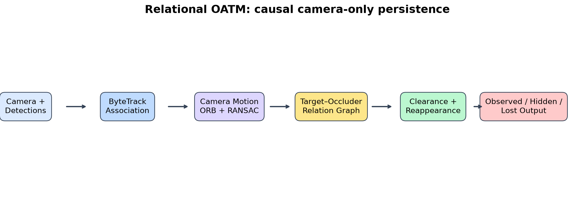
Figure 1. OATM extends ByteTrack with an occlusion-conditioned branch. Observed detections follow ordinary association; only a mature, unmatched target enters target-occluder reasoning and temporal memory.
3.2.1 Occlusion Candidate Scoring and Relational Lifecycle
For an unmatched, mature target, OATM scores every other visible object as a candidate occluder using target-relative coverage, occluder-to-target scale ratio, a depth-order cue from each box's lower image boundary, trajectory agreement, and track maturity; this weighted score is a deterministic engineering signal, not a calibrated probability. A supported target forms exactly one primary relation with its highest-scoring occluder, moving through a defined lifecycle: FORMING, when a visible occluder first explains the disappearance; ACTIVE, while the relation stays geometrically consistent (Section 3.2.2); CLEARING, once separation is predicted or support becomes inconsistent; RESOLVED, when a valid detection reconnects the original identity; and FAILED, when persistence ends without recovery. The primary occluder cannot switch mid-episode, so a different nearby object can never silently take over ownership of the target.
3.2.2 Occluder-Centric Geometric Memory
Rather than remembering a hidden target's last appearance, OATM remembers its position relative to its occluder. At relation formation, the target box is encoded as a normalized center offset and scale relative to the occluder box; on later frames, the current occluder's box decodes an implied target position from this stored relation. This decoded position is accepted only when it agrees with the target's own, entirely independent causal Kalman prediction, within a bounded center residual and scale ratio. If the two disagree, OATM does not follow the occluder-relative anchor; it keeps the independent prediction and moves the relation to CLEARING. This is what protects the hidden target's memory from being silently overwritten by whatever is occluding it: an inconsistent or drifting relation is rejected rather than trusted.
3.2.3 Expected Clearance, Termination, and Protected Reappearance
While a relation is active, OATM propagates both boxes over a bounded horizon and identifies the first frame at which target-relative coverage falls below a low threshold, the expected clearance time, after which the target receives a short, fixed reappearance grace window rather than indefinite persistence. A mature target that never forms an occlusion relation at all is not dropped immediately either: after its ordinary one-frame output grace expires, it may hold its identity for one further silent frame, emitting no box at all, and reconnects only through a separate, higher-threshold check; failing that check ends the identity. A hidden target is terminated the first time any one condition holds: outward motion toward an image boundary with less than 60% of the predicted box still visible, an immature track, no occlusion relation beyond the ordinary one-frame grace and its single silent frame, expected clearance passing without reappearance, hidden duration exceeding twelve frames, or localization uncertainty exceeding a configured bound. Persistence is therefore always tied to one specific, traceable reason.
A relationally hidden target is excluded from ByteTrack's own association rounds; reconnection instead uses a separate, stricter, one-to-one stage scoring remaining detections on class agreement, distance to the independently predicted box, scale agreement, and consistency with the expected clearance time, accepting a match only above a fixed threshold and within a hard-capped search radius. An active occluder blocks reconnection unless the relation has already entered CLEARING. This prevents a nearby same-class object from hijacking the target's identity, and prevents a distant, unrelated weak detection from being accepted merely because the ordinary buffer has not yet expired.
A camera-motion compensation branch (background feature tracking and robust translation estimation) was implemented and evaluated as an ablation but is disabled in the promoted configuration and was not used for the final reported experiment, because it reduced error on a controlled panning scenario while producing severe drift on longer natural sequences once combined with the image-space velocity already modeled by the target's own Kalman filter.
3.3 Evaluation Protocol and Metrics
OATM is compared against ByteTrack itself at two track-buffer lengths, using identical cached detections and identical association thresholds, so OATM's relational reasoning is the single controlled variable. ByteTrack-5 uses a five-frame buffer, matching this project's earlier baselines; ByteTrack-12 uses a twelve-frame buffer matching OATM's own maximum hidden-duration ceiling, so any OATM advantage cannot be attributed to a longer generic wait than its baseline is given.
The final comparison uses all ten nuScenes-mini scenes, split whole into five development scenes, used only to fix lifecycle and consistency thresholds, and five held-out validation scenes, used only for the reported comparison in Section 4. Tracker output and official 3D annotations are matched after tracking finishes, offline, using class-aware one-to-one Hungarian matching at an IoU of 0.30, with IoU 0.10 and 0.50 checked as sensitivity gates; the 1,873 validation-scene annotations are the sole basis for every reported number.
nuScenes visibility tokens (four coarse bins from roughly 0-40% to 80-100% annotated-visible fraction) and LiDAR/radar point counts accompany each official annotation and are used only offline, as sensitivity strata for stratifying recall by occlusion severity and sensor support, never as an online occlusion signal and never to remove hard examples from the reported denominator. A zero-LiDAR-point annotation is not treated as occluded, since an object can register zero points from distance or sparse sampling alone; it is retained in the headline population like every other annotation. This coarse, image-level label is not an exact per-pixel occlusion mask, so precise occlusion start, end, and duration still require manual CAM_FRONT review.
Reported metrics are precision, recall, and F1 against the matched annotations; MOTA and IDF1 as standard tracking-accuracy and identity-consistency scores; identity switches and fragmentation counts; mean center error between matched predicted and annotated box centers; predicted-hidden precision, the fraction of temporally predicted, currently-invisible outputs that match a real annotation; and an unsupported-keyframe-track rate, a sparse-label proxy for ghost persistence measuring how often a tracker output at an annotated keyframe corresponds to no official annotation at all. Every threshold used in Section 4 was fixed on the five development scenes before the five validation scenes were scored, and the run carries a single identifier (lidar-fixes-20260805) so every reported number is traceable to its source.
4. Results and Discussion
Earlier development-phase synthetic and natural-pilot studies, illustrated in Figures 2 and 3, validated the relational mechanism and its localization safeguards before final thresholds were fixed on the five development scenes; per the evaluation protocol in Section 3.3, only the final scene-disjoint run (lidar-fixes-20260805) is reported numerically below.
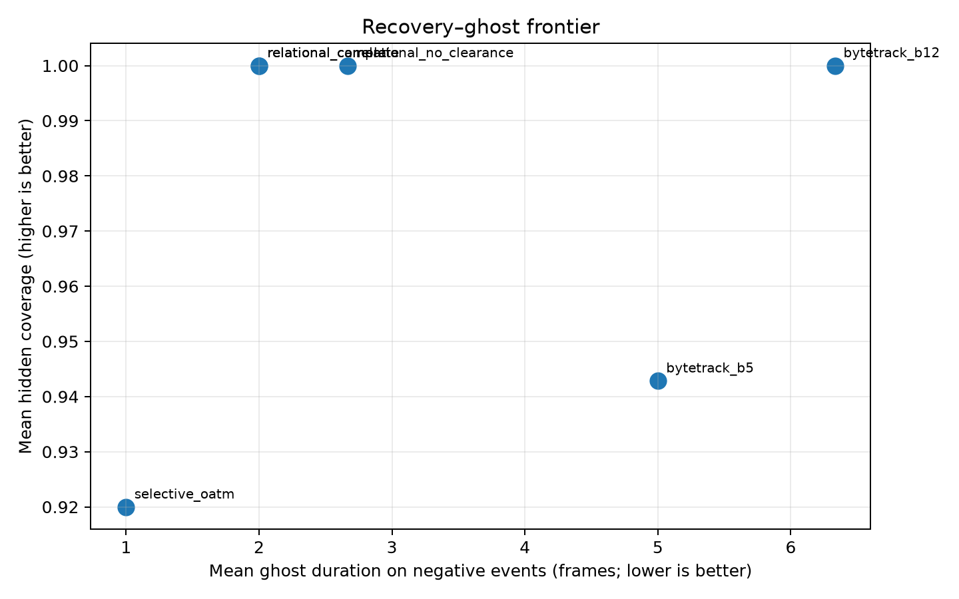
Figure 2. Recovery versus negative ghost persistence on the eight development-phase stress scenarios. OATM matches ByteTrack-12's recovery using less than one-third of its mean ghost duration.
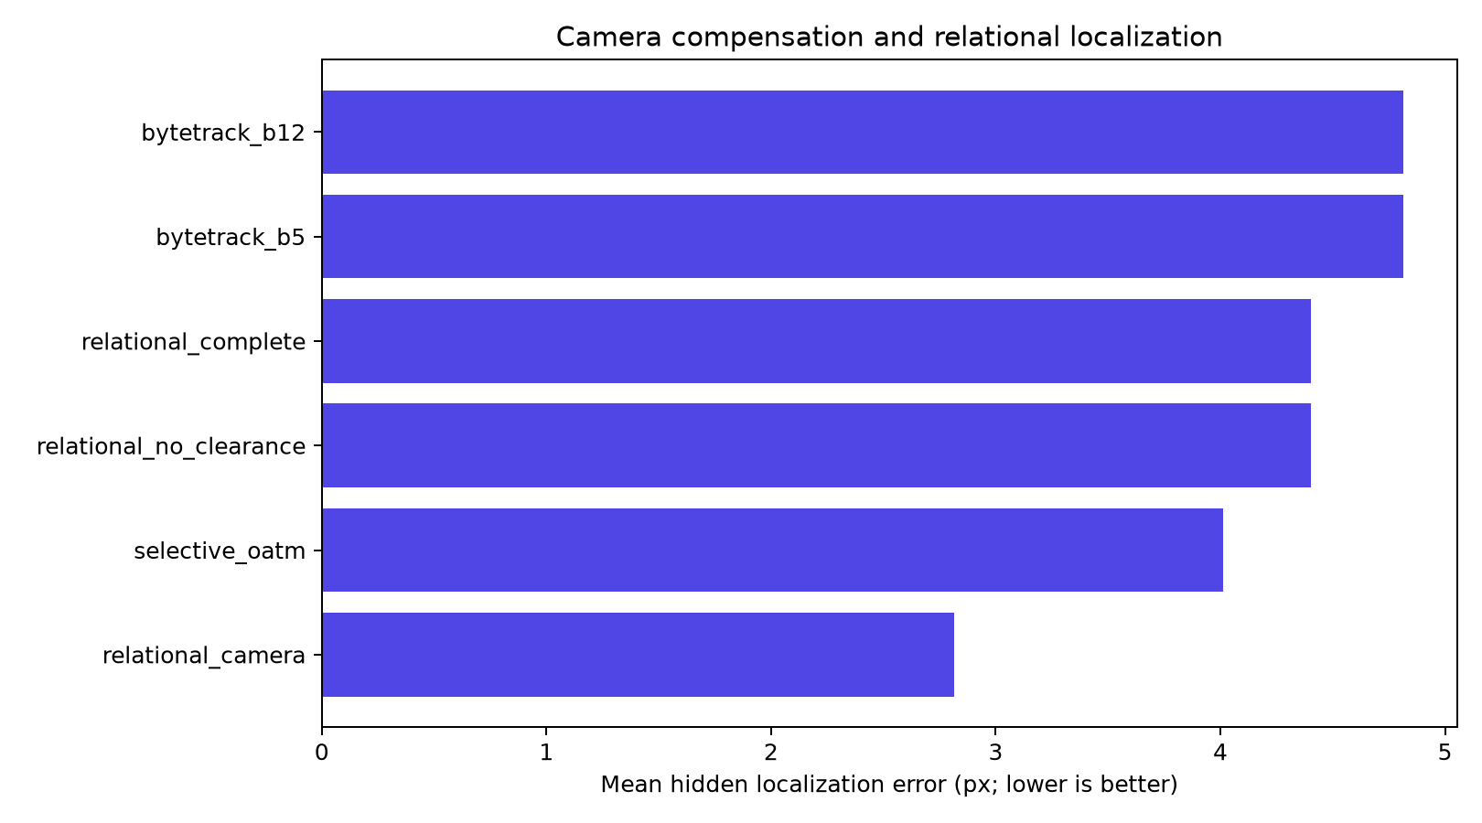
Figure 3. Mean hidden-box center error in the development-phase synthetic mechanism study. All methods use identical detections and target trajectories.
4.1 Final Scene-Disjoint Evaluation
On the five held-out validation scenes (1,873 annotations, IoU 0.30), OATM reached 84.1% precision, 40.4% F1, 18.4% MOTA, and 30.3% IDF1, with 59 identity switches, 28 fragmentations, and 20.055 px mean center error. ByteTrack-5 reached 73.4% precision, 40.1% F1, 14.2% MOTA, and 29.6% IDF1, with 64 identity switches, 33 fragmentations, and 21.084 px error. ByteTrack-12 reached 55.3% precision, 37.7% F1, 1.1% MOTA, and 27.4% IDF1, with 82 identity switches, 33 fragmentations, and 21.361 px error.
OATM also reached 39.4% predicted-hidden precision and a 7.8% unsupported-keyframe-track rate, versus 25.0% and 25.9% for ByteTrack-5 and 14.0% and 22.1% for ByteTrack-12; in absolute counts, OATM produced only 40 false predicted-hidden matches against 150 for ByteTrack-5 and 393 for ByteTrack-12.
OATM led both baselines on every metric above except recall. F1, MOTA, and IDF1 together indicate the strongest balanced detection-and-identity result; the fewest identity switches and fragmentations indicate the most stable identity assignment; the lowest center error indicates the best localization; and the combination of the highest predicted-hidden precision with the lowest unsupported-track rate indicates that OATM's persistence is selective rather than merely longer. ByteTrack-12's own numbers make the contrast explicit: giving it OATM's own maximum hidden duration did not translate into a better balanced result, since its identity switches, fragmentations, precision, and unsupported-track rate were all worse than OATM's, and its MOTA fell even below the shorter ByteTrack-5 buffer's. A longer generic wait is not, by itself, evidence toward the tradeoff OATM targets.
4.2 Limitations
This result does not extend to every axis. OATM's overall recall was 26.6%, slightly below ByteTrack-5's 27.6% and ByteTrack-12's 28.6%, and in the most-occluded visibility bin (annotated visible fraction under 40%) OATM's recall fell to 8.3%, versus 9.3% and 10.7% for the two baselines, the clearest remaining target for the relation-formation mechanism specifically. The evaluation itself is a ten-scene nuScenes-mini study with 1,873 validation annotations, not a full-nuScenes benchmark or a statistically powered universal comparison, and its occlusion evidence is the coarse visibility label described in Section 3.3, not an exact per-camera pixel mask or a verified occlusion start and end time; the unsupported-track rate is likewise a sparse-label proxy rather than a directly verified ghost duration. All three methods share the same frozen detector, so objects too small, distant, or heavily obscured to produce any usable detection are outside what association (relational or otherwise) can recover.
Taken together, these results support a specific, bounded set of claims. OATM is causal and camera-only at inference time; it distinguishes current detections from temporal predictions in every saved output; it achieved the strongest F1, MOTA, IDF1, identity-switch count, fragmentation count, localization error, predicted-hidden precision, and unsupported-track rate among the three evaluated methods on the final validation split. They do not support broader claims: OATM does not lead in recall, either overall or in the most-occluded bin; the occlusion-candidate score is a deterministic engineering signal, not a calibrated probability; and no result here reproduces a published MOT17, MOT20, or full nuScenes benchmark number, since this ten-scene mini comparison is specific to this project.
5. Conclusions
This work presented OATM, a causal, camera-only tracking method that extends ByteTrack with explicit target-occluder relational reasoning: occlusion-candidate scoring and lifecycle, occluder-centric geometric memory checked against independent motion prediction, expected-clearance termination with a single silent, high-threshold identity frame for a mature miss that never forms a relation, and protected reappearance association. In a final scene-disjoint evaluation on ten nuScenes-mini scenes, five held out for validation, OATM reached the strongest precision, F1, MOTA, IDF1, identity-switch count, fragmentation count, localization error, predicted-hidden precision, and unsupported-track rate among the tested methods, using identical frozen detections and identical association thresholds throughout.
Three conclusions follow. First, conditioning persistence on an explicit, causally scored occlusion relation, rather than an undifferentiated miss or a fixed buffer, is implementable from camera signals alone and produces a measurably stronger balanced accuracy-identity-persistence tradeoff than either tested ByteTrack buffer on this evaluation. Second, that advantage is not simply a longer wait: ByteTrack-12 was given OATM's own maximum hidden duration and still trailed OATM on identity, localization, and false-persistence measures, and trailed even the shorter ByteTrack-5 buffer on MOTA. Selectivity, not duration, is what the relational mechanism contributes. Third, the result is bounded rather than universal: OATM's overall and most-occluded-bin recall remained slightly below both baselines, and the ten-scene, 1,873-annotation evaluation is a reproducible nuScenes-mini study, not a claim of universal ByteTrack superiority or a reproduced published benchmark.
The clearest next step is closing the recall gap in the most-occluded visibility bin, since this is where the relation-formation mechanism specifically underperforms rather than where its safeguards are too conservative. A full nuScenes evaluation, rather than the ten-scene mini subset used here, would support confidence intervals and per-class results instead of a single matched comparison. Manually verified, event-level review of individual occlusion episodes, rather than the coarse visibility-label stratification used here, would let ghost duration and occlusion timing be checked directly instead of through the sparse unsupported-track proxy. Camera-motion compensation, evaluated as an ablation but disabled in the promoted configuration, should be reconsidered only once target state and ego-motion are fused within one stabilized coordinate system.
6. Acknowledgements
The author thanks Tanveer Hussain for guidance and mentorship throughout the design, implementation, and evaluation of this project, and Ahmed Bahaj for additional support. This work was completed as part of the Saudi Research Science Institute (SRSI) 2026 program, hosted by the [KAUST Division Name] division at King Abdullah University of Science and Technology (KAUST). The author also acknowledges the Motional/nuScenes team for the public release of the nuScenes dataset used throughout this study.

References
[1] Caesar, H., Bankiti, V., Lang, A. H., Vora, S., Liong, V. E., Xu, Q., Krishnan, A., Pan, Y., Baldan, G., & Beijbom, O. (2020). nuScenes: A multimodal dataset for autonomous driving. Proceedings of the IEEE/CVF Conference on Computer Vision and Pattern Recognition (CVPR 2020), 11618-11628.
[2] Bewley, A., Ge, Z., Ott, L., Ramos, F., & Upcroft, B. (2016). Simple online and realtime tracking. 2016 IEEE International Conference on Image Processing (ICIP), 3464-3468.
[3] Zhang, Y., Sun, P., Jiang, Y., Yu, D., Weng, F., Yuan, Z., Luo, P., Liu, W., & Wang, X. (2022). ByteTrack: Multi-object tracking by associating every detection box. Proceedings of the European Conference on Computer Vision (ECCV 2022).
[4] Zhu, X., Wang, Y., Dai, J., Yuan, L., & Wei, Y. (2017). Flow-guided feature aggregation for video object detection. Proceedings of the IEEE International Conference on Computer Vision (ICCV 2017), 408-417.
[5] Cai, J., Xu, M., Li, W., Xiong, Y., Xia, W., Tu, Z., & Soatto, S. (2022). MeMOT: Multi-object tracking with memory. Proceedings of the IEEE/CVF Conference on Computer Vision and Pattern Recognition (CVPR 2022), 8080-8090.
[6] Gao, R., & Wang, L. (2023). MeMOTR: Long-term memory-augmented transformer for multi-object tracking. Proceedings of the IEEE/CVF International Conference on Computer Vision (ICCV 2023), 9901-9910.
[7] Tokmakov, P., Li, J., Burgard, W., & Gaidon, A. (2021). Learning to track with object permanence. Proceedings of the IEEE/CVF International Conference on Computer Vision (ICCV 2021).
[8] Hashmi, K. A., Sheikh, T. U., Stricker, D., & Afzal, M. Z. (2025). Beyond boxes: Mask-guided spatio-temporal feature aggregation for video object detection. IEEE/CVF Winter Conference on Applications of Computer Vision (WACV 2025).
[9] Jocher, G., Qiu, J., Liu, M., Lyu, S., Akyon, F. C., & Kalfaoglu, M. E. (2026). Ultralytics YOLO26: Unified real-time end-to-end vision models. arXiv:2606.03748.
[10] Kwon, S. K., Hyun, E., Lee, J.-H., Lee, J., & Son, S. H. (2017). Detection scheme for a partially occluded pedestrian based on occluded depth in lidar-radar sensor fusion. Optical Engineering, 56(11), 113112.
[11] Guo, A., Zhang, S., Tang, E., Gao, X., Pang, H., Tian, H., Mu, Y., Wen, W., Fang, C., & Chen, Z. (2025). When autonomous vehicle meets V2X cooperative perception: How far are we? arXiv:2509.24927.

