SUPPLEMENTAL DATA 1
EXPECTED HISTOGRAMS FOR NORMAL AND LOG-NORMAL DISTRIBUTIONS
For the reader less familiar with normal and log-normal distributions, typical histograms and their fitted ideal distribution have been generated with Minitab. One hundred (100) data points following a normal distribution with a mean of 0 and a standard deviation of 1 were randomly generated. A histogram with a fitted normal curve was then generated. A similar process was performed for log-normal data with a location of 0, a scale of 1 and a threshold of 0.

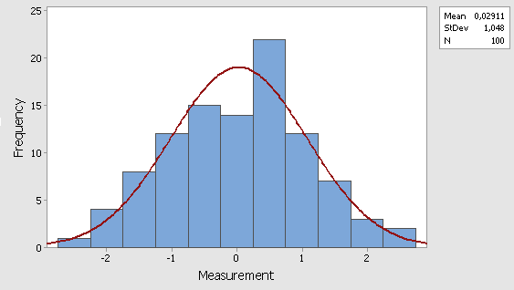
Figure 1: Histogram of 100 randomly generated measures having a normal distribution

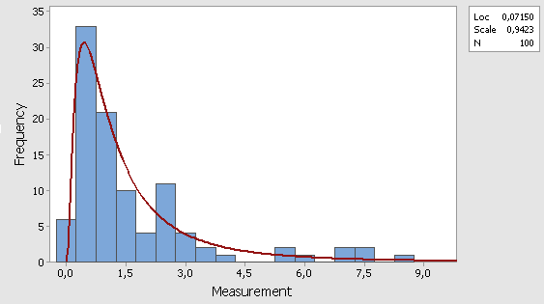
Figure 2: Histogram of 100 randomly generated measures having a log-normal distribution

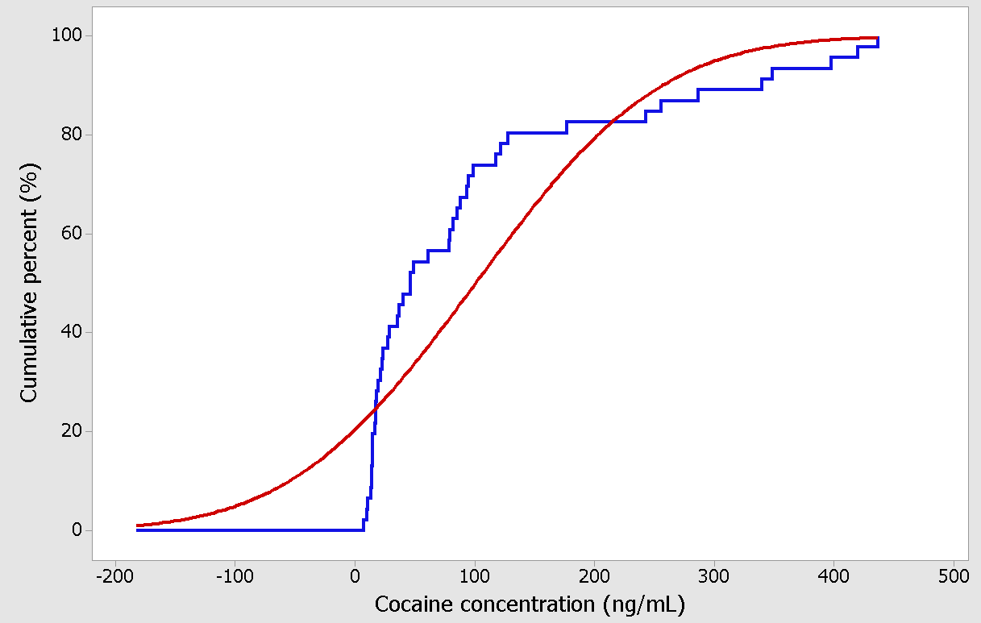 Figure 3: Theoretical (red) and empirical (blue) cumulative distribution functions used to perform the Kolmogorov-Smirnov normality test. The statistic of the test is the maximal distance between the two functions and is compared to the known distribution of the statistic.

