Hip contact force magnitude and regional loading patterns are altered in individuals with femoroacetabular impingement syndrome

# Abstract

**Background**

Individuals with femoroacetabular impingement (FAI) syndrome experience altered biomechanics during daily activities which are thought to lead to the onset of hip osteoarthritis. Acetabular damage occurs in the anterosuperior region in those with FAI syndrome, yet it remains unclear if hip contact forces are applied to this same region.

**Purpose/Hypothesis**

We sought to investigate hip contact force magnitudes and how these were applied regionally, to the articular surfaces, in those with FAI syndrome and controls during walking. We hypothesised that hip contact forces of individuals with FAI syndrome would have lower magnitude and more focussed regional loading compared with healthy controls.

**Study Design**

Controlled laboratory study.

**Methods**

Motion capture, ground reaction forces and surface electromyograms (EMG) were collected from 41 individuals with FAI syndrome and 24 pain-free controls walking at self-selected speed. Hip contact forces were predicted using an EMG-assisted neuromusculoskeletal model. Average and spread of regional loading were evaluated by projecting the hip contact force onto the femoral and acetabular articular surfaces. The hip contact forces’ magnitude and regions of loading were compared between groups using statistical parametric mapping and independent t-tests, respectively (p<.05).

**Results**

Compared with controls, participants with FAI syndrome walked with lower magnitude resultant hip contact forces (mean difference -0.7N**·**BW-1, p<.001) during the first and second half of stance with lower anteroposterior, vertical and mediolateral force vector components. Compared with controls, those with FAI syndrome had average regional loading that was more anterior (3.8°, p<.035) and lateral (2.2°, p<.01) on the acetabulum and more posterior (-4.8°, p<.01) on the femoral head, with less between-participant variation. Those with FAI syndrome had smaller spread of regional loading for both the acetabulum (-1.9 mm, p=0.049) and femur (1 mm, p<0.001) during stance, compared with controls.

**Conclusion**

In those with FAI syndrome, walking resulted in lower magnitude hip contact forces that were constrained to smaller regions, located more posteriorly on the femur and anterolaterally on the acetabulum, compared with controls.

**Clinical Relevance**

Changes in hip contact forces may alter the mechanical loading environment of the hip and initiate changes in its tissue properties and structure.

**What is known about the subject:** Those with femoroacetabular impingement syndrome walk with altered biomechanics, which may alter hip regional loading, and often suffer articular cartilage damage.

**What this study adds to existing knowledge:** Compared with controls, those with femoroacetabular impingement syndrome generate contact forces that are lower in magnitude, but with a smaller region of loading that is located more posteriorly on the femur and anteriolaterally on the acetabulum, which are closer to areas of reported damage.

**Keywords**

Femoroacetabular impingement syndrome

Hip contact forces

Regional loading

Neuromusculoskeletal modelling

Electromyography

# Introduction

Femoroacetabular impingement (FAI) syndrome is a movement-related hip condition that causes pain in healthy young adults and may antecede hip osteoarthritis (OA).22,24 Many individuals with FAI syndrome present with cam morphology; a thickening of the femoral head/neck junction adjacent to the femoral articulating surfaces.22 The cam morphology is surmised to strike the acetabulum at terminal hip range-of-motion, possibly impinging articular soft tissues and damaging the labrum and articular cartilage.22 Alternatively, altered biomechanics in individuals with FAI syndrome during daily activities1,10,18,25,33,37,46,55 may affect regional loading patterns on the articular surfaces of the hip, focussing loads towards, or away from, reported regions of damage, i.e. the anterosuperior region of the acetabulum and cam region of the femur.3,6,28,34,52,57 Such loading patterns may present a risk factor for the development of hip OA20 and are potentially modifiable through mechanobiology-inspired gait retraining.49,51 Critically, hip regional loading in FAI syndrome has received limited research focus.

During movement, hip contact forces are repeatedly applied to specific regions of the articular surfaces, driving changes to tissue biology and structure. Individuals with FAI syndrome demonstrate lower magnitudes of hip contact forces during walking and squatting compared with controls. 11,46 Further, analyses using the finite element method (FEM) have identified concentrated cartilage and subchondral stresses within the anterosuperior acetabulum in those with FAI syndrome.35,45,47 Taken together, these results suggest that regional loading patterns of the femoral and acetabular surfaces, and not just magnitude of hip contact force, may be altered in those with FAI syndrome compared with controls. Traditionally, FEM would be implemented to test similar hypotheses. However, FEM is impractical for appropriately powered studies with large sample sizes due to considerable resource demands. Neuromusculoskeletal (NMS) models present a computationally tractable alternative, but their use has so far been limited to assessing magnitude of hip contact forces,30,38,46,62 rather than regional loading patterns.

Muscles are the main contributors to the magnitude of hip contact force.12 There are infinite combinations of muscle forces to produce a given set of joint moments, making the neuromuscular system highly redundant.13 To address this redundancy, previous modelling studies in those with FAI syndrome have predicted muscle forces by employing static optimisation11,46 which tracks external joint moments while minimising the sum of muscle activation patterns.13 However, minimising activation cannot account for subject-,32 task-,8 pathology-5 and training-specific nature42 in co-ordinating muscle activations. Electromyography (EMG)-assisted modelling approaches explicitly incorporate an individual’s muscle activation patterns to determine muscle forces while also satisfying rigid-body physics53 and producing physiologically valid results.30,31 Thus, EMG-assisted NMS models are ideal for examining hip contact forces in those with FAI syndrome.

The purpose of this study was to evaluate hip regional loading during walking, using an EMG-assisted NMS model, in those with FAI syndrome and pain-free controls. We examined whether there were between-group differences in the magnitude of hip contact forces, both the resultant and vector components, as well as the regional loading patterns on both the femoral and acetabular surfaces. We hypothesised the magnitude of hip contact forces would be lower in those with FAI syndrome compared with controls. We also hypothesised that regional loading would be more concentrated in those with FAI syndrome compared with controls when expressed in femoral and pelvic coordinate systems.

# Methods

Motion capture, ground reaction forces and surface EMG, were acquired from 54 participants with FAI syndrome and 27 controls.55 Both groups were recruited over 2 years. Those with FAI syndrome were participating in the Australian FASHIoN trial (Australian Clinical Trials Registration Number: ACTRN12615001177549), for which inclusion criteria have been detailed elsewhere.44 Briefly, individuals over the age of 16 who had no evidence of hip OA (Tonnis grade < 1), previous hip injury or shape changing surgery and who had been diagnosed with FAI syndrome by an orthopaedic surgeon, were included as participants. Controls (aged 21–41 years) who had no history of lower-limb chronic pain, trauma or surgery were recruited from the local community, reflecting the age distribution of FAI syndrome participants as closely as possible. Radiological indicators for FAI syndrome were measured in all participants, as described previously.55 Prospective participants with any incomplete data and those with FAI syndrome and alpha angle <55° were excluded. Human research ethics committees approved the study and participants provided their written informed consent.

Participants with FAI syndrome and controls underwent integrated motion capture, collected as described previously.55 Participants with FAI syndrome provided a verbal rating of average hip pain during the walking trials on an 11-point numerical rating scale (0=no pain, 10=worst pain possible). Two additional trials, wherein participants were instructed to walk faster and slower than their self-selected walking speed, were also acquired for calibration of the NMS model. Surface electromyograms (EMG), recorded with either Noraxon DTS2400 wireless telemetry system (Noraxon, Arizona, USA) at 1200 Hz (FAI syndrome) or Wave Wireless (Cometa, Milan, Italy) at 1000 Hz (control) were acquired from 14 muscles from the analysed leg: gluteus maximus, gluteus medius, rectus femoris, vastus lateralis and medialis, adductor group, gracilis, semimembranosus, biceps femoris, gastrocnemius (medial and lateral), soleus, tibialis anterior and peroneus longus in accordance with the SENIAM guidelines.29 Maximal voluntary contractions were collected from a series of dynamic and static tasks.31

All motion capture data were processed with MOtoNMS.41 Marker trajectories and ground reaction forces were filtered using a second-order zero-lag low-pass Butterworth filter (6 Hz cut-off). The EMG were band-pass filtered (30–300 Hz), full-wave rectified and low-pass filtered at 6 Hz with a zero-lag Butterworth filter to produce linear envelopes.40 Linear envelopes were amplitude-normalised to maximum processed EMG value recorded across maximal effort and walking trials to produce muscle excitations. Joint centres were defined for the hip, knee and ankle using regression equations,27 average of the medial and lateral femoral condyles, and average of the medial and lateral malleoli with an inferior offset (2.7% of shank length), respectively.7

A generic anatomical model (gait239215) with 23-degrees of freedom and 34 muscle-tendon unit actuators (MTU) was linearly scaled to match participant dimensions and body segment mass and inertia36 using OpenSim v3.3.14 Following scaling, optimal fibre and tendon slack lengths were optimised to preserve the dimensionless muscle and tendon force-length operating curves for each muscle in the model.43 Maximum isometric muscle forces were estimated using the mass-height-muscle volume relationship.26 Inverse kinematics, inverse dynamics and muscle analysis were subsequently performed in OpenSim to determine generalised coordinates, joint loads (generalised forces and moments) and MTU kinematics (i.e., lengths and moment arms). These were used as inputs to estimate MTU and hip contact forces using a calibrated, EMG-assisted, NMS model in CEINMS.50

Within CEINMS, the 14 experimentally acquired muscle excitations were distributed to 34 MTU.54 An electromechanical delay of 50ms was applied based on pilot testing the effects of delay on tracking of the moments and activation. Model calibration used three walking trials performed at different self-selected speeds: fast, slow, and normal. Calibration adjusted NMS parameters to minimise both peak hip contact force and joint moment prediction errors for hip flexion/extension, hip adduction-abduction, knee flexion/extension and ankle dorsi/plantar flexion joint moments,54 consistent with previous research.31 Inclusion of minimised peak contact forces at the targeted joint in the penalty function during calibration has previously resulted in physiologically plausible hip31 and knee23 contact forces. The neuromuscular parameters adjusted during calibration and their boundary conditions are documented in Appendix Table A1.

The calibrated NMS model was then used to predict muscle and hip contact forces in remaining walking trials using an EMG-assisted approach. The EMG-assisted approach uses experimental muscle excitations to inform muscle force predictions, by synthesizing excitations for muscles without experimental EMG and minimally adjusting experimental muscle excitations to ameliorate EMG quality issues, such as poor electrode placement, cross-talk and skin impedance and to improve joint moment tracking.31,53 For each trial, weighting coefficients were tuned to optimise joint moment and EMG excitation tracking, as described, previously.53 Joint reaction analysis in OpenSim was used to calculated the hip contact forces,59 which were qualitatively compared with contact forces measured using instrumented hip prostheses.4

The magnitude and regional loading of the hip contact force were analysed. The magnitude of the hip contact force vector and its orthogonal components were first determined.46 Subsequently, regional loading was determined by analysing the path of articular loading, i.e., the position of the hip contact force vector on the surfaces of both the femur and acetabulum. To achieve this, the hip contact force vector was expressed in both the femoral and pelvic coordinate systems and projected onto a sphere representing the articular surface (Figure 1A). The radius of the sphere was determined by fitting a sphere to the femoral head of gait2392 model,15 which includes cartilage, using 3-matic v 10.0 (Materialise, Leuven, Belgium). Subsequently, the sphere was scaled to each participant’s skeletal geometry using the same femoral scale factors employed for linear scaling of the anatomical model. The path of articular loading was calculated as the position where the instantaneous hip contact force vector intersected with the sphere, in both femoral and pelvic coordinate systems (Figure 1B). Average regional loading was calculated by expressing the rotation of the instantaneous hip contact force vector relative to the anteroposterior axis as quaternions and determining the mean quaternion (Figure 1B) which was then expressed in spherical coordinates corresponding to anteroposterior and mediolateral directions of the femur and acetabulum. The spread of regional loading was calculated as the arc distance (in mm) from the path’s instantaneous position to average regional loading (Figure 1B). All data were time normalised to 100% of the gait cycle, averaged for each participant and averaged for each group.

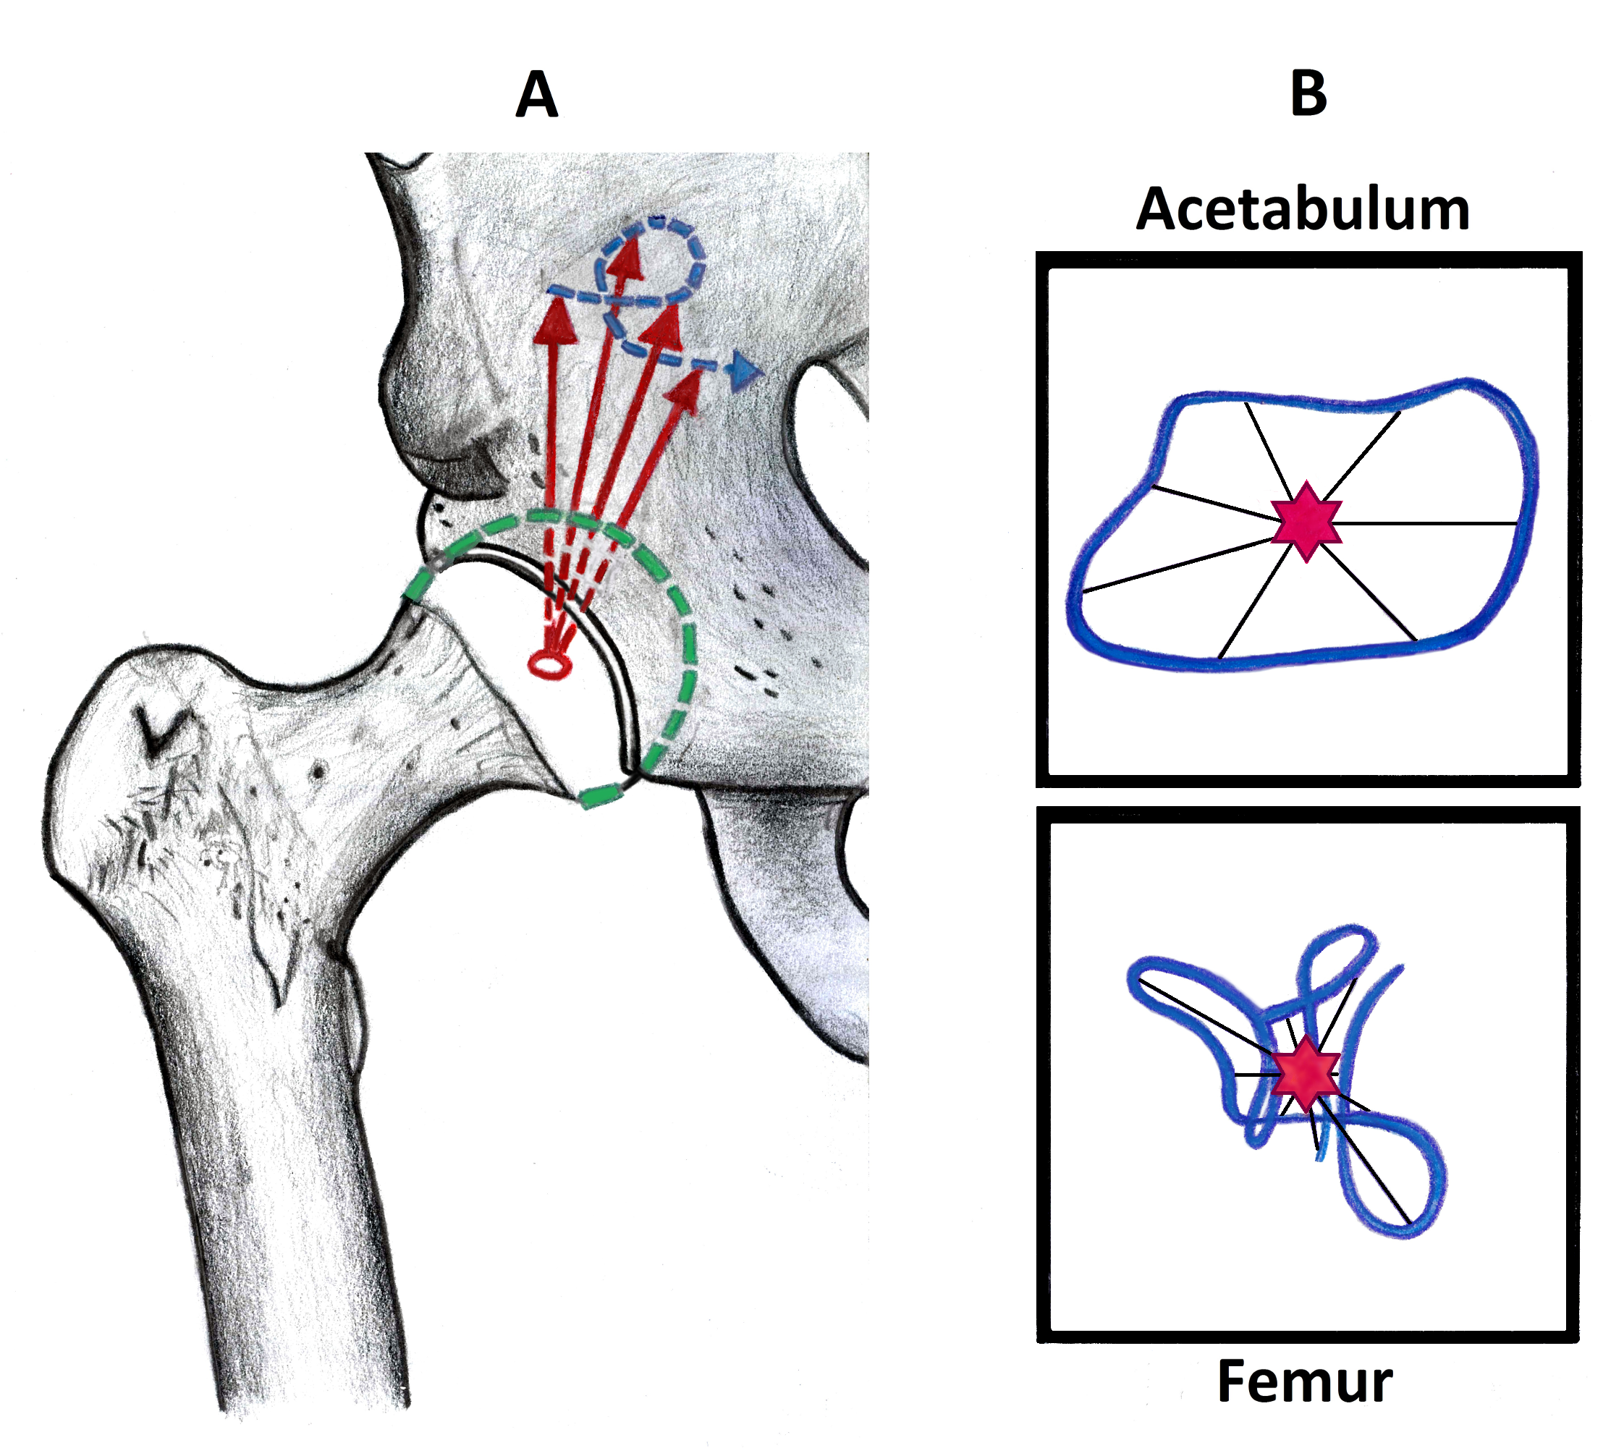

Figure 1: Calculation of regional loading. A) The contact forces expressed in the femoral or acetabular coordinate system were projected onto a sphere (shown as green dashed line) representing the articular surfaces of the hip. B) The path of articular loading on the surface of the sphere (blue line) and its average regional loading (red hexagram) were determined for the acetabulum and femoral head. The spread of regional loading was then calculated as the length of the arc from average regional loading (red hexagram) to the time-varying path of articular loading (blue line).

Participant characteristics, gait temporospatial variables and average regional loading were assessed for normality using a Kolmogorov-Smirnov test and parametric or non-parametric tests were used as required. In all cases, Statistical Package for the Social Sciences (SPSS), version 25 (IBM, New York, USA) was used (α<.05). Data are reported within-text as mean differences ±95% confidence intervals (CI). Within-group variation in average regional loading was calculated as the mean Euclidean distance (in mm) between group average regional loading and participant average regional loading, in both the anteroposterior and mediolateral directions. Between-group differences in both variation and average regional loading and were compared using independent t-tests.

The magnitude of the hip contact forces and the spread of the regional loading were compared over the gait cycle between those with FAI syndrome and controls using statistical parametric mapping (SPM).21 Both a general linear model, including walking speed and pain as covariates, and a two sample t-test, for reference, were applied using the open-source spm1d code (v0.4, [www.spm1d.org](http://www.spm1d.org)) in Matlab (Mathworks, MASS, USA).48 For this purpose, pain assessed on the numerical rating scale was dichotomised, wherein any rating greater than zero was deemed painful. Controls were assumed to have a pain rating of zero, owing to inclusion criteria. To assist interpretation of the magnitude, duration and timing of SPM differences within the gait cycle, between-group mean difference (±95%CI) over the SPM range were reported within-text and the timing of the SPM range was given according to phase during the gait cycle. For this purpose, five phases gait cycle were defined: loading (0-10% of the gait cycle); early stance (10-30%); mid-stance (30-50%); swing preparation (50-60%) and swing (60-100%).60

# Results

Eighty-one participants were available for analysis. Thirteen individuals with FAI syndrome and 3 controls were excluded due to incomplete medical imaging data or they did not meet inclusion criteria (FAI syndrome: alpha angle > 55°; controls: free of injury).55 Of the 65 participants included in the study, 41 were individuals with FAI syndrome (cam morphology only) and 24 were controls. Nine participants with FAI syndrome (22% of FAI syndrome participants) had bilateral symptoms and 6 controls (25% of control participants) had a maximum alpha angle greater than 55° (range 40.6°–74.8°) (Table 1). A complete lower limb contact force analysis was conducted and validated against available in-vivo hip and knee contact force measurements (Appendix Figure A1).

Compared with controls, those with FAI syndrome were heavier (8.27 kg, 95% CI 1.82–14.72, p<.013), had higher body mass index (1.8 kg**·**m-2, 95% CI 0.42–3.18, p<.012), and walked 12% slower (-0.18 m**·**s-1, 95% CI -0.26–-0.1, p<.001) with strides that were 11% shorter (-0.17 m, 95% CI -0.23–-0.11, p<.001) (Table 1).

When unadjusted for pain and walking speed, the magnitude of the resultant hip contact force was lower in those with FAI syndrome compared with controls (Figure 2) from loading to early stance (-0.71 N·BW-1, p<.001) and mid-stance to swing preparation (-0.65 N·BW-1, p<.001), as well as swing (-0.49 N·BW-1, p=.015). When corrected for pain and walking speed, differences with respect to hip contact forces remained for similar phases of the gait cycle (range hip: p=.015 to p=.047).

Table 1: Participant characteristics of those with FAI syndrome and controls. Unless otherwise stated, values are mean (±standard deviation).



\*Significant difference p<0.05

†Significant difference p<0.001

*a* Maximum of alpha angles measured at 30° intervals, from superior (i.e., 12 o’clock) to anterior (i.e., 3 o’clock) positions.55 Where the participant had bilateral symptoms, alpha angle is reported for the most painful hip

*b* Pain during gait testing was assessed on a numerical rating scale from 0–10 with zero representing no pain and 10 representing worst pain possible

Figure 2: Mean (±95% confidence interval) resultant and component (anteroposterior, superoinferior and mediolateral) hip contact forces in the pelvic and femoral coordinate systems in those with femoroacetabular impingement (FAI) syndrome (red) and controls (blue). Regions where significant between-group differences occurred resulted from statistical parametric mapping: i) a t-test (yellow shading); and ii) a general linear model with gait speed and dichotomous pain as covariates (pink shading); are shown. See text for levels of significance.

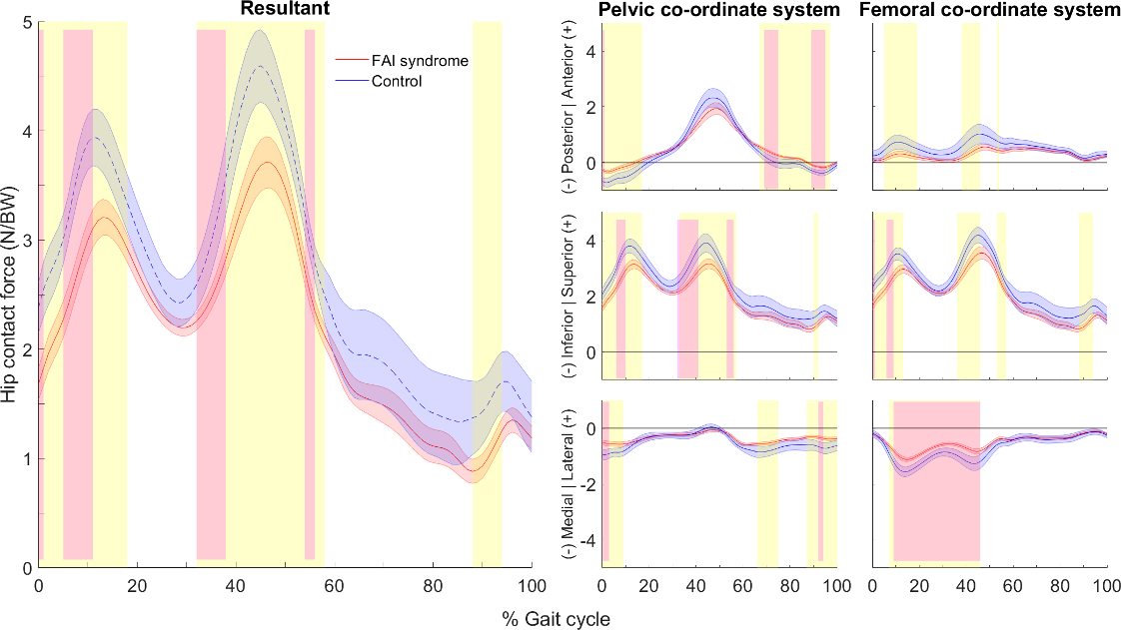

When expressed in the femoral coordinate system, participants with FAI syndrome had lower anteroposterior component of the hip contact force during loading and early stance (-0.37 N**·**BW-1, p=.002), mid-stance (-0.49 N**·**BW-1, p=.015) and pre-swing (-0.31 N**·**BW-1, p=.047) (Figures 2 and 3) compared with controls. Likewise, the vertical component of the hip contact force was lower during loading (mean difference -0.65 N**·**BW-1, p<.001), mid-stance (-0.62 N**·**BW-1, p=.002), pre-swing (-0.37 N**·**BW-1, p=.025) and swing (-0.47 N**·**BW-1, p=.013) (Figures 2 and 3), while the mediolateral component was more lateral during most of stance (mean difference 0.37 N**·**BW-1, p<.001) (Figures 3 and 4) compared with controls. When corrected for pain and walking speed, between-group differences remained for the vertical component of the hip contact force during loading (p=.032) and for mediolateral component during mid- and late-stance (p<.001) (Figure 2).

C:\Users\s5001683\Dropbox\PhD\For Trevor\Thesis\6_JointContactForces-FOR_REVIEW\Figure3_PelFem_ButterflyMontage_bigStackedSaxbyLabel.tif

Figure 3: Mean hip contact forces (N/BW) expressed in the pelvis and femoral coordinate systems for those with FAI syndrome (red) and controls (blue). Triangles and squares represent the start and end of stance phase respectively, with the solid line representing stance and the dotted line representing swing.

Examining the hip contact forces in the pelvic coordinate system, those with FAI syndrome had more anteriorly directed contact forces from loading to early stance (0.35 N**·**BW-1, p<.001) and swing (0.22 N**·**BW-1, p<.001) (Figures 2 and 3) compared with controls. Compared with controls, those with FAI syndrome had lower magnitude vertical component of the hip contact force from loading to early stance (0.61 N**·**BW-1, p<.001) and mid-stance and pre-swing (0.55 N**·**BW-1, p<.001) (Figures 2 and 3), while the mediolateral component of the hip contact force was more lateral during loading (0.34 N**·**BW-1, p=.016) and swing (0.27 N**·**BW-1, p=.012). When corrected for pain and walking speed, those with FAI syndrome still had more anteriorly directed hip contact forces during swing (p=.02), with lower vertical component during loading (p=.028) and mid-stance (p=.004) and more lateral component during late swing and loading (both p=.04) compared with controls.

Those with FAI syndrome had different regional loading patterns compared with controls. On the acetabular surface, average regional loading was located more anteriorly (3.8° ± 3.5°, p=.035) and more laterally (2.2° ± 1.7°, p=.01) in those with FAI syndrome compared with controls. Further, there was smaller between-subject variation in the anteroposterior location of average regional loading (-1.3 mm, p=.001) (Figure 4A) and a smaller spread in contact forces across mid-stance to pre-swing (-1.9 mm, p=.049), as well as during various stages of swing (Figure 4B) in those with FAI syndrome compared with controls. On the femoral head, average regional loading was located more posteriorly (mean, 4.8°; SD, ± 3.9°, p=.018) in those with FAI syndrome compared with controls and there was smaller between subject variation in anteroposterior (-1.9 mm, p<.001) and mediolateral (-0.8 mm, p<.001) average regional loading (Figure 4A). In those with FAI syndrome the spread of regional loading was smaller during mid-stance (1.0 mm, p<.001) and, briefly, during swing (1.6 mm, p<.001) compared with the controls (Figure 4B).

Figure 4: Hip regional loading in those with FAI syndrome and controls, showing: (A) Path of regional loading over the gait cycle for those with FAI syndrome (red line) and controls (blue line), group-level averages for average regional loading (hexagram) and 95% confidence intervals (red ellipse: FAI syndrome; blue ellipse: control); and (B) Average spread of regional loading, i.e. the length of the arc between average regional loading and the instantaneous position on the hip contact force vector path, expressed in the acetabular and femoral coordinate system.

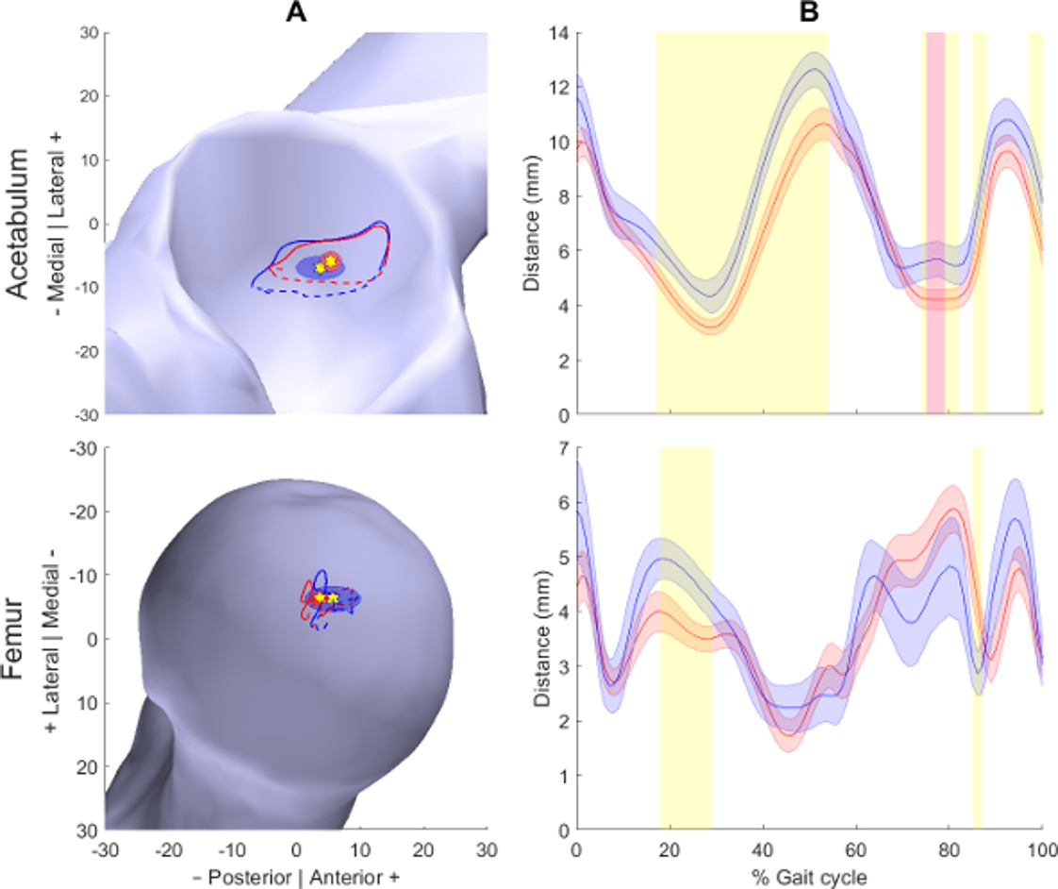

# Discussion

Previous research has used indirect measures of joint loading, such as joint moments, magnitudes of joint contact forces, EMG and range of motion have been employed to ascertain what is happening at the joint surface. This study evaluated hip regional loading during walking in those with FAI syndrome compared with controls using an EMG-assisted NMS model. Hip contact forces and regional loading were determined for both acetabular and femoral articular surfaces. We found that those with FAI syndrome walked with lower magnitude hip contact forces, compared with controls (Figures 2-3). Additionally, the hip contact force vector was concentrated in a different position (Figure 4A) and spread across a smaller region on both femoral and acetabular surfaces (Figure 4B). There was also less between-participant variation in average regional loading in those with FAI syndrome compared with controls (Figure 4A). In other words, compared with controls, those with FAI syndrome generated contact forces that were lower in magnitude and concentrated these loads to smaller femoral and acetabular regions.

Consistent with our first hypothesis, hip contact forces, both resultant and vector components, were smaller in those with FAI syndrome compared with controls during walking. This finding, consistent with previous joint contact force analyses comparing FAI syndrome with healthy controls, has two possible explanations.46 Firstly, previous research has found that smaller hip adduction angle and pelvic obliquity resulted in lower hip contact forces.62 Compared with controls, this group of individuals with FAI syndrome had less frontal plane motion of the hip, pelvis and trunk,55 which is consistent with other analyses of walking in FAI syndrome.18,33,37 Secondly, muscles make large contributions to joint contact forces12 and those with FAI syndrome have weaker muscles and altered muscle activation patterns compared with controls.9,16,17 Thus, altered muscle actions may be causing the between-group differences in direction and magnitude of hip contact forces. Importantly, consistent with previous findings regarding the external biomechanics of this group of participants,55 between-group differences in contact forces persisted even after including walking speed as a covariate. This suggests that walking speed does not fully account for the lower magnitude contact forces in those with FAI syndrome compared with controls.

The magnitude of joint contact force alone does not describe how the force is applied regionally to the articular surfaces of the hip. By projecting hip contact forces onto the articular surfaces, we found that regional loading was altered in those with FAI syndrome compared with controls. Average regional loading on the acetabular surface was more anterior (Figure 4A) and the spread of regional loading was smaller when magnitudes of anteroposterior and vertical acetabular contact forces were largest (early stance to swing preparation) in those with in FAI syndrome compared with controls (Figure 4B). Hip motions generated during walking are likely insufficient to elicit contact between the femur and acetabulum.2 However, biomechanical analyses have consistently reported altered movement patterns during walking in those with FAI compared with healthy controls.1,18,33,37,46,55 Such patterns may alter regional loading at the hip. For example, larger posterior pelvic tilt and anterior trunk lean compared with controls, which have been observed previously in this group of participants,55 may shift average regional loading anteriorly on the acetabulum in those with FAI syndrome. Further, reduced femoral motion limits the spread of the contact force’s articular path around the position of average regional loading in comparison to controls. Potentially, these movement patterns could arise to avoid painful joint positions, possibly because of impingement or fear of impingement. Alternatively, altered muscle strength9,16,17 or slower walking speeds33,39,46,55 may be their origin. Irrespective of origin, altered regional loading found in those with FAI syndrome may disturb local tissue mechanobiology. Future studies should explore the application of mechanobiology-inspired gait retraining49,51 to modify regional loading in those with FAI syndrome.

Regional loading in those with FAI syndrome aligned with regions where acetabular damage has been reported.3,6,28,34,52,58 Moreover, we found less between-subject variation in average regional loading across both the femur and acetabulum in those with FAI syndrome compared with controls (Figure 4A), suggesting a more consistent pattern of regional loading in those with FAI syndrome. Less variation in regional loading supports speculation of loading concentration in those with FAI syndrome.22 Further, more concentrated loading could contribute to known FAI syndrome-related tissue modifications, including higher subchondral bone mineral density compared with controls,58 potentially disturbing the local cartilage mechanobiology and, therefore, presenting potential risk for OA development. Whether the regional loading patterns described here create sufficient stress to cause tissue injury and subsequent degeneration observed in those with FAI syndrome is a worthy target of future research.

There are some limitations that should be acknowledged. Firstly, we did not personalise each anatomical model to incorporate subject-specific skeletal morphology. Skeletal morphology, e.g. femoral neck shaft angle and length, have been shown to alter joint loads38,45 by influencing contact geometry but also MTU kinematics.19,56 Models including more subject-specific morphometry have been found to result in better predictions of hip articular contact forces,61 and further investigation with subject-specific skeletal morphometry (bones and wrapping surfaces representing the hip capsule etc.), in addition to subject-specific muscle excitation patterns, that we employed in the current study, may produce different results. However, NMS modelling methods were identical for both groups and, although those with FAI syndrome may have altered proximal femoral morphology, there is no evidence bony morphology alters muscle moment arms or lines of action. Secondly, there were between-group differences in walking speed and it is difficult to delineate those differences in contact forces due to walking speed from those due to FAI syndrome. We included walking speed as a co-variate in our statistical analyses and found that many between-group differences remained, albeit of shorter duration but sharing similar gait cycle loci. Thirdly, our analysis of regional loading used a sphere fit to a generic femoral head and scaled for each participant. We assumed a sphere provided a good approximation of femoral head shape but acknowledge this method does not account for variations in articular surface shape (i.e., both cartilage shape and thickness). However, it is unclear what effect, if any, this limitation would impose on the between-group comparisons made in this study.

# Conclusions

Using an EMG-assisted NMS model, this study found that hip contact forces were smaller in magnitude but more concentrated in those with FAI syndrome compared with controls. This regional loading pattern may alter mechanobiology of the hip joint, leading to cartilage breakdown. It is unclear if current treatments for FAI syndrome can modify load concentration of hip contact forces and this presents as a good avenue for future research.

# References

1. Atkins PR, Fiorentino NM, Hartle JA, et al. In Vivo Pelvic and Hip Joint Kinematics in Patients With Cam Femoroacetabular Impingement Syndrome: A Dual Fluoroscopy Study. *J Orthop Res.* 2020;38(4):823-833.

2. Audenaert EA, Mahieu P, Pattyn C. Three-dimensional assessment of cam engagement in femoroacetabular impingement. *Arthroscopy.* 2011;27(2):167-171.

3. Beaule PE, Hynes K, Parker G, Kemp KA. Can the alpha angle assessment of cam impingement predict acetabular cartilage delamination? *Clin Orthop Relat Res.* 2012;470(12):3361-3367.

4. Bergmann G, Bender A, Dymke J, Duda G, Damm P. Standardized Loads Acting in Hip Implants. *PLoS One.* 2016;11(5):e0155612.

5. Besier TF, Fredericson M, Gold GE, Beaupré GS, Delp SL. Knee muscle forces during walking and running in patellofemoral pain patients and pain-free controls. *J Biomech.* 2009;42(7):898-905.

6. Bittersohl B, Steppacher S, Haamberg T, et al. Cartilage damage in femoroacetabular impingement (FAI): preliminary results on comparison of standard diagnostic vs delayed gadolinium-enhanced magnetic resonance imaging of cartilage (dGEMRIC). *Osteoarthritis Cartilage.* 2009;17(10):1297-1306.

7. Bruening DA, Crewe AN, Buczek FL. A simple, anatomically based correction to the conventional ankle joint center. *Clin Biomech.* 2008;23(10):1299-1302.

8. Buchanan TS, Lloyd DG. Muscle activity is different for humans performing static tasks which require force control and position control. *Neuroscience Letters.* 1995;194(1–2):61-64.

9. Casartelli NC, Maffiuletti NA, Item-Glatthorn JF, et al. Hip muscle weakness in patients with symptomatic femoroacetabular impingement. *Osteoarthritis Cartilage.* 2011;19(7):816-821.

10. Catelli DS, Kowalski E, Beaulé PE, Smit K, Lamontagne M. Asymptomatic participants with a femoroacetabular deformity demonstrate stronger hip extensors and greater pelvis mobility during the deep squat task. *Orthop J Sports Med.* 2018;6(7):2325967118782484.

11. Catelli DS, Ng KCG, Wesseling M, et al. Hip Muscle Forces and Contact Loading During Squatting After Cam-Type FAI Surgery. *J Bone Joint Surg Am.* 2020;102(Suppl 2):34-42.

12. Correa TA, Crossley KM, Kim HJ, Pandy MG. Contributions of individual muscles to hip joint contact force in normal walking. *J Biomech.* 2010;43(8):1618-1622.

13. Crowninshield RD, Brand RA. A physiologically based criterion of muscle force prediction in locomotion. *J Biomech.* 1981;14(11):793-801.

14. Delp SL, Anderson FC, Arnold AS, et al. OpenSim: open-source software to create and analyze dynamic simulations of movement. *IEEE Trans Biomed Eng.* 2007;54(11):1940-1950.

15. Delp SL, Loan JP, Hoy MG, et al. An interactive graphics-based model of the lower extremity to study orthopaedic surgical procedures. *IEEE Trans Biomed Eng.* 1990;37(8):757-767.

16. Diamond LE, van den Hoorn W, Bennell KL, et al. Coordination of deep hip muscle activity is altered in symptomatic femoroacetabular impingement. *J Orthop Res.* 2017;35(7):1494-1504.

17. Diamond LE, van den Hoorn W, Bennell KL, et al. Deep hip muscle activation during squatting in femoroacetabular impingement syndrome. *Clin Biomech.* 2019;69:141-147.

18. Diamond LE, Wrigley TV, Bennell KL, et al. Hip joint biomechanics during gait in people with and without symptomatic femoroacetabular impingement. *Gait Posture.* 2016;43(1):198-203.

19. Duda GN, Brand D, Freitag S, Lierse W, Schneider E. Variability of femoral muscle attachments. *J Biomech.* 1996;29(9):1185-1190.

20. Felson DT. Osteoarthritis as a disease of mechanics. *Osteoarthritis Cartilage.* 2013;21(1):10-15.

21. Friston KJ, Holmes AP, Worsley KJ, et al. Statistical parametric maps in functional imaging: a general linear approach. *Hum Brain Mapp.* 1995;2(4):189-210.

22. Ganz R, Leunig M, Leunig-Ganz K, Harris WH. The etiology of osteoarthritis of the hip. *Clin Orthop Relat Res.* 2008;466(2):264-272.

23. Gerus P, Sartori M, Besier TF, et al. Subject-specific knee joint geometry improves predictions of medial tibiofemoral contact forces. *J Biomech.* 2013;46(16):2778-2786.

24. Griffin DR, Dickenson EJ, O'Donnell J, et al. The Warwick Agreement on femoroacetabular impingement syndrome (FAI syndrome): an international consensus statement. *Br J Sports Med.* 2016;50(19):1169-1176.

25. Hammond CA, Hatfield GL, Gilbart MK, Garland SJ, Hunt MA. Trunk and lower limb biomechanics during stair climbing in people with and without symptomatic femoroacetabular impingement. *Clin Biomech.* 2017;42:108-114.

26. Handsfield GG, Meyer CH, Hart JM, Abel MF, Blemker SS. Relationships of 35 lower limb muscles to height and body mass quantified using MRI. *J Biomech.* 2014;47(3):631-638.

27. Harrington ME, Zavatsky AB, Lawson SEM, Yuan Z, Theologis TN. Prediction of the hip joint centre in adults, children, and patients with cerebral palsy based on magnetic resonance imaging. *J Biomech.* 2007;40(3):595-602.

28. Hashimoto S, Rai MF, Gill CS, et al. Molecular characterization of articular cartilage from young adults with femoroacetabular impingement. *J Bone Joint Surg Am.* 2013;95(16):1457.

29. Hermens HJ, Freriks B, Disselhorst-Klug C, Rau G. Development of recommendations for SEMG sensors and sensor placement procedures. *J Electromyogr Kinesiol.* 2000;10(5):361-374.

30. Hoang HX, Diamond LE, Lloyd DG, Pizzolato C. A calibrated EMG-informed neuromusculoskeletal model can appropriately account for muscle co-contraction in the estimation of hip joint contact forces in people with hip osteoarthritis. *J Biomech.* 2019;83:134-142.

31. Hoang HX, Pizzolato C, Diamond LE, Lloyd DG. Subject-specific calibration of neuromuscular parameters enables neuromusculoskeletal models to estimate physiologically plausible hip joint contact forces in healthy adults. *J Biomech.* 2018;80:111-120.

32. Hug F, Vogel C, Tucker K, et al. Individuals have unique muscle activation signatures as revealed during gait and pedaling. *J Appl Physiol.* 2019;127(4):1165-1174.

33. Hunt MA, Gunether JR, Gilbart MK. Kinematic and kinetic differences during walking in patients with and without symptomatic femoroacetabular impingement. *Clin Biomech.* 2013;28(5):519-523.

34. Jannelli E, Parafioriti A, Acerbi A, et al. Acetabular delamination: epidemiology, histological features, and treatment. *Cartilage.* 2019;10(3):314-320.

35. Jorge J, Simões F, Pires E, et al. Finite element simulations of a hip joint with femoroacetabular impingement. *Comput Methods Biomech Biomed Eng.* 2014;17(11):1275-1284.

36. Kainz H, Hoang H, Stockton C, et al. Accuracy and reliability of marker based approaches to scale the pelvis, thigh and shank segments in musculoskeletal models. *J Appl Biomech.* 2017;33(5):1-21.

37. Kennedy MJ, Lamontagne M, Beaulé PE. Femoroacetabular impingement alters hip and pelvic biomechanics during gait: walking biomechanics of FAI. *Gait Posture.* 2009;30(1):41-44.

38. Lenaerts G, De Groote F, Demeulenaere B, et al. Subject-specific hip geometry affects predicted hip joint contact forces during gait. *J Biomech.* 2008;41(6):1243-1252.

39. Lewis CL, Khuu A, Loverro KL. Gait Alterations in Femoroacetabular Impingement Syndrome Differ by Sex. *J Orthop Sports Phys Ther.* 2018;48(0):1-36.

40. Lloyd DG, Besier TF. An EMG-driven musculoskeletal model to estimate muscle forces and knee joint moments in vivo. *J Biomech.* 2003;36(6):765-776.

41. Mantoan A, Pizzolato C, Sartori M, et al. MOtoNMS: A MATLAB toolbox to process motion data for neuromusculoskeletal modeling and simulation. *Source Code Biol Med.* 2015;10(1):1-14.

42. Menegaldo LL, Oliveira LF. An EMG-driven model to evaluate quadriceps strengthening after an isokinetic training. *Proc Iutam.* 2011;2:131-141.

43. Modenese L, Ceseracciu E, Reggiani M, Lloyd DG. Estimation of musculotendon parameters for scaled and subject specific musculoskeletal models using an optimization technique. *J Biomech.* 2016;49(2):141-148.

44. Murphy NJ, Eyles J, Bennell KL, et al. Protocol for a multi-centre randomised controlled trial comparing arthroscopic hip surgery to physiotherapy-led care for femoroacetabular impingement (FAI): the Australian FASHIoN trial. *BMC Musculoskelet Disord.* 2017;18(1):406.

45. Ng KCG, Mantovani G, Lamontagne M, Labrosse MR, Beaulé PE. Increased Hip Stresses Resulting From a Cam Deformity and Decreased Femoral Neck-Shaft Angle During Level Walking. *Clin Orthop Relat Res.* 2017;475(4):998-1008.

46. Ng KCG, Mantovani G, Modenese L, Beaulé PE, Lamontagne M. Altered walking and muscle patterns reduce hip contact forces in individuals with symptomatic cam femoroacetabular impingement. *Am J Sports Med.* 2018;46(11):2615-2623.

47. Ng KCG, Rouhi G, Lamontagne M, Beaulé PE. Finite element analysis examining the effects of cam FAI on hip joint mechanical loading using subject-specific geometries during standing and maximum squat. *HSS J.* 2012;8(3):206-212.

48. Pataky TC. Generalized n-dimensional biomechanical field analysis using statistical parametric mapping. *J Biomech.* 2010;43(10):1976-1982.

49. Pizzolato C, Lloyd DG, Barrett RS, et al. Bioinspired Technologies to Connect Musculoskeletal Mechanobiology to the Person for Training and Rehabilitation. 2017;11:96.

50. Pizzolato C, Lloyd DG, Sartori M, et al. CEINMS: A toolbox to investigate the influence of different neural control solutions on the prediction of muscle excitation and joint moments during dynamic motor tasks. *J Biomech.* 2015;48(14):3929-3936.

51. Pizzolato C, Reggiani M, Saxby DJ, et al. Biofeedback for gait retraining based on real-time estimation of tibiofemoral joint contact forces. *IEEE Trans Neural Syst Rehabil Eng.* 2017;25(9):1612-1621.

52. Pollard TCB, McNally EG, Wilson D, et al. Localized cartilage assessment with three-dimensional dGEMRIC in asymptomatic hips with normal morphology and cam deformity. *J Bone Joint Surg Am.* 2010;92(15):2557-2569.

53. Sartori M, Farina D, Lloyd DG. Hybrid neuromusculoskeletal modeling to best track joint moments using a balance between muscle excitations derived from electromyograms and optimization. *J Biomech.* 2014;47(15):3613-3621.

54. Sartori M, Reggiani M, Farina D, Lloyd DG. EMG-driven forward-dynamic estimation of muscle force and joint moment about multiple degrees of freedom in the human lower extremity. *PLoS One.* 2012;7(12):e52618.

55. Savage TN, Saxby DJ, Pizzolato C, et al. Trunk, pelvis and lower limb walking biomechanics are similarly altered in those with femoroacetabular impingement syndrome regardless of cam morphology size. *Gait Posture.* 2021;83:26-34.

56. Scheys L, Spaepen A, Suetens P, Jonkers I. Calculated moment-arm and muscle-tendon lengths during gait differ substantially using MR based versus rescaled generic lower-limb musculoskeletal models. *Gait Posture.* 2008;28(4):640-648.

57. Speirs AD, Beaule PE, Huang A, Frei H. Properties of the cartilage layer from the cam-type hip impingement deformity. *J Biomech.* 2017;55:78-84.

58. Speirs AD, Beaulé PE, Rakhra KS, Schweitzer ME, Frei H. Increased acetabular subchondral bone density is associated with cam-type femoroacetabular impingement. *Osteoarthritis Cartilage.* 2013;21(4):551-558.

59. Steele KM, DeMers MS, Schwartz MH, Delp SL. Compressive tibiofemoral force during crouch gait. *Gait Posture.* 2012;35(4):556-560.

60. Sturnieks DL, Besier TF, Lloyd DG. Muscle activations to stabilize the knee following arthroscopic partial meniscectomy. *Clin Biomech.* 2011;26(3):292-297.

61. Wesseling M, de Groote F, Bosmans L, et al. Subject-specific geometrical detail rather than cost function formulation affects hip loading calculation. *Comput Methods Biomech Biomed Eng.* 2016;19(14):1475-1488.

62. Wesseling M, de Groote F, Meyer C, et al. Gait alterations to effectively reduce hip contact forces. *J Orthop Res.* 2015;33(7):1094-1102.