# Tables

#### Table . Task orders and positions used during the maximal isometric strength testing.

|  |  |  |  |  |  |
| --- | --- | --- | --- | --- | --- |
| **Hip muscle action (abbreviation)** | **Testing position** | **Hip position (°)** | **Knee position (°)** | **Attachment** | **Lever arm origin#** |
| Extension (HE) | Standing | 0/0/0 | 0 | Knee\* | GT |
| Flexion (HF) | Supine | 45/0/0/ | 90 | Knee\* | GT |
| Abduction (HABD) | Supine | 0/15/0 | 0 | Ankle\*\* | GT |
| External rotation (HER) | Sitting | 90/0/0 | 90 | Ankle\*\* | Patella |

**** values represent (+) Flexion / (+) abduction / (+) external rotation

\* Immediately above the femoral condyles

\*\* Immediately above the malleoli

# Lever arms were used to convert force (N) to torque (Nm). Force was not converted during the combined tasks.

GT = grater trochanter

#### Table 2. Mean (±1 standard deviation) demographics, activity patters, and hip morphology for individuals with femoroacetabular impingement syndrome (FAIS), individuals with asymptomatic cam morphology (CAM), and healthy controls (Control).

|  |  |  |  |
| --- | --- | --- | --- |
|  | FAIS (n = 13) | CAM (n = 16) | Control (n = 18) |
| Sex (% male) | 84.62 | 93.75 | 50.00 |
| Age (years) | 31.0 (5.1) | 26.1 (4.2)\* | 25.2 (5.8)\* |
| Weight (kg) | 80.1 (13.2) | 76.9 (9.9) | 71.2 (10.9) |
| Height (cm) | 176.7 (7.6) | 179.8 (7.2) | 173.6 (8.2) |
| BMI (kg.m-2) | 25.5 (2.8) | 23.7 (2.0) | 23.5 (2.8) |
| Exercise (min.wk-1) | 446.5 (219.4) | 368.1 (204.3) | 433.6 (175.9) |
| Max alpha angle (deg) | 64.6 (7.9) | 66.7 (6.8) | 45.9 (5.6)\*# |
| Modified Tegner Scale (a.u.)a | 6.4 (1.1) | 6.5 (1.0) | 6.8 (0.9) |
| iHOT-33 (a.u.)b | 64 (18) | - | - |
| HAGOS (a.u.)b |  |  |  |
| Symptoms | 63 (16) | - | - |
| Pain | 75 (9) | - | - |
| ADL | 80 (12) | - | - |
| Sport | 66 (18) | - | - |
| Participation | 51 (36) | - | - |
| QoL | 51 (20) | - | - |
| \* Represents a significant difference compared to FAIS.  \*\* Represents a significant difference compared to CAM.  a 0 = disability, 10 = competitive sport at the professional level  b 0 = extreme hip and/or groin problems, 100 = no hip and/or groin problems  a.u. = arbitrary units.  ADL = activities of daily living.  QoL = quality of life | | | | |

#### Table 3. Mean (±1 standard deviation) spatiotemporal parameters individuals with femoroacetabular impingement syndrome (FAIS), individuals with asymptomatic cam morphology (CAM), and healthy controls (Control) during a 10-metre sprint, before (pre) and after (post) repeated sprint exercise.

|  |  |  |  |  |
| --- | --- | --- | --- | --- |
|  |  | FAIS (n = 13) | CAM (n = 16) | Control (n = 18) |
| Sets performed (range)a |  | 12(9 - 12) | 12(8 - 15)# | 12(8 - 16) |
| Maximal speed (m.s-1) | pre | 6.51 (0.48) | 6.52 (0.46) | 6.39 (0.46) |
|  | post | 5.57 (0.59) | 5.10 (0.66) | 5.14 (0.74) |
|  | MD (%) | -14.34 (7.52)\* | -21.71 (8.34)\* | -19.68 (8.97)\* |
|  |  |  |  |  |
| Maximal acceleration (m.s-2) | pre | 2.32 (0.18) | 2.29 (0.18) | 2.27 (0.16) |
|  | post | 2.02 (0.21) | 1.88 (0.26) | 1.89 (0.23) |
|  | MD (%) | -12.80 (7.84)\* | -17.75 (8.91)\* | -16.39 (8.61)\* |
|  |  |  |  |  |
| Step time (s) | pre | 0.50 (0.05) | 0.49 (0.03) | 0.50 (0.04) |
|  | post | 0.56 (0.05) | 0.61 (0.06) | 0.60 (0.07) |
|  | MD (%) | 11.71 (8.86)\* | 25.38 (13.57)\* | 19.96 (10.78)\* |
|  |  |  |  |  |
| Contact time (s) | pre | 0.17 (0.02) | 0.16 (0.02) | 0.17 (0.01) |
|  | post | 0.20 (0.02) | 0.20 (0.02) | 0.20 (0.03) |
|  | MD (%) | 20.14 (14.11)\* | 27.66 (16.38)\* | 21.40 (14.30)\* |
|  |  |  |  |  |
| Step length (m) | pre | 2.98 (0.30) | 2.85 (0.29) | 2.89 (0.24) |
|  | post | 2.88 (0.32) | 2.72 (0.79) | 2.82 (0.27) |
|  | MD (%) | -3.07 (7.77) | 1.71 (10.29) | -2.11 (9.33) |
|  |  |  |  |  |
| Step frequency (Hz) | pre | 2.00 (0.22) | 2.07 (0.14) | 2.01 (0.19) |
|  | post | 1.80 (0.17) | 1.66 (0.15) | 1.68 (0.19) |
|  | MD (%) | -9.84 (7.03)\* | -19.27 (8.55)\* | -16.02 (7.58)\* |
|  |  |  |  |  |
| a the repeated sprint protocol consisted of twelve 30-metre sprints. Some participants could not complete the full protocol while others required more trials to achieve a minimum of 8% reduction in maximal speed.  \* Represents a significant difference compared to pre  # Represents a significant difference compared to FAIS  $ Represents a significant difference compared to CAM  MD = mean difference calculated as (post-pre)/pre \*100; | | | | | |

#### Figure – Ensemble average (±1 standard deviation) hip angles in the sagittal (top), frontal (middle), and transverse (bottom) planes across a stride cycle (displayed as toe-off to toe-off, foot contact represented with a vertical dashed line) before (pre, left), after (post, middle) repeated sprint exercise in individuals with femoroacetabular impingement syndrome (FAIS, solid brown, n = 13), individuals with asymptomatic cam morphology (CAM, dashed blue, n = 16), and in healthy controls (Control, dotted purple , n = 18). Mean differences shown in absolute units (post-pre, right). No significant group\*time interaction were observed as a result of a two-way repeated measures ANOVA using statistical parametric mapping.

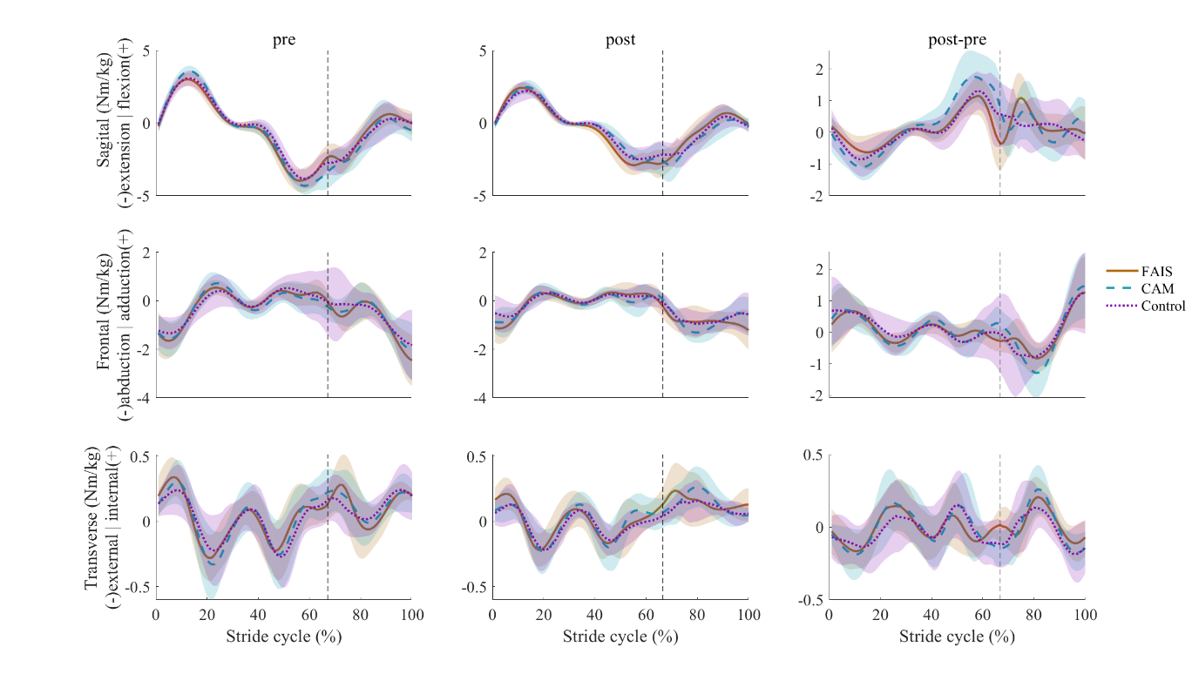

#### Figure 2 – Ensemble average (±1 standard deviation) hip internal moments in the sagittal (top), frontal (middle), and transverse (bottom) planes across a stride cycle (displayed as toe-off to toe-off, foot contact represented with a vertical dashed line) before (pre, left), after (post, middle) repeated sprint exercise in individuals with femoroacetabular impingement syndrome (FAIS, solid brown, n = 13), individuals with asymptomatic cam morphology (CAM, dashed blue, n = 16), and in healthy controls (Control, dotted purple , n = 18). Mean differences shown in absolute units (post-pre, right). No significant group\*time interaction were observed as a result of a two-way repeated measures ANOVA using statistical parametric mapping.

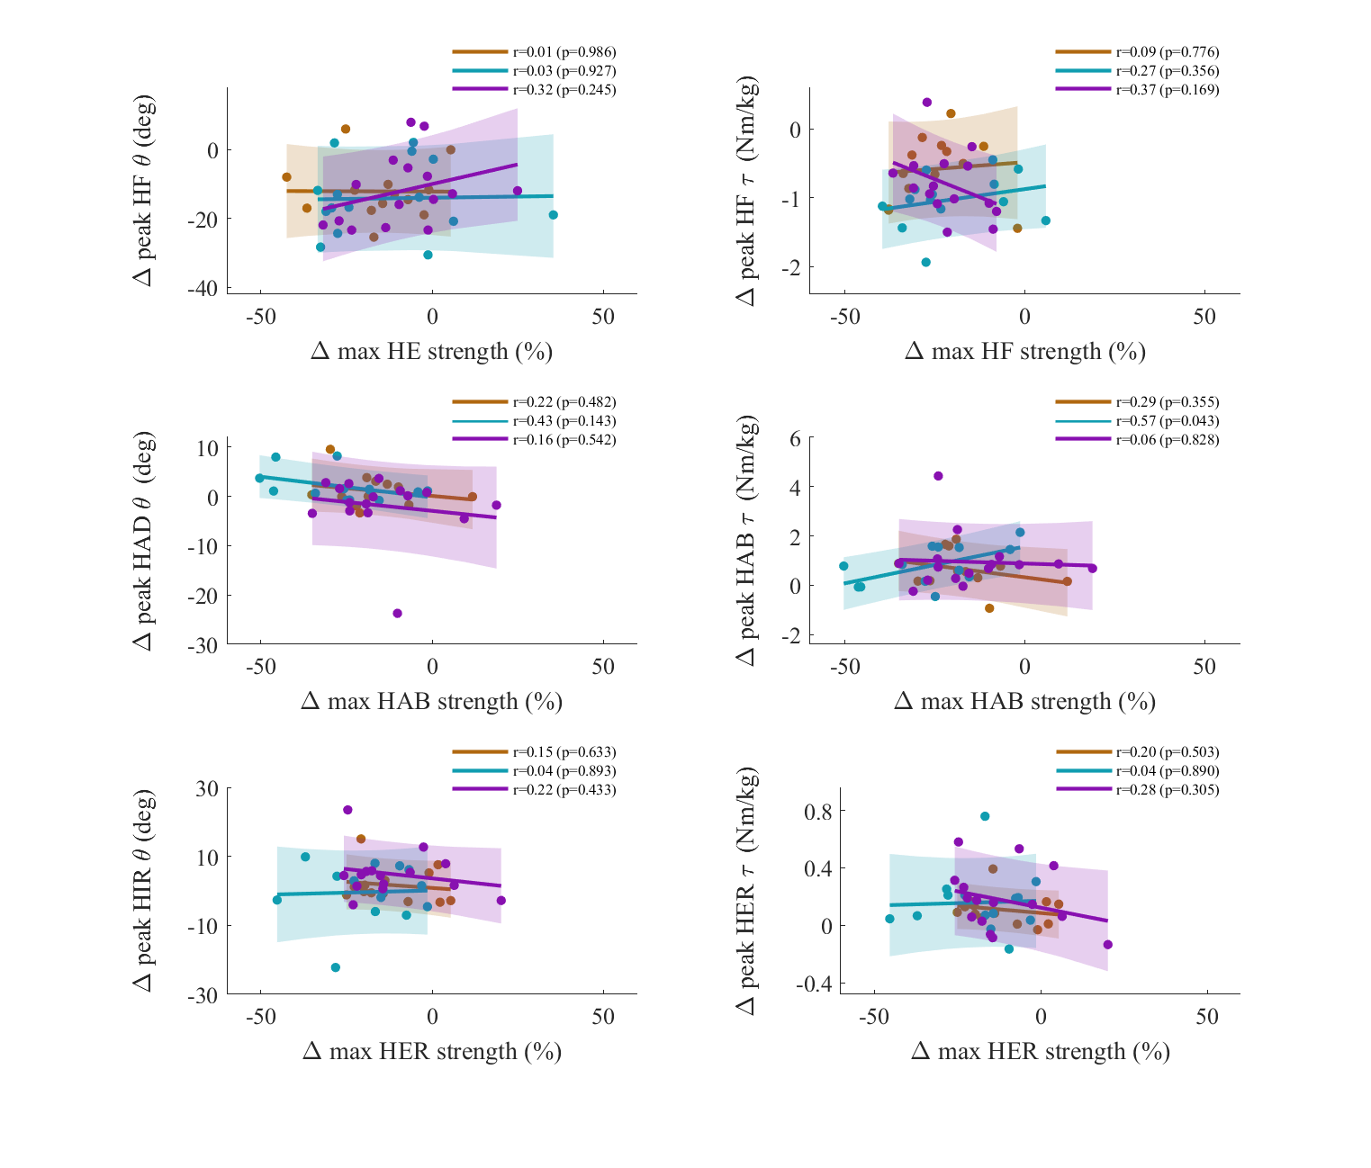

#### Figure 3 – Pearson correlations representing the relationship between changes (Δ) in peak hip angles (θ, left) or moments (τ, right) and task specific changes in maximal isometric strength following repeated sprint exercise in individuals with femoroacetabular impingement syndrome (brown, n = 13), individuals with asymptomatic cam morphology (blue, n = 16), and healthy controls (purple, n = 16). HAB = hip abduction; HAD = hip adduction; HE = hip extension; HER = hip external rotation; HF = hip flexion; HIR = hip internal rotation;

# Supplementary figures

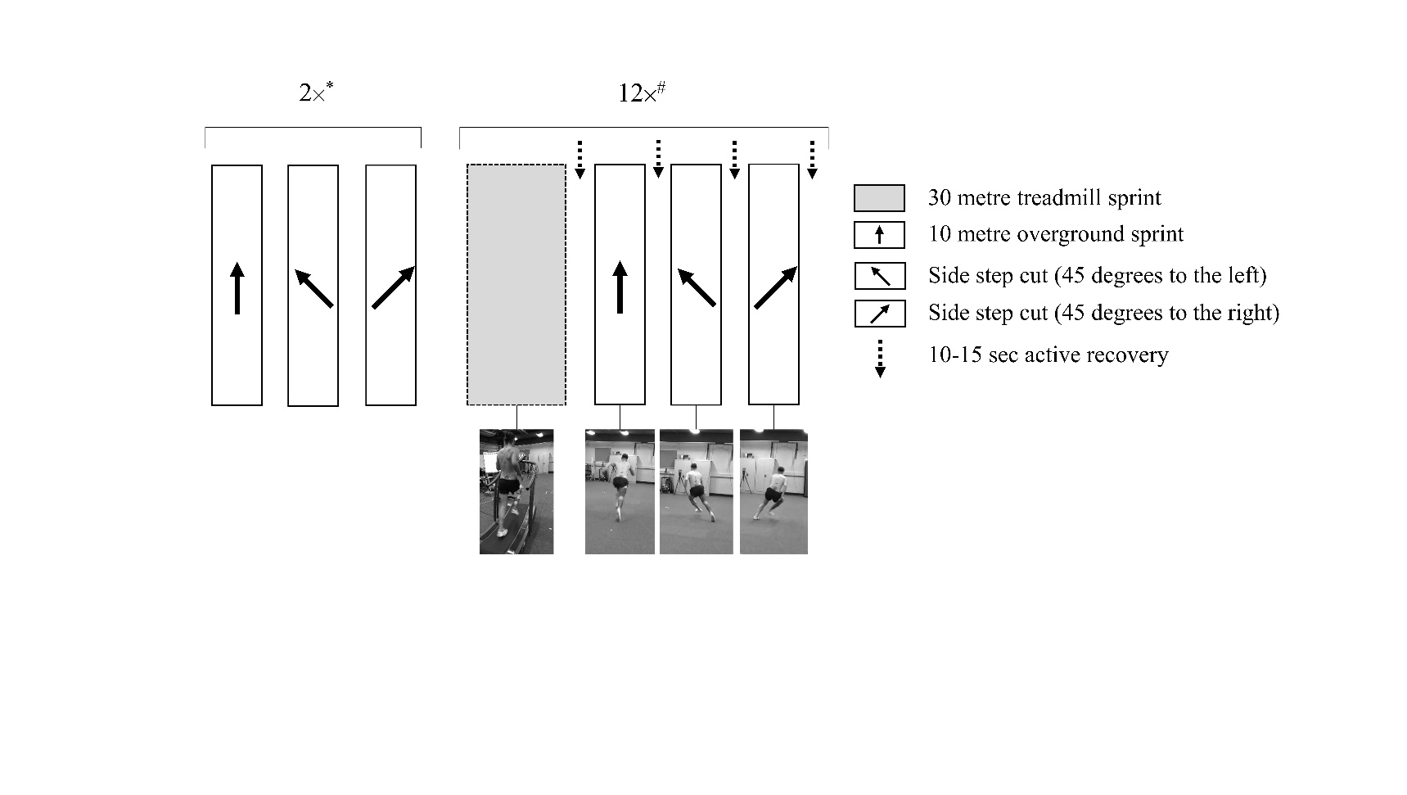

#### Sup 1. Schematic representation of the repeated sprint exercise (12 x 30-metre maximal sprints).

# Participants were

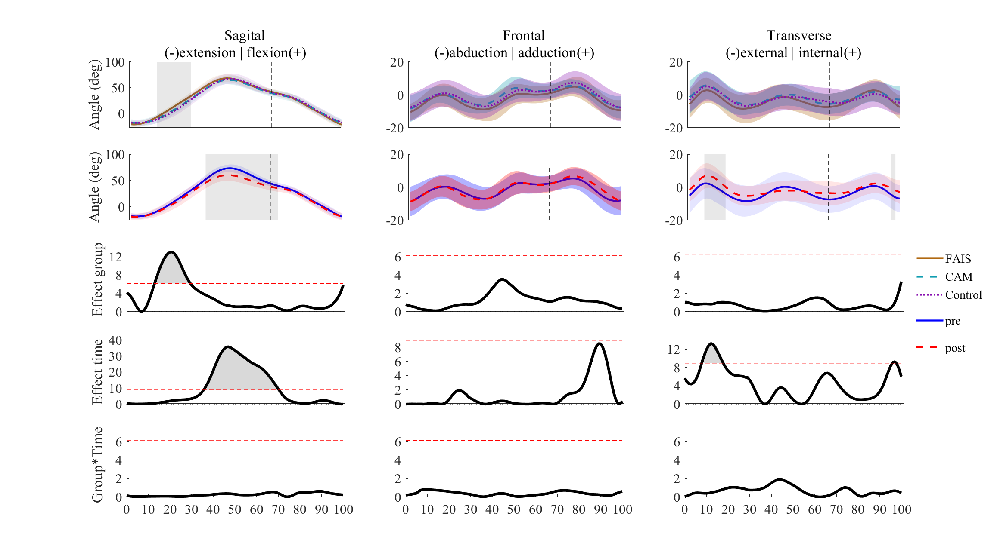

#### Sup - Ensemble average (±1 standard deviation) hip angles in the sagittal (left), frontal (centre), and transverse (right) planes across a stride cycle (displayed as toe-off to toe-off, foot contact represented with a vertical dashed line) before (pre, first row), after (post, second row) repeated sprint exercise in individuals with femoroacetabular impingement syndrome (FAIS, solid brown, n = 13), individuals with asymptomatic cam morphology (CAM, dashed blue, n = 16), and in healthy controls (Control, dotted purple , n = 18). Mean differences shown in absolute units (post-pre, right). Results of a two-way repeated measures ANOVA using statistical parametric mapping are shown for the main effect of group (third row), main effect of time (fourth row), and interaction between group and time (fifth row).

C:\Users\s5109036\AppData\Local\Microsoft\Windows\INetCache\Content.Word\HipMoments_MainEffects.tiff

#### Sup - Ensemble average (±1 standard deviation) hip moments in the sagittal (left), frontal (centre), and transverse (right) planes across a stride cycle (displayed as toe-off to toe-off, foot contact represented with a vertical dashed line) before (pre, first row), after (post, second row) repeated sprint exercise in individuals with femoroacetabular impingement syndrome (FAIS, solid brown, n = 13), individuals with asymptomatic cam morphology (CAM, dashed blue, n = 16), and in healthy controls (Control, dotted purple , n = 18). Mean differences shown in absolute units (post-pre, right). Results of a two-way repeated measures ANOVA using statistical parametric mapping are shown for the main effect of group (third row), main effect of time (fourth row), and interaction between group and time (fifth row).

#### Sup . Mean (bars), 95% confidence intervals (error bars) and individual participant data (black dots) for normalised torque during maximal isometric contractions comparing individuals with femoroacetabular impingement syndrome (FAIS, blue, n = 13), individuals with asymptomatic cam morphology (CAM, purple, n = 16), and healthy controls (Control, brown, n = 16). Data shown for hip extension (HE), flexion (HF), adduction (HAD), abduction (HAB), external rotation (HER), internal rotation (HIR), and knee extension (KE) and flexion (KF). Symbols represent a difference between FAIS and CAM (\*), FAIS and Control (#), or CAM and Control ($).

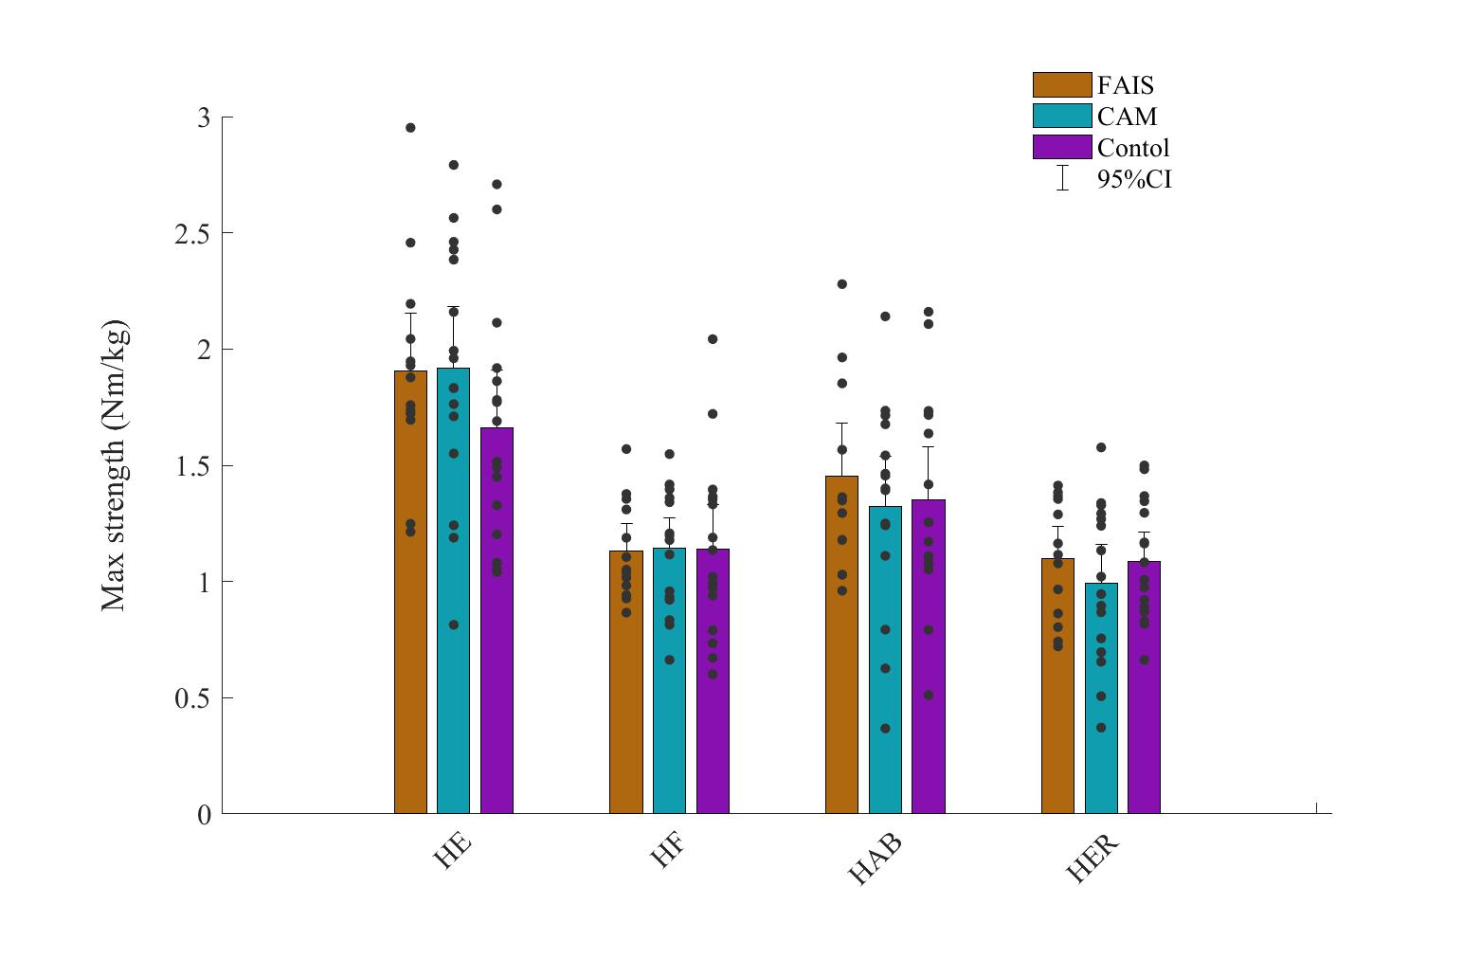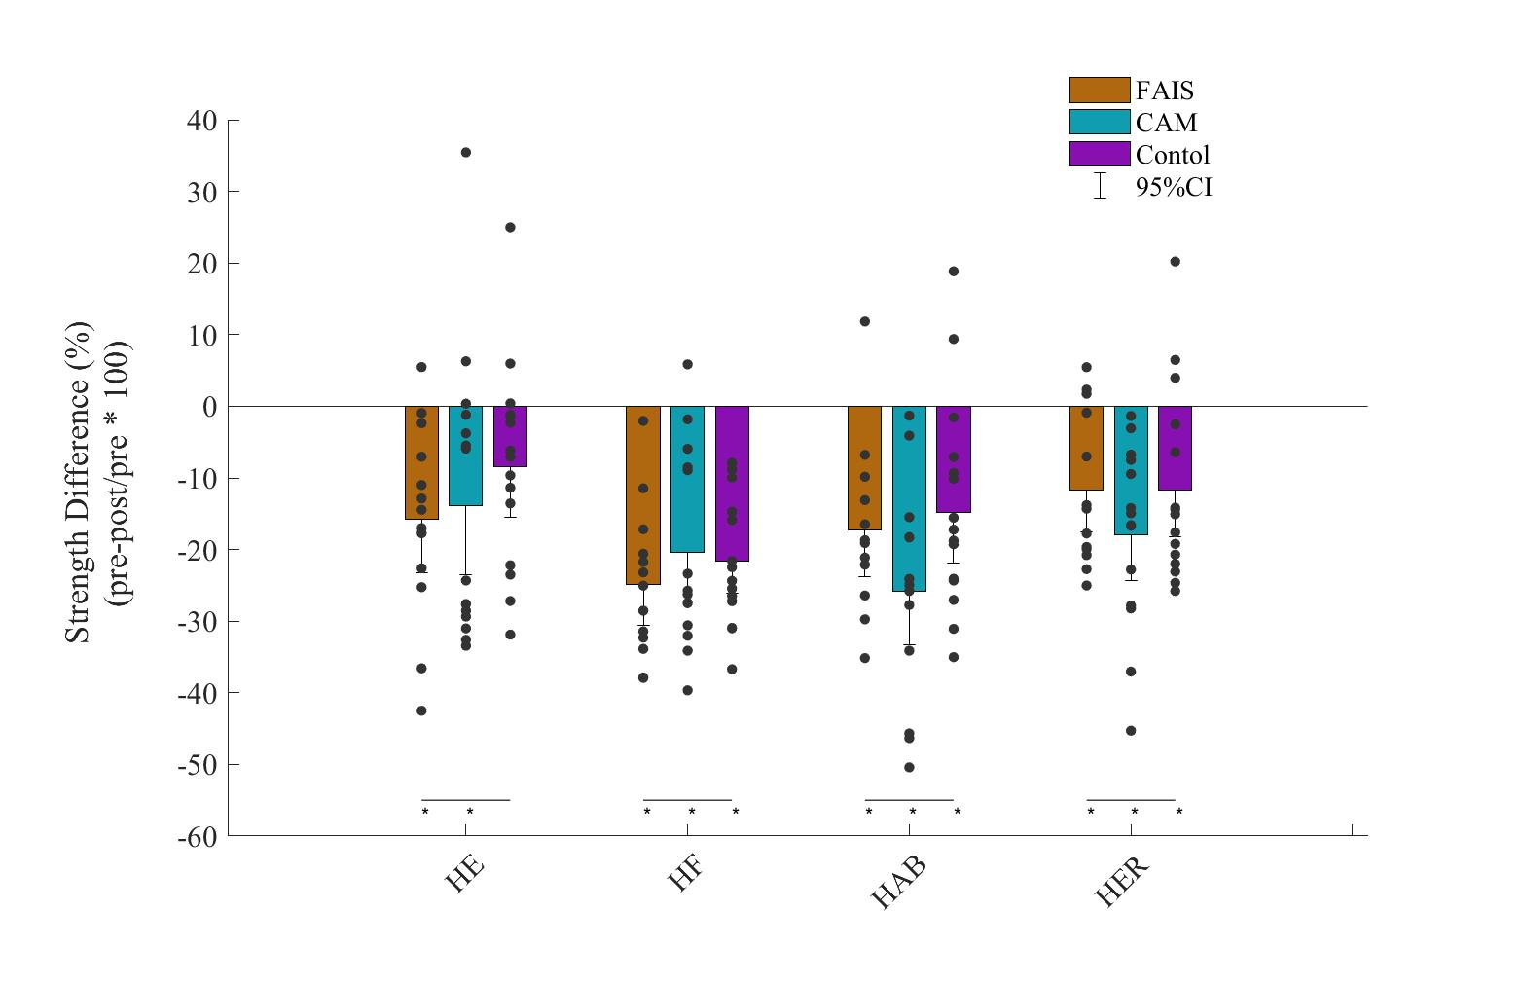

#### Sup 5. Mean (bars), 95% confidence intervals (error bars) and individual participant data (black dots) for differences in maximal strength following repeated sprint exercise individuals with femoroacetabular impingement syndrome (FAIS, blue, n = 13), individuals with asymptomatic cam morphology (CAM, purple, n = 16), and healthy controls (Control, brown, n = 16). Data shown for hip extension (HE), flexion (HF), abduction (HAB), external rotation (HER). \*Represents a significant (P<0.05) differences from pre to post. No significant differences were observed between groups.