AquaShield AI
Coastal Disaster Intelligence & Marine Safety Platform
Comprehensive Engineering Project Specification, System Architecture, End-to-End Methodology, and Complete Technical Diagrams.
Project Name | AquaShield AI (Coastal Disaster Intelligence Platform)
System Architecture | 3-Tier Decoupled (Offline PWA + FastAPI + Dual-Stream Deep Learning)
Computer Vision Model | DualStreamForensicNet (EfficientNet-B0 RGB + ELA CASIA2 Trained)
Target Users | Coastal Residents, Daily Beachgoers, Artisanal Fishers, Disaster Responders (112, Coast Guard)

1. Project Idea & Executive Summary
AquaShield AI is an intelligent coastal disaster intelligence and marine safety platform designed specifically for coastal zones (e.g., Mumbai, Arabian Sea, Bay of Bengal). It bridges the operational divide between oceanographic sensor telemetry, emergency response organizations (Indian Coast Guard, NDMA, State Disaster Management Authorities), and the general coastal public.
Key Innovations & Problem Solutions:
• Fake Disaster Misinformation Filter: Eliminates false civilian panic by deploying an onboard PyTorch dual-stream deep learning model (EfficientNet-B0 + Error Level Analysis) that scans crowdsourced hazard imagery and detects synthetic, recycled, or AI-generated flood/cyclone images.
• Extreme Resilience & Zero-Data SMS Fallback: When cyclones destroy power grids and telecommunication towers, cloud-only systems fail. AquaShield utilizes an offline-first Service Worker (sw.js) cache combined with an SMS URI emergency gateway that sends critical GPS coordinates directly to Coast Guard (1554) and National Emergency (112) helplines without internet.
• Safety-Weighted Evacuation Engine: Rather than computing simple geographic distance, AquaShield computes elevation-safe evacuation paths that actively steer citizens away from low-elevation storm-surge inundation zones toward designated relief centers.
• Marine Wildlife Incident Dispatch: Integrates an automated rescue ticket dispatcher for stranded sea turtles, dolphins, and cetaceans with automatic telemetry tagging for regional NGOs.
2. Overview & System Methodology
The AquaShield methodology operates through five interconnected technical phases:
Phase 1 — Ocean Telemetry Ingestion:
Collects continuous real-time telemetry from moored oceanographic buoys (B-04, B-09, B-12) and meteorological services (INCOIS, IMD). Telemetry streams include swell height (meters), wave period, wind velocity (km/h), sea-surface temperature, and barometric pressure. Metrics are normalized into a composite Coastal Hazard Index (CHI).
Phase 2 — Citizen Incident Ingestion:
Through a mobile-optimized PWA interface, citizens submit observations (High Tide Inundation, Coastal Surge, Rip Current, Stranded Marine Fauna). The browser Geolocation API securely injects high-precision latitude/longitude coordinate pairs alongside camera timestamps.
Phase 3 — Multi-Layer AI Forensic Computer Vision Pipeline:
To prevent fake reports from distorting emergency dispatch, uploaded imagery is processed through a 6-stage verification engine:
1. PyTorch DualStreamForensicNet (RGB stream + ELA compression stream with EfficientNet-B0 backbones).
2. 2D Artwork & Synthetic Rendering Filter (detects vector illustrations, cartoons, and digital paintings).
3. EXIF Metadata & Device Sensor Forensics (verifies hardware camera signatures and editing software markers).
4. Error Level Analysis (ELA) (re-saves at 90% JPEG quality to detect pixel-level compression anomalies from splicing).
5. Frequency Domain Noise & Laplacian Entropy (analyzes noise consistency across image regions).
6. Hydro-Hazard Spectral Analysis (evaluates hue/saturation fluid sheen to confirm legitimate flood/water signatures).
Phase 4 — Risk-Weighted Evacuation Routing:
Employs a modified A* / Dijkstra algorithm where coastal road networks are assigned dynamically weighted safety penalties based on topographic elevation and inundation probability.
Phase 5 — Multi-Channel Emergency Dispatch:
Online transactions are committed via Async SQLAlchemy 2.0 to SQLite/PostgreSQL and pushed to live responder feeds. In network blackouts, the offline PWA triggers a pre-formatted SMS emergency payload containing exact coordinates.
3. System Architecture
AquaShield AI is organized as a decoupled, multi-tier architectural system:
• Tier 1: Client & Presentation Tier (Offline-First PWA)
Built with vanilla HTML5 and custom CSS tokens adhering to an obsidian navy palette (#07111e, #0c1827) and distress amber (#f59e0b). Visual components include Leaflet.js GIS radar maps with native SVG fallbacks, Chart.js telemetry charts, and a registered Service Worker (sw.js) for persistent asset caching.
• Tier 2: Application & AI Backend Tier (FastAPI ASGI)
A high-performance asynchronous Python backend. Includes security middleware (no-sniff, SAMEORIGIN frame guards, strict CORS), modular feature routers (/disasters, /reports, /marine, /routes, /sos, /chat), and asynchronous SQLAlchemy session management.
• Tier 3: AI & Algorithmic Intelligence Tier
Houses the PyTorch DualStreamForensicNet model, computer vision image manipulation detection filters, Dijkstra/A* evacuation calculation services, and a context-aware coastal disaster Copilot engine trained on NDMA standard operating procedures.
• Tier 4: Data & Dispatch Tier
Provides dual database support (zero-configuration SQLite for standalone edge devices, PostgreSQL for centralized production deployments), an encrypted local image store, and cellular SMS gateways.
4. Core Features & Module Specifications
Feature Module | Operational Functionality | Primary Technology & Route
Live Coastal Radar & Swell Telemetry | Real-time monitoring of wave heights, wind velocity, and tide levels with traffic-light safety ratings (Safe, Caution, Hazard). | Leaflet.js, SVG Radar, Chart.js  GET /api/disasters
Citizen Hazard Ingest & Forensics | Crowdsourced incident submission paired with automated fake-image detection to prevent false panic. | PyTorch, EfficientNet-B0, ELA  POST /api/reports
Safe Evacuation Corridors | Calculates elevation-weighted escape paths that circumvent inundated lowlands. | A* / Dijkstra Algorithm  POST /api/routes/calculate
Marine Wildlife Rescue Dispatch | Logs stranded marine fauna (turtles, cetaceans, birds) and coordinates dispatch with regional conservation NGOs. | Async SQLAlchemy, Geo-indexing  GET/POST /api/marine
Offline PWA & Cache Engine | Maintains operational availability of safety checklists and radar baselines during network collapse. | Service Worker Cache API, Web Manifest  sw.js, manifest.json
Zero-Data SMS SOS Gateway | Generates pre-formatted emergency SMS packets with GPS coordinates to 112 and 1554 without cellular internet. | Native sms: URI Protocol  POST /api/sos/broadcast
Disaster Copilot (SOP Assistant) | Interactive emergency advisor providing instant standard operating procedures for cyclones and first aid. | Context-aware RAG Engine  POST /api/chat

5. Diagram 1: Data Flow Diagram (DFD Level 1)
The Data Flow Diagram illustrates how information moves across external entities (citizens, ocean buoys, emergency responders, and wildlife NGOs), processes, and persistent data stores.
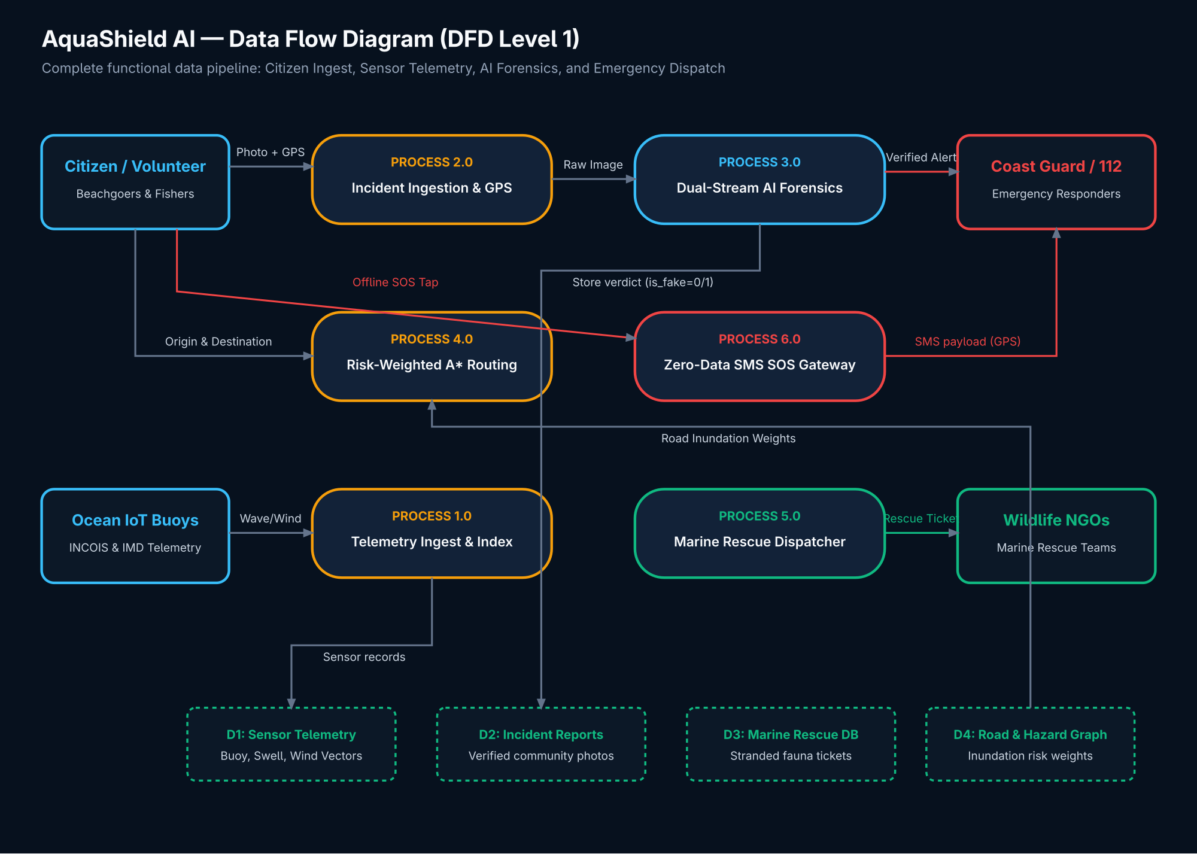
Figure 1: AquaShield AI — Data Flow Diagram (DFD Level 1)
Ready-to-Use Generation Prompt: Data Flow Diagram (DFD Level 0 & Level 1)
Create a comprehensive Level 0 and Level 1 Data Flow Diagram (DFD) for 'AquaShield AI', an AI-powered coastal disaster intelligence and marine safety platform.
External Entities:
- Coastal Citizens / Beachgoers / Volunteers
- Oceanographic Buoy IoT Sensors & Meteorological Services (INCOIS, IMD)
- Emergency Response Agencies (Indian Coast Guard, NDMA, Police 112)
- Marine Wildlife Rescue NGOs
Level 1 Processes:
- Process 1.0: Ocean Sensor Telemetry Ingestion & Hazard Calculation
- Process 2.0: Citizen Incident Observation Capture (collects photo, GPS, category)
- Process 3.0: Dual-Stream AI Forensic Verification (EfficientNet-B0 + Error Level Analysis)
- Process 4.0: Risk-Weighted Evacuation Route Optimization
- Process 5.0: Marine Wildlife Rescue Dispatcher
- Process 6.0: Offline Emergency SOS & SMS Transmission
Data Stores:
- D1: Ocean Telemetry & Coastal Hazard Store
- D2: Community Incident Reports & Forensic Verifications
- D3: Marine Wildlife Rescue Registry
- D4: Coastal Elevation & Road Inundation Graph
Output clean Gane & Sarson DFD notation with labeled directional arrows.

6. Diagram 2: System Workflow Flowchart
The System Workflow Flowchart diagrams the end-to-end decision tree, bifurcating into an offline Service Worker / SMS recovery path and an online path equipped with dual-stream AI forensic image verification.
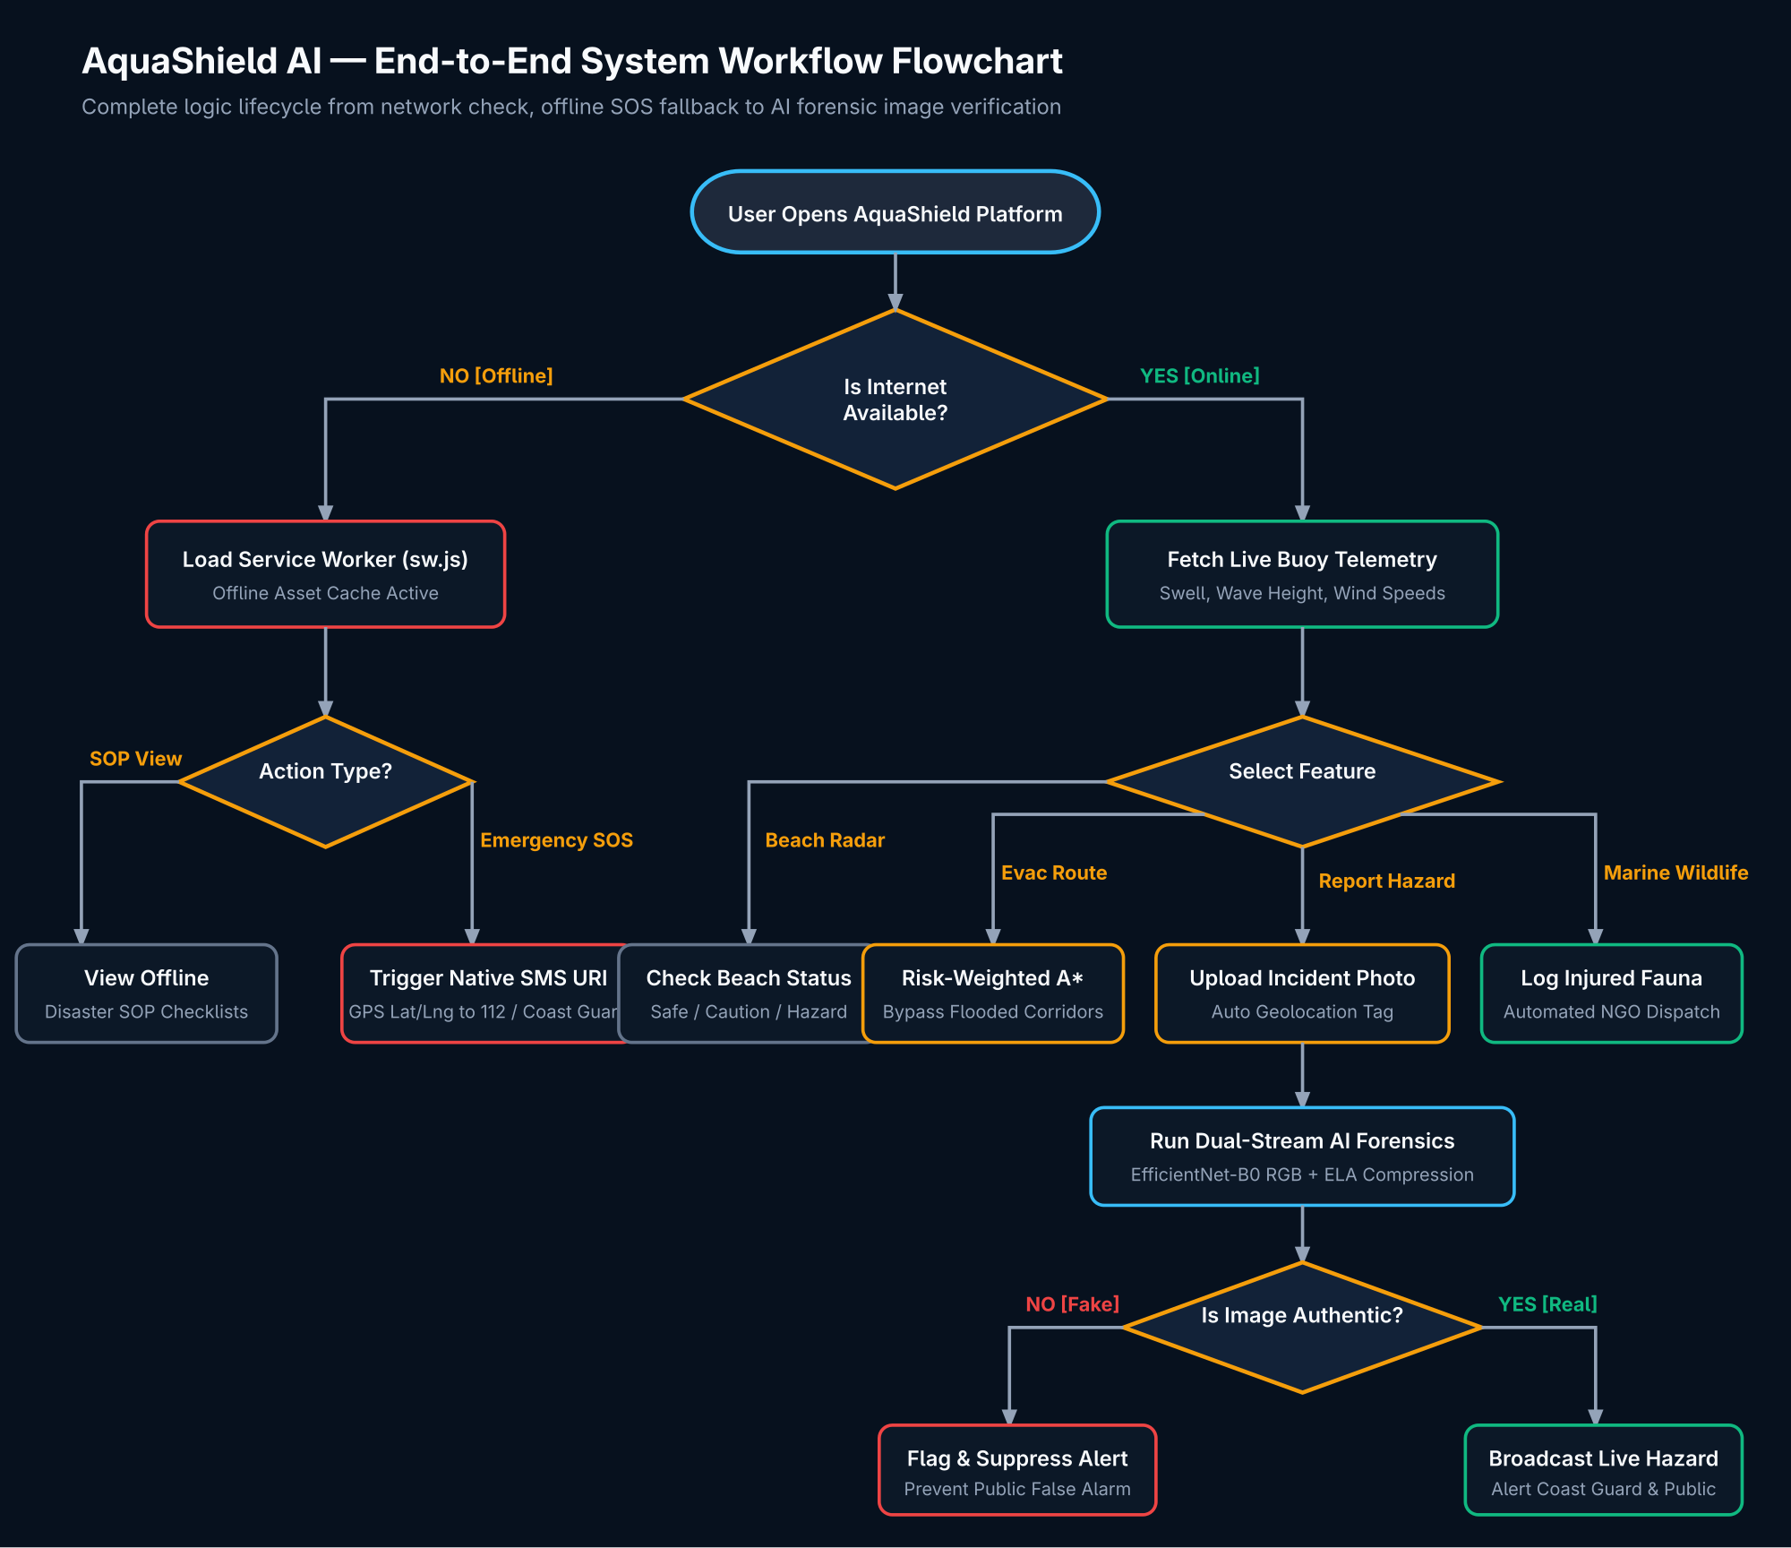
Figure 2: AquaShield AI — End-to-End Decision & Workflow Flowchart
Ready-to-Use Generation Prompt: System Workflow Flowchart
Create an end-to-end user decision and system execution Flowchart for 'AquaShield AI'.
Logic Requirements:
1. Start: User opens AquaShield Application.
2. Decision: 'Is Internet Available?'.
- NO (Offline Mode): Service Worker (sw.js) activates local asset cache. User can view cached SOPs and radar baseline. If Emergency SOS is tapped, app generates a pre-formatted SMS URI with GPS coordinates to 112 / Coast Guard without mobile data.
- YES (Online Mode): Loads live ocean buoy telemetry (swell, wave height, wind). User chooses: (a) Check Beach Safety, (b) Evacuation Route Navigation, (c) Marine Wildlife Rescue, or (d) Report Hazard Observation.
3. Forensic Gate for Hazard Photos: Image passes to Dual-Stream Neural Network (EfficientNet-B0 RGB + ELA stream). Decision: 'Is Image Authentic?'. If NO: Flag as fake/tampered, suppress public alert, display warning. If YES: Mark verified, commit to database, display on live GIS radar, and alert first responders.
4. End State.
Use standard ISO flowchart symbols with labeled yes/no paths.

7. Diagram 3: Unified Modeling Language (UML) Class Diagram
The UML Class Diagram defines the object-oriented structure of AquaShield, covering SQLAlchemy ORM models, PyTorch deep learning modules, and business logic services.
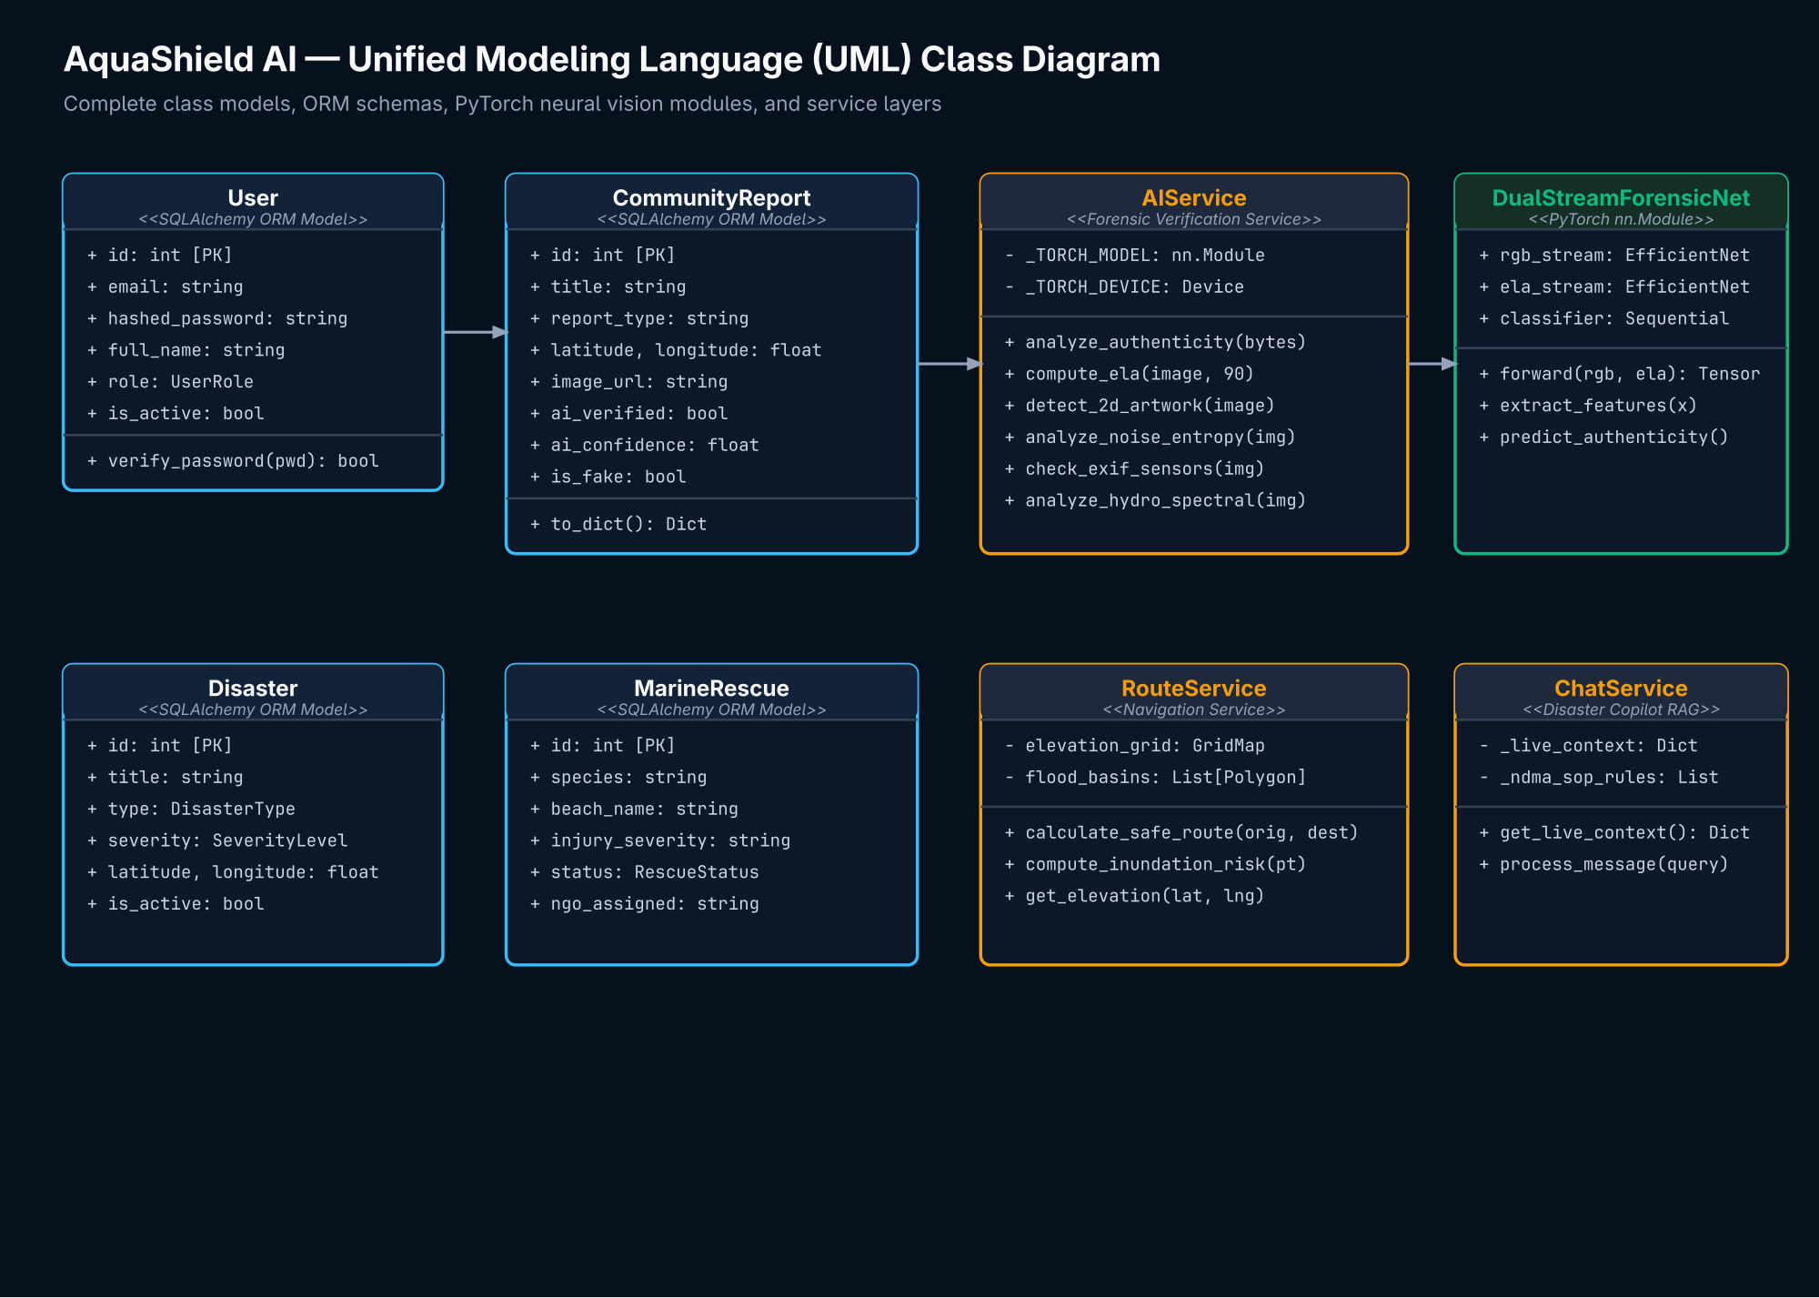
Figure 3: AquaShield AI — UML Class Architecture Diagram
Ready-to-Use Generation Prompt: UML Class Diagram
Generate a professional UML Class Diagram for the 'AquaShield AI' platform.
Entities & Data Models:
- User (id, email, hashed_password, full_name, role, is_active, created_at)
- Disaster (id, title, type, severity, region, latitude, longitude, is_active)
- CommunityReport (id, title, report_type, latitude, longitude, image_url, ai_verified, ai_confidence, is_fake, forensic_details)
- MarineRescue (id, species, beach_name, injury_severity, status, ngo_assigned)
Service & Neural Classes:
- AIService (analyze_image_authenticity(), compute_ela(), detect_2d_artwork(), analyze_noise_entropy())
- DualStreamForensicNet (inherits PyTorch nn.Module: rgb_stream, ela_stream, classifier, forward())
- RouteService (calculate_safe_route(), compute_inundation_risk())
- ChatService (get_live_context(), process_message())
Show associations between User, CommunityReport, AIService, and DualStreamForensicNet using standard PlantUML syntax.

8. Diagram 4: System Engineering Block Diagram
The System Block Diagram categorizes the complete platform into five distinct functional hardware and software tiers, illustrating data buses and inter-block protocols.
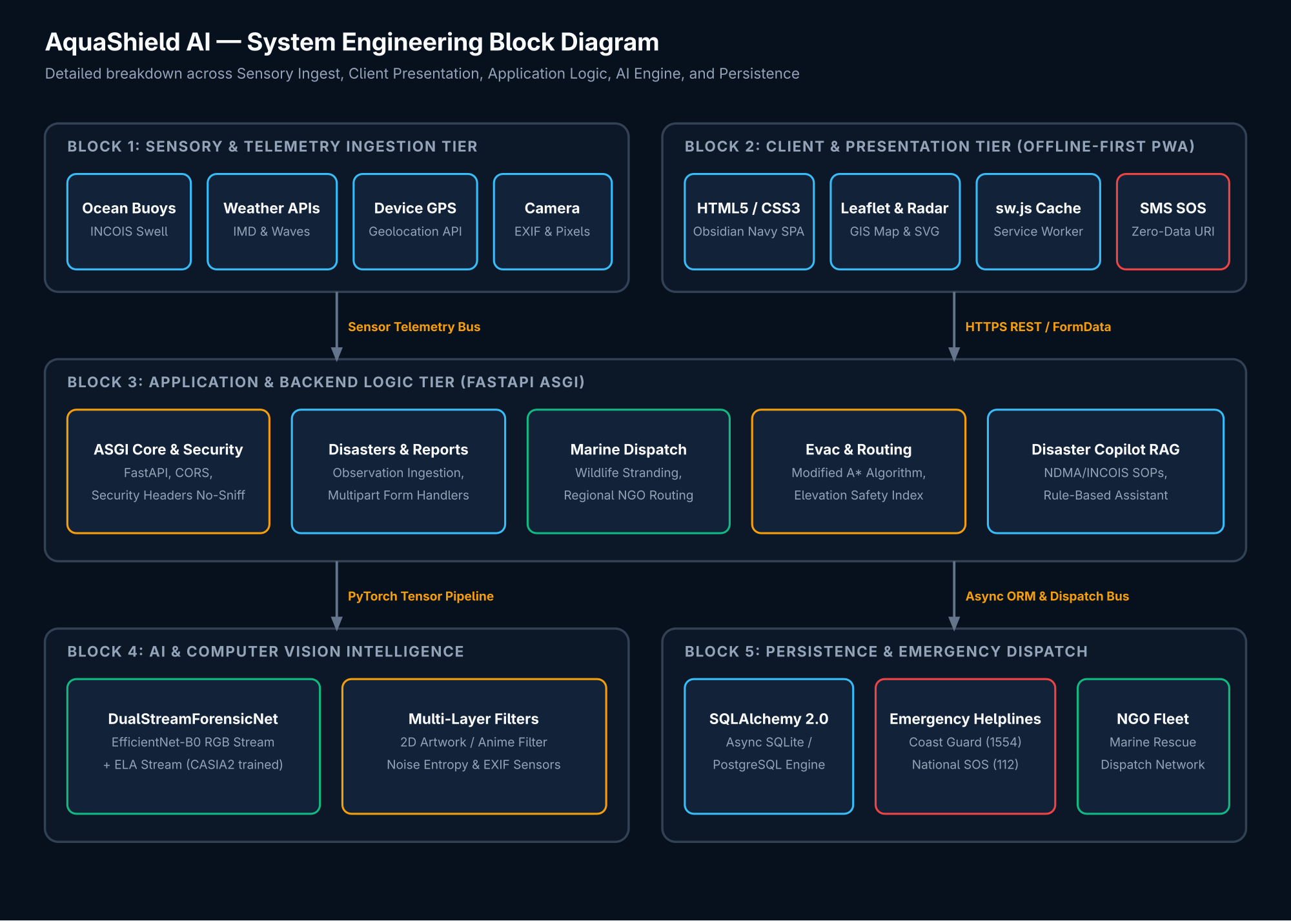
Figure 4: AquaShield AI — Engineering System Block Diagram
Ready-to-Use Generation Prompt: System Engineering Block Diagram
Create an engineering Block Diagram for 'AquaShield AI' organized into 5 functional tiers:
1. Sensory & Telemetry Ingestion Block: Oceanographic Buoys, Weather APIs, Device GPS Sensor, Smartphone Camera.
2. Client & Presentation Block (Offline-First): HTML5/CSS3 SPA, Leaflet GIS Radar, Chart.js Visualizer, Service Worker (sw.js) Cache, Native sms: URI Gateway.
3. Application & Backend Logic Block: FastAPI ASGI Server, Security Middleware, RESTful Feature Routers, Async SQLAlchemy 2.0 ORM.
4. AI & Algorithmic Intelligence Block: PyTorch DualStreamForensicNet (RGB EfficientNet + ELA Stream), Error Level Analysis & Noise Entropy, Risk-Weighted A* Route Optimizer, Disaster Copilot RAG SOP Engine.
5. Persistence & Dispatch Block: SQLite/PostgreSQL DB, Encrypted File System Image Store, Emergency Dispatch Gateway (Coast Guard 1554, NDMA 112), Marine Wildlife NGO Network.
Show directional data buses with protocol annotations (HTTPS, REST, ORM, SMS URI).

9. Technical Stack & Deployment Specifications
Client Frontend | HTML5, Vanilla CSS3 (Obsidian Navy Design Tokens), ES6+ JavaScript
Mapping & Data Visuals | Leaflet.js GIS, OpenStreetMap, SVG Radar Engine, Chart.js 4.4
Backend Framework | Python 3.10+, FastAPI 0.115, Uvicorn 0.30 (ASGI Server)
Database & ORM | Async SQLAlchemy 2.0, aiosqlite (standalone), asyncpg (PostgreSQL production)
Deep Learning & Vision | PyTorch 2.x, Torchvision, EfficientNet-B0, Pillow (PIL), NumPy, ELA Algorithm
Offline Architecture | Service Worker (sw.js) Cache Storage API, Web App Manifest, sms: URI Gateway
Security Standards | No-Sniff, SAMEORIGIN iframe protection, Geolocation permission policy, Pydantic v2 validation

