🎓 StudySync

UX Research & Design Diagrams

Modern Academic Class Coordination & Productivity Command Center

Project | StudySync — Academic Coordination Platform
Personas | Core Faculty Incharge · Class Representative (CR) · Student Cohort (50 members)
Tech Stack | React 19 · TypeScript 6.0 · Vite 6 · Tailwind CSS v4
Repository | github.com/bash30ribs/studysync

━━━━━━━━━━━━━━━━━━━━━━━━━━━━━━━━━━━━━━━━━━━━━━━━━━

Table of Contents
1. Empathy Map — Student Persona
2. Fishbone Diagram (Ishikawa / Cause-and-Effect)
3. Student Journey Map
4. CR & Faculty Incharge Journey Map

1. Empathy Map — Student Persona
The Empathy Map captures the student persona's internal thoughts, emotional states, verbal expressions, and observable behaviors. It reveals the core pains and gains that StudySync directly addresses through its unified coordination platform.
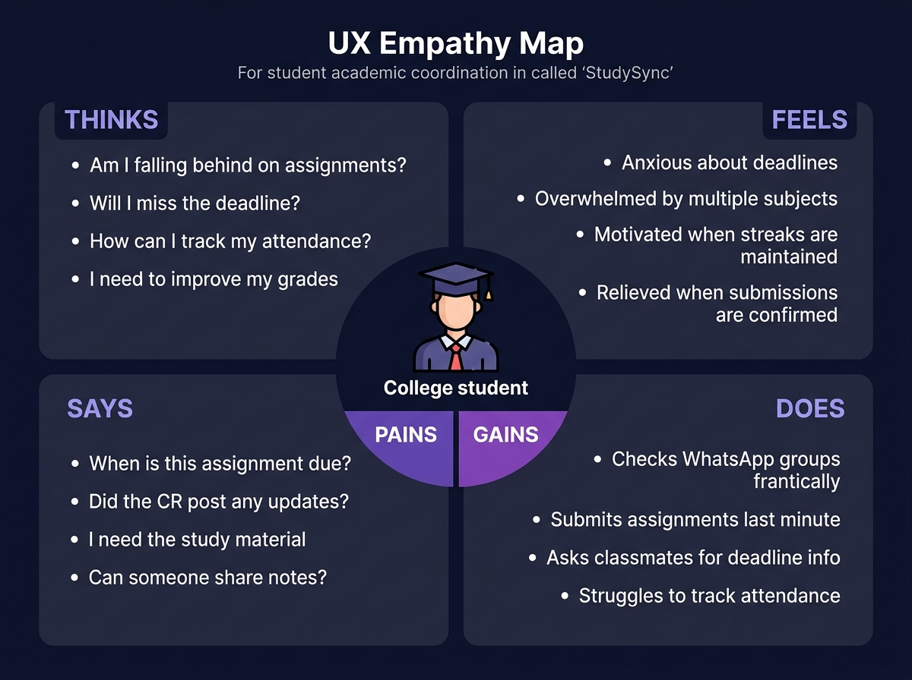
Quadrant | Key Insights
THINKS | "Am I falling behind on assignments?", "Will I miss the deadline?", "How can I track my attendance?", "I need to improve my grades"
FEELS | Anxious about deadlines, overwhelmed by multiple subjects, motivated when streaks are maintained, relieved when submissions are confirmed
SAYS | "When is this assignment due?", "Did the CR post any updates?", "I need the study material", "Can someone share notes?"
DOES | Checks WhatsApp groups frantically, submits assignments last minute, asks classmates for deadline info, struggles to track attendance
PAINS | Fragmented communication channels, no centralized tracking system, deadline anxiety, no holistic growth visibility
GAINS | Real-time CR updates, automated deadline reminders, gamified streaks & badges, AICTE accreditation tracking

2. Fishbone Diagram (Ishikawa / Cause-and-Effect)
The Fishbone (Ishikawa) Diagram performs a structured root-cause analysis of the central problem: "Poor Academic Coordination & Missed Deadlines". Six major cause categories are identified, each with specific contributing factors that StudySync resolves.
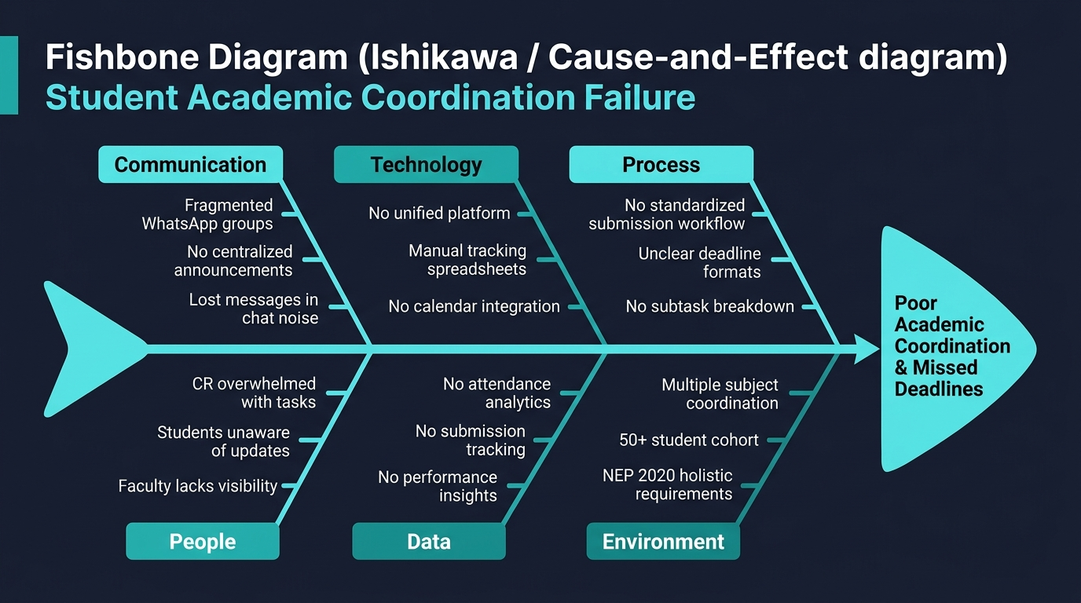
Category | Root Causes | StudySync Solution
Communication | Fragmented WhatsApp groups, no centralized announcements, lost messages in chat noise | Unified broadcast system, pinned announcements, real-time delivery confirmations
Technology | No unified platform, manual tracking spreadsheets, no calendar integration | React 19 SPA with iCal/Google Calendar sync, PWA offline support
Process | No standardized submission workflow, unclear deadline formats, no subtask breakdown | Structured assignment creation with milestone subtasks, cryptographic submission hashes
People | CR overwhelmed with tasks, students unaware of updates, faculty lacks visibility | 3-role portal system: Faculty Incharge, CR Command Center, Student Cohort
Data | No attendance analytics, no submission tracking, no performance insights | Real-time attendance sessions, submission pace radar, defaulter detection (<75%)
Environment | Multiple subject coordination, 50+ student cohort, NEP 2020 holistic requirements | Multi-subject engine, 50-member roster, AICTE 100-point holistic growth tracker

3. Student Journey Map
The Student Journey Map traces the end-to-end experience of a student using StudySync, from initial discovery through daily engagement to achievement milestones. Each phase captures touchpoints, actions, emotional states, and pain points.
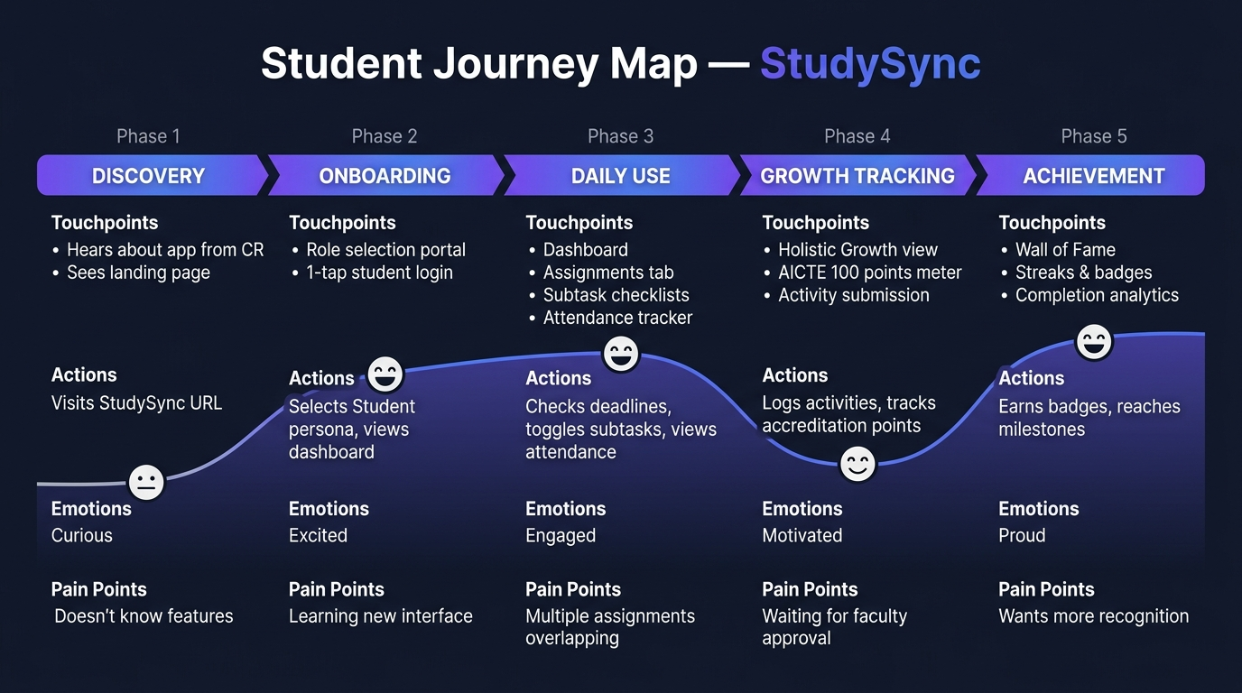
Phase | Touchpoints | Actions | Emotions | Pain Points
1. Discovery | Landing page, CR referral | Visits StudySync URL | Curious 😐 | Doesn't know features
2. Onboarding | Role selection portal, 1-tap student login | Selects Student persona, views dashboard | Excited 😊 | Learning new interface
3. Daily Use | Dashboard, Assignments tab, Subtask checklists, Attendance tracker | Checks deadlines, toggles subtasks, views attendance | Engaged 😄 | Multiple assignments overlapping
4. Growth Tracking | Holistic Growth view, AICTE 100 points meter, Activity submission form | Logs activities, tracks accreditation points | Motivated 😊 | Waiting for faculty approval
5. Achievement | Wall of Fame, Streaks & badges, Completion analytics | Earns badges, reaches milestones, celebrates streaks | Proud 😄 | Wants more recognition options

4. CR & Faculty Incharge Journey Map
The dual-lane Journey Map illustrates the parallel workflows of the Class Representative (CR) and Core Faculty Incharge through five key phases. The CR lane (blue) focuses on task creation and student management, while the Faculty lane (purple) emphasizes oversight, accreditation, and confidential governance.
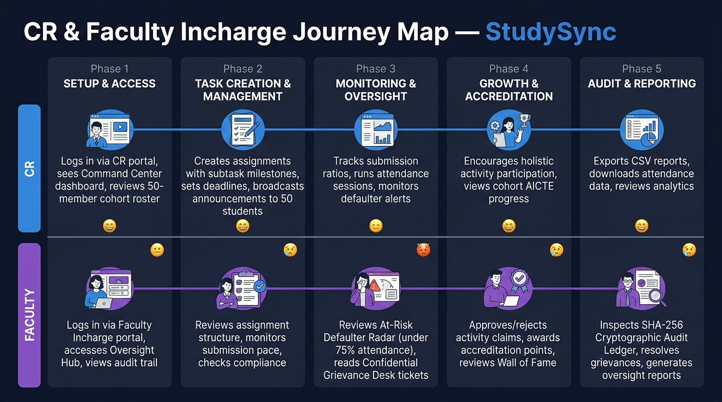
Phase | CR (Class Representative) | Faculty Incharge
1. Setup & Access | Logs in via CR portal, sees Command Center dashboard, reviews 50-member cohort roster | Logs in via Faculty Incharge portal, accesses Oversight Hub, views cryptographic audit trail
2. Task Creation & Management | Creates assignments with subtask milestones, sets deadlines, broadcasts announcements to 50 students | Reviews assignment structure, monitors submission pace, checks compliance metrics
3. Monitoring & Oversight | Tracks submission ratios, runs attendance sessions, monitors defaulter alerts | Reviews At-Risk Defaulter Radar (<75% attendance), reads Confidential Grievance Desk tickets
4. Growth & Accreditation | Encourages holistic activity participation, views cohort AICTE progress | Approves/rejects activity claims, awards accreditation points, curates Wall of Fame
5. Audit & Reporting | Exports CSV reports, downloads attendance data, reviews cohort analytics | Inspects SHA-256 Cryptographic Audit Ledger, resolves grievances, generates oversight reports

━━━━━━━━━━━━━━━━━━━━━━━━━━━━━━━━━━━━━━━━━━━━━━━━━━
StudySync — github.com/bash30ribs/studysync

