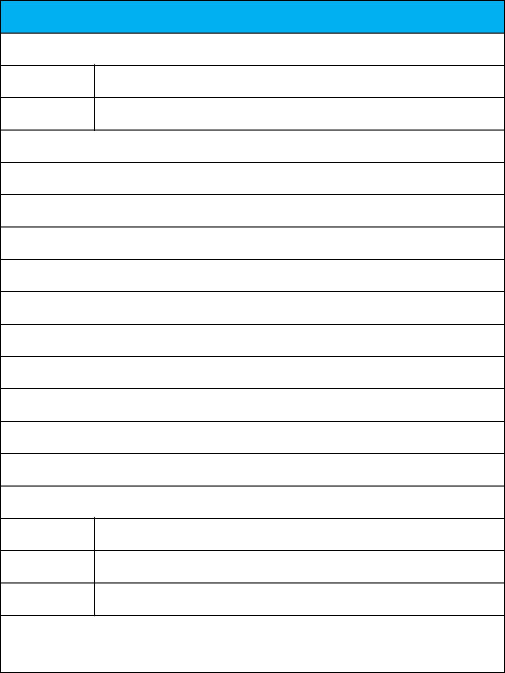
Rent Receipt Template

1. Employee details

Employee ID

Full Name

2. Address of the rented house

CITY: ……………………………………………………………………………….

STATE: …………………….......................................................................................... PIN CODE: ……………………...…………………………

3. Rent details

Received with thanks from (employee name) Mr./Ms. ……………………………………………………………

sum of Rs.

(Rupees…………………..……………………………………………………….……………………………….only)

towards the rent of the above mentioned residential premises for the month of

Mode of Payment (Cash/Cheque/Online):............................................... Payment Dated:............................

4. Landlord Details

Permanent account

number (PAN)

Full Name

Landlord Signature

and Date

Note: The HRA tax benefit is applicable only for the amount paid towards rent. Payment towards other expenses like maintenance, water, electricity, food, security deposits, late payment charges etc. are excluded. If other expenses are being paid along with the rent, the rent receipt should contain a break-up of all the components paid.

