

CPIS 483

Assignment 1

Due date: Monday, October 22, 2018

|  |  |
| --- | --- |
| Bashair | 1505365 |
| Bashaer Omar BinSalman | 1505765 |

* **Tools:**

We downloaded the Gephi tool to illustrate the social network database.

* **Database**:

It is a social network content of 77 nodes and 254 edges, the database is about of Les Misérables novel characters.

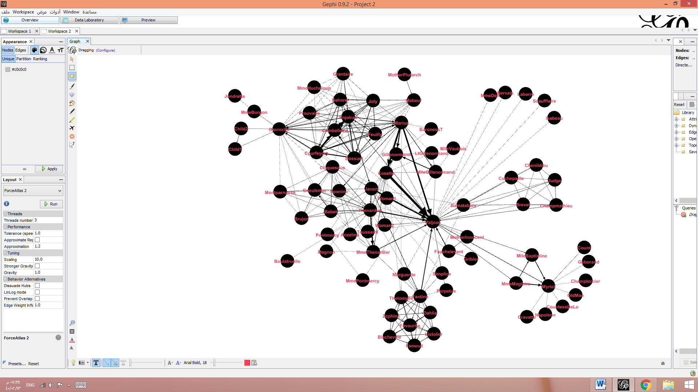

In this network, we found the most important node, that can be the main character in the novel of Les Misérables. It is "Valjean", that can be also betweenness centrality, degree centrality, closeness.

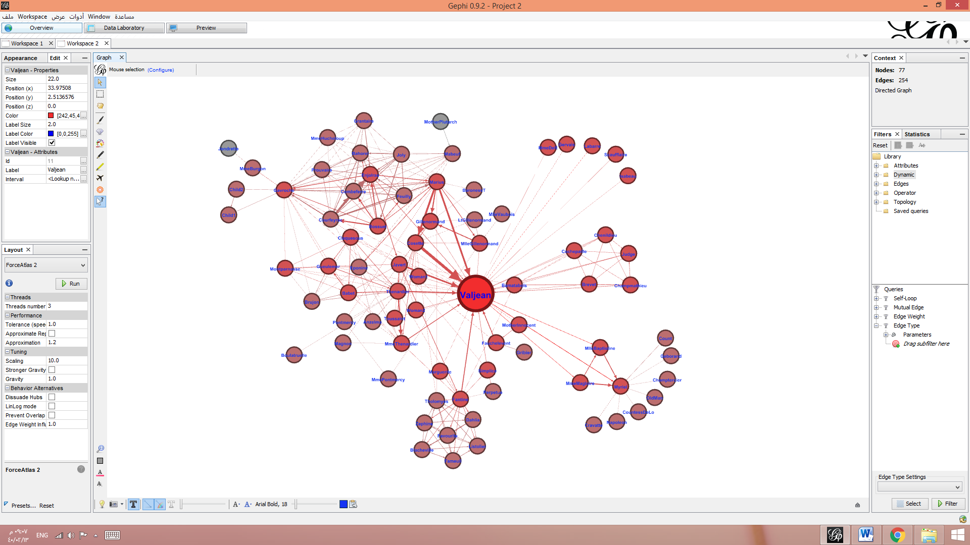

Betweenness centrality: is measures the number of times a node lies on the shortest path between other nodes. the primary character can be betweenness centrality such as" Tholomyes "," Myriel", "Gavroche "," Marius "," Enjolras "," Fantine "," Javert "," Thenardier "," MlleGillenormand".

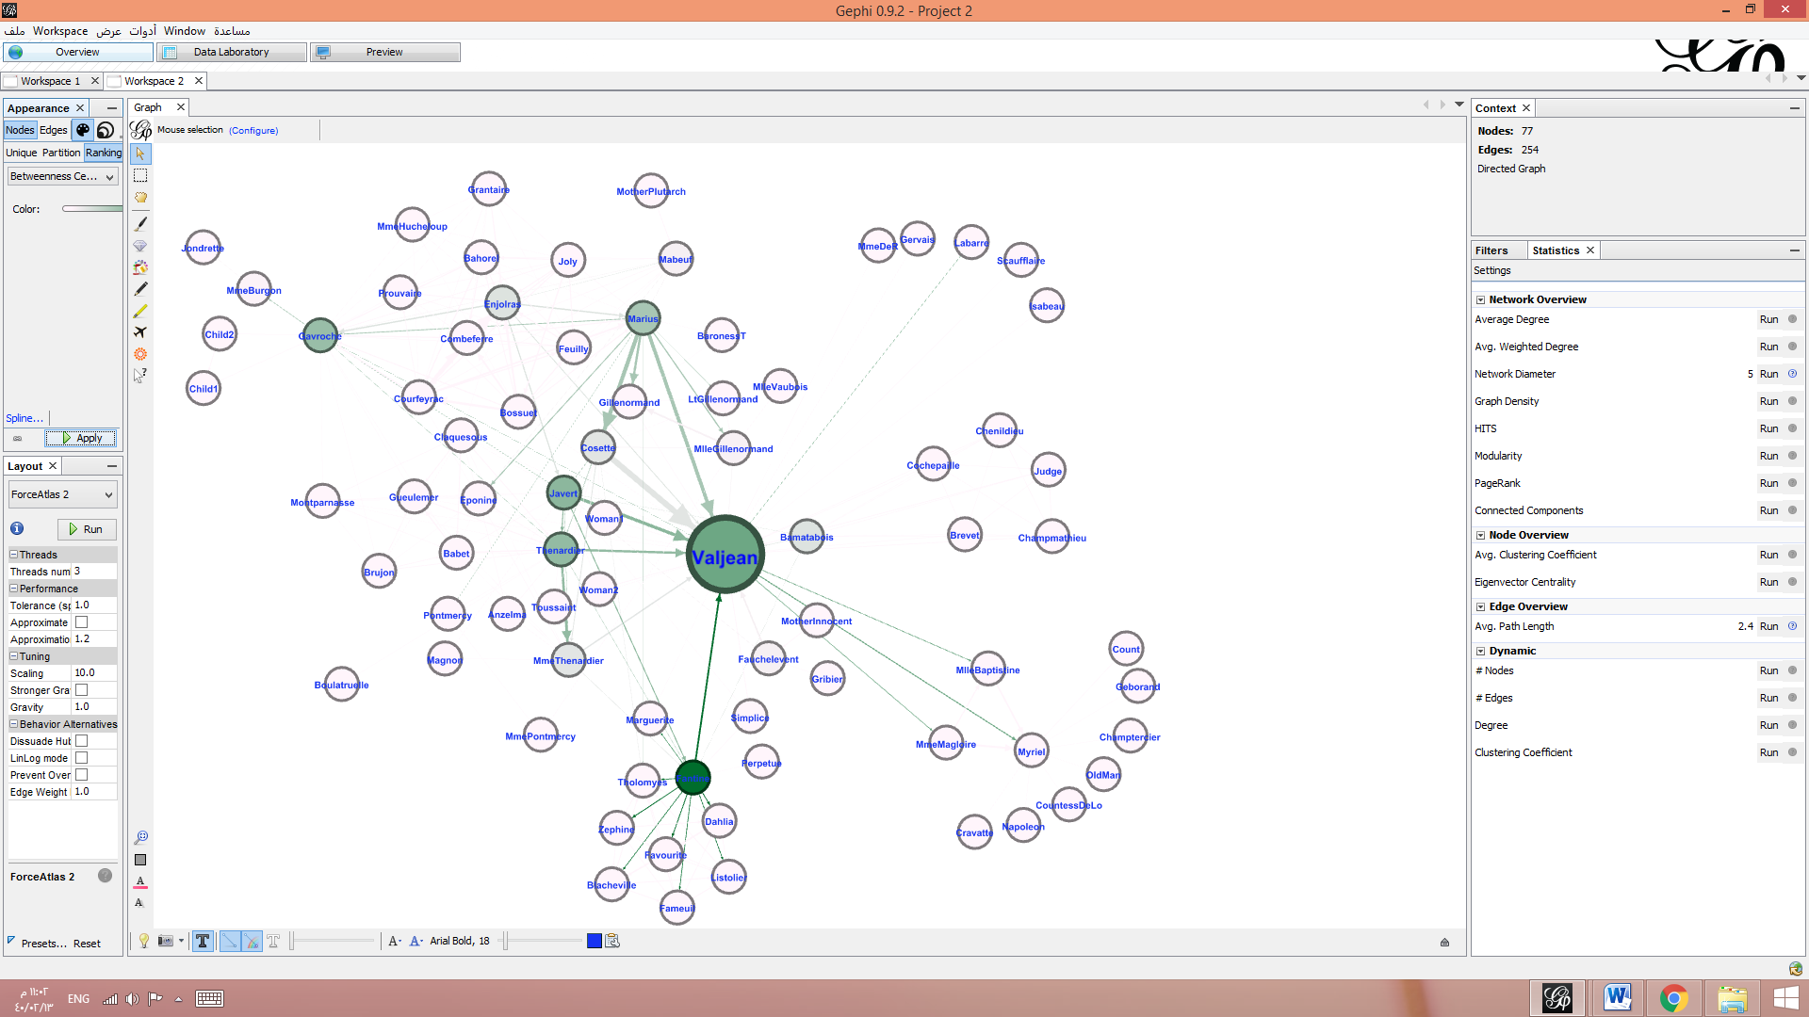

Closeness: This measure scores each node based on their ‘closeness’ to all other nodes within the network. some of the primary character can be closeness like " Marius "," Thenardier "," Javert "," Gavroche "and "Enjolras".

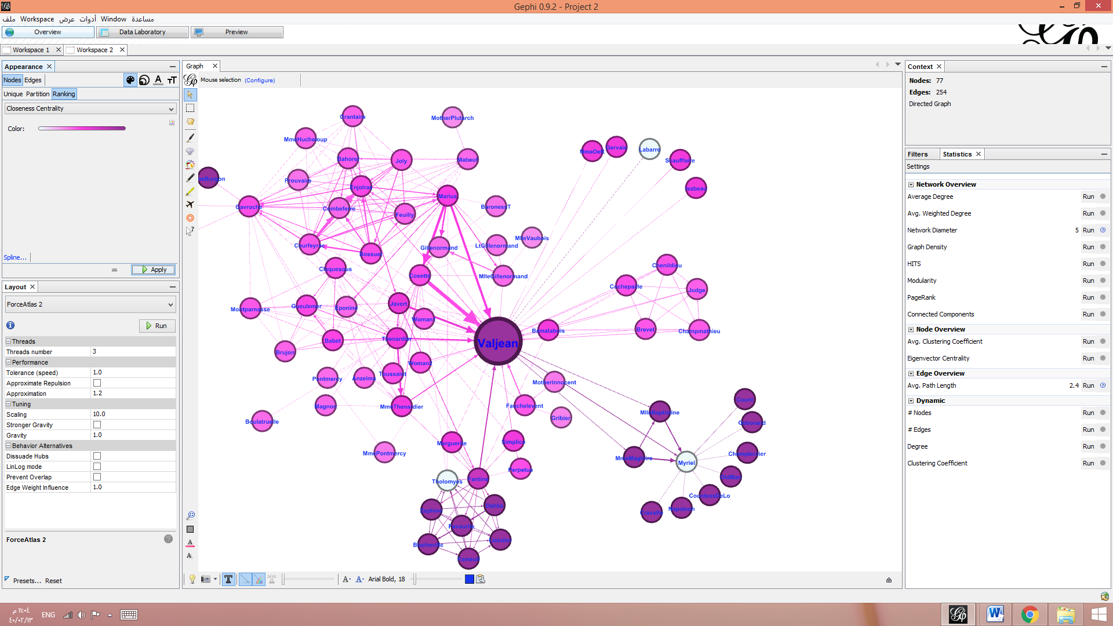

It is difficult to identify the second most important node, after Valjean node, but most likely will be "Javert".

The secondary character is far to be centralities betweenness and Closeness such as "Jondrette" and " MotherPlutarch ".

Degree centrality: is assigns an importance score based purely on the number of links held by each node.

