An Internship Report On

“**Intern Software Engineer**” **at Nybsys (Pvt.) Ltd.**



This Report is submitted to the Department of Information and Communication Technology, Islamic University, Kushtia-7003,Bangladesh in partial fulfillment of the requirement for the degree of M.Sc.(Engg.) in Information and Communication Technology.

### Submitted By

Md Monayem Islam

Roll: 191834

Reg. No: 1309

Session: 2019-2020 (M.Sc. Engg.)

Dept. of Information and Communication Technology Islamic University, Kushtia-7003, Bangladesh.

#### Under the guidance of Anisuzzaman Khan (Trainer) & Ziasmin Akter

**HR Manager Nybsys (Pvt.) Ltd.**



21/2A Extension Pallabi, Mirpur-6, Dhaka-1216, Bangladesh.

# Declaration

We do hereby declare that the internship entitled “**Intern Software Engineer**” embodies the results of our own research work, prepared to fulfill the requirement of the degree of M.Sc.(Engg.) in the Department of Information and Communication Technology, Islamic University, Kushtia, Bangladesh.

We further affirm that the work reported in this internship is original and part or whole of the report has not been submitted to any degree or any other purpose.

Sincerely yours,

#### Md. Monayem Islam(191834) Mst. Tanjima Tabassum (191841) Ivin Ara Akhi(191842)

Session: 2019-2020 M.Sc.(Engg.)

Dept. of Information and Communication Technology Islamic University, Kushtia-7003,Bangladesh.

**Submission Letter**

To Chairman

Department of Information and Communication Technology Islamic University, kushtia-7003,Bangladesh.

**Subject:** Submission of Internship Report on “**Intern Software Engineer**”.

Dear Sir,

We are very glad to submit you an Internship Report titled **“Intern Software Engineer**” at **Nybsys (Pvt.) Ltd.** We have tried our best to prepare and complete the report with relevant data, which have been collected during two weeks of Internship programs on **“Intern Software Engineer”.**

We hope that you would be kind enough to receive this report and bless us heartily.

Sincerely yours,

#### Md. Monayem Islam (191834) Mst. Tanjima Tabassum (191841) Ivin Ara Akhi (191842)

Session: 2019-2020 M.Sc.(Engg.)

Dept. of Information and Communication Technology Islamic University, Kushtia-7003,Bangladesh.

Certificate

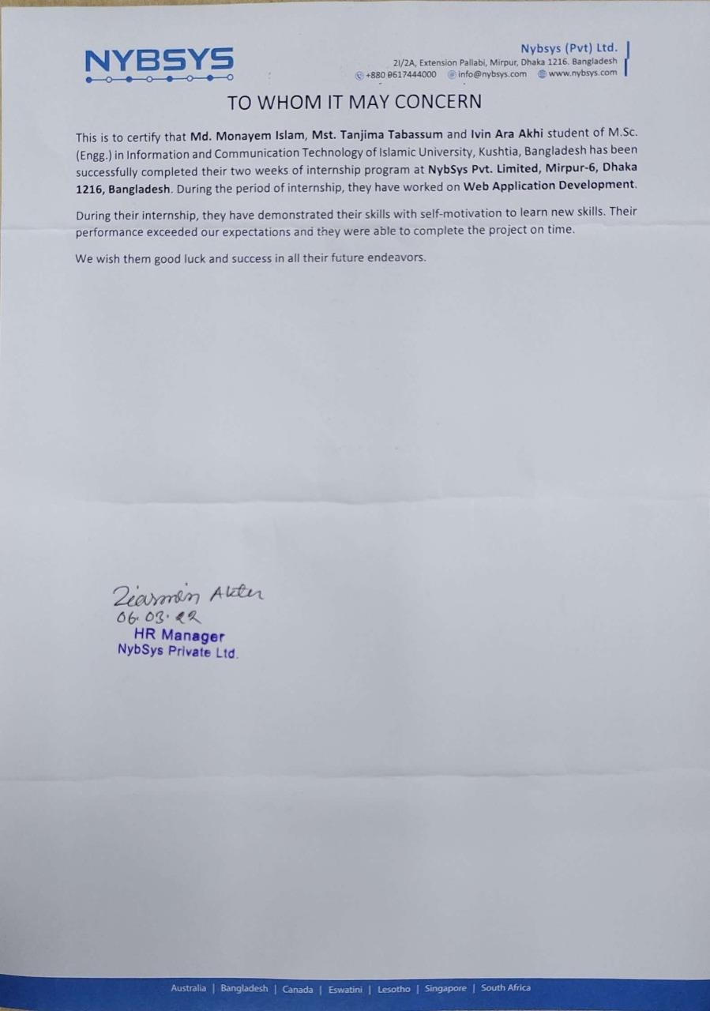

## Acknowledgement

First of all I remember the Almighty Allah for giving me opportunity and patience to carry on and complete this internship work successfully.

I would like to express my special thanks of gratitude to my trainer Anisuzzaman Khan as well as the Nybsys (Pvt.) Ltd. who gave me the golden opportunity to do this wonderful internship on the topic Text and real life industry project and culture, which also helped me in doing a lot of Research and I came to know about so many new things. I am really thankful to them.

Secondly I would also like to thank my family and friends who helped me a lot in finishing this internship within the limited time. I would like to extend my sincere appreciation to Md.Monayem Islam and Ivin Ara Akhi.

I am really thankful to all of them who directly or indirectly contribute to my internship.

# Abstract

The Use of Information and Communication Technology at **Nybsys (Pvt.) Ltd**. is a significant issue for its growth and stability. During our internship period at **Nybsys (Pvt.) Ltd.** we have investigated opportunities where technology could be effectively used. If a technology strategically fits the company’s technology and business objectives, we recommend ways to integrate and commercialize it. The technologies we investigated were at various stages of development: some are available today but others are one to two years away from being commercially available. This report describes new and evolving technologies that can enhance the performance of existing tools or aid in the development of a new generation of tools at **Nybsys (Pvt.) Ltd.** which gather our knowledge about the IT industry. We have successfully completed our two weeks internship as a member of an “**Intern Software Engineer”.** In this work ,we are able to manage Web application, website development, web programming ,Hardware troubleshooting, Data recovery, Internal Communication, Antivirus setup, Virus scan, Open office, Internet phone connection or Configuration, Printer setup, Basic Linux commands.

## Table of Content

**Chapter One Introduction**

* 1. Introduction 8
  2. Motivation 9
  3. Objectives 9
  4. Scope of study 9
  5. Limitations 10
  6. Hardware Troubleshooting & Maintenance 10
  7. Network Connectivity 11
  8. Software Development Life Cycle(SDLC)… 12

Chapter Two

Nybsys (Pvt.) Ltd. Overview

* 1. Overview 13
  2. Mission 13

Chapter Three

Acquired Knowledgement

* 1. Web Development 15
  2. Linux 16
  3. REST API… 19

Chapter Four

Recommendations And Conclusion

* 1. Recommendations 21
  2. Conclusion 21

**Chapter- One**

Introduction

## Introduction

Through the internship I have got to know the real working environment that was highly particular for my course study. I am really happy to work in the department to know about how a software industry develops the software products as applications used by various functional requirements. I am assigned as an intern software engineer in **Nybsys (Pvt.) Ltd .**My responsibilities are to develop the website and web applications. I have attended the project discussion meeting and they define my responsibilities for the project. I have also attended and contributed to database design for the project. Those experiences increase my knowledge and improve my confidence and prepare myself for the next project. I have faced many problems in my internship period. My team members help me to overcome the problems both technical and non-technical. I also attend some client meetings and collect the requirements for the projectAll my experience helps me to get parts like group work and working with a team. I also get the flavor of working in a corporate field. Thus, the internship duration period provides me with the opportunity to enlarge my knowledge, acknowledge the strength and weakness that will be helpful for my future career. I really feel proud to be a student of the department of Information and Communication Technology, Islamic University, Kushtia-7003,Bangladesh. I am also thankful to the **Nybsys (Pvt.) Ltd.,**they provide me the opportunity to work with them and they make me a part of their developer team, and give me a chance to utilize my theoretical knowledge and experience in the real-life project.

## Motivation

Internship program provides me an opportunity to enlarge my skills, gather experience through industrial work on advanced production and my goal is to be familiar with the real-life corporate environment. Internship helps me to connect with an organization and provides scope to work with them. Through this engagement I am able to sharpen my knowledge and improve my experience. I am able to learn a lot of technologies both old and new. I always want to be a valuable asset for a renowned company. And I am determined to give my best service for this. Through this internship program I am able to get the proper knowledge about the software industry.

## Objectives

My objective is to join the internship program for gathering industrial environment experience and gather practical and real-life knowledge with direct interaction with customers. My objective is to know the customer requirements and then go through the development. **Nybsys (Pvt.) Ltd.** has strengthened Quality Management practices since its inception. They help me to do my job by following the industrial rules and regulations. I am preparing to do a project with a group and team, and also get the knowledge on how to develop a project properly.

### Scope of study

The goal is to prepare me as a Software engineer with various dimensions of Software. And I am doing my activities as an intern to be a Software Engineer. I am also getting and learning the official responsibility to maintain the time and deliver my activities in due time. It helps me to improve my communication and data exchange.

* + - Learn how to maintain and follow the official rules.
    - To solve real life problems.
    - Know the business pattern & develop the software.
    - Deliver product and official presentation.
    - Training about the new applications.
    - Coding is not only the profession.
    - It's the passion where one should never compromise.

### Limitations

While gathering information, analyzing and representing them we have faced some limitations. However, despite the limitations we have tried hard to prepare a comprehensive and rather interesting report. The overall limitations of the report are mentioned below:

* Some statistical and qualitative data that were needed were not fully obtained.
* I could not put or disclose some information in the report.

### Hardware Troubleshooting & Maintenance

Hardware troubleshooting is the process of reviewing, diagnosing and identifying operational or technical problems within a hardware device or equipment. It aims to resolve physical and/or logical problems and issues within computing hardware. Hardware troubleshooting is done by hardware or technical support technician.

Hardware troubleshooting is generally done on hardware equipment installed within a computer, server, laptop or related device.

Some processes within hardware troubleshooting include:

* Removing, repairing and replacing faulty RAM, hard disk or video/graphic card.
* Cleaning dust from RAM and Video carts slot/ports and from cooling fan.
* Tightening cable and jumpers on motherboard and/or components.
* Software related hardware problems such as device driver update or installation.

## Network connectivity

Network connectivity is also a kind of metric to discuss how well parts of the network connect to one another. Related terms include network topology, which refers to the structure and makeup of the network as a whole.

There are many different network topologies including hub, linear, tree and star designs, each of which is set up in its own way to facilitate connectivity between computers or devices. Each has its own pros and cons in terms of network connectivity.

IT professionals, particularly network administrators and network analysts, talk about connectivity as one piece of the network puzzle as they look at an ever- greater variety of networks and the ways networking pieces go together.

Ad hoc networks and vehicular networks are just two examples of new kinds of networks that work on different connectivity models. Along with network connectivity, network administrators and maintenance workers also have to focus on security as a major concern, where the reliability of networking systems is closely related to protecting the data that is kept within them.

### Software Development Life Cycle (SDLC)

Software Development Life Cycle (SDLC) is a process used by the software industry to design, develop and test high quality software. The SDLC aims to produce high-quality software that meets or exceeds customer expectations, reaches completion within times and cost estimates’ is the acronym of Software Development Life Cycle.

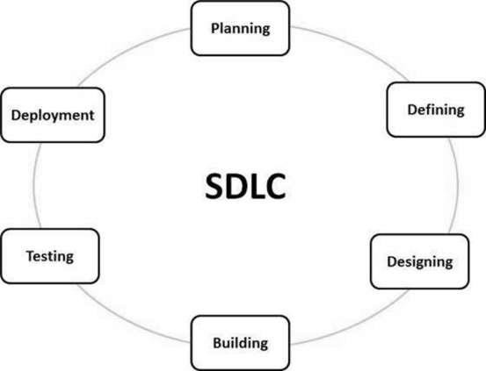

## Chapter-Two

Nybsys (Pvt.) Ltd. Overview

#### Overview

**Nybsys** is a dynamic ICT service company having operations in Australia, Bangladesh, Singapore, South Africa, Swaziland, Lesotho. NybSys specializes in combining cutting-edge technology with proven business expertise to provide our clients with turn-key service solutions – innovative combinations of software, hardware, training and people that deliver tremendous impact on a client's business. The cornerstone of our success has been innovation, and NybSys maintains not only a team of 30 software engineers, but also two laboratories for testing hardware and communication solutions. As well as developing customised solutions for clients, NybSys currently offers two very successful service products: our Central Deduction Administration System (CDAS) service for the government and financial sector, and our Direct Trader Input (DTI) services for the Customs & Excise sector.NybSys's strength lies in its ability to integrate a wide range of services into a single, simple package tailored to each client's needs. This package can include any or all of business analysis, software design and development, hardware and communications solution design, procurement, training, technical & helpdesk support, data-entry staff and customer-service staff.

**Nybsys (Pvt.) Ltd.**is a startup company based on real world problem solutions. **Nybsys (Pvt.) Ltd.** carries its history and culture by its name. **Nybsys (Pvt.) Ltd.** has a cherished dream to compete with world largest tech giants like Google, Amazon, Microsoft, Apple, Facebook. If we validate tech giant such as,

➔ Apple : Created a different reality

➔ Google : Platform

➔ Microsoft : GUI & UX

➔ Amazon : Retailer

➔ Alibaba : Delivery channel

➔ Met averse : Social activity

* 1. **Mission**

The mission of **Nybsys (Pvt.) Ltd.**is to build up quality full ERP software for garments industry as far as local industry and provides Domain and hosting, web design and development, E-commerce solutions, Graphics design services, Android app development, School management software, Hospital management software. Besides reducing dependency from AWS, Google cloud, Microsoft AZURE, and Oracle. Slogan of **Nybsys (Pvt.) Ltd.**is:

* + - Digitally and truly yours
    - One-stop solution
    - Engineered for excellence
    - Technology made simple
    - Better designs and functions
    - Fast and reliable
    - The only compatible partner
    - Networking made easier
    - The future is here
    - Innovation explored

## Chapter-Three Acquired Knowledge

#### Web Development

Web development is the work involved in developing a website for the Internet or an intranet. Web development can range from developing a simple single static page of plain text to complex web applications, electronic businesses, and social network services. Here I have gathered experience as full stack developer who who can develop both **client** and **server** software. In addition to mastering HTML and CSS, he/she also knows how to:

* + - Program a **browser** (like using JavaScript, jQuery, Angular, or Vue)
    - Program a **server** (like using PHP, ASP, Python, or Node)
    - Program a **database** (like using SQL, SQLite, or MongoDB)

#### Advantages

The advantage of being a full stack web developer is:

* + - We can master all the techniques involved in a development project
    - We can make a prototype very rapidly
    - We can provide help to all the team members
    - We can reduce the cost of the project
    - We can reduce the time used for team communication
    - We can switch between front and back end development based on requirements
    - We can better understand all aspects of new and upcoming technologies

#### Disadvantages

* + - The solution chosen can be wrong for the project
    - The solution chosen can be dependent on developer skills
    - The solution can generate a key person risk
    - Being a full stack developer is increasingly complex
  1. **Linux**

Linux is a family of free and open-source operating systems based on the Linux kernel. Operating systems based on Linux are known as Linux distributions or distros. Examples include Debian, Ubuntu, Fedora, CentOS, Gentoo, Arch Linux, and many others. The Linux kernel has been under active development since 1991 and has proven to be extremely versatile and adaptable. You can find computers that run Linux in a wide variety of contexts all over the world, from web servers to cell phones. Today, 90% of all cloud infrastructure and 74% of the world’s smartphones are powered by Linux.

However, newcomers to Linux may find it somewhat difficult to approach, as Linux filesystems have a different structure than those found on Windows or macOS. Additionally, Linux-based operating systems depend heavily on working with the command-line interface, while most personal computers rely on graphical interfaces.

This guide serves as an introduction to important command-line concepts and skills and equips newcomers to learn more about Linux.

#### Basic Linux Commands

Now, let us look at the most important 20 commands in Linux. Linux commands are case sensitive hence you need to be careful about what you are keying in.

1. ls –List directory contents. If you know windows you would know that the command dir is used to list the contents in a directory. In Linux, the *ls* command is used to list out files and directories. Some versions may support color-coding. The names in blue represent the names of directories.
2. cd /var/log –

Change the current directory. The forward slash is to be used in Linux. The example is a Linux directory that comes with all versions of Linux.

When you use *ls –I* you will be able to see more details of the contents in the directory. It will list down the

* + Permissions associated with the file
  + The owner of the file
  + The group associated with the file
  + The size of the file
  + The time stamps

1. grep –

* The name of the file

Find text in a file. The *grep* command searches through many files at a time to find a piece of text you are looking for.

1. su / sudo command –

There are some commands that need elevated rights to run on a Linux system. So, you run them as a System Administrator which normal users cannot do.

***su*** command changes the shell to be used as a super user and until you use the exit command you can continue to be the super user

***sudo* –** if you just need to run something as a super user, you can use the **sudo** command. This will allow you to run the command in elevated rights and once the command is executed you will be back to your normal rights and permissions. Example – shutdown command the shutdown command safely turns off the computer system.

* + *sudo shutdown 2* – shutdown and turns of the computer after 2 minutes
  + *sudo shutdown –r 2* – shuts down and reboots in 2 minutes
  + Using *ctrl C* or *shutdown –c* helps in stopping the shutdown process.

1. pwd – Print Working Directory

One way to identify the directory you are working in is the *pwd* command. It displays the current working directory path and is useful when directory changes are often

1. passwd –

Though looks similar to the *pwd* command the role it plays is different. This command is used to change the user account password. You could change your password or the password of other users. Note that the normal system users may only change their own password, while *root* may modify the password for any account.

*passwd [username]* - changes the password for the user.

1. mv – Move a file

To move a file or rename a file you would use the *mv* command. Here the file name gets changed from *first.txt* to *second.txt.* Type ***ls*** to view the change

1. cp – Copy a file

*cp source file destination file*. In case you need a copy of the file *second.txt*

in the same directory you have to use the *cp* command 9.rm – Remove files

This command is used to remove files in a directory or the directory itself. A directory cannot be removed if it is not empty.

*rm [name of the file]*

*rm –r* removes all the contents in a directory and the directory as well.

1. mkdir- to make directory.

*mkdir [directory name]* if you would like to create a directory in the name ‘myproject’ type *mkdir myproject*

1. chmod -

To change mode of a file system object. Files can have r – read, w- write and x-execute permissions.

For example:

* + *chmod mode FILE*
  + *chmod 744 script.sh*
  + The first number stands for the user who is associated with the file
  + The second number is for the group associated with the file
  + The third number is associated with everyone else who is not a part of the user or group

1. chown –

This command is used to change the ownership of a file/folder or even multiple files/folders for a specified user/group.

*chown owner_name file_name.*

#### REST API What is API?

An API is a set of definitions and protocols for building and integrating application software. It’s sometimes referred to as a contract between an information provider and an information user—establishing the content required from the consumer (the call) and the content required by the producer (the response). For example, the API design for a weather service could specify that the user supply a zip code and that the producer reply with a 2-part answer, the first being the high temperature, and the second being the low.

In other words, if you want to interact with a computer or system to retrieve information or perform a function, an API helps you communicate what you want to that system so it can understand and fulfill the request.

You can think of an API as a mediator between the users or clients and the resources or web services they want to get. It’s also a way for an organization to share resources and information while maintaining security, control, and authentication—determining who gets access to what.

Another advantage of an API is that you don’t have to know the specifics of caching—how your resource is retrieved or where it comes from.

#### REST

REST is a set of architectural constraints, not a protocol or a standard. API developers can implement REST in a variety of ways. When a client request is made via a RESTful API, it transfers a representation of the state of the resource to the requester or endpoint. This information, or representation, is delivered in one of several formats via HTTP: JSON (Javascript Object Notation), HTML, XLT, Python, PHP, or plain text. JSON is the most generally popular file format to use because, despite its name, it’s language-agnostic, as well as readable by both humans and machines. Something else to keep in mind: Headers and parameters are also important in the HTTP methods of a RESTful API HTTP request, as they contain important identifier information as to the request's metadata, authorization, uniform resource identifier (URI), caching, cookies, and more. There are request headers and response headers, each with their own HTTP

connection information and status codes. In order for an API to be considered RESTful,it has to conform to this criteria:

* resources can be manipulated by the client via the representation they receive because the representation contains enough information to do so.
* self-descriptive messages returned to the client have enough information to describe how the client should process it.
* hypertext/hypermedia is available, meaning that after accessing a resource the client should be able to use hyperlinks to find all other currently available actions they can take.
* A layered system that organizes each type of server (those responsible for security, load-balancing, etc.) involved the retrieval of requested information into hierarchies, invisible to the client.
* Code-on-demand (optional): the ability to send executable code from the server to the client when requested, extending client functionality.

# Chapter - 4

### RECOMMENDATIONS and CONCLUSIONS

### RECOMMENDATIONS

A lot of fresh graduates are joining and the company is becoming very powerful day by day. The talented young generation can take the company a long way. They are already developing the software for us and exporting abroad. Through outsourcing and freelancing a lot of young people are getting their own wages. The new firms can be formed to improve the industry. But there are many obstacles too. As a developing third world country we face a lot of unwanted conditions. We have to overcome those and make the software industry one of most powerful in the world. Our suggestions are. The government should take proper steps to make the way for new start-ups. Young people should form their own firm. Business magnets should invest more in this sector. The ICT act should be more flexible for the developers. The business rules should be easier for the software industry.

* 1. **CONCLUSIONS**

The total period while we were visiting **Nybsys (Pvt.) Ltd.**was very pleasant to us. It will help me a lot in future life. Without practical knowledge it is quite impossible to develop quality software. This internship has extended the way to look into the development environment and marketplace. The market does not depend on only developing quality applications. There are a lot more things than that. First, we have to specify what we have to develop, for whom, why and how. Understanding the user’s mind and their requirements a software engineer has to think about new software. They gave me a lot of good advice that I will take with me as I prepare to enter the workforce after graduation. The age is totally dependent on modern information technologies. Nobody can escape from it. Our one step to invent new technology can take the whole world a step forward.