VIRTUAL UNIVERSITY OF PAKISTAN
Department of software Engineering


FINAL PROJECT REPORT

Website for VU Sports Society

(Flask-Based Web Application)

Group ID | F25PROJECTF3ABD
Student ID | BC220416508
Supervisor | Abdur Rafay
Course | CS619 - Final Year Project
Semester | Fall 2025
Submission Date | 2026

Software Projects & Research Section
Department of software Engineering
Virtual University of Pakistan

CERTIFICATE

This is to certify that BC220416508 has worked on and completed the Software Project titled "Website for VU Sports Society" at the Software & Research Projects Section, Department of Computer Sciences, Virtual University of Pakistan, in partial fulfillment of the requirement for the degree of BS in Computer Sciences, under the guidance and supervision of Mr. Abdur Rafay.
In our opinion, the project is satisfactory and up to the mark, and therefore fulfills the requirements of BS in Computer Sciences.

Supervisor / Internal Examiner
Mr. Abdur Rafay
Supervisor, Software Projects & Research Section
Department of Computer Sciences, Virtual University of Pakistan

___________________
(Signature)

External Examiner / Subject Specialist
_______________________
___________________
(Signature)

Accepted By:
_____________ (For office use)

EXORDIUM
In the name of Allah, the Compassionate, the Merciful.
Praise be to Allah, Lord of Creation,
The Compassionate, the Merciful,
King of Judgment-day!
You alone we worship, and to You alone we pray for help,
Guide us to the straight path,
The path of those who You have favored.

DEDICATION
This project is dedicated to my parents and family, whose endless support, prayers, and encouragement have been the driving force throughout my academic journey. It is also dedicated to my respected supervisor Mr. Abdur Rafay, whose guidance and mentorship have been invaluable, and to all students and sports enthusiasts at Virtual University of Pakistan who inspired the development of this platform.

ACKNOWLEDGEMENT
All praise and gratitude are due to Almighty Allah, the most gracious and merciful, who blessed me with the knowledge, ability, and perseverance to complete this project.
I would like to express my heartfelt gratitude to my supervisor, Mr. Abdur Rafay, for his continuous guidance, constructive feedback, and unwavering support throughout this project. His expertise in software engineering and web development greatly contributed to shaping this project into its final form.
I am also deeply thankful to the faculty members and staff of the Department of Computer Sciences at Virtual University of Pakistan for their constant encouragement and academic support.
Finally, I extend my appreciation to all participants and sports enthusiasts at Virtual University who provided insight and inspiration for developing this platform.

PREFACE
This Final Report documents the complete development lifecycle of the "Website for VU Sports Society," a Flask-based web application developed as part of the CS619 Final Year Project at Virtual University of Pakistan for Fall 2025.
The VU Sports Society plays a vital role in promoting physical activity, sportsmanship, and a healthy lifestyle among students and staff. However, the traditional manual approach to managing sports events, team registrations, and communications led to significant inefficiencies. This project was conceived to address these challenges by providing a centralized, digital platform.
This report is organized into three main chapters: Chapter 1 covers requirements gathering and analysis including functional and non-functional requirements, use cases, and development methodology. Chapter 2 presents the complete system design including architecture, class diagrams, database design, and interface designs. Chapter 3 documents the development, testing, and deployment of the final application.

CHAPTER 1
GATHERING & ANALYZING INFO

1.1 Introduction
The VU Sports Society website is a dynamic, web-based application developed using the Python Flask framework. It is designed to modernize and streamline the management of all sporting activities at Virtual University of Pakistan. The platform serves as a central digital hub for Participants, Coaches/Team Leaders, and Administrators, bringing together event management, team coordination, performance tracking, and communication into one unified system.
The system eliminates the inefficiencies of manual sports management by automating processes such as event registration, team formation approval, and performance reporting. Built following the MVC architectural pattern, the application ensures scalability, maintainability, and a seamless user experience across devices.

1.2 Purpose
The purpose of this project is to architect and develop a comprehensive sports management solution for Virtual University. The system aims to:
- Provide a centralized platform for all sports-related activities at VU
- Automate manual processes such as registration, team formation, and event scheduling
- Enable effective communication between participants, coaches, and administrators
- Track individual and team performance through statistics and leaderboards
- Ensure secure, role-based access control for all users

1.3 Scope
The VU Sports Society Website covers the following scope:
- User registration and authentication for Participants, Coaches, and Administrators
- Event creation, scheduling, and participant registration
- Team formation, management, and coach-approval workflows
- Performance tracking with personal and team statistics and leaderboards
- Real-time messaging and communication between users
- Administrative controls including user management, reporting, and notifications
- Responsive design compatible with desktop, tablet, and mobile devices
The system does NOT include integration with external payment gateways, live video streaming, or third-party social media platforms.

1.4 Definitions, Acronyms and Abbreviations
Term / Acronym | Definition
VU | Virtual University of Pakistan
FYP | Final Year Project
Flask | A lightweight Python web micro-framework
MVC | Model-View-Controller – architectural pattern
SRS | Software Requirements Specification
ERD | Entity Relationship Diagram
HTTPS | Hyper Text Transfer Protocol Secure
SQL | Structured Query Language
SQLite | Lightweight relational database used in development
PostgreSQL | Production-grade relational database
GDPR | General Data Protection Regulation
UI/UX | User Interface / User Experience
XSS | Cross-Site Scripting – a web vulnerability
API | Application Programming Interface
CMS | Content Management System

1.5 Project Requirements

1.5.1 Functional Requirements
Functional requirements define what the system must do:
For Participants:
- Register on the platform to access all features
- Login and logout securely using email and password
- Modify profile including sports preferences, past participation, and achievements
- View and register for upcoming sports events (tournaments, friendly matches, fitness sessions)
- Join or create sports teams (football, cricket, badminton, etc.)
- Track personal and team performance through stats and leaderboards
- Communicate with team members, coaches, and event organizers
For Coaches / Team Leaders:
- Register on the platform (requires admin approval)
- Login and logout securely
- Modify profile including sports expertise, team management skills, and availability
- Create and manage teams, assign roles, and coordinate practices or matches
- Review participant profiles and manage team selections
- Communicate with team members, monitor performance, and provide feedback
- Organize events or matches and invite participants
For Administrators:
- Login and logout securely
- Modify profiles of participants, coaches, and team leaders
- Add/delete/block participants, teams, or coaches
- Approve team formations and event registrations
- Schedule sports events and manage event logistics (venues, equipment, timings)
- Send messages and notifications to participants
- Manage sports categories and assign organizers
- View statistics on participation and generate reports

1.5.2 Non-Functional Requirements
Requirement | Description
Performance | The website shall load within 3 seconds even during high traffic conditions.
Scalability | Must support thousands of concurrent users, especially during peak event or membership registration periods.
Availability | Ensure 99.9% uptime with minimal downtime for maintenance or updates.
Security | Use HTTPS for secure communication; encrypt personal data; protect against SQL injection and XSS attacks.
Usability | Intuitive and easy-to-navigate interface suitable for both tech-savvy and less-experienced users.
Compatibility | Compatible with Chrome, Firefox, Safari, and Edge; responsive design for mobile, tablet, and desktop.
Maintainability | Easy content updating through a CMS; modular system design for long-term maintenance.
Compliance | Adhere to legal standards such as GDPR for data privacy and protection.
Localization | Support for multiple languages for international students.
Backup & Recovery | Regular data backups with instant recovery in case of server failure or data loss.

1.6 Use Cases and Usage Scenarios

1.6.1 Use Case Diagrams
The system has three primary actors: Participants, Coaches/Team Leaders, and Administrators. The use case diagram illustrates the interactions between these actors and the system functionalities described in the functional requirements section.

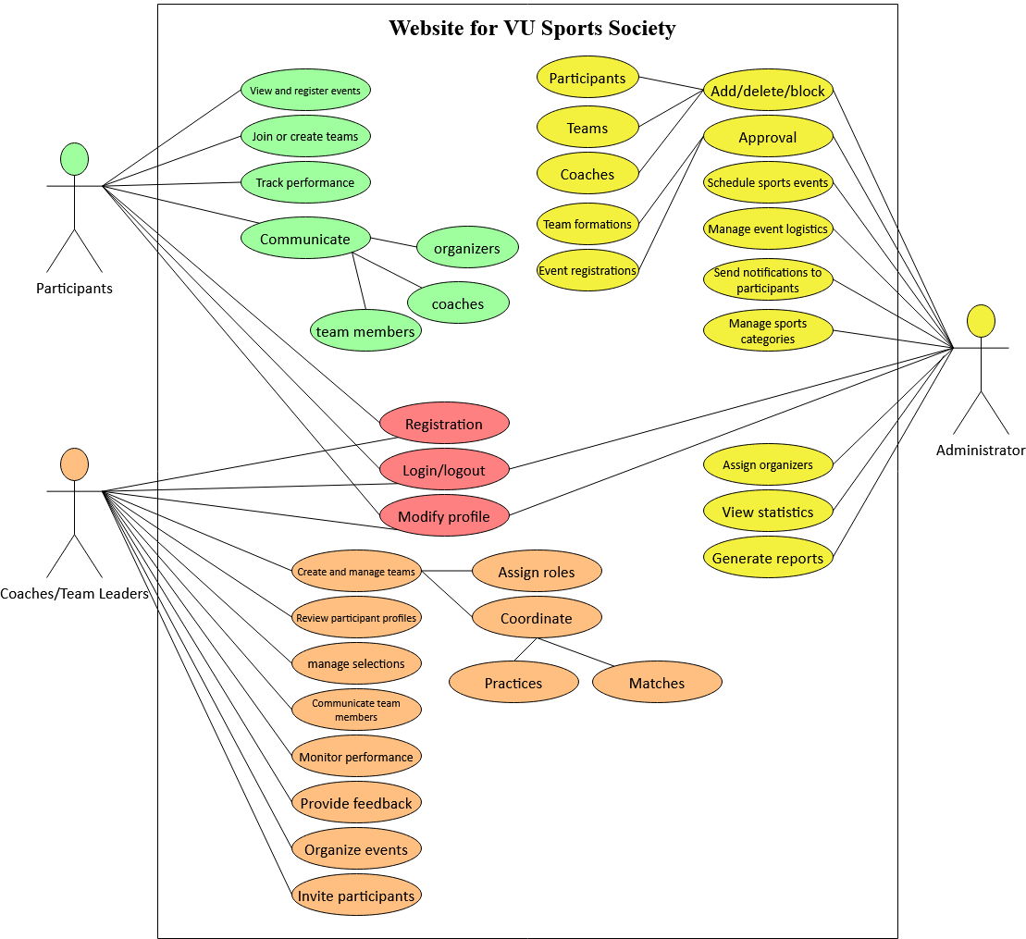

1.6.2 Usage Scenarios
The following use case tables describe the key interactions within the system:

Use Case Title: | Login and Logout
Use Case ID: | UC-01
Actors: | Participants, Coaches/Team Leaders, Administrator
Description: | This use case covers the login and logout functionality for all user types.
Pre-Condition: | The website is running and active with live database.
Actions: | 1. Access the website. 2. Navigate to login section. 3. Enter valid email and password. 4. Click Login button. 5. For logout, select Logout from navigation.
Post-Condition: | Users are successfully authenticated and can access role-specific features. Logout clears the session.
Created: | 01/12/2025 | Author: BC220416508

Use Case Title: | Registration
Use Case ID: | UC-02
Actors: | Participants, Coaches/Team Leaders
Description: | This use case covers the registration process for participants and coaches.
Pre-Condition: | The website is running and accessible. The user does not have an existing account.
Actions: | 1. Access the website. 2. Navigate to registration section. 3. Select role (Participant or Coach/Team Leader). 4. Enter personal details and set password. 5. Agree to terms and click Register. 6. Coach registration requires admin approval.
Post-Condition: | Participant account is immediately active. Coach receives a notification that their account is pending admin approval.
Created: | 01/12/2025 | Author: BC220416508

Use Case Title: | View and Register for Events
Use Case ID: | UC-04
Actors: | Participants
Description: | Participants can view all upcoming sports events and register for them.
Pre-Condition: | Participants are logged in. The system has upcoming sports events listed.
Actions: | 1. Navigate to Events section. 2. View list of upcoming sports events. 3. Select an event to view details. 4. Click Register button. 5. Confirm registration.
Post-Condition: | Participant successfully registers for the event and receives a confirmation notification.
Created: | 01/12/2025 | Author: BC220416508

Use Case Title: | Create and Manage Teams
Use Case ID: | UC-08
Actors: | Coaches/Team Leaders
Description: | Coaches can create new teams, assign roles, and coordinate practices or matches.
Pre-Condition: | Coach/Team Leader is logged in and has been approved by admin.
Actions: | 1. Navigate to Teams section. 2. Click Create Team. 3. Enter team details. 4. Submit to create the team. 5. Manage existing teams by assigning roles and scheduling practices.
Post-Condition: | New team is successfully created. Team members receive notifications about roles and scheduled events.
Created: | 01/12/2025 | Author: BC220416508

Use Case Title: | Admin User Management
Use Case ID: | UC-16
Actors: | Administrator
Description: | Administrator can add, delete, or block participants, teams, or coaches.
Pre-Condition: | Administrator is logged in. The user or team exists in the system.
Actions: | 1. Navigate to User Management section. 2. Search and select the target user or team. 3. Choose Add, Delete, or Block action. 4. Confirm the action.
Post-Condition: | The selected action is successfully performed. Affected users receive appropriate notifications.
Created: | 01/12/2025 | Author: BC220416508

1.7 Development Methodology

1.7.1 Chosen Methodology
The VU Process Model has been chosen for this project. The VU Process Model is a hybrid methodology that combines the sequential structure of the Waterfall Model with the iterative risk-management approach of the Spiral Model.

1.7.2 Reasons for Chosen Methodology
- The project has clearly defined, sequential stages that must be submitted to the supervisor one by one
- The Waterfall component ensures each completed and approved stage becomes the foundation for the next
- The Spiral component allows for iterative error correction and improvement when feedback is received
- The model emphasizes understanding user needs and continuous engagement with end-users
- It breaks development into small, manageable iterations with deliverables at each stage
- This combined approach results in a disciplined yet flexible development lifecycle suitable for academic FYP projects

1.7.3 Work Plan (Gantt Chart)
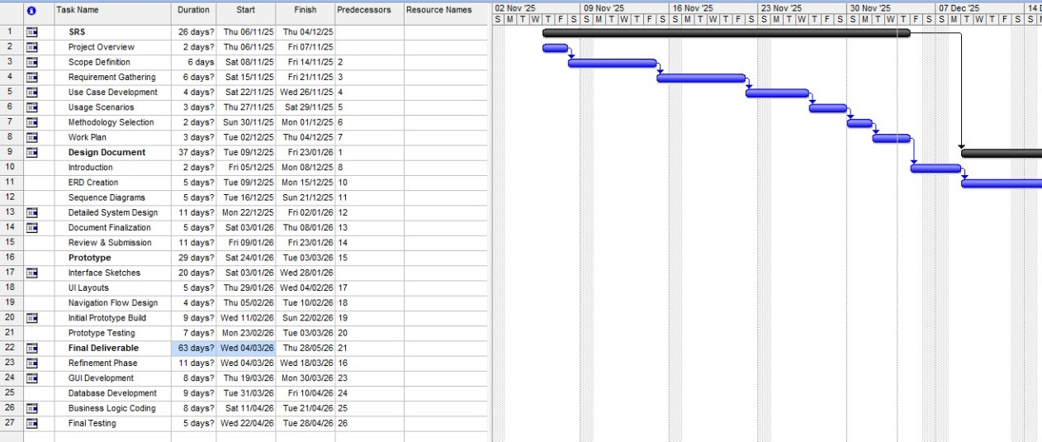

CHAPTER 2
DESIGNING THE PROJECT

2.1 Introduction
This chapter presents the complete technical design of the VU Sports Society Flask-based web application. It translates the requirements gathered in Chapter 1 into concrete, implementable system designs. The design artifacts in this chapter serve as the blueprint for the development phase and provide a structured approach to building a robust, scalable, and maintainable system.

2.2 Purpose
The purpose of this design phase is to architect a detailed solution for the VU Sports Society platform. It defines the system architecture, data models, component interactions, and user interfaces, ensuring all stakeholders have a clear and shared understanding of the system before implementation begins.

2.3 Scope
The design covers the complete system including the backend Flask application, database schema, frontend interface layouts, and the communication flows between all components and user roles.

2.4 Definitions, Acronyms and Abbreviations
Refer to Section 1.4 for a complete list of definitions and acronyms used throughout this document.

2.5 Architectural Representation
The VU Sports Society application follows the Model-View-Controller (MVC) architectural pattern implemented within the Flask micro-framework. This architecture ensures a clear separation of concerns, making the application modular, testable, and scalable.
Technology Stack:
- Backend: Python 3.x with Flask Framework
- Frontend: HTML5, CSS3, JavaScript, Jinja2 Templating Engine
- Database: SQLite (Development) / PostgreSQL (Production)
- Version Control: Git / GitHub
- Authentication: Flask-Login with session-based management
- ORM: SQLAlchemy for database interactions
- Deployment: Configured for production server deployment
The three-tier architecture consists of the Presentation Layer (browser-based HTML/CSS/JS frontend), the Application Layer (Flask server handling business logic and routing), and the Data Layer (relational database storing all system data).

2.6 Dynamic Model: Sequence Diagrams
The sequence diagrams illustrate the interaction flows between the system components for key operations. Each diagram shows how requests flow from the user interface through the Flask controller to the model layer and database.

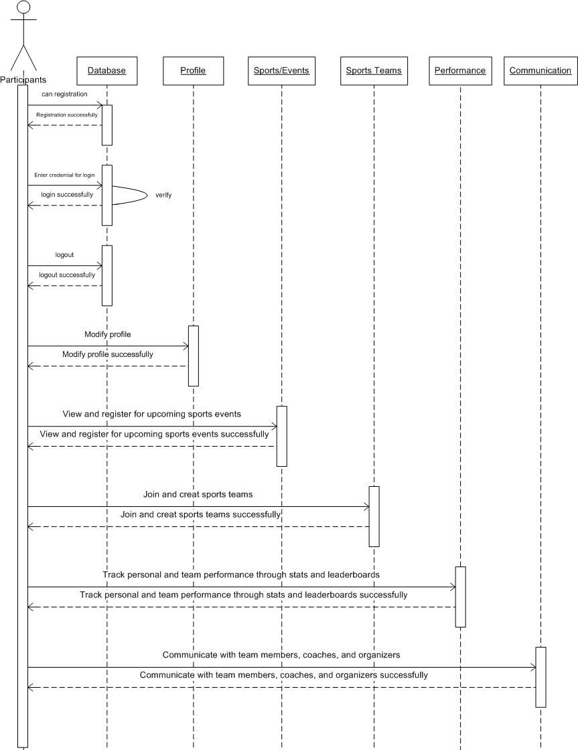

Coach Approval Flow:
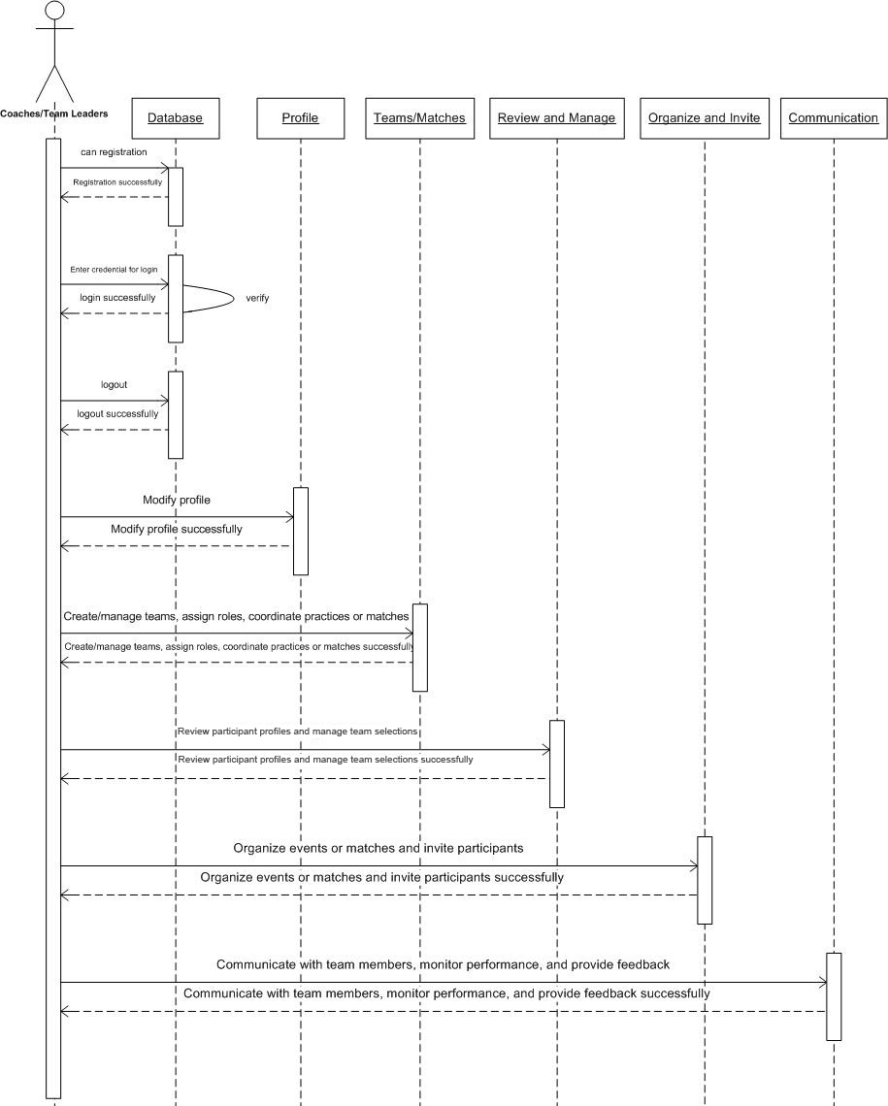

Event Registration Flow:

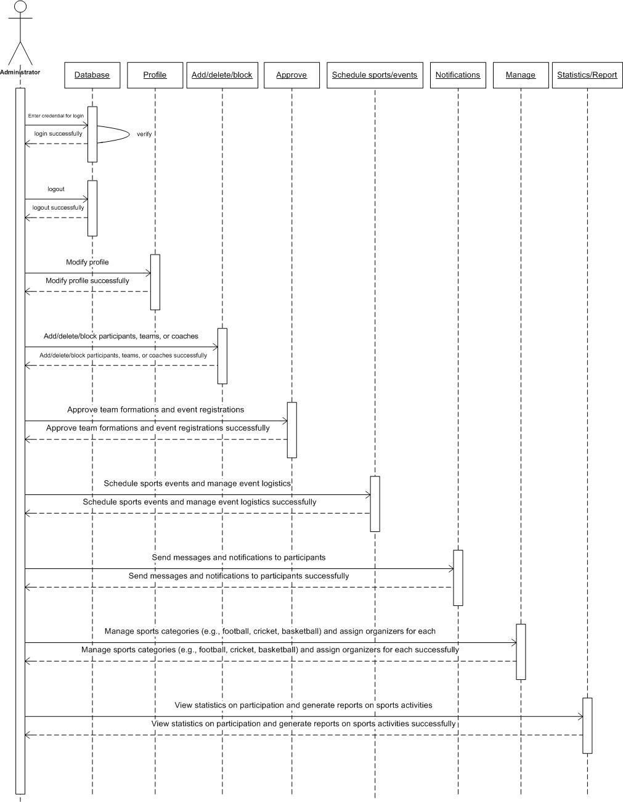

2.7 Object Model / Logical Model: Class Diagram
The class diagram defines the core entities of the system and their relationships. The main classes are:
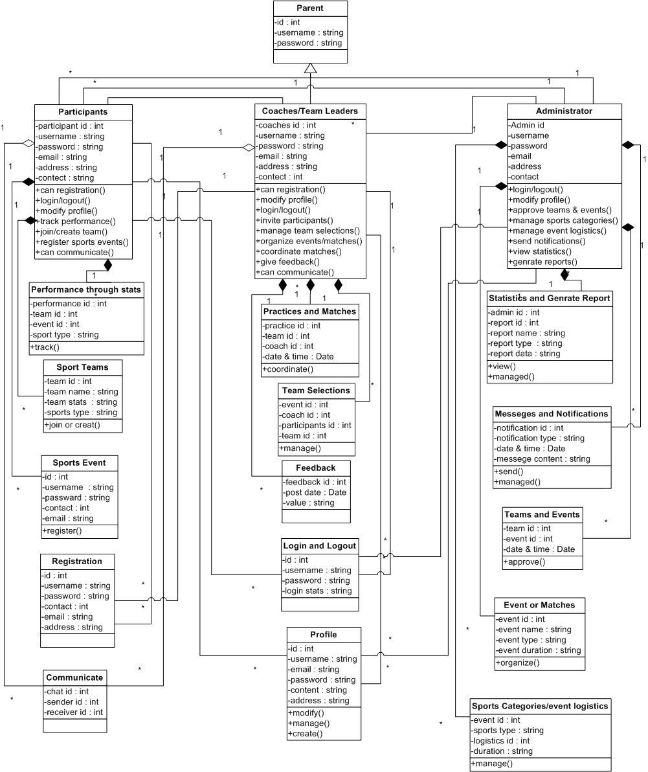
2.8 Database Model (Database Diagram)
The database follows a normalized relational structure. The following tables represent the core data schema:
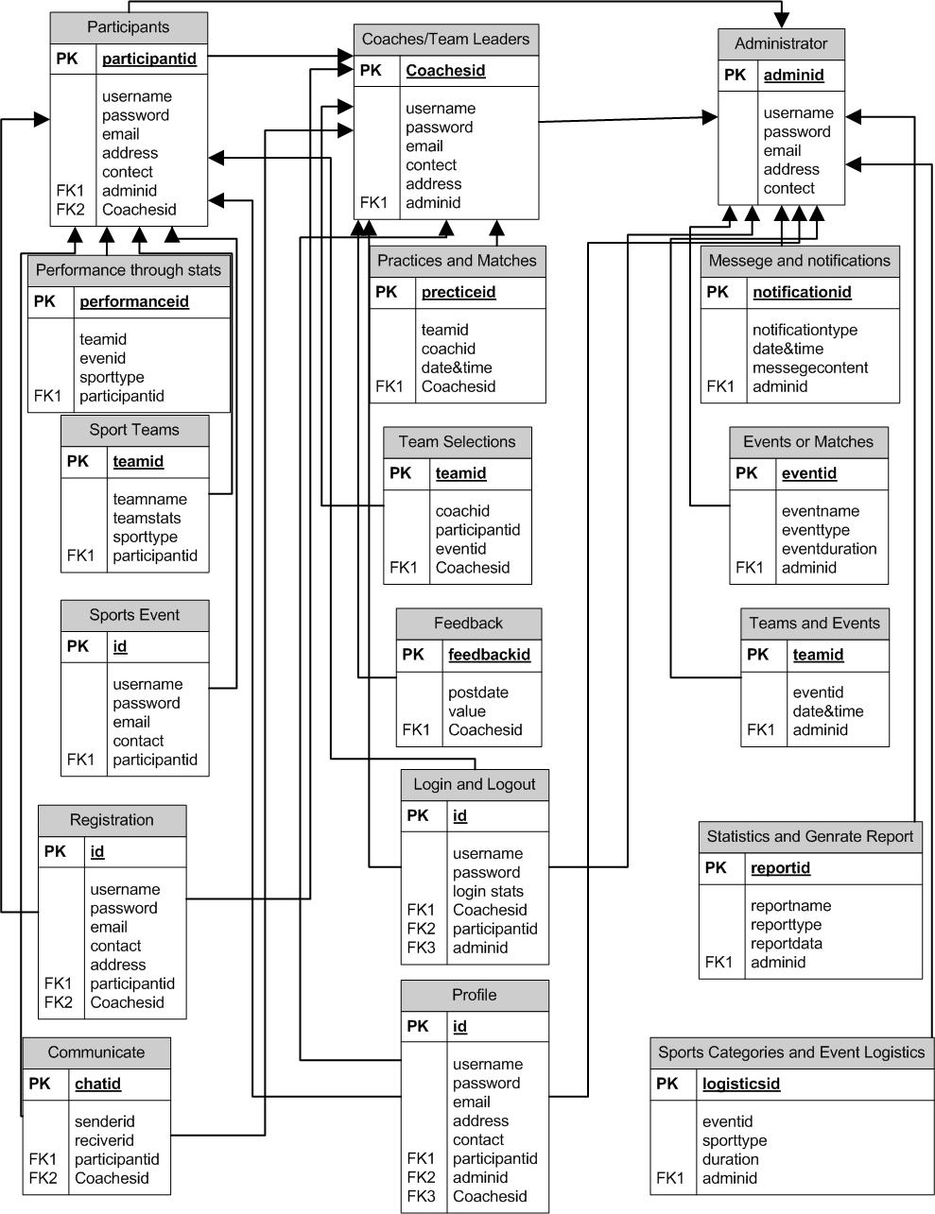

2.9 Graphical User Interfaces
The interface design follows a clean, responsive layout optimized for usability across all devices. Key interface screens include:

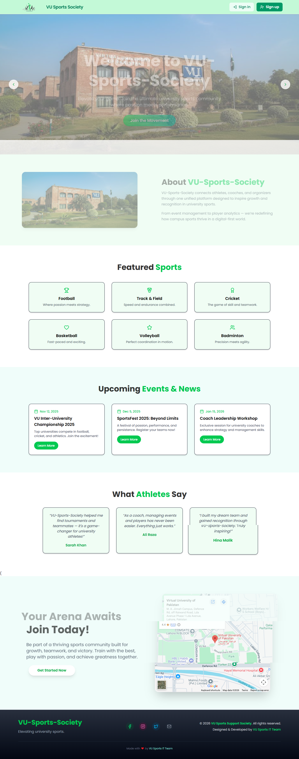

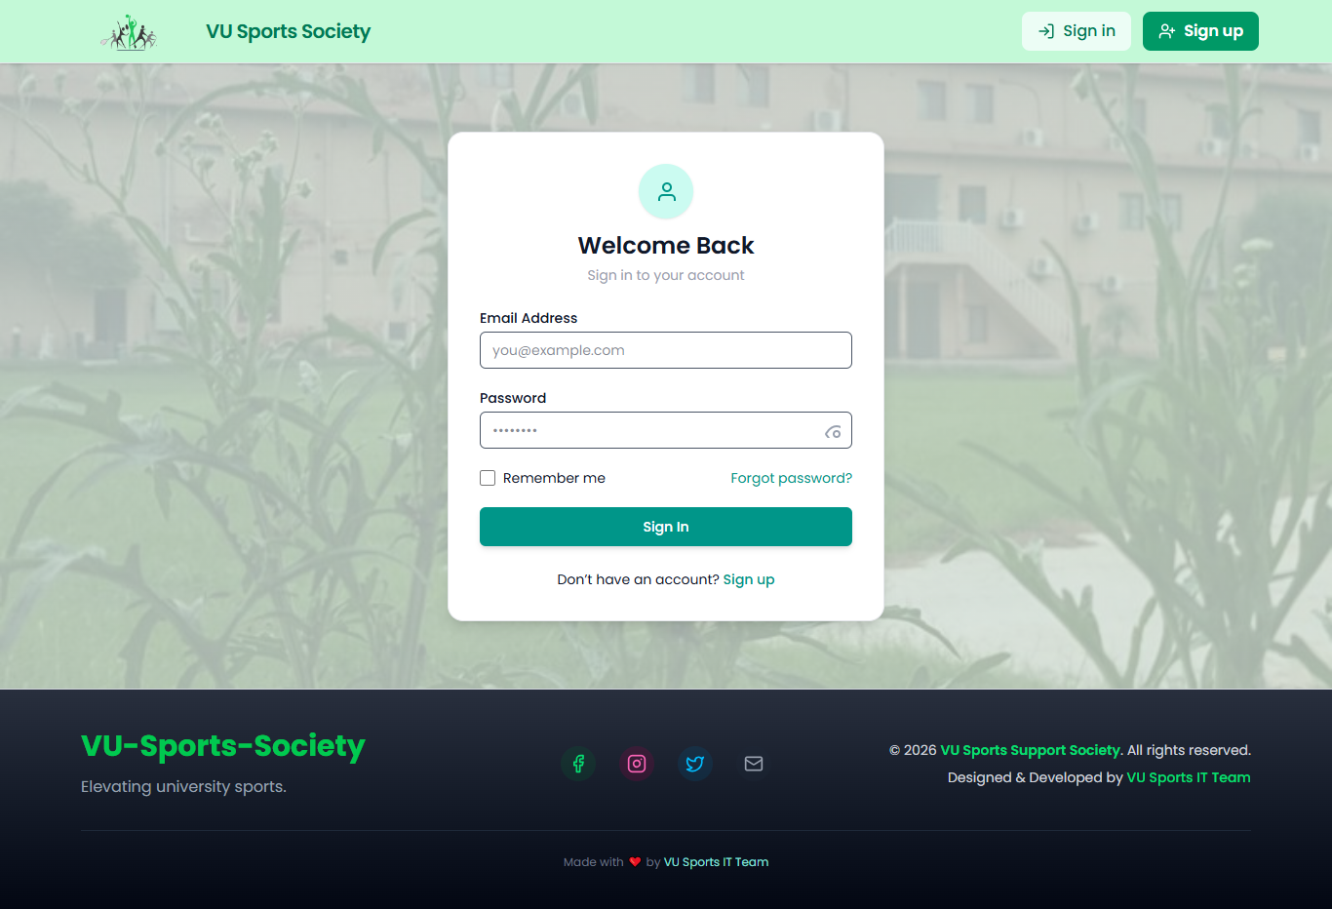

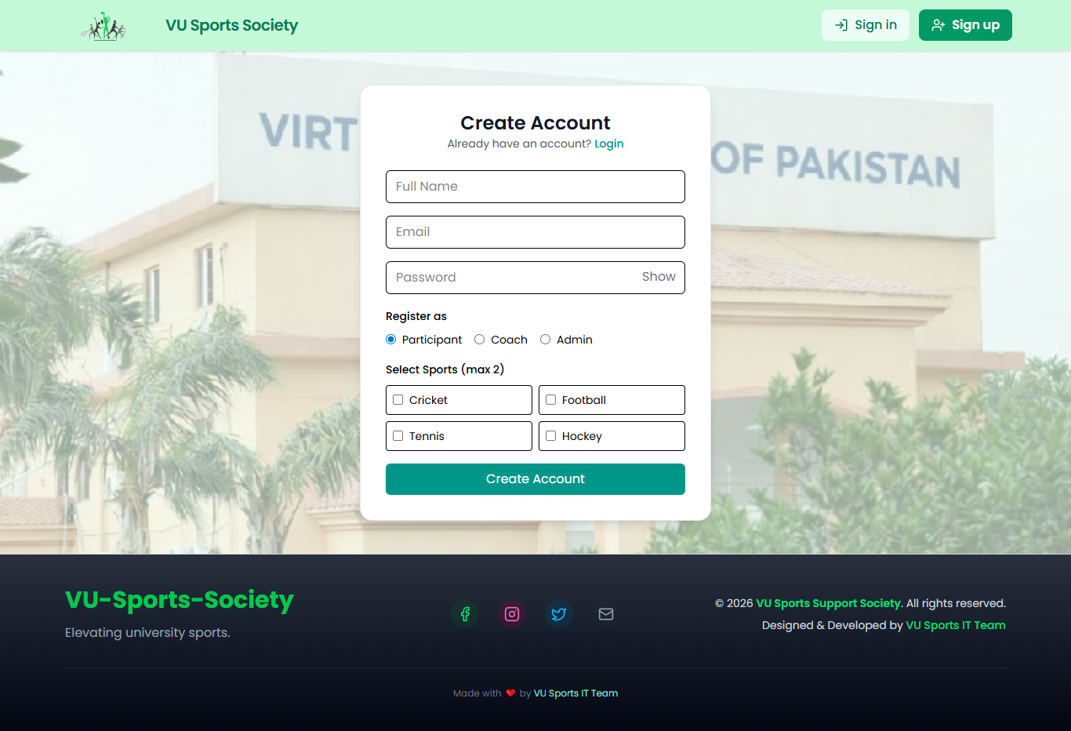

CHAPTER 3
DEVELOPMENT

3.1 Development Plan
The development of the VU Sports Society web application followed the VU Process Model, progressing through clearly defined sequential stages with iterative refinement at each step based on supervisor feedback.

3.2 Technology Implementation

3.2.1 Backend Development
The backend was developed using Python 3.x and the Flask micro-framework. Flask was chosen for its simplicity, flexibility, and the rich ecosystem of extensions available:
- Flask-Login: Manages user sessions and authentication state
- Flask-SQLAlchemy: ORM for database operations, supporting both SQLite and PostgreSQL
- Flask-WTF: Form handling with CSRF protection
- Flask-Mail: Email notification system for registrations and approvals
- Werkzeug: Password hashing and security utilities
The application is structured using Flask Blueprints to organize routes by functionality (auth, participant, coach, admin, events, teams), ensuring clean code organization and maintainability.

3.2.2 Frontend Development
The frontend utilizes HTML5, CSS3, and JavaScript with Jinja2 templating for dynamic content rendering. The responsive design ensures compatibility across desktop, tablet, and mobile viewports:
- Bootstrap framework for responsive grid layout
- Custom CSS for VU Sports Society branding and theme
- JavaScript for form validation, dynamic content loading, and real-time notifications
- Chart.js for performance statistics visualization
- Jinja2 templates with base template inheritance for consistent layout

3.2.3 Database Implementation
The database schema was implemented using SQLAlchemy ORM with SQLite for development and PostgreSQL for production. Database migrations were managed using Flask-Migrate, ensuring version-controlled schema updates throughout development.

3.3 Key Features Implementation
Authentication & Authorization:
Role-based access control was implemented with three distinct user roles. Each role has specific permissions enforced through Flask-Login decorators and database role checks. All passwords are hashed using Werkzeug's generate_password_hash function with salt.
Event Management System:
Events are created by administrators with full details including title, sport type, date, time, venue, capacity, and registration deadline. Participants can browse, filter, and register for events. The system tracks capacity and prevents over-registration.
Team Management:
Coaches can create teams associated with specific sports. Team creation requires admin activation. Participants can request to join teams, and coaches manage member acceptance. The system tracks team rosters, roles, and match schedules.
Communication System:
An internal messaging system allows direct communication between users. Administrators can send broadcast notifications to all users or specific groups. Real-time notification indicators alert users of new messages.
Performance Tracking:
The system records participant performance in events, tracking scores, participation counts, and rankings. A leaderboard feature displays top performers by sport and overall category.

3.4 Testing
Comprehensive testing was conducted throughout the development lifecycle:
# | Test Case | Expected Result | Result | Tested By
1 | Participant views and registers for events | Successful registration with confirmation | Pass | BC220416508
2 | Join or create sports teams | Team membership confirmed; new team visible | Pass | BC220416508
3 | Participant tracks performance | Stats and leaderboard display accurately | Pass | BC220416508
4 | Participant communication | Messages sent and received in real time | Pass | BC220416508
5 | Login / Logout all roles | Successful authentication and session termination | Pass | BC220416508
6 | Profile modification | Profile updated and saved with confirmation | Pass | BC220416508
7 | New participant/coach registration | Account created; coach pending admin approval | Pass | BC220416508
8 | Coach creates and manages teams | Team created; roles assigned; schedule set | Pass | BC220416508
9 | Coach reviews participant profiles | Profiles accessible; team selections updated | Pass | BC220416508
10 | Coach communicates with team | Messages delivered to team members | Pass | BC220416508
11 | Coach monitors performance & feedback | Stats visible; feedback saved for players | Pass | BC220416508
12 | Coach organizes events/matches | Event created; participants receive invitations | Pass | BC220416508
13 | Admin add/delete/block users | Action performed; user notified appropriately | Pass | BC220416508
14 | Admin approves team/event formations | Approved items added to system schedule | Pass | BC220416508
15 | Admin schedules sports events | Event added to calendar with notifications | Pass | BC220416508
16 | Admin manages event logistics | Updated logistics saved and notified | Pass | BC220416508
17 | Admin sends notifications | All targeted users receive the notification | Pass | BC220416508
18 | Admin manages sports categories | Categories updated in system successfully | Pass | BC220416508
19 | Admin assigns organizers | Organizer linked to selected sport category | Pass | BC220416508

3.5 Deployment
The application is configured for deployment on a production server with the following setup:
- PostgreSQL database for production data persistence
- HTTPS enforced for all connections using SSL certificates
- Environment variables used for all sensitive configuration (database URLs, secret keys)
- Database backups scheduled for regular intervals
- Error logging and monitoring configured for production environment

3.6 Conclusion
The VU Sports Society Web Application successfully addresses the challenges of manual sports management at Virtual University of Pakistan. The Flask-based platform provides a comprehensive, role-specific solution for Participants, Coaches, and Administrators, centralizing event management, team coordination, performance tracking, and communication.
All 19 core test cases passed successfully, demonstrating the system's reliability and correctness. The application is responsive, secure, and scalable, meeting all functional and non-functional requirements specified in Chapter 1.
This project demonstrates the effective application of software engineering principles — from requirements analysis through system design to final implementation and testing — following the VU Process Model methodology. The platform is ready to enhance the sports culture and community engagement at Virtual University of Pakistan.

REFERENCES
- Flask Documentation. (2024). Flask Web Development Framework. https://flask.palletsprojects.com
- SQLAlchemy Documentation. (2024). The Python SQL Toolkit and ORM. https://www.sqlalchemy.org
- Virtual University of Pakistan. (2025). CS619 Final Project Guidelines. VU LMS.
- Sommerville, I. (2016). Software Engineering (10th Edition). Pearson Education.
- Pressman, R. S. (2014). Software Engineering: A Practitioner's Approach (8th Edition). McGraw-Hill.
- Bootstrap Documentation. (2024). Responsive Web Framework. https://getbootstrap.com
- PostgreSQL Documentation. (2024). The World's Most Advanced Open Source Database. https://www.postgresql.org

