Flask App for VU Sports Society-Abdur Rafay
Design Document

Version 1.0



Group Id: < F25PROJECTF3ABD
Supervisor Name : Abdur Rafay

Revision History
Date (dd/mm/yyyy) | Version | Description | Author
10/01/2026 | 1.0 | It is a web-based application developed using Flask technology aimed at modernizing the process of managing VU Sports Society. It acts as an online hub that can automate functions such as event organization, registrations for teams, and coordination of participants. It will enable hassle-free interaction between students, trainers, and administrators, thereby increasing efficiency for promoting activities related to sports at Virtual University. | Bc220416508

Table of Contents

- Introduction (of the document)……………………………………………….4
- Entity relationship diagram …………………………8
- Sequence diagram ………………………………………9
- Architecture Design Diagram ……………………………12

- Class diagram .. …………………………………………..13

- Database Design ………………………………………… …14
- Interface Design……………………………………………….15
- Test Cases ……………………………………………………..17

- Introduction of Design Document
This design document provides the complete technical blueprint for the Flask-based VU Sports Society Web Application. It translates the society's operational needs into a structured, implementable system design. The document serves as the single source of truth for developers, testers, and project stakeholders throughout the development lifecycle, ensuring the final product is robust, scalable, and meets all specified requirements for managing sports events, teams, and participant engagement at the Virtual University.

Purpose:

The purpose of this design phase is to architect a detailed solution for automating the VU Sports Society's manual processes. It defines how the system's elements, such as roles of system users (Participants, Coaches, and Administrators), event management, and communication systems, can operate under the framework of the Flask application system. In building this blueprint, it is intended to anticipate and solve design issues, as well as formulate a systematic approach for better system development to optimize societal efficiency.

Benefits:

One of the most important advantages of having a structured design for this application is that it helps solve problems related to abstract application requirements. This plays an important role in translating abstract application requirements into a visual and technical solution that can easily detect potential problems in database relationships and user interfaces, including coach approval workflow. In addition, this design helps prevent possible errors by creating a layout that gives all team members a clear understanding and implementation of the project, which results in a better quality application that is safe and faster.

Target Audience:

This document is intended for the project development team, software testers, the project supervisor (Mr. Abdur Rafay), and the administrative stakeholders of the VU Sports Society. It provides developers with implementation specs, testers with a basis for test cases, and stakeholders with a tangible overview of the system's structure and capabilities.

Assumptions and Constraints:

Key assumptions include consistent internet access for users, and that coaches and admins will diligently perform their approval and management duties within the system. Constraints involve development within the Flask micro-framework, using a relational database (SQLite/PostgreSQL), and adhering to the academic project timeline.

Technology Stack:

The system will be developed using the Python Flask framework for the backend logic and RESTful APIs. The frontend will utilize HTML, CSS, JavaScript, and Jinja2 templating. Data persistence will be managed by a SQL relational/non-relational database (SQLite for development/mongodb, PostgreSQL for production). Additional tools include Git for version control and a server for deployment.

Key Design Artifacts:

This document will employ standard software engineering diagrams to specify the system:

- Entity Relationship Diagram (ERD):
This diagram is used to model the complete database schema of the system by defining key entities such as Users, Events, Teams, Registrations, Coaches, and Administrators, along with their attributes and relationships. It provides a clear representation of data structure, entity connections, cardinality, and constraints to ensure data integrity and efficient database organization.
- Sequence Diagram:
This diagram illustrates the detailed interaction flow between system components and users. It represents the multi-step process of participant registration, where a user registers for an event, the request is reviewed by the coach, followed by admin verification and approval, and finally the system confirms the registration. This helps in understanding system behavior, logic flow, and process execution over time.
- Architecture Design Diagram:
This diagram illustrates the client–server architecture of the Flask-based application following the MVC (Model–View–Controller) pattern. It shows how the frontend interacts with the backend server, how controllers handle requests, how business logic is processed in the model layer, and how data is stored and retrieved from the database, ensuring modularity, scalability, and maintainability of the system.
- Class Diagram:
This diagram defines the structure of the backend system by representing the core application classes, their attributes, methods, and relationships. It explains object-oriented design concepts such as inheritance, association, and dependency, providing a clear blueprint of how system components are structured and interact with each other.
- Database Design:
This section details the complete database architecture, including table structures, fields, primary and foreign keys, relationships, indexing, and normalization techniques. It ensures data consistency, eliminates redundancy, improves storage efficiency, and supports optimized data retrieval and system performance.
- Interface Design:
This section outlines the user interface (UI) and user experience (UX) design through structured wireframes and layouts. It covers major system pages such as the user dashboard, event registration page, coach panel, and admin panel, ensuring usability, accessibility, intuitive navigation, and a consistent visual experience across the application.
- Test Cases:
This section defines structured test scenarios and validation cases for core system functionalities, including user authentication, user registration, event creation, event enrollment, approval workflows, and role-based access control. It ensures system reliability, functional correctness, error handling, and overall quality assurance of the application.

- Entity Relationship Diagram (ERD)
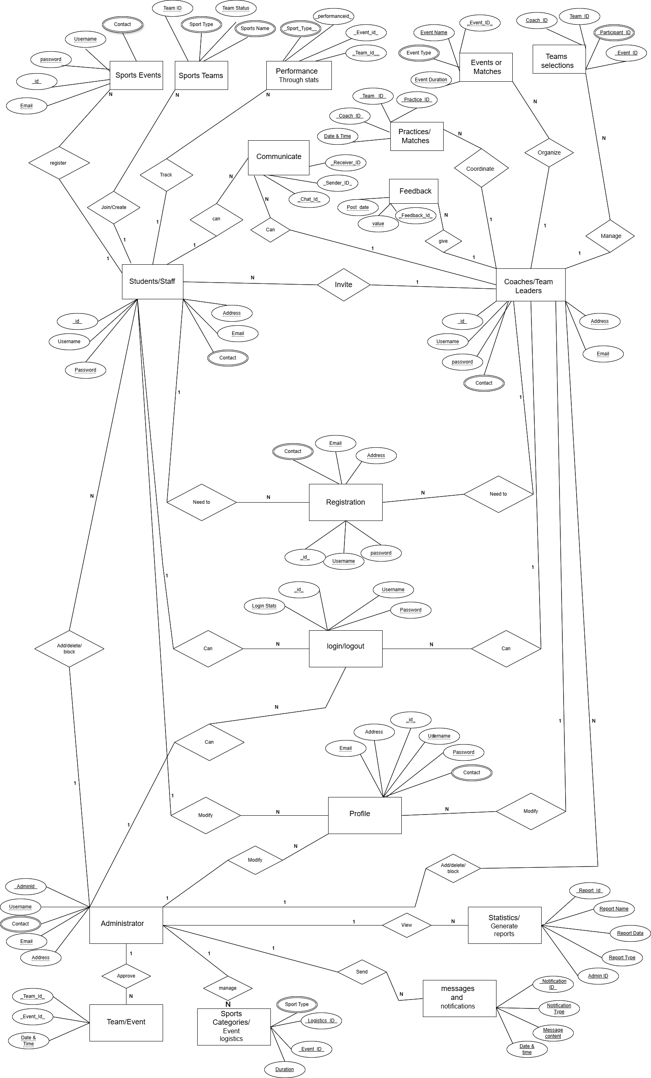
- Sequence Diagrams
For Participants can registration, login and logout, modify profile, view and register sports events, join or create sports teams, track performance, and communicate (with team members, etc.)
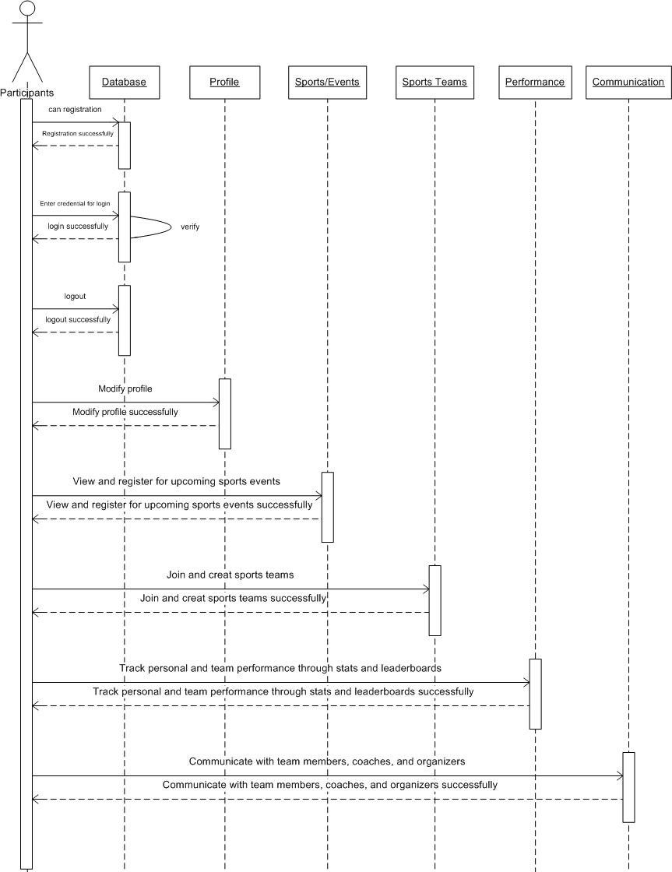

For Coaches/Team Leaders can registration, login and logout, modify profile, create and manage teams or matches, organize events and invite participants, review profiles and manage selections, communicate (with team members) and provide feedback.
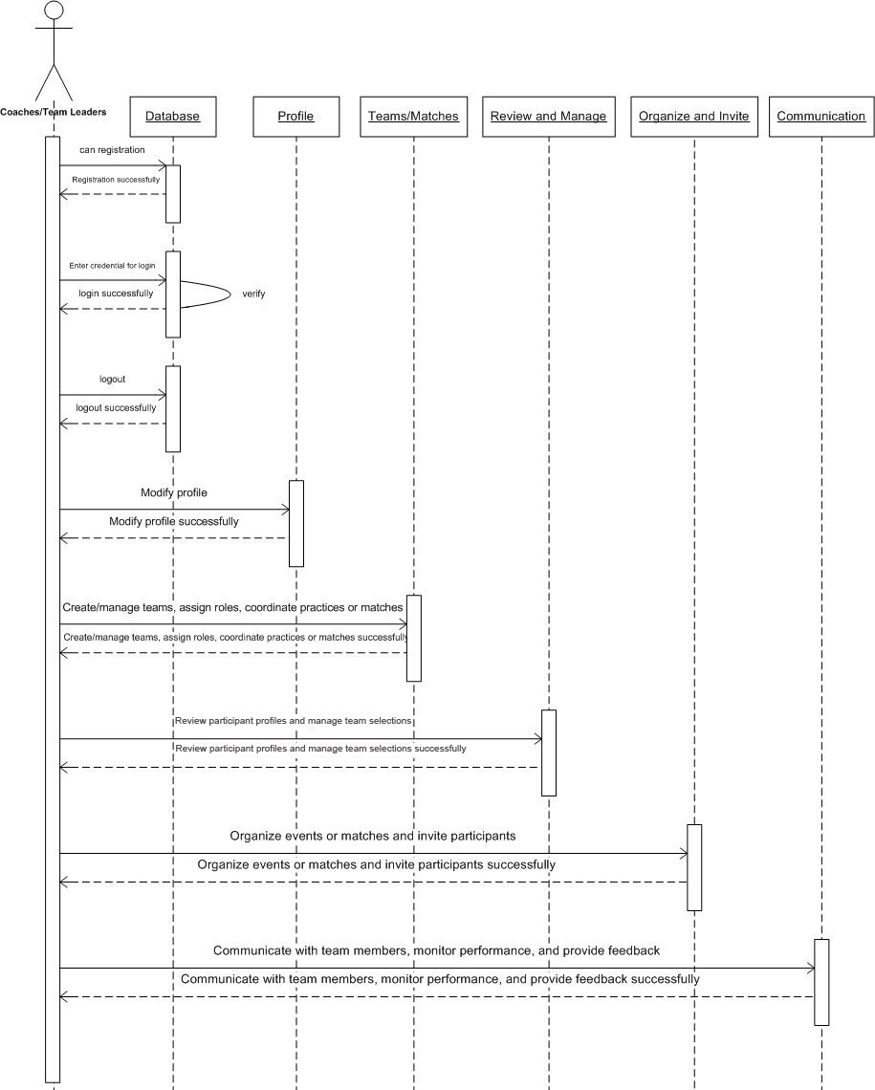
For Administrator can login and log out, modify profile, Add/delete/block (participants etc.), Approve teams and events, schedule sports events, send notifications to participants, manage sports and assign organizers, statistics and reports.
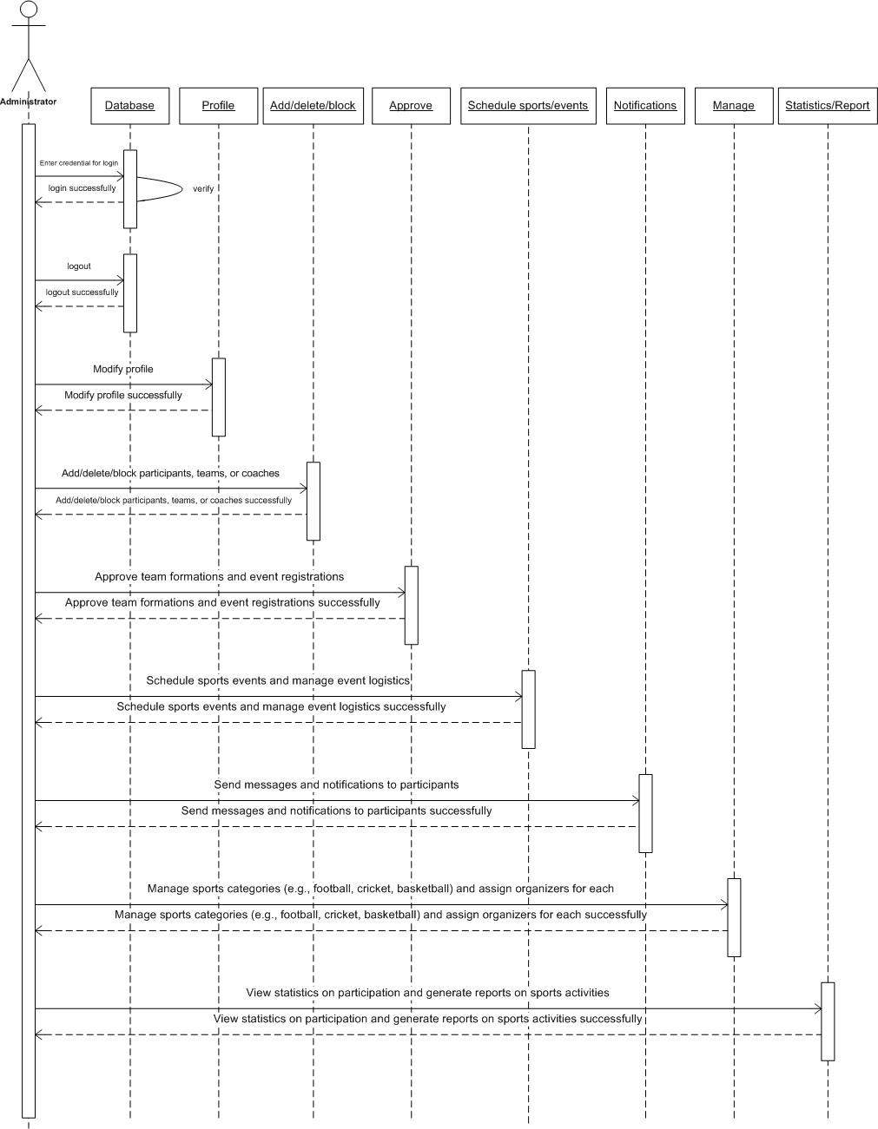

- Architecture Design Diagram
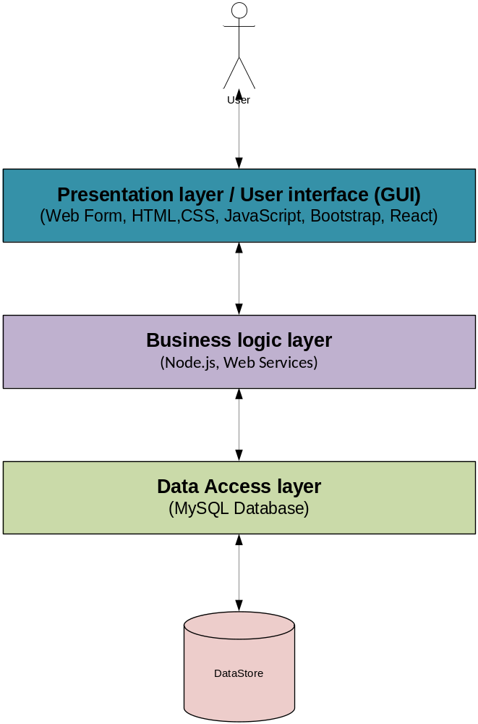

- Class Diagram

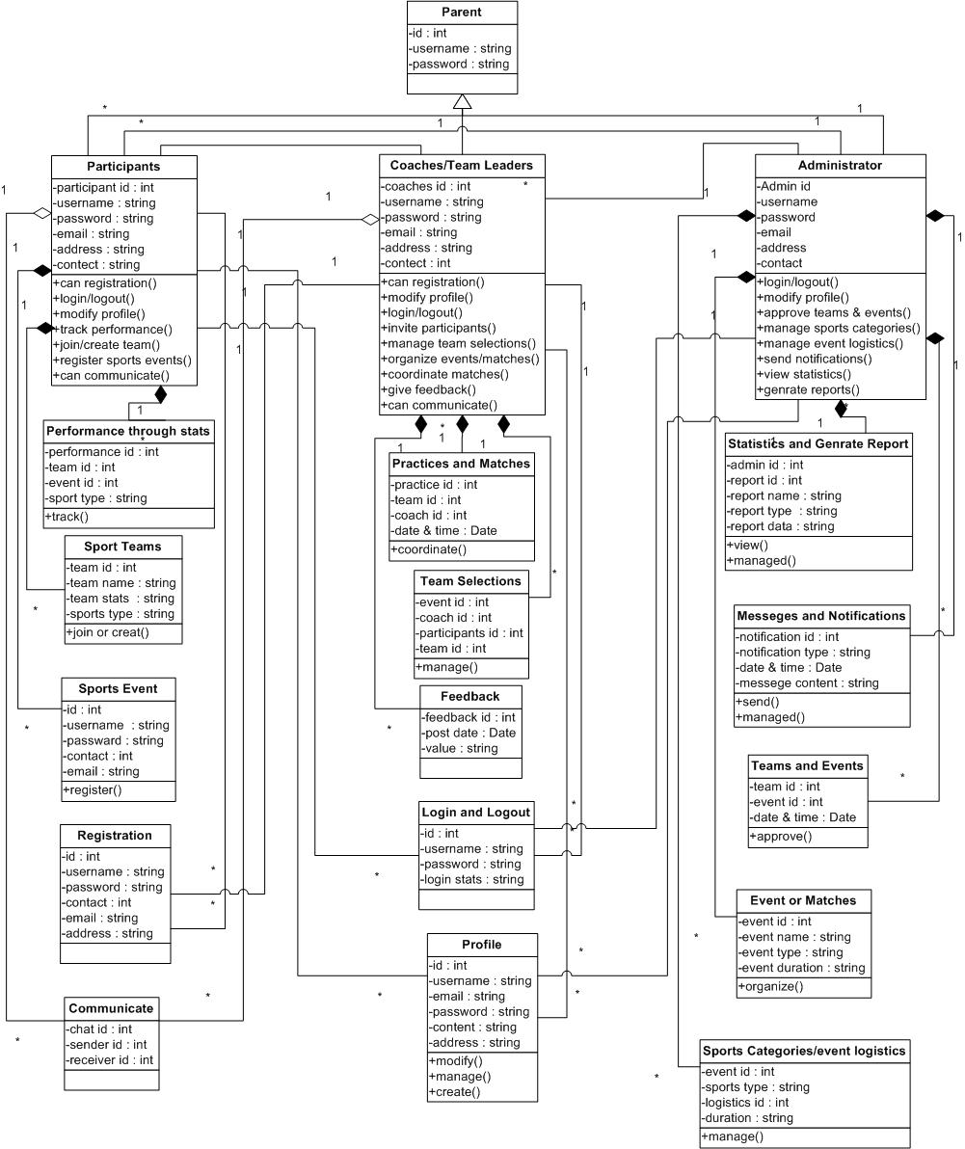

- Database Design
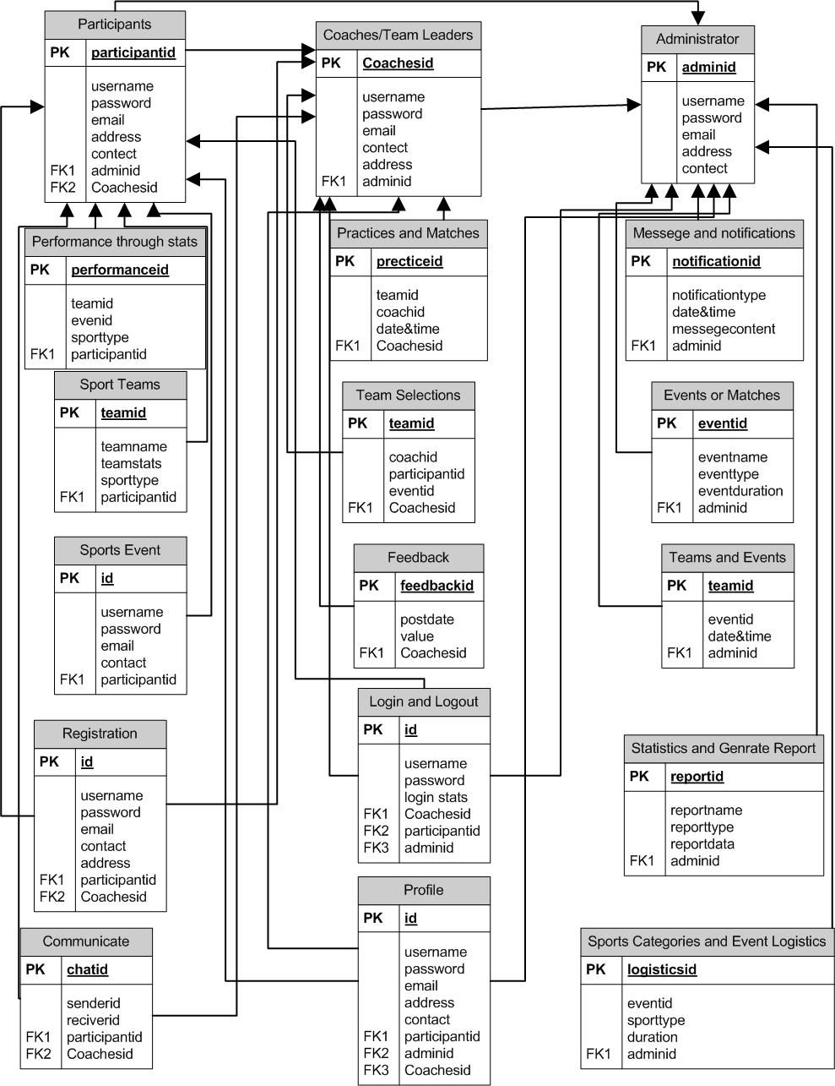

- Interface Design

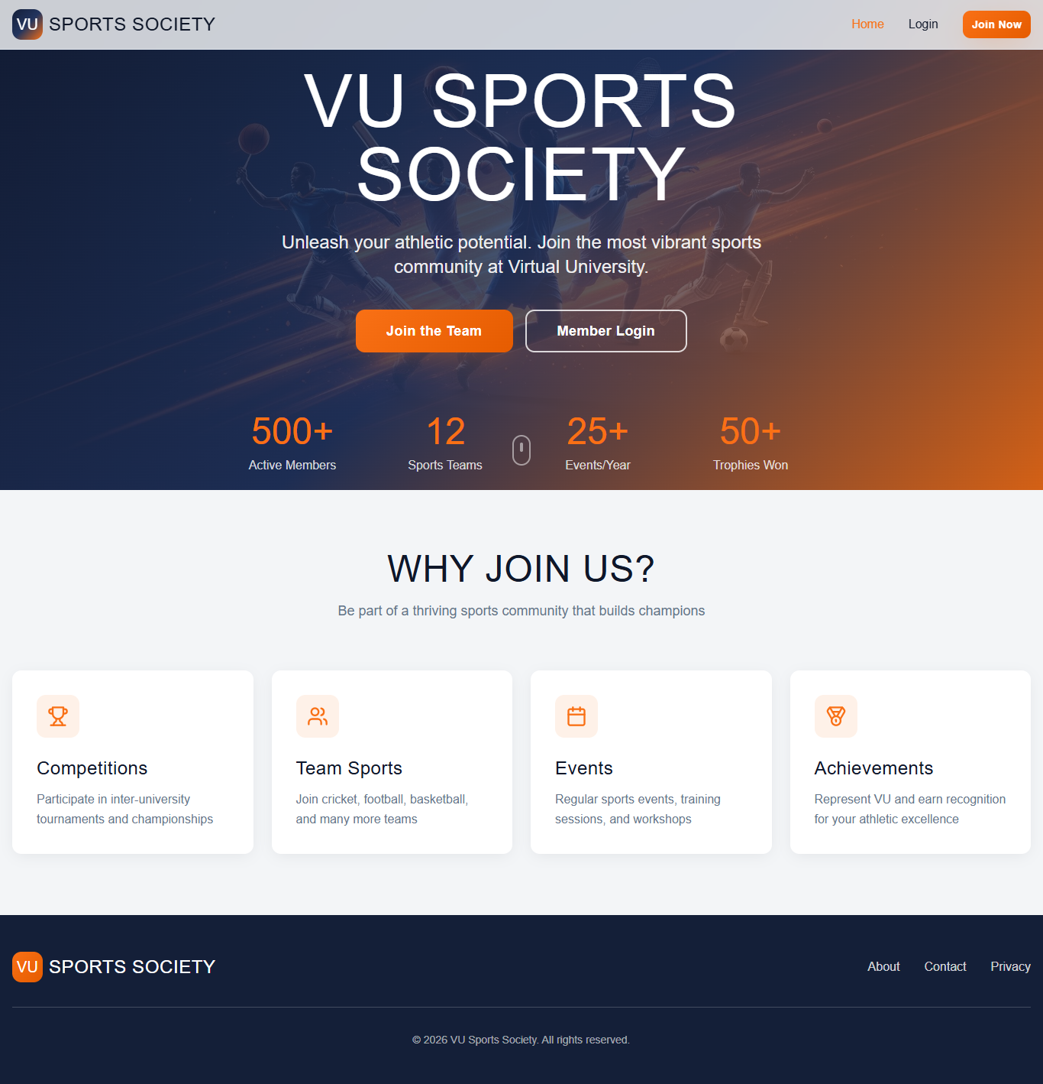
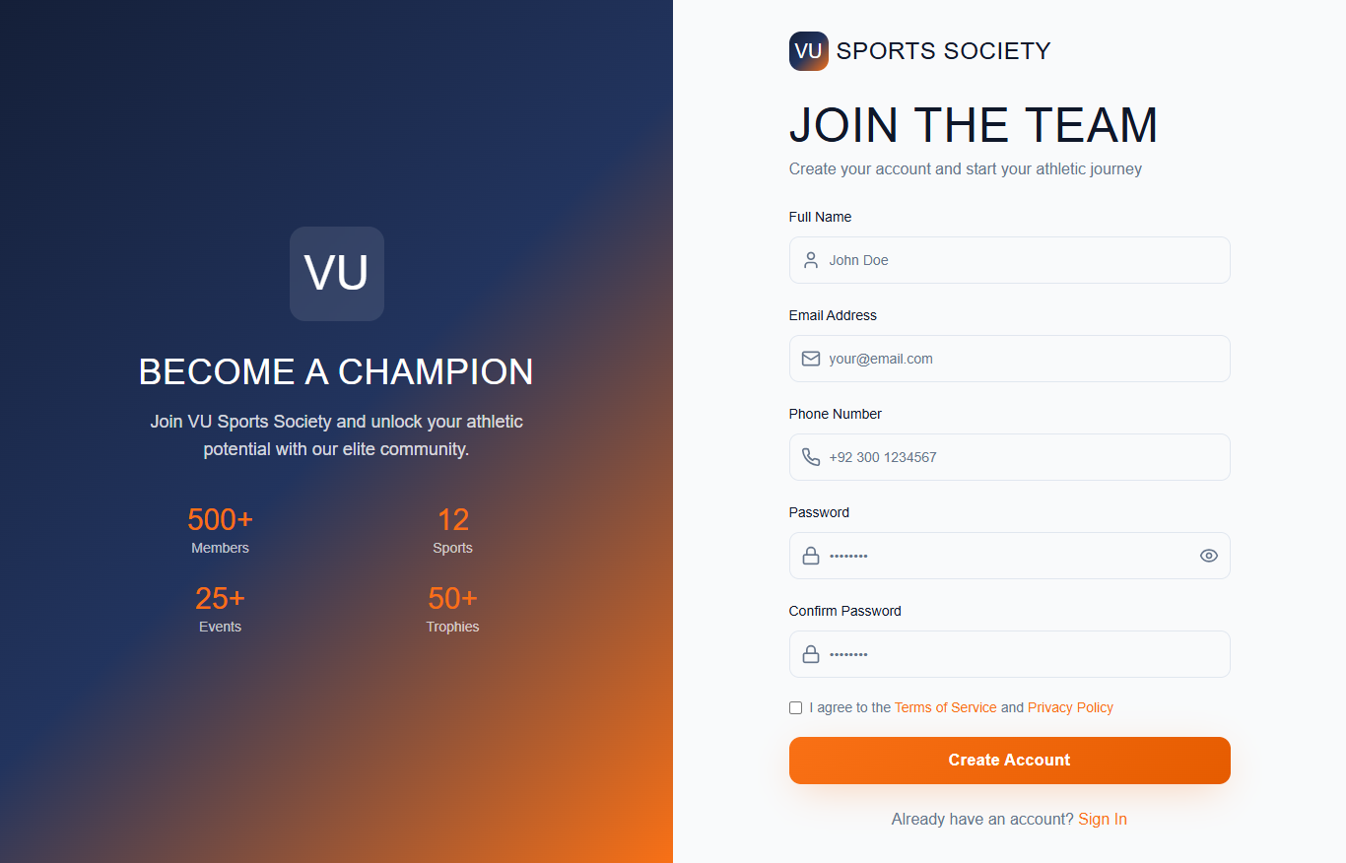

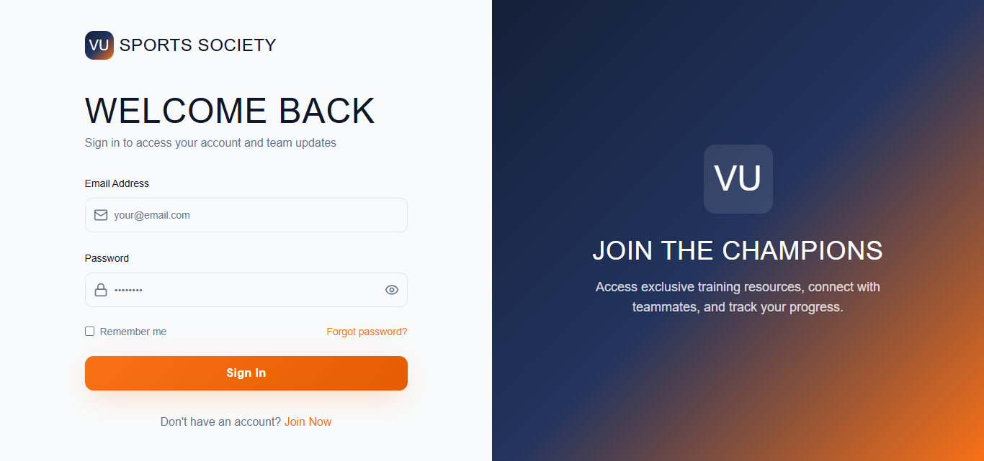

8.Test Cases

Test Case # 1
Test Case Title | Participants view and register events
Preconditions | - Participants are logged into the platform.  - The system has upcoming sports events listed.
Actions | - Navigate to the "Events" section.  - View the list of upcoming sports events.  - Select an event to view details.  - Click on the "Register" button.  - Confirm registration.
Expected Results | - Participants can see a list of upcoming events.  - Event details are displayed upon selection.  - User successfully registers for the event and receives confirmation.
Tested by | BC220416508
Result | Pass

Test Case # 2
Test Case Title | Join or create sports teams
Preconditions | - Participants are logged in.  - There are teams available to join.  - Users have the necessary permissions to create a team.
Actions | - Navigate to the "Teams" section.  - View the list of available teams.  - Select a team to view details.  - Click "Join Team."  - Receive confirmation of joining.  - Click on "Create Team."  - Enter team details.  - Click "Submit" to create the team.
Expected Results | - Participant sees a list of available teams.  - Upon selection, team details are displayed.  - Participant successfully joins the team and appears on the roster.  - Participants can create a new team.  - The new team appears in the list of available teams.
Tested by | BC220416508
Result | Pass

Test Case # 3
Test Case Title | Participants Track Performance
Preconditions | - Participants are logged in.  - The system has collected stats and leaderboard data.  - The participant is a member of a team.  - System has collected team performance stats
Actions | - Navigate to the "Stats" section.  - View personal performance metrics.  - Navigate to the "Leaderboard" section.  - View rankings among other participants.  - Navigate to the "Teams" section.  - Select the team and view performance metrics.  - Navigate to the "Leaderboard" section.  - View team rankings
Expected Results | - Participants see accurate performance stats.  - The leaderboard displays rankings based on performance metrics.  - Team stats are displayed correctly.  - Team ranking is visible on the leaderboard.
Tested by | BC220416508
Result | Pass

Test Case # 4
Test Case Title | Participants Communicate with Team Members, Coaches, and Organizers
Preconditions | - Participants are logged in.  - Participants are part of a team or event.
Actions | - Navigate to the "Messages" or "Chat" section.  - Select a team, coach, or organizer to message.  - Type and send a message.
Expected Results | - Participants can send and receive messages.  - Messages appear in the chat history.
Tested by | BC220416508
Result | Pass

Test Case # 5
Test Case Title | Participants, Coaches/Team Leaders, Administrator can Login/logout.
Preconditions | - The user (Administrator, Coach/Team Leader, or Participant) has an existing account.  - The system is online and accessible.  - The user is logged into the system.
Actions | - Navigate to the login page.  - Enter valid credentials (username/email and password).  - Click the "Login" button.  - Select "Logout" on navigation.  - Confirm the logout action.
Expected Results | - Participants can send and receive messages.  - Messages appear in the chat history.
Tested by | BC220416508
Result | Pass

Test Case # 6
Test Case Title | Participants, Coaches/Team Leaders, Administrator can Modify Profile.
Preconditions | - The user (Administrator, Coach/Team Leader, or Participant) is logged into the system.  - Profile details exist in the system.
Actions | - Navigate to the "Profile" or "Account Settings" section.  - Click on "Edit Profile."  - Modify personal details.  - Click "Save" to update the information.
Expected Results | - The updated profile information is successfully saved.  - A confirmation message appears: "Profile updated successfully."
Tested by | BC220416508
Result | Pass

Test Case # 7
Test Case Title | New Participants, Coaches/Team Leaders Registration.
Preconditions | - The system is online and accessible.  - The participant, coach/team leader, does not have an existing account.
Actions | - Navigate to the registration page.  - Select "Participant", "Coach/Team Leader" as the role.  - Enter personal details.  - Set a username and password.  - Agree to the terms and conditions.  - Click "Register."  - For Coach/Team Leader must need approval from admin after registration.
Expected Results | - The participant, coach/team leader account is successfully created.  - For participant confirmation message appears: "Registration successful."  - For coach/team leader confirmation message appears: "Registration submitted for approval."  - The participant, coach/team leader, receives an email notification about account status.
Tested by | BC220416508
Result | Pass

Test Case # 8
Test Case Title | Coaches/Team Leaders create and manage teams, assign roles, and coordinate practices or matches.
Preconditions | - Coach/Team Leader is logged in.  - The team has multiple members.  - A team exists with registered players.
Actions | - Navigate to the "Teams" section.  - Click on "Create Team."  - Enter team details.  - Click "Submit" to create the team.  - Select a team to manage.  - Click on "Manage Roles."  - Assign roles.  - Save the changes.  - Navigate to the "Schedule" section.  - Click on "Create Practice/Match."  - Select date, time, and venue.  - Assign players and set match/practice details.  - Click "Save" to schedule the event.
Expected Results | - The new team is successfully created.  - The team appears in the list of available teams.  - Assigned roles are updated successfully.  - Team members can see their assigned roles.  - Practice/match is successfully scheduled.  - Team members receive notifications about the event.
Tested by | BC220416508
Result | Pass

Test Case # 9
Test Case Title | Coaches/Team Leaders review Participant Profiles and Manage Team Selections.
Preconditions | - Coach/Team Leader is logged in.  - There are participants available for selection.
Actions | - Navigate to the "Participants" section.  - View participant profiles (stats, history, availability).  - Select participants and assign them to the team.  - Click "Confirm Selection."
Expected Results | - Selected participants are added to the team.  - Team members can view the updated roster.
Tested by | BC220416508
Result | Pass

Test Case # 10
Test Case Title | Coaches/Team Leaders communicate with team members.
Preconditions | - Coach/Team Leader is logged in.  - Team members exist in the system.
Actions | - Navigate to the "Messages" or "Chat" section.  - Select a team member or group chat.  - Type and send a message.
Expected Results | - Message is successfully sent and received.  - Team members can respond in real time.
Tested by | BC220416508
Result | Pass

Test Case # 11
Test Case Title | Coaches/Team Leaders monitor performance and provide feedback.
Preconditions | - Coach/Team Leader is logged in.  - The system has recorded performance data.
Actions | - Navigate to the "Stats" or "Performance" section.  - Select a team member to review their stats.  - Add feedback comments or rating.  - Click "Save" to store feedback.
Expected Results | - Performance stats are visible to the coach.  - Feedback is successfully recorded and visible to players.
Tested by | BC220416508
Result | Pass

Test Case # 12
Test Case Title | Coaches/Team Leaders Organize Events or Matches and Invite Participants.
Preconditions | - Coach/Team Leader is logged in.  - Team and participant data exist in the system.
Actions | - Navigate to the "Events" or "Matches" section.  - Click "Create Event."  - Enter event details.  - Select and invite participants.  - Click "Save."
Expected Results | - Event is successfully created.  - Participants receive invitations.
Tested by | BC220416508
Result | Pass

Test Case # 13
Test Case Title | Administrator Add/delete/block participants, teams, or coaches.
Preconditions | - The administrator is logged into the system.  - The participant, team, or coach exists in the system.
Actions | - Navigate to the "User Management" or "Teams" section.  - Click on "Add Participant/Coach/Team."  - Enter the required details.  - Click "Save" to confirm the addition.  - Search and select the user or team to be deleted or blocked.  - Click "Delete" or "Block."  - Confirm the action.
Expected Results | - The participant, team, or coach is successfully added.  - The participant, team, or coach is either removed or restricted from further actions.
Tested by | BC220416508
Result | Pass

Test Case # 14
Test Case Title | Administrators approve team formations and event registrations.
Preconditions | - The Administrator is logged in.  - Teams are pending approval.  - Event registration requests are pending.
Actions | - Navigate to the "Team Approvals" section.  - View the list of teams pending.  - Review team details and submitted information.  - Navigate to the "Event Approvals" section.  - View the list of pending event registrations.  - Review event details.  - Click "Approve" or "Reject."
Expected Results | - Approved teams are successfully registered.  - Rejected teams receive a notification.  - Approved events are added to the schedule.  - Rejected events notify organizers with a reason.
Tested by | BC220416508
Result | Pass

Test Case # 15
Test Case Title | Administrators schedule sports events.
Preconditions | - The Administrator is logged in.  - Event requests exist, or the admin is creating a new event.
Actions | - Navigate to the "Events" section.  - Click "Create Event."  - Enter details.  - Click "Save" to schedule the event.
Expected Results | - Event is successfully added to the system.  - Notifications are sent to relevant participants.
Tested by | BC220416508
Result | Pass

Test Case # 16
Test Case Title | Administrators manage event logistics.
Preconditions | - The administrator is logged in.  - An event is scheduled.
Actions | - Navigate to the "Events" section.  - Select an event.  - Update logistics details.  - Click "Save."
Expected Results | - Event logistics are updated.  - Assigned personnel receive notifications.
Tested by | BC220416508
Result | Pass

Test Case # 17
Test Case Title | Administrators send messages and notifications to participants.
Preconditions | - The administrator is logged in.  - Participants exist in the system.
Actions | - Navigate to the "Messaging" or "Notifications" section.  - Select recipients (individuals or groups).  - Type the message.  - Click "Send."
Expected Results | - Message is successfully delivered.  - Recipients receive notifications.
Tested by | BC220416508
Result | Pass

Test Case # 18
Test Case Title | Administrators manage sports categories.
Preconditions | - The administrator is logged in.  - The system has existing sports categories.
Actions | - Navigate to the "Sports Categories" section.  - View, add, edit, or delete sports categories.  - Click "Save" after making changes.
Expected Results | - Sports categories are updated in the system.
Tested by | BC220416508
Result | Pass

Test Case # 19
Test Case Title | Administrators assign Organizers for each.
Preconditions | - The administrator is logged in.  - Organizers exist in the system.
Actions | - Navigate to the "Organizers Management" section.  - Select a sport.  - Assign an organizer.  - Click "Save."
Expected Results | - The assigned organizer is linked to the selected sport.
Tested by | BC220416508
Result | Pass

Test Case # 20
Test Case Title | Administrators view statistics on participation.
Preconditions | - The administrator is logged in.  - The system has participation data.
Actions | - Navigate to the "Statistics" section.  - View participation data.
Expected Results | - The system displays accurate participation stats.
Tested by | BC220416508
Result | Pass

Test Case # 21
Test Case Title | Administrators generate reports on sports activities.
Preconditions | - The administrator is logged in.  - Data is available for reporting.
Actions | - Navigate to the "Reports" section.  - Select the type of report (event-based, participant-based, performance-based).  - Generate the report.
Expected Results | - The report is successfully generated.
Tested by | BC220416508
Result | Pass

