‘Website for VU Sports Society

Software Requirements Specification

Version 1.0



Group Id: F25PROJECTF3ABD
Supervisor Name: Abdur Rafay

Revision History
Date (dd/mm/yyyy) | Version | Description | Author
01/12/2025 | 1.0 | The VU Sports Society aims to promote physical activity, sportsmanship, and a healthy lifestyle among students and staff of Virtual University. Currently, the organization of sports events, member registrations, and the management of teams and schedules are often done manually, leading to inefficiencies and a lack of streamlined communication. | BC220416508

Table of Contents

- Scope (of the project)
- Functional Requirements Non Functional requirements
- Use Case Diagram
- Usage Scenarios
- Adopted Methodology
- Work Plan (Use MS Project to create Schedule/Work Plan)

SRS Document

- Scope of Project:

The VU Sports Society website will be a dynamic, user-friendly platform designed to streamline the management of sporting activities and enhance communication within the University’s sporting community. Participants, including students and staff, will be able to register, log in and create detailed profiles, showcasing their sporting preferences, achievements and past participation. They will have access to an event calendar so they can view and register for upcoming sporting activities, such as tournaments, friendly matches and fitness sessions. Additionally, participants can join or form teams, track their personal and team performance through statistics and leaderboards, and communicate with teammates, coaches and event organizers.

Coaches and team leaders will also have specific features, including registration (with admin approval), profile management, and the ability to create and manage teams. They can assign roles, coordinate practices, review participant profiles for team selection, and organize events or matches. Coaches will also have tools to track team performance, communicate with players, and provide feedback.

For administrators, the platform will offer comprehensive administrative capabilities, including user management, event scheduling, and content moderation. Administrators will be able to approve team formations, manage event logistics (e.g., locations, equipment, times), and send notifications or announcements to participants. They will also have access to performance data and reporting tools so they can track participation and generate insights into sports activities.

The platform is designed to drive engagement, streamline sports society operations, and improve the overall sports experience at the university, benefiting participants, coaches, and administrators alike. The success of the VU Sports Society website will be measured by increased participation, streamlined event management, and positive user feedback, establishing the website as an essential tool for the university's sports community.

- Functional and non-Functional Requirements:

Functional requirements are detailed descriptions of the tasks, operations, or behaviors that a system must perform to fulfill its purpose and meet user needs. They define what the system should do, focusing on the desired functionality rather than the technical methods to achieve it. These requirements are user-centric and process-oriented, covering features such as user authentication, data processing, search capabilities, notifications, and system interaction. For example, a website may require features such as secure login, the ability to search for products, or sending email notifications for user activity. Functional requirements are necessary to align development efforts with business goals, provide clarity to stakeholders, and form the basis for testing and validation to ensure that the system works as intended.

2.1 functional requirements:
    - Registration for participants
Registration (Participants need to register to access the platform).
    - Login/logout
Participants, Coaches/Team Leaders and Administrator can login and logout on website.
2.1.3 Modify profile for Participants
Modify profile (Profiles should include sports preferences, past participation, and achievements).
2.1.4 Participants view and register for sports events
View and register for upcoming sports events (e.g., tournaments, friendly matches, fitness sessions).

2.1.5 Participants join and create teams
Join or create sports teams (e.g., football, cricket, badminton, etc.).
2.1.6 Participants track performance
Track personal and team performance through stats and leaderboards.
2.1.7 Participants communicates
Communicate with team members, coaches, and organizers.
2.1.8 Registration for Coaches
Registration (Coach must need an approval from admin after registration).
2.1.9 Modify profile for Coaches
Modify profile (Include sports expertise, team management, and availability).
2.1.10 Coaches can create and manage teams
Create and manage teams, assign roles, and coordinate practices or matches.
2.1.11 Coaches can Review participant profiles
Review participant profiles and manage team selections.
2.1.12 Coaches can communicate
Communicate with team members, monitor performance, and provide feedback.
2.1.13 Coaches Organize events
Organize events or matches and invite participants.
2.1.14 Administrator modify profiles
Modify profiles (Participants, coaches, and team leaders).
2.1.15 Administrator can add/delete/block
Add/delete/block participants, teams, or coaches.
2.1.16 Administrator approval
Approve team formations and event registrations.
2.1.17 Administrator confirm schedules
Schedule sports events and manage event logistics (e.g., venues, equipment, timings).
2.1.18 Administrator give updates
Send messages and notifications to participants (event updates, team announcements, etc.).
2.1.19 Administrator manage sports
Manage sports categories (e.g., football, cricket, basketball) and assign organizers for each.

2.1.20 Administrator generate reports
View statistics on participation and generate reports on sports activities.

Non- functional requirements refer to the essential features and attributes that a system must have to function effectively, efficiently, and reliably. Unlike functional requirements, which specify what the system must do, non-functional requirements focus on how well the system must perform specific tasks, ensuring that the system meets both user expectations and operational constraints. These requirements are based on key factors such as performance, scalability, security, availability, usability, compatibility, and maintainability.

  - Non-functional requirements:

2.2.1 Performance of website:
The website should load within 3 seconds even during high traffic.
2.2.2 Scalability:
Must handle increased user volume, supporting thousands of concurrent users, especially during peak event or membership registrations.
2.2.3 Availability:
Ensure 99.9% uptime, with minimal downtime for maintenance or updates.
2.2.4 Security:
Use HTTPS for secure communication and encryption of personal and payment data and protect against web vulnerabilities such as SQL injection and cross-site scripting (XSS).
2.2.5 Usable:
An intuitive and easy-to-navigate interface for all users, enabling quick access to event details, team registration, and membership options and user friendly for both tech savvy and less experienced users.
2.2.6 Compatibility:
Compatible with major browsers (Chrome, Firefox, Safari, Edge) and responsive design for mobile devices, tablets and desktops.

2.2.7 Retention Capacity:
Easy content updating through a content management system (CMS) and modular system design for easy updates and long-term maintenance.
2.2.8 Compliance:
Follow legal standards like GDPR for data privacy and protection.
2.2.9 Localization:
Support multiple languages ​​for international students and ensure culturally appropriate content.
2.2.10 Backup and Disaster Recovery:
Regular backup of user data and content with instant recovery in case of server failure or data loss.

- Use Case Diagram(s):

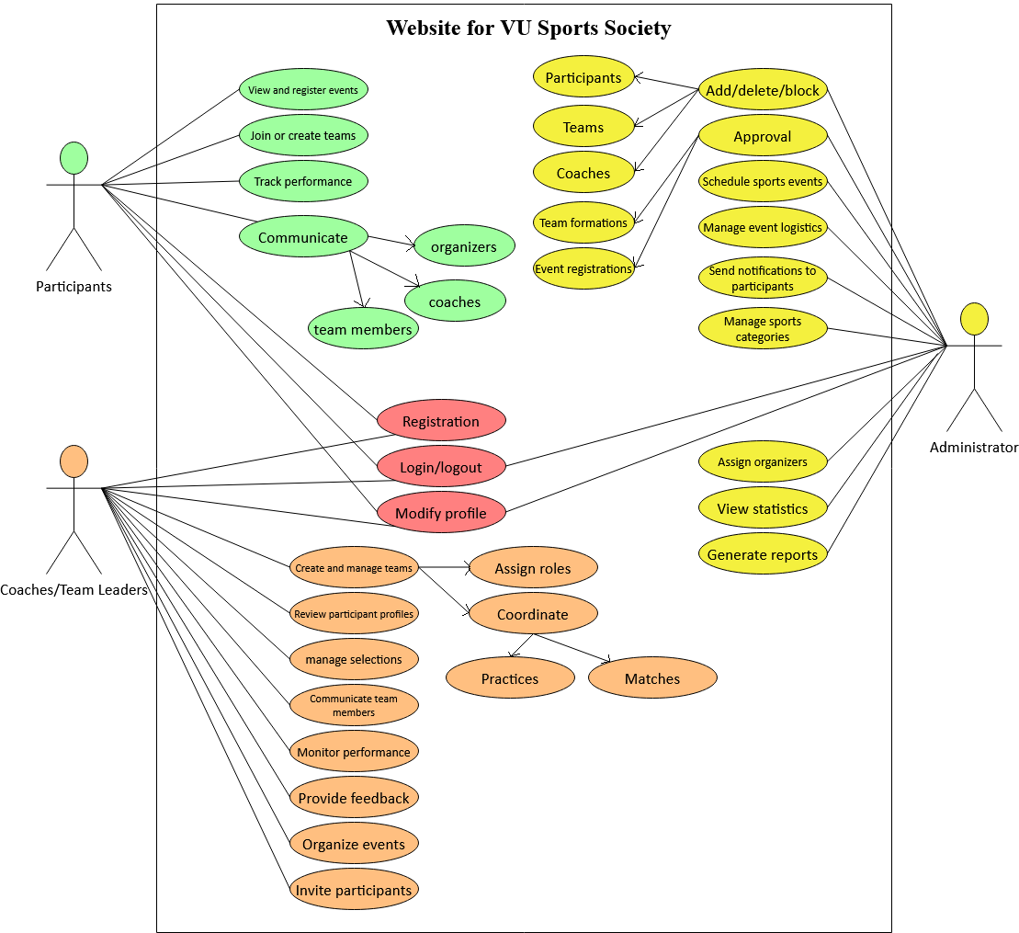

- Usage Scenarios:

#Use case related login and logout
Use case Title: | Login and logout
Use case ID: | 01
Actors: | Participants, Coaches/Team Leaders, Administrator
Description:
- This use case will be used for login and logout.
Pre-Condition:
- The website is running and active with live database.
Tasks sequence / Actions:
- Assess the website
- Navigate to login/logout section.
- Participants, Coaches/Team Leaders, Administrator login/logout account on website using email and password.
Post-Condition:
- Participants, Coaches/Team Leaders, Administrator successfully login and logout on website.
Create History: 1-12-2025
Author: BC220416508

#Use case related registration
Use case Title: | Registration
Use case ID: | 02
Actors: | Participants, Coaches/Team Leaders
Description:
- This use case will be used for registration.
Pre-Condition:
- The website is running and active with live database.
Tasks sequence / Actions:
- Assess the website
- Navigate to registration section.
- Participants, Coaches/Team Leaders, registration on website using necessary details.
Post-Condition:
- Participants, Coaches/Team Leaders registration on website.
Create History: 1-12-2025
Author: BC220416508

#Use case related modify profile
Use case Title: | Modify profile
Use case ID: | 03
Actors: | Participants, Coaches/Team Leaders, Administrator
Description:
- This use case will be used for modifying profile.
Pre-Condition:
- The website is running and active with live database.
Tasks sequence / Actions:
- Assess the website
- Navigate to login/logout section.
- Participants, Coaches/Team Leaders, Administrator login our account and modify profile.
Post-Condition:
- Participants, Coaches/Team Leaders, Administrator successfully modify profile.
Create History: 1-12-2025
Author: BC220416508

#Use case related view and register event
Use case Title: | view and register event
Use case ID: | 04
Actors: | Participants
Description:
- This use case will be used for view and register event.
Pre-Condition:
- The website is running and active with live database.
Tasks sequence / Actions:
- Assess the website
- Navigate to notification section.
- Participants view and register for upcoming sports events (e.g., tournaments, friendly matches, fitness sessions).

Post-Condition:
- Participants successfully view and register for upcoming sports events.
Create History: 1-12-2025
Author: BC220416508

#Use case related join or create teams
Use case Title: | Join or create sports teams
Use case ID: | 05
Actors: | Participants
Description:
- This use case will be used for joining or create sports teams.
Pre-Condition:
- The website is running and active with live database.
Tasks sequence / Actions:
- Assess the website
- Navigate to login/logout section.
- Participants login our account for join or create sports teams (e.g., football, cricket, badminton, etc.).

Post-Condition:
- Participants successfully join or create sports teams.
Create History: 1-12-2025
Author: BC220416508

#Use case related track performance
Use case Title: | Track performance
Use case ID: | 06
Actors: | Participants
Description:
- This use case will be used for track performance.
Pre-Condition:
- The website is running and active with live database.
Tasks sequence / Actions:
- Assess the website
- Navigate to login/logout section.
- Participants login our account for track personal and team performance through stats and leaderboards.

Post-Condition:
- Participants successfully track personal and team performance through stats and leaderboards.
Create History: 1-12-2025
Author: BC220416508

#Use case related communicate
Use case Title: | Communicate
Use case ID: | 07
Actors: | Participants
Description:
- This use case will be used for communication.
Pre-Condition:
- The website is running and active with live database.
Tasks sequence / Actions:
- Assess the website
- Navigate to login/logout section.
- Participants login our account for communicate with team members, coaches, and organizers.

Post-Condition:
- Participants successfully communicate with team members, coaches, and organizers.
Create History: 1-12-2025
Author: BC220416508

#Use case related create and manage teams
Use case Title: | Create and manage teams
Use case ID: | 08
Actors: | Coaches/Team Leaders
Description:
- This use case will be used for creating and manage teams.
Pre-Condition:
- The website is running and active with live database.
Tasks sequence / Actions:
- Assess the website
- Navigate to login/logout section.
- Coaches/Team Leaders login our account for create and manage teams, assign roles, and coordinate practices or matches.
Post-Condition:
- Coaches/Team Leaders successfully create and manage teams, assign roles, and coordinate practices or matches.
Create History: 1-12-2025
Author: BC220416508

#Use case related review participant profiles
Use case Title: | Review participant profiles
Use case ID: | 09
Actors: | Coaches/Team Leaders
Description:
- This use case will be used for review participant profiles.
Pre-Condition:
- The website is running and active with live database.
Tasks sequence / Actions:
- Assess the website
- Navigate to login/logout section.
- Coaches/Team Leaders login our account for review participant profiles and manage team selections.
Post-Condition:
- Coaches/Team Leaders successfully review participant profiles and manage team selections.
Create History: 1-12-2025
Author: BC220416508

#Use case related communicate team members
Use case Title: | Communicate team members
Use case ID: | 10
Actors: | Coaches/Team Leaders
Description:
- This use case will be used for communicating with team members.
Pre-Condition:
- The website is running and active with live database.
Tasks sequence / Actions:
- Assess the website
- Navigate to login/logout section.
- Coaches/Team Leaders login our account for communicating with team members.
Post-Condition:
- Coaches/Team Leaders successfully communicating with team members.
Create History: 1-12-2025
Author: BC220416508

#Use case related monitor performance
Use case Title: | Monitor performance
Use case ID: | 11
Actors: | Coaches/Team Leaders
Description:
- This use case will be used for monitor performance of team members.
Pre-Condition:
- The website is running and active with live database.
Tasks sequence / Actions:
- Assess the website
- Navigate to login/logout section.
- Coaches/Team Leaders login our account for monitor performance of team members.
Post-Condition:
- Coaches/Team Leaders successfully monitor performance of team members.
Create History: 1-12-2025
Author: BC220416508

#Use case related provide feedback
Use case Title: | Provide feedback
Use case ID: | 12
Actors: | Coaches/Team Leaders
Description:
- This use case will be used for providing feedback of team members.
Pre-Condition:
- The website is running and active with live database.
Tasks sequence / Actions:
- Assess the website
- Navigate to login/logout section.
- Coaches/Team Leaders login our account for providing feedback of team members.
Post-Condition:
- Coaches/Team Leaders successfully monitor providing feedback of team members.
Create History: 1-12-2025
Author: BC220416508

#Use case related organize events
Use case Title: | Organize events
Use case ID: | 13
Actors: | Coaches/Team Leaders
Description:
- This use case will be used for organizing events.
Pre-Condition:
- The website is running and active with live database.
Tasks sequence / Actions:
- Assess the website
- Navigate to login/logout section.
- Coaches/Team Leaders login our account for organize events or matches.
Post-Condition:
- Coaches/Team Leaders successfully organize events or matches.
Create History: 1-12-2025
Author: BC220416508

#Use case related invite participants
Use case Title: | Invite participants
Use case ID: | 14
Actors: | Coaches/Team Leaders
Description:
- This use case will be used for invite participants.
Pre-Condition:
- The website is running and active with live database.
Tasks sequence / Actions:
- Assess the website
- Navigate to login/logout section.
- Coaches/Team Leaders login our account for invite participants.
Post-Condition:
- Coaches/Team Leaders successfully invite participants.
Create History: 1-12-2025
Author: BC220416508

#Use case related manage selections
Use case Title: | Manage selections
Use case ID: | 15
Actors: | Coaches/Team Leaders
Description:
- This use case will be used for managing selections.
Pre-Condition:
- The website is running and active with live database.
Tasks sequence / Actions:
- Assess the website
- Navigate to login/logout section.
- Coaches/Team Leaders login our account for manage team selections.
Post-Condition:
- Coaches/Team Leaders successfully manage team selections.
Create History: 1-12-2025
Author: BC220416508

#Use case related Add/delete/block
Use case Title: | Add/delete/block
Use case ID: | 16
Actors: | Administrator
Description:
- This use case will be used for add/delete/block participants, teams, or coaches.
Pre-Condition:
- The website is running and active with live database.
Tasks sequence / Actions:
- Assess the website
- Navigate to login/logout section.
- Administrator login our account for add/delete/block participants, teams, or coaches.
Post-Condition:
- Administrator successfully add/delete/block participants, teams, or coaches.
Create History: 1-12-2025
Author: BC220416508

#Use case related Approval
Use case Title: | Approval
Use case ID: | 17
Actors: | Administrator
Description:
- This use case will be used for approval team formations and event registrations.
Pre-Condition:
- The website is running and active with live database.
Tasks sequence / Actions:
- Assess the website
- Navigate to login/logout section.
- Administrator login our account for approval team formations and event registrations.
Post-Condition:
- Administrator successfully approval team formations and event registrations.
Create History: 1-12-2025
Author: BC220416508

#Use case related schedule sports events
Use case Title: | Schedule sports events
Use case ID: | 18
Actors: | Administrator
Description:
- This use case will be used for schedule sports events.
Pre-Condition:
- The website is running and active with live database.
Tasks sequence / Actions:
- Assess the website
- Navigate to login/logout section.
- Administrator login our account for schedule sports events.
Post-Condition:
- Administrator successfully schedule sports events.
Create History: 1-12-2025
Author: BC220416508

#Use case related manage event logistics
Use case Title: | Manage event logistics
Use case ID: | 19
Actors: | Administrator
Description:
- This use case will be used for managing event logistics.
Pre-Condition:
- The website is running and active with live database.
Tasks sequence / Actions:
- Assess the website
- Navigate to login/logout section.
- Administrator login our account for managing event logistics (e.g., venues, equipment, timings).
Post-Condition:
- Administrator successfully managing event logistics (e.g., venues, equipment, timings).
Create History: 1-12-2025
Author: BC220416508

#Use case related send notifications to participants
Use case Title: | Send notifications to participants
Use case ID: | 20
Actors: | Administrator
Description:
- This use case will be used for sending notifications to participants.
Pre-Condition:
- The website is running and active with live database.
Tasks sequence / Actions:
- Assess the website
- Navigate to login/logout section.
- Administrator login our account for send messages and notifications to participants.
Post-Condition:
- Administrator successfully send messages and notifications to participants.
Create History: 1-12-2025
Author: BC220416508

#Use case related manage sports categories
Use case Title: | Manage sports categories
Use case ID: | 21
Actors: | Administrator
Description:
- This use case will be used for managing sports categories.
Pre-Condition:
- The website is running and active with live database.
Tasks sequence / Actions:
- Assess the website
- Navigate to login/logout section.
- Administrator login our account for manage sports categories (e.g., football, cricket, basketball).
Post-Condition:
- Administrator successfully manage sports categories (e.g., football, cricket, basketball).
Create History: 1-12-2025
Author: BC220416508

#Use case related assign organizers
Use case Title: | Assign organizers
Use case ID: | 22
Actors: | Administrator
Description:
- This use case will be used for assign organizers.
Pre-Condition:
- The website is running and active with live database.
Tasks sequence / Actions:
- Assess the website
- Navigate to login/logout section.
- Administrator login our account for manage sports categories (e.g., football, cricket, basketball).
Post-Condition:
- Administrator successfully manage sports categories (e.g., football, cricket, basketball).
Create History: 1-12-2025
Author: BC220416508

#Use case related View statistics
Use case Title: | View statistics
Use case ID: | 23
Actors: | Administrator
Description:
- This use case will be used for view statistics.
Pre-Condition:
- The website is running and active with live database.
Tasks sequence / Actions:
- Assess the website
- Navigate to login/logout section.
- Administrator login our account for view statistics on participation.
Post-Condition:
- Administrator successfully manage view statistics on participation.
Create History: 1-12-2025
Author: BC220416508

#Use case related generate reports
Use case Title: | Generate reports
Use case ID: | 24
Actors: | Administrator
Description:
- This use case will be used for generating reports.
Pre-Condition:
- The website is running and active with live database.
Tasks sequence / Actions:
- Assess the website
- Navigate to login/logout section.
- Administrator login our account for generate reports on sports activities.
Post-Condition:
- Administrator successfully generate reports on sports activities.
Create History: 1-12-2025
Author: BC220416508

- Adopted Methodology

Methodologies provide systematic methods for planning, developing, and maintaining software systems. These procedures define processes, procedures and principles to guide the development lifecycle and ensure quality, performance and stakeholder satisfaction.
The Vu process model is a combination of the waterfall and spiral models.

Waterfall Model:

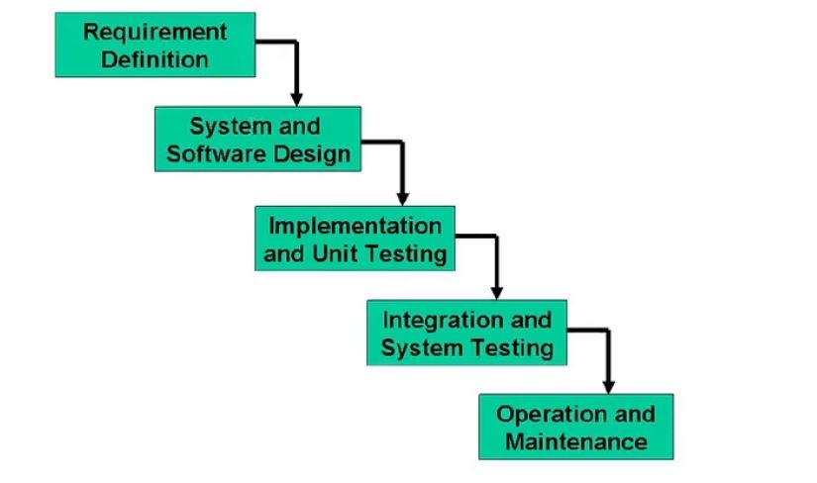

The five stages above are as follows:

- Requirement Analysis and Definition:
What - The systems services, constraints and goals are established by consultation with system users. They are then defined in detail and serve as a system specification.

- System and Software Design:
How – The system design process partitions the requirements to either hardware of software systems. It establishes and overall system architecture. Software design involves fundamental system abstractions and their relationships.

- Implementation and Unit Testing:
How – During this stage the software design is realized as a set of programs or program units. Unit testing involves verifying that each unit meets its specifications.

- Integration and system testing:
The individual program unit or programs are integrated and tested as a complete system to ensure that the software requirements have been met. After testing, the software system is delivered to the customer.

- Operation and Maintenance:
Normally this is the longest phase of the software life cycle. The system is installed and put into practical use. Maintenance involves correcting errors which were not discovered in earlier stages of the life cycle, improving the implementation of system units and enhancing the system’s services as new requirements are discovered.

Spiral Model:
The Spiral Model is a (Software Development Life Cycle (SDLC) model that provides a systematic and iterative approach to software development. In its diagrammatic representation, looks like a spiral with many loops. The exact number of loops of the spiral is unknown and can vary from project to project. Each loop of the spiral is called a phase of the software development process.
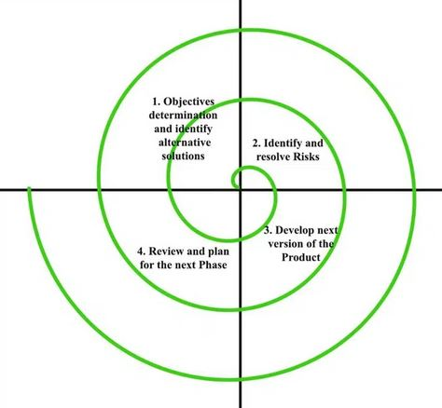

- Objectives determination and identify alternative solutions:
In the “Setting Objectives and Identifying Alternative Solutions” phase, requirements are collected from users to define and analyse the objectives of the current phase of the project. This involves a thorough understanding of what needs to be achieved and assessing the feasibility of these objectives. Once the objectives are clear, alternative solutions are proposed, considering different ways to achieve the desired results. These alternatives are evaluated based on factors such as feasibility, cost, time, resource requirements, and associated risks. By systematically analysing and documenting these aspects, this phase ensures that each iteration begins with a clear direction and supports informed decision-making. This approach is particularly effective in reducing risks and improving the development process, in conjunction with the principles of iterative models such as the spiral model.

- Identify and resolve Risks:
In the second quadrant of the development process, the primary focus is on evaluating potential solutions to select the most viable solution. This involves a thorough analysis of each proposed solution, considering factors such as feasibility, cost-effectiveness, scalability, and alignment with the project goals. Once the best solution is identified, the associated risks are systematically identified and assessed. These risks can range from technical challenges and resource constraints to potential market or operational uncertainties. Once the risks are identified, appropriate strategies are devised to mitigate or effectively address them. These strategies may include contingency planning, resource allocation, additional testing, or stakeholder consultation. By addressing these risks, the project reduces the likelihood of failures and ensures smooth progress. At the end of this phase, a prototype of the selected solution is developed. This prototype serves as a concrete representation of the chosen approach, enabling further testing, feedback, and refinement before moving on to later stages.

- Develop the next version of the Product:
The third quadrant of the development process focuses on turning identified features and improvements into a functional and testable product. During this phase, the development team designs, codes, and integrates new features while addressing any issues identified in the earlier stages. Rigorous testing, including unit tests, integration tests, and user acceptance tests, ensures that the features perform as intended and meet the overall product requirements. This quadrant emphasizes quality assurance to reduce errors and enhance the user experience. By the end of this phase, an improved and functional version of the software is ready for deployment, marking a major milestone in the product’s lifecycle.

- Review and plan for the next Phase:
The fourth phase of the software development life cycle, often called the “Review and Plan” phase, is critical to ensuring the success of the project. During this phase, customers or end users evaluate the current version of the software to determine whether it meets their expectations and needs. Feedback is collected about functionality, usability, performance, and any potential improvements or issues. This evaluation allows the development team to understand which aspects of the software are working well and which areas need improvement. Based on this feedback, a detailed plan for the next phase of development is initiated. This planning process involves setting priorities, setting objectives, allocating resources, and updating timelines. It ensures that subsequent development iterations are aligned with customer needs and project goals, keeping the focus on delivering a high-quality, user-centred product.

Chosen Methodology

We will choose vu process model for our project.

The VU process model is a hybrid approach that combines elements of waterfall and spiral methods. It has five sequential phases: requirements gathering, planning, analysis and design, development, and final reporting.

“V-Model” (Verification and Validation Model) is a widely used software development methodology that emphasizes a sequential design process with a strong focus on quality. It is an extension of the Waterfall Model but introduces a verification and validation approach, aligning each development phase with a corresponding testing phase. The model is shaped like the letter "V", with the left side representing the system development phases (requirements analysis, system design, and coding) and the right side representing the corresponding testing phases (unit testing, integration testing, system testing, and acceptance testing). At each stage of the process, deliverables are verified to ensure that they meet specified requirements. This proactive approach helps to identify and resolve issues early, reducing the likelihood of defects in the final product. The V-Model is particularly suited to projects with well-defined requirements and emphasizes a systematic, rigorous approach to achieving high-quality software.

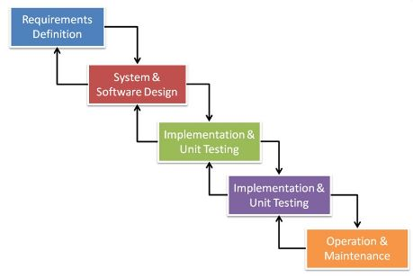

Reasons for choosing Vu Process Model:

The main reasons for choosing the VU process model for our project are as follows.

- Our project is divided into different stages which we must complete sequentially and submit to our supervisor.

- The “U” in VU emphasizes understanding user needs and ensuring that the process prioritizes delivering value to the end user. It promotes continuous engagement with users to validate assumptions and improve usability.

- If some errors are found, they suggest us to correct those errors and improve our project. This process will be adopted because of its spiral nature.

- It breaks development into small, manageable iterations. Each iteration potentially provides an increment in deliverable product, allowing teams to review progress and resolve issues quickly.

- When the stage is well developed, and it is also accepted by our supervisor, then we will move towards the next stage. This will be done because of the waterfall nature of the VU process model.

- Therefore, both the models are compressed into a single form, and this will be our VU process model. This will provide error-free result because each step is done in a sequence.

- Work Plan

