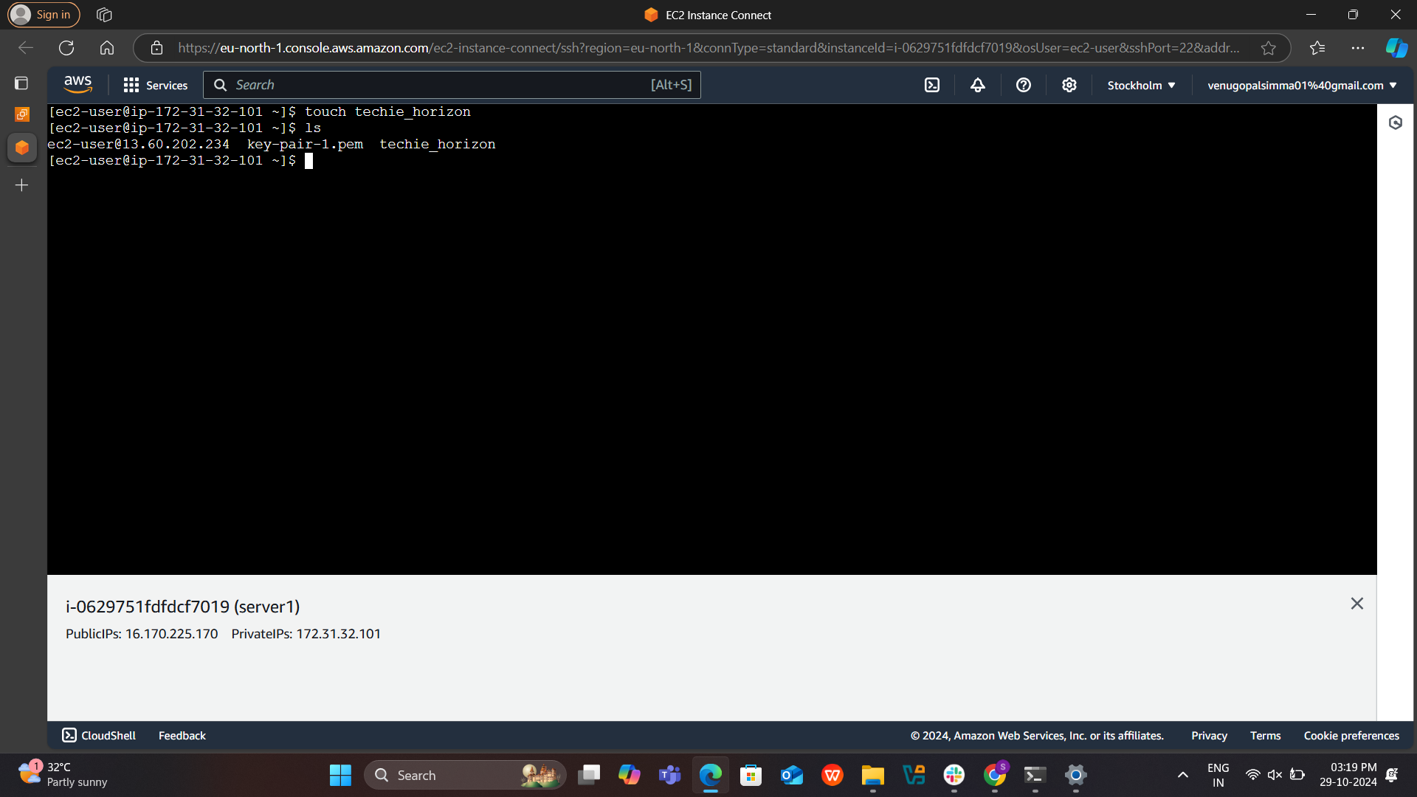

C:\Users\nagur\Downloads>scp -i key-pair-1.pem ec2-user@16.170.225.170:/home/ec2-user/techie_horizon C:\Users\nagur\Downloads

C:\Users\nagur\Downloads>

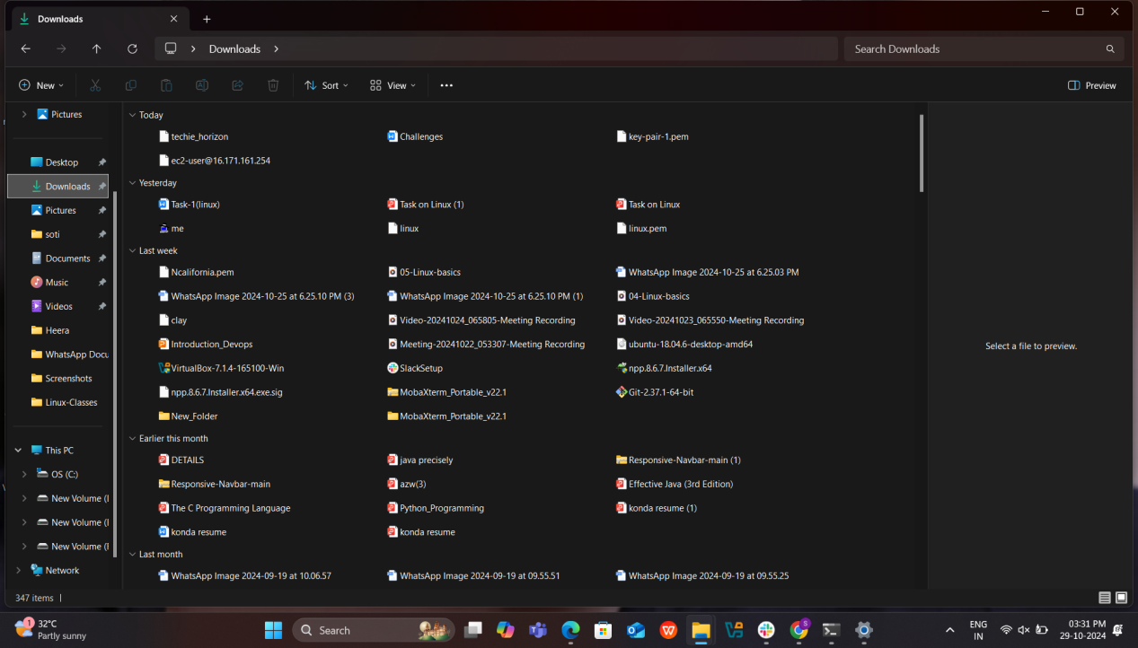

[ec2-user@ip-172-31-32-101 ~]$ sudo yum install jenkins -y

Jenkins 911 kB/s | 120 kB 00:00

Dependencies resolved.

============================================================================================================================================================

Package Architecture Version Repository Size

============================================================================================================================================================

Installing:

jenkins noarch 2.482-1.1 jenkins 91 M

Transaction Summary

============================================================================================================================================================

Install 1 Package

Total download size: 91 M

Installed size: 92 M

Downloading Packages:

jenkins-2.482-1.1.noarch.rpm 32 MB/s | 91 MB 00:02

------------------------------------------------------------------------------------------------------------------------------------------------------------

Total 32 MB/s | 91 MB 00:02

Running transaction check

Transaction check succeeded.

Running transaction test

Transaction test succeeded.

Running transaction

Preparing : 1/1

Running scriptlet: jenkins-2.482-1.1.noarch 1/1

Installing : jenkins-2.482-1.1.noarch 1/1

Running scriptlet: jenkins-2.482-1.1.noarch 1/1

Verifying : jenkins-2.482-1.1.noarch 1/1

Installed:

jenkins-2.482-1.1.noarch

Complete!

