1. **Install jenkins and run jenkins on port number 8081.**

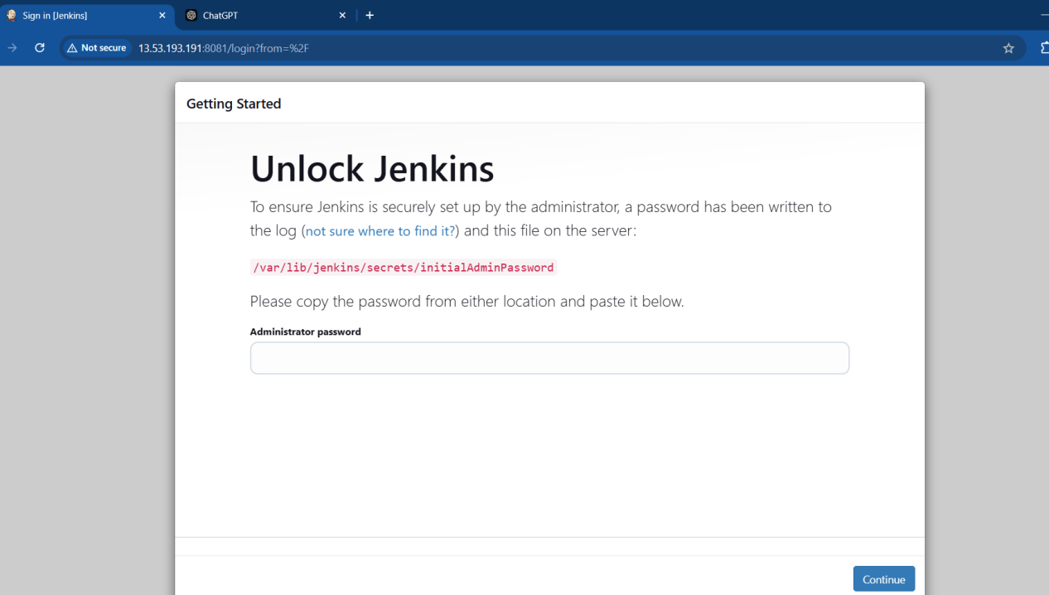

**2) Secure Jenkins server**

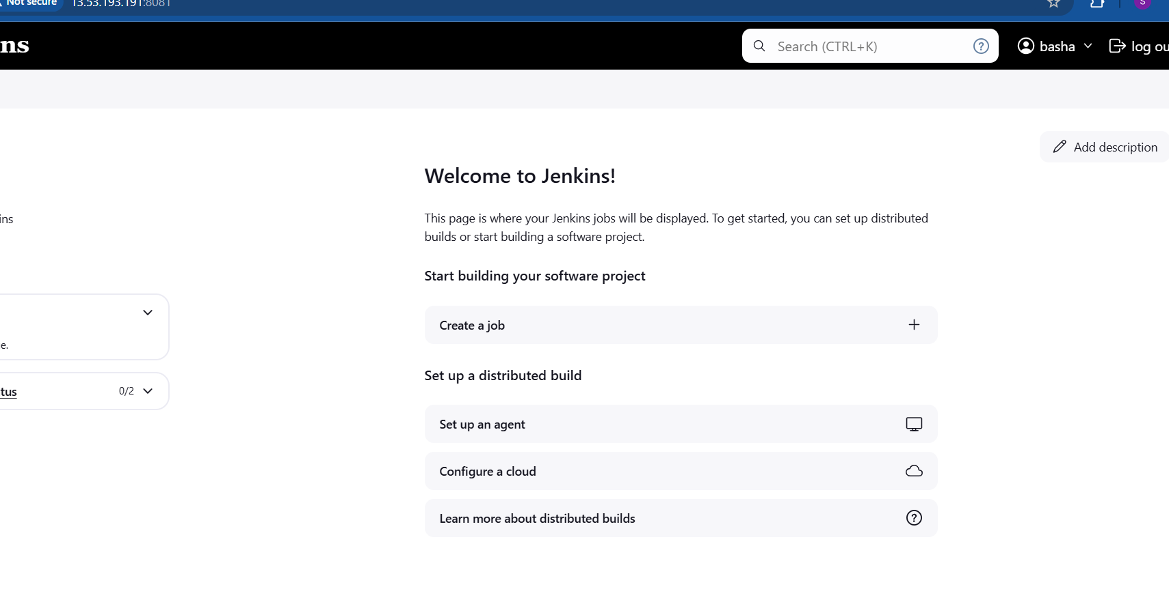

1. **Create users called Devops, Testing in Jenkins with Limited access.**

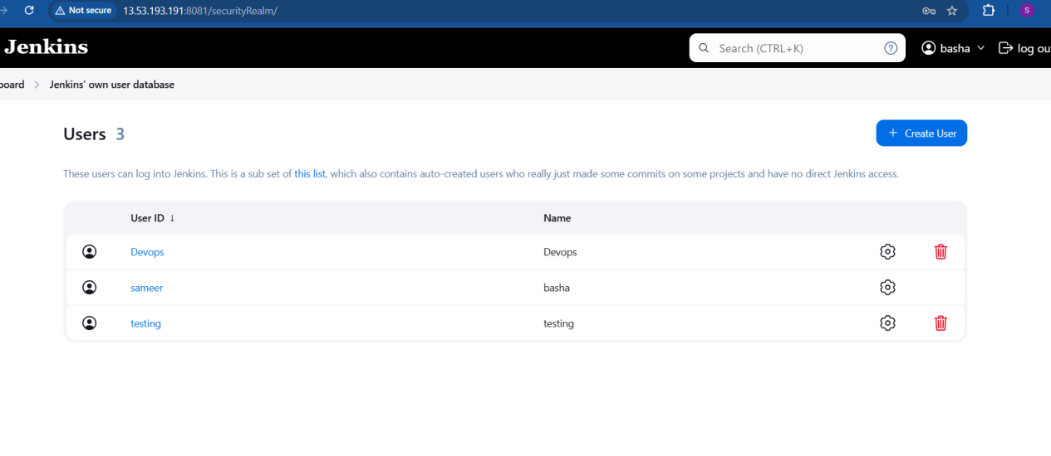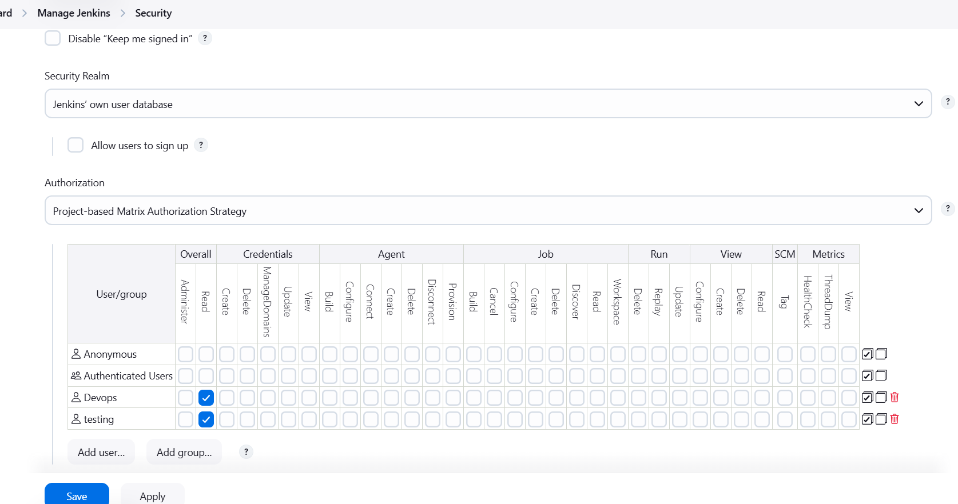

**4) Configure labels and restrict the jobs to execute based on label only.**

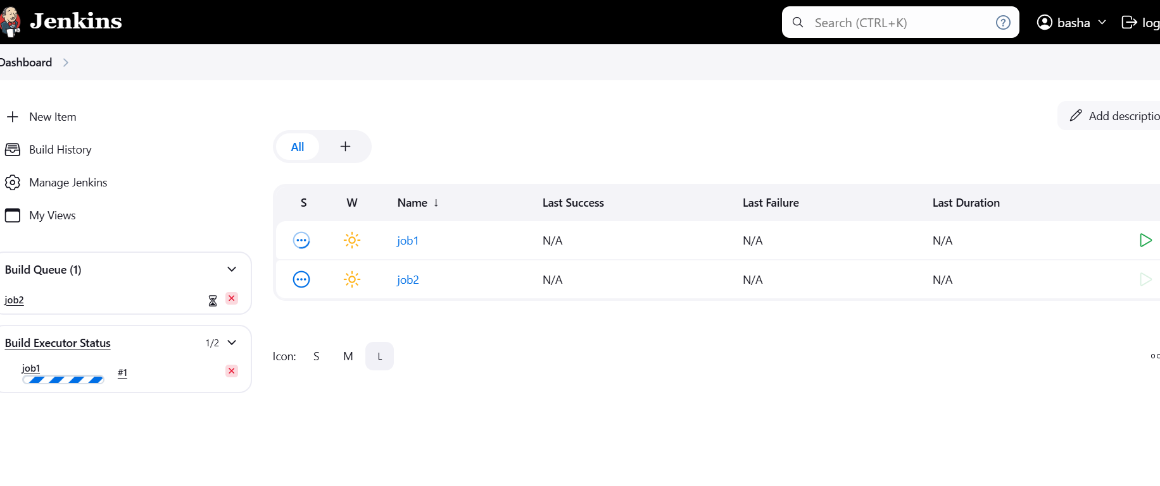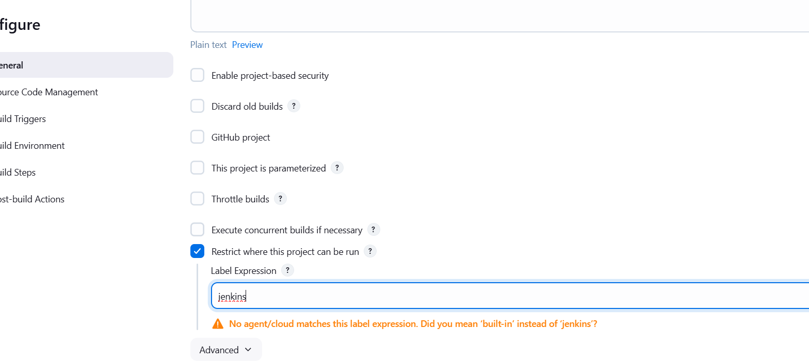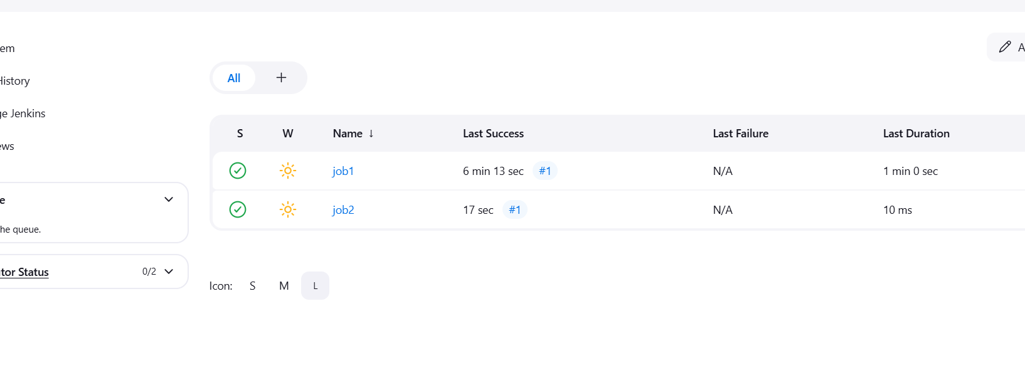**5) Create Three sample jobs using the below URL.**

**<https://github.com/betawins/Techie_horizon_Login_app.git>**

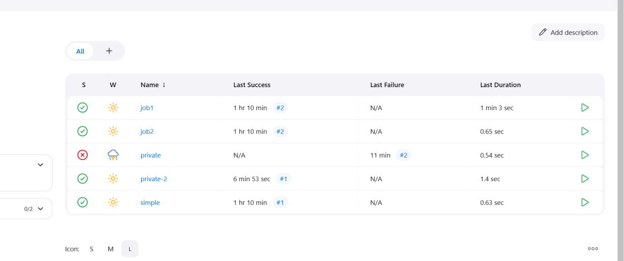

1. **Create one jenkins job using git hub Private repository.**

