1. **Configure VPC peering in cross regions.(Need to do this again)**

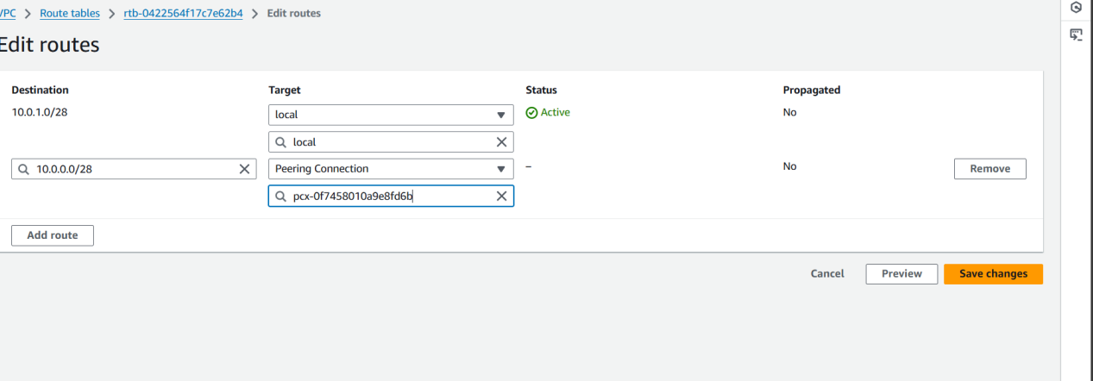

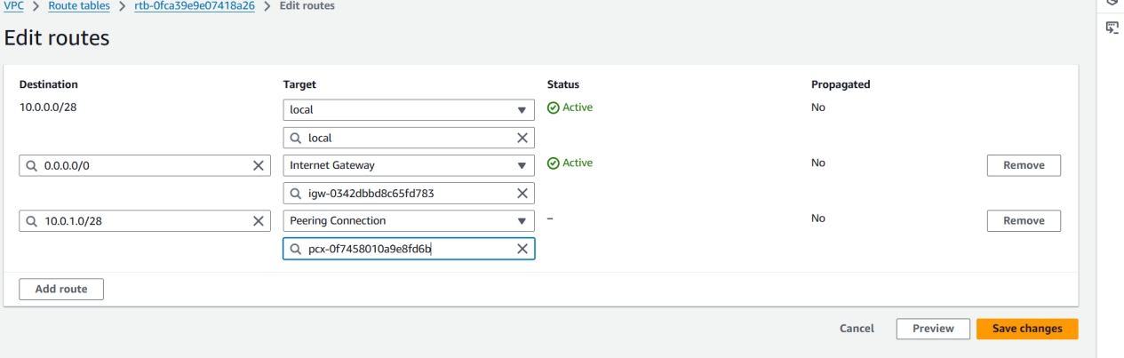

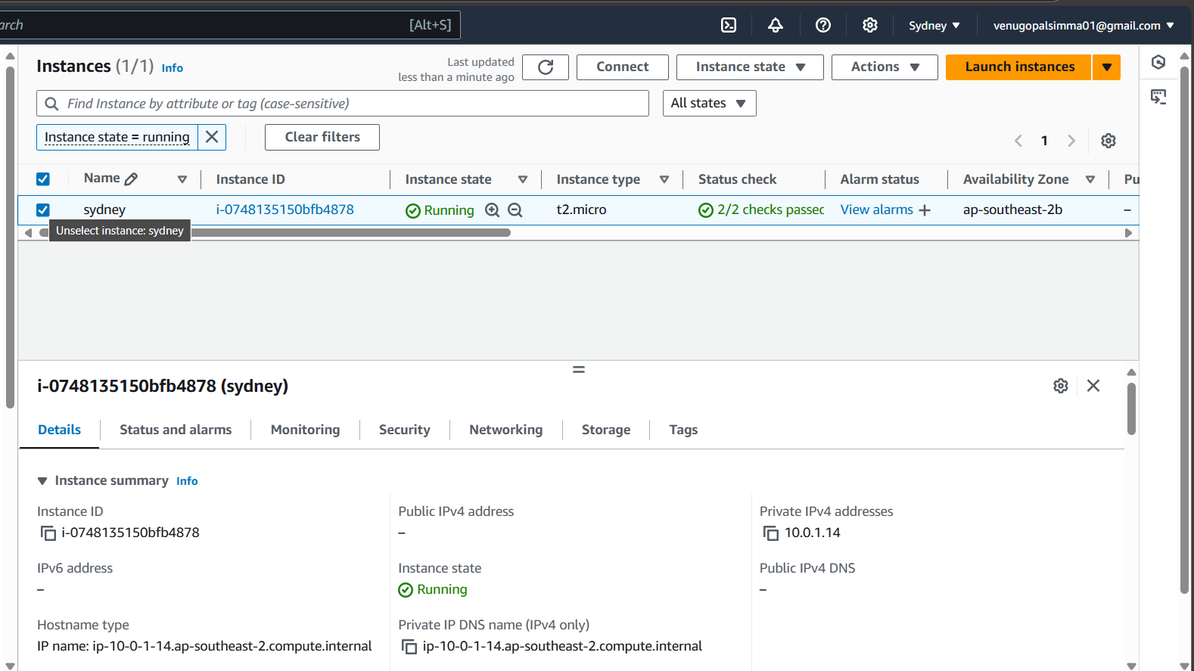

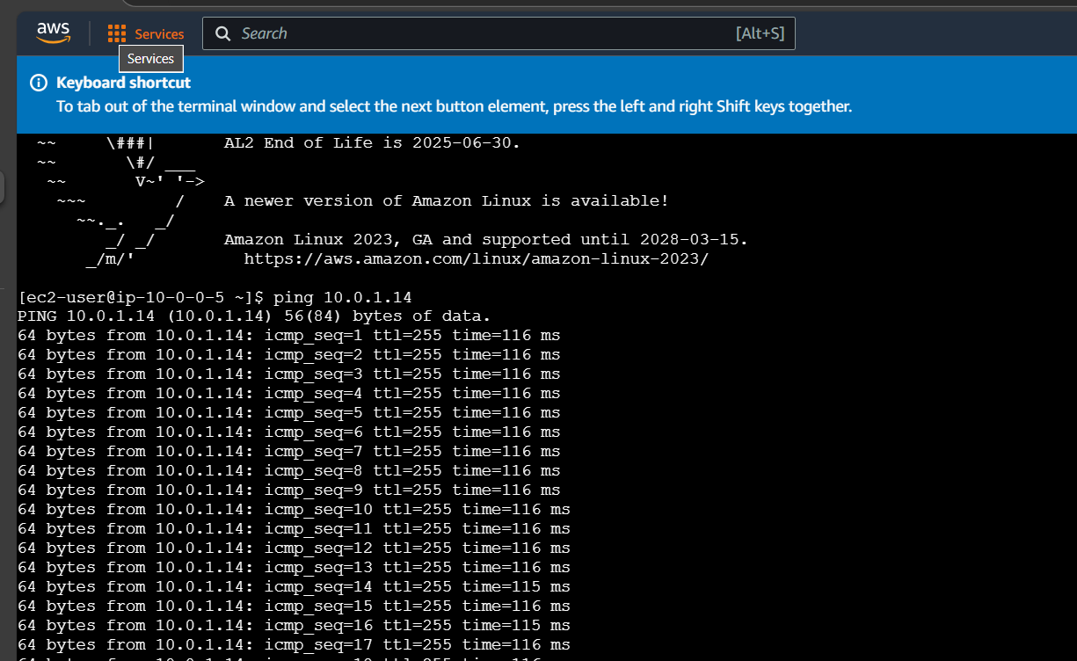

1. **Purchase one domain from GoDaddy.**

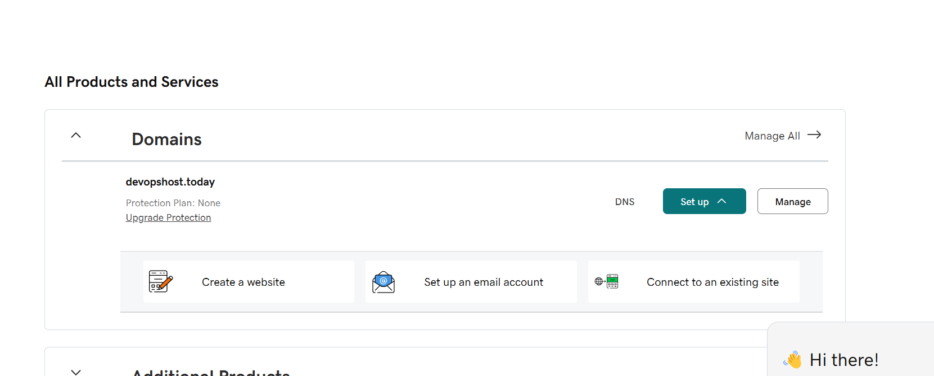

1. **Deploy static website in s3.**

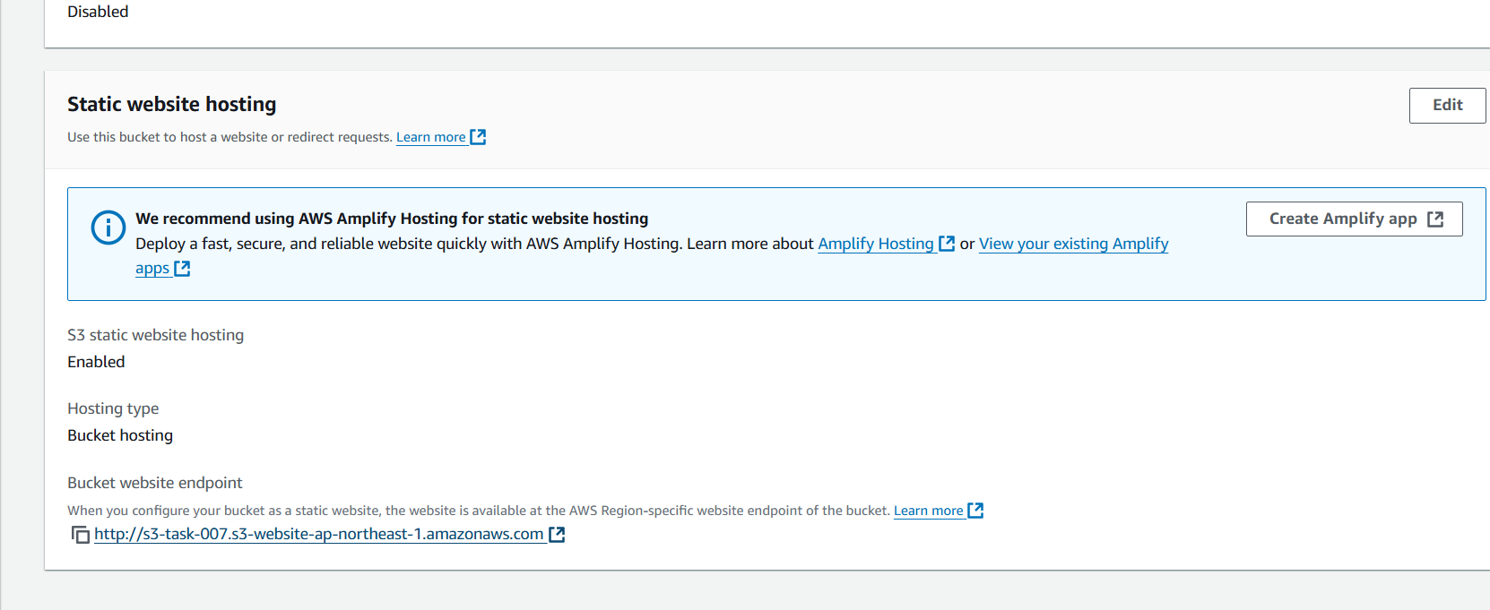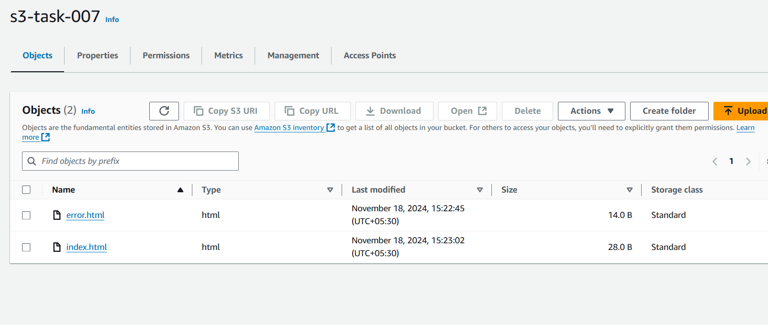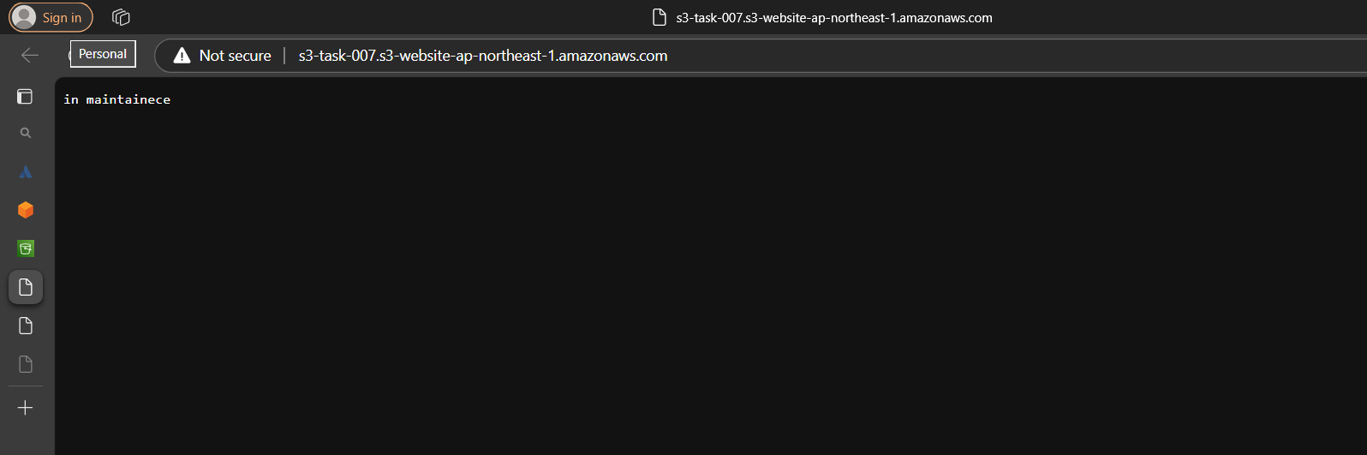

1. **Create CDN and attach one SSL certificate.**

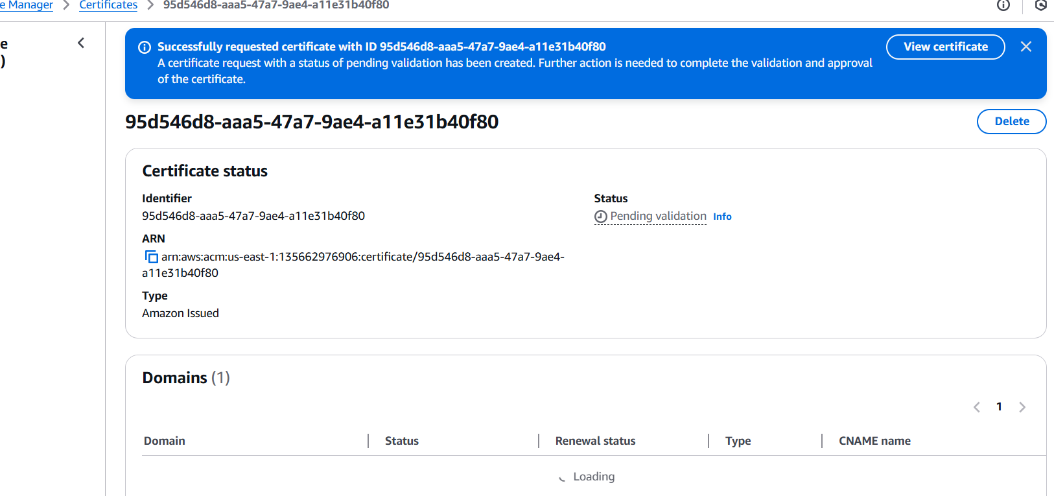

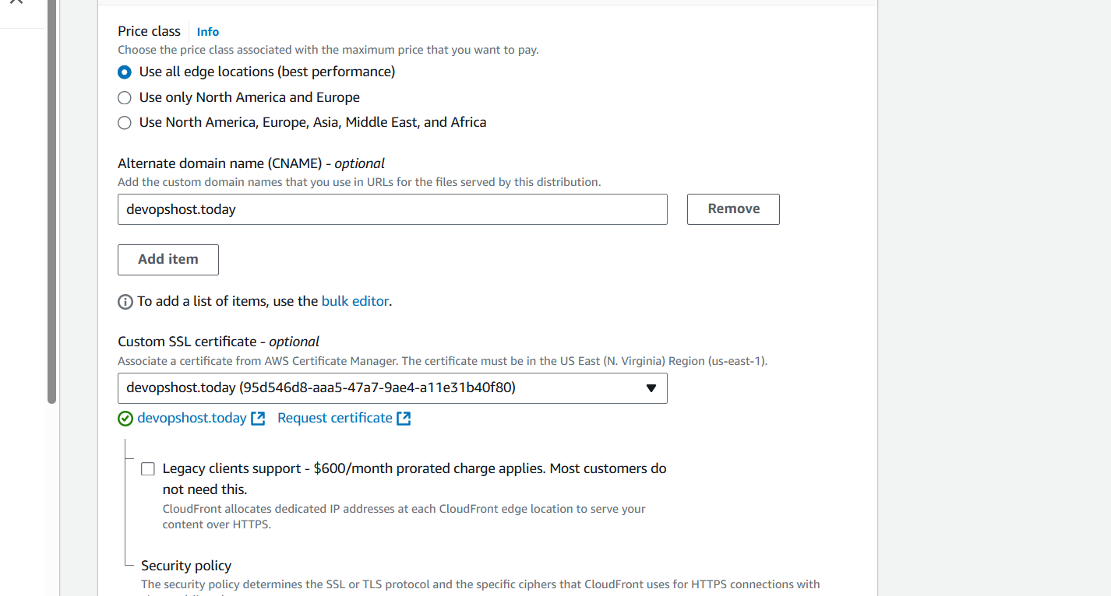

1. **Create Route53 hosted zone and MAP the domain with CDN.**

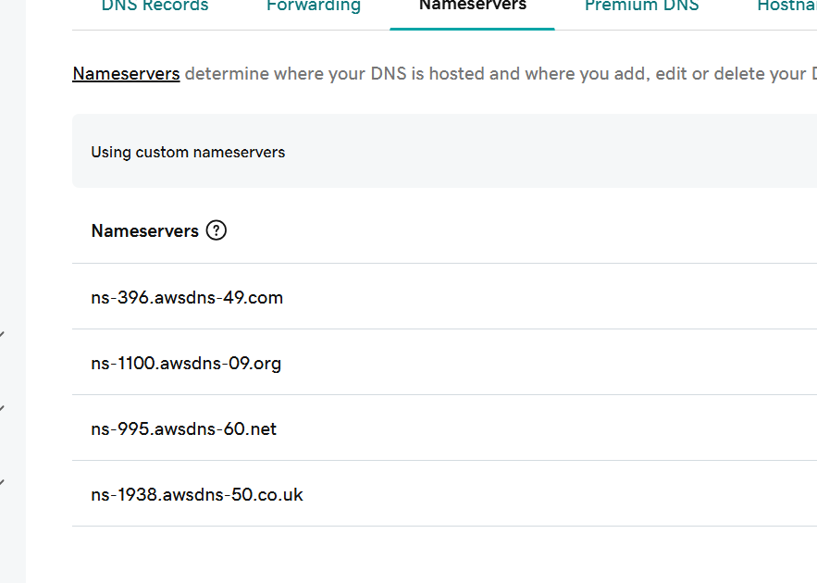

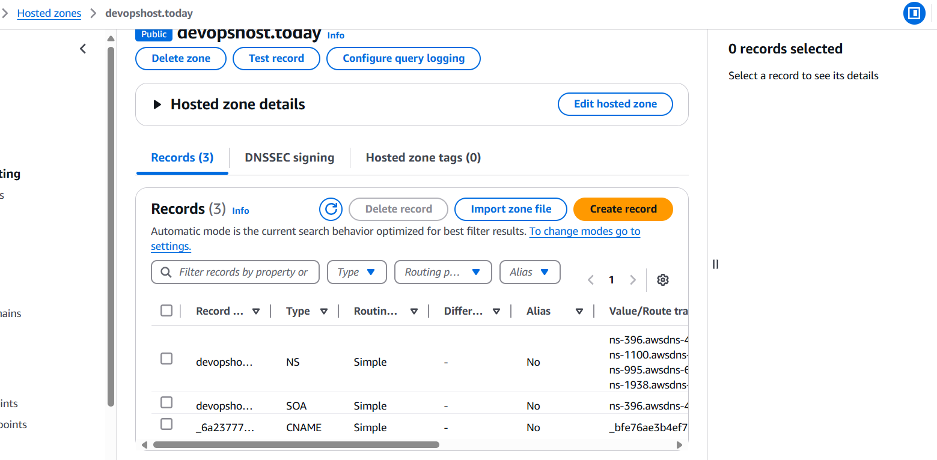

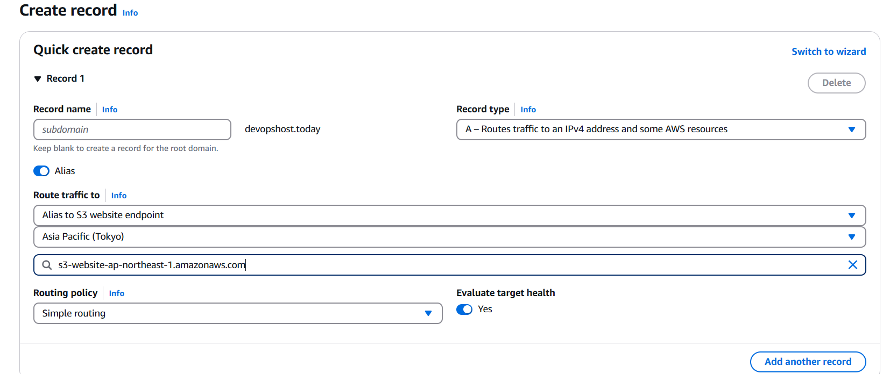

1. **Update the index.html in s3 bucket and the updated file should be accessible by using domain name**
2. **Share the Domain name in slack to test the connectivity.**

**Devopshost.today**