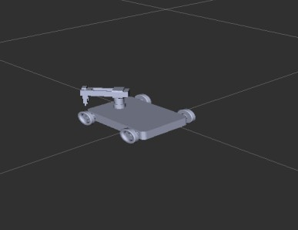

Final examination

ROBOTIC OPERATING SYSTEM

**Basheer Altawil | 08-02-2021**

**Summary for running the code for mobile robot integrated with three DoF robot manipulator simulated with rviz,gazebo.**

1. The package name is **steering_robot**
2. The folders inside it will be like the following and it will be the responsible for visualizing, simulating, and controlling the robot manipulator:
   * There will be one file inside urdf folder that file is under the name of **final.urdf** and its containing all materials needed for both **rviz**,and **gazebo**
   * There will be two files inside **launch** folder one of them for running **rviz** with name of **final_rviz** The other is for running **gazebo** with name of **final_gazebo**
   * One folder with name of **yaml** that will contain folder of name of **arm_controllers.yaml** and it will be responsible for arm joint controlling and differential mobile robot wheels rotating .

3-I faced a problem with gazebo simulation relating with mobile root orientation. However, I could publish a message from the terminal to change robot position even if its orientation is not at require place.

PAGE 1